Zone Blocking
Zone blocking in the running game is when two or three offensive linemen work in tandem as opposed to each offensive lineman having a specific, predetermined man to block. Zone blocking involves the center, guard, tackle and tight end working in combination to block an area with an emphasis on double-teaming the defensive linemen who are aligned on the line of scrimmage.
The concept is for two adjacent linemen to come off in unison and attack a defensive line to the play side or to the side the ball carrier is going. The advantage, as opposed to man blocking, is that you create a double-team with two players blocking one defensive lineman. This allows the offensive linemen to be aggressive because he knows he has help if his defensive lineman was to pinch inside. It also provides movement at the point of attack, which can open creases for the running back.
Zone blocking initially starts out as a double team at the point of attack on the down defensive linemen, but the beauty of it is that one of the offensive linemen will leave to attack the linebacker while one stays to take over the defensive lineman. The key is for the two offensive linemen working in unison to double-team the defensive lineman to decide who and when one of them will leave to block the linebacker. In the diagram below, we show the offensive line starting the initial double team on the defensive lineman.

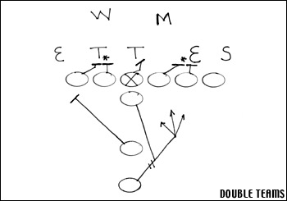

It appears that they have doubled the defensive end and defensive tackle and allowed the linebackers to go free, but both offensive linemen on the double team have all four of their eyes on the linebacker while the double team is taking place. One of the linemen will come off the double and block the linebacker.

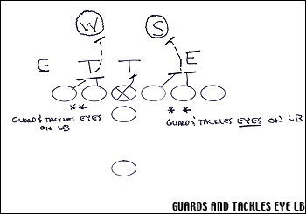

There are several keys to this technique:
1. The linemen stay hip to hip.
2. The linemen keep their shoulders square.
3. Most importantly, all four of their eyes are on the linebacker.
4. Knowing when and who takes over the defensive lineman and who leaves to block the linebacker.
In the next diagrams, we show the technique of going from the double team to taking over the linebacker. If the end pinches inside, the guard will take over and the tackle will leave for the linebacker. (See below)

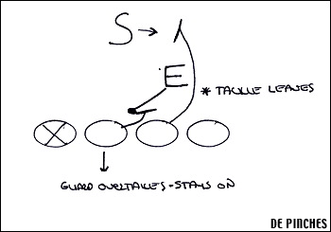

If the end stays outside, the tackle will take over and the guard will leave for the linebacker. (See below)

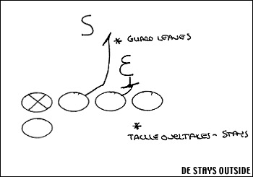

Difference between man blocking and zone blocking
Zone blocking first started to take place back when teams ran an old slant and angle defense. They would line head-up on an offensive lineman then slant the defense one way or another. It is easy to show this problem in man blocking and the best way to illustrate it is to show the defensive end pinching inside. If you are in man blocking and the tackle is assigned to the defensive end, he not only misses the defensive end pinching, but the DE knocks off the guard and keeps him from going to the linebacker.

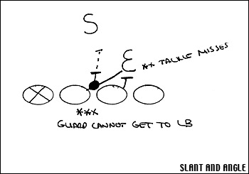

There are different kinds of zone plays and you will often here the term the outside zone. In the figure below, we show the landmark of the back in the outside zone. It is obvious that at the angle the back takes the ball there is very little opportunity for the back to cut back behind the center. This affects all of the linemen's techniques because it is predetermined where the ball is going.

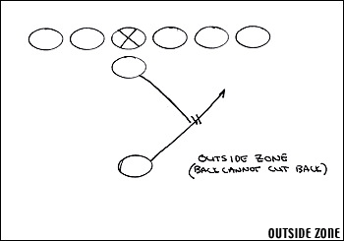

The inside zone is another term you hear. On the inside zone, the back's angle is more to the inside leg of the offensive tackle. Because the back is headed in a more straight-ahead angle, there is now the ability for the back to cut back behind the center. It is important that the back gets into the heels of the offensive linemen before he makes the cut. The offensive line can't allow penetration.

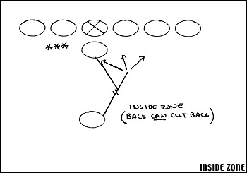

Pass blocking
Zone or Man
Zone-locking or man-locking principles may also be applied to pass blocking. Offensive linemen, when facing twisting defensive linemen, can also either lock on man-to-man or pass it off in a zone concept. When passing it off, or zone blocking, the key is to stop the penetration of the defensive end. In the figure below, the offensive tackle must stop the penetrating defensive end before passing him off to the guard. The offensive tackle then takes the defensive tackle looping around.

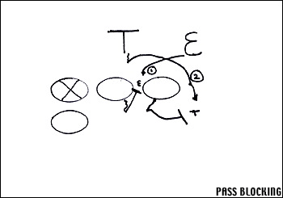

Conclusion
Zone blocking was created to handle moving defensive linemen. It is a simple concept, but it takes a lot of practice because it involves offensive linemen working in unison and decisions have to be made while the play is taking place. In zone blocking, you don't have a lot of different assignments, but you have a lot of techniques. It takes many repetitions to get the feel of working together as a unit. The diversity of zone blocking comes by the back running different angles and by the offense using different formations to confuse the defense.

