21IWS Co-op Share and Loan Management System with Data Analytics for Loan Transacation History

________________

o

A Capstone Project Presented to

The Faculty of the College of Computer Studies

Tarlac State University

Tarlac City

________________

In Partial Fulfillment

of the Requirements for the Degree

Bachelor of Science in Information Systems

Specialized in Business Analytics

________________

by:

John Bharon M. Tolentino

Angelito L. Pineda

Nico C. Narciso

John Paul N. Cortez

<Month and year of degree conferral, not date of submission

# TABLE OF CONTENTS

TABLE OF CONTENTS ii

LIST OF TABLES iv

LIST OF FIGURES v

1 INTRODUCTION 1

1.1 Project Context 1

1.2 Purpose and Description 4

1.3 Objectives 6

1.4 Scope and Limitations 7

2 REVIEW OF RELATED LITERATURE 10

2.1 Discussion of Models 10

2.2 Conceptual Framework 17

3 TECHNICAL BACKGROUND 20

3.1 Software Development Requirements 20

3.2 Hardware Development Requirements 22

3.3 Peopleware 23

3.4 Sources of Data 24

4 METHODOLOGY 26

4.1 Methods in Data Gathering 26

4.1.1 Interview Method 26

4.1.2 Internet Method 26

4.1.3 Observation 27

4.1.4 Library Research 28

4.2 Story Board 28

LIST OF TABLES

**Table 1.**

LIST OF FIGURES

Figure 1. Design Mockup 6

# INTRODUCTION

## Project Context

The IWS Co-Op is a vital financial institution serving a membership base of over 10,000 individuals who rely on its services for share contributions, loans, and various financial support. Over the years, the co-op has played a crucial role in providing its members with opportunities for saving, borrowing, and managing their finances. However, with such a large membership base, the current processes in place for managing member accounts, tracking share balances, handling loan requests, and tracking payments are highly manual and time-consuming. Members are required to physically visit the co-op’s office to inquire about their share balances, loan statuses, and eligibility for additional loans. These processes involve waiting in long lines, filling out paperwork, and undergoing lengthy interactions with staff, which often leads to frustration and delays.

This process, while initially manageable for a smaller membership, has become inefficient for a co-op of this size. The sheer volume of daily transactions and inquiries, combined with the administrative burden on co-op staff, leads to significant bottlenecks. Members often experience inconvenient delays when seeking answers to their financial questions or tracking essential transactions. Over time, this inefficiency affects the co-op’s overall operational capacity and diminishes the member experience. This challenge is not unique—cooperatives worldwide face similar difficulties when traditional processes fail to scale with growing membership [1].

Furthermore, this traditional approach fails to meet the growing expectations of today’s digital-first society. In an era where individuals expect convenient, accessible, and efficient services, the current system limits members' ability to manage their finances at their convenience. Members may only be able to access their accounts and track payments during office hours, which may not be ideal for those with busy schedules or who live far from the co-op office. This often results in delays, and missed opportunities for members to apply for new loans or manage their finances effectively. Studies show that digitization significantly enhances financial inclusion and customer engagement in cooperative institutions [2], [3].

In response to these challenges, the proposed project, "IWS Co-Op Share and Loan Management System with Data Analytics for Loan Transaction History," seeks to introduce an innovative, efficient, and user-friendly solution. The system will provide members with an intuitive digital platform that allows them to access all their co-op-related information anytime and anywhere, via a web-based interface. Through this platform, members will be able to view their share balances, track their loan statuses, and monitor their repayment progress. The system will also display real-time updates on loan eligibility, allowing members to check their ability to apply for new loans based on their current financial status, without the need to visit the co-op office.

The introduction of this integrated system will not only drastically reduce the long lines and waiting times at the co-op office but will also significantly enhance the overall experience for members. By providing real-time access to their financial information and offering an easy way to track payments online, members will benefit from a streamlined and modernized approach to managing their co-op services. This shift toward digital services will ultimately lead to increased transparency, as members can instantly access and track their financial data, resulting in greater trust in the co-op's operations [4].

Additionally, the new system will relieve the administrative burden on co-op staff. With loan eligibility checks, tracking payment notifications, and digital records, the need for manual data entry and processing will be reduced, freeing up staff to focus on more strategic tasks. The system’s ability to generate reports and track transaction history will further aid in data management, improving accuracy, and enabling the co-op to scale its operations more efficiently. This will also help ensure that the co-op can manage and service its growing membership base with fewer resources and less effort. Digital transformation in financial cooperatives has been shown to increase operational efficiency and reduce administrative overhead [5].

In the long term, the Co-OpShare System will serve as a cornerstone for the IWS Co-Op's future growth and modernization. As more members embrace digital platforms, the co-op will be better positioned to meet the demands of its members while reducing operational inefficiencies. The introduction of this system will not only improve member satisfaction but also contribute to the co-op’s financial health, as members will be more likely to track payments and maintain up-to-date financial records.

By implementing this system, the IWS Co-Op will demonstrate its commitment to innovation, member-centric services, and the continuous improvement of its operations, making it a leader in the cooperative sector. Ultimately, Co-OpShare will ensure that the IWS Co-Op can continue to support its members’ financial goals and foster a stronger, more connected community for years to come.

A similar approach to improving loan management was studied in Rwanda, where the implementation of a loan management system significantly contributed to the financial performance of savings and credit cooperative societies (Saccos), showing the potential benefits of digital transformation in cooperative environments [6].

## Purpose and Description

The purpose of the ""IWS Co-Op Share and Loan Management System with Data Analytics for Loan Transaction History"" is to modernize and streamline the entire process by which IWS Co-Op members access, manage, and interact with their financial accounts. This system is specifically designed to address the challenges faced by both members and co-op staff due to the outdated, this processes that currently dominate member transactions. One of the key objectives of the system is to eliminate the time-consuming task of physically visiting the co-op office, which results in long queues and extensive waiting times. With real-time access to financial data such as share balances, loan statuses, and repayment progress, members will no longer have to endure long lines or rely on office hours to receive essential information.

In addition to providing real-time account access, the system aims to enhance the user experience by incorporating features that allow members to track their loan status, remaining balances, and eligibility for future loans. Members will be able to view up-to-date information about their current loans, including outstanding amounts and due dates. Additionally, the system will assess their eligibility for future loans based on their repayment history and other relevant criteria. This feature ensures that members can manage their financial commitments effectively and stay informed about their loan status from any device, whether at home, at work, or on the go.

Moreover, the introduction of this digital solution will also enable greater flexibility in financial management. Members will have the ability to track their loan eligibility, monitor their repayment progress, and access detailed reports and statements without waiting for manual processing. This real-time information will give members more control over their finances, enabling them to make informed decisions regarding loans, repayments, and share contributions.

Furthermore, automating these processes through the Co-OpShare system will lead to improved operational efficiency within the IWS Co-Op. By reducing the reliance on in-person visits, the system will lessen the administrative workload for staff, enabling them to focus on higher-priority tasks such as member engagement, financial planning, and strategic growth. The system’s automation capabilities will also ensure accurate and up-to-date records, reducing the chances of human error and improving overall data integrity. Through these improvements, the IWS Co-Op will be better equipped to handle its growing membership base and serve its members more effectively.

Ultimately, the Co-OpShare system will foster a more efficient, modernized, and user-centric environment that aligns with the needs and expectations of today’s digital-first society. By providing seamless access to financial information, the system will enhance the overall member experience, increase transparency, and strengthen the IWS Co-Op’s ability to serve its members. As a result, both members and the co-op itself will benefit from a more streamlined, efficient, and convenient system that supports the long-term growth and success of the cooperative.

## Objectives

The goal of this project is to create an "IWS Co-Op Share and Loan Management System with Data Analytics for Loan Transaction History" that makes it easier for members to manage their shares and loans. The system will allow members to view their financial details, check loan history, and use data analytics to see trends. This will help members make better financial choices and assist co-op staff in improving operations, managing loans more effectively, and providing better service.

Specifically, the study aims to achieve the following:

1. To design and develop an Co-OpShare and Loan Management System with Data Analytics for Loan Transaction History a with the following features:
   1. Admin
      1. Manage member account
      2. Track loan application and approvals
   2. Member
      1. Track loan details and repayment history
      2. View share balances
      3. Check eligibility for new loans
2. Evaluate Co-OpShare functionality through ISO/ICE 25010 standards, using security and performance.
   1. Security
      1. Confidentiality
      2. Integrity
      3. Non-Repudiation
      4. Authenticity
   2. Functional Suitability
      1. Functional Completeness
      2. Functional Correctness
      3. Functional Appropriateness
   3. Reliability
      1. Faultlessness
      2. Availability
      3. Recoverability

## Scope and Limitations

This capstone project, titled "IWS Co-Op Share and Loan Management System with Data Analytics for Loan Transaction History," is designed exclusively for IWS Co-Op members. The system will allow members to easily track their shares and loans while providing insights through data analytics.

Co-OpShare provides a comprehensive, user-friendly platform designed to streamline the management of member accounts, share balances, and loans. The system begins with a secure Member Dashboard, where members can log in to access a detailed overview of their accounts. This includes the ability to view current share balances, track loan details and history, and check eligibility for new loans based on their financial standing.

While the Co-OpShare system provides a comprehensive solution for managing member shares, loans, and transaction histories, online payment functionality is not included. Payments for shares and loan repayments are automatically deducted from members' salaries. This approach simplifies the payment process and ensures timely contributions and repayments without the need for online transactions through the platform. Members do not need to manually process payments through the system, as the salary deductions are handled through an integrated payroll system.

The Loan Eligibility Check feature further enhances the user experience by automating the process of determining eligibility, taking into account members' repayment history, outstanding loan balances, and other co-op-specific criteria, ensuring a quick and accurate decision-making process.

The system includes a secure Admin Portal that provides co-op staff with powerful tools to manage member accounts, track loan applications, approve or reject loan requests, and generate detailed financial reports. This helps streamline administrative tasks and ensures transparency in operations.

To safeguard all sensitive data, security features are built into every aspect of the system. All member details are encrypted, and multi-factor authentication is implemented to protect information from unauthorized access. Additionally, secure login and session management protocols ensure safe and reliable access to the platform.

Lastly, the User Interface is designed to be accessible via web, ensuring that members with varying levels of technical proficiency can easily navigate and utilize the platform, making Co-OpShare a comprehensive, secure, and efficient solution for co-operative financial management.

This seamless integration of user-friendly interfaces with robust functionality and security makes Co-OpShare a cutting-edge tool for managing cooperative finances and member services.

# REVIEW OF RELATED LITERATURE

## Discussion of Models

The "IWS Co-Op Share and Loan Management System with Data Analytics for Loan Transaction History" is designed to modernize cooperative financial management by automating loan processing, share contributions, and online payments. To achieve this, the system follows a Three-Tier Architecture Model consisting of the Presentation Layer, Application Layer, and Database Layer.

The Three-Tier Architecture of the Co-OpShare system is designed to ensure scalability, security, and ease of maintenance by structuring the system into three layers: Presentation, Application, and Database. The Presentation Layer serves as the user interface, providing web and mobile access for both members and administrators. Members can conveniently view share balances, check loan eligibility, and make payments online, while administrators manage member accounts, loan approvals, and financial reports. The Application Layer handles core business logic, including loan application processing, repayment tracking, and eligibility checks. It also integrates direct payment solutions through PayMongo or similar gateways, while automated notifications and real-time updates keep members informed about their financial status. Lastly, the Database Layer securely stores all member profiles, share contributions, loan records, and payment transactions, ensuring data confidentiality, integrity, and availability through encryption and backup mechanisms. Together, these three layers create a seamless, efficient, and secure financial management system for the cooperative.[7]

Table 1. Functionality and Feature Matrix

|  |  |  |  |
| --- | --- | --- | --- |
| Software | Loan Payment Tracking | Share Contribution Management | Check eligibility for new loans |
| CitiXsys | / | X | / |
| FinTech | / | X | / |
| SoftCoop | X | / | / |
| Member365 | X | / | X |
| SympliFi | X | / | X |
| Tallyfy | / | X | / |
| Co-OpShare | / | / | / |

Table 1 shows the Functionality and Feature Matrix comparing seven software systems based on three key functionalities relevant to cooperative financial management. Each row corresponds to a different software, while each column represents a specific functionality or features:

1. Loan Payment Tracking: tracking of loan payments, including interest calculations and repayment schedules.

2. Share Contribution Management: It also provides tools for managing member share contributions and balances.

3. Loan Eligibility Check: automated eligibility checks, using members' financial data to determine their qualification for new loans, helping both the members and the co-op ensure proper loan management.

4. Online Payment: enabling members to pay their loan installments, share contributions, and other related charges online

Table 2. Literature Matrix [LOCAL AND INTERNATIONAL]

|  |  |  |  |
| --- | --- | --- | --- |
| rEFERENCE | DESCRIPTION | STRENGTH | WEAKNESs |
| "Multi-Purpose Cooperative Loan Management System Capstone Project Document" | This Capstone Project Focuses on Developing a Loan Management System Tailored for Multi-Purpose Cooperatives in The Philippines. It Addresses Challenges in Record-Keeping, Loan Processing, And Member Management. | Provides A Practical Solution to Common Issues Faced by Local Cooperatives, Enhancing Efficiency and Accuracy in Loan Management. | Being A Project Document, It May Lack Comprehensive Real-World Testing and Long-Term Performance Data. |
| "Credit Management System: An Effective Tool for Credit Cooperatives in The Philippines" | This Research Focuses on The Implementation of a Credit Management System Tailored for Credit Cooperatives In The Philippines. It Emphasizes the System's Effectiveness in Managing Member Accounts And Controlling Credits. | Provides A Targeted Solution for Credit Cooperatives, Enhancing Efficiency in Credit Management. | Study May Not Address the Needs Of Multi-Purpose Cooperatives With Diverse Services. |
| "A Study of Loan Management Systems in Cooperative Banks: A Case of the United States" by Mary A. Smith & James T. Williams (2020) | This study explores the adoption of loan management systems (LMS) in cooperative banks in the United States. It evaluates the effectiveness of these systems in streamlining the loan application, disbursement, and collection processes. The paper also discusses the integration of technology and automation in loan servicing and assesses the challenges and benefits that these systems bring to the operational efficiency of cooperative banks. | The study examines the technological transformation of loan management practices in U.S. cooperative banks, exploring the adoption of automated systems. It provides insights into system integration, data security, customer experience, and operational performance, highlighting the benefits and challenges of implementing such systems. The findings can assist cooperative banks in improving their operations and adopting similar technologies, with a specific focus on the U.S. context. | The study has several weaknesses, including its limited focus on U.S. cooperative banks, which reduces its applicability to other regions. It also lacks a comparison with other financial institutions and does not address the human or organizational factors that impact the successful adoption of loan management systems. |
| "The Contribution Of Loan Management On The Financial Performance Of Savings And Credit Cooperative Societies (Saccos) In Rwanda" By Jean Claude Mutabazi. | This Study Examines How Loan Management Practices Impact The Financial Performance Of Saccos In Rwanda, Focusing On Factors Such As Client Appraisal, Credit Risk Control, And Collection Policies. | Provides Empirical Data Linking Loan Management Practices To Financial Outcomes, Offering Insights Into Effective Strategies For Saccos. | The Findings Are Specific To Rwanda And May Not Be Directly Applicable To Cooperatives In Other Regions Without Considering Local Contexts. |

Cooperatives in the Philippines help members by providing loans and managing credit. Studies show that loan and credit management systems improve efficiency, ensure transparency, and reduce financial risks.

1. "Multi-Purpose Cooperative Loan Management System Capstone Project Document"  
   This project developed a loan management system for cooperatives. It focused on record-keeping, loan processing, and member management.
   * Key Insight: Automated systems improve loan tracking and reduce errors.
2. "Credit Management System: An Effective Tool for Credit Cooperatives in The Philippines"  
   This research studied credit management systems for cooperatives. It showed how loan policies and credit controls help manage finances and prevent unpaid loans.
   * Key Insight: Digital credit systems make loan processing faster and improve decision-making.

Foreign Literature/Studies

Other countries use loan and credit management systems to improve financial performance and loan administration.

1. "Enhancing Cooperative Loan Scheme Through Automated Loan Management System" – Mbam B.C.E. & Igboji, Kingsley O.  
   This study developed an automated loan system for cooperatives. It solved problems with data consistency, redundancy, and security.
   * Key Insight: Automation reduces delays and improves financial accuracy.
2. "The Contribution of Loan Management on the Financial Performance of Savings and Credit Cooperative Societies (SACCOS) in Rwanda" – Jean Claude Mutabazi  
   This research looked at loan management and financial stability in Rwandan cooperatives. It focused on credit risk control and loan collection strategies.
   * Key Insight: Structured loan policies improve cooperative finances.

## Conceptual Framework

*Figure 1 Conceptual Framework*

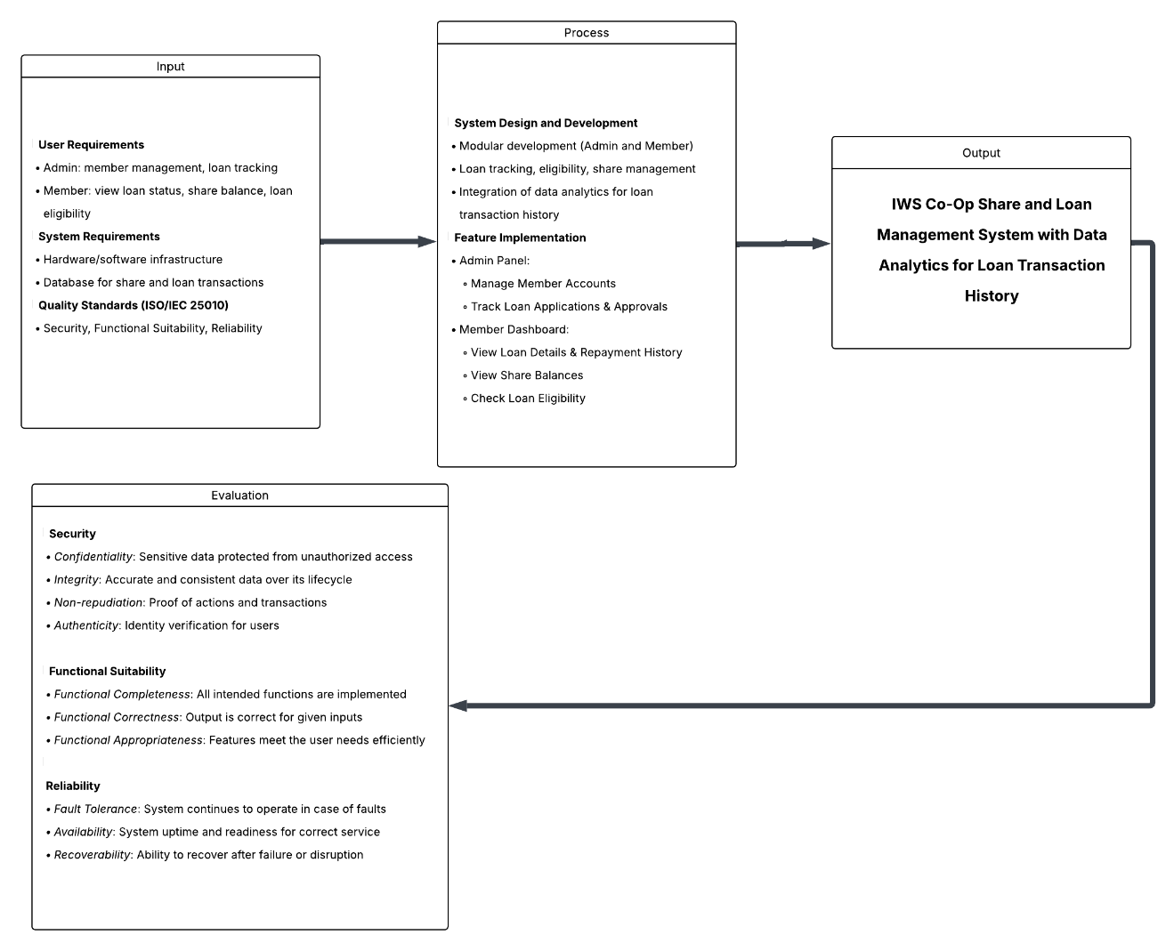

Figure 1 Shows the Conceptual Framework, By use of a digital platform for loan payment management, share contributions, and loan eligibility evaluations, it seeks to meet the demands of both administrative staff members and cooperative members. Through data analytics, the system is meant to increase openness, simplify processes, and provide intelligent insights that would help members make better financial decisions and the cooperative provide better service.Four basic elements make up the framework: input, process, evaluation, output. Along with the basis for system development—ISO/IEC 25010 software quality standards—user and system requirements form the input. System features for both administrative and member purposes are methodically designed, developed, and implemented under the process. This covers handling member accounts, following loan applications and repayments, and seeing share balances and loan eligibility. Embedded analytics let consumers know loan trends and histories so they could make wise decisions.Focusing on Security, Functional Suitability, and Reliability, the assessment component ensures that the system satisfies accepted software quality criteria, therefore playing a critical part. Security guarantees user data non-repudiation, authenticity, secrecy, and integrity. Functional Suitability verifies that features are suitable for user demands and that the system runs entirely and functionally. Reliability attends to the fault tolerance, availability, and recoverability of the system. These quality criteria guarantee that the end result, a completely operational, safe, and effective Co-Op management system, satisfies users as well as operational excellence.

# TECHNICAL BACKGROUND

## Software Development Requirements

Table 4 Sofware Development Requirements

|  |  |
| --- | --- |
| **Software** | **Description** |
| Windows 10 | Operating system that was utilized by the researchers in developing the system. This OS was used because some websites or web portals runs different in other OS and may look different in other OS. |
| HTML5 | HTML5 is the latest Hypertext Markup Language (HTML), the standard programming language for describing the contents and appearance of Web pages. These days all major browsers (Chrome, Safari, Firefox, Opera, and IE) offer HTML5 support, which makes it the newest HTML technology used today. HTML5 was used as the main building block in the system. |
| JavaScript | JavaScript is a text-based programming language used both on the client-side and server-side that allows you to make web pages interactive. Where HTML and CSS are languages that give structure and style to web pages, JavaScript gives web pages interactive elements that engage a user. JavaScript was used in the system, for example, in login/sign up page where a pop-up alert will show up if you didn’t fill-up a certain field, or to show and hide an information in the system. |
| CSS | CSS is the style sheet language for describing the presentation and design of web pages including colors, fonts, and layouts. It is mainly designed to enable the distinction between presentation and content, including colors, layouts, and fonts. It can be used in different types of devices, like large or small screens and printers. CSS was used mainly to add a style or design in the system and to make an interface for the users |
| MySQL | MySQL is a relational database management system (RDBMS) based on the SQL (Structured Query Language) queries. It is one of the most popular languages for accessing and managing the records in the table. MySQL is open-source and free software under the GNU license. Oracle Company supports it. MySQL was used to keep data safe and organized in the system. |
| PHP | PHP is a server-side scripting language that is embedded in HTML. It is used to manage dynamic content, databases, session tracking, even build entire e-commerce sites. It is integrated with a number of popular databases, including MySQL, PostgreSQL, Oracle, Sybase, Informix, and Microsoft SQL Server. PHP was used to interact (create, open, read, write) with files or data in the data server of the system |
| phpMyAdmin | The researchers used phpMyAdmin as the MySQL administration tool. phpMyAdmin is a free web application that provides a convenient GUI for working with the MySQL database management system. phpMyAdmin was used as an interface to communicate with MySQL. |

Table 4 shows the lists of the software used in developing system , above are tools used by the researchers during the development of the system. Windows 10 was used as the operating system because its stability and performance has been greatly improved that helped the researchers for utilizing it. HTML5 was the main language used for the system, it gave the researchers more control over the performance of their websites. JavaScript was also a language used for making the system more interactive. CSS was also used in the developing the system, it gives the system its design. MySQL is one of the most popular relational database management systems in the world, the researchers used it because it’s easy to install, it’s compatible with virtually every operating system, and is more or less an industry standard. PHP is a server-side scripting language that can be used to retrieve data from a MySQL database, in addition to many other purposes it can serve. PhpMyAdmin was the used software as the server and database of the researchers because it has a user interface, and they could run queries within the SQL and also that they could paste queries into the SQL to test data output.

## Hardware Development Requirements

|  |  |  |
| --- | --- | --- |
| **Hardware** | **Specifications** | **Descriptions** |
| Laptop/PC | Dell Inspiron 5459 Intel Core i3 Intel Core i3-6100 Processor, Intel HD Graphics, 4GB DDR Memory, 1TB Hard Drive, DVD-RW Drive, Bluetooth, Windows 10 Operating System | This laptop was used in the development of the system. This is the device used where the needed software is installed to help in the development of the system. |
| Printer | Epson L3110 | This printer would be used in printing the documents. A printer is a device that accepts text and graphic output from a computer and transfers the information to paper, usually to standard size sheets of paper. |

Table 5 Hardware Development Requirements

Table 5 shows the hardware requirements used for developing and running the system. These hardware requirements gave important role in helping the researchers for the development and final documentation. Specifications were enough for the researchers to conduct the research and its process.

## Peopleware

Table 6 Peopleware

|  |  |  |
| --- | --- | --- |
| Role | Name | Responsibilities |
| Project Manager | John Bharon M. Tolentino | Oversees the entire project, assigns tasks, manages deadlines, and ensures team coordination. |
| UI/UX Designer | Angelito L. Pineda | Designs the user interface and user experience, ensuring usability and visual consistency. |
| Developer | Nico C. Narciso | Implements system functionalities, writes code, and integrates different modules based on the requirements. |
| Tester/Users |  | Conducts system testing to identify bugs, verify performance, and ensure overall quality. |
| Documenter | John Paul N. Cortez | Creates and compiles all project documentation including reports, manuals, and technical documents. |

Table 6 shows the Peopleware , where involved in the development and testing of the system. Each member of the team had a specific role that contributed to the successful completion of the project. The Project Manager was responsible for overseeing the entire project, assigning tasks, managing schedules, and ensuring that the team stayed on track with the project objectives. The UI/UX Designer handled the design of the system’s interface and overall user experience, ensuring that the application was intuitive, visually appealing, and easy to navigate.

The Developer was tasked with writing the code, implementing system functionalities, and integrating the necessary features based on the project requirements. This role was crucial in transforming design and logic into a working application. The Tester was in charge of identifying bugs, verifying performance, and conducting multiple testing phases to ensure the quality and stability of the system. Lastly, the Documenter prepared all necessary project documentation, including user manuals, reports, and technical documentation, which were vital in presenting and maintaining the system.

Each member played a significant role in their respective areas, and their collaboration ensured that the project was completed efficiently and effectively.

## Sources of Data

The data used in the development and testing of the system was primarily gathered through surveys, user interviews, and direct user input. These methods provided essential insights into the current processes and challenges faced by both the members and staff of the IWS Co-Op. The survey was distributed among selected co-op members to gather feedback on their experience with the existing manual system, particularly regarding loan applications, share inquiries, and payment tracking. Interviews with co-op staff were also conducted to understand the workflow from an administrative perspective and to identify inefficiencies in their daily operations.

The types of data collected include transaction histories, share balances, loan application records, and qualitative feedback on user experience. These data points helped in designing and refining the system’s features to meet real user needs. The data was collected during the first quarter of the academic year 2024–2025 and served as the basis for creating system requirements, building use case scenarios, and performing testing phases.

This information was crucial in shaping the proposed system, “IWS Co-Op Share and Loan Management System with Data Analytics for Loan Transaction History.” It ensured that the development process was rooted in actual user behavior and institutional requirements, leading to a solution that directly addresses the co-op’s pain points and improves overall operational efficiency. The combination of user-driven data and contextual project understanding allowed for a more tailored, user-friendly, and effective system design.

# METHODOLOGY

## Methods in Data Gathering

Data collection is the process of gathering and measuring information use to support and validate the developed system. It serves as evidence of the study that allows researchers to lead the formulating convincing and credible references. The gathering of information refers to the step in collecting the data for the development of the system which helped the researchers to do analysis and design.

The following are the methods used by researchers in gathering data:

### Interview Method

Interviews were conducted with members and staff of the IWS Co-Op to gain firsthand insights into the current processes and challenges in managing share contributions, loan applications, and payment tracking. These interviews revealed the manual nature of most operations, including the need for members to physically visit the co-op office, long queues, and the time-consuming loan eligibility checking process. Researchers also interviewed co-op administrative staff, who discussed the burden of data entry, paperwork handling, and the inefficiencies of servicing a large membership base manually. These insights directly influenced the design of the proposed digital platform, ensuring that it responds to real user pain points and aligns with the needs and preferences of both the members and staff.

### Internet Method

The internet served as a primary tool for gathering crucial information and insights related to the development of the IWS Co-Op Share and Loan Management System. Utilizing platforms such as Google Scholar, IEEE Xplore, ResearchGate, and reputable financial technology websites, the researchers collected a wide range of literature, including academic studies, case analyses, and technical reports on cooperative digitization, online loan management, and financial inclusion. These materials were instrumental in understanding global trends and identifying best practices in the digitization of cooperative services. The information gathered helped the researchers bridge existing gaps in traditional co-op operations and supported the conceptual framework of the proposed system. The internet was especially vital in studying how similar challenges were addressed by cooperatives in other countries, such as the implementation of digital systems in savings and credit cooperatives (Saccos) in Rwanda, which provided a reference point for system design and implementation.

### Observation

Observation was carried out during the interviews and site visits at the IWS Co-Op office. Researchers observed how members inquire about share balances and loan statuses, the flow of transactions, and the steps involved in processing payments and loan applications. The long lines, manual ledger reviews, and frequent delays were evident during peak hours. These observations validated the interview findings and highlighted operational bottlenecks. By combining the data gathered through interviews and firsthand observation, researchers were able to design system features that specifically address inefficiencies and streamline the transaction process for members and staff alike.

### Library Research

Library research also played a supporting role in the initial stages of the study. Researchers spent time reviewing available materials at the Tarlac State University-San Isidro library, where they examined past research studies, theses, and publications related to cooperative systems and financial service automation. This method was useful in understanding how existing systems function, what challenges they faced, and what improvements were proposed or achieved. The literature gathered helped form the foundation for the system's structure, especially in identifying recurring problems in manual processes. It also served as an initial reference for the documentation layout, formatting, and methodology used in similar academic system development studies.

## Story Board

Here you will draw and discuss potential design considerations and constraints that you have. You can put design mock-ups here to show how you visualize your proposed system.

***Figure 3. Dashboard***

***Figure 4 Loan Menu***

***Figure 5 Payment menu***

***Figure 6 Borrower Menu***

***Figure 7 Loan Plan Menu***

* 1. **Design and Development of IWS Co-op Share and Loan Management system with Data Analytics for Loan Transaction History**
     1. **Requirement Analysis and Documentation**
        1. **User Requirements**

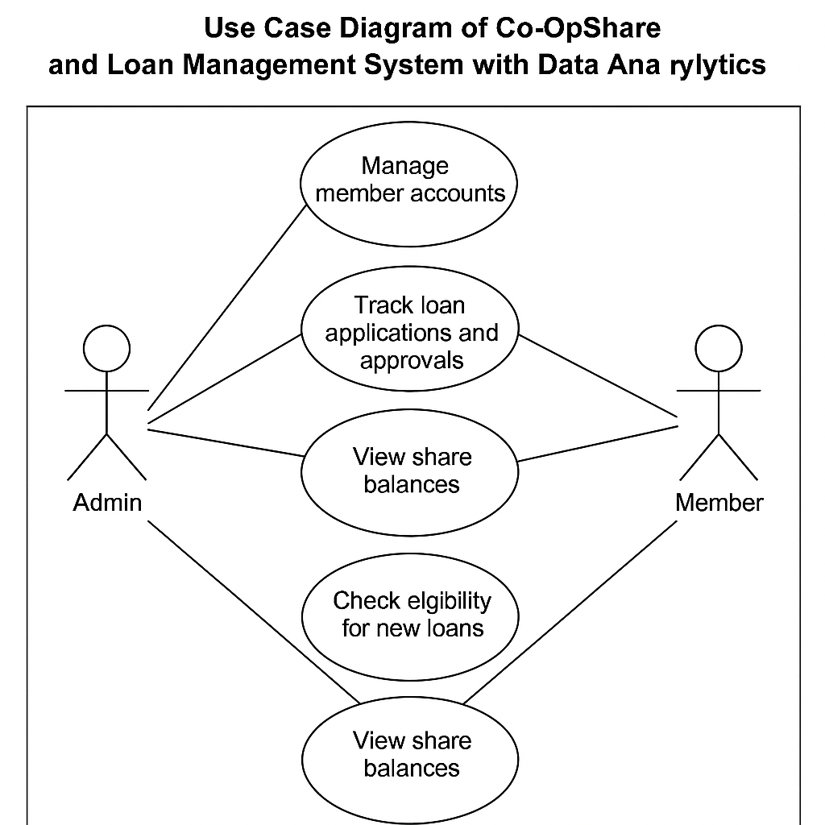

***Figure 8. Use Case Diagram of Co-OpShare and Loan Management System with Data Analytics***

Figure 8 shows the Use Case Diagram of the Co-OpShare and Loan Management System with Data Analytics. It illustrates the interactions between the primary users Admin and Member and the system. The Admin manages member accounts, tracks loan applications and approvals, and oversees share balances. The Member can track their loan details, view their repayment history, monitor share balances, and check eligibility for new loans. The diagram clearly defines the roles and system functionalities, ensuring that all critical user actions are addressed in the design.

**4.3.1.2 User Characteristics**

The following are the user characteristics based on the use case diagram. The users defined here are consistent with the actors illustrated.

The primary users of the system are the Admin (typically the co-op officer or manager) and the Member (the individual coop participant). Both user groups are expected to have basic computer literacy but not necessarily advanced technical expertise. Therefore, the system must feature an intuitive, user-friendly interface to ensure ease of use and accessibility.

The Admin will be able to:

1. Manage member accounts (create, update, deactivate)
2. Track loan applications and approve or reject loan requests
3. View and update share balances
4. Set system settings such as backup and restore options
5. Monitor overall loan transaction history and analytics

The Member will be able to:

1. Track their loan details, including outstanding balances and repayment schedules
2. View their repayment history
3. Monitor their share balances
4. Check their eligibility for new loan applications
   * + 1. **Functional Requirements**

***Table 2 Functional Requirements***

|  |  |  |
| --- | --- | --- |
| **Module** | **Functionality** | **Description** |
| Admin | Manage member account | Add, update, and delete member details. |
|  | Track loan application and approvals | Monitor loan status and perform approvals or rejections. |
| Member | Track loan details and repayment history | View past and ongoing loan data and payment progress. |
|  | View share balances | Access current share balance in real time. |
|  | Check eligibility for new loans | Determine if member qualifies for new loan based on share and payment data. |

Table 2 Shows the Functional Requirements , expected capabilities of the system based on the roles of Admin and Member. Admin users are responsible for backend operations like managing member accounts and processing loans. Members, on the other hand, can check their share balances, view their loan history, and determine their eligibility for new loans. Each function listed ensures that users can interact with the system as needed, improving both accessibility and efficiency.

* + - 1. **Non-Functional Requirements**

|  |  |
| --- | --- |
| Requirement Type | Requirement |
| Performance | The system must handle at least 100 simultaneous users. |
| Reliability | The system should have 99.9% uptime. |
| Usability | The interface must be user-friendly and accessible. |
| Security | User data must be encrypted and only accessible by authorized roles. |
| Maintainability | The system should be easy to update with future features. |
| Availability | The system must be accessible 24/7 via a web interface. |

***Table 3 Non-functional Requirements***

The table 3 shows the Non-Functional Requirements, highlights the quality attributes of the system such as security, performance, and availability. These requirements ensure that the system runs reliably, protects user data, and is scalable as usage increases. It supports the goal of creating a stable and efficient digital platform for the IWS Co-Op and its members.

* + 1. **A screenshot of a computer

       AI-generated content may be incorrect.Design of Software and/or System and/or Product and/or Processes**
       1. **ER Diagram**

*Figure 9. Database Schema of IWS Co-op Share and Loan Management system with Data Analytics for Loan Transaction History*

Figure 9 shows the entity relationship diagram (ERD) of the proposed IWS Co-Op Share and Loan Management System, highlighting the core entities and their relationships within the system. The ERD includes six main entities: admin, member, loan_application, loan_repayment, and loan_eligibility.

* The Admin entity manages system operations, including the approval of loan applications. Each admin has a unique identifier, along with a name, email, and password.
* The Member entity represents individual co-op members, each having a unique ID, name, email, password, and a record of their current share balance. This entity supports the member functionalities such as viewing share balances and checking loan eligibility.
* The Loan_Application entity stores information about loan requests submitted by members. It includes the loan amount, application date, status (e.g., pending, approved, rejected), and references the admin who approved or rejected the application.
* The Loan_Repayment entity tracks payment records made by members for specific loans. It includes payment dates and amounts, and is linked to the corresponding loan application.
* The Loan_Eligibility entity evaluates whether a member is qualified for new loan applications based on their financial history. It stores the eligibility status and the date the check was last performed.

The relationships between these entities ensure that administrative actions are traceable, member data is centralized, and all loan-related transactions are properly recorded and linked to their respective owners. This ERD supports both the admin’s ability to manage members and loans, and the member’s ability to independently access and manage their financial data.

* + - 1. 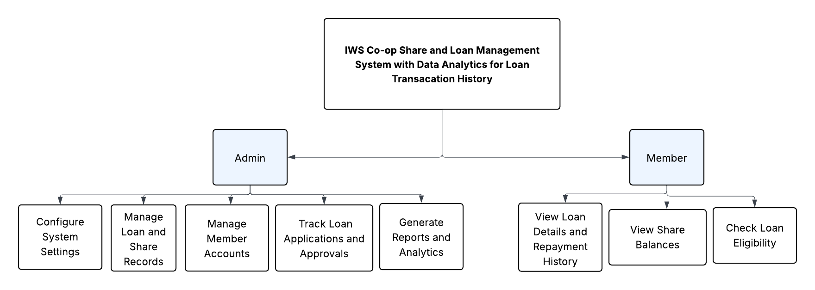**Functional Decomposition Diagram**

*Figure 10. Functional Decomposition Diagram of IWS Co-op Share and Loan Management System with Data Analytics for Loan Transacation History*

Figure 10 shows the Functional Decomposition Diagram (FDD) of the Co-OpShare and Loan Management System with Data Analytics for Loan Transaction History.  
The diagram illustrates the breakdown of the system’s main functions into smaller, more manageable sub-functions to clearly define the scope and operational flow of the system.

The top-level function is the Co-OpShare and Loan Management System, which is divided into two major modules:

* Admin Module
* Member Module

The Admin Module consists of the following functions:

* Manage Member Accounts: Handles creating, updating, and deleting member profiles.
* Track Loan Applications and Approvals: Administers the review, approval, or rejection of loan applications submitted by members.
* Manage Loan and Share Records: Updates and monitors the loan balances, share contributions, and repayments.
* Generate Reports and Analytics: Provides summaries and visualizations of loan histories, repayments, and share balances.
* Configure System Settings: Includes management of user access rights, backup and restore settings, and business information setup.

The Member Module includes the following functions:

* View Loan Details and Repayment History: Allows members to view their current loans, payment schedules, and repayment records.
* View Share Balances: Displays the accumulated share contributions of the member.
* Check Loan Eligibility: Enables members to assess their eligibility for new loans based on their share balance and repayment history.
  + - 1. **Operating Environment**

This system will run all kinds of operating systems and any type of windows that contain web browsers. As well as it also runs in mobile.

***Table 4. Operating Enviroment***

| **Code** | **Environment Description** |
| --- | --- |
| **OE1** | IWS Co-op Share and Loan Management System with Data Analytics for Loan Transacation History shall use any Windows that contain web browser. |
| **OE2** | IWS Co-op Share and Loan Management System with Data Analytics for Loan Transacation History shall use in mobile. System is Mobile Responsive |
| **OE3** | Web browser shall be installed on the computer to access the system. |
|  |  |

This table 4 shows the operating environment which is the system shall use of any windows that contain web-browse. Also, it is very capable to mobile phones and for the computer that will access the system. The IWS Co-op Share and Loan Management System with Data Analytics for Loan Transacation History will be a Web Based that will run all over a web browser environment. This system shall be developed using Java programming language, html and php.

**4.3.2.4 Design and Implementation Constraints**

***Table 5. Design and Implementation Constraints***

|  |  |
| --- | --- |
| **Code** | **Design Constrains and Implementation Constraints Description** |
| **DC1** | The software shall be programmed in sublime MySQL database**.** |
| **IC1** | The software shall run any types of Windows with browser. |
| **IC2** | The Software shall be developed using Java, HTML, PHP |
| **IC3** | The user must require password to login. |

. Table 5 shows the system is being run for that software MySQL database also, it will run for any types of windows browsers as well as it can be developed through java, HTML and PHP. And the user must require a password to login.

* + 1. **System Development Methodology**

Agile methodology was utilized for the system development technique since it is the most adaptable approach for this kind of project. Iterations are a great way to minimize issues throughout the system since they allow us to interact and communicate as the system is being developed using the Agile methodology.

Agile Methodology has stages Requirements, Design, development, testing and deployment.

*Figure 11 Web-Based Water Ordering and Payment System of Elezor Water Refilling Station*

**The Phase 1** is Requirements. In this phase, the researcher defines the idea of the Co-OpShare and Loan Management System with Data Analytics and the expected goals to achieve. During this time, the necessary information about the system’s users and functionalities is gathered. A Use Case Diagram is created to describe the interaction between the Admin and the Member. The Admin manages member accounts and loan applications, while the Member tracks loan details, repayments, share balances, and checks loan eligibility. This phase ensures that all expectations are clearly defined before development begins. Questions about what the system should do, who the users are, and the overall purpose are answered. After gathering the requirements, a feasibility study is conducted to analyze if the project is achievable within the available resources and timeline.

**The Phase 2** is Design. The researcher defines the technical structure of the system by preparing the system architecture, Entity Relationship (ER) Diagram, and identifying the hardware and software requirements. The ER Diagram describes the relationship between entities such as Members, Loans, and Shares. During this phase, the system’s layout, interfaces, and key modules are planned carefully to ensure that the functionalities gathered during the requirements phase are properly addressed. This phase also outlines how the system will be implemented to meet the goals defined earlier.

**The Phase 3** is Development. During this stage, the researcher transforms the design into a functional system. Developers begin coding based on the technical documents prepared during the design phase. Functionalities such as member account management, loan tracking, repayment history monitoring, and data analytics are built and integrated. This phase focuses on writing clean and functional source code, ensuring that each module follows the planned design and is ready for integration.

**The Phase 4** is Testing. After the development of the system, rigorous testing is conducted to ensure that the software meets the intended requirements. Each module is tested for bugs, errors, and functionality issues. Testers use the Software Requirements Specification (SRS) document to validate that the system performs as expected. Regression testing and retesting are done to eliminate any remaining issues and to ensure that the system is stable and ready for deployment. The system's accuracy in managing loans, repayments, and shares is carefully checked during this phase.

**The Phase 5** is Deployment. Once the system has passed the testing phase, it is prepared for deployment. The Co-OpShare and Loan Management System with Data Analytics is installed on the target environment, and final User Acceptance Testing (UAT) is conducted. The Admin and selected Members test the system to ensure it meets their expectations. After approval, the system is officially launched and made available for use, allowing users to manage member accounts, monitor loans and shares, and view historical data analytics.

* + - 1. ***Planning***

The project focuses on the design and development of a Co-OpShare and Loan Management System with Data Analytics for Loan Transaction History, using the Agile methodology. The project is completed across four phases over the span of four months, following a schedule that covers the key deliverables for each chapter. Chapter 1 includes the Introduction, Project Context, Purpose and Description, and Scope and Limitations. Chapter 2 discusses the Review of Related Literature (RRL) and Definitions of Terms. Chapter 3 presents the Technical Background, covering both Hardware and Software Development. Chapter 4 details the Methodology, including Requirements Analysis, the creation of the Entity Relationship Diagram (ERD), and consultations for technical advice. Early weeks are devoted to activities such as brainstorming, submitting a progress report for the subject teacher, and revising Chapter 1 based on feedback. During the planning phase, the team meets with stakeholders to gather system requirements, develop a project plan with defined goals, tasks, timeline, and needed resources, assess potential risks, and design a communication plan. Proper planning ensures that the project stays aligned with its objectives, meets deadlines, and remains within budget. Regular evaluation of the project timeline, active communication with stakeholders, and continuous monitoring of risks are emphasized to ensure project success. With a clear and structured plan in place, the team is confident in achieving the successful completion of the system through to Chapter 4.

* + - 1. **Project Schedule**

*Figure 12. Burn Down Chart*

Figure 12 shows the graphical representation of Estimated Time and Actual Time in the development of the system. The blue dotted line on the chart represents the estimated time that the researchers needed to achieve for the development of the system. The red-dotted line represents the actual time in the development of the system. The hours represent the total duration of the development period while the sprints represent the start and end date of the development.

* 1. **To evaluate the performance of the Co-OpShare and Loan Management System with Data Analytics for Loan Transaction History by means of ISO/IEC 25010-based tests focusing on Security, Functional Suitability, and Reliability.**

The evaluation of the system is conducted to ensure that it meets the functional and non-functional requirements based on the ISO/IEC 25010 software quality model. The tests are designed to assess key quality characteristics, specifically security, functional suitability, and reliability, to ensure that the system operates accurately, safely, and effectively for both administrators and members.

* + 1. **Functional and Non-Functional Testing Based on ISO/IEC 25010 Standards**

The testing was carried out through a series of planned functional and non-functional tests. Functional tests involved verifying the core system features such as member account management, loan application tracking, loan details viewing, share balance checking, and loan eligibility checking. Each functionality was tested to ensure completeness, correctness, and appropriateness of system responses.

Non-functional tests focused on three critical aspects:

* Security: Evaluating confidentiality (ensuring sensitive data is accessible only to authorized users), integrity (ensuring data accuracy and protection against unauthorized changes), non-repudiation (ensuring actions cannot be denied), and authenticity (ensuring users are verified).
* Functional Suitability: Confirming that all intended functionalities are complete, correct, and suitable to the tasks expected by users.
* Reliability: Testing the system for fault tolerance, system availability during operations, and the ability to recover from failures.

Testing was conducted using repeated trials for each function, with careful logging of outcomes, to observe the system's behavior under normal and error-prone conditions. No results are discussed at this stage. Tools such as manual test cases, system logs, and basic simulation of user interactions were utilized during the testing phase to ensure that all quality attributes defined in the objectives were thoroughly evaluated.

# REFERENCES

[1] C. Amoako-Gyampah and F. K. Boachie, “Digital transformation in cooperative financial institutions: Enhancing service delivery and operational efficiency,” *Int. J. Financial Services Management*, vol. 13, no. 2, pp. 105–121, 2023.

[2] A. Yadav, M. K. Sinha, and R. P. Agarwal, “Digitization in Cooperative Banks: A step towards financial inclusion,” *Int. J. Management Studies*, vol. 6, no. 1, pp. 34–41, Jan. 2020.

[3] M. S. Khan and S. R. Khan, “Digital financial inclusion: Emerging issues and policy implications,” *J. Financial Economic Policy*, vol. 11, no. 1, pp. 22–38, 2019.

[4] J. M. Mwangi, “Role of Information Systems in Improving Customer Service in SACCOs,” *Int. J. Scientific and Research Publications*, vol. 10, no. 4, pp. 553–560, Apr. 2020.

[5] H. M. Chikati and T. D. Mapuranga, “Impact of digital technologies on financial cooperative operations: A Zimbabwean case study,” *African J. Business Management*, vol. 15, no. 6, pp. 138–147, Jun. 2021.

[6] Industrial Credit Union, “Credit union digital transformation,” *Industrial Credit Union*, Mar. 1, 2024. [Online]. Available: <https://www.iccreditunion.org/insights-resources/credit-union-digital-transformation/>

[7] IBM, “What is three-tier architecture?” *IBM Think*. [Online]. Available: <https://www.ibm.com/think/topics/three-tier-architecture>

[8] Capstone Guide, “Multi-purpose cooperative loan management system capstone project document.” [Online]. Available: <https://capstoneguide.com/multi-purpose-cooperative-loan-management-system-capstone-project-document/>

[9] Author(s), “Credit management system: An effective tool for credit cooperatives in the Philippines,” *ResearchGate*, Jun. 22, 2021. [Online]. Available: <https://www.researchgate.net/publication/353508570_credit_management_system_an_effective_tool_for_credit_cooperatives_in_the_philippines>

[10] M. A. Smith and J. T. Williams, “A study of loan management systems in cooperative banks: A case of the United States,” 2020.

[11] J. C. Mutabazi, “The contribution of loan management on the financial performance of savings and credit cooperative societies (Saccos) in Rwanda,” *Austin Journal of Business Administration and Management*, vol. 4, May 6, 2020. [Online]. Available: <https://austinpublishinggroup.com/business-administration-and-management/fulltext/ajbam-v4-id1047.php>