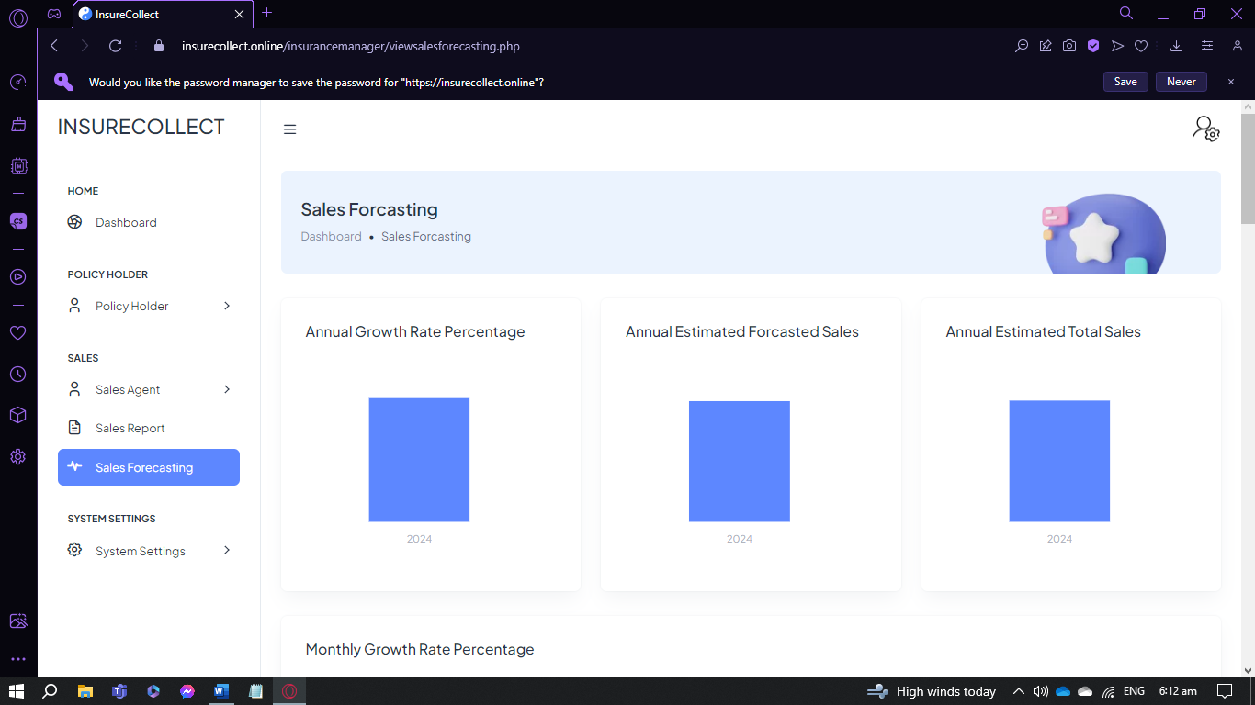

Semi-Annual Forecasting

Annual Forecasting

(Same formula sa Annual Forecasting)

Quarterly Forecasting using Growth Rate

Quarterly Forecasting using Moving Average

**FORMULA USING GROWTH RATE FOR QUARTERLY** //Sames lang formula sa monthly kaso tinototal muna yung Month 1 to 3.

M= Month

Q- Quarter

M1+M2+M3= Q1 (this serves as the previous sales)

M4+ M5+M6= Q2 (this serves as the Current Sales)

(GR)Growth Rate = Q2 – Q1 / Q1

(EQS)Estimated Quarter Sales = GR X Q2

Estimated Total Quarterly Sales= EQS + Q2 = Q3

**FORMULA USING MOVING AVERAGE FOR QUARTERLY**

(Actual Sales) M1 + M2 + M3 / 3 = Estimated Sales for M4

(Actual Sales) M2 + M3 + M4 / 3 = Estimated Sales for M5

(Actual Sales) M3 + M4 + M5 / 3 = Estimated Sales for M6

(Actual Sales) M4 + M5 + M4 / 3 = Estimated Sales for M6

And so on…

(Magkaiba yung lalabas na graph ng Growth Rate and Moving Average.

Kasi yung Growth Rate, tinototal niya yung 3 months, while si moving average ginagamit niya lang yung 3 months to predict the average sales for the next month)