To modify

Eto ilalagay po sa may Renewal sa User.

We are thrilled to welcome you here ka-Iskolar! We are greatful to assist you through your Iskolar Journey. Curious what's happening today? Head on over to the notification page and see for announcements from our dear Mayor.

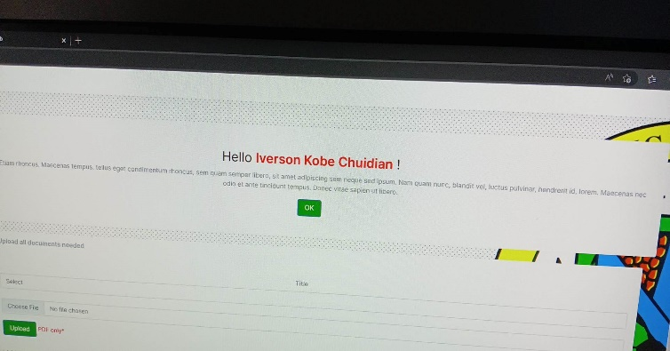

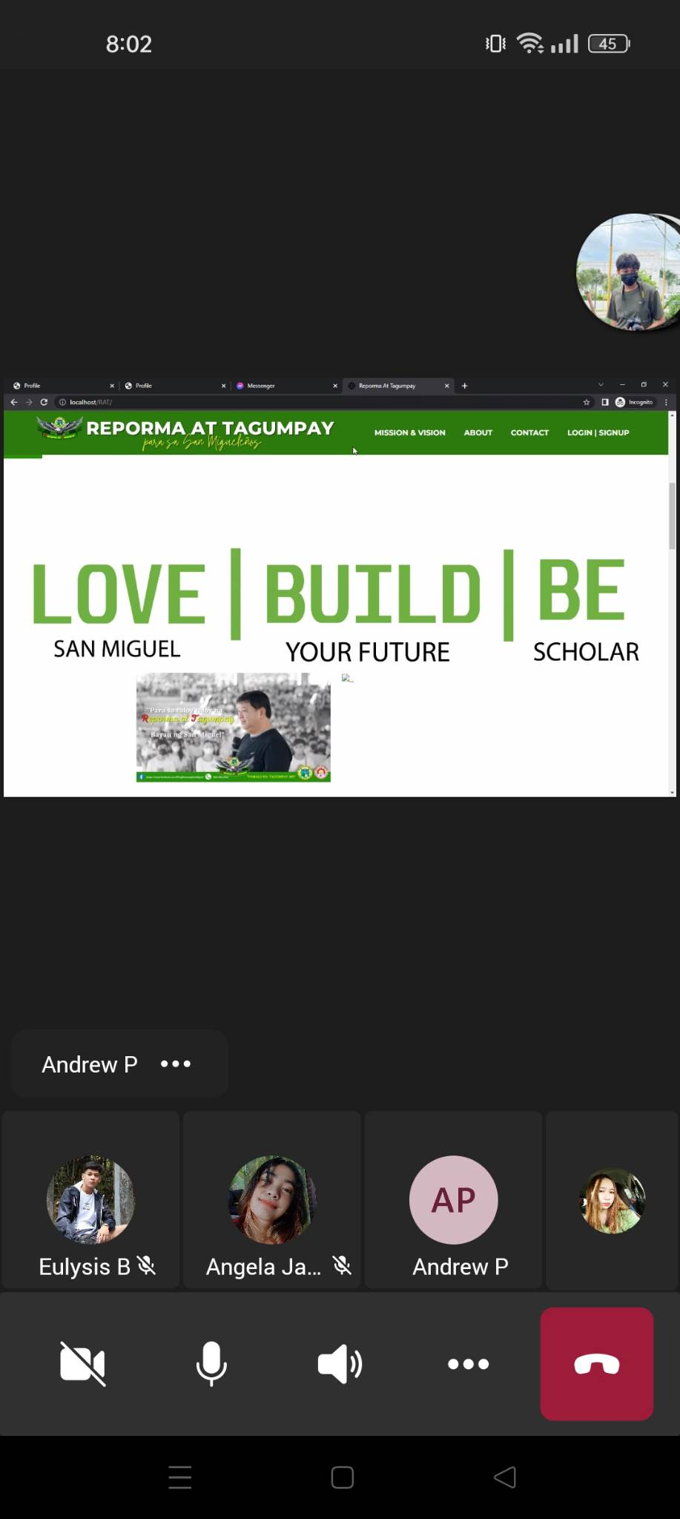

- Lagyan po ng Home button, kasi nawala po, tas yung logo po na Reporma at Tagumpay palagay po sa gilid kasi sayang po space sa gilid.

- Yung maglalagay po ng Deceased pag patay magulang sa Scholar Registration.

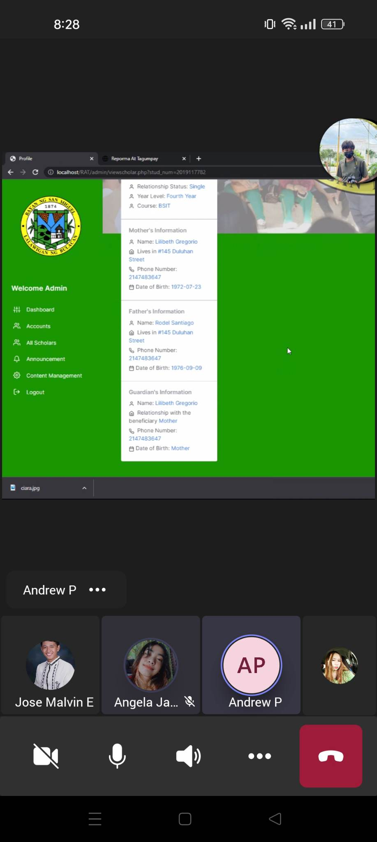

- Isama po yung Occupation, Source of Income and Salary po diyan. kasi yan po tinitingnan ng mga admin pag mag a accept ng scholars.

- Sa Application Form naman po, palagay po button sa homepage, kung saan po maganda, kahit maliit po na button tas automatic ma do download yung Application Form po na nilagay sa Content Management.

- Gawing word/pdf file kasi image lang tinatanggap e

- Paalis na po yung Graduates sa Admin Dashboard

- Gawing clickable po yung Reporma at Tagumpay tabi ng Mission and Vision

- Yung Application form naman po, ilagay sa Quick Links sa baba po ng Sign Up, gawing clickable pag kinlick po, automatic na do download

- Palagay Copyright 2022 Group 1 Team Jokjoks sa footer