**Web-Based Water Ordering and Payment System**

**of Elezor Water Refilling Station**

**________________**

**A Capstone Presented to  
The Faculty of the College of Computer Studies  
Tarlac State University  
Tarlac City**

**_______________**

**In Partial Fulfillment**

**of the Requirements for the Degree**

**Bachelor of Science in Information System**

**________________**

**by:**

**Domingo, Jenica S.**

**Daileg, Clyde P.**

**Garcia, Tracy Francesca U.**

**Peping, Adelaida D.**

**INTRODUCTION**

One of the most vital resources, water is fundamentally necessary for all forms of life, including the maintenance of ecosystems and biodiversity. The availability of enough affordable high-quality and low-quality water is essential for human wellbeing. People must be aware of the water quality requirements for quality water because they must be able to live and exist [1]. The drinking water directive 98/83/EC has governed the quality of drinking water in most European nations for almost 20 years. Since the United Nations has declared that everyone has the right to access safe water, the rule is currently being revised to satisfy more stringent requirements. The use of a risk-based approach in all regulated water sources is a significant modification to the regulation. The Aqua Valens project, part of the EU's Seventh Framework Programmer, created several novel pathogen and indication detection technologies and tested them in water sources across seven different European nations [2]. As water-borne diseases are a leading cause of morbidity and mortality, countries worldwide are concerned about exposure to unclean drinking water. According to the World Health Organization (WHO), around 1.8 million people worldwide die from diarrheal diseases each year due to ingestion of contaminated water. Access to safe drinking water is essential to human health [3]. Almost all businesses today are computer-based and very dependent on telecommunication networks, and the internet, even the smallest kind of businesses are relying on technology. If we observe how people do business nowadays. Many small organizations are afraid and hesitant to invest in information systems and technology because of various reasons, such as the cost of investment or the fear of what change it would bring to the organization and their competitors in upgrading their business processes by information systems and technology [4]. Water consumption is involved in the bottling or refilling process, where the treated water is transferred into bottles or containers for customers to purchase or use.

* 1. **Project Context**

One of the fastest expanding businesses in most Metro cities nationwide is the water refilling station. Many people prefer to get drinking water from the water refilling station, and it is just clean and safe.

Almost all businesses today are computer-based and very dependent on telecommunication networks, and the internet, even the smallest kind of businesses are relying on technology. If we observe how people do business nowadays, we can say that business without technology is impossible. From communicating customers or vendors, it is essential to have a phone and a network connection. Even in the most straightforward transactions, technology is a must [5].

Decentralized water treatment and refill stations operate in parallel to existing government water treatment and distribution schemes in developing countries. Such stations treat water onsite and sell it to consumers by volume, typically by refilling 10-gallon water containers. Most refill stations employ membrane-based technologies. Membrane-based refill stations use ultrafiltration or a reverse osmosis membrane separation process, usually coupled with activated carbon adsorption and UV or a chlorination disinfection [6].

The main processes in a water refilling station is dictated by raw quality water and those typically steps are filtration which as a several stages, softening and disinfection.

Lack of Order Tracking After making a purchase, customers may have trouble tracking their orders. Customers could start to worry or doubt the delivery process if there is no dependable tracking system or information on the status of their orders. Customers may experience difficulties making payments, such as credit cards being denied, transaction failures, or problems with the payment gateway. These issues may result in unsuccessful transactions, preventing customers from completing their purchases.

Payment methods that are secure: The online system includes secure payment channels to preserve the confidentiality of clients’ financial data. It enables a variety of payment options, including credit cards, debit cards, and digital wallets, allowing clients to select the one they prefer. Order history and tracking: The system frequently has tools that let users keep tabs on the progress of their orders in real time. Customers may track the status of their delivery and predict the time of arrival, which offers transparency and peace of mind. Customers can reorder their preferred water items more easily because order histories are frequently preserved..

* 1. **Purpose and Descriptions**

Elezor Water Refilling Station's innovative web-based water ordering and payment system, where we combine technology and sustainability to reimagine how you get clean, refreshing water. Our mission is to reinvent water distribution by providing a convenient, environmentally friendly, and efficient alternative. With our cutting-edge online platform, you can easily place your water purchases, choose the bottle size, and amount that works best for you, and even set up regular deliveries to ensure you never run out of hydration. As part of our commitment to sustainability, we provide the opportunity to refill your reusable containers, decreasing the usage of single-use plastic bottles.

**Customers.** The system will help them to order water easily and conveniently without having to go to water refilling station.

**Water Refilling Station Owners.** This will help them to monitor the deliveries and check the scope of their customer. The system can also let them know if their ordering and distribution system operates well.

**Management.** This study will aim to aid the management to enhance their operation and asses their yearly status.

**Business Entities.** Results can be used as their basis in designing their business plan in the future.

**Future Researchers.** This study will serve as a related study which will provide data that may be undertaken in future, give them more knowledge in developing the system and this will be add to their knowledge and skills as programmers.

**1.3 Objectives**

The researcher study aims design and develop a Web-based Water Ordering and Payment System of Elezor Water Refilling Station. To improve the quality delivery of rider and to locate the specific place of the users.

1. To design and develop a Web-Based Ordering and Payment System of Elezor Water Refilling Station incorporating the following features.

1.1 Admin Module

1.2.1 List of user profile

1.2.2 List of product ordered

1.2.3 Data Analytics

1.2.3.1 Water Filtration

1.2.3.2 Water Consumption

1.2.3.3 Place most Ordered.

1.2.3.4 Order Record

1.2.4 Generate Printable Report

1.2.3. Order Report

1.2 User Module

1.2.1 Ordering

1.2.1. List of Product

1.2.1.1 Bottled Water

1.2.2.1.2 Container (Round/Slim)

1.2.2.1.3 Water Only

1.2.2. Payment

1.2.2.2.1 Cash on Delivery

1.2.2.2.2 G-cash

1.2.3 GPS

1.2.3.1 Location of Rider

1.2.3.2 Location of Customer

1.2.3.3 Geo-Fencing

1.2.4 Promo

1.3 Rider Module

1.3.1 View Order Details

1.3.2 Deliver Order

1.3.3 Track Location of Customer

To Testing the performance of Web-Based Water Ordering and Payment System in Villa Paz by means of:

2.1 Functional Test

2.2 Repeated Trial Test

To Evaluate the performance of Web-Based Water Ordering and Payment System in Villa Paz by means of:

3.1 Efficiency

3.2 Accuracy

* 1. **Scope and Delimitations**

This Describes the Scope covered by the system including its limitations.

Scope

This Web-Based Water Ordering and Payment System of Elezor Water Refilling Station focused on the point of ordering system, which is you can order water per gallon or bottled. Including GPS which will be used to locate the rider and customer to one another. Also, the printable report will be monitor and record the sales report of the business daily. This system also includes the filtration and consumption of water which is it will identify when to filter the water and how much water is already disposed and available.

Delimitation

This study is limited to the Elezor Water Refilling Station and the two end users: The admin who is responsible for the data information and transaction of water refilling station and the Employee/Rider who will use the system for getting the transaction and to the costumer of water refilling station. The Elezor water refilling station is geo-fencing only for the municipality of Gerona and the other places that near to the water refilling station which is not part of the town of Gerona

Data on Water Purchases The project's scope will include the analysis and visualization of information about water purchases. This may contain the quantity bought, the dates of purchase, the type of water products bought (for example, flavored, mineral, or bottled), and any other pertinent purchase information.

Payment methods that are secure: The online system includes secure payment channels to preserve the confidentiality of clients’ financial data. It enables a variety of payment options, including credit cards, debit cards, and digital wallets, allowing clients to select the one they prefer. Order history and tracking: The system frequently has tools that let users keep tabs on the progress of their orders in real time. Customers may track the status of their delivery and predict the time of arrival, which offers transparency and peace of mind. Customers can reorder their preferred water items more easily because order histories are frequently preserved.

**II REVIEW RELATED LITERATURE**

* 1. **Discussion of Models**

Since water is a vital necessity, there are water refilling stations everywhere, and the rivalry is fierce. They need to leave a lasting impact with their work if they want people to choose them. Individuals are used to placing telephone orders for water refills or physically visiting water refilling stations. The water replenishing station also makes deliveries; therefore, the consumer is unable to determine the location or precise delivery time of the water. Both the management and the clients find the manual system uncomfortable. Customer satisfaction is inefficient, and management is unable to keep track of the number of deliveries that need to be made. [8]

Some water refilling stations still employ a manual procedure, which makes it challenging to run the business. The “Aqua Water Refilling Management System Database Design” study by Glayy Eliver (2019) described how the system organizes the data that users enter based on their customers’ personal information. Additionally, customers pay for the transactions they make in the water refilling station system as well as the services they wish to use. The major goal of this study is to replace the outdated, manually operated refilling station operation with a computerized system to satisfy customers and resolve operational challenges [9].

|  |  |  |  |  |  |  |  |  |
| --- | --- | --- | --- | --- | --- | --- | --- | --- |
| **Software** | **1** | **2** | **3** | **4** | **5** | **6** | **7** | **8** |
| Wilkins Water | 🗸 | 🗸 | 🗴 | 🗸 | 🗸 | 🗸 | 🗴 | 🗸 |
| Nature Spring | 🗸 | 🗸 | 🗴 | 🗸 | 🗸 | 🗸 | 🗴 | 🗸 |
| AJC Water Care Solution | 🗸 | 🗸 | 🗴 | 🗸 | 🗸 | 🗸 | 🗴 | 🗸 |
| Absolute | 🗸 | 🗸 | 🗴 | 🗸 | 🗸 | 🗸 | 🗴 | 🗸 |
| Summit | 🗸 | 🗸 | 🗴 | 🗸 | 🗸 | 🗸 | 🗴 | 🗸 |
| Aquafina | 🗴 | 🗴 | 🗴 | 🗴 | 🗴 | 🗴 | 🗴 | 🗸 |
| Premier Water | 🗴 | 🗴 | 🗴 | 🗴 | 🗴 | 🗴 | 🗴 | 🗸 |

**Table 1. Functionality and Feature Matri**

**CRITERIA**

1. Sign in / Sign Up

2. Ordering

3. GPS (Geo-Fencing)

4. Notification

5. Generate Printable Report

6. Payment (API)

7. Data Analytic (track water consumption & filtration)

8. Dashboard

Table 1 shows a tabular presentation of the functionality and feature matrix, the results visibility shows the system’s strength and weaknesses, the common functionality, and features that all systems have login form, payment, and access. It is essential to protect user’s data and information from unauthorized access. On the other hand, Wilkins Water, Nature Spring, AJC Water Care Solution, Absolute, Summit, Aquafina, Premier Water do not have a GPS feature and Data Analytics that can be added to the system.

**Table 2. Literature Matrix**

|  |  |  |  |
| --- | --- | --- | --- |
| **REFERENCE** | **DESCRIPTION** | **STREGHTH** | **WEAKNESESS** |
| Amy Schmidt et. al. [10] | Who manages the data in the system was discussed; this is filled in by the user in accordance with the information of the customer so that their personal details |  | The safety of data the system handles private financial and consumer information that needs to be protected from illegal access. |
| QUORA. (N.D.).  [11] | Adopting new techniques and improvements in water filtration and purification can enhance the water's quality and draw in more customers. | High demand the need for water refilling stations is growing along with worries about water safety and the requirement for clean drinking water. Low running costs since water filtration and purification procedures account for most of a water refilling station's operational expense, | Competition It may be difficult to draw in and keep consumers because of the competition from other water refilling stations and bottlers of water and maintaining the quality of the water is essential for a water refilling station; any gaps in quality control could pose health risks and drive away customers. |

**Local Literature**

Aquatic Dragon Water Refill Sation, a company that provides water to customers, is housed in a building on Chavez Street in Central Bicutan, Taguig City. Delivery and walk-in services are available, depending on the client. The basic operations of the company, such as keeping track of daily sales and the quantity of containers or gallons delivered, were made simple with the use of a water delivery system. A water delivery system ensures that the employees of the organization may quickly compute, document, and compute their daily sales. Due to its similarity to the system being advocated by the proponents, we employ this study. Elezor Water Refilling Station has developed a method that would replace their human process with automation. 2017 (Forebs)[12].

**Foreign Literature**

The physical actions that transport water from the water source to the intended recipient or user are referred to as water distribution. It is created and of a high enough caliber to satisfy customer needs. In closed systems under pressure, this is often accomplished using pumps and motors, water mains, service pipes, storage tanks or reservoirs, and related equipment. A clean, safe supply of drinkable water is produced or delivered by modern small water systems. What is a "Small System"?

Using this relatively broad definition, a small water system's complexity can range from a straightforward well and pump design to a multi-barrier system that might include coagulation, filtration, and disinfection. (Thompson Rivers University,2018)[13].

* 1. **Conceptual Framework**

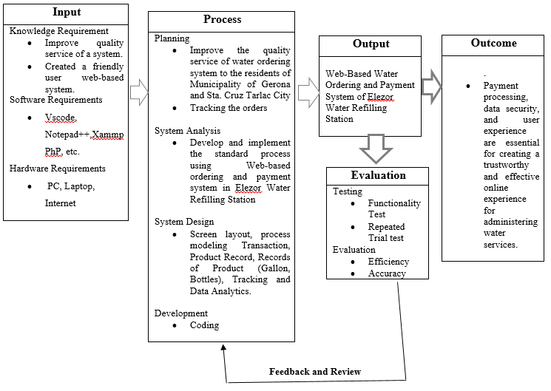

*Figure 1. Conceptual Framework of the* *Web-Based Water Ordering and Payment System of Elezor Water Refilling Station*

This figure the focus of this study was undertaken by the following conceptual framework shows the flow of the system and how data are processed show in figure 1 which has a three four-part process. The input, process, and output

* 1. **Definition of Terms**

The terminologies and definitions used in this study are presented in this section for better explanation and understanding:

|  |  |
| --- | --- |
| **Admin** | The one who will be able to monitor the system. |
| **Cash on Delivery (COD** | This method of payment allows you to pay for your order, which is water in a gallon or sized bottle |
| **Dashboard** | Dashboards, organize, store, and display important information from multiple data sources into one, easy-to-access place. |
| **Delivery Rider** | The one who deliver the order Water in a gallon |
| **Global Positioning System (GPS)** | This is the map where in you can find the exact location for the delivery of water in a gallon. |
| **Hardware** | Refers to the physical parts of a computer and related devices. Internal hardware devices include motherboards, hard drives, and RAM |
| **Owner** | The one who owns and manages the business |
| **Software** | Software is the programs and routines for a computer or the program material for an electronic device that make it run. |
| **Web-Based** | Web-Based is a type of learning that is accessible on browsers. A platform for learning that helps instructors and students to interact. |
| **Filtration** | Water filters improve the quality of the water by removing undesired contaminants such taste and odor hardness, and bacteria. |
| **Water Consumption** | The amount of water that consume by the customer in |
| **Geo-Fencing** | Set radius to set the boundary of the locations where delivery is allowed |
| **Promo** | Freebies for those loyal customers who refill 10 gallons will get free one gallon. |

**III.** **TECHNICAL BACKGROUND**

All computer software requires specific hardware parts or other software resources to be present on a computer to function properly. These prerequisites, also referred to as (computer)system needs, are frequently employed as a recommendation rather than as an unbreakable law. Most of the software specifies minimal and recommended sets of system requirements. System requirements tend to rise over time due to the rising demand for more processing power and resources in newer versions of software. According to industry observers, this trend more than technological improvements is what is pushing changes to current computer systems.

1. *Software Development Requirements*

Software requirements define the per-requisites and software resource requirements that must be installed on a computer for an application to function optimally. Typically, these prerequisites and requirements are not included in the software installation package and must be installed separately before the software is installed.

*Table 1. Software Requirements*

|  |  |
| --- | --- |
| SOFTWARE | DESCRIPTION |
| **XAMPP** | Xammp is a stack of web-server solutions that will be used to build the system's database. Can create a website offline on a local web server on their PC by using cross-platform Apache, MySQL, PHP, and Perl. |
| **PHP** | Popular general-purpose scripting language Hypertext Preprocessor is best suited for web development. |
| **JAVASCRIPT** | JavaScript is a scripting language or programming language that enables the integration of sophisticated features on web sites. |
| **HYPERTEXT MARKUP LANGUAGE** | HTML is the common markup language used to make web pages. |
| **CASCADING STYLE SHEET (CSS)** | CSS is the language employed by researchers to design web pages. |
| **STRUCTURED QUERY LANGUAGE (SQL)** | SQL is a computer language called Structured Query Language that is used to store, manipulate, and retrieve data from relational databases. The preferred language for relational database systems is SQL. |
| **NOTEPAD++** | Notepad++ is a free and open-source text and source code editor for Windows. It provides a wide range of features and tools designed to help programmers and developers write and edit code more efficiently. |
| **VS CODE** | Visual Studio Code, commonly referred as VS Code, is a free and open-source cross-platform code editor developed by Microsoft. It designed to be lightweight and efficient, Wide range of features and functionality for developers. |
| **GOOGLE CHROME** | Google Chrome is a web browser developed by Google that allows users to browse the internet, access websites and web applications, and test, perform various online activities. Chrome is one of the most popular web browsers and is available on multiple platforms, including Windows, Mac, Linux, and mobile devices. |
| **MOZILLLA FIREFOX** | Mozilla Firefox is a free and open-source web browser developed by the Mozilla Foundation that allows users to browse the internet, access websites and web applications, and perform various online activities. |
| **MICROSOFT EDGE** | Microsoft Edge is a web browser developed by Microsoft that allows users to browse the internet, access websites and web applications, and perform various online activities |

Table 1 shows the name and description of the software that needs to be used for making the system. Researchers will use XAMMP, which will host and manage the database and PHP files. PHP is used as an open-source server-side programming and scripting language that is especially suited for web development and can be embedded into HTML. JavaScript will be used for the system’s behavior, increasing its interactivity with the user. Researchers will use HTML and CSS for creating web pages, content layers, structural foundations, a presentation layer, and layout for the system. JavaScript will be used for the system’s behavior, increasing its interactivity with the user. In order to store, manipulate, and retrieve data that is stored in SQL, these tools will be used. Code mirror will do the job, for it has a rich programming API and a focus on extensibility. Researchers will be using Notepad++ is a free and open-source text editor for Windows with a user-friendly interface and a wide range of features, while VS Code is a free and open-source code editor developed by Microsoft that supports a variety of programming languages and has a robust extension system.

1. *Hardware Development Requirements*

The physical computer resources, sometimes known as hardware, are the most typical set of specifications given out by any operating system or software program. A hardware compatibility list (HCL) is frequently included with a list of the necessary hardware, especially when operating systems are involved. For a specific operating system or application, an HCL describes hardware components that have been evaluated for compatibility and occasionally for incompatibility. The many facets of hardware requirements are covered in the following subsections.

*Table 2. Hardware Requirements*

|  |  |
| --- | --- |
| **HARDWARE** | **SPECIFICATION** |
| **Central Processing Unit** | Ryzen 3 3200g 3.6GHz, 4 cores, 4 threads, 384KB L1 Cache. |
| **Motherboard** | MSI AMDR A320 Chipset |
| **Random Access Memory** | HyperX FURY DDR4 8GB, 2666mhz. |
| **Storage** | Kingston A400 SSD, 240GB, 500MB/s read, and 350MB/s write. |
| **Mobile Phone** | 2GB RAM, 64 GB in built, 5000 mAh Battery |

Table 2 shows the hardware and their specification, Central Access Unit has a specification of AMD Ryzen 3 3200G 3.6 GHz Quad-Core AM4 that is located in the base panel of a laptop. Motherboard has a specification of MSI b450-a pro max this is the main circuit board for the computer, containing both soldered, non-removable components along with the slots. It can also hold the CPU, RAM, and ROM chips. Random Access Memory(RAM) has a specification of DDR3-1333(PC3-10600)= 1333MHz/10,600Mbps. It is a primary storage that hold data and instruction that being used. Storage has a specification of Kingston 240GB SSD Now UV400 SATA. This is used where it you can store the data and information of the system. Laptop has a specification pf Support for Windows 10 64-bit and Windows 7 64-bit. Laptop are constituted mainly by hardware it allows you to give an instruction or to receive information from it.

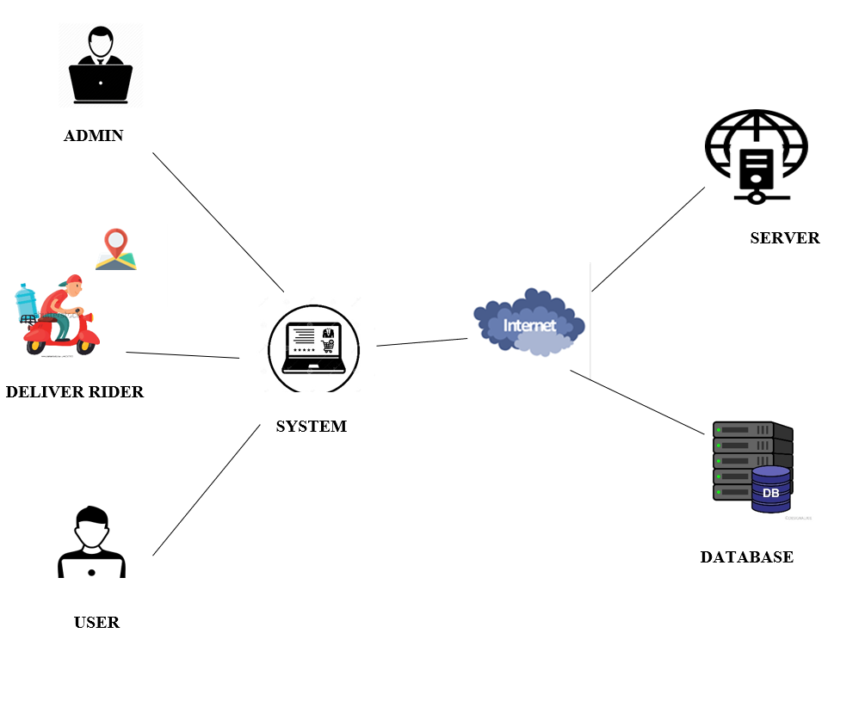

*Figure 2. System Architecture of the Web-Based Water Ordering and Payment System of Elezor water Refilling Station*

Figure 2 the proposed system architecture. It shows that the user, deliver rider and admin must connected to the internet. All of them can used any devices with GPS as much as it is connected to the internet.

1. *Sources of Data for Development and Testing*

The source of data for the development of the system the analysts conduct research and journal readings that comes from google scholar that helped analysts to make the initial design of the proposed website. The analysts use system analysis and designing which give an insight for further development. All the information was strictly examined and analyzed. This chapter also helped the analysts make a good point of view of the plan on how to develop and visualize the proposed system that would certainly work and will be useful in the present.

Admin. A person who has been legally designated by an officer of authority, with his approval, to manage and settle the estate of a deceased person who has no executor or who is temporarily unable to handle their affairs.

User. A user is a human or machine agent who interacts with a device or network service. A username is used to identify a user who has a user account.

**IV. METHODOLOGY**

Water management is a critical issue in many parts of the world. Efficient and effective water management is essential for sustainability, and one solution to this problem is the development of a web-based water ordering and payment system of elezor water refilling station. Such a system can help automate the process of ordering water, tracking water usage, and generating accurate bills for customers. We will discuss the requirements, which can be used to develop a web-based water ordering and payment system.

**4.1 Methods in Data Gathering**

**4.1.1 Internet Method**

The research process and the planning of the work were greatly helped by Mendeley, Google Chrome, Google Scholar, and Course Hero. Thanks to Google Scholar, which has a significant library of scholarly articles, the researcher was able to investigate a variety of peer-reviewed studies. This improved the theoretical foundations of the paper by enabling the incorporation of different points of view and empirical facts. The reference management tool Mendeley made it easier to categorize these diverse sources, ensuring a logical approach to citation and reference management. The study process was sped up by the speedy retrieval and cross-referencing of information made possible by Google Chrome's efficient multitasking and seamless interaction with other tools. Course Hero enhanced the study by providing additional insights, even though it was not the primary source. Course Hero enhanced the study by providing new insights and explanations, while it was not the primary source. This improved understanding of challenging subjects related to the paper's theme. Together, these technologies produced an important research environment that sped up data collecting and organization while simultaneously promoting a thorough, all-encompassing analysis of the problem. This improved the conceptualization of the paper.

1. 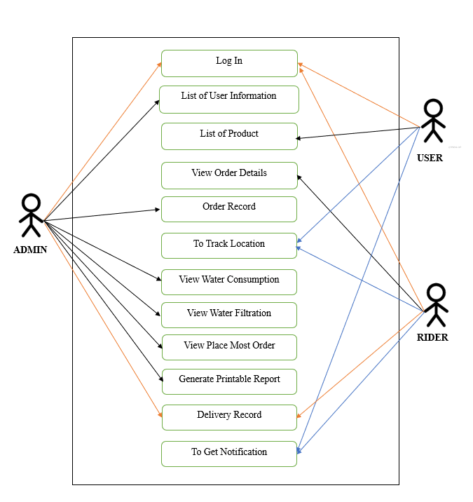*Requirement Analysis*

User Requirements

*Figure 3. Use Case Diagram of Web-Based Water Ordering and Payment System of Elezor Water Refilling Station*

Figure 3 shows the use of Case Diagram. That describes the interaction between user and admin. It consists of 3 factors in the Web-Based Water Ordering and Payment System of Elezor Water Refilling Station. It consists of 3 actors, namely the admin, user, and rider. The admin operates activities such as view list of user information, view list of products ordered, view water filtration, view water consumption, view place most ordered, view order records, generate printable reports. The user performs activities such as o make orders, to track location, to get notification, view product prices and to pay as per payment & transactions. The rider will view order details, deliver order, track location, and get notification.

User Characteristics

The system requires the user to be familiar with the gadget being used to access the website. The administrator is expected to be more knowledgeable about the system's interface, should also be capable of analyzing data.

The administrator will be able to:

1. View the user information

2. Control the list of products

3. Update water filtration

4. Update water consumption

5. View place most ordered

6. View order records

7. Generate printable reports

The user will be able to:

1. To Make Order

2. To Track Location

3. To Get Notification

4. Payment

5. View Product Prices

The rider will be able to:

1. View order details
2. Deliver Order
3. To Track Location
4. To Get Notification

Functional Requirements

This part discusses the requirements the login module of Web-Based Water Ordering and Payment System of Elezor Water Refilling Station is an essential part that performs a crucial role in ensuring secure access to the system.

*Table 4. Functional Requirement for Admin Module*

|  |  |  |  |
| --- | --- | --- | --- |
| Req.ID | Requirement Description | Priority | Complexity |
| FR1. | * The system must allow users to log in into their email and password | High | Medium |
| Req.ID | Requirement Description | Priority | Complexity |
| FR2. | * Password Reset: Allow users to reset their password if they forget | Medium | Medium |

*Table 4. Functional Requirement for Admin Module*

|  |  |  |  |
| --- | --- | --- | --- |
| **Req.ID** | **Requirements Description** | **Priority** | **Complexity** |
| **FR3.** | Admin can be able to view the data | High | Low |
| **FR4.** | Admin can be able to manage the location | High | Medium |
| **FR5.** | Admin can be able to transmit notification | Low | Medium |

Non-Functional Requirements

In this table, the Non-Functional Requirements for the Water Ordering and Payment System of Elezor Water Refilling Station to function properly and be reliable and secure sensitive data about customers, there are non-functional requirements that need to be met.

*Table 5. Non-Functional Requirement for Safety and Security of Web-Based Water Ordering and Payment System of Elezor Water Refilling Station.*

|  |  |
| --- | --- |
| **Code** | **Dependencies Description** |
| **SS1** | Accessing the software will require a username and password |
| **SS2**  **Code** | The database where the password should be saved shall have encryption.  **Dependencies Description** |
| **SS3** | All transaction including adding, editing, and deleting are recorded in audit logs |
| **SS4** | Backup and restore function |

1. *Design of Software and/or System and/or Product and/or Processes*

ER Diagram

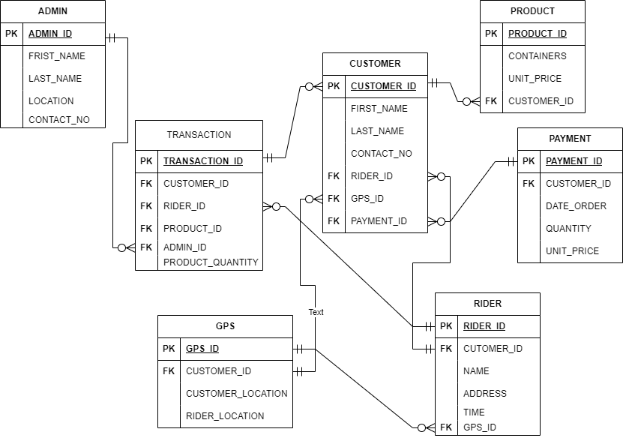

*Figure 4. Database Schema of Web-Based Water Ordering and Payment System of Elezor Water Refilling Station.*

Figure 4 shows the Database Schema of Web-Based Water Ordering and Payment System of Elezor Water Refilling Station. The Entity Relationship Diagram of the software. Describe the relationship of all the entities listed.

Functional Decomposition Diagram

*Figure 5. Functional Decomposition Diagram of Web-Based Water Ordering and Payment System of Elezor Water Refilling Station*

*Figure 6. Functional Decomposition Diagram of Web-Based Water Ordering and Payment System of Elezor Water Refilling Station*

*Figure 7. Functional Decomposition Diagram of Web-Based Ordering and Payment System of Elezor Water Refilling Station*

*Figure 8. Functional Decomposition Diagram of Web-Based Water Ordering and Payment System of Elezor Water Refilling Station*

Figure 5,6,7,8 shows the Functional Decomposition Diagram of Web-Based Water Ordering and Payment System of Elezor Water Refilling Station. This figure shows departmentalize of each category together with their perspective function in this system. In Registration, where customers create accounts and verifying customers credentials during login. Responsible for managing the order-related processes. It includes maintaining the product managing the shopping cart, facilitating order placement, and offering order tracking for customers. Manages notifications and alerts. And to Admin low inventory warnings, suspicious activities. This component is the database that houses important information about users, products, orders, payment history, inventory levels, and admin data for user roles and permissions. It includes sending notifications to User’s order confirmation, payment receipts. And to the rider manages notifications from the admin to view the order of the customer.

Operating Environment

This system will run all kinds of operating system any types of windows that contain web browser. As well as it also run in mobile.

|  |  |
| --- | --- |
| **Code** | **Environment Description** |
| **OE1** | Web-Based Water Ordering and Payment System of Elezor Water Refilling Station shall use any Windows that contain web browser. |
| **OE2** | Web-Based Water Ordering and Payment System of Elezor Water Refilling Station shall use in mobile. |
| **OE3** | Web browser shall be installed on the computer to access the system. |

Design and Implementation Constraints

The Web-Based Water Ordering and Payment System of Elezor Water Refilling Station will be a Web Based that will run all over a web browser environment. This system shall be developed using Java programming language, html and php.

**Design and Implementation Constraints Requirements**

|  |  |
| --- | --- |
| **Code** | **Design Constrains and Implementation Constraints Description** |
| **DC1**  **Code** | The software shall be programmed in sublime MySQL database**.**  **Design Constrains and Implementation Constraints Description** |
| **IC1** | The software shall run any types of Windows with browser. |
| **IC2** | The Software shall be developed using Java, HTML, PHP |
| **IC3** | The user must require password to login. |

1. *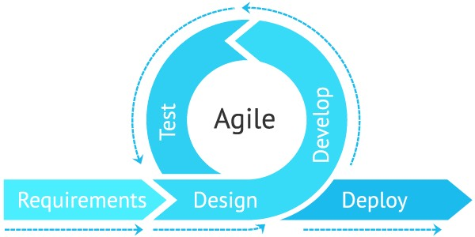System Development Methodology*

Agile methodology was utilized for the system development technique since it is the most adaptable approach for this kind of project. Iterations are a great way to minimize issues throughout the system since they allow us to interact and communicate as the system is being developed using the Agile methodology.

Agile Methodology has stages Requirements, Design, development, testing and deployment.

The first Phase is Requirements, the researcher is about to define the idea of this system and the expected goal to achieve also this this were you defined the following: Use case diagram That describes the interaction between user and admin. It consists of 3 factors in the Web-Based Water Ordering and Payment System of Elezor Water Refilling Station. It consists of 3 actors, namely the admin, user, and rider.

To create a product that meets the needs of the consumer, all necessary information is gathered from them during this phase. Any questions must be answered during this specific time. The intended question will provide an information such as what the customer wants to construct, who will be the end user, and what the product's purpose is. A fundamental knowledge or understanding of the product is crucial before building it. After gathering requirements, an analysis is conducted to determine whether it is feasible to produce a product.

The second Phase is Design, the researcher is about to define the idea of this system that will define those task that been used and modified, such as the GPS will be used to locate the specific place, Design Architecture, ER Diagram which is The Entity Relationship Diagram of the software. Describe the relationship of all the entities listed. Hardware and Software requirements. This phase needs to determine the software architecture needed to implement system development.

The third Phase is Development, the researcher is about to define the idea this system. This Phase is about creating your final development system. when the developer receives the Design document, tarts. The source code is converted from the software design. All the components of the software are implemented in this phase.

The fourth Phase is Testing, the researcher is about to define the idea of this system. The checking if the code is correct at the same time if it is clean, checking the bugs and errors of the system and performing the trials if there are no errors that use the testing tools. As soon as the code is finished and the modules are made available for testing, testing begins. The software is rigorously evaluated in this phase, and any flaws are assigned to developers to be corrected. Retesting and regression testing are carried up till the program meets customer expectations. To ensure that the program meets the requirements of the customer, testers consult the SRS document.

The fifth Phase is Deployment, the researcher is about to define the idea this Phase is assigned for deploying a system once it is ready it is time to release to the locale. Depending on the customer's expectations, the system may first undergo UAT (User Acceptance Testing) before being deployed. The customer and developers test the software together. The consumer must provide their approval for the application to go online if they find it to be what they expected.

User Interface

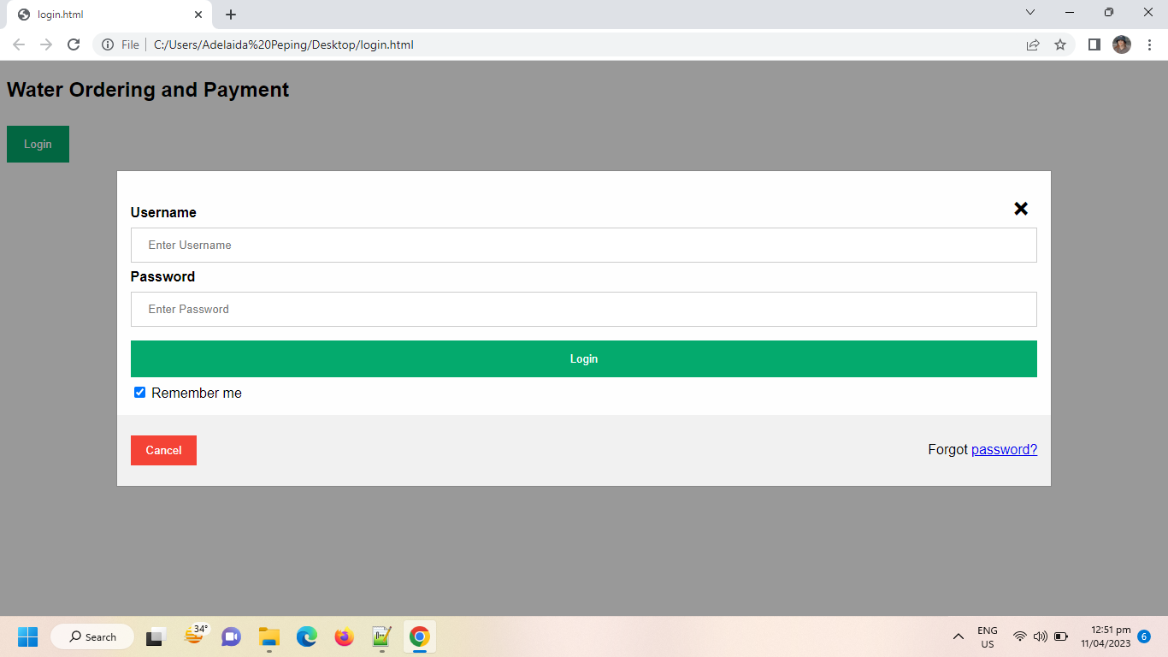

*Figure 9. User Interface of Web-Based Water Ordering and Payment System of Elezor Water Refilling Station*

Figure 9 shows the log in of water ordering and payment system you can see the cancel bottom and the forgot password.

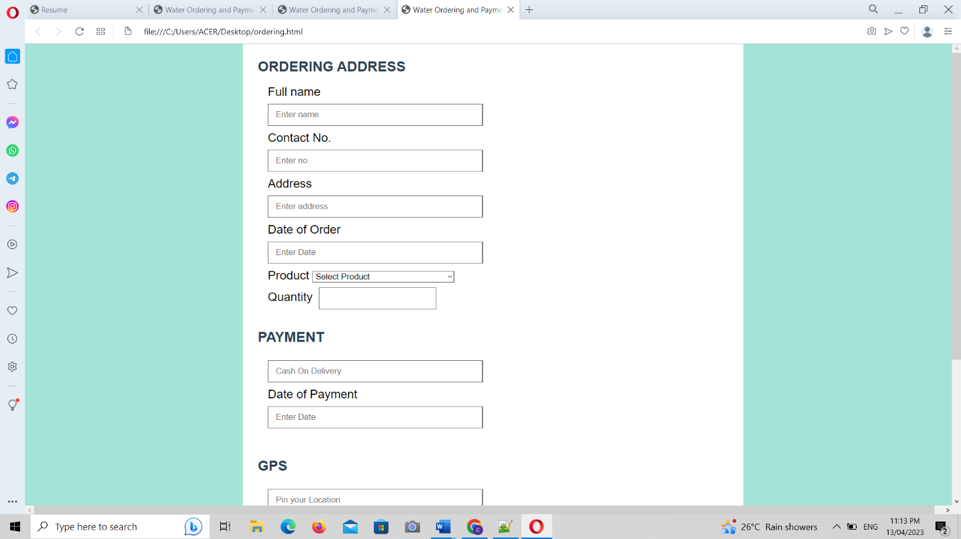

*Figure 10. Main Interface of Web-Based Water Ordering and Payment System of Elezor Water Refilling Station*

Figure 10 shows the ordering of a user including full name, contact number, date of order, product which you can select the type of product if it is bottled water, container with water or water only.

*Figure 11. Main Interface of Web-Based Water Ordering and Payment System of Elezor Water Refilling Station* Figure 11 shows you can see also the type of payment that you want to use if it is COD (cash on delivery) or G-cash.



*Figure 12. Main Interface of Web-Based Water Ordering and Payment System of Elezor water Refilling Station*

Figure 12 shows the Main Interface of Web-Based Water Ordering and Payment System of Elezor water Refilling Station. It shows the pin location including the location of the rider where you can locate the rider.

# RESULTS AND DISCUSSION

This chapter provides the Web-Based Water Ordering and Payment System of Elezor Water Refilling Station’s functions and features. The following section depicts the designed system's actual design. It also shows the results of the tests that were conducted to confirm that all its operations were successful.

## 5.1 Design and Development of Web-Based Water Ordering and Payment System of Elezor Water Refilling Station.

Figure 1. Login Page

This is the Login Page where the user is going to sign in if he/she has an existing account or sign up to create a new account.

Figure 2. Registration Page

A registration page is a crucial part of online platforms and websites that enable users to register personal accounts. It often includes a form where people may enter their important information, such as their email address, password, and confirmation password.

Figure 3. Order form for customer modules

An easy-to-use digital interface called an order form for customer modules allows customers to ask a company or organization for goods or services. Customers often have fields to fill up with important data, such as the Jar type, quantity, and payment status.

Figure 4. Address Page for customer module

An address page within a customer module is a crucial component of digital platform websites that allows customers to manage and store their shipping or billing addresses. This user-friendly interface simplifies the process of entering and saving essential location information, such as first name, last name, phone number, address, city/municipality, barangay, and zip code. Customers can update, delete, or add new addresses, streamlining the checkout process and ensuring accurate delivery of products or services.

Figure 5. Location of the Customer for delivery

The address or geographic coordinates where a consumer wants a good or service delivered are referred to as the customer's location for delivery. This data is an essential component of logistics and supply chain operations, enabling businesses to precisely deliver goods or services to the locations that customers specify. It is usually given by the client during the ordering process and is important for ensuring timely and precise deliveries.

Figure 6. Admin dashboard

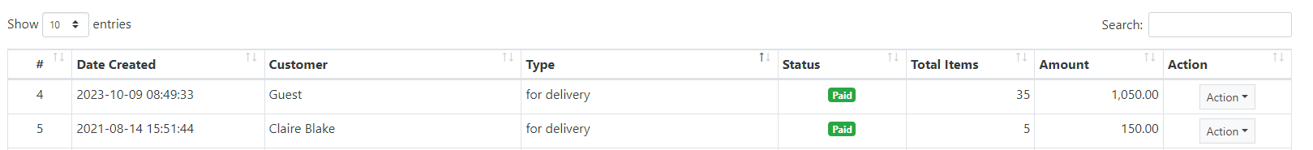

Figure 7. Transaction table for admin module

A transaction table within an admin module is an organized data display that provides a date created, customer, type, status, total items, amount, and action. It is a concise, organized summary of financial or operational transactions occurring within

Figure 8. jar type and Pricing table

Figure 9. Sales report

A sales report is a concise yet comprehensive document that offers a thorough overview of a company's sales activities for a specified time period, such as a day, week, month, quarter, or year. Important information and insights are frequently included, such as the overall amount of sales revenue, the quantity of units sold, product or service performance, customer patterns, and more.

## 5.2 To evaluate the performance of Web-Based Water Ordering and Payment System of Elezor Water Refilling Station System by means of Functionality Testing using Repeated Trial testing.

Functionality Test using Repeated Trial

|  |  |  |  |  |  |
| --- | --- | --- | --- | --- | --- |
| **Module** | **Submodule** | **Test Case** | **Expected Output** | **Actual Output** | **Status** |
| Admin | List of user profile | View user profiles | Display list of user profiles | User profiles listed correctly | ✓ |
| Admin | List of product ordered | View ordered products | Display list of ordered products | Ordered products listed correctly | ✓ |
| Admin | Data Analytics | Water Filtration | Display data related to water filtration | Relevant water filtration data displayed | ✓ |
| Admin | Data Analytics | Water Consumption | Display data related to water consumption | Relevant water consumption data displayed | ✓ |
| Admin | Data Analytics | Place most Ordered | Display the most ordered places | Correct most ordered places displayed | ✓ |
| Admin | Data Analytics | Order Record | Display records of orders | Order records displayed correctly | ✓ |
| Admin | Generate Printable Report | Order Report | Generate printable order report | Printable order report generated successfully | ✓ |
| User | Ordering | View list of products | List of available products displayed | Products listed correctly | ✓ |
| User | Ordering | Select Bottled Water product | Bottled water product selected successfully | Bottled water product selected as expected | ✓ |

|  |  |  |  |  |  |
| --- | --- | --- | --- | --- | --- |
| **Module** | **Submodule** | **Test Case** | **Expected Output** | **Actual Output** | **Status** |
| User | Ordering | Select Container (Round/Slim) product | Container (Round/Slim) product selected | Container product selected as expected | ✓ |
| User | Ordering | Select Water Only product | Water Only product selected successfully | Water Only product selected as expected | ✓ |
| User | Payment | Choose Cash on Delivery as payment method | Cash on Delivery selected as payment method | Cash on Delivery selected as expected | ✓ |
| User | Payment | Choose G-cash as payment method | G-cash selected as payment method | G-cash selected as expected | ✓ |
| User | GPS | Locate Rider's current location | Rider's current location displayed on map | Rider's location displayed correctly on map | ✓ |
| User | GPS | Locate Customer's current location | Customer's current location displayed on map | Customer's location displayed correctly | ✓ |
| User | GPS | Set up Geo-Fencing | Geo-Fencing set up successfully | Geo-Fencing set up as expected | ✓ |
| User | Promo | View available promotions | List of available promotions displayed | Promotions listed correctly | ✓ |
| Rider | View Order Details | View details of assigned orders | Display order details | Order details displayed correctly | ✓ |
| Rider | Deliver Order | Complete delivery of assigned order | Order marked as delivered successfully | Order marked as delivered as expected | ✓ |
| Rider | Track Location of Customer | Monitor customer's location | Display customer's location on map | Customer's location displayed correctly | ✓ |

1. **CONCLUSIONS AND RECOMMENDATIONS**
   1. **Conclusions**

The researcher concludes the problem of water refilling station which is the traditional way of delivery turn into a new innovative web-application. As mentioned in the project context, the effect of a traditional way of delivery is that the raider wants to know where the exact place of a customer.

In conclusions, water refilling station conclude that the new changes which is converted into web-based it very helpful to the consumers. It improves the water refilling stations the traditional way of delivering of water will be now in a web- based approach. Also, it will be very easy to determine when to change the filtration and disinfection based on the data that we gather depend on the months and seasons. Tracking of customers is one changes as well as the payment method.

The result of the study indicate that the accessibility and stability of the network coverage are the two factors to access the pin point of the customer by the raider.

* 1. **Recommendations**

The findings of the study entitled web-based ordering and payment system of elezor water refilling station system. The date driven of the water refilling stations have a positive outcome for the owner, employees, and the consumers. The services and the applications demonstrate a systems effectiveness. The successfully provider system will result a good and quality services of water refilling station.

For the owners, to ensure that the Water Station can effectively manage huge datasets and complex analysis, it is crucial to conduct ongoing system performance monitoring and optimization.

For the consumers, it is important to provide their feedback and other information for more innovation of the system. Their opinions and feedback while using this system is reasonable and valid.

For future researchers, it is encouraged to explore more sophisticated machine learning strategies, such as ensemble models and deep learning. The Web-Based Water Ordering and Payment System of Elezor Water Refilling Station System can be made more thorough by utilizing this exploration’s ability to considerably increase predicted accuracy and reveal detailed patterns within sales data. Future research may improve the system’s capabilities by incorporating cutting-edge security techniques. They can also focus on improving the system’s scalability to support a growing user base and satisfy rising needs. Its total efficacy and utility will unquestionably increase because of these improvements.

**REFERENCES:**

[1] F. Mark S. Dagalea, K. Milagros C. Lim, M. Cecille G. Vicencio, and F. L. Sanico, “An Analytical Physicochemical and Bacteriological Drinking Water Quality Assessment - University of Eastern Philippines - Main Campus”, JAMB, vol. 22, no. 3, pp. 63–72, Mar. 2022.

[2] Gunnarsdottir, M. J., Gardarsson, S. M., Figueras, M. J., Puigdomènech, C., Juárez, R., Saucedo, G., Arnedo, M. J., Santos, R., Monteiro, S., Avery, L., Pagaling, E., Allan, R., Abel, C., Eglitis, J., Hambsch, B., Hügler, M., Rajkovic, A., Smigic, N., Udovicki, B., Albrechtsen, H. J., … Hunter, P. “Water safety plan enhancements with improved drinking water quality detection techniques. The Science of the total environment”, 698, 134185, Jan 1, 2020.

[3] Magtibay, B. B.“ Study On Water Refilling Station - Water Refilling Business.” Retrieved from Business Diary Philippines website: https://businessdiary.com.ph/835/water- refilling-station-study/, Nov 11, 2021.

[4] Inettutor. “*Water refilling system free download template in Bootstrap and php*.” Itsourcecode.com. Retrieved April 16, 2023. (2022, February 4).

[5] S. Popa and G. I. Prostean, Timisoara, Romania "Improving management of utilities payment with web-based solution," 2013 IEEE 8th International Symposium on Applied Computational Intelligence and Informatics (SACI), pp. 327-330, doi: 10.1109/SACI.2013.6608991. 2013

[6] Darmawan, B. "Small-scale water purification business." Indonesia case study [PowerPoint slides] (2009).

[7] <https://ijarcce.com/wp-content/uploads/2023/03/IJARCCE.2023.12301.pdf>.”Developing and managing the digital twin of a smart city by using fuzzy ... (n.d.)”. Retrieved. April 20, 2023

[8]  *Jerom e Sario “Chapter 2 review of Related Literature and studies this chapter examines*.” Studocu. (n.d.). Retrieved April 16, 2023

[9] Schmidt, A., & Lewis, L. “The cost of stability: Consumption-based fixed rate billing for water utilities. *Journal of Contemporary Water Research & Education*, “*160*(1), 5–24. https://doi.org/10.1111/j.1936-704x.2017.03237.x. (2017).

[10] Cormick, G., Gibbons, L., & Belizán, J. M. (2022, February). “*Impact of water fortification with calcium on calcium intake in different countries: A simulation study*. Public health nutrition.” Retrieved April 17, 2023,”

[11]  *Jerom e Sario –“ Chapter 2 review of Related Literature and studies this chapter examines*. Studocu”. (n.d.). Retrieved April 16, 2023,

[12] *SWOT analysis strengths weaknesses brand name and Power Multiple Awards and: Course hero*. 26 SWOT Analysis Strengths Weaknesses Brand Name and Power Multiple Awards and | Course Hero. (n.d.). Retrieved April 17, 2023

[13] *EDUMISC - Rrl.docx - local literature according to the case study published by Ieeexplore April 2020 m.young Tj.lauengco Ab.carreon sd.bucao-2020 over the: Course hero*. EDUMISC - Rrl.docx - Local Literature According To The Case Study Published By Ieeexplore April 2020 M.young Tj.lauengco Ab.carreon Sd.bucao-2020 Over The | Course Hero. (n.d.). Retrieved April 17, 2023

[14] Willis, K., Hardesty, B. D., Vince, J., & Wilcox, C “*The success of water refill stations reducing single-use plastic bottle litter*. “MDPI. Retrieved April 17, 2023, (2019, September 24

[15]  *Darwan, B. “Small-Scale water purification business” Indonesia case study [powerpoint slides]” 2009.*

[16]  *A.P Macatangay et al. “Operation Performance of purified water business in Batangas city, Philippines: Basis of Enhanced business operation Initiatives” Asia Pacific J. Acad. Res. Bus. Adm. Vol.1, no.1, pp. 11-19. 2015*