Q2: Build an ego-graph of the linear modelled robot. Select the best trajectory with the model and cost function enclosed.

1. Integration
2. Optimal solution

The solution process is shown in the enclosed ‘chap4_2.mlx’.

First, get the cost function with single variable T, and known parameters P0, Pt, V0.

Then get the first order differential of dJ(T)/dT = 0.

The result is a 4th order polynomial equation.

I select to solve it by computing the eigenvalue of the companion matrix. The algorithm is shown here:

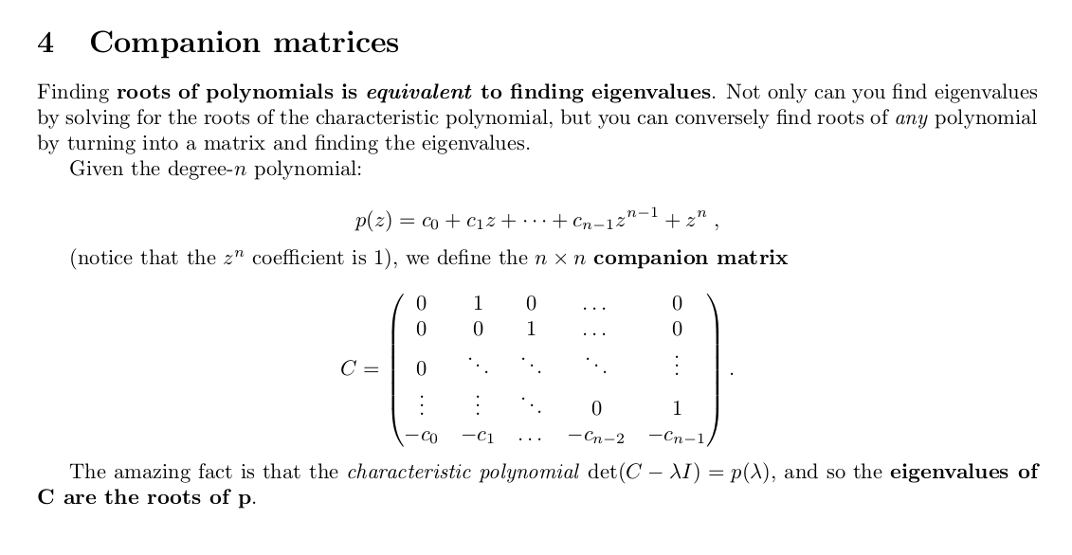

and the excurate result is here:

