WEATHER TREND
FORECASTING
Global Weather Repository | Technical Assessment Report

A concise, evidence-led account of data quality, exploratory findings, decision-support analyses and leakage-safe temperature forecasting.
PREPARED FOR  Product Manager Accelerator | SUBMISSION  Technical Assessment | July 2026
Scope: 153,586 cleaned observations | 219 retained country-location pairs | May 2024–July 2026
Data validation • Exploratory analysis • Anomaly detection • Forecasting

EXECUTIVE SUMMARY

What the analysis shows
The central finding is not that the most complex model wins; it is that careful data preparation, leakage-safe evaluation and a strong persistence signal produce reliable short-horizon forecasts.

153,586  cleaned observations | 219  country-location pairs | 0.2206°C  best test MAE | 3.8%  MAE improvement vs naive

The project analyses weather and air-quality observations across a broad international sample, then forecasts the country-balanced sampled global daily mean temperature. The final dataset retains almost all source records while removing redundant units and replacing only clearly invalid measurements with missing values.

Three conclusions matter most
- Temperature is highly persistent: lag-1 autocorrelation is 0.996, and the previous day’s temperature is the dominant feature in both Ridge regression and Random Forest.
- An 85% Ridge / 15% rolling-naive ensemble is the best test model across MAE, RMSE, MAPE and sMAPE. Random Forest adds complexity without improving accuracy.
- Seasonal, geographic and environmental patterns are strong, but the two-year, unevenly sampled repository is suitable for short-term weather analysis—not long-term climate-change claims.
Decision takeaway
Use the ensemble as the benchmark for next-day trend forecasting, but invest first in coverage consistency, calibrated uncertainty and location-level targets before increasing model complexity.

Why the results are credible
The modelling design separates training, validation and final testing. Ensemble weights are selected on the validation period only, while the final 60-day test period remains untouched until the model comparison. Forecast features use only lagged temperatures and calendar information; current-day humidity, pressure, precipitation, cloud and wind are excluded because they would not yet be known at prediction time.
The preprocessing design follows the same principle of restraint: clearly impossible cells are replaced without discarding otherwise useful rows, and statistical anomalies are retained for investigation. Together, these choices make the results more realistic than an analysis based on blanket row deletion, random splitting or untested model complexity.

NAVIGATION

Contents
The report follows the analytical workflow: validate the data, extract robust insights, test decision-support ideas, then evaluate forecasting models.

01 | Executive Summary | 2
02 | Project and Data Foundation | 4
03 | Data Quality and Preprocessing | 5
04 | Exploratory Weather Insights | 6
05 | Environmental and Geographic Insights | 9
06 | Applied Decision-Support Analyses | 14
07 | Anomaly Detection | 17
08 | Forecasting Design and Evaluation | 18
09 | Results and Future Outlook | 21
10 | Recommendations, Limitations and References | 24

How to read the findings
Evidence type | Interpretation
Descriptive patterns | Summarise the sampled observations; they do not establish causality.
Illustrative indices | Demonstrate possible decision-support products; weights are subjective.
Backtest metrics | Measure rolling one-day-ahead performance on an untouched 60-day test period.
Future forecast | Shows a broad sampled-global trend, not a city- or country-level weather prediction.

Scope discipline
Country and location rankings reflect only the dates and places present in the repository. “Global” refers to the country-balanced sample, not a formal global climate index.

PROJECT AND DATA FOUNDATION

Objective, scope and analytical workflow
The project combines descriptive analysis with a fair comparison of statistical and machine-learning forecasts.

Project objective
Analyse the Global Weather Repository, identify meaningful weather and environmental patterns, and forecast the next-day value and short-term trend of a country-balanced sampled global temperature series.
16 May 2024  first observation | 18 Jul 2026  last observation | 186  countries represented | 38  final analytical features

Dataset snapshot
Dimension | Raw data | Analytical data
Observations | 153,971 | 153,586
Features | 41 | 38
Country-location pairs | 286 | 219
Exact duplicate rows | 0 | 0
Date coverage | May 2024–July 2026 | Same period

Workflow
1  Validate | 2  Clean | 3  Explore | 4  Detect | 5  Forecast

Scope and unit of analysis. The repository is observational and unevenly sampled, so descriptive results refer to the locations and dates represented in the data rather than complete national climatology. For forecasting, temperatures are balanced at country level before the daily global sample mean is calculated, preventing countries with several observed cities from receiving disproportionate influence.
Forecast target
Daily temperature is first averaged within each country, then averaged across represented countries. This prevents countries with multiple sampled locations from receiving disproportionate weight.

PROJECT AND DATA FOUNDATION

Data quality and preprocessing
The cleaning strategy preserves useful observations while isolating clear data errors.

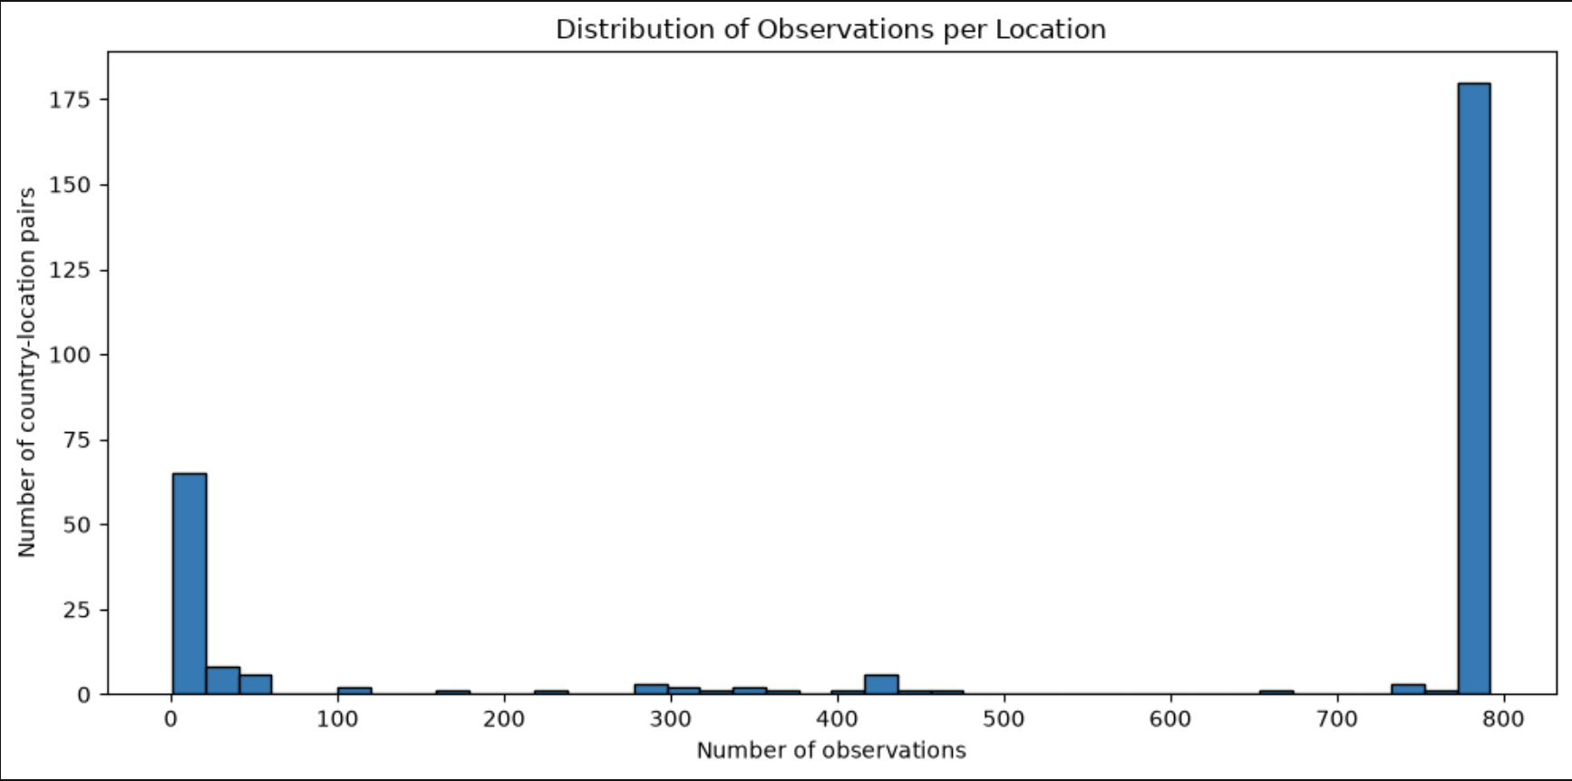
Figure 1. Observation counts per retained country-location pair.
385  rows removed | 0.25%  of source rows | 10  invalid cells replaced | 8  redundant unit fields removed

Decision | Rationale
Require ≥30 observations per country-location pair | Removes highly inconsistent or sparse groups while retaining 99.75% of rows.
Retain metric units only | Reduces duplicated information and avoidable multicollinearity.
Replace impossible values with NaN | Preserves all other valid measurements in the affected row.
Use analysis-specific missing-value handling | Avoids unrealistic global imputation across very different climates.
Scale only where required | StandardScaler is used for Ridge and Isolation Forest, not Random Forest.

Coverage filtering removed 67 sparse country-location pairs but only 385 rows, or 0.25% of the source data. This indicates that most excluded groups were very small. Redundant imperial-unit fields were dropped while their metric equivalents were retained, reducing duplicate information without losing analytical content.
Ten clearly invalid individual measurements—including values near 3,000 km/h or 3,000 mb, a 79.3°C temperature and negative or placeholder pollutant concentrations—were converted to missing values. Missingness was then handled by analytical purpose: available-case summaries for EDA, complete selected features for anomaly detection, and time interpolation only for six gaps in the aggregated forecasting series. Standardisation was limited to Ridge and Isolation Forest, where scale affects estimation.
Key quality principle
A statistical outlier is not automatically a data error. Impossible values were corrected; unusual but physically plausible weather was retained for anomaly review.

EXPLORATORY WEATHER INSIGHTS

Weather distributions
Distribution shape determines which summaries are reliable, which values require physical validation and which modelling assumptions are appropriate.

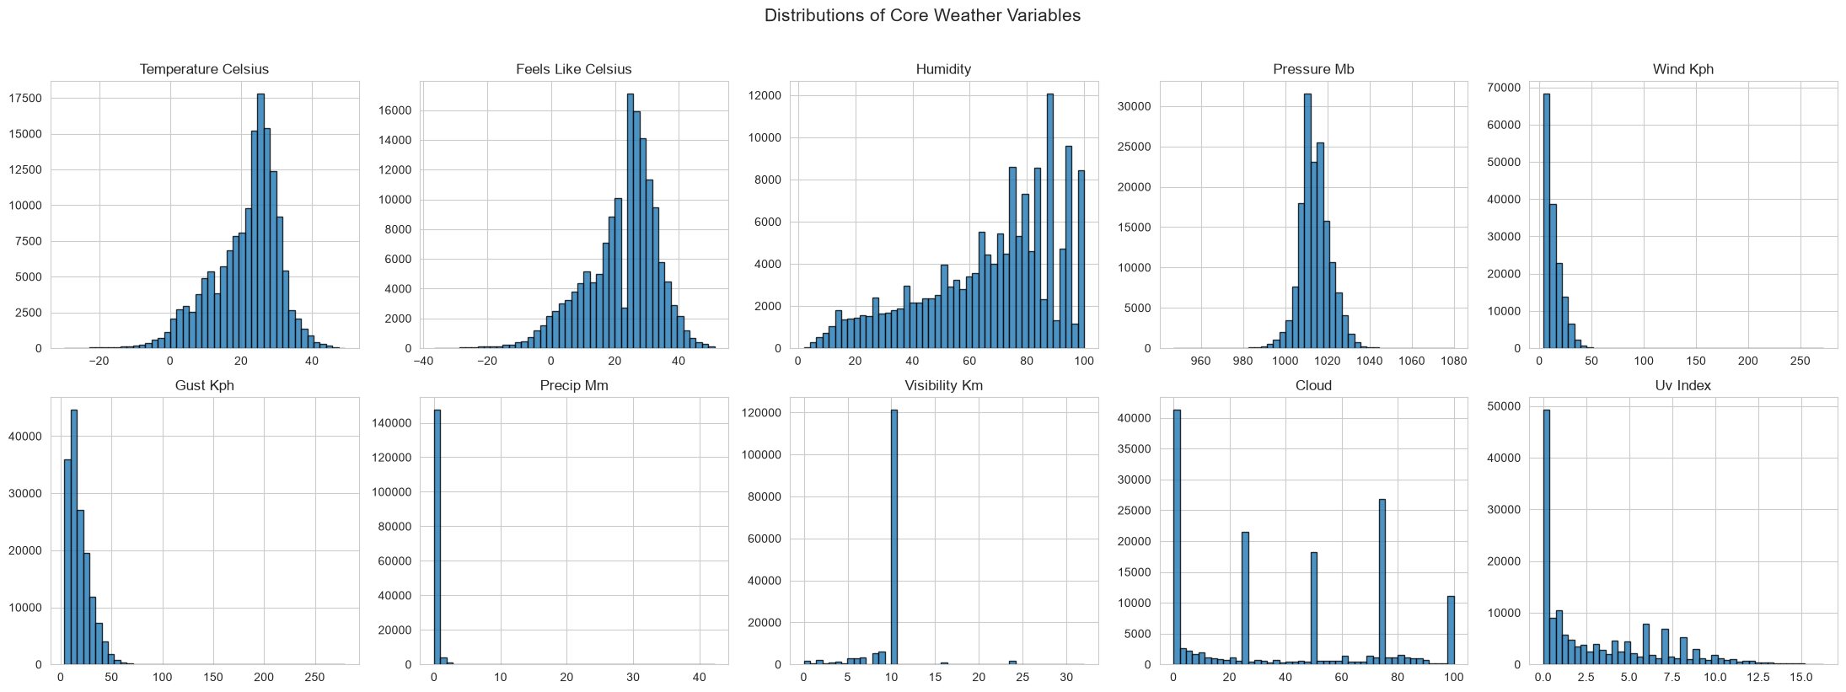
Figure 2. Distributions of ten core weather variables.
Variable | Observed pattern | Analytical implication
Temperature | Mean 21.36°C; median 23.7°C | Colder tails pull the mean below the median.
Precipitation | Many zero values and a long right tail | Median and robust summaries are more informative.
Wind and UV | Right-skewed with a small high-value tail | Extreme values require review, not automatic deletion.
Pressure | Concentrated around normal levels | Large departures are easier to flag as quality issues.

Temperature is broad but comparatively concentrated. Its mean of 21.36°C sits below the 23.7°C median, which is consistent with a colder tail created by high-latitude and winter observations. Pressure is also concentrated around plausible atmospheric levels, whereas precipitation is zero-inflated and strongly right-skewed, with many dry observations and a small number of heavy-rainfall events.
These distribution shapes affect the analysis. Means alone can be misleading for precipitation, UV and pollution, and automatic statistical-outlier removal would discard genuine storms or extreme exposure. The workflow therefore combines medians, distribution plots, robust interpretation and explicit physical-validity rules.
Insight
The sample contains genuine extremes and strongly skewed variables. Robust statistics and multivariate anomaly detection are therefore more appropriate than assuming normality.

EXPLORATORY WEATHER INSIGHTS

Relationships among weather variables
The strongest associations are physically intuitive, reveal where variables contain overlapping information and help explain later model behaviour.

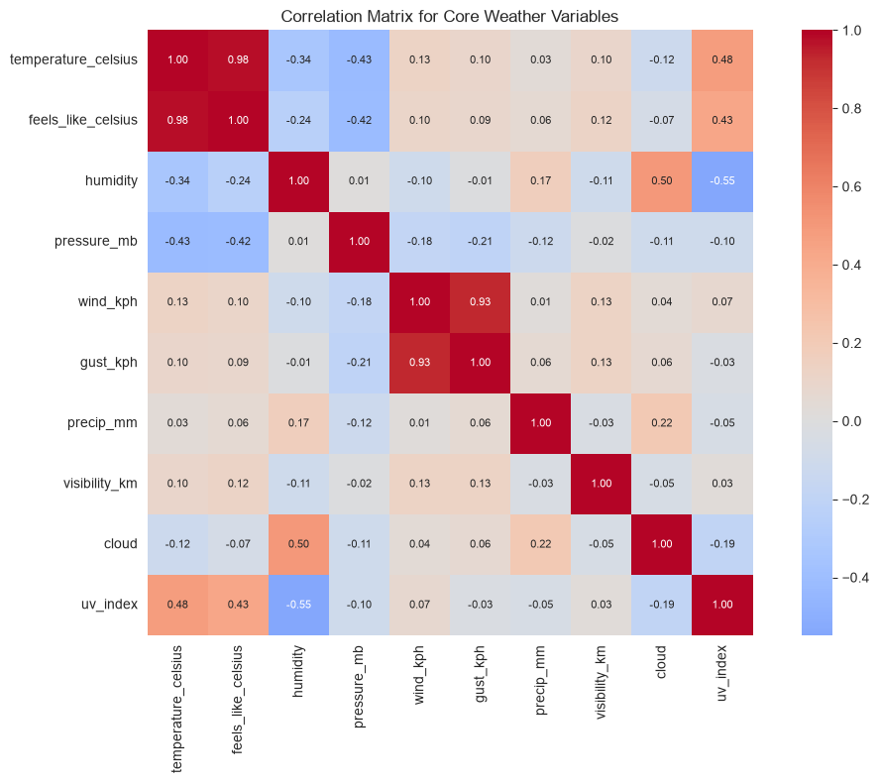
Figure 3. Correlation matrix for selected weather variables.
Variable pair | Correlation | Interpretation
Temperature ↔ feels-like | 0.980 | Near-duplicate thermal signal
Wind speed ↔ gust speed | 0.932 | Closely related wind intensity measures
Humidity ↔ UV index | −0.549 | Humid/cloudier conditions align with lower UV
Humidity ↔ cloud cover | 0.503 | Moist conditions tend to be cloudier
Temperature ↔ pressure | −0.425 | Moderate inverse association in the sample

The 0.980 correlation between measured and feels-like temperature confirms that the two variables carry nearly the same thermal signal; including both without care can introduce redundancy. Wind speed and gust speed show a similarly strong relationship (0.932), although gusts still provide useful information about short-lived extremes.
Humidity is positively associated with cloud cover (0.503) and negatively associated with UV index (-0.549), which is consistent with cloudier, moister conditions reducing surface UV exposure. Temperature is moderately related to UV and pressure rather than fully determined by them, reflecting the additional effects of season, geography and local atmospheric circulation.
Interpret with care
Correlation describes co-movement, not causation. Geography, season and local atmospheric conditions can influence both variables at the same time.

EXPLORATORY WEATHER INSIGHTS

Seasonality in the sampled data
Monthly averages reveal a clear annual cycle, while precipitation, humidity and wind are less regular.

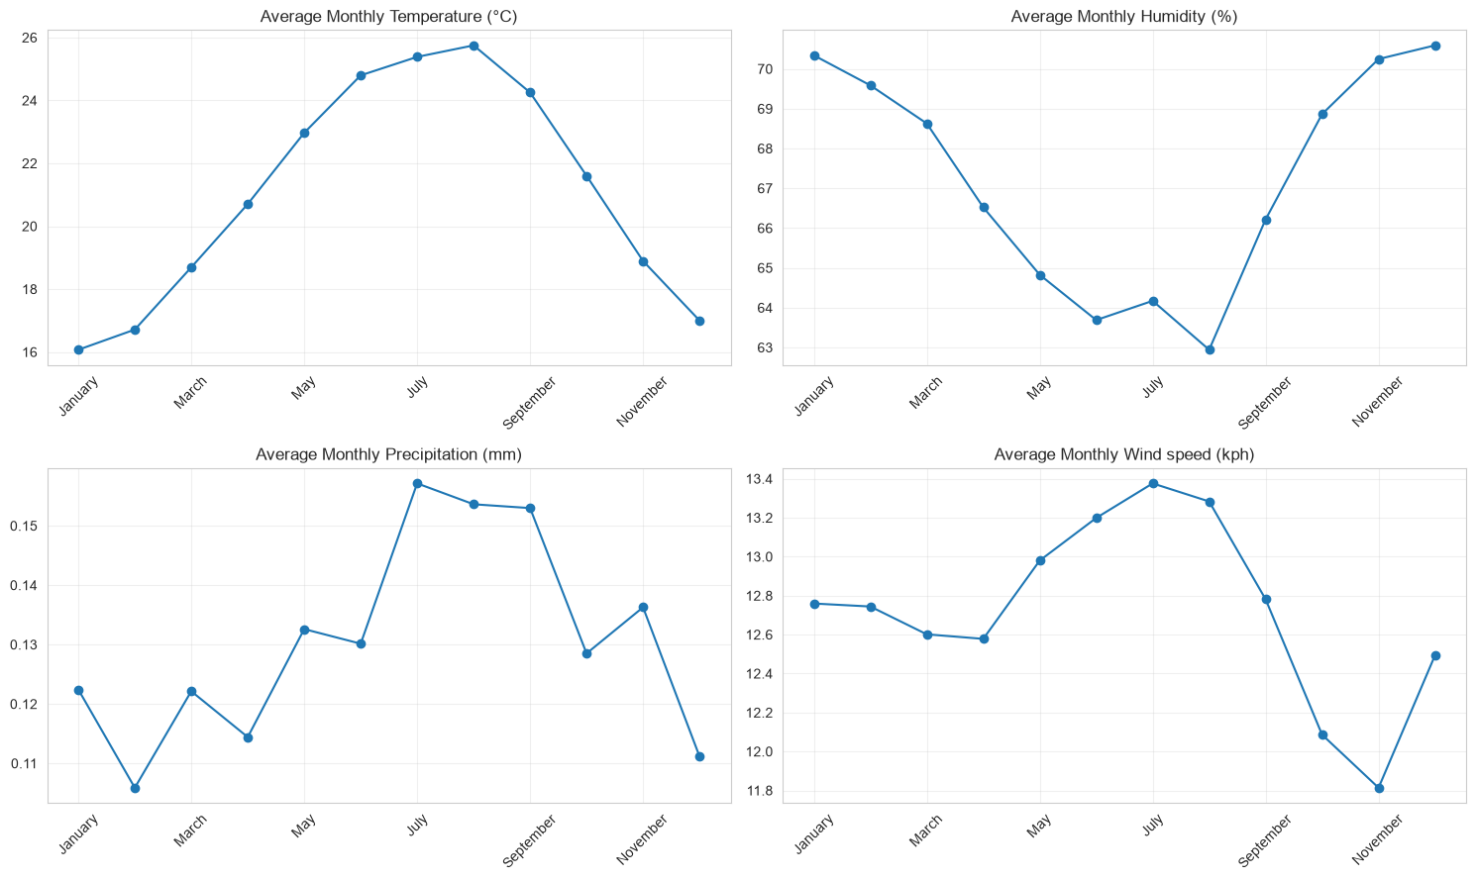
Figure 4. Dataset-wide monthly patterns in temperature, humidity, precipitation and wind.
25.7°C  warmest sampled month: August | 16.1°C  coolest sampled month: January | 9.6°C  sampled seasonal range

Temperature follows the clearest cycle. Precipitation changes more irregularly, while humidity and wind remain strongly influenced by which countries and locations are represented in each month.
Temperature shows the clearest annual cycle: August has the highest sampled monthly average at about 25.7°C, while January is lowest at about 16.1°C. Average daylight duration broadly follows the same pattern, supporting a seasonal solar-exposure explanation. Precipitation, humidity and wind vary less regularly because they are more sensitive to the mix of locations observed each month.
The curve combines both hemispheres and uneven geographic coverage, so it should not be read as a balanced global climate index. It is best interpreted as the seasonal pattern of this repository over a little more than two years, useful for short-term context but insufficient for long-term climate-change conclusions.
Coverage caveat
May 2024 and July 2026 are partial months, and the dataset mixes hemispheres. The curves are seasonal patterns in this repository—not universal global climatology.

ENVIRONMENTAL AND GEOGRAPHIC INSIGHTS

Air-quality relationships
Pollutants are more strongly related to one another than to individual weather variables.

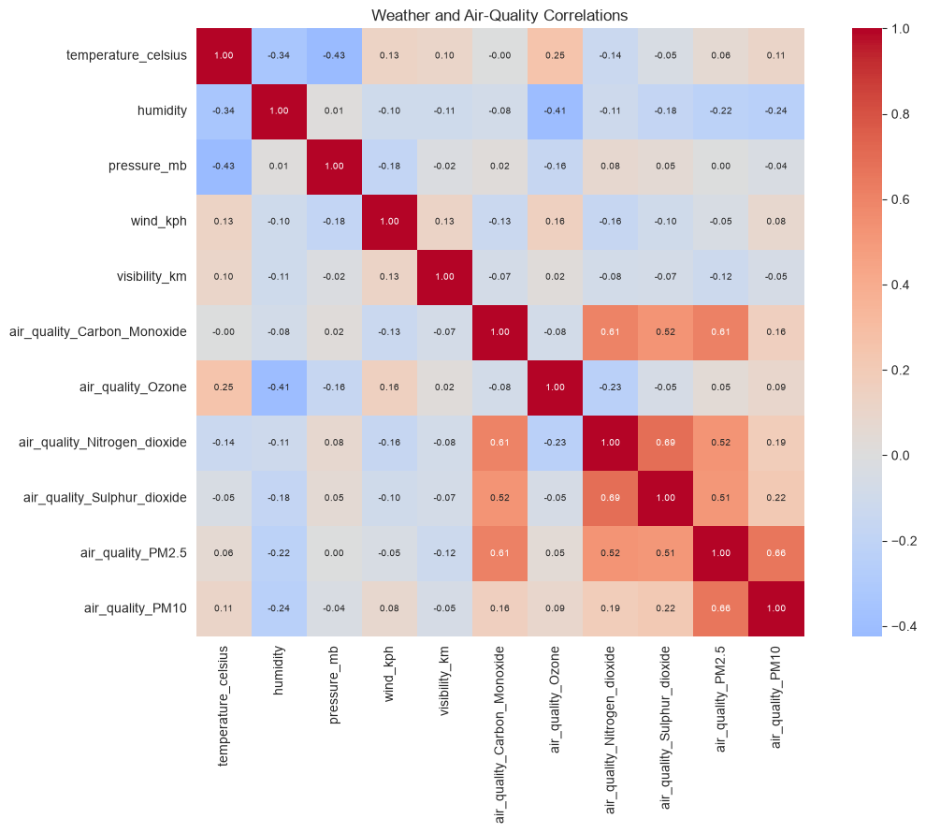
Figure 5. Correlations between selected weather and air-quality measurements.
- PM2.5, PM10 and several gaseous pollutants rise together more consistently than they track temperature, humidity or wind.
- Pollutant distributions are strongly right-skewed: most observations are low to moderate, with a smaller number of high-pollution episodes.
- Weather alone cannot explain most air-quality variation; traffic, industry, geography, population activity and circulation also matter.
PM2.5 and PM10 often increase together because they represent related particulate fractions, while several gaseous pollutants can co-occur under common emission or stagnant-air conditions. By contrast, individual weather variables show mostly weak-to-moderate relationships with pollutant concentrations.
This has a practical implication for modelling and product design: useful air-quality explanations should combine meteorology with emissions, location, traffic, industry, population activity and time. A weather-only dashboard may describe some dispersion conditions, but it risks overstating how much weather causes or predicts local pollution.
Analytical boundary
The results identify associations only. They do not prove that a specific weather condition caused a change in pollution.

ENVIRONMENTAL AND GEOGRAPHIC INSIGHTS

Seasonal pollution and weather categories
Monthly and weather-category views suggest how atmospheric mixing, sunlight and precipitation may shape particulate and ozone patterns in the sampled observations.

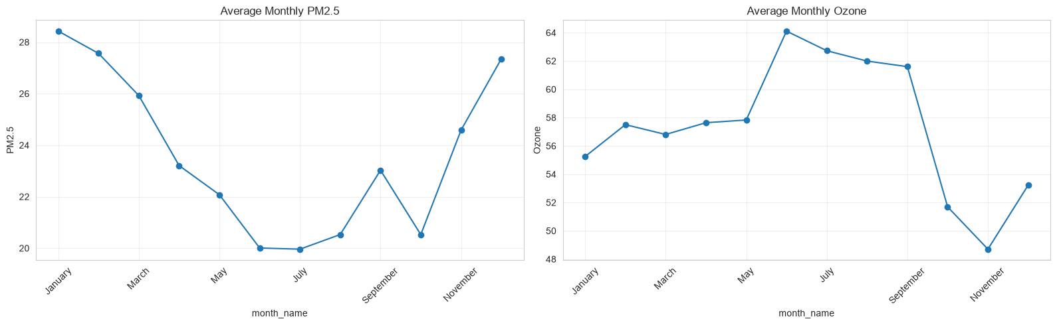
Figure 6a. Monthly average PM2.5 and ozone.
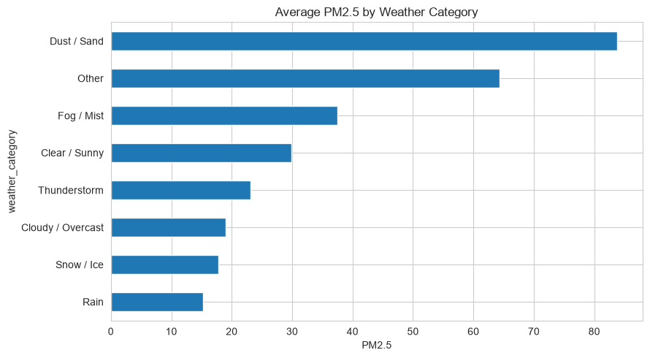
Figure 6b. Average PM2.5 by broad weather category.
Pattern | Plausible explanation | Caution
PM2.5 falls in warmer months | Stronger atmospheric mixing and dispersion | Global averaging may mask regional emissions.
Ozone rises in sunnier months | Photochemical formation increases with sunlight | This is descriptive, not a causal estimate.
Dust/sand has the highest PM2.5 | Airborne particles dominate | Category coverage is uneven.
Rain has lower PM2.5 | Atmospheric washout may remove particles | Local timing is not controlled.

Weather categories provide a second consistency check. Dust and sand observations have the highest average PM2.5, rain has one of the lowest, and fog or mist remains elevated. These patterns are physically plausible—airborne dust adds particles, rainfall can wash particles out, and shallow fog can trap pollution near the surface—but category frequency and local timing are uneven.
Recorded update-hour patterns also show temperature rising toward late afternoon, humidity falling during the warmest hours and UV peaking around midday; normalised PM2.5 and nitrogen dioxide are generally higher later in the day. Because the records span many locations and time zones, these are aggregate signals rather than precise local diurnal cycles.

ENVIRONMENTAL AND GEOGRAPHIC INSIGHTS

Latitude and temperature
Distance from the equator is a strong geographic signal, but it does not fully determine local weather.

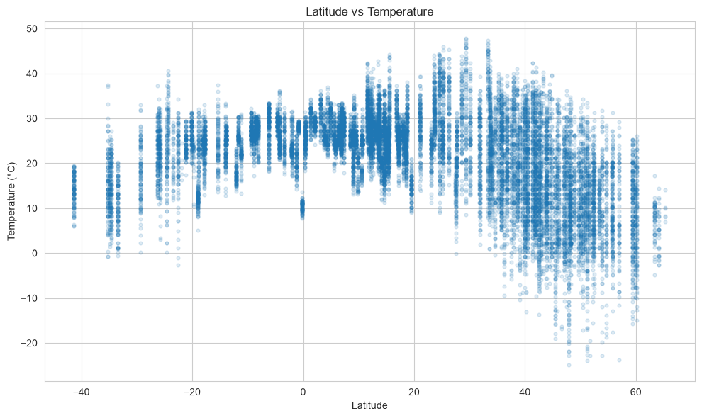
Figure 7. Temperature versus latitude for a sample of observations.
−0.558  correlation: |latitude| vs temperature | 20,000  observations visualised | Strong  equator-to-pole gradient

Why points vary around the trend | Effect
Altitude | High-elevation locations are cooler than latitude alone implies.
Ocean and coastal influence | Water moderates temperature extremes.
Season and hemisphere | The same latitude can be observed in different seasons.
Regional climate | Cloud, circulation and terrain create local departures.

A correlation of -0.558 is substantial for a dataset that combines seasons, elevations and regional climates. The spread around the trend is therefore informative rather than simple noise: two locations at similar latitudes can differ because altitude, ocean proximity, terrain and circulation modify the broad equator-to-pole gradient.
For predictive work, latitude is a valuable structural feature, but it should be paired with local and seasonal information. It explains broad geographic variation more reliably than day-to-day changes at an individual location.
Insight
Absolute latitude is one of the clearest explanatory variables in the dataset, but local context remains essential for location-level prediction.

ENVIRONMENTAL AND GEOGRAPHIC INSIGHTS

Geographic temperature patterns
Maps and rankings show broad spatial variation, while making the consequences of uneven country and location coverage explicit.

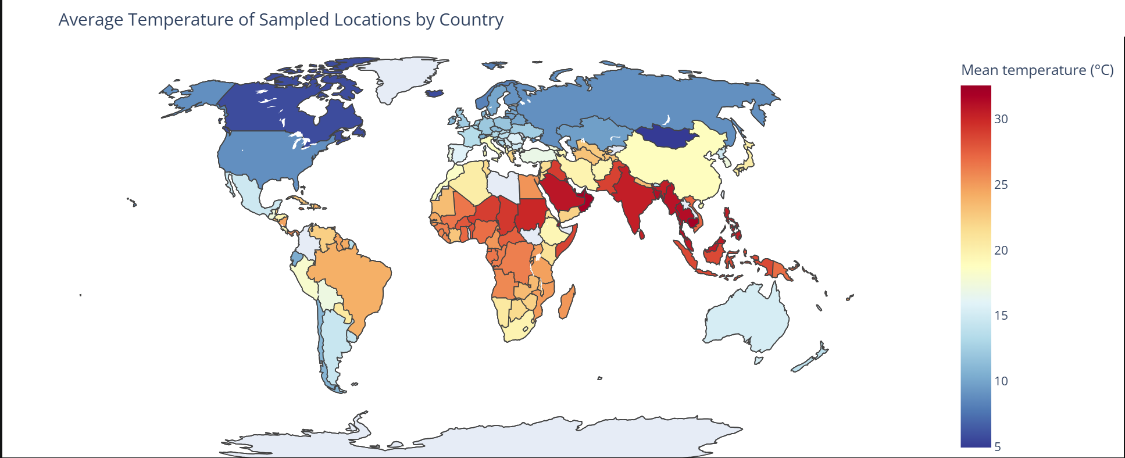
Figure 8a. Average temperature of sampled locations by country.
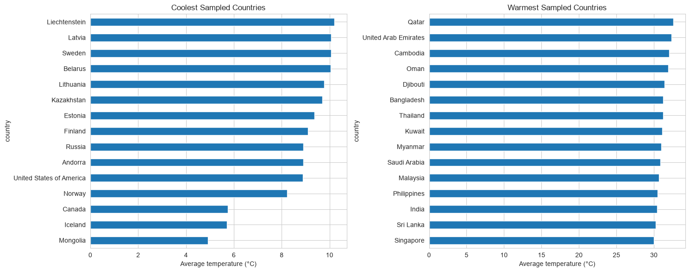
Figure 8b. Coolest and warmest sampled country averages.
The map concentrates the warmest sampled averages in tropical and low-latitude regions, while Canada, northern Europe and other high-latitude areas appear cooler. The ranked bars make these contrasts easier to compare and reinforce the latitude result, but they also amplify differences in sampling coverage.
A country can appear unusually warm or cool because of which city was observed and during which dates, not because the value represents its full territory. The defensible use is exploratory segmentation—identifying regions or locations for deeper analysis—rather than publishing a definitive national climate ranking.
Correct interpretation
These are averages of sampled locations and dates—not complete national climate rankings. Some countries are represented by one location, others by several.

ENVIRONMENTAL AND GEOGRAPHIC INSIGHTS

Country-level air quality
The overall sample is dominated by acceptable categories, but country averages reveal a pronounced high-pollution tail.

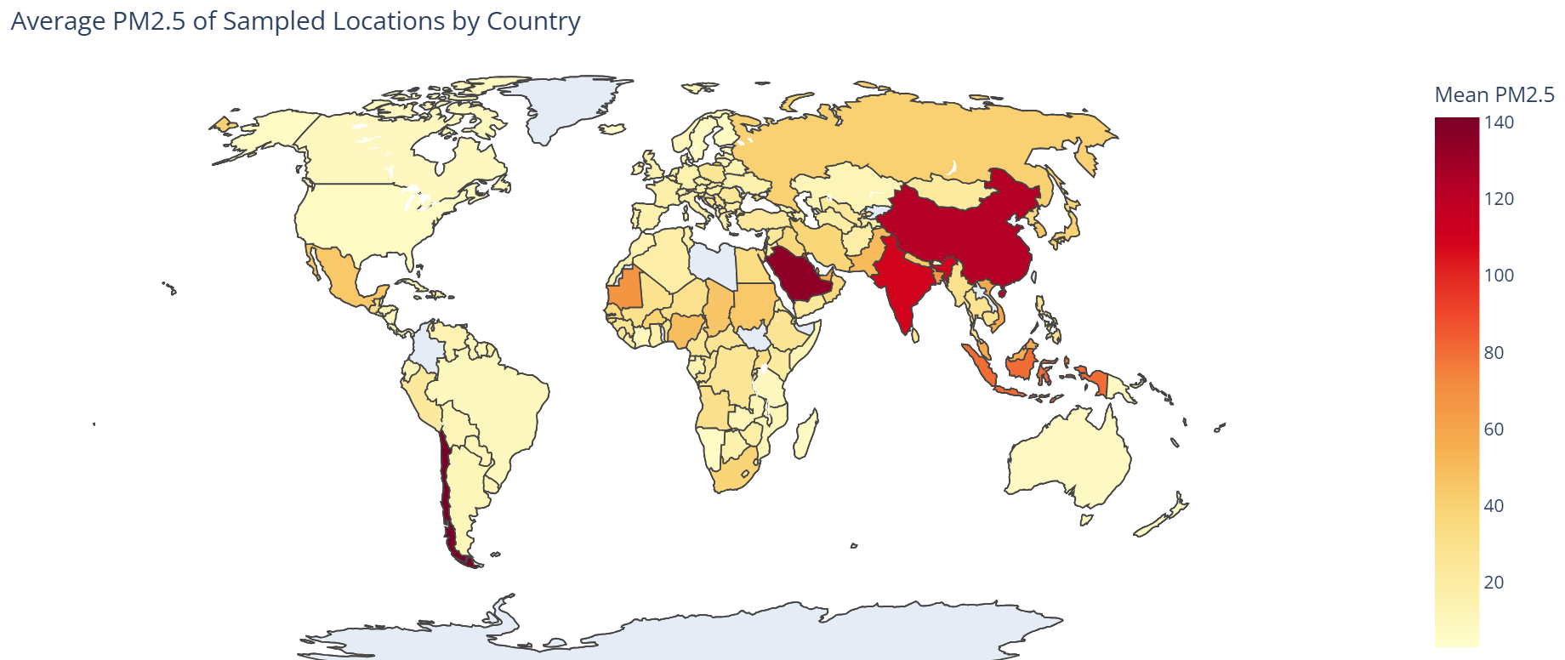
Figure 9a. Average sampled PM2.5 by country.
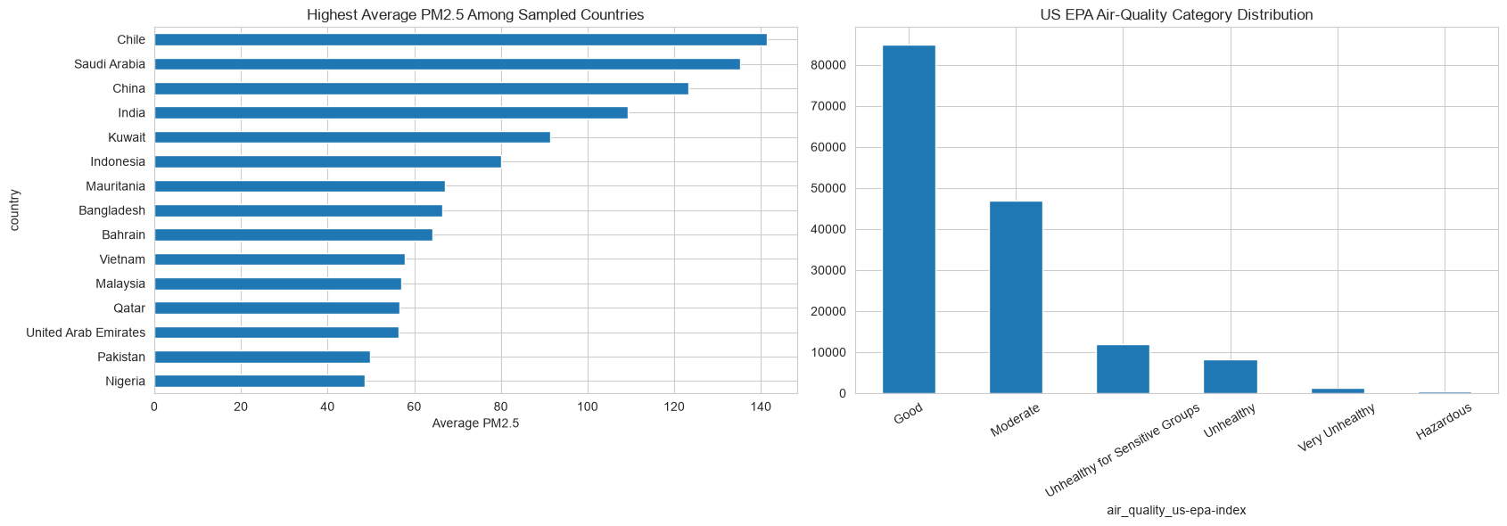
Figure 9b. Highest sampled PM2.5 averages and EPA category counts.
Most observations fall in Good or Moderate EPA categories. A smaller set of countries and observations records substantially higher particulate pollution, making geographic segmentation more informative than the overall average alone.
Among the sampled country averages, Chile, Saudi Arabia, China and India appear near the high end of PM2.5, with Chile exceeding 140 in the available records. At the same time, the EPA category distribution shows that most observations overall are classified as Good or Moderate.
These findings are not contradictory: a large acceptable majority can coexist with a small but consequential high-pollution tail. Reporting only the overall distribution would hide concentrated risk, while reporting only the highest countries would exaggerate typical conditions. Both views are needed for a balanced interpretation.
Use case
A country-level dashboard should show both the category distribution and the high-tail locations; either view alone can hide important risk.

APPLIED DECISION-SUPPORT ANALYSES

Illustrative liveability index
A transparent scoring framework demonstrates how weather and air quality can be combined into an explainable product-oriented indicator.

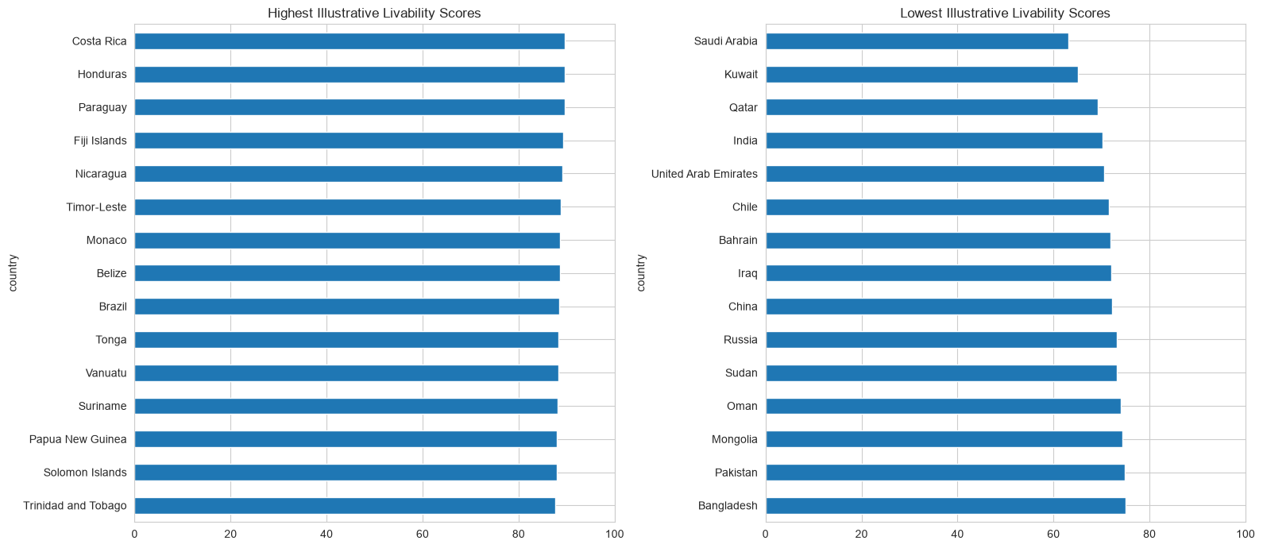
Figure 10. Highest and lowest illustrative liveability scores.
Component | Comfort target / scoring direction
Temperature | Highest score near 21°C
Humidity | Highest score near 50%
Wind | Comfort target around 10 kph
UV and air quality | Lower exposure scores better
Stability adjustment | Small reward for lower score variability

Costa Rica, Honduras, Paraguay, Fiji and Nicaragua rank highly because the selected formula rewards moderate conditions and acceptable air quality. Very hot climates, poorer air quality or greater variability lower the score.
The index is intentionally transparent: each country is scored against selected comfort targets, aggregated, and given a small stability adjustment. This makes the mechanism easy to explain, challenge and tune, which is useful for an early product prototype.
The ranking is not an objective measure of quality of life. Housing, income, safety, healthcare, infrastructure, culture and personal preferences are outside the formula, and the selected comfort targets may not suit every user. Its strongest value is as a personalised and explainable weather-comfort layer rather than a universal league table.
Important caveat
This is an illustrative decision-support prototype. Targets and weights are subjective and should be validated with user research before any product or policy use.

APPLIED DECISION-SUPPORT ANALYSES

Best time to visit
Monthly scoring turns weather observations into an interpretable travel-planning signal.

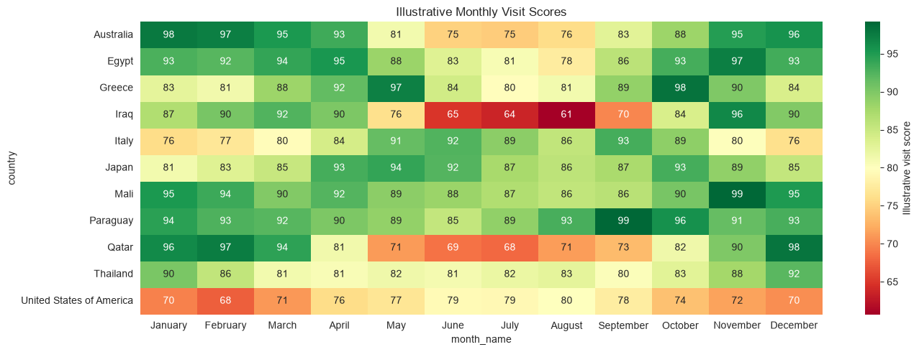
Figure 11. Illustrative monthly visit scores for selected countries.
23°C  temperature target | Low  precipitation preferred | Moderate  humidity and UV preferred

- Countries with intense summer heat, such as Qatar and Iraq, score highest in cooler months.
- Mediterranean destinations such as Greece and Italy favour spring or early autumn.
- Some destinations maintain high scores across much of the year, suggesting lower seasonal sensitivity.
Qatar and Iraq score best in cooler months because their summer temperature and UV exceed the target range. Greece and Italy shift toward spring or early autumn, when heat and rainfall are more moderate. Paraguay and Mali remain comparatively suitable across more months in the sampled data, indicating lower seasonal sensitivity under the chosen formula.
In a travel product, the score could support month filters and plain-language explanations, but it should be combined with cost, crowding, events, safety and user-specific tolerances. The output is a weather-suitability signal, not a complete travel recommendation.
Product interpretation
The score is useful as a filter or explainer in a travel product, not as a definitive recommendation. Cost, events, safety and user preferences are outside the model.

APPLIED DECISION-SUPPORT ANALYSES

Wind-resource and UV screening
Two high-level rankings show where additional location-specific investigation may be worthwhile.

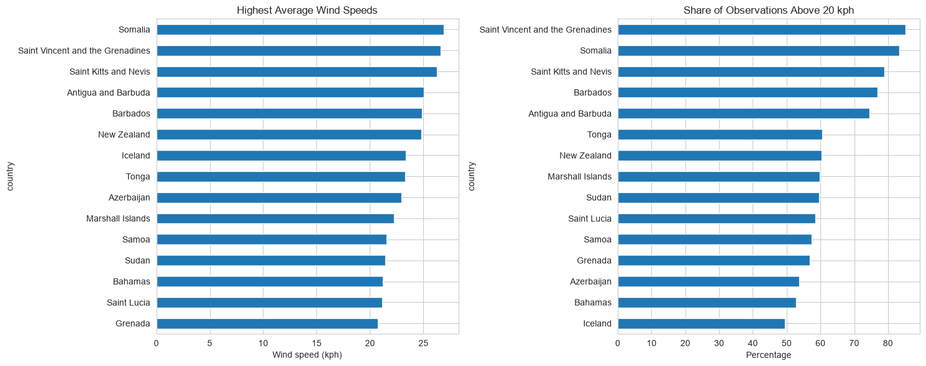
Figure 12a. Countries with the highest average wind and frequent high-wind observations.
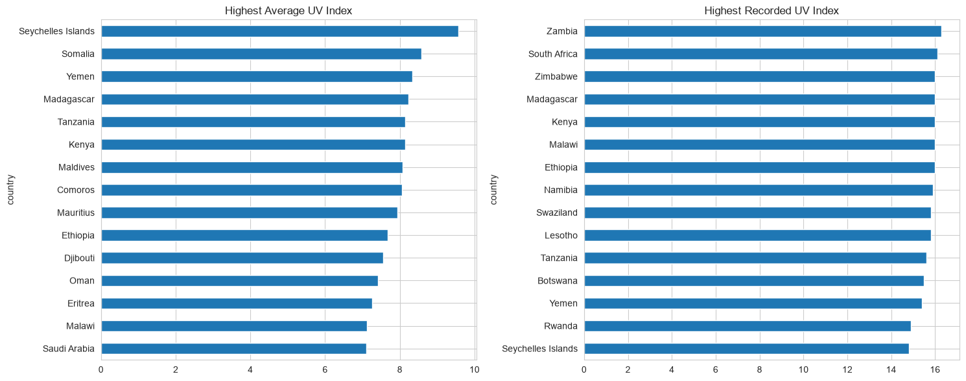
Figure 12b. Countries with the highest average and maximum UV index.
Screen | Leading sampled results | What is still needed
Wind | Somalia 26.92 kph; St Vincent 26.64; St Kitts 26.28 | Hub-height measurements, terrain, air density and turbine data
UV | Seychelles mean 9.57; maximum 16.3 in Zambia | Time-of-day, altitude, season and cloud adjustment

High average wind and a large share of observations above 20 kph are concentrated in several coastal and island settings, which is directionally consistent with greater exposure to open-water circulation. However, surface weather-station wind is not equivalent to turbine-hub wind, so the ranking is only an initial resource screen.
High UV averages occur mainly in tropical and low-latitude countries, while the maximum value of 16.3 in Zambia indicates potentially extreme exposure. Any operational risk assessment should become more granular by hour, season, cloud cover and altitude before recommendations are made.
Interpretation
These rankings are screening proxies. They identify candidates for deeper analysis; they do not establish energy feasibility or complete exposure risk.

ANOMALY DETECTION

Rare observations: errors or genuine extremes?
The analysis deliberately separates impossible measurements from unusual multivariate weather combinations.

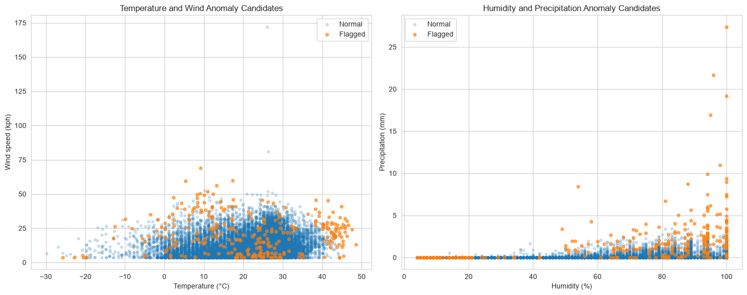
Figure 13. Isolation Forest review candidates in temperature–wind and humidity–precipitation space.
6  standardised features | 2%  contamination setting | 3,072  review candidates

Method | Purpose | Treatment
Physical validity rules | Identify impossible values such as 3,000 mb pressure | Replace the invalid cell with NaN
IQR summaries | Describe unusually high or low values in one variable | Retain; investigate context
Isolation Forest | Detect unusual combinations across six variables | Flag for review, not deletion

The univariate IQR method is useful for describing rare values, but it flags many physically valid observations because precipitation, wind and UV are naturally skewed. Isolation Forest instead searches for unusual combinations across temperature, humidity, pressure, wind, precipitation and UV after standardisation.
Separating these methods protects the analysis from two opposite mistakes: retaining impossible sensor values and deleting genuine extreme weather. The 3,072 flagged observations are therefore review candidates that could support event investigation, quality-control queues or alerting, rather than records to remove automatically.
Key distinction
The 2% setting tells the model how many complete rows to flag. It does not prove that 2% of the dataset is wrong.

FORECASTING DESIGN AND EVALUATION

Forecast target and persistence
A balanced target and strong short-lag dependence make the series suitable for rolling next-day forecasting.

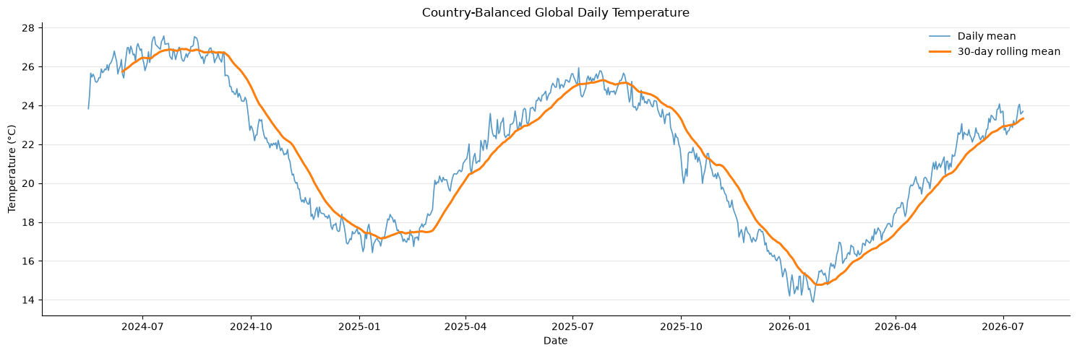
Figure 14. Country-balanced sampled global daily temperature and 30-day rolling mean.
Target-construction step | Reason
Average temperature within each country and date | Prevents multiple locations within a country from multiplying its weight.
Average across countries | Creates a country-balanced sampled global daily mean.
Require at least 150 countries per date | Maintains broad geographic coverage.
Restore the daily calendar and interpolate six gaps | Creates a regular time series for lagged modelling.

794  daily observations | 0.996  lag-1 autocorrelation | 0.979  lag-7 autocorrelation | 0.875  lag-30 autocorrelation

To prevent countries with many sampled locations from dominating the target, temperature is first averaged within each country and date, then averaged across countries. Dates with fewer than 150 represented countries are excluded, the complete daily calendar is restored, and only six missing dates are interpolated. The resulting series contains 794 daily observations.
The very high lag correlations explain why simple approaches are competitive. A next-day forecast starts with a strong persistence signal; statistical and machine-learning models add value mainly by adjusting that signal for recent movement, rolling behaviour and annual seasonality.
Forecasting implication
Recent temperature carries most of the predictive signal. Any advanced model must beat a strong rolling-naive baseline under the same chronological test.

FORECASTING DESIGN AND EVALUATION

Chronological, leakage-safe evaluation
The validation and test periods are separated, and every forecast uses only information available before the predicted date.

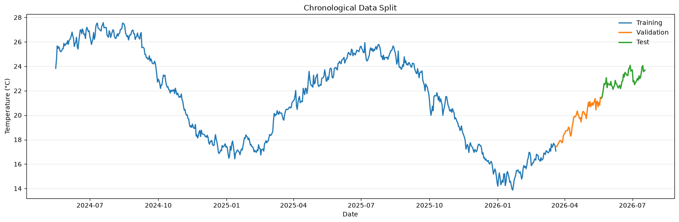
Figure 15. Chronological training, validation and test split.
Period | Dates | N | Purpose
Training | 16 May 2024–20 Mar 2026 | 674 | Fit model parameters
Validation | 21 Mar–19 May 2026 | 60 | Select settings and ensemble weight
Test | 20 May–18 Jul 2026 | 60 | One final unbiased comparison

Rolling one-day-ahead loop
- Fit or update using history available before the forecast date.
- Predict the next day.
- Reveal the actual value and append it to history.
- Repeat for the following day.
Random splitting would allow later seasonal and trend information to influence training, producing an unrealistically optimistic score. The chronological design instead uses 674 training days, 60 validation days for model and ensemble selection, and a final 60-day test period for one-time evaluation.
The rolling loop also mirrors deployment: after each forecast, the actual observation becomes available and is appended to history before the next prediction. This makes the reported accuracy more credible for a daily operating process than a single static holdout forecast.
Leakage prevention
Current-day humidity, pressure, precipitation, cloud and wind are excluded because they would not be known when predicting a future date. Features use only temperature lags, trailing statistics, calendar seasonality and time trend.

FORECASTING DESIGN AND EVALUATION

Model comparison and selection
Seven approaches are compared on the same rolling test; MAE is the primary selection metric because it is directly interpretable in degrees Celsius.

Model | MAE °C | RMSE °C | MAPE % | sMAPE %
Ridge + Naive Ensemble | 0.2206 | 0.2918 | 0.9665 | 0.9639
SARIMA | 0.2233 | 0.2991 | 0.9760 | 0.9765
Holt Damped | 0.2262 | 0.2990 | 0.9895 | 0.9887
Ridge Regression | 0.2276 | 0.2952 | 0.9980 | 0.9948
Rolling Naive | 0.2293 | 0.3008 | 1.0027 | 1.0027
Random Forest | 0.2774 | 0.3552 | 1.2166 | 1.2182
Seasonal Naive (7-day) | 0.6190 | 0.7612 | 2.7028 | 2.7333

85%  Ridge weight | 15%  rolling-naive weight | Best  all four test metrics

Why these models
Model family | Role in the comparison
Naive baselines | Set realistic persistence and weekly reference points.
Holt / SARIMA | Test classical level, trend, differencing and weekly structure.
Ridge | Uses scaled lags, rolling statistics, seasonal transforms and trend.
Random Forest | Tests whether nonlinear interactions add value.
Ensemble | Combines Ridge adaptability with persistence robustness.

The model set is deliberately broad rather than uniformly complex. Naive forecasts establish persistence and weekly reference points; Holt and SARIMA test classical level, trend and seasonal structure; Ridge uses regularised lag and calendar features; and Random Forest tests whether nonlinear interactions add value.
The level series is non-stationary (ADF p = 0.6403), while the first-differenced series is stationary (p < 0.0001), supporting the SARIMA differencing choice. The ensemble weights—85% Ridge and 15% rolling naive—are selected on validation MAE, not by inspecting the final test results.
Stationarity check
The level series is non-stationary (ADF p = 0.6403); first differencing is stationary (p < 0.0001), supporting d = 1 in SARIMA.

RESULTS AND FUTURE OUTLOOK

Forecast performance
The ensemble tracks the observed series closely across the test period; its largest misses occur when the country-balanced daily mean changes abruptly rather than gradually.

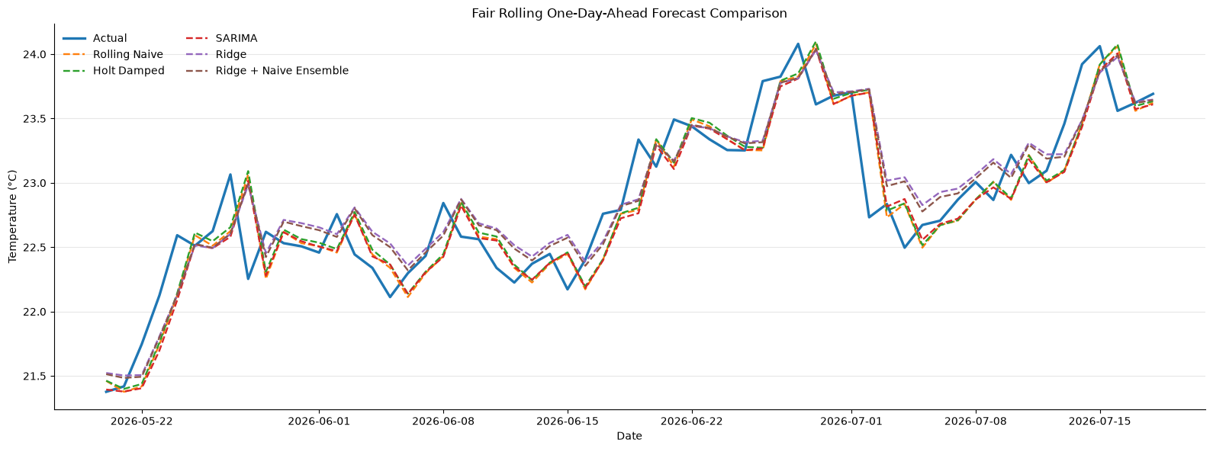
Figure 16. Actual and predicted temperature during the final 60-day test.
0.2206°C  MAE | 0.2918°C  RMSE | 0.9665%  MAPE | 0.9639%  sMAPE

Comparison | MAE reduction
Versus rolling naive | 3.8%
Versus Random Forest | 20.5%
Versus 7-day seasonal naive | 64.4%

The ensemble MAE of 0.2206°C represents a 3.8% improvement over rolling naive. The gain is modest, but it is meaningful because the baseline is already difficult to beat: yesterday's country-balanced average is an excellent estimate of tomorrow's.
SARIMA and Holt remain close competitors, while Random Forest performs worse. The result indicates that the smooth, persistent target rewards parsimonious models and stable extrapolation more than flexible nonlinear fitting. Abrupt day-to-day changes remain the hardest cases for every model.
Model-selection result The ensemble—not Ridge alone—achieves the lowest test RMSE as well as the lowest MAE, MAPE and sMAPE. The improvement over the rolling-naive baseline is modest but consistent.

RESULTS AND FUTURE OUTLOOK

Feature importance and model interpretation
Both linear and nonlinear models agree that the most recent temperature observation dominates next-day prediction.

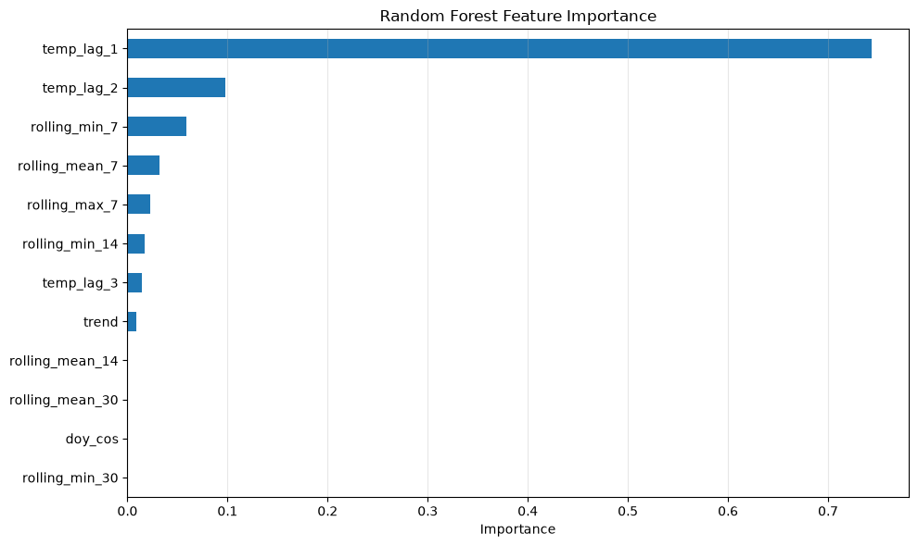
Figure 17. Random Forest feature importance.
0.7434  Random Forest importance: lag 1 | 2.4239  standardised Ridge coefficient: lag 1 | 0.0979  Random Forest importance: lag 2

Feature group | Contribution
Recent lags | Capture the very strong persistence of the daily series.
Rolling means / ranges | Summarise recent level and variability.
Day-of-year sine and cosine | Represent smooth annual seasonality.
Trend | Captures gradual movement across the observed period.

Feature rankings are consistent across two different model families. Lag 1 dominates, lag 2 and recent rolling summaries add smaller contributions, and day-of-year terms capture annual movement. Rolling minima, maxima and variability describe the recent range rather than introducing a separate external weather driver.
The standardised Ridge coefficient and Random Forest importance are not directly comparable in magnitude; they are used as complementary evidence. Their agreement on the ordering strengthens the conclusion that short-term persistence, rather than complex interaction structure, drives most of the forecast accuracy.
Why Random Forest underperformed
The target is smooth, highly autocorrelated and supported by only 794 daily observations. A regularised linear model can capture most of the useful structure without the variance and complexity of a forest.

Feature importance is predictive, not causal: a high score means the fitted model relies on the feature, not that the feature independently causes temperature change.

RESULTS AND FUTURE OUTLOOK

Thirty-day trend outlook
After evaluation, Ridge is retrained on all available daily observations and used recursively for dates beyond the dataset.

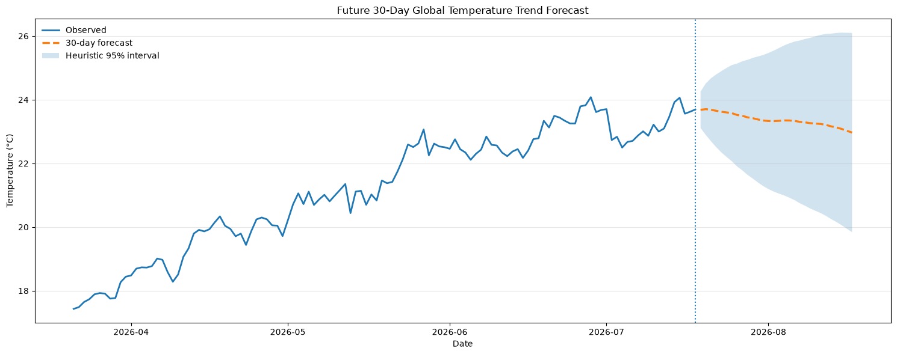
Figure 18. Recursive 30-day forecast with heuristic widening uncertainty.
19 Jul 2026  forecast start | 23.681°C  first forecast | Gradual  late-July decline

- Each forecast becomes an input for later lag and rolling features, so uncertainty accumulates with horizon.
- The shaded interval is heuristic rather than a calibrated probabilistic confidence interval.
- The result describes the broad country-balanced sample; it is not a local weather forecast.
The future path is generated recursively: Ridge predicts one day, that estimate is appended to history, and new lag and rolling features are calculated for the next date. The first forecast is approximately 23.68°C, followed by a gradual decline through late July that is consistent with the seasonal movement learned from the historical series.
Recursive forecasting compounds error because later features depend on earlier predictions. The widening band is therefore directionally appropriate, but it is not a calibrated probability statement. Operational use would require rolling backtests for interval coverage, scheduled retraining and monitoring for geographic-coverage or feature drift.
Deployment requirement
Before operational use, recalibrate prediction intervals through rolling backtests, refresh the model as new data arrives, and monitor coverage drift by country.

RECOMMENDATIONS AND LIMITATIONS

What to do next
The analysis is strongest as a validated benchmark and decision-support prototype. The next gains are more likely to come from better targets and uncertainty than from a more complex algorithm.

RECOMMENDATIONS  - Keep the Ridge–naive ensemble as the benchmark for next-day sampled-global trend forecasts.  - Build country- or city-level targets for operational weather use; the current aggregate is too broad.  - Replace heuristic uncertainty with calibrated intervals from rolling residuals or probabilistic models.  - Track country coverage, missingness and feature drift alongside forecast accuracy.  - Validate liveability and travel-score weights with users before product deployment. | LIMITATIONS  - Only about 2.2 years of observations: insufficient for long-term climate-change inference.  - Uneven locations and dates: country rankings represent the available sample.  - Aggregated forecast target: not suitable for a specific city or country.  - Recursive horizon: forecast error can compound over time.  - Correlations and rankings are descriptive; they do not establish causation.  - Isolation Forest contamination and applied-index weights are modelling choices.

The limitations interact rather than operating independently: uneven geographic coverage affects country rankings, the short history constrains seasonal validation, and recursion increases uncertainty with horizon. None of these issues invalidates the results, but together they define the appropriate use case—short-term trend forecasting, analytical benchmarking and exploratory decision support.
Recommended next experiment. Build a country- or city-level forecasting prototype with calibrated intervals and the same rolling evaluation discipline. This would test whether the strong persistence result transfers to noisier local series. A more complex model should be adopted only when it repeatedly improves on location-specific naive baselines.

Conclusion
The project demonstrates a complete data-science workflow from validation and exploratory analysis to anomaly detection and forecasting. Its strongest contribution is methodological: preserve valid information, avoid leakage, compare against strong baselines and interpret complexity honestly. Under those conditions, a simple regularised model combined with persistence outperforms the more complex alternative.
Bottom line
Reliable forecasting depends more on disciplined data and evaluation than on algorithm novelty.

REPRODUCIBILITY AND REFERENCES

Analytical traceability
This report is grounded in the three supplied notebooks and retains the validated results, figures and modelling decisions used in the original submission.

Notebook pipeline
Notebook | Primary responsibility | Key outputs used in this report
Data_Preprocessing(8).ipynb | Validation, cleaning and export | Coverage filtering, validity rules, feature preparation
EDA(4).ipynb | Exploration and applied analyses | Distributions, relationships, geography, indices and anomalies
Forecasting(7).ipynb | Time-series modelling | Balanced target, backtest, metrics, importance and outlook

Reproducibility checklist
- Use the cleaned CSV exported by the preprocessing notebook.
- Run EDA after derived fields and weather categories are created.
- Construct the country-balanced daily series with the ≥150-country coverage rule.
- Select ensemble weight on validation data only; evaluate the test period once.
- Record package versions, random seeds and data extraction date for future reruns.

References
1. Global Weather Repository. Kaggle dataset by N. Elgiriyewithana: https://www.kaggle.com/datasets/nelgiriyewithana/global-weather-repository
2. Product Manager Accelerator. About Dr. Nancy Li and PM Accelerator: https://www.pmaccelerator.io/about-dr-nancy-li

Final note
All numerical claims and figures in this report come from the supplied project files. Applied rankings remain illustrative, future forecasts should be refreshed as new observations arrive, and every operational interpretation should preserve the stated sampling and causality limitations.
Evidence standard A coherent technical report that preserves the important methodology, explanations and decision-relevant insights without repeating the same findings across sections.

