Weather Trend Forecasting
  - Global Weather Repository | Technical Assessment
Prepared for Product Manager Accelerator
Submission Report | July 2026
PM Accelerator Mission
“Making product managers feel empowered, confident and supported to reach their full leadership potential.”
Source: Product Manager Accelerator, About Dr. Nancy Li
Contents
Project Overview and Objective | 3
Data Preprocessing | 5
Exploratory Data Analysis | 9
Advanced Analysis | 14
Forecasting Methodology | 21
Model Evaluation and Forecasting Results | 25
Key Findings | 29
Project Limitations | 30
Conclusion | 31
References | 32

Project Overview and Objective
The objective of this project was to analyse the Global Weather Repository dataset, identify meaningful weather and environmental patterns, and develop models capable of forecasting future temperature trends. The dataset contains daily weather observations for cities across the world, including temperature, precipitation, humidity, pressure, wind conditions, visibility, ultraviolet index, geographic information and several air-quality measurements. The analysed data covers the period from May 2024 to July 2026 and includes observations from more than 180 countries.
The data-preprocessing stage focused on improving data quality and preparing a reliable analytical dataset. Dates and data types were validated, duplicate and low-coverage records were examined, redundant imperial-unit columns were removed, and clearly invalid measurements were identified. These included unrealistic wind speeds and pressure readings, negative pollutant concentrations and implausible temperature values. Invalid individual measurements were replaced with missing values rather than removing otherwise useful records. Missing values were then handled according to the requirements of each analysis, while normalization was applied within the Ridge regression and anomaly-detection pipelines where feature scaling was necessary.
Exploratory data analysis examined distributions, correlations, temporal coverage, seasonal patterns, precipitation behaviour and differences across sampled locations and countries. The advanced analysis added multivariate anomaly detection, air-quality relationships, geographic visualisation and feature-importance analysis. Together, these methods identified unusual weather combinations, environmental associations and the variables that contributed most strongly to temperature forecasting.
Several forecasting approaches were built and compared using a chronological, leakage-safe evaluation process. These included rolling and seasonal naive baselines, Holt’s damped-trend model, SARIMA, Ridge regression, Random Forest and a validation-weighted ensemble. The Ridge and rolling-naive ensemble achieved the best overall test performance, with a mean absolute error of approximately 0.22. Ridge regression produced a similarly strong result, while the more complex Random Forest model did not outperform the simpler statistical and linear approaches.
The main conclusion of the project is that accurate weather-trend forecasting depends as much on careful preprocessing, leakage prevention and fair evaluation as it does on model complexity. Recent temperature observations were the strongest predictors of the next day’s global average temperature, showing that the series was highly persistent. The ensemble produced a modest improvement over the rolling-naive baseline, demonstrating that combining a regularized linear model with a strong persistence forecast can improve accuracy without introducing unnecessary complexity. The analysis also showed clear seasonal and geographic variation, although the limited time range means that the findings should be interpreted as short-term weather and seasonal patterns rather than evidence of long-term climate change.

Data Preprocessing

Dataset Overview
The Global Weather Repository dataset contains daily weather and air-quality observations for cities and locations around the world. It includes meteorological variables such as temperature, precipitation, humidity, pressure, wind speed, visibility and UV index, as well as geographic, astronomical and air-quality information.
The original dataset contained 153,971 observations and 41 features, covering the period from 16 May 2024 to 18 July 2026. After preprocessing, the final analytical dataset contained 153,586 observations, 38 features and 219 country-location pairs. The last_updated field was used as the main time variable for temporal analysis and forecasting.

Data Cleaning and Preprocessing
Data preprocessing was performed to improve data quality, ensure consistency and prepare the dataset for exploratory analysis, anomaly detection and forecasting. The main steps included datetime conversion, duplicate checks, location-coverage filtering, removal of redundant variables, treatment of invalid measurements, missing-value handling and calendar-feature creation.

Initial Data-Quality Assessment
The raw dataset was first examined for its dimensions, date coverage, duplicate rows, missing values and the number of observations available for each location.
Data-quality measure | Result
Original observations | 153,971
Original features | 41
Original country-location pairs | 286
Exact duplicate rows | 0
Invalid dates | 0
Date range | 16 May 2024–18 July 2026
The last_updated feature was converted to datetime format and used as the main time variable throughout the project.

Location-Coverage Filtering
The number of observations available for each country-location pair was calculated to determine whether each location had enough historical information for meaningful temporal analysis.
Manual inspection showed that some low-frequency groups contained inconsistent or unusual location names, while others represented valid locations with insufficient temporal coverage. Rather than manually correcting uncertain records and introducing subjective decisions, all locations below the selected minimum threshold were consistently excluded.
A minimum threshold of 30 observations per country-location pair was used.
Location-filtering result | Value
Original country-location pairs | 286
Pairs below 30 observations | 67
Final retained pairs | 219
Rows removed | 385
Percentage of rows removed | 0.25%
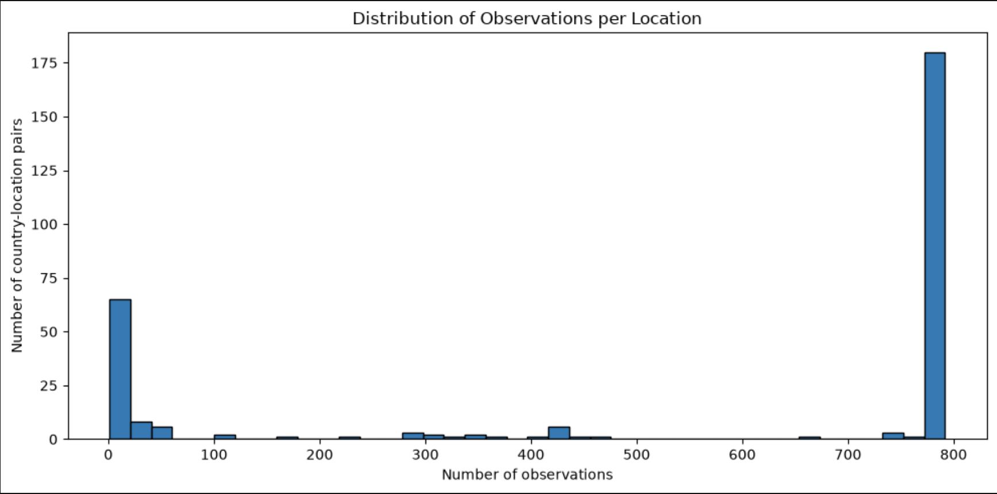
Figure 1. Distribution of observations per retained country-location pair.
Because only a small proportion of the observations were removed, the filtering improved consistency without substantially reducing the dataset.

Removal of Redundant Features
The dataset contained several measurements recorded in both metric and imperial units. Imperial-unit versions were removed while metric variables were retained.
Removed feature | Retained equivalent
temperature_fahrenheit | temperature_celsius
feels_like_fahrenheit | feels_like_celsius
wind_mph | wind_kph
gust_mph | gust_kph
pressure_in | pressure_mb
precip_in | precip_mm
visibility_miles | visibility_km
last_updated_epoch | last_updated
Removing these variables reduced duplicated information, simplified the dataset and avoided unnecessary multicollinearity.

Invalid Measurements and Outlier Treatment
Weather and air-quality variables were checked using conservative physical validity ranges and known placeholder values. Several clearly invalid measurements were identified, including extremely high wind and pressure values, an implausible temperature reading and negative pollutant concentrations.
Data-quality issue | Example | Cleaning action
Unrealistic wind speed | Approximately 3,000 km/h | Replaced with NaN
Unrealistic gust speed | Approximately 3,000 km/h | Replaced with NaN
Unrealistic pressure | Approximately 3,000 mb | Replaced with NaN
Implausible temperature | 79.3°C | Replaced with NaN
Negative pollutant concentration | Negative PM10 or gas value | Replaced with NaN
Placeholder pollution value | −9,999 | Replaced with NaN
A total of 10 individual measurements were converted to missing values. The complete rows were not deleted because the remaining measurements in those observations were still valid and useful.
This distinction was important because unusual values are not always data errors. Clearly impossible values were treated as quality problems, while unusual but physically plausible observations were retained for later anomaly analysis.

Missing-Value Handling
Missing values were handled according to the purpose of each analysis rather than applying a single global imputation method.
Analysis | Missing-value approach
Descriptive statistics | Available observations were used
Correlation analysis | Complete values for the relevant variables were used
Geographic analysis | Rows missing the required geographic variable were excluded only from that analysis
Anomaly detection | Complete selected features were standardized and analysed
Forecasting | Missing dates in the aggregated daily series were interpolated using time-based interpolation
This approach avoided creating unrealistic values across locations with very different climates and weather patterns.

Feature Normalization
Normalization was applied only when required by the modelling technique.
StandardScaler was used in the Ridge regression pipeline and in the multivariate anomaly-detection analysis. Tree-based models such as Random Forest were not scaled because their predictions are not affected by differences in feature measurement units.

Calendar-Feature Creation
The following calendar features were derived from last_updated:
- Year
- Month
- Month name
- Day of the week
These variables supported the analysis of monthly and seasonal weather patterns. The original last_updated feature was retained and later used to construct the chronological forecasting series.

Final Processed Dataset
Dataset characteristic | Final result
Final observations | 153,586
Final features | 38
Final country-location pairs | 219
Duplicate rows | 0
Invalid dates | 0
Invalid measurements replaced | 10
The resulting dataset was sufficiently consistent for exploratory analysis, advanced anomaly detection, geographic comparisons and time-series forecasting.

Exploratory Data Analysis
Exploratory data analysis was conducted to characterise the cleaned dataset before modelling. The analysis examined variable distributions, robust summary statistics, correlation structure, observation coverage over time, dataset-wide seasonal patterns and weather-condition categories. Particular attention was given to temperature and precipitation, as required by the assessment.

Descriptive Statistics
Summary statistics were calculated for the main weather measurements. These statistics provided an initial understanding of the centre, spread and shape of the variables before more detailed visual analysis was performed.
Weather variable | Main observation
Temperature | Mean of approximately 21.4°C and median of approximately 23.7°C
Precipitation | Strongly right-skewed, with many zero-rainfall observations
Humidity | Broadly distributed across dry, temperate and tropical locations
Pressure | Concentrated around normal atmospheric-pressure levels
Wind speed | Mostly low to moderate, with a smaller number of high values
UV index | Right-skewed, with higher values concentrated in warmer and sunnier locations
Visibility | Generally high, but reduced under fog, rain and other poor-weather conditions
The difference between the mean and median temperature indicates that the overall distribution was influenced by colder observations from high-latitude and winter locations. Precipitation was particularly uneven because most observations recorded little or no rainfall, while a relatively small number recorded much higher precipitation.

Weather-Variable Distributions
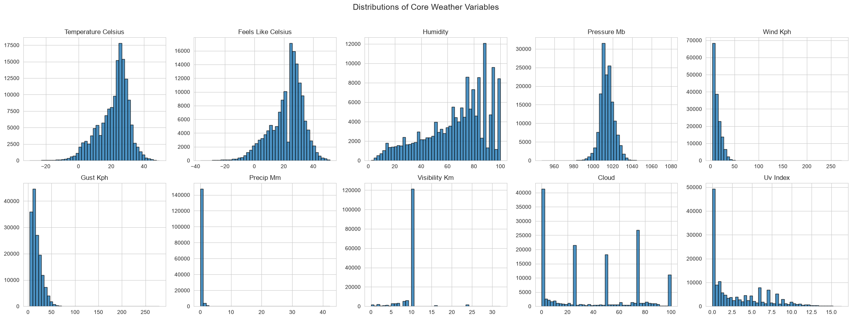
Figure 2. Distributions of selected weather variables in the cleaned dataset.
The distribution plots show that temperature and pressure were more concentrated than precipitation, wind speed and UV index. Precipitation had the strongest positive skew, with a large concentration of observations close to zero and a long tail containing heavier rainfall events.
Because several weather variables were not normally distributed, the analysis also used medians, correlations and anomaly-detection techniques that did not depend entirely on normally distributed data.

Correlation Analysis
A correlation matrix was created to measure the strength and direction of relationships between the main numerical weather variables.
Variable pair | Correlation | Interpretation
Temperature and feels-like temperature | 0.980 | Very strong positive relationship
Wind speed and gust speed | 0.932 | Very strong positive relationship
Humidity and UV index | −0.549 | Moderate negative relationship
Humidity and cloud cover | 0.503 | Moderate positive relationship
Temperature and UV index | 0.485 | Moderate positive relationship
Temperature and pressure | −0.425 | Moderate negative relationship

Weather Correlation Heatmap
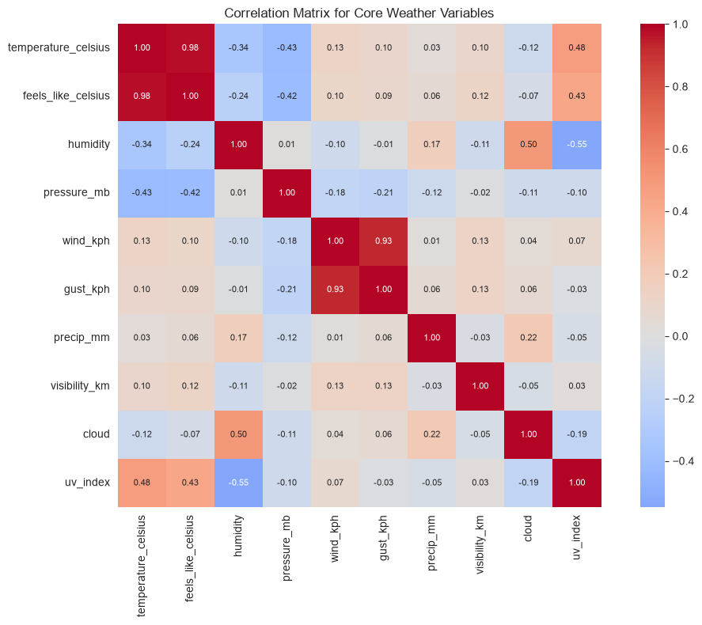
Figure 3. Correlation matrix showing relationships between selected weather measurements.
Temperature and feels-like temperature had the strongest relationship. This was expected because perceived temperature is heavily influenced by measured air temperature. Wind speed and gust speed also moved closely together.
Humidity was positively associated with cloud cover and negatively associated with UV index. More humid conditions were therefore generally linked with greater cloud coverage and reduced ultraviolet exposure. Temperature had a moderate positive relationship with UV index and a moderate negative relationship with atmospheric pressure.
The correlation results describe statistical associations and should not be interpreted as evidence that one variable directly caused another. Weather measurements are interconnected and may also be affected by geography, season and local atmospheric conditions.

Temporal Coverage and Seasonality
Observation counts were reviewed before calculating monthly averages. Temperature, precipitation, humidity and wind speed were then aggregated by calendar month to examine dataset-wide seasonal patterns.
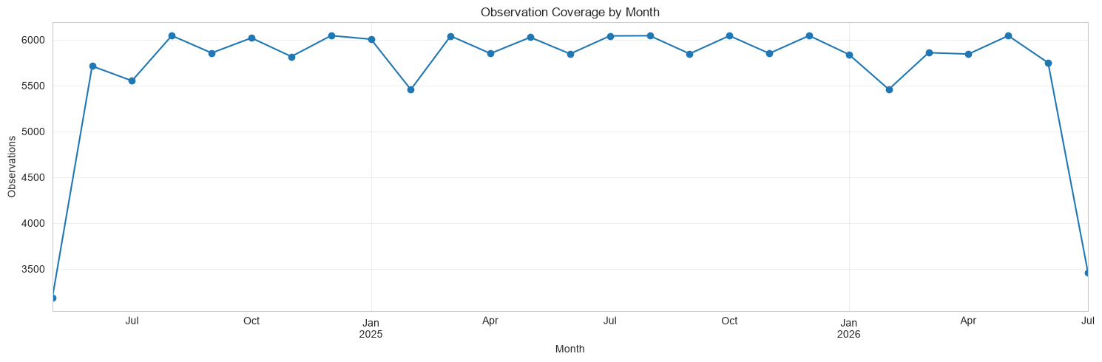
Figure 4a. Observation coverage by month; the first and final months are partial.
Coverage is broadly stable across the central period but drops sharply at the dataset boundaries because May 2024 and July 2026 are incomplete. This check is important because raw monthly averages can otherwise reflect changing sample composition rather than weather alone.
Monthly result | Finding
Warmest sampled month | August, approximately 25.7°C
Coolest sampled month | January, approximately 16.1°C
Temperature pattern | Higher combined averages during the middle of the year
Precipitation pattern | Greater variation between months than temperature
Humidity pattern | Changed seasonally but remained influenced by geographic composition
Wind pattern | More stable than temperature, with moderate monthly variation

Dataset-Wide Monthly Weather Trends
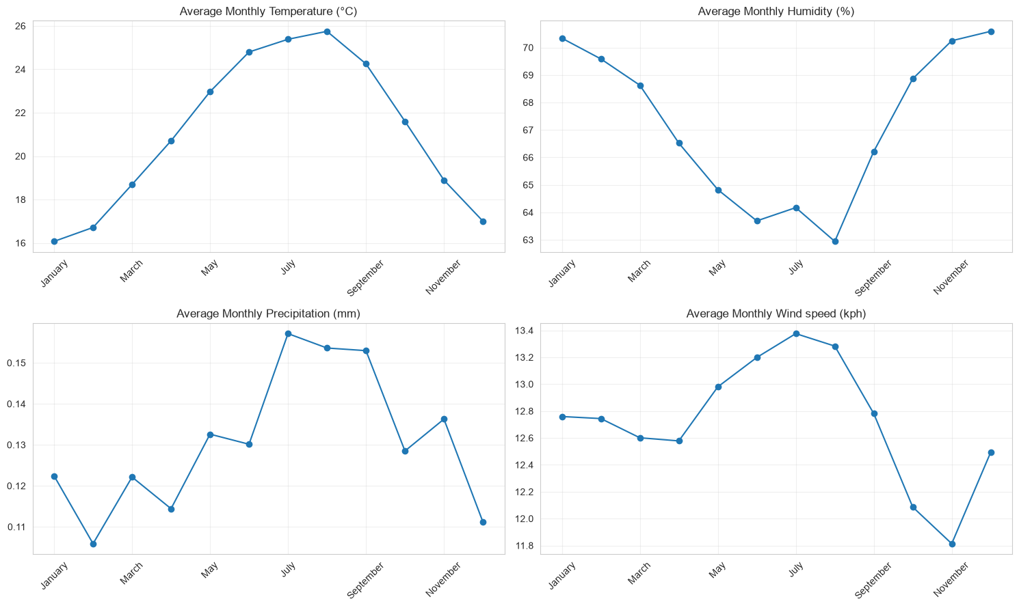
Figure 4b. Dataset-wide monthly patterns in average temperature, precipitation, humidity and wind speed.
The sampled data showed a noticeable annual temperature cycle: August had the highest combined monthly average (approximately 25.7°C), while January had the lowest (approximately 16.1°C). Precipitation, humidity and wind speed also varied by month, but their patterns were less regular than temperature.
These values are not a balanced global climate index. The repository mixes both hemispheres, incomplete edge months and uneven country-location coverage. The curves should therefore be interpreted as seasonal patterns in the available sample, not as universal global climatology.

Daylight Duration by Month
The daylight pattern broadly aligned with the monthly temperature cycle, suggesting that seasonal solar exposure contributed to the higher sampled temperatures observed during the middle of the year. This relationship is descriptive and is also affected by latitude, hemisphere and geographic sampling.
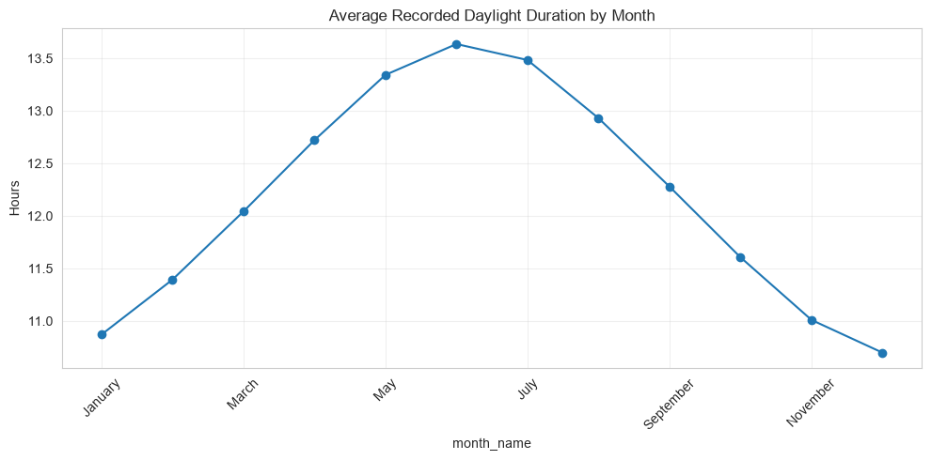

Weather-Condition Categories
Weather-description labels were grouped into broader categories such as clear, cloudy, rainy, foggy, snowy and thunderstorm conditions.
Weather category | General observed pattern
Clear or sunny | Higher UV exposure and lower cloud cover
Cloudy or overcast | Higher cloud cover and generally lower UV exposure
Rainy | Higher precipitation and humidity
Fog or mist | Reduced visibility
Snow or ice | Much lower temperatures
Thunderstorm | Warmer conditions with increased precipitation and wind activity
Cloudy and clear conditions were among the most frequently recorded categories. Snow and ice observations occurred at considerably lower temperatures, while fog and mist were associated with reduced visibility. Thunderstorm observations generally showed higher precipitation and stronger atmospheric activity.
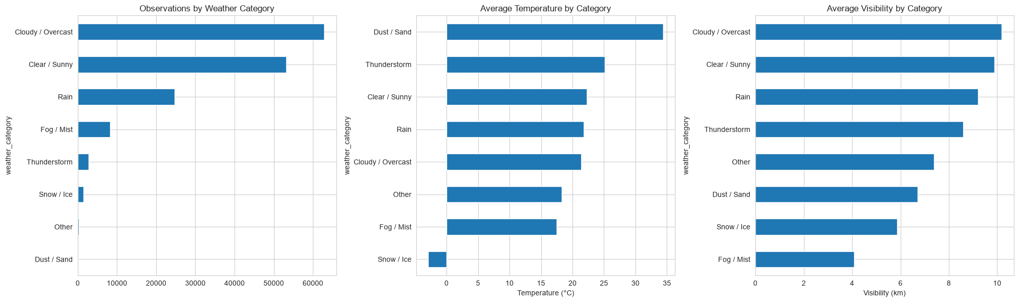

Main EDA Findings
The exploratory analysis produced the following main findings:
- The cleaned dataset contained a wide range of weather conditions across global locations.
- Temperature showed a clear seasonal pattern, while precipitation was highly right-skewed.
- Temperature and feels-like temperature had the strongest observed correlation.
- Wind speed and gust speed also showed a very strong relationship.
- Higher humidity was generally associated with greater cloud cover and lower UV exposure.
- Geographic and temporal sampling contributed substantially to the variation observed in the weather measurements.
- Several variables contained genuine extreme observations, supporting the need for separate anomaly detection rather than automatically removing all statistical outliers.

Advanced Analysis
The advanced analysis extended the core EDA by examining environmental relationships, geographic variation and unusual multivariate weather observations.

Air Quality and Environmental Relationships
The dataset includes measurements of carbon monoxide, ozone, nitrogen dioxide, sulphur dioxide, PM2.5 and PM10. Their distributions were examined alongside weather variables such as temperature, humidity, pressure, wind speed and precipitation.
The air-quality variables were strongly right-skewed. Most observations recorded relatively low or moderate pollution levels, while a smaller number contained much higher concentrations. Several pollutant measurements were positively related to one another, indicating that elevated concentrations sometimes occurred together.
Environmental-analysis result | Main finding
Pollutant distributions | Strongly right-skewed
PM2.5 and PM10 | Often increased together
Weather–pollution relationships | Generally weak to moderate
Humidity and cloud conditions | Associated with some pollutant variation
Geographic differences | Pollution levels differed considerably across regions
Interpretation | Relationships were descriptive, not causal
Weather variables alone did not explain most of the variation in air quality. Pollution may also be affected by traffic, industrial activity, geography, population density, season and atmospheric circulation.
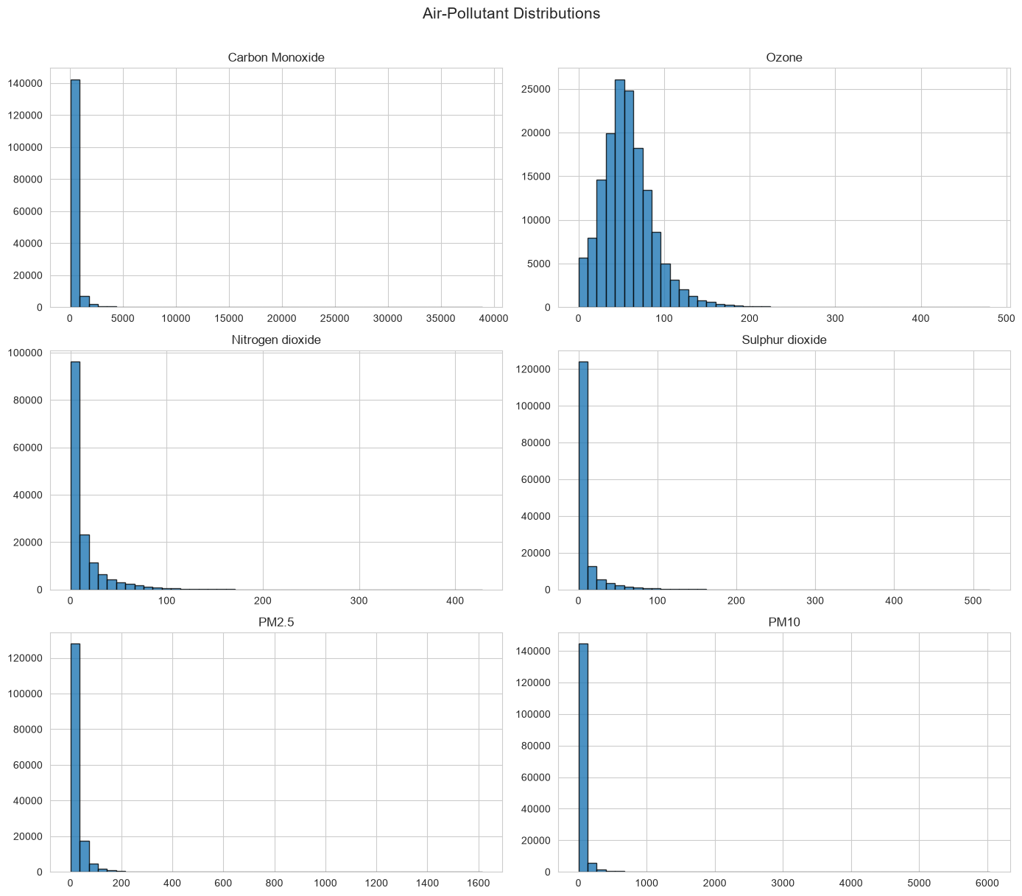
Figure 5a. Distributions of selected air-pollutant measurements.

Air-Quality Correlation Heatmap
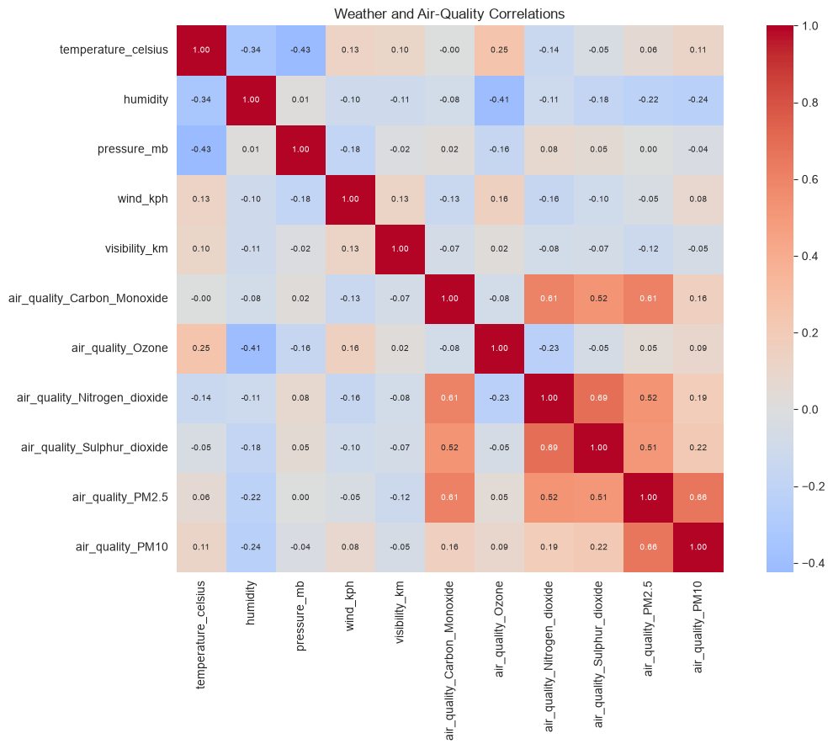
Figure 5b. Correlations between selected weather conditions and air-quality measurements.
The heatmap shows that relationships between different pollutants were generally stronger than relationships between pollutants and individual weather measurements. This suggests that air quality is influenced by a combination of environmental and human factors.
The analysis identifies associations only and does not prove that a particular weather condition caused a change in pollution.

Seasonal Air Quality
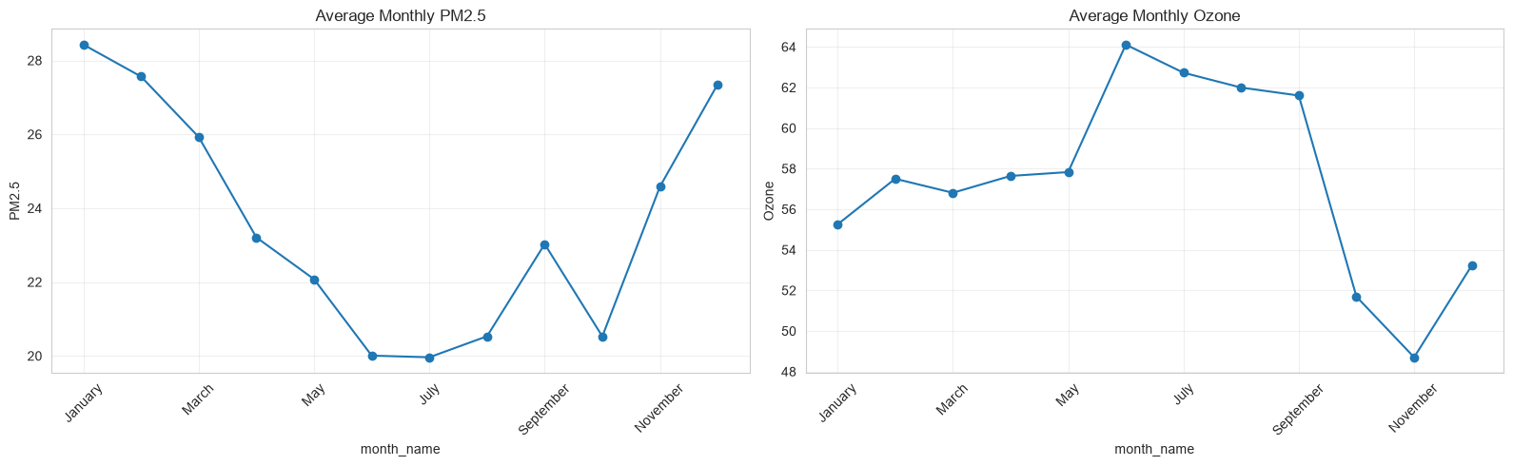
PM2.5 and ozone appear to follow opposite seasonal patterns. Lower PM2.5 during warmer months may reflect stronger atmospheric mixing and dispersion, while higher summer ozone may be linked to increased sunlight and photochemical activity. However, these averages combine many global locations, so geography, emissions, and uneven sampling may also influence the trend.
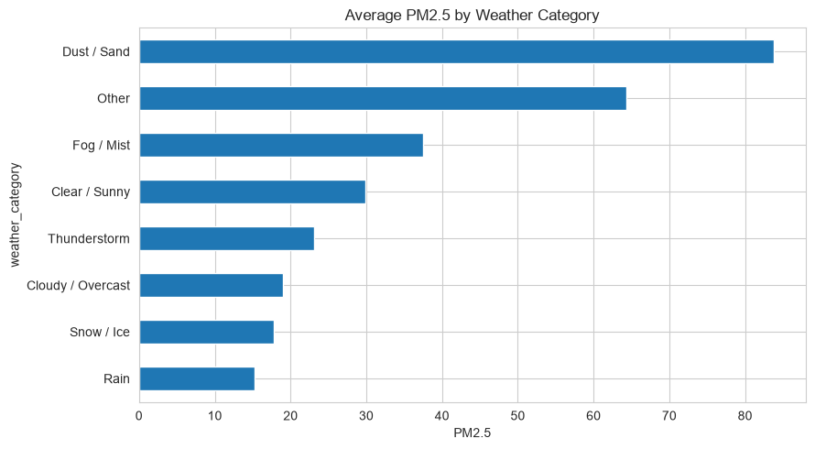
Dry and dusty conditions are associated with much higher particulate pollution, while rainfall appears to reduce airborne PM2.5 through atmospheric washout. Fog and mist may also trap pollutants near the surface.

Geographic and Spatial Analysis
Geographic analysis was performed using latitude, longitude, country and location information. The objective was to examine how weather patterns differed across parts of the world.
A clear negative relationship was found between absolute latitude and temperature.
Geographic measure | Result
Correlation between absolute latitude and temperature | −0.558
General pattern | Locations farther from the equator were cooler
Warmest sampled areas | Mainly tropical and low-latitude locations
Coolest sampled areas | Mainly high-latitude locations
Important limitation | Countries were represented by sampled locations only

Latitude and Temperature
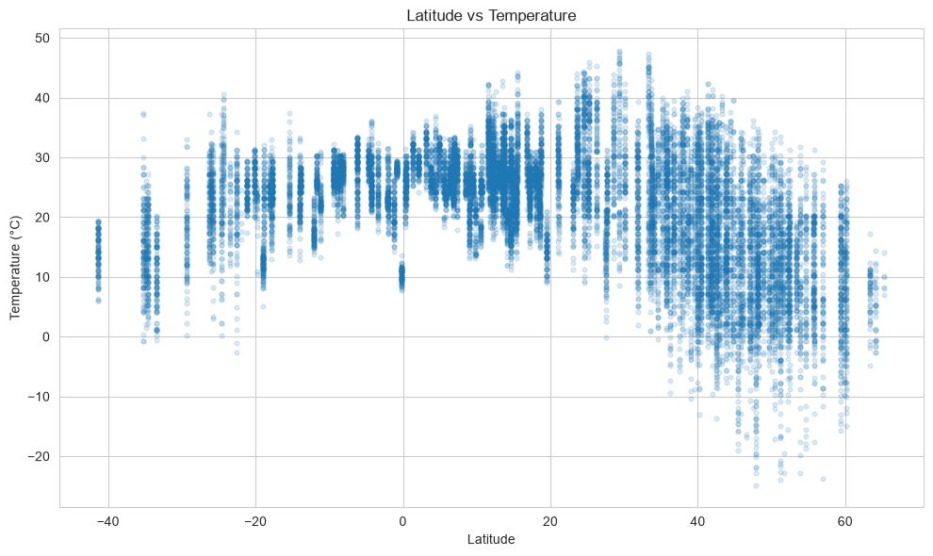
Figure 6. Relationship between latitude and observed temperature.
The scatter plot shows that temperatures generally decreased as the distance from the equator increased. However, the relationship was not perfect because local altitude, coastal influence, season and regional climate also affected temperature.

Geographic Temperature Map
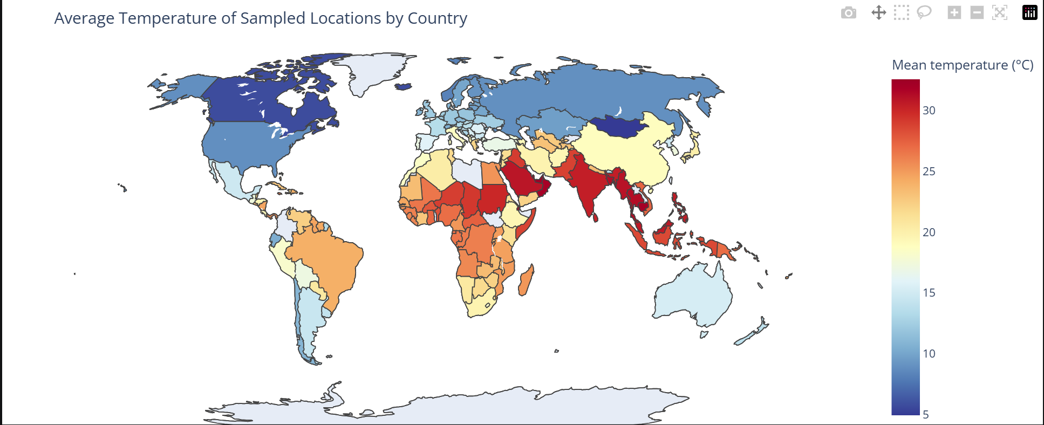
Figure 7. Geographic variation in average temperature across sampled locations.
The map should be described as showing the average temperature of sampled locations rather than the full national average. Some countries were represented by one location, while others contained several observations or locations.

Sampled Country Temperature Rankings
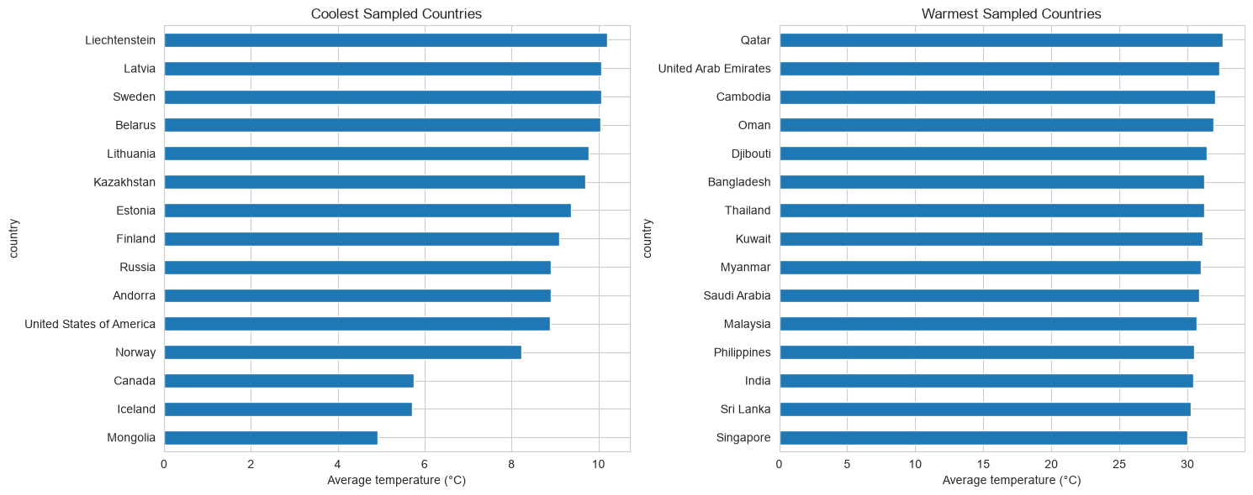
Figure 8. Coolest and warmest country averages among the sampled observations.
The ranking illustrates geographic variation in the repository, but it should not be interpreted as a complete national climate ranking because countries have unequal location and date coverage.

Country-Level Air Quality
The country comparison shows that Chile, Saudi Arabia, China, and India had the highest average PM2.5 among the sampled countries, with Chile exceeding 140. However, these values reflect only the locations and dates represented in the dataset and should not be interpreted as complete national averages.
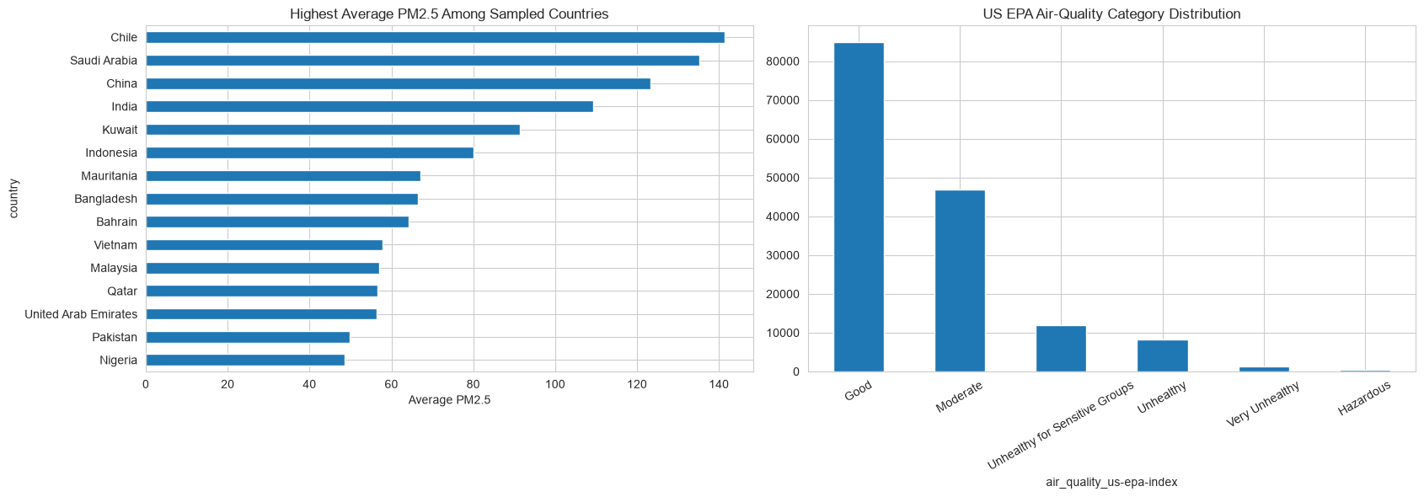

The EPA category distribution indicates that most observations were classified as Good or Moderate, while far fewer fell into the Unhealthy, Very Unhealthy, or Hazardous categories.

Key insight: although the overall dataset is dominated by acceptable air-quality conditions, a smaller group of countries and observations experienced substantially elevated particulate pollution. This highlights strong geographic variation and the importance of examining both overall category counts and country-level averages.
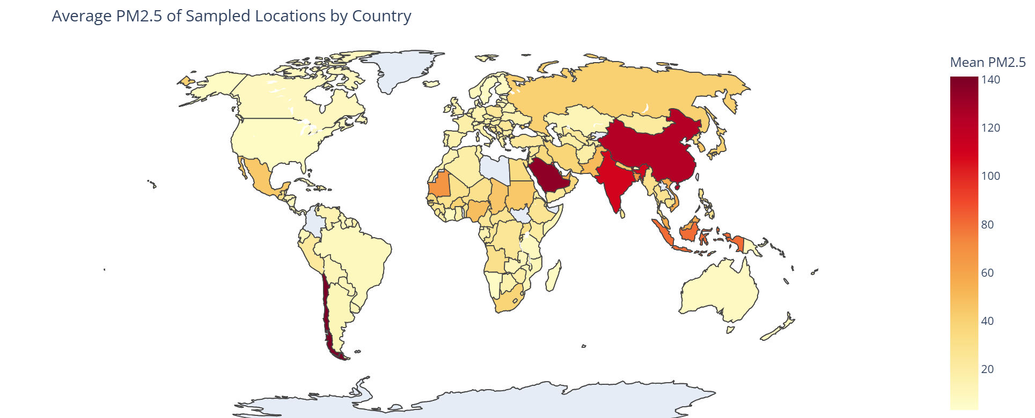

Applied Analyses

Liveability Index
The illustrative liveability ranking suggests that Costa Rica, Honduras, Paraguay, Fiji, and Nicaragua achieved the highest adjusted scores, while Saudi Arabia, Kuwait, Qatar, India, and the United Arab Emirates were among the lowest-ranked countries.
The score rewards conditions close to the selected comfort targets: approximately 21°C temperature, 50% humidity, 10 kph wind, low UV exposure, and favourable EPA air-quality categories. It also gives a small advantage to countries with more stable scores over time.
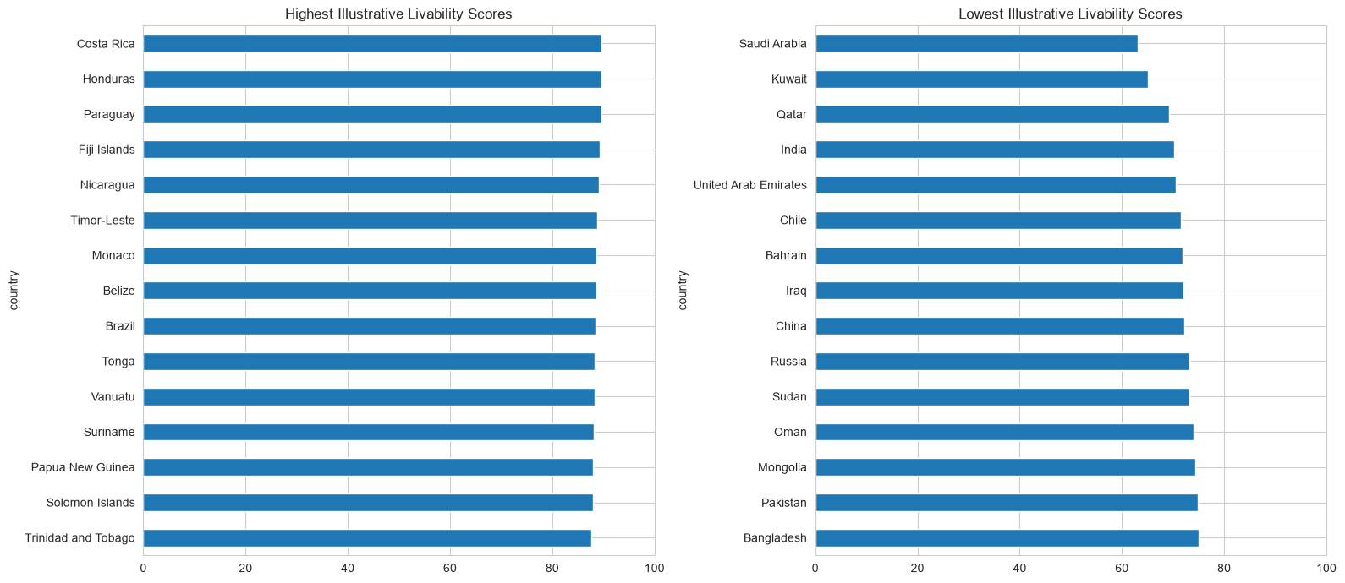
Key insight: countries with moderate temperatures, acceptable air quality, and relatively stable conditions tend to rank higher, while very hot climates, poorer air quality, or greater variability reduce the score.

Best Time to Visit A Country
The heatmap shows that the most suitable travel month varies substantially by country. Countries with strong seasonal heat, such as Qatar and Iraq, receive their highest visit scores during cooler months and much lower scores in summer. In contrast, Greece and Italy perform best during spring or early autumn, when temperatures are moderate and rainfall is limited. Countries such as Paraguay and Mali maintain relatively high scores across most months.

Key insight: weather-based travel suitability is strongly seasonal, and the best month is usually the period with temperatures near 23°C, moderate humidity, low precipitation, and manageable UV levels
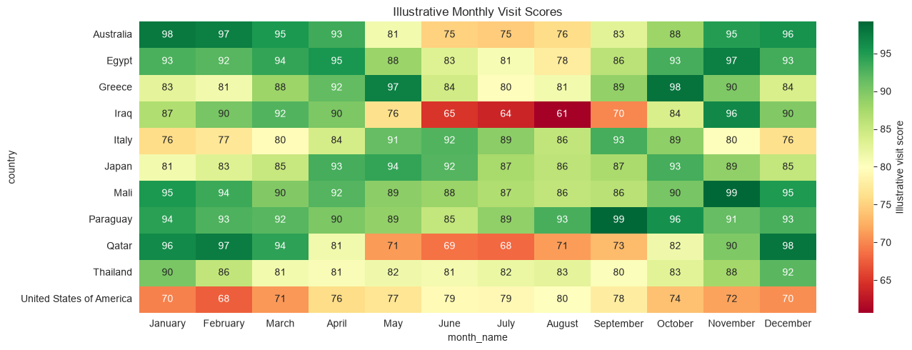

Wind resource screening proxy
Somalia, Saint Vincent and the Grenadines, and Saint Kitts and Nevis recorded the highest average wind speeds, all above 26 kph. Several Caribbean and island countries also had a high share of observations exceeding 20 kph.
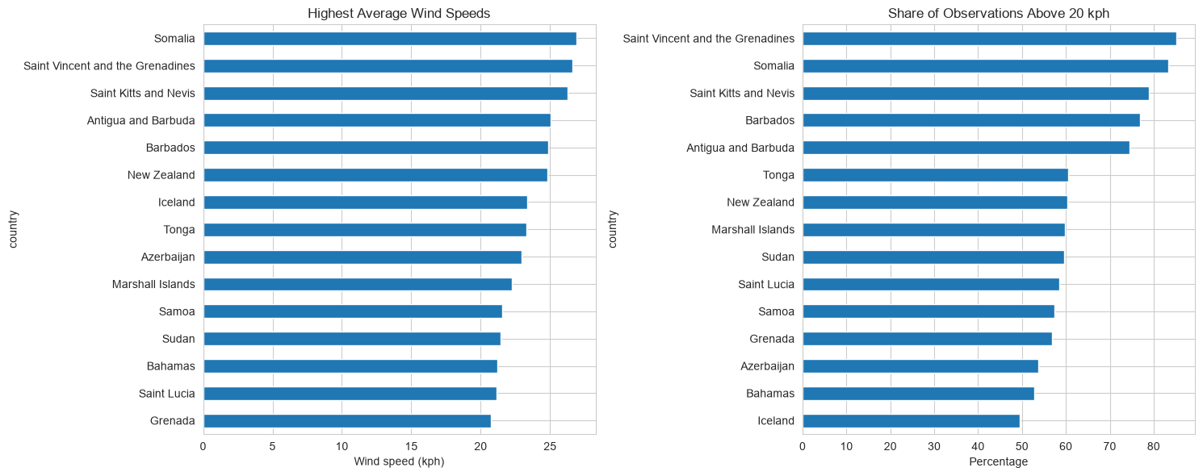
Key insight: consistently windy conditions are concentrated in coastal and island regions. These locations may have stronger wind-energy potential, but wind-power conclusions would require altitude, terrain, and turbine-level measurements.

UV Exposure Patterns Across Countries
The Seychelles Islands recorded the highest average UV index at about 9.6, followed by Somalia and Yemen. The highest individual UV reading was 16.3 in Zambia, with several southern and eastern African countries also recording values near 16.
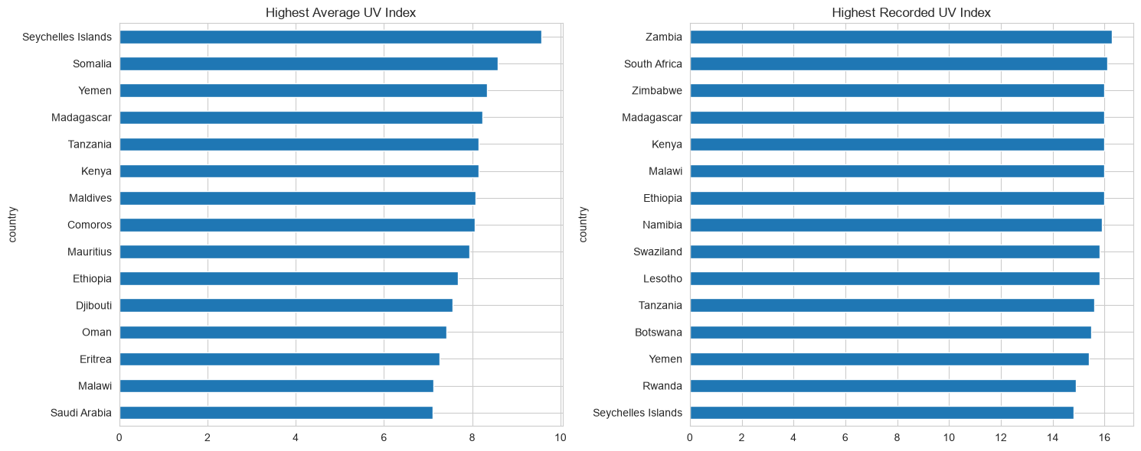

Key insight: consistently high UV exposure is concentrated in tropical and low-latitude regions. These levels indicate substantial sun-exposure risk, although altitude, season, cloud cover, and observation timing also affect UV intensity.
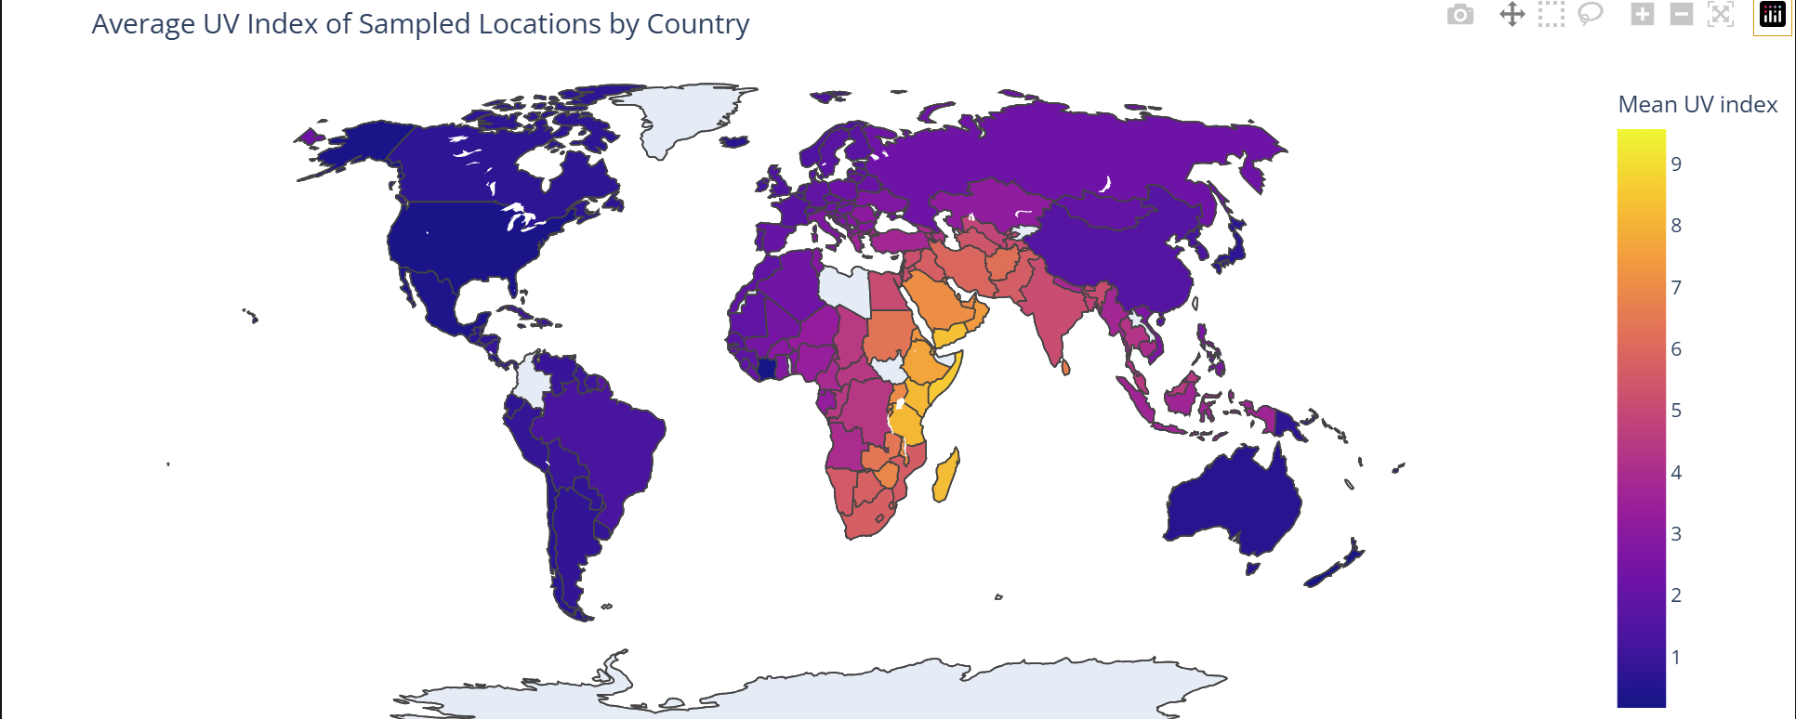

Pollution Patterns by Recorded Update Hour
The normalized pollutant levels are generally lower during the early morning, rise from late morning, and reach their highest values during the afternoon. PM2.5 and nitrogen dioxide follow similar patterns, while carbon monoxide shows greater hour-to-hour variation.
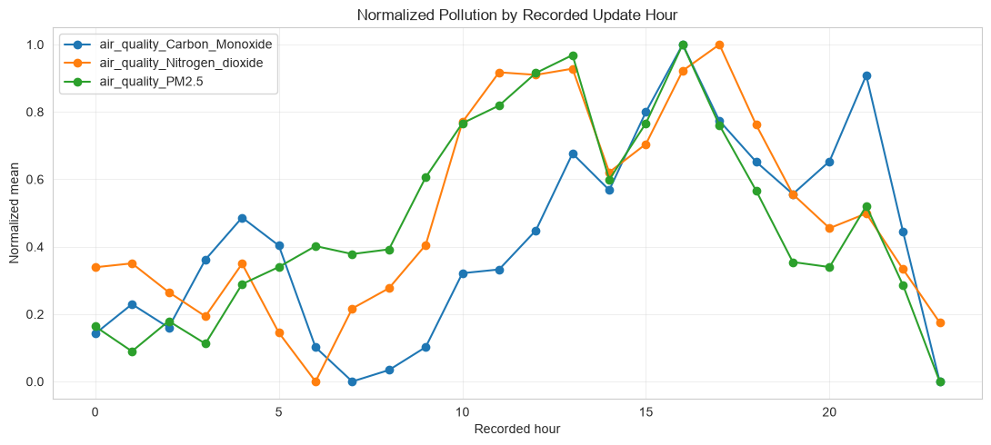
Key insight: pollution appears to build during daytime hours, potentially reflecting human activity, traffic and atmospheric conditions.

Intraday Weather Patterns
Recorded temperatures generally rise through the day and peak in the late afternoon, while humidity follows the opposite pattern and reaches its lowest level during the warmest hours. The UV index increases rapidly during the morning, peaks around midday, and declines toward evening.

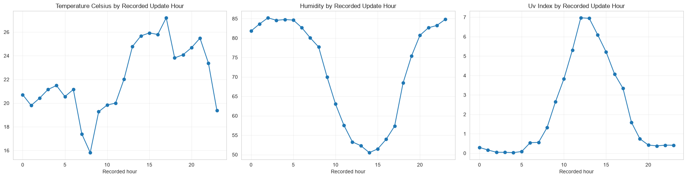
Key insight: the three variables show a consistent daily cycle: stronger daytime solar exposure is associated with higher temperatures, lower relative humidity, and elevated UV levels. Because the chart uses recorded update hours across many locations and time zones, it should be interpreted as an aggregated pattern rather than a precise local-day cycle.

Anomaly Detection
Anomaly detection was used to identify unusual observations that may represent data-quality problems or genuine extreme weather events.
Two complementary approaches were used:
- The interquartile range method for individual variables.
- Isolation Forest for unusual combinations across several weather variables.

Univariate IQR Analysis
The interquartile range method identified values outside the typical range of each variable.
Variable | Reason for frequent statistical outliers
Precipitation | Many zero values and a long right tail
Visibility | Large concentration at common maximum values
Wind speed | Small number of storm-related high observations
Temperature | Extreme cold or hot regional observations
UV index | High values in sunny tropical locations
IQR outliers were not automatically treated as incorrect. For example, heavy rainfall or unusually high wind may be rare but still physically valid.

Isolation Forest
Isolation Forest was applied to standardized values of:
- Temperature
- Humidity
- Pressure
- Wind speed
- Precipitation
- UV index
StandardScaler was used so that variables measured in different units could be compared within the same multivariate model.
The model used a contamination setting of 2% and flagged 3,072 observations for further review.
Isolation Forest result | Value
Variables analysed | 6
Contamination setting | 2%
Observations flagged | 3,072
Treatment of flagged rows | Retained as review candidates
Interpretation | Potential extreme events or unusual combinations

Multivariate Anomaly Visualisation
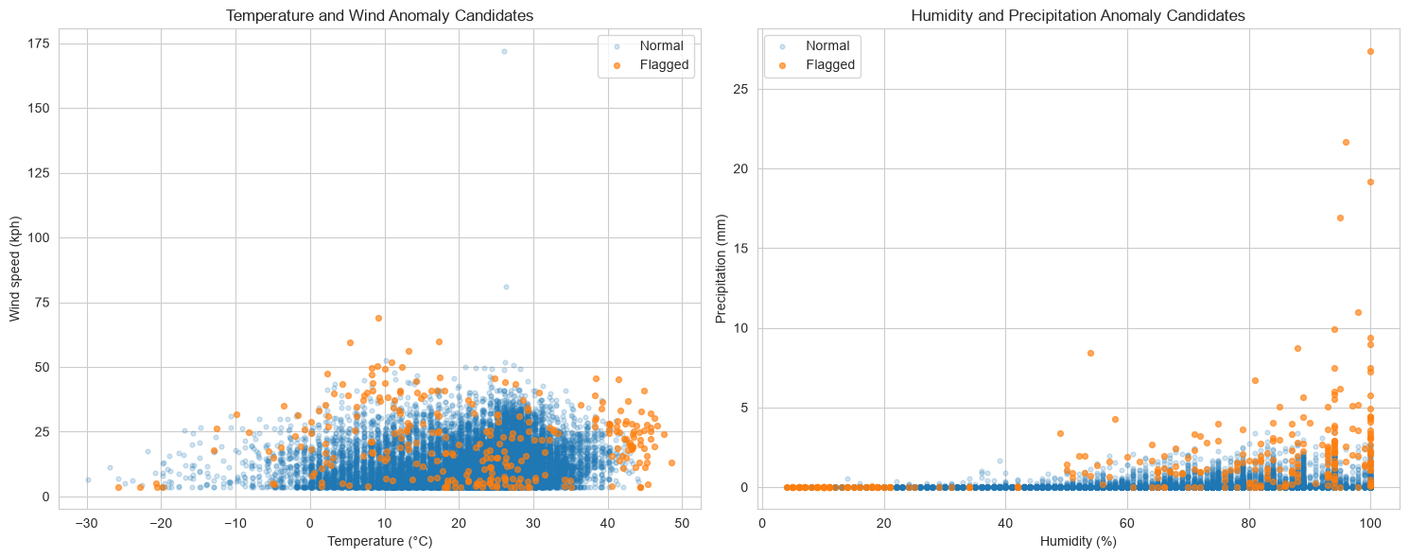
Figure 9. Multivariate anomaly candidates identified using Isolation Forest.
The flagged observations included unusual combinations of temperature, pressure, humidity, precipitation and wind. Some may represent storms, heat events, dry conditions or other genuine weather extremes.
The contamination setting instructed the model to identify approximately 2% of complete observations as unusual. It does not prove that exactly 2% of the dataset was incorrect.

Distinguishing Data Errors from Genuine Extremes
A clear distinction was maintained between invalid values and statistical anomalies.
Type | Example | Treatment
Hard data-quality error | 3,000 mb pressure | Replaced with NaN
Hard data-quality error | Negative pollutant concentration | Replaced with NaN
Statistical anomaly | Heavy rainfall | Retained for review
Statistical anomaly | Strong but plausible wind | Retained for review
Statistical anomaly | Unusual temperature–humidity combination | Retained for review
This approach prevented genuine extreme weather events from being removed simply because they were rare.

Main Advanced-Analysis Findings
The advanced analysis produced the following main findings:
- Air-quality variables were strongly right-skewed and varied substantially across sampled countries.
- Relationships among pollutants were generally stronger than relationships between pollutants and individual weather variables.
- Temperature decreased as absolute latitude increased.
- Average sampled temperatures varied substantially across countries and locations.
- The latitude analysis showed a clear equator-to-pole temperature gradient, with substantial local variation around the trend.
- Isolation Forest successfully identified unusual multivariate weather combinations.
- Statistical anomalies were treated as review candidates rather than automatic errors.
- The short date range supports short-term seasonal and geographic comparisons, but not long-term climate-change conclusions.

Forecasting Methodology
The forecasting stage aimed to predict the future trend of the global daily average temperature using the last_updated feature as the time index.

Forecast Target Construction
A country-balanced global daily mean temperature series was created to prevent countries with several sampled locations from having greater influence than countries with fewer locations.
The target was constructed in four steps:
- Temperature observations were averaged within each country for each date.
- The resulting country-level averages were averaged across countries.
- Dates with fewer than 150 represented countries were excluded to maintain adequate geographic coverage.
- The complete daily calendar was restored and six missing dates were filled using time-based interpolation.
Target-series characteristic | Result
Forecast variable | Daily mean temperature
Aggregation method | Country-balanced daily average
Minimum countries per date | 150
Final daily observations | 794
Missing dates interpolated | 6
Date range | 16 May 2024–18 July 2026
This approach produced a smoother and more balanced temperature series than directly averaging all rows, because countries with multiple locations did not receive disproportionate weight.

Daily Temperature Series
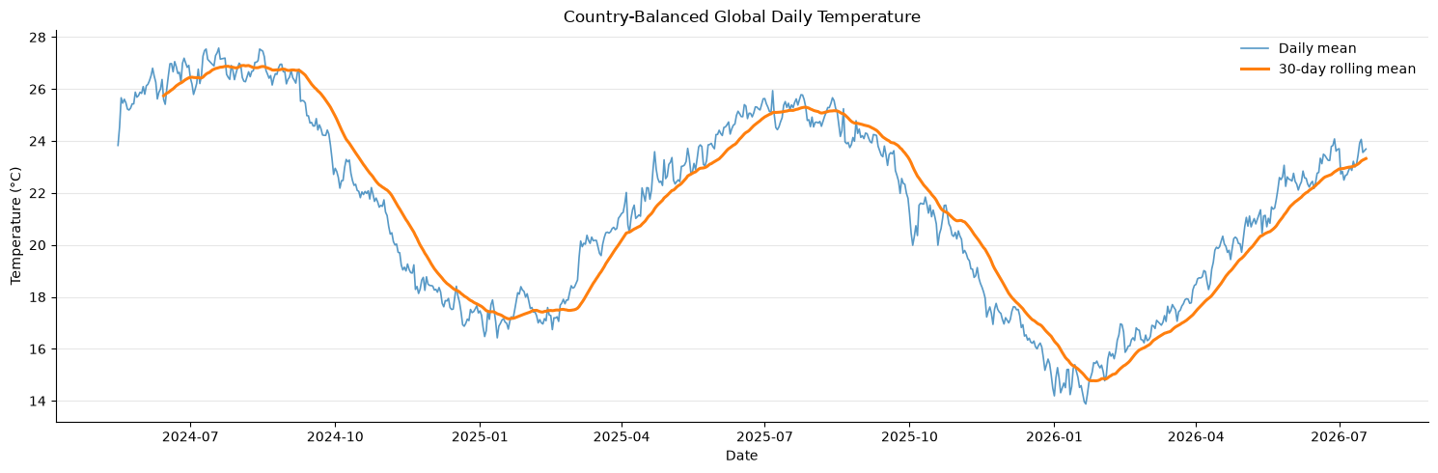
Figure 10a. Country-balanced global daily temperature and its 30-day rolling average.
The daily series showed short-term fluctuations combined with a broader seasonal pattern. The 30-day rolling mean made the underlying trend easier to observe by reducing day-to-day noise.

Chronological Data Split
The time series was divided chronologically into training, validation and test periods. Random splitting was not used because it would allow future observations to appear in the training data.
Dataset period | Dates | Observations | Purpose
Training | 16 May 2024–20 March 2026 | 674 | Model fitting
Validation | 21 March 2026–19 May 2026 | 60 | Model and ensemble selection
Test | 20 May 2026–18 July 2026 | 60 | Final performance evaluation
The validation period was used to select model settings and ensemble weights. The test period was reserved for the final comparison and was not used during model selection.
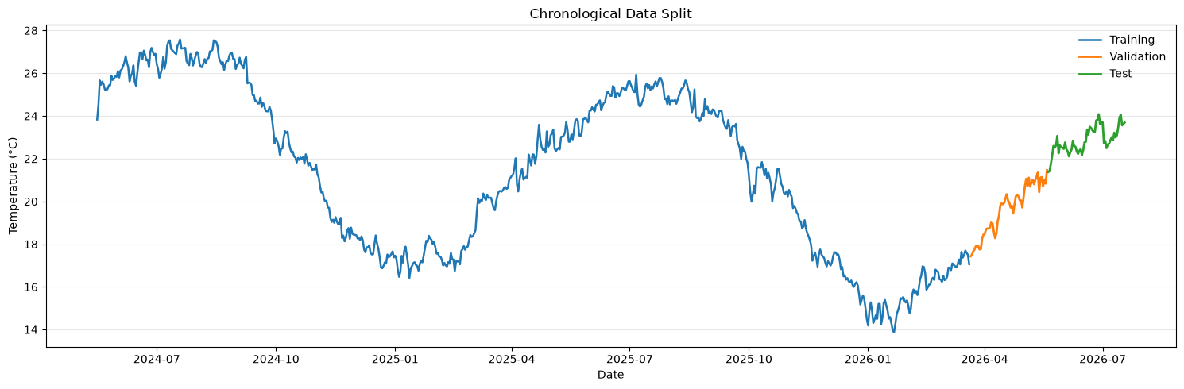
Figure 10b. Chronological training, validation and test split used for model evaluation.

Leakage Prevention
All models were evaluated using a rolling one-day-ahead forecasting process.
For each test date:
- The model used only information available before that date.
- A prediction was produced for the next day.
- The true value was revealed only after the prediction.
- The actual value was then added to the historical series before forecasting the following day.
This process ensured that the evaluation closely represented how the model would operate in practice.
Current-day weather measurements such as humidity, pressure, precipitation, cloud cover and wind speed were excluded from the forecasting features because these values would not be known when predicting a future date.

Forecasting Features
The machine-learning models used only leakage-safe variables derived from previous temperature observations and the calendar.
Feature group | Examples
Temperature lags | Previous 1, 2, 3, 7, 14, 30 and 60 days
Rolling averages | 7-, 14-, 30- and 60-day averages
Rolling variability | Rolling standard deviations
Rolling ranges | Rolling minimum and maximum values
Seasonal features | Sine and cosine transformations of day of year
Trend feature | Ordinal date trend
The lagged temperature features captured short-term persistence, while rolling statistics summarized recent weather behaviour. Calendar features represented annual seasonality.

Stationarity Analysis
The Augmented Dickey-Fuller test was used to examine whether the daily temperature series was stationary.
Series | ADF p-value | Interpretation
Original daily temperature series | 0.6403 | Non-stationary
First-differenced series | <0.0001 | Stationary
The original series did not meet the stationarity requirement because its p-value was greater than 0.05. After first differencing, the series became stationary. This supported using a differencing order of one in the SARIMA model.

Forecasting Models
Several statistical, baseline and machine-learning models were compared.
Model | Description
Rolling naive | Uses the previous day’s observed temperature
Seasonal naive | Uses the temperature recorded seven days earlier
Holt damped trend | Models the current level and a gradually reducing trend
SARIMA | Models autoregression, differencing, moving-average and weekly seasonal effects
Ridge regression | Regularized linear model using scaled lag and calendar features
Random Forest | Nonlinear tree-based model using lag and rolling features
Ridge–naive ensemble | Weighted combination of Ridge and rolling-naive predictions

Baseline Models
The rolling-naive model predicted the next day using the most recent observed temperature. This provided a strong baseline because daily average temperature generally changes gradually.
The seasonal-naive model used the value from seven days earlier to represent possible weekly repetition.

Holt Damped-Trend Model
Holt’s method estimated the current level and trend of the temperature series. The damped trend prevented long-term forecasts from increasing or decreasing indefinitely.

SARIMA
The SARIMA model captured:
- Autoregressive relationships
- First differencing
- Moving-average effects
- Weekly seasonal behaviour
The model used a seasonal period of seven days.

Ridge Regression
Ridge regression used lagged temperatures, rolling statistics and calendar features. StandardScaler was applied before fitting the model because Ridge regression is sensitive to differences in feature scale.
Regularization reduced the risk of unstable coefficients and excessive dependence on highly correlated lag features.

Random Forest
Random Forest was included to test whether nonlinear relationships between lagged temperatures and rolling statistics could improve the forecast.
Unlike Ridge regression, Random Forest did not require feature normalization.

Ensemble Construction
A weighted ensemble combined the Ridge and rolling-naive forecasts.
Ensemble component | Weight
Ridge regression | 85%
Rolling naive | 15%
The ensemble weights were selected using validation-set MAE. The final test period was not used when selecting these weights.
The purpose of the ensemble was to combine the adaptability of Ridge regression with the strong persistence behaviour of the naive forecast.

Evaluation Metrics
Four evaluation metrics were used.
Metric | Meaning
MAE | Average absolute prediction error
RMSE | Gives greater penalty to larger errors
MAPE | Average percentage error
sMAPE | Symmetric percentage error
MAE was used as the main model-selection metric because it is easy to interpret in degrees Celsius and is less affected by individual large errors than RMSE.

Model Evaluation and Forecasting Results
The forecasting models were evaluated on the final 60-day test period using the same rolling one-day-ahead procedure. This ensured that every model was compared under the same conditions.

Model Performance Comparison
Model | MAE (°C) | RMSE (°C) | MAPE (%) | sMAPE (%)
Ridge + Naive Ensemble | 0.2206 | 0.2918 | 0.9665 | 0.9639
SARIMA | 0.2233 | 0.2991 | 0.9760 | 0.9765
Holt Damped | 0.2262 | 0.2990 | 0.9895 | 0.9887
Ridge Regression | 0.2276 | 0.2952 | 0.9980 | 0.9948
Rolling Naive | 0.2293 | 0.3008 | 1.0027 | 1.0027
Random Forest | 0.2774 | 0.3552 | 1.2166 | 1.2182
Seasonal Naive | 0.6190 | 0.7612 | 2.7028 | 2.7333
The Ridge and rolling-naive ensemble achieved the lowest MAE, MAPE and sMAPE. Ridge regression achieved the lowest RMSE, although its MAE was slightly higher than the ensemble.
The ensemble improved MAE by approximately 3.8% compared with the rolling-naive baseline. The improvement was modest, showing that the previous day’s temperature was already a strong predictor of the next day’s global average temperature.
Random Forest performed worse than the simpler Ridge, Holt, SARIMA and persistence-based approaches. This suggests that additional model complexity did not provide a clear advantage for the smooth and highly persistent target series.

Actual and Predicted Temperatures
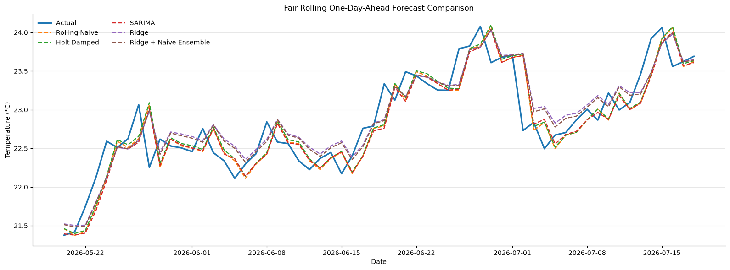
Figure 11. Actual and predicted temperatures during the final 60-day test period.
The prediction lines followed the overall movement of the actual temperature series closely. The largest errors generally occurred during sudden daily changes, while forecasts were more accurate during periods of gradual movement.
The ensemble balanced the Ridge model’s trend and seasonal features with the persistence of the rolling-naive forecast. This produced a small but consistent reduction in average absolute error.

Model Ranking and Interpretation
Rank | Model | Main interpretation
1 | Ridge + Naive Ensemble | Best overall MAE and percentage errors
2 | SARIMA | Strong statistical time-series performance
3 | Holt Damped | Competitive simple trend model
4 | Ridge Regression | Best RMSE and strong linear performance
5 | Rolling Naive | Strong baseline due to temperature persistence
6 | Random Forest | More complex but less accurate
7 | Seasonal Naive | Weekly lag did not represent the series well
The results demonstrate that the best-performing models were relatively simple. This is an important finding because advanced or nonlinear algorithms do not automatically produce better forecasts.

Feature Importance
Feature importance was examined using two approaches:
- Standardized Ridge regression coefficients
- Random Forest feature importance

Main Feature-Importance Results
Feature | Result
Previous day’s temperature | Most influential feature in both models
Recent temperature lags | Strong contribution to next-day prediction
Rolling averages | Captured recent temperature level
Rolling minimum and maximum | Represented recent variation and range
Day-of-year features | Captured annual seasonality
Trend feature | Represented gradual movement over time
The previous day’s temperature was the most important predictor. Its Random Forest importance was approximately 0.743, while its standardized Ridge coefficient was approximately 2.424.
This result confirms that the daily global temperature series had strong short-term persistence. Recent observations contained more predictive information than distant lags or complex nonlinear interactions.
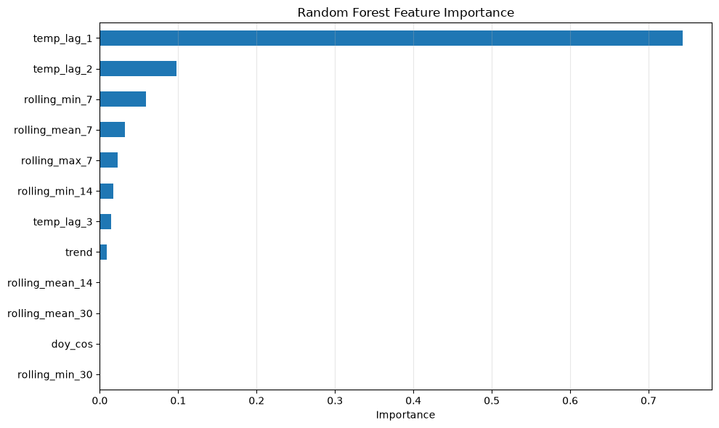
Figure 12. Relative importance of lagged, rolling and calendar features in the Random Forest model.
The feature-importance results should not be interpreted as causal effects. They indicate which variables were most useful for prediction within the fitted models.

Future 30-Day Forecast
After model evaluation, Ridge regression was retrained using all available daily observations and used to generate a recursive 30-day future forecast.
The forecast began on 19 July 2026, the day after the final observation in the dataset.

Future-Forecast Method
For each future date:
- Lagged and rolling features were calculated from the available history.
- Ridge regression predicted the next temperature.
- The predicted value was added to the historical series.
- The updated history was used to forecast the following day.
This recursive process allowed forecasts to be generated for dates where actual temperature observations were not available.
The first forecast value was approximately 23.68°C. The forecast then showed a gradual decline through late July, consistent with the seasonal pattern learned by the model.
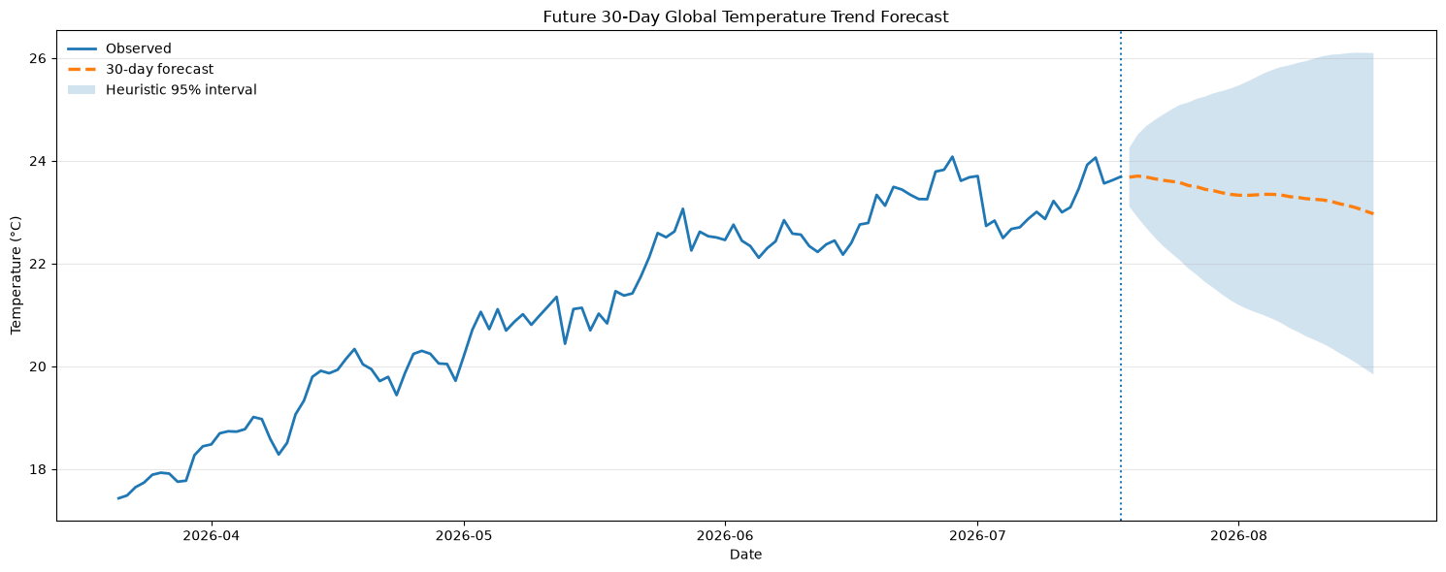
Figure 13. Recursive 30-day forecast of the country-balanced global temperature trend.
The uncertainty interval widened as the forecast horizon increased. This reflects the accumulation of uncertainty when predicted values are repeatedly used as inputs for later forecasts.
The displayed interval was heuristic rather than a fully calibrated probabilistic confidence interval. It should therefore be interpreted as an approximate indication of increasing uncertainty.
The forecast represents a broad trend in the sampled global daily temperature series. It is not intended to predict the weather of a specific city or country.

Main Forecasting Findings
- The Ridge and rolling-naive ensemble achieved the lowest test MAE.
- Ridge regression achieved the lowest RMSE.
- The rolling-naive model remained a strong baseline.
- SARIMA and Holt produced competitive results.
- Random Forest did not outperform the simpler models.
- The previous day’s temperature was the strongest forecasting feature.
- The future forecast showed a gradual short-term temperature decline.
- Careful evaluation and leakage prevention were more important than model complexity.

Key Findings
The project produced several important findings across data quality, exploratory analysis, environmental analysis and forecasting.
- A small number of severe data-quality errors were present.
These included unrealistic pressure, wind and temperature values, as well as negative pollution measurements. Replacing only the invalid measurements preserved the remaining useful information in those rows.
- Temperature showed clear seasonal and geographic variation.
Average sampled temperature changed across months and generally decreased as absolute latitude increased.
- Precipitation and pollution variables were strongly right-skewed.
Most observations contained low or zero values, while a smaller number contained much higher measurements.
- Temperature and feels-like temperature were very strongly related.
Wind speed and gust speed also showed a strong positive relationship.
- Air quality differed considerably across sampled countries.
However, relationships between weather and pollution were generally weaker than relationships among the pollutant variables themselves.
- Anomaly detection identified unusual multivariate weather combinations.
These observations were retained as review candidates because statistical anomalies may represent genuine extreme weather rather than data errors.
- Simple forecasting approaches performed strongly.
The rolling-naive baseline, Holt, SARIMA and Ridge regression all achieved competitive results.
- The Ridge and rolling-naive ensemble produced the best overall MAE.
It achieved an MAE of approximately 0.2206°C, modestly improving on the rolling-naive baseline.
- Recent temperature was the strongest predictor.
The previous day’s temperature was the most important feature in both Ridge regression and Random Forest.
- Greater model complexity did not guarantee better accuracy.
Random Forest performed worse than several simpler statistical and linear approaches.

Project Limitations
Although the project provides useful insights, several limitations should be considered.

Limited Time Coverage
The dataset covers approximately 2.2 years, from May 2024 to July 2026. This period is sufficient for analysing short-term weather variation and seasonal patterns, but it is not long enough to support strong conclusions about long-term climate change.

Uneven Geographic Coverage
The number of observations varied across locations and countries. Some countries were represented by a single sampled location, while others contained multiple locations. The geographic results therefore represent the available sample rather than complete national or global averages.

Location Filtering
Locations with fewer than 30 observations were removed to improve temporal consistency. Some excluded groups contained unusual or inconsistent location names, while others were valid locations with insufficient historical coverage. As a result, the filtering may have removed a small amount of valid information.

Aggregated Forecast Target
The forecasting model predicts a country-balanced global daily temperature trend. It does not predict the weather for a specific city, country or individual location.

Recursive Forecast Uncertainty
The 30-day forecast was generated recursively. Each predicted value was used to create later lagged features, meaning that prediction errors could accumulate as the forecast horizon increased.
The displayed uncertainty interval was heuristic and was not a fully calibrated probabilistic confidence interval.

Correlation Does Not Establish Causation
Relationships between weather and pollution variables were descriptive. The analysis did not establish that one variable directly caused changes in another. Air quality can also be influenced by emissions, traffic, industry, geography and population activity.

Anomaly-Detection Assumptions
The Isolation Forest contamination parameter was set to 2%, meaning that the model was instructed to flag approximately 2% of complete observations. This does not prove that exactly 2% of the data was incorrect.

Conclusion
This project analysed the Global Weather Repository dataset using data cleaning, exploratory analysis, anomaly detection, environmental analysis, geographic comparisons and time-series forecasting.
The preprocessing stage identified and treated invalid measurements, removed redundant variables and improved temporal consistency. Exploratory analysis revealed clear seasonal, geographic and environmental patterns, while advanced analysis identified unusual weather combinations and geographic differences in temperature and air quality.
Several forecasting approaches were evaluated using a chronological, leakage-safe rolling procedure. The Ridge and rolling-naive ensemble achieved the lowest mean absolute error, while Ridge regression achieved a similarly strong result. The improvement over the persistence baseline was modest, demonstrating that recent temperature observations already contained substantial predictive information.
The results show that reliable forecasting depends not only on selecting advanced algorithms, but also on careful data validation, appropriate feature construction, leakage prevention and fair evaluation. In this project, simpler statistical and regularized linear models performed better than the more complex Random Forest model.
Overall, the project demonstrates a complete data-science workflow, from raw-data preparation and exploratory investigation to advanced analysis, model comparison and future forecasting. It also highlights the importance of interpreting results honestly and recognising the limitations of the available data.

References
1. Global Weather Repository. Kaggle dataset: https://www.kaggle.com/datasets/nelgiriyewithana/global-weather-repository
2. Product Manager Accelerator. About Dr. Nancy Li: https://www.pmaccelerator.io/about-dr-nancy-li

