Is phoneme inventory size influenced by speaker population size and isolation?
Sam, Xia, Lindell

Journal of Language Evolution
- Short reports: focused reports of empirical or theoretical findings, presenting a clear account of the data, methods and results, but without necessarily providing extensive background or interpretations; 3,000 words maximum;

Abstract:
Phoneme inventory size is related to speaker population size, but the cause of this relationship has remained a mystery. The correlation was first reported by Hay and Bauer (2007), who considered several possible causes of this relationship, including ascertainment bias, similarity between relatives, and loss of phonemes in small, isolated populations. Here we test these three proposed causes of the correlation, and show that the relationship reported by Hay and Bauer is driven by similarity between relatives and neighbours in both speaker population size and phoneme inventory size. However, we also show that phoneme inventory size is related to aspects of linguistic isolation, in particular that languages endemic to islands have lower phoneme inventories, and those with more languages in contact have higher phoneme inventories.

Introduction:

“To our knowledge, no-one has ever reported a statistical correlation between the number of speakers of a language, and how many phonemes that language has. This, of course, is not surprising: why would anyone look for such an association in the first place? It is certainly not an association one would necessarily expect.”
HAY, J. & BAUER, L. 2007. Phoneme inventory size and population size. Language, 83, 388-400.

A short paper published in Language in 2007 reported a curious result (Hay and Bauer 2007). The analysis had been prompted not by a theoretical question but by an observation. When collating typological features of a sample of languages, the authors noticed an apparent association between number of vowels and speaker population size that suggested further investigation might be fruitful. For a sample of 216 languages, they found significant correlations between population size and phoneme inventory size, not only for total phoneme count but also subsets of types of phonemes including vowels, consonants, obstruents and sonorants. Hay and Bauer (2007) noted that language families differ in both population size and phoneme inventory size, so they added family as a factor in an analysis, and also repeated the analysis on family average values. But however they analysed their data, the basic pattern remained: a positive association between population size and phoneme inventory size. The authors seemed frankly surprised at the generality and robustness of the relationship: “In this short report we show that there is, indeed, an association between phoneme inventory and population size. We do not have well-developed theoretical arguments to offer about why this should be. However the correlation seemed intriguing enough that it was worth simply publishing the result, and leaving it up to readers to draw their own conclusions.” (Hay and Bauer 2007).

They did offer some possible explanations of the observed association between phoneme inventory size and population size based on previous proposals:
(1) small, isolated populations lose phonemes because lower accuracy of phonological definition is tolerable (attributed to Haudricourt 1961);
(2) small, isolated populations lose phonemes because close social connections permit reduction in phonological redundancy (Trudgill 2002);
(3) large speaker populations can support larger phoneme inventories because child learners are exposed to a greater number of speakers, and increased exposure allows robust learning permitting more categories to be distinguished.
Hay and Bauer (2007) also considered whether data bias or analytical artefacts could have produced their result. For example, languages with large numbers of speakers may be better studied so may have more thoroughly recorded phoneme inventories, inflating phoneme inventory counts relative to smaller, less well-studied languages. They rejected this explanation on the grounds that the positive relationship between population size and phoneme inventory size occurred for family averages, which they argued would reduce the influence of well-studied families such as Indo-European. They also considered whether their result could be driven by family bias in both phoneme inventory size and population size – for example, Australian languages have small vowel inventories and small populations, while Indo-European languages have larger vowel inventories and larger populations. But they rejected these family level trends as a cause of the relationship because the same correlation was observed for family average values of both phoneme inventory size and population size. They conclude that the “positive correlation between how many phonemes a language has, and how many speakers it has….. is not an artefact of language family. We do not know what the underlying causes of this correlation are. But it is certainly intriguing, and we hope that this short discussion note will generate some discussion of the possible causes of such a relationship” (Hay and Bauer 2007). In this paper we test several of the proposed causes of the relationship between phoneme inventory size and population size: artefacts of analysis (relatedness and proximity of languages), uneven research effort (geographic bias and level of documentation) and linguistic isolation (degree of contact between languages).

There are three ways for a phoneme to enter a language, vertically (inherited from ancestral language), horizontally (borrowed from another language), or de novo origin (innovation within a language). In addition, phonemes can be lost from a language, through attrition or redundancy. Size of phoneme inventory can therefore influenced by inheritance, contact, innovation and population-level processes that increase chance of loss. While studies at the individual, population or generational level can highlight processes of gain and loss of phonemes within speaker populations (e.g. Baranowski 2013; Kerswill and Shockey 2007), comparing phoneme inventories of different languages allows evaluation of general drivers of phoneme gain, retention and loss over longer time periods (e.g. Atkinson 2011; Creanza et al. 2015; Dediu et al. 2017; Maddieson 2023). By comparing overall phoneme inventory size between languages with different population sizes and language ecologies, we can identify factors that are associated with phoneme gain, retention and/or loss. Here we consider inheritance from shared ancestors (vertical transmission of phonemes), contact with neighbouring languages (horizontal transmission of phonemes) and population size (potentially influencing de novo origin, retention and loss of phonemes).

Phoneme inventories undergo descent with modification. Languages inherit their phoneme inventories from their ancestors, but these inventories can then become modified by gain and loss of phonemes. Because they are derived from the same ancestral phoneme inventory, we would expect two related languages to be more similar in phoneme inventory size and composition than two randomly selected languages. Phoneme inventory sizes are broadly similar between relatives, for example many of the smallest phoneme inventories are from Austronesian languages, while many of the largest are from African languages (Figure 1). Population size is also non-randomly distributed (Bromham 2024a). This non-random distribution across regions and families could lead to a correlation even in the absence of a causal connection between population size and phoneme gain, retention or loss (Bromham and Yaxley 2023; Roberts and Winters 2013; Urban and Moran 2021). Furthermore, phoneme inventories can be influenced by borrowing, so contact and proximity with other languages may also influence phoneme inventory size and content (Blevins and Egurtzegi 2023; Creanza et al. 2015; Moran et al. 2021).

Our focus in this paper is testing Hay and Bauer’s (2007) observed relationship between population size and phoneme inventory size. Because the theories cited by Hay and Bauer focus on the effect of small isolated populations on reduction in phoneme inventories, we use a number of measures of language isolation in addition to population size and area. Isolation and contact are notoriously tricky to quantify, so our approach here is to use a range of variables that might reflect the ease of contact between speakers of different languages, such as how many other language distributions are in contact, and whether a language occurs on an island or in a mountainous area or area of rough terrain. But in order to examine the possible influence of these population factors on phoneme inventories we must take language distribution and relationships into account.

Because languages are similar to their relatives and neighbours in many aspects, we expect to find correlations between many aspects of language, population and environment. Correlations generated by phylogenetic non-independence (similarity due to descent) and spatial autocorrelation (similarity due to proximity and shared environments) can be sufficient to drive a strong correlation between aspects of language, population and environment. For example, a correlation between tonality and humidity has been reported (Everett et al. 2016), but this could be due to a greater concentration of languages in tropical areas, or non-random patterns of tones among areas and language groups (Collins 2017). When language data is analysed with information on location and relationships, there is no significant association between tone and humidity beyond that accounted for by similarity between neighbours and relatives (Bromham and Yaxley 2023; Hartmann et al. 2024). Similarly, an association between ejectives and altitude has been proposed (Everett 2013), but questioned on the grounds that mountain communities might be similar due to language relationships and distribution, and a shared history that resulted in contact-induced change in phoneme inventories between languages (Urban and Moran 2021).

Correlation due to descent from a common ancestor is generally known as phylogenetic non-independence or referred to as “Galton’s problem” (Bromham 2024b). Moran et al (2012) addressed the problem of non-independence of phoneme inventories due to genealogical relationships between languages by adding language family as a factor in an analysis. Using a hierarchical mixed model with family as a factor, they found that language families tend to have a greater influence on phoneme inventory size than population size factors. They concluded that “although overall the trend across languages is modestly positive, for many families we can expect the relationship between the phoneme inventory size and population to be negative or zero” (Moran et al. 2012). Similarly, Donahue and Nicholls (2011) examined the relationship between phoneme inventory size and L1 population size and found that the relationship varied between families, with some showing a positive association, but others no association or a negative trend (Donohue and Nichols 2011). We can conclude from these studies that phoneme inventory size is often correlated with population size, but this relationship is moderated by family and region, so to describe general relationships and test proposed mechanisms we need to take language relationships and distribution into account. However, adding language or region as a factor in an analysis does not fully account for phylogenetic non-independence {Hua, 2025 #45}. For example, the Austronesian language family contains over 1200 languages (Hammarström et al. 2022), 89 of which are represented in PHOIBLE, with phoneme inventory counts range from 17 to 55 (Moran et al. 2014). Within this family there are clear areal and genetic patterns, for example a west-to-east decline in inventory size for the Oceanic languages (Blust 2013). A number of processes have been proposed that shape phoneme inventory sizes within this family, such as a gradual “erosion” as populations expand eastward across Oceania, due to founder effects, isolation and small population size (Blust 1990; Trudgill 2004). We expect two closely related and co-located Austronesian languages to be more similar in their phoneme inventory count than two languages chosen at random from the family - for example, within the Austronesian language family, eastern Polynesian languages all tend to have relatively small phoneme inventories compared to other languages in the family. Therefore we need to take relationships between all languages into account when analysing data on phoneme inventory size, not simply their family or macroarea (Naranjo and Mertner 2023).

In this study we assess the generality of the association between phoneme inventory size and L1 speaker population size. We test several possible causes of the previously reported correlation between phoneme inventory size and population size {Hay, 2007 #2}: population size and isolation (phonemes inventories undergo reduction in small isolated populations), ascertainment bias (well-studied languages have larger phoneme inventories) phylogenetic non-independence (relatives more similar in both phoneme inventory and population size) and spatial autocorrelation (neighbours more similar in both phoneme inventory and population size).

Methods
1. Is phoneme inventory size related to population size?
Several phoneme inventory databases are available, differing in their coverage and their reported phoneme sizes (and some databases contain multiple values for the same language). To ensure that phoneme classification and representation are in the same data format, we use standardised language phoneme count data provided by Anderson et al. (2023), who matched phonemes according to the Cross Linguistic Transcription System (CLTS) so that all datasets shared the same phoneme representation convention. Only segmental phonemes were included (vowels and consonants), other suprasegmental features such as tone were not (Anderson et al. 2023). We match language phoneme count data entries from Anderson et al. (2023) to the language database of Bromham et al. (2022) by mapping Glottocodes to ISO-693 codes (using PHOIBLE values as they have the largest coverage). There is not always a simple one-to-one mapping from Glottocodes to ISO codes, largely because dialects can have glottocodes, reducing the number of languages for which we can map phoneme inventory data to language population data (see Table 1). For example, the ISO-693 code gru (Kistane, Afro-Asiatic) corresponds to the glottocodes kist1241 (Kistane) and sodd1242 (Soddo, which does not have an ISO.693 code). Similarly, sgw (Sebat Bet Gurage, Afro-Asiatic) corresponds seba1251, ezha1238, chah1248 and gume1239, and nyf (Giryama, Atlantic-Congo) corresponds to giry1241, kamb1298 and kaum1238. Where we have duplicate codes, we delete all of them, as we do not have a systematic method to determine which one should be retained. This resulted in the deletion of 94 entries.

To represent speaker population size, we use estimated number of first language (L1) speakers {Bromham, 2022 #5}. Clearly these are imperfect measures of speaker population size, because they do not include second language speakers, and are dependent on census size from a range of sources – furthermore, speaker size and distribution is dynamic so any values can represent only a snapshot at a point in time {Bromham, 2023 #8}. However, these data are relevant to this question because previous studies have explored the association between contemporary L1 population and phoneme inventory size {Hay, 2007 #2;Moran, 2012 #9}. Although historic population sizes would be a more relevant reflection of the language ecology in which each language developed its phoneme inventory, available population size data is limited to reflecting contemporary speaker population sizes (Bromham 2023): for example, there are 13 languages in this dataset that have a reported L1 speaker population of zero (Figure 2). However, there is currently no alternative source of historic L1 speaker population size available for a sufficient sample of languages (see discussion in (Bromham 2023). We do not use second language (L2) estimates because they are available for relatively few languages (e.g. 120 in (Shcherbakova et al. 2023))

We assign languages to families and macroareas (geographic regions) using Glottolog 4.8 (Hammarström et al. 2022). We use the assignment of languages to broad geographic areas to test for geographic bias in data on phoneme inventory size. The twelve regions are defined in Bromham et al (2022) based on the overlap between language distributions with regions defined in the Natural Earth dataset (https://www.naturalearthdata.com/), defines regions with respect to both geography and political sovereignty.

To ask whether phoneme inventory size is related to L1 population size, we use a phylospatial analysis method that takes into account the location of each language and its relationship to all other languages {Hua, 2019 #46}.

2. Is phoneme inventory size shaped by area and isolation?
Relative degree of language contact is challenging to represent than in a format that is comparable across all languages {Bromham, 2022 #5}. We use several variables to represent different aspects of contact which are available for the majority of the world’s spoken languages (Table 2). Language area has previously been used to represent linguistic isolation, on the assumption that a more widespread language will have increased opportunity for contact with L1 speakers of other languages, or adult L2 learners within the language area (Lupyan and Dale 2010). We also include how many other autochthonous languages whose distributions overlap or touch the language area, both as an absolute number of languages, and number of languages divided by the perimeter of the language range. We include two variables representing physical isolation - altitudinal range and whether the language occurs only or predominantly on an island – though we acknowledge that physical barriers of steep terrain or water may reflect ease of moving over the landscape they do not necessarily represent barriers to contact between language groups. Because we are concerned with the historical development of phoneme inventories, we do not include measures that might reflect recent contact, such as roads or change in the built environment {Bromham, 2022 #5}.

3. Is phoneme inventory size of island languages influenced by isolation of islands?
Phoneme inventory sizes tend to be smaller for island languages {Bromham, 2024 #47}, and it has been suggested that phoneme inventories could undergo serial reduction along chains of colonization and settlement. Here we ask if phoneme inventory size for island endemic languages (>90% distribution on landmasses <11,000km2) is correlated with the further an island is away from a mainland (>25000km2) or continental (>xxx) landmass. We also include L1 population and area of each language endemic.
- Optional: We also add area and maximum elevation of the island to separate the effects of island size and topology. (This is possible if we can link islands to island endemic languages – I cant see this in the datatables for the NEE24 paper – there is data on language per island in Data S2 but not apparently in a form than links to the list of island endemic languages in Table S1. We could scrape island size from Table S1 but I don’t think it would be worth it as it wont give better info compared to language range).

4. Does ascertainment bias influence global analysis of phoneme inventory size?
Sampling bias has been put forward as a possible explanation for the relationship between phoneme inventory size and population size, on the assumption that larger languages tend to be better studied, and well-studied families may not have globally representative phoneme inventory sizes (Hay and Bauer 2007). We investigate the sources of two forms of data bias in phoneme inventory sizes: geographic coverage and relative linguistic attention as represented by level of available language documentation.

We test whether our dataset of phoneme inventory sizes is biased towards particular regions, compared to a random sample of the world’s languages. To generate a null model of the expected number of languages per area, we randomly sampled N languages from the global database where N is the number of languages included in the phoneme inventory dataset (see Table 1), and record how many of the randomly sampled languages are in each global region. We repeat the random sample 1000 times, report the average, minimum and maximum values for languages per region, against which our language sample can be compared. This generates the number of languages from each region that we would expect from a geographically unbiased sampling process. We can then compare the distribution across regions in our observed sample - the languages for which we have comparable phoneme inventory size data.

To generate this null model, we use the database of Bromham et al (2022) which contains 6511 languages (over 90% of the world’s L1 spoken languages), which has been database curated to only include languages for which comparable data is available on population size and distribution. While Glottolog contains a larger set of languages (8595), it includes languages for which population size data is not currently available. In addition, Glottolog includes a wide range of language types including cants (e.g. Polari, pld), constructed languages (like Esperanto, eco), market languages and pigins (like Fanagalo, fng), and speech registers (like Shelta, sth), as well as signed languages and unattested languages. Because none of these categories of language are included in the database that we use to test the relationship between population size and phoneme inventory size, we could not have included them in this analysis, so they are not appropriate for the null model of sampling bias. For example, if relatively more non-L1 languages such as cants and speech registers recorded for Indo-European languages, then it will give the impression that our empirical sample of phoneme inventories (which didn’t include cants and speech registers) is under-sampling Indo-European languages.

For documentation, we use an ordered categorical variable based on information on language documentation available in Glottolog (v4.2.1): 0 = little or none (no documentation recorded or only basic wordlist); 1 = basic (e.g. phonology, textual material, grammar sketch); 2 = detailed (e.g. long grammar) {Bromham, 2022 #5}. This basic measure does not fully reflect linguistic research attention, but it is the only globally comparative metric that would allow us to ask if language that have been more extensively studied have relatively higher phoneme counts.

Results
Geographic bias
The null model reveals that the available data on phoneme inventory size from PHOIBLE is geographically biased. African languages are relatively well-represented in these databases, whereas languages from Southern Asia, South East Asia are relatively undersampled, compared to the number of languages in the global database.

Literature cited
Anderson C, Tresoldi T, Greenhill SJ, Forkel R, Gray R, List J-M (2023) Variation in phoneme inventories: quantifying the problem and improving comparability. Journal of Language Evolution:lzad011
Atkinson QD (2011) Phonemic diversity supports a serial founder effect model of language expansion from Africa. Science 332(6027):346-349
Baranowski M (2013) On the role of social factors in the loss of phonemic distinctions. English Language and Linguistics 17(2):271-295
Blevins J, Egurtzegi A (2023) Refining explanation in Evolutionary Phonology: macro-typologies and targeted typologies in action. Linguistic Typology 27(2):289-311
Blust R (1990) Patterns of sound change in the Austronesian languages. Linguistic change and reconstruction methodology:231-267
Blust R (2013) The Austronesian: revised edition. Asia-Pacific Linguistics, Research School of Pacific and Asian Studies, The Australian National University, Canberra
Bromham L (2023) Language endangerment: Using analytical methods from conservation biology to illuminate loss of linguistic diversity. Cambridge Prisms: Extinction 1:e3
Bromham L (2024a) Population size and language change: an evolutionary perspective. Annual Review of Linguistics 11
Bromham L (2024b) Solving Galton’s problem:practical solutions for analysing language diversity and evolution. In: Evans B, Gallego MK, Miceli L (eds) Historical Linguistics 2019: Selected papers from the 24th International Conference on Historical Linguistics, Canberra, 1–5 July 2019. John Benjamins, pp 75–109
Bromham L, Dinnage R, Skirgård H, Ritchie A, Cardillo M, Meakins F, Greenhill S, Hua X (2022) Global predictors of language endangerment and the future of linguistic diversity. Nature ecology & evolution 6(2):163-173
Bromham L, Yaxley KJ (2023) Neighbours and relatives: accounting for spatial distribution when testing causal hypotheses in cultural evolution. Evolutionary Human Sciences 5:e27
Collins J (2017) Real and spurious correlations involving tonal languages. In: Dependencies in language: On the causal ontology of linguistics systems. Language Science Press, pp 129-139
Creanza N, Ruhlen M, Pemberton TJ, Rosenberg NA, Feldman MW, Ramachandran S (2015) A comparison of worldwide phonemic and genetic variation in human populations. Proceedings of the National Academy of Sciences 112(5):1265-1272
Dediu D, Janssen R, Moisik SR (2017) Language is not isolated from its wider environment: vocal tract influences on the evolution of speech and language. Language & Communication 54:9-20
Donohue M, Nichols J (2011) Does phoneme inventory size correlate with population size? Linguistic Typology 15:161-170
Everett C (2013) Evidence for direct geographic influences on linguistic sounds: The case of ejectives. PloS one 8(6):e65275
Everett C, Blasi DE, Roberts SG (2016) Language evolution and climate: the case of desiccation and tone. Journal of Language Evolution 1(1):33-46
Hammarström H, Forkel R, Haspelmath M, BAnk S (2022) Glottolog 4 (Available online at http://glottolog.org) In: Max Planck Institute for the Science of Human History, Jena
Hartmann F, Roberts SG, Valdes P, Grollemund R (2024) Investigating environmental effects on phonology using diachronic models. Evolutionary Human Sciences 6:e8
Hay J, Bauer L (2007) Phoneme inventory size and population size. Language 83(2):388-400
Kerswill P, Shockey L (2007) The description and acquisition of variable phonological patterns: phonology and sociolinguistics. In: Phonology in context. Springer, pp 51-75
Lupyan G, Dale R (2010) Language structure is partly determined by social structure. PloS one 5(1):e8559
Maddieson I (2023) Investigating the ‘what’, ‘where’ and ‘why’ of global phonological typology. Linguistic Typology 27(2):245-266
Moran S, Lester NA, Grossman E (2021) Inferring recent evolutionary changes in speech sounds. Philosophical Transactions of the Royal Society B 376(1824):20200198
Moran S, McCloy D, Wright R (2012) Revisiting population size vs. phoneme inventory size. Language:877-893
Moran S, McCloy D, Wright R (2014) PHOIBLE online.
Naranjo MG, Mertner M (2023) Estimating areal effects in typology: a case study of African phoneme inventories. Linguistic Typology 27(2):455-480
Roberts S, Winters J (2013) Linguistic diversity and traffic accidents: Lessons from statistical studies of cultural traits. PloS one 8(8):e70902
Shcherbakova O, Michaelis SM, Haynie HJ, Passmore S, Gast V, Gray RD, Greenhill SJ, Blasi DE, Skirgård H (2023) Societies of strangers do not speak less complex languages. Science Advances 9(33):eadf7704
Trudgill P (2004) Linguistic and social typology: The Austronesian migrations and phoneme inventories.
Urban M, Moran S (2021) Altitude and the distributional typology of language structure: Ejectives and beyond. Plos one 16(2):e0245522

Table V. Variables included in the phylospatial analysis
Phoneme inventory size from (Anderson et al. 2023), all other variables are taken from (Bromham et al. 2022).
- Sam you can make the variable names whatever you like (you don’t need to use these ones but update them if you use something different) as long as they are consistent across all tables, figures text. Recommend variable names that are as simple to comprehend as possible. You could choose to use same variable names as used in NEE database or relable, as long as they are clear and consistent.
- Is Island from endangerment paper databse or updated for island NEE 2024

Information | Variable | Description | Source
Phoneme Inventory Size | PIS | Number of phonemes in language’s phoneme inventory | {Anderson, 2023 #20}, {Creanza, 2015 #24}
Population | L1_pop | Number of L1 speakers (log transformed value) | {Bromham, 2022 #5}
 | Area | Language distribution area (km²) | {Bromham, 2022 #5}
Contact | Bordering | Number of languages in contact | {Bromham, 2022 #5}
 | Altitude | Average altitudinal range of 10,000km² neighbourhood | {Bromham, 2022 #5}
 | Island | Language with >90% of distribution on landmasses <11000km² | {Bromham, 2024 #47}
Ascertainment bias | Documentation | Degree of availability of textual linguistic resources | {Bromham, 2022 #5}
 | Region | In which of XX global regions language is located | ???

Figure 1: Map of phoneme inventory size for 782 languages from the PHOIBLE dataset, plotted at the midpoint of the range
- Is the spatial position data from NEE database or from Glottolog
- Map looks a bit squished?

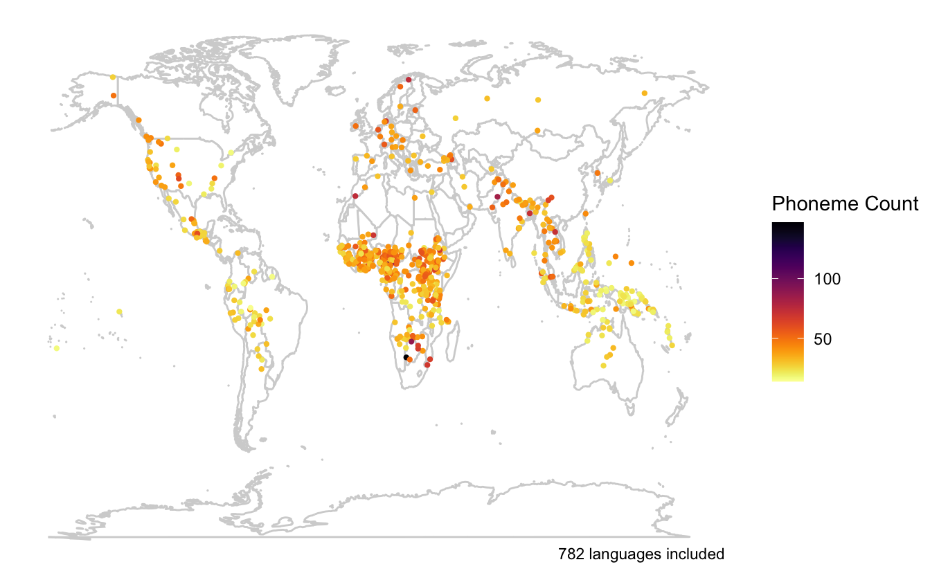

Figure 2: Phoneme inventory size vs L1 speaker population size across different global regions

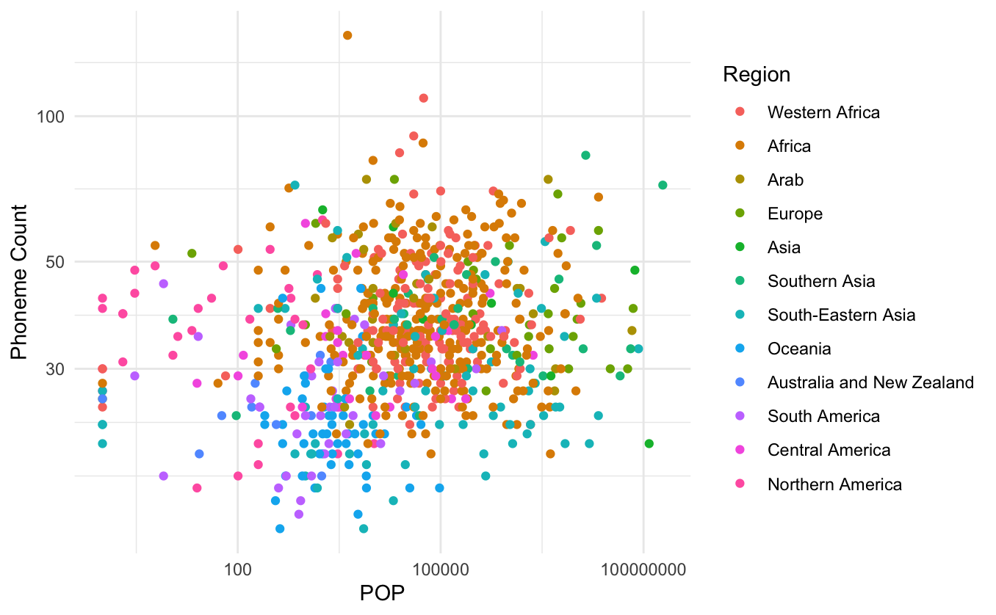

Figure 3 Geographic bias of phoneme inventory data, with the number of languages with available data from PHOIBLE (red dot) compared to the expected to expected number of languages from an unbiased sample (box and whisker) for each of 12 regions (see Bromham et al. 2022 for definition of regions).

