FAITH FISF Dataset
12/05/2013
Greg Zilliac
Gregory.G.Zilliac@NASA.gov
Nettie Halcomb
Nettie.V.Halcomb@NASA.gov

The FAITH_FISF.dat file is a Tecplot (version 10.0-3-66) readable .dat file. The dataset contains results of skin friction interferometry measurements on the FAITH model as well as measurements on the floor upstream and downstream of the FAITH model. All measurements were performed in the Fluid Mechanics Lab 32x48 inch wind tunnel at NASA Ames Research Center.

The measurements on the FAITH model were collect 9/2/09 and consisted of a single flow condition. The data were taken during three tunnel runs and combined into a single data set. The nominal tunnel dynamic pressure was 6.051 inched of H2O which corresponds to a nominal tunnel free stream velocity of approximately 163 ft/sec. The ambient temperature varied between 73.4 and 73.5º F.

The floor measurements were made 4/24/12. The data were taken during 5 tunnel runs and combined into a single data set. The nominal tunnel dynamic pressure was 5.836 inches of H2O which corresponds to a nominal tunnel free stream velocity of approximately 161 ft/sec. The ambient temperature varied between 66.20 and 67.98 º F.

This data set has combined the two data sets listed above for an overall total 2518 independent skin friction measurements. The format is an unstructured grid with the x, y, z coordinates listed first followed by the Cf value and the Cf components in the x, y, and z directions. The other information listed is not relevant for CFD purpose and is only useful to the FISF user.

The FAITH model geometry is described by H=3*cos(π x/9)+3 where H and x are in inches. The right-handed coordinate system used has its origin at the center of the model (at the model base) and X is positive in the stream-wise direction and Z points up along the symmetry axis. All dimensions are in inches.

Shown below are a couple of images of the dataset (viewed looking down on the model from above with flow from left to right).

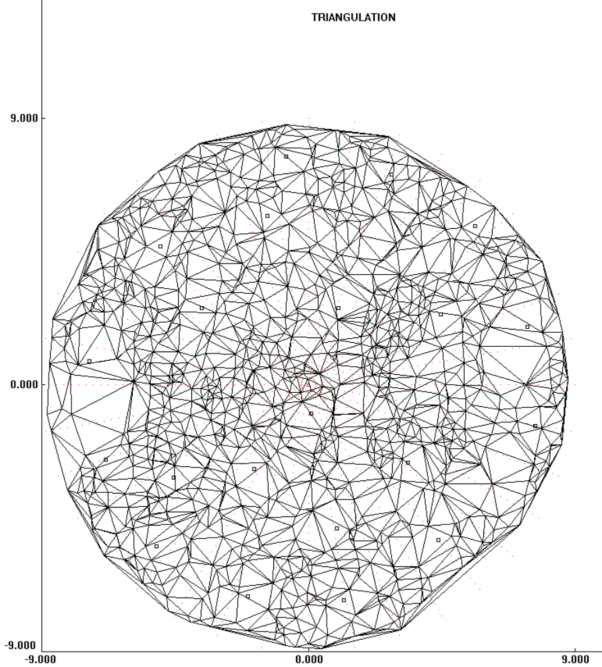

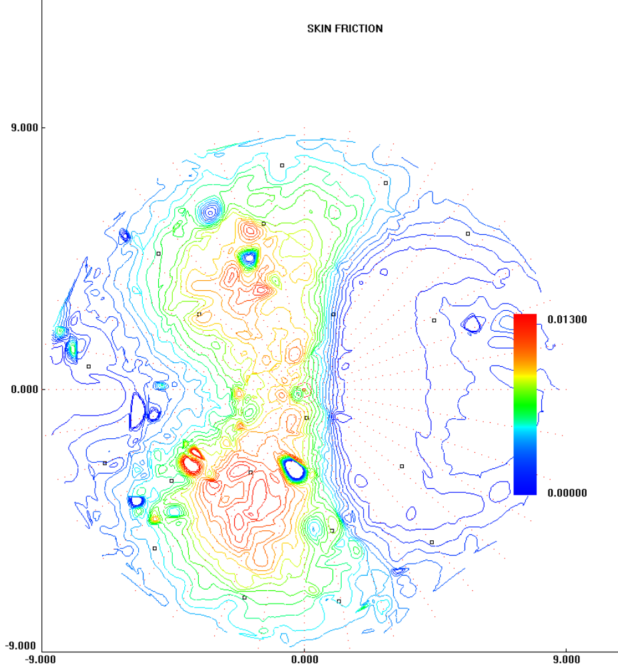

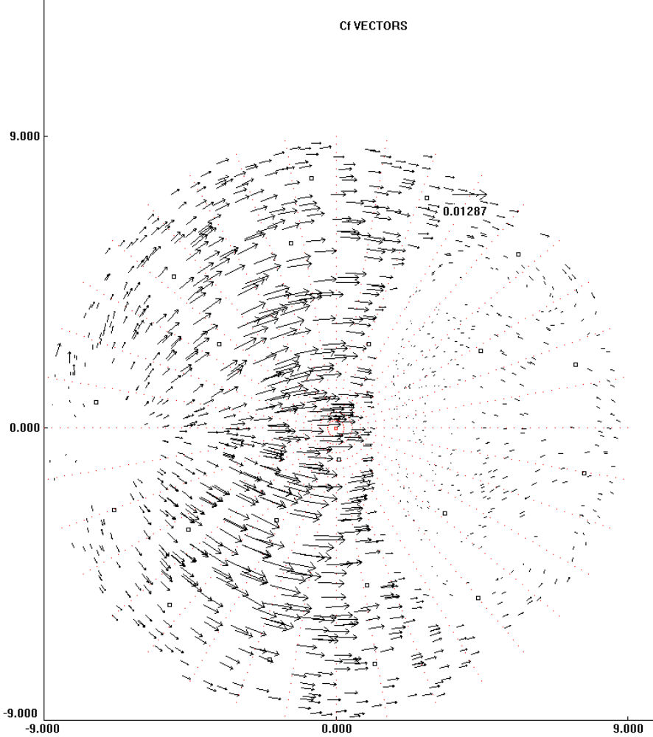

Additional information concerning the FISF measurement technique can be found in:

- Zilliac, G.G., “The Fringe Imaging Skin Friction Technique PC Application V5.0 User’s Manual,” NASA TM-2010-216391, July. 2010.

2. Zilliac, G. G.: Further Developments of the Fringe-Imaging Skin Friction Technique, NASA TM-110425, Dec. 1996.

3. Driver, D. M.: Application of Oil Film Interferometry Skin-Friction to Large Wind Tunnels, AGARD CP-601, Paper no. 25, Sept. 1997.

4. Walatka, P. P.; Plessel, T.; McCabe, R. K.; Clucas, J.; and Elson, P. A.: FAST User’s Manual, NASA Internal Report, Sept. 1991. (This document describes the PLOT3D format)

