Login Screen

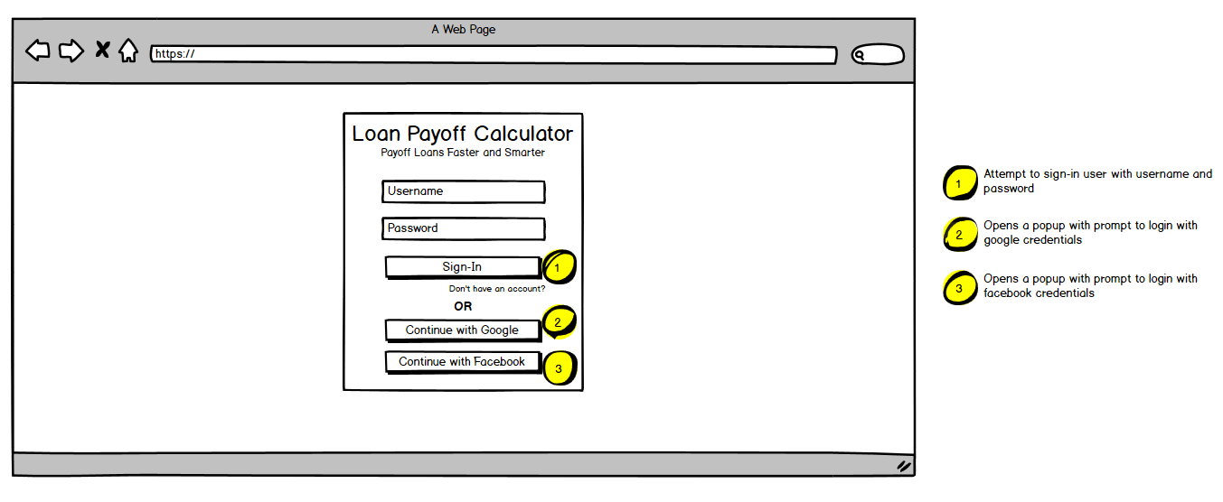

Dashboard

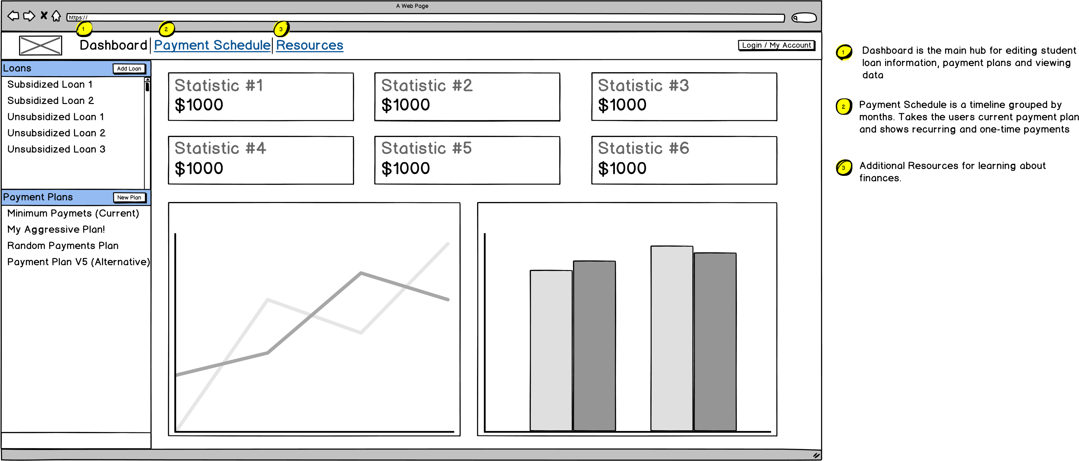

Dashboard - Loan

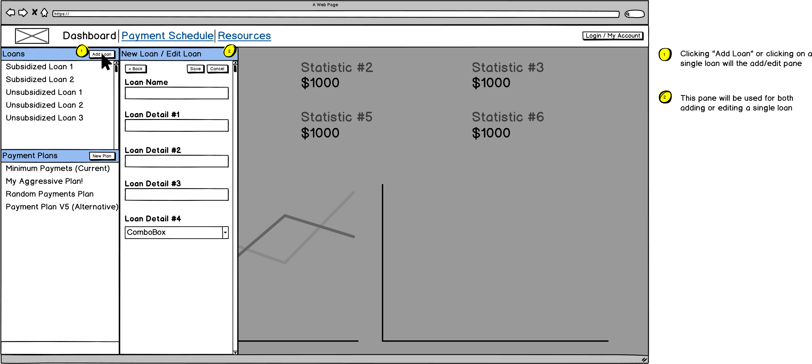

Dashboard - Payment Plans

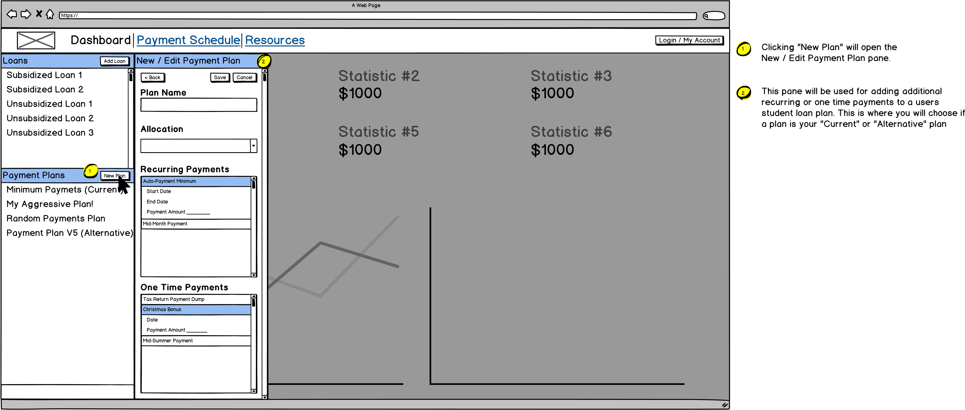

Payment Schedule

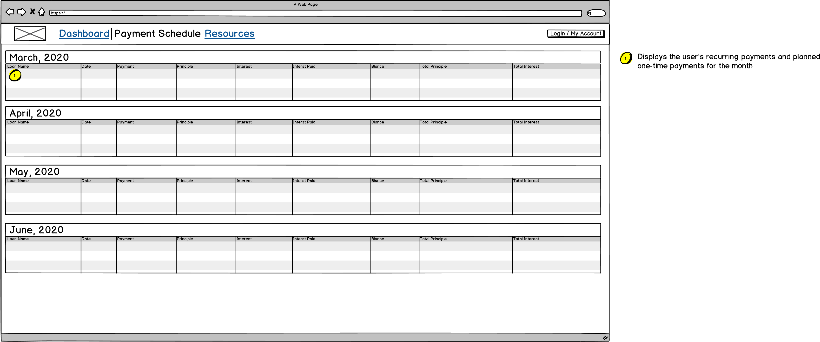

Resources

https://

A Web Page

Dashboard

Payment Schedule

Resources

Login / My Account

Resource Section #1

• Link #1 - Link Description

• Link #2 - Link Description

• Link #3 - Link Description

• Link #4 - Link Description

Section Description

Resource Section #2

• Link #1 - Link Description

• Link #2 - Link Description

• Link #3 - Link Description

• Link #5 - Link Description

• Link #6 - Link Description

• Link #7 - Link Description

• Link #8 - Link Description

Section Description

Resource Section #3

• Link #1 - Link Description

• Link #2 - Link Description

Section Description