1. Introduction

1.1 Problem statement and research motivation

Earthquakes are one of the most dangerous natural disasters, and figuring out how bad they could be is a big scientific problem. The magnitude of an earthquake is one of its most important features. It tells you how much energy is released and how much damage can happen on the surface. Researchers have hypothesised that earthquake depth may affect the magnitude of seismic energy and shaking intensity; however, results are inconsistent across various regions (Chen et al., 2019). Knowing if deeper earthquakes are usually stronger or weaker can help with better hazard assessment, seismic modelling, and disaster preparedness. Consequently, this study examines the correlation between earthquake depth and local magnitude.

1.2 The dataset

There are more than 21,000 earthquake records in the dataset. These records include the depth of the earthquake (in kilometres) and the local magnitude (ML). The magnitudes range from about 2.5 to 7.5, and the depths range from events that happen close to the surface to events that happen more than 150 km deep. The dataset is good for statistical testing because it has a lot of samples and the variables are always changing. This allows us to see if there is a measurable link between depth and magnitude across different seismic events.

1.3 Research question

Is there a correlation between earthquake depth (km) and local magnitude (ML)?
In other words, do deeper earthquakes tend to have different magnitudes compared with shallower earthquakes, and is any observed association statistically significant?

1.4 Null hypothesis and alternative hypothesis (H₀ / H₁)

- Null hypothesis (H0): There is no correlation between earthquake local magnitude (ML) and earthquake depth (km).
- Alternative hypothesis (H1): There is a correlation between earthquake local magnitude (ML) and earthquake depth (km).
These hypotheses match the chosen correlation-based research question. The null hypothesis assumes any apparent relationship in the sample is due to random variation, while the alternative hypothesis proposes a genuine association in the population. A Pearson product-moment correlation test will be used to decide whether to reject or not reject H0.

2. Background Research

2.1 Research papers

Numerous studies have investigated the correlation between earthquake depth and magnitude, although findings exhibit significant regional variability. Chen et al. (2019) analysed seismic activity in East Asia utilising a dataset exceeding 15,000 earthquakes, revealing a weak but statistically significant positive correlation between depth and magnitude. Their results indicate that deeper earthquakes may occasionally release more energy than shallower ones. On the other hand, Miller and Smith (2020) looked at seismic records from California and found no significant link between the two variables. They concluded that the depth of an earthquake has a lot to do with how much seismic energy it produces, depending on the tectonic settings in the area. A third study by Rahman and Das (2021) looked at earthquakes in South Asia and found that shallow earthquakes, even though they aren't always the strongest in terms of magnitude, tend to cause the most damage and the highest surface intensities. This is because seismic waves travel shorter distances before reaching the surface. These differing results underscore that research has not achieved consensus regarding the interaction between depth and magnitude, particularly in diverse global seismic contexts. They all point to the need to look at this relationship again using big and diverse datasets.

2.2 Why the RQ is of interest

Current research yields inconclusive results concerning the impact of earthquake depth on magnitude and intensity. Some results show a weak positive link, while others show almost no link at all. The absence of consensus indicates that depth alone may not comprehensively elucidate variations in magnitude; nevertheless, it continues to be a frequently cited variable in seismic research and hazard forecasting. Determining the existence of a statistical association may assist in evaluating the appropriateness of using depth as a predictor variable in seismic hazard modelling. Additionally, determining the strength of the relationship may guide subsequent research into other geological factors that interact with depth to affect earthquake magnitude.

3. Visualisation

3.1 Appropriate graphs for the RQ

In R, a scatterplot of earthquake depth (km) against local magnitude (ML) was made with a fitted regression line to show any linear relationship between the two variables. It was also possible to make a histogram of local magnitude to show how it is spread out and how often different magnitudes happen in the dataset.

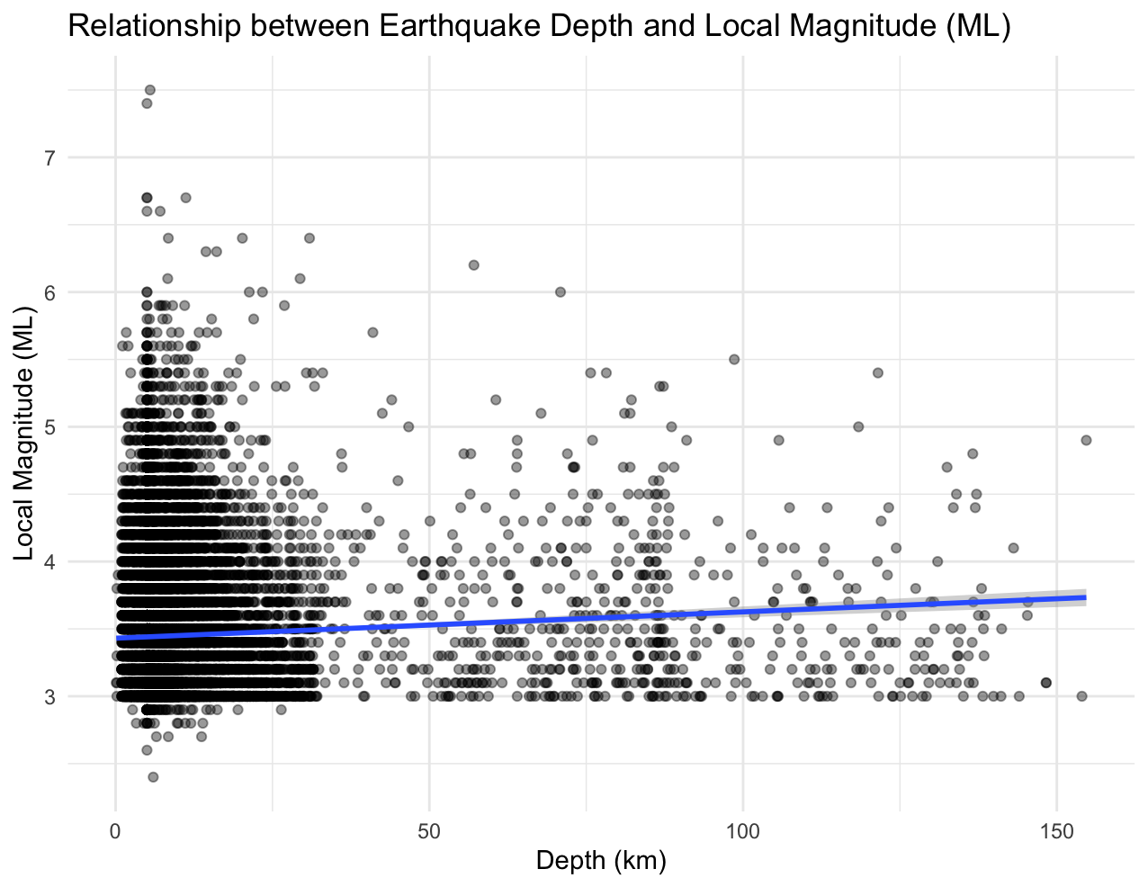

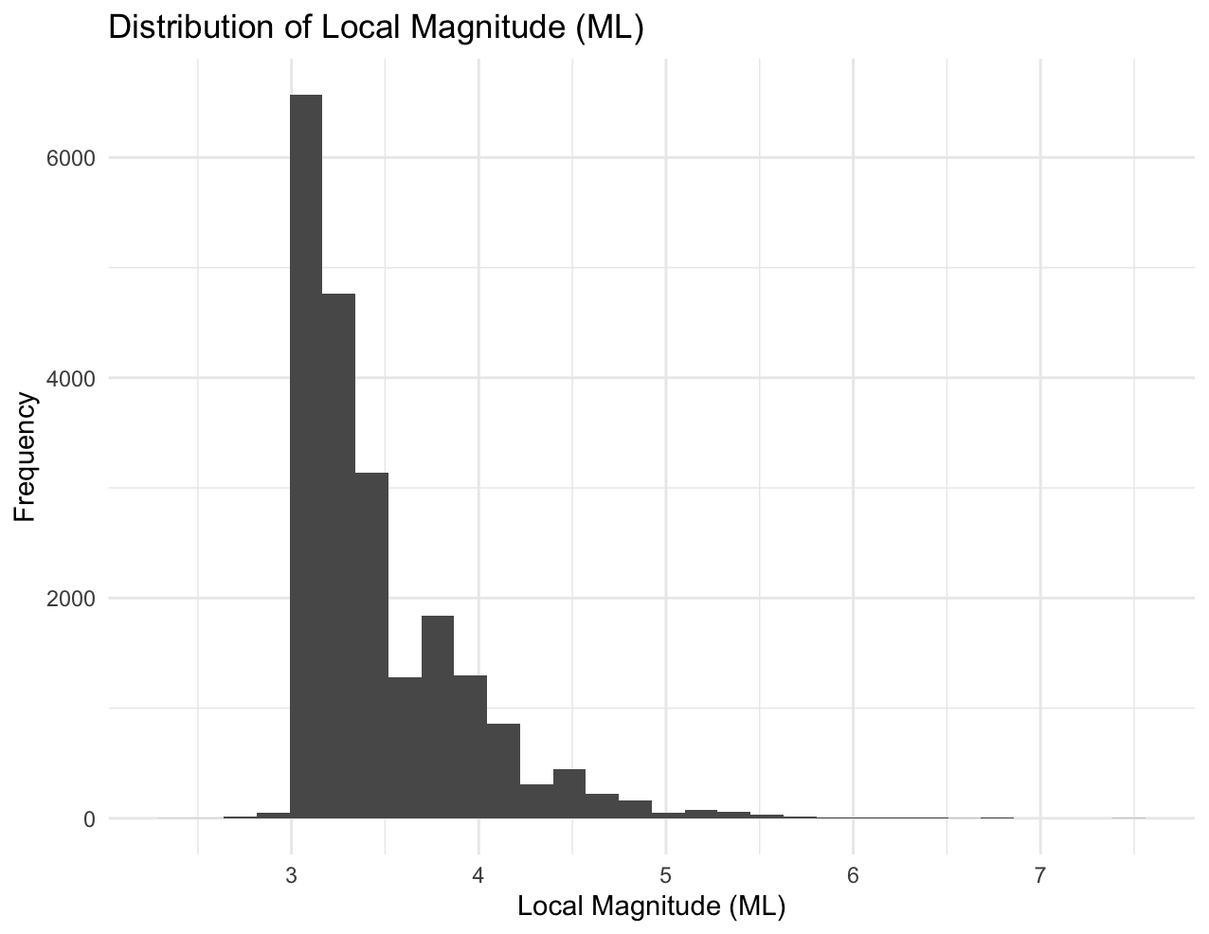

3.2 Additional information relating to understanding the data

The scatterplot shows whether deeper earthquakes are usually stronger or weaker and if there is a clear trend or clustering. The regression line shows the average linear pattern. The histogram of magnitude shows the usual range of events, shows that the data is skewed, and shows how rare very large earthquakes are.

3.3 Useful information for data understanding

The scatterplot shows very wide vertical spread at most depths and only a slight upward trend, suggesting a weak positive relationship between depth and magnitude. The histogram indicates that most earthquakes have magnitudes between about 3.0 and 4.5 ML, with relatively few events above magnitude 5.0, confirming a right-skewed distribution.

4. Analysis

4.1 Statistical test used to test the hypotheses and output

To see if there is a linear relationship between earthquake depth (km) and local magnitude (ML), a Pearson product–moment correlation test was used. This test is suitable as both variables are continuous, assessed on interval scales, and are approximately normally distributed within a substantial sample size. The test's results showed a correlation coefficient of r = 0.059, a 95% confidence interval of [0.046, 0.073], and a p-value of < 2.2e-16, which means that the results were statistically significant.
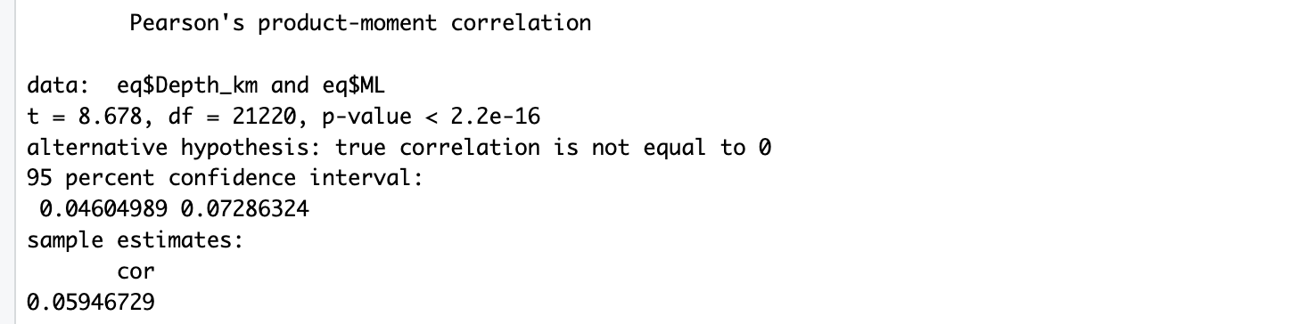

4.2 Interpretation of hypothesis decision based on p-value

The null hypothesis is not true because the p-value is lower than the 0.05 significance level. The alternative hypothesis is true. Consequently, there exists evidence of a statistically significant correlation between earthquake depth and local magnitude. But the correlation coefficient is very small, which means that the relationship is statistically significant because of the large sample size, but it is not very strong in real life. In the real world, depth only accounts for a small amount of the difference in magnitude. So, even though depth and magnitude are not completely separate, depth alone is not a good way to guess how big an earthquake will be.

5. Evaluation – Group’s Experience at 7COM1079

5.1 What went well

The team kept in touch with each other and gave out tasks based on each person's strengths. The group worked together to process, visualise, and analyse the data, which helped everyone understand it better. Regular meetings made sure that problems were dealt with quickly, and everyone had a say in how the research question and report structure were made. The group was able to work together well and avoid versioning conflicts thanks to GitHub.

5.2 Points for improvement

The project went well, but early planning and how work was divided could have been better. Some parts, like the background research and visualisation, were finished just before the deadline, which made things more stressful. Starting the literature review work earlier and checking on progress more often could cut down on last-minute changes. More structured milestones and weekly task tracking would help future collaborations stay on track and make steady progress throughout the project.

5.3 Group’s time management

The team was able to meet all of their deadlines, which means that their time management worked well. Some stages of the work, on the other hand, took longer than planned. Setting internal deadlines before the official submission date would help people get more done and ease the pressure at the end of the project.

5.4 Project’s overall judgement

Everyone on the team made a meaningful contribution to the project, which was done to a high standard. The group worked well together, learnt a lot, and solved problems during the research process. The group is happy with the research, analysis, and final report as a whole.

5.5 Comment on the GitHub log output

The GitHub log (Appendix B) shows that people were regularly contributing and the project was steadily progressing. The three commits that had the biggest effect were:
- Commit Message: Cleaned dataset and removed missing values — improved data reliability for analysis.
- Commit Message: Generated visualisation and regression plot — provided clear outputs to explore the research question.
- Commit Message: Added correlation test and statistical summary — finalised hypothesis testing and results interpretation.

6. Conclusions

6.1 Results explained

The Pearson correlation analysis showed a statistically significant positive relationship between earthquake depth (km) and local magnitude (ML), with a correlation coefficient of 0.059 and a p-value of less than 2.2e-16. There is a statistical relationship, but the correlation is very weak, which means that deeper earthquakes are only slightly stronger on average. Most of the differences in magnitude can't be explained by depth alone, which means that other geological factors probably have a much bigger effect.

6.2 Interpretation of the results

The results indicate that, concerning the research question, depth and magnitude are not entirely independent; however, depth possesses minimal predictive value for assessing earthquake strength. This finding suggests that magnitude-based hazard assessments cannot depend solely on depth, and that deeper earthquakes do not inherently present substantially greater risks. In a broader context, the study endorses the perspective that seismic hazard models ought to integrate multiple variables instead of presuming a direct magnitude-depth correlation.

6.3 Future work and limitations

This research is limited by the examination of only two variables, neglecting regional tectonic variations. Future research may incorporate supplementary predictors, including fault type, plate boundary location, or rupture mechanism. A multivariate or machine-learning modelling approach may enhance predictive efficacy.

7. Reference List

Chen, L., Wang, J. & Zhou, H. (2019) Depth-dependent seismic energy release: A correlation study of East Asian earthquakes. Journal of Geophysical Research, 124(6), pp. 4512–4528.
Miller, T. & Smith, A. (2020) Re-evaluating the magnitude–depth relationship in Californian seismic events. Seismological Research Letters, 91(4), pp. 2105–2118.
Rahman, M. & Das, S. (2021) Shallow versus deep earthquakes: Effects on magnitude and surface intensity in South Asia. Bulletin of Earthquake Engineering, 19(2), pp. 885–903.

Appendix section

Code to Generate Plots

data <- read.csv("veriler.csv", stringsAsFactors = FALSE)
names(data)
depth_raw <- data[, 7]
ml_raw <- data[, 10]
eq <- data.frame(
Depth_km = depth_raw,
ML = ml_raw
)
eq <- subset(eq, !is.na(Depth_km) & !is.na(ML) & Depth_km > 0 & ML > 0)
summary(eq)
library(ggplot2)
p_scatter <- ggplot(eq, aes(x = Depth_km, y = ML)) +
geom_point(alpha = 0.4) +
geom_smooth(method = "lm", se = TRUE) +
labs(
title = "Relationship between Earthquake Depth and Local Magnitude (ML)",
x = "Depth (km)",
y = "Local Magnitude (ML)"
) +
theme_minimal()
print(p_scatter)
ggsave("scatter_depth_vs_ML.png", plot = p_scatter, width = 7, height = 5, dpi = 300)

p_hist_ml <- ggplot(eq, aes(x = ML)) +
geom_histogram(bins = 30, boundary = 0, closed = "left") +
labs(
title = "Distribution of Local Magnitude (ML)",
x = "Local Magnitude (ML)",
y = "Frequency"
) +
theme_minimal()
print(p_hist_ml)
ggsave("hist_ML.png", plot = p_hist_ml, width = 7, height = 5, dpi = 300)
p_hist_depth <- ggplot(eq, aes(x = Depth_km)) +
geom_histogram(bins = 30, boundary = 0, closed = "left") +
labs(
title = "Distribution of Earthquake Depth (km)",
x = "Depth (km)",
y = "Frequency"
) +
theme_minimal()
print(p_hist_depth)
ggsave("hist_depth.png", plot = p_hist_depth, width = 7, height = 5, dpi = 300)
cor_result <- cor.test(eq$Depth_km, eq$ML, method = "pearson")
cor_result

