**Advanced Statistics and Time Series Analysis with IT and Financial Applications**

**Midtem**

**Due: Tuesday 31 March**

PART 1

**1.** You have collected quarterly data on Canadian unemployment (*UrateC*) and inflation (*InfC*) from 1962 to 1999 with the aim to forecast Canadian inflation.

**(a)** To get a better feel for the data, you first inspect the plots for the series.

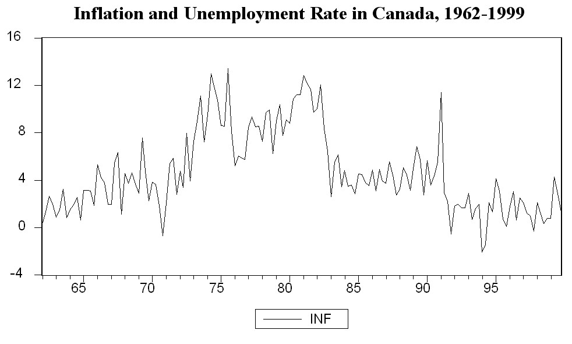

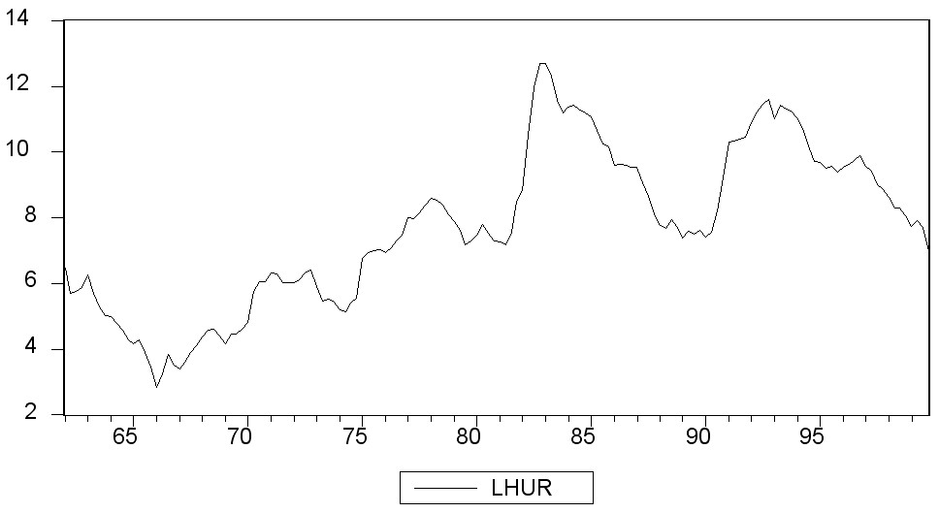

Inspecting the Canadian inflation rate plot and having calculated the first autocorrelation to be 0.79 for the sample period, do you suspect that the Canadian inflation rate has a stochastic trend? What more formal methods do you have available to test for a unit root?

**(b)** You run the following regression, where the numbers in parenthesis are the standard errors on the coefficients:

 = 0.49– 0.10 *Inft*-1 – 0.39 △*InfCt*-1 – 0.33 △*InfCt*-2 – 0.21 △*InfCt*-3 + 0.05 △*InfCt*-4,

(0.28) (0.05) (0.09) (0.09) (0.09) (0.08)

Calculate the Augmented Dickey-Fuller (ADF) statistic for the test of a unit root in the Canadian inflation rate (*InfC*).

**(c)** Test for the presence of a unit root (stochastic trend) in the Canadian inflation rate (*InfC*) using the ADF statistic you calculated in part b) of the question and the following table of the critical values of the ADF test statistic at the 1%, 5%, and 10% level.

**Table 1.**

|  |  |  |  |
| --- | --- | --- | --- |
| **Large-Sample Critical Values of the Augmented Dickey-Fuller Statistic**  **for Testing for a Unit Root** | | | |
| **Deterministic regressors** | **10%** | **5%** | **1%** |
| **Intercept only** | −2.57 | −2.86 | −3.43 |
| **Intercept & time trend** | −3.12 | −3.41 | −3.96 |

**(d)** Discuss how you would determine the number of lags of △*InfC* to be included in the regression estimated in part (b).

**(e)** To forecast the Canadian inflation rate for 2000:I, you estimate an AR(1), AR(4), and an ADL(4,1) model for the sample period 1962:I to 1999:IV. The results are as follows:

 = 0.002 – 0.31 △*InfCt*-1

(0.014) (0.10)

 = 0.021 – 0.46 Δ*InfCt*-1 – 0.39 Δ*InfCt*-2 – 0.25 Δ*InfCt*-3 + 0.03 Δ*InfCt*-4

(0.158) (0.10) (0.11) (0.08) (0.07)

 = 1.279 – 0.51 Δ*InfCt*-1 – 0.44 Δ*InfCt*-2 – 0.30 Δ*InfCt*-3 – 0.02 Δ*InfCt*-4 – 0.16 *UrateCt*-1

(0.57) (0.10) (0.11) (0.09) (0.08) (0.07)

In addition, you have the following information on inflation in Canada during the four quarters of 1999 and the first quarter of 2000:

**Inflation and Unemployment in Canada, First Quarter 1999 to First Quarter 2000**

|  |  |  |  |  |
| --- | --- | --- | --- | --- |
| **Quarter** | **Unemployment Rate**  **(*UrateC*t)** | **Rate of Inflation at  an Annual Rate**  **(*Inft*)** | **First Lag**  **(*Inf*t-1)** | **Change in Inflation**  **(△*Inft*)** |
| 1999:I | 7.7 | 0.8 | 0.8 | 0.0 |
| 1999:II | 7.9 | 4.3 | 0.8 | 3.5 |
| 1999:III | 7.7 | 2.9 | 4.3 | –1.4 |
| 1999:IV | 7.0 | 1.3 | 2.9 | –1.5 |
| 2000:I | 6.8 | 2.1 | 1.3 | 0.8 |

For each of the three models, calculate the predicted inflation rate for the period 2000:I and the forecast error.

**(f)** Perform a test on whether or not Canadian unemployment rates Granger-cause the Canadian inflation rate.

PART 2

**2.** Economic theory suggests that the law of one price holds. Applying this concept to foreign and domestic goods implies that goods will sell for the same price across countries. The consumer price index is the price for a basket of goods, and is calculated for countries as a whole. Hence in the absence of barriers to trade, and large transportation costs (and the fact that not all goods are traded) you should observe Purchasing Power Parity (PPP) between two countries, or *ExchRate × P = Pf*, where *ExchRate* is the foreign exchange rate between the two countries, and *P* represents the price index, with *f* indicating the foreign country. Dividing both sides of the equation by the domestic price level then gives you the standard formulation for *PPP*: *ExchRate =*  . If PPP holds in the long run, then the exchange rate and the price ratio should share a common trend. Since it is a long-run concept, cointegration provides an interesting way to test for it.

**(a)** You begin your numerical analysis by testing for a unit root (stochastic trend) in the variables, using an ADF test and monthly data for the U.S./UK exchange rate ($/₤) and the respective price indexes. Discuss how you would calculate the ADF statistics for the time series of the logarithm of the U.S./UK exchange rate (denoted $\ln{{ExchRate}_{t}}$) and the difference of the logarithms of the price indices in the U.S. and UK (denoted ${\ln{P}}_{t}^{US}-$ ${\ln{P}}_{t}^{UK}$).

**(b)** The ADF statistic for the test of unit root in the logarithm of the U.S./UK exchange rate $\ln{{ExchRate}_{t}}$ is −1.67 and the ADF statistic for the difference ${\ln{P}}_{t}^{US}-$ ${\ln{P}}_{t}^{UK}$ of the logarithms of the price indices in the U.S. and UK is −2.66. Using critical values in Table 1 in Question 1, test the null hypothesis of the unit root in each of these time series.

**(c)** Next, you estimate the following regression:

$\ln{{ExchRate}_{t}}$ = 0.44 + 0.69 ( ${\ln{P}}_{t}^{US}-$ ${\ln{P}}_{t}^{UK}$)

Collecting the residuals from this regression and using the EG-ADF test for cointegration, you find a *t*-statistic of −2.71. Using the critical values of the EG-ADF test in the following Table 2, test the null-hypothesis of no cointegration between the logarithm of the U.S./UK exchange rate and the difference ${\ln{P}}_{t}^{US}-$ ${\ln{P}}_{t}^{UK}$ between the logarithms of the price indices in the U.S. and UK.

**Table 2.**

|  |  |  |  |
| --- | --- | --- | --- |
| **Large-Sample Critical Values of the Engle-Granger ADF Statistic for Cointegration** | | | |
| **Number of nonconstant regressors in cointegrating equation** | **10%** | **5%** | **1%** |
| **1** | −3.12 | −3.41 | −3.96 |
| **2** | −3.52 | −3.80 | −4.36 |
| **3** | −3.84 | −4.16 | −4.73 |

**(d)** Discuss your conclusions in parts (b)-(c). Is there evidence for the law of one price?

PART 3

**3.** A study investigated the impact of house price appreciation on household mobility. The underlying idea was that if a house were viewed as one part of the household's portfolio, then changes in the value of the house, relative to other portfolio items, should result in investment decisions altering the current portfolio. Using 5,162 observations, the logit equation

$P\left(Y=1 | X_{1},X_{2},…, X_{k}\right)=\frac{1}{1+e^{-\left(β_{0}+β_{1}X_{1}+β_{2}X_{2}+…+β_{k}X_{k}\right)}}$

was estimated as shown in the table, where the limited dependent variable is one if the household moved in 1978 and is zero if the household did not move:

|  |  |
| --- | --- |
| **Regression**  **model** | **Logit** |
| *constant* | −3.323  (0.180) |
| *Male* | −0.567  (0.421) |
| *Black* | −0.954  (0.515) |
| *Married78* | 0.054  (0.412) |
| *marriage*  *change* | 0.764  (0.416) |
| *A7983* | −0.257  (0.921) |
| *PNRN* | −4.545  (3.354) |
| *Pseudo*-R2 | 0.016 |

where *male*, *black*, *married78*, and *marriage change* are binary variables. They indicate, respectively, if the entity was a male-headed household, a black household, was married, and whether a change in marital status occurred between 1977 and 1978. *A7983* is the appreciation rate for each house from 1979 to 1983 minus the SMSA-wide rate of appreciation for the same time period, and *PNRN* is a predicted appreciation rate for the unit minus the national average rate.

**(a)** Interpret the results. Comment on the statistical significance of the coefficients. Do the slope coefficients lend themselves to easy interpretation?

**(b)** The mean values for the regressors are as shown in the accompanying table.

|  |  |
| --- | --- |
| **Variable** | **Mean** |
| *male* | 0.82 |
| *black* | 0.09 |
| *married78* | 0.78 |
| *marriage change* | 0.03 |
| *A7983* | 0.003 |
| *PNRN* | 0.007 |

Taking the coefficients at face value and using the sample means, calculate the probability of a household moving.

**(c)** Given this probability, what would be the effect of a decrease in the predicted appreciation rate of 20 percent, that is *PNRN* = –0.20?

PART 4

**4.** Recall that, according to empirical results we discussed in class, financial returns and foreign exchange rates ($r_{t})$ in developed countries typically have tail indices *ζ* in the interval (2, 4). That is, the tails of distributions of these variables follow a power law: $P\left(\left|r_{t}\right|>x\right)\sim \frac{C}{x^{}}$ for large *x*>0, with *ζ*∈(2, 4). This implies, as we discussed that the variances of the financial returns and foreign exchange rates in developed economies are finite. However, the variables have infinite fourth moments and their kurtosis is thus not well-defined.

You decide to check whether the above empirical results and conclusions on tail indices and heavy-tailedness of foreign exchange rates also hold in emerging economies using the daily time series on the exchange rate $X_{t}$ of the Russian Ruble to the US dollar.

**(a)** Discuss how you would estimate the tail index *ζ* of $X_{t}$ in the power law $P\left(\left|X_{t}\right|>x\right)\sim \frac{C}{x^{}}$ using Hill’s estimate and the log-log rank size regression.

**(b)** Discuss how the standard errors of Hill’s estimate ${\hat{}}_{Hill}$ and the log-log rank-size regression estimate ${\hat{}}_{RS}$ of the tail index *ζ* relate to the values of these estimates.

**(c)** Using the daily data on the Russian Ruble foreign exchange rate from 1 January 1999 to 22 June 2012 and the 10% tail truncation, you obtain Hill’s estimate ${\hat{}}_{Hill}=1.94$ with the standard error ${s.e.}_{Hill}=0.11.$ Construct the 95% confidence interval for the true value of the tail index *ζ* of the Russian Ruble exchange rate.

**(d)** Using the results in part c) of the question, test the null hypothesis that the tail index *ζ* of the Russian Ruble exchange rate equals to 2: $H_{0}: =2$ against the one-sided alternative that it is smaller than 2: $H_{a}: <2$. Does the exchange rate appear to have finite variance? Do heavy-tailedness properties of the Russian Ruble foreign exchange market appear to be similar to those in developed foreign exchange markets?

**(e)** Now you want to test whether there was a change in heavy-tailedness properties of the Russian Ruble foreign exchange rate due to the beginning of the on-going economic and financial crisis in September 2008. In order to do so, you estimate the tail index of this time series using the data before and after 15 September 2008. For the pre-crisis data (before 15 September 2008), estimation of the tail index using the log-log rank-size regression results in the estimate ${\hat{}}_{RS}=1.87$ with the standard error ${s.e.}_{RS}=0.17.$ For the data in the crisis period (after 15 September 2008), you obtain the estimate ${\hat{}}_{RS}=3.12$ with the standard error ${s.e.}_{RS}=0.41.$ Construct the 95% confidence intervals for the true values of the tail of the Russian Ruble exchange rate before and after the beginning of the on-going crisis.

**(f)** Does your analysis in part e) of the question provide evidence for a structural break in the tail index of the Russian Ruble exchange rate due to the beginning of the on-going crisis? Discuss your conclusions. Compare the heavy-tailedness properties (the estimates of the tail index) of the Russian Ruble exchange rate before and after the beginning of the on-going crisis with the empirical estimates *ζ*∈(2, 4) for tail indices of developed country exchange rates discussed above.

**(g)** Motivated by your heavy-tailedness analysis in parts **(a)-(f)** of the question, you now aim to describe the time series dynamics of the Russian Ruble foreign using a GARCH model that, as we discussed in class, produces heavy-tailed time series with volatility clustering. The GARCH model for the foreign exchange rate using the data from 1 January 1999 to 22 June 2012 is as follows:

$X_{t}=σ_{t}ε_{t}$,

$σ_{t}^{2}$ = 0.012 + 0.06 ${}_{t-1}^{2}$ + 0.93 ${}_{t-1}^{2}$,

(0.002) (0.03) (0.09)

where $ε_{t}$ are i.i.d. standard normal *N*(0, 1) random variables and the numbers in brackets denote standard errors. Test the coefficients in the above GARCH model for the dynamics of  individually for statistical significance. Does the fitted GARCH model support your conclusions in part d) of the question on the variance of the Russian Ruble foreign exchange rate?