Flutter Widgets & Layouts
Lecture 2 — Assignment Report
Building a Profile Screen UI using Core Flutter Layout Widgets
Submitted by: Aeman Imtiaz
Registration No: 04162313001
Internship: Mobile Application Development — PKCERT
Date: July 11, 2026

1. Objective
Building on the environment set up in Lecture 1, this session focused on Flutter's UI-building fundamentals: the widget tree, core layout widgets, common content widgets, scrollable lists, buttons and input fields, and app-wide theming. The objective of the accompanying practice task was to apply these concepts by designing and implementing a fully functional Profile Screen using only layout widgets — without any backend or state management.

2. The Widget Tree
Every Flutter screen is composed of a tree of widgets nested inside one another. Each widget describes what its portion of the UI should look like based on its current configuration and state. Flutter is efficient because it rebuilds only the parts of the tree that actually change, rather than redrawing the entire screen.
A typical app structure follows this hierarchy:
Root Widget → MaterialApp → Scaffold → AppBar / Body / BottomNavigationBar

3. Core Layout Widgets

3.1 Container
A box that can be styled, sized, and positioned — conceptually similar to a <div> in web development. It supports padding, margin, decoration (color, borders, radius), width, and height.
Container(
width: 150,
height: 80,
padding: const EdgeInsets.all(12),
decoration: BoxDecoration(
color: Colors.blue.shade50,
borderRadius: BorderRadius.circular(12),
),
child: const Text('Hello Box'),
)

3.2 Row & Column
Row arranges its children horizontally, while Column arranges them vertically. Both accept mainAxisAlignment and crossAxisAlignment properties to control spacing and alignment along their respective axes.

3.3 Stack
Overlaps widgets on top of one another — commonly used for badges, image overlays, and floating labels, positioned precisely using the Positioned widget.

3.4 Expanded & Flexible
Used inside a Row or Column to make a child widget share or fill the remaining available space. The flex property determines the proportion of space each Expanded child receives relative to its siblings.

4. Common Content Widgets
- Text — displays styled text using the TextStyle property (font size, weight, color).
- Icon — renders Material Design icons with configurable color and size.
- Image — Image.asset() for bundled images, Image.network() for remote URLs.
- Card — a Material surface with rounded corners and elevation, ideal for list items.
- Divider — a thin horizontal line used to visually separate sections.

5. Scrollable Widgets

5.1 ListView
ListView.builder() is the preferred approach for long or dynamic lists, as it lazily constructs only the widgets currently visible on screen rather than rendering the entire list upfront — improving performance significantly.

5.2 GridView
GridView.count() arranges children in a two-dimensional, scrollable grid, with crossAxisCount defining the number of columns.

6. Buttons & User Input
- ElevatedButton — a raised, filled button used for primary actions.
- TextButton — a flat button with no elevation, used for secondary actions.
- OutlinedButton — a bordered, medium-emphasis button.
- IconButton — a tappable icon, commonly used in app bars.
- TextField / Form + TextFormField — used to capture and validate user input as a group.

7. Styling & Theming
Rather than styling every widget individually, a Theme is defined once inside MaterialApp so the entire application maintains a consistent visual identity across all screens.

8. Padding & Alignment
- Padding — adds space around a widget.
- Center — centers a widget within its parent.
- Align — positions a widget precisely using an Alignment value.
- SizedBox — an empty box, most commonly used purely for spacing between widgets.

9. Practice Task — Building the Profile Screen
The practice task required recreating a simple profile screen UI using exclusively the widgets covered in this lecture, with no backend or state management involved. The following requirements were implemented:
- An AppBar with the title 'My Profile'.
- A circular profile picture (CircleAvatar) centered at the top, styled with a soft drop shadow.
- The user's name and a short bio using styled Text widgets.
- A Row of 3 stats — Posts, Followers, Following — evenly spaced using Expanded, presented inside a card-style container with vertical dividers.
- A ListView of 5 settings options (Edit Profile, Notifications, Privacy, Help, Logout) using ListTile, each with a leading icon and trailing chevron.
- An ElevatedButton at the bottom that prints 'Logged out' to the console when tapped.

9.1 Project Setup
A new Flutter project was created inside the D: drive projects folder, consistent with the environment configured in Lecture 1:
cd D:\FlutterDev\projects
flutter create profile_screen
cd profile_screen
flutter run
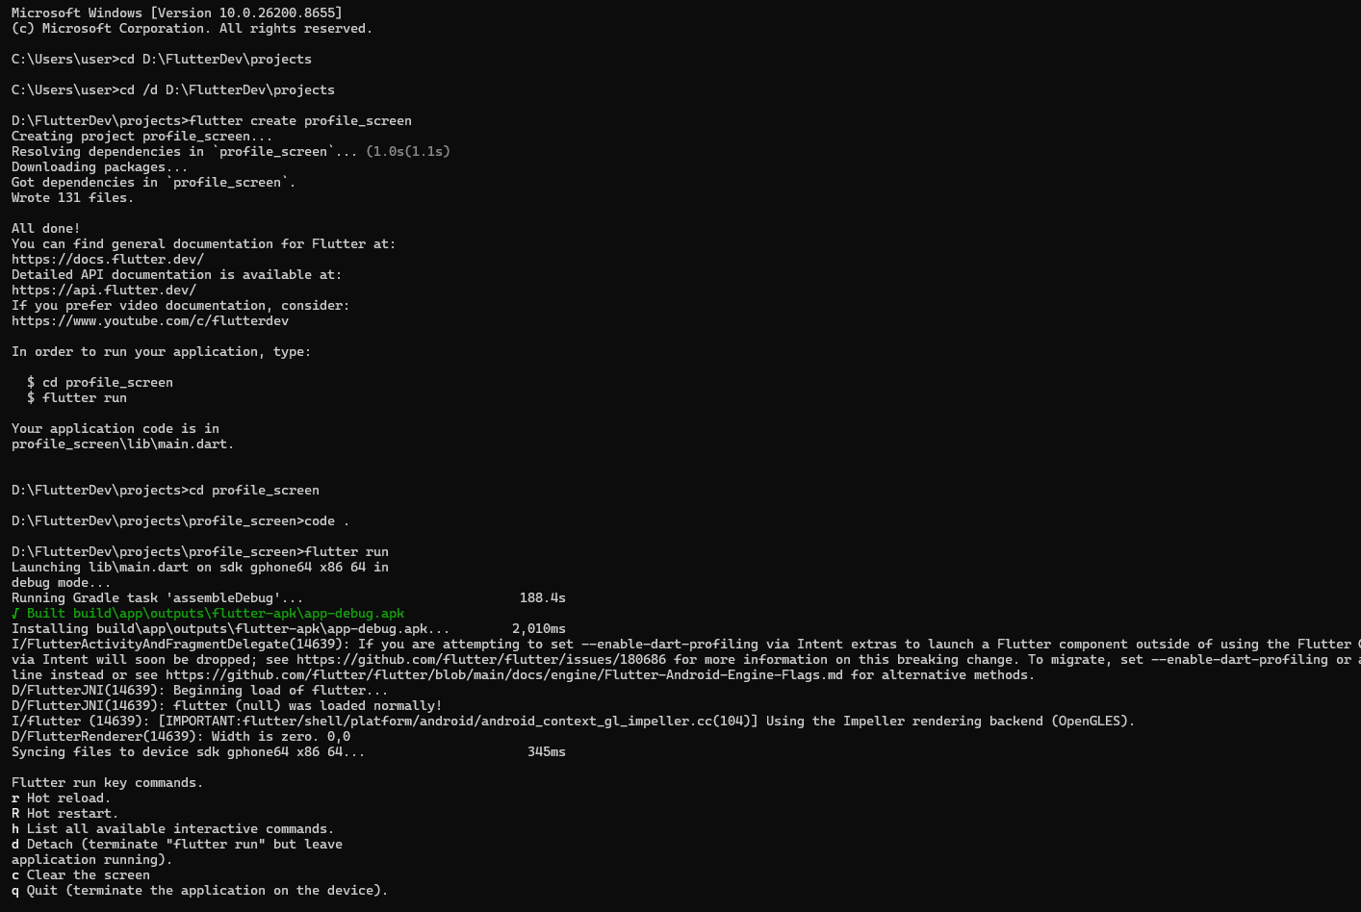
Figure 1: Terminal output showing successful project creation and build (app-debug.apk built and installed).

9.2 Adding a Custom Profile Image
To personalize the CircleAvatar, an assets/images folder was created inside the project root, and the profile picture was registered as a Flutter asset in pubspec.yaml:
flutter:
uses-material-design: true
assets:
- assets/images/profile.jpeg
After registering the asset, 'flutter pub get' was run to sync the dependency, followed by 'flutter clean' to clear the build cache and resolve an initial asset-loading issue caused by a file extension mismatch.

9.3 Implementation
The UI was implemented as a StatelessWidget, structured with a Column containing the profile picture, name and bio, a stats card built with Row and Expanded, a settings ListView, and a full-width Logout button. A private helper method (_buildStat) was used to avoid repeating widget code for each of the three stats, and Container with BoxDecoration was used to add card-style shadows for a more polished, professional appearance.
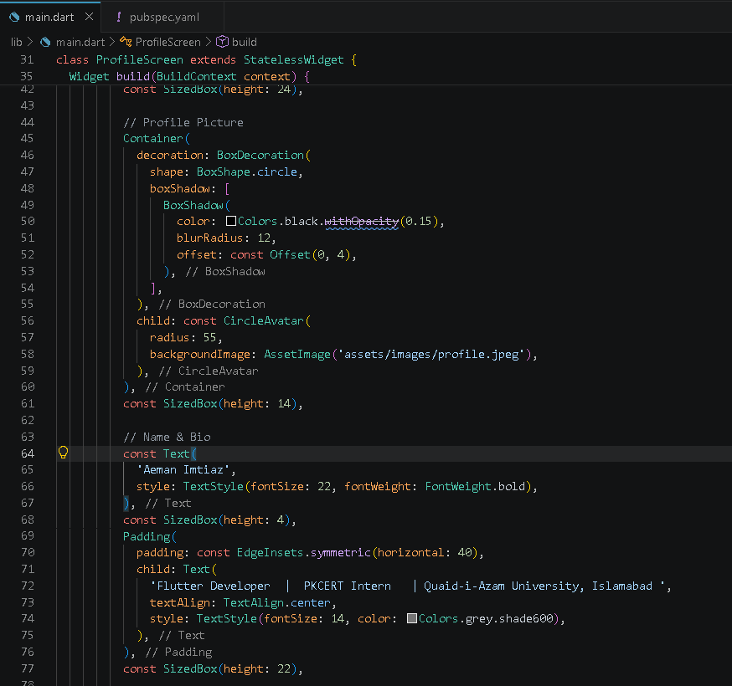
Figure 2: Excerpt of main.dart showing the Container-based CircleAvatar with shadow decoration, and styled Text widgets for name and bio.

9.4 Result
The completed profile screen was run on the Pixel 6 (API 34) Android emulator. The final UI includes a centered profile photo, name and bio, an evenly spaced stats row, a scrollable settings list with icons, and a bottom-anchored Logout button — matching all six requirements of the practice task.
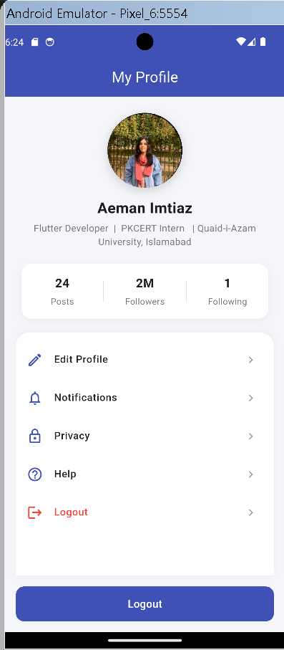
Figure 3: Final Profile Screen running on the Android emulator, displaying the profile photo, stats, settings list, and Logout button.

10. Issues Faced and Resolutions
Issue | Resolution
ListView inside a Column caused a 'RenderFlex overflowed' layout error | Wrapped the ListView in an Expanded widget so it fills only the remaining available space in the Column, allowing the list to scroll while the button stays fixed at the bottom
pubspec.yaml assets entry was accidentally nested under 'dependencies' instead of the top-level 'flutter' section, breaking the YAML structure | Corrected the indentation and moved the assets: list under the existing top-level flutter: section
Build failed with 'No file or variants found for asset: assets/images/profile.jpg' | Discovered the actual file had a double extension (profile.jpg.jpeg) because Windows had hidden the true extension; renamed the file to profile.jpeg and updated both pubspec.yaml and main.dart to match exactly
New asset did not appear after editing pubspec.yaml | Ran 'flutter clean' followed by 'flutter pub get' and a full restart (not just hot reload) to force Flutter to rebuild the asset bundle

11. Conclusion
This lecture provided a solid foundation in Flutter's UI layer — understanding the widget tree, and applying core layout widgets (Container, Row, Column, Stack, Expanded), content widgets (Text, Icon, Image, Card), scrollable widgets (ListView), buttons, and app-wide theming. The practice task successfully translated these concepts into a complete, polished Profile Screen, reinforcing the importance of composition, spacing, and consistent styling in building professional-looking Flutter UIs. In Lecture 3, these static screens will be connected using navigation, with proper state management introduced for real interactivity.

