### Flipkart Business Model:

Marketplace > List vendors who sell desired products > Get shoppers browsing through the products > Make enticing deals & discounts > Customer purchase desired products > Vendor/Flipkart ships the product to customer > Product accepted & Not returned back > Vendor gets the agreed price for the product sold minus the commission charged by Flipkart for making the sale.

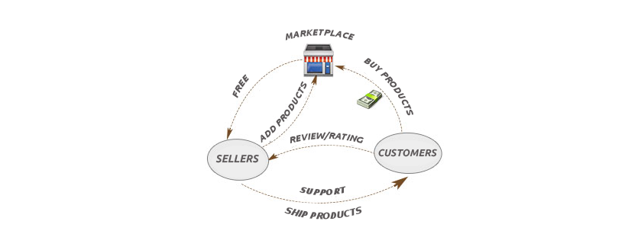

Therefore, the primary source of **income Model of Flipkart** is “X% commission on the total selling value given to the vendor”.

The sale can happen through many channels as given below and for all the trading is achieved by Flipkart for the same supplier – Flipkart will charge a percentage (%) cut on the whole total sale amount which does not include taxes.

1. Direct through Website

2. Direct through Web App

3. Direct through Mobile App (Android, iOS, etc.)

4. Direct through Telesales (Customer calls and Place order – rarely happens now)

5. Through Affiliate Networks (Coupon Websites, Review Websites, and Bloggers)

6. Social Buy

The percentage of commission differs on the kind of product and type kind of selling which Flipkart makes.

#### **Flipkart Revenue Model: The income of Flipkart from other sources are as follows**

The giant eCommerce platform creates revenue not only by the sale of products but also from different income channels. Here are some of them:

***Web portal:***

The basic source of income of Flipkart is collecting a commission for the services from the vendors who use its platform.

***Listing and convenience fee:***

The other way of getting revenue to the company are inclusion and convenience fee. The listing fee is collected from the vendors, and the convenience fee is collected from the purchasers for quicker delivery. Convenience fee adds wrapping charges for the gifts; Billings includes to the whole income of the company Flipkart.

***Logistics:***

For delivering the goods of the vendors; an amount is charged from them. It supplies services to its vendors like other delivery companies. Charging services for delivery differ from location to location covering the distance.

***Digital media:***

It also sells ads and different products such as co-branding and co-advertising to the vendors or brands via digital media. The ads are divided into three classes:

* Co-branding on Flipkart’s homepage via sliding banners that gets millions of views everyday
* Co-advertising products for publications in newspapers or magazines’ front page for popular brands
* Target search results where Flipkart decides which vendor’s product to be displayed at the top result

In addition to the above revenue model, Flipkart also gets funding from several other sources to upgrade their business. Flipkart companies include recent acquisition of other Indian eCommerce companies like Myntra, Jabong, eBay.in which are now termed as Flipkart Group!

### Which eCommerce technology does flipkart use?

#### **Technical working function of flipkart- Let us see some facts:**

Since it is created chiefly on PHP, this website provides us to experience as contented purchasing as in a real store. At present, the engineers of this site’s program clear that the site is now high in its responsiveness and very low at showing the mistakes of technology which assists the online store to keep up the selling.

* According to reports, an ex-Flipkart Engineer reported that it does not rely on any firmed technology stacks, but finds out a tool which is a problem solver and flexible. He had used Java, Scala and pure python for various projects when he worked at Flipkart.
* All their software function on Linux – Debian and most of other systems are not built ever on Java. But they take JVM for their use.
* For data storage Flipkart make use of MySQL, and for caching it uses Memcached. The company has estimated large No SQL data stores to choose the best for the production.
* For different projects, Flipkart uses Hadoop software, and make it easier for evaluation and data management.

The complete rules which are seen above provides the reason why Flipkart is one of the best selling eCommerce brands in our country!

The actions of your idea should define your success; not just your idea alone.

### How to build a Flipkart like website?

On understanding the working functionalities, your next question will be how to build a website like Flipkart! All you have to focus on is a feature-rich, scalable, open-source platform which provides you with changeable and powerful features to customize and manage both the front-end and back-end in an efficient manner. We can use leading technologies using WordPress or Magento eCommerce platform to build it as they have plenty of features that makes it possible for to build a flipkart clone.

**[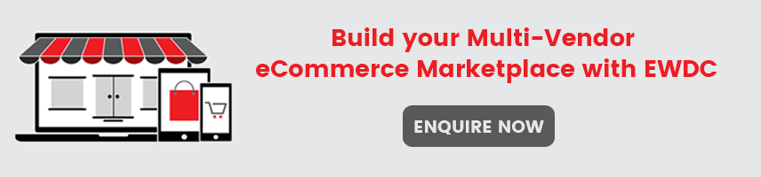](https://www.ecommercewebsitedevelopmentchennai.in/multi-vendor-marketplace-platform.html?utm_source=blog&utm_campaign=flipkart-like-website&utm_medium=banner)**

### How EWDC can help you create ecommerce website like flipkart?

EWDC lets you run a business with the latest technology trends, without significant investments and time-consuming deployments.

Fear is a natural thing- when you order a dedicated online store and stand the invested amount. So you might have asked yourself good many of times: “How much do I have to spend?, How much does it cost to build a website like flipkart?” If the amount with several zeros often occur, from the availability of costs details on internet forums doesn’t assist with the final decision.

Meantime, picking a **ready-made online store like EWDC** doesn’t incur expenses on licenses purchase, equipment, installations or necessary adjustments – the starting costs are pretty small for startup, and of all, it is the one-time price!

Sure that, the change of the storefront does not need the employment of any people as you can do it by yourself. Even the smallest graphic details can be managed individually in the admin panel of a store for no difference – be it a banner, a tiny icon or a logo!

### Why do you choose EWDC for your multi-vendor marketplace?

EWDC is built using world’s leading platform, Magento, which helps you to manage your store without prior technical knowledge. And, the most important is, you’ll pay less money for the basic version of the online store than on any other eCommerce marketplace platforms in India. With EWDC you get complete transparency and no hidden prices compared to other markets.

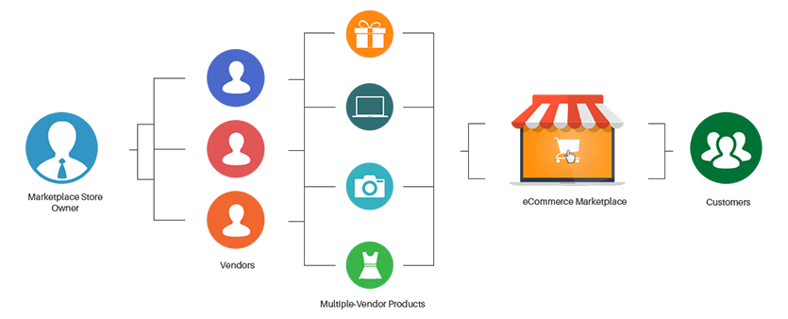

At Amazon, you have to pay a subscription fee (Rs. 499 /monthly), commission (5-15%) and listing fee (Rs. 10/sale). And at Flipkart, you have to manage commission (from 4 to 20% which depends upon product category).

But, at EWDC, there is no need of having monthly commitments or any other excess fees. And you get 100+ pre-loaded features to get your store up and running effortlessly!

**[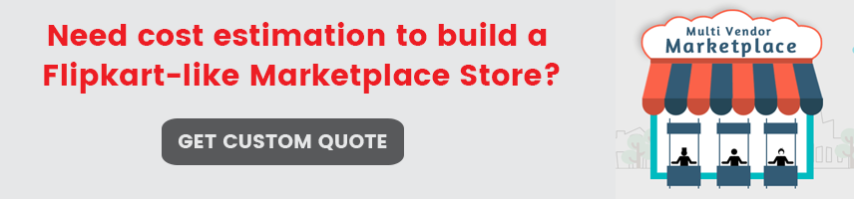](https://www.ecommercewebsitedevelopmentchennai.in/contact.html?utm_source=blog&utm_campaign=flipkart-like-website&utm_medium=banner)**

### How your Multi-seller Marketplace Store will look like?

Multi-Vendor shopping cart supplies the multi-seller functionality letting various vendors to sell and manage their products in a common storefront.

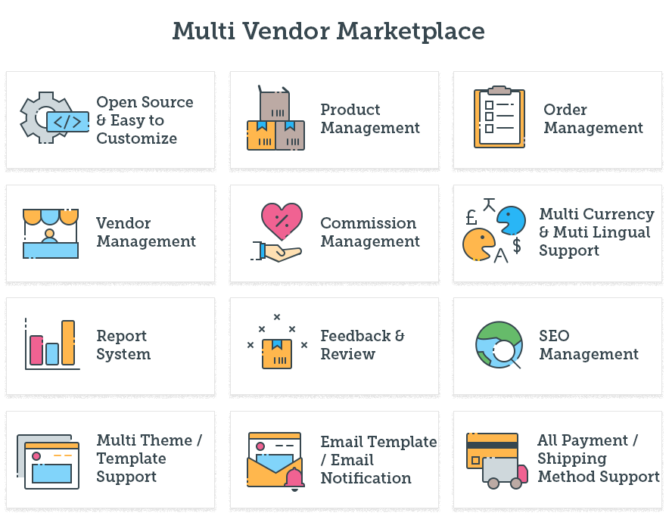

### Features you get when you create a marketplace website with EWDC

* Free setup/installation
* 100% Source Code
* Fully Customizable
* One-time cost
* Dedicated dashboard & admins can easily manage vendor account
* On-demand iOS & Android mobile applications
* Simple mechanism to calculate individual commissions
* Options to set national & international shipping
* Hassle free admin options for marketplace owner & vendors
* Live chat & support

#### **User Friendly Features:**

* Wish list or buy later
* Easy sharing options to Social Media
* Product comparison with other sellers
* User reviews, comments & product ratings
* SMS & Payment Gateway Integrations
* Multiple online payment methods including COD, debit & credit cards
* Logins via social credentials for shoppers and sellers

#### **Powerful Features for Admins:**

* Show/Hide new product or category
* Manual product approvals by store administrator
* Control on ‘Stock available’ or ‘Product sold’ count
* Enable or Disable individual profile pages of vendors
* Manual or Auto-approval of Vendor accounts by admin

#### **Powerful Features for Sellers:**

* Unlimited seller accounts
* Unique seller profile to manage vendor’s information
* ‘Seller vacation mode’ available for enabling or disabling products
* Multiple language options
* One page checkout
* Individual vendor SEO friendly URL’s
* Enable or disable review/rating options