EfficientNet-B4 Cross-Dataset Testing
INSE 6610 | Team 2 | Individual Contribution: Aena (ae_verma)
Concordia University | Winter 2026

1. Overview
This document describes the cross-dataset evaluation of the EfficientNet-B4 deepfake detection model. The model was trained on the FaceForensics++ (FF++) dataset at C23 compression quality and subsequently tested on four different datasets to evaluate its generalization capability across different deepfake types and image domains.

2. Model Details
Parameter | Value
Algorithm | EfficientNet-B4
Training Dataset | FaceForensics++ (FF++) at C23 compression
Training Location | Concordia Speed HPC Cluster (speed-27, Tesla V100 GPU)
Model File | /speed-scratch/ae_verma/best_efficientnet_b4.pth
Epochs | 10
Batch Size | 64
Optimizer | Adam (lr=1e-4, weight_decay=1e-6)
Frozen Layers | Blocks 0, 1, 2 (partial freezing)
Training Accuracy | 86.78%
Training AUC-ROC | 95.19%

3. Datasets Used for Testing
All datasets were stored in the shared team directory: /speed-scratch/inse6610team2/

3.1 FaceForensics++ (FF++)
- Location: /speed-scratch/inse6610team2/ff_faces/
- Structure: real/ and fake/ folders containing .jpg images
- Total Images Tested: 30,000 (15,000 real + 15,000 fake)
- Owner/Contributor: Aena (ae_verma)
- Description: Video-based face manipulation dataset with C23 compression. Contains face swap and face reenactment videos from which face images were extracted.

3.2 CelebDF V2
- Location: /speed-scratch/inse6610team2/Celeb_V2/Test/
- Structure: Test/real/ and Test/fake/ folders
- Total Images Tested: 10,103 (5,036 real + 5,067 fake)
- Owner/Contributor: Lilas (g_lilas)
- Description: High quality celebrity deepfake dataset with advanced face swapping and blending techniques. Significantly more realistic than FF++.

3.3 Sarra Dataset (UADFV)
- Location: /speed-scratch/inse6610team2/dataset_images/
- Structure: real/ and fake/ folders containing face images
- Total Images Tested: 946 (478 real + 468 fake)
- Owner/Contributor: Sarra (s_benred)
- Description: UADFV dataset containing face swap images extracted from videos. Uses older and simpler manipulation techniques compared to FF++.

3.4 CIFAKE
- Location: /speed-scratch/inse6610team2/CIFAKE-ResNet-50/test/
- Structure: REAL/ and FAKE/ folders
- Total Images Tested: 20,000 (10,000 real + 10,000 fake)
- Owner/Contributor: Bhumi (bh_son)
- Description: AI-generated image dataset where fake images are produced by diffusion models, not face swaps. Fundamentally different from face manipulation datasets.

4. Testing Methodology
The testing script (test.py) was executed as a SLURM batch job on the Concordia Speed HPC cluster using a Tesla V100 GPU. The same preprocessing pipeline used during training was applied during testing:
- Image resized to 224x224 pixels
- Normalized with ImageNet mean [0.485, 0.456, 0.406] and std [0.229, 0.224, 0.225]
- No data augmentation applied during testing
- Classification threshold: 0.5 (sigmoid output >= 0.5 classified as fake)
- Batch size: 64, evaluated using GPU acceleration
- Metrics computed: Accuracy and AUC-ROC per dataset

Job Script: /speed-scratch/ae_verma/test_job.sh
Test Script: /speed-scratch/ae_verma/test.py

5. Results
Dataset | Total Images | Accuracy | AUC-ROC | Performance
FF++ (own dataset) | 30,000 | 69.62% | 76.56% | Best
CelebDF V2 (Lilas) | 10,103 | 53.57% | 56.73% | Poor
Sarra Dataset (UADFV) | 946 | 58.03% | 63.98% | Below Average
CIFAKE (Bhumi) | 20,000 | 52.12% | 52.28% | Worst (near random)

5.1 Cross-Dataset Accuracy and AUC-ROC Comparison
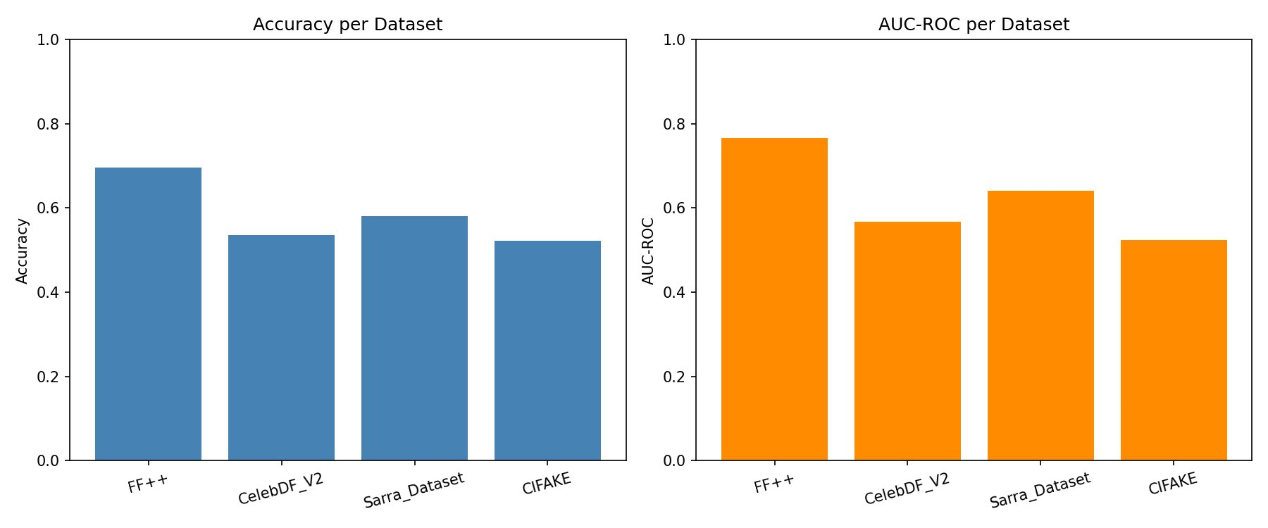

6. Analysis and Discussion

6.1 FF++ (69.62% Accuracy, 76.56% AUC) - Best Performance
Performed best because the model was trained on FF++ data and already knows the specific compression artifacts, face swap techniques, and image style of this dataset. The score is lower than the training result (86.78%) because cross-dataset testing used all 30,000 images including many harder unseen examples, whereas training evaluation used only a small controlled 15% split of 6,000 images.

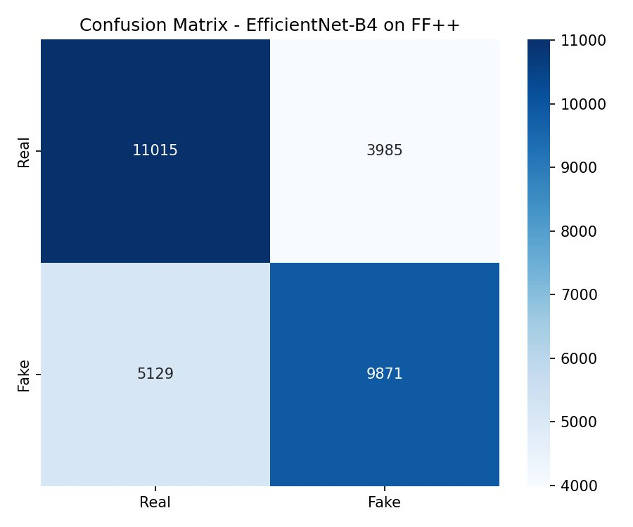

6.2 CelebDF V2 (53.57% Accuracy, 56.73% AUC) - Poor Performance
Performed poorly because CelebDF uses significantly higher quality face swaps with better blending, color correction, and post-processing compared to FF++. The celebrities in CelebDF also have different lighting conditions, makeup styles, and camera angles that the model has never seen. Since the model was trained only on FF++ manipulation patterns, it struggles to reliably detect the more advanced and visually realistic fakes in CelebDF. The AUC near 0.57 indicates only slightly better than random guessing, confirming the model has no reliable signal for this domain.

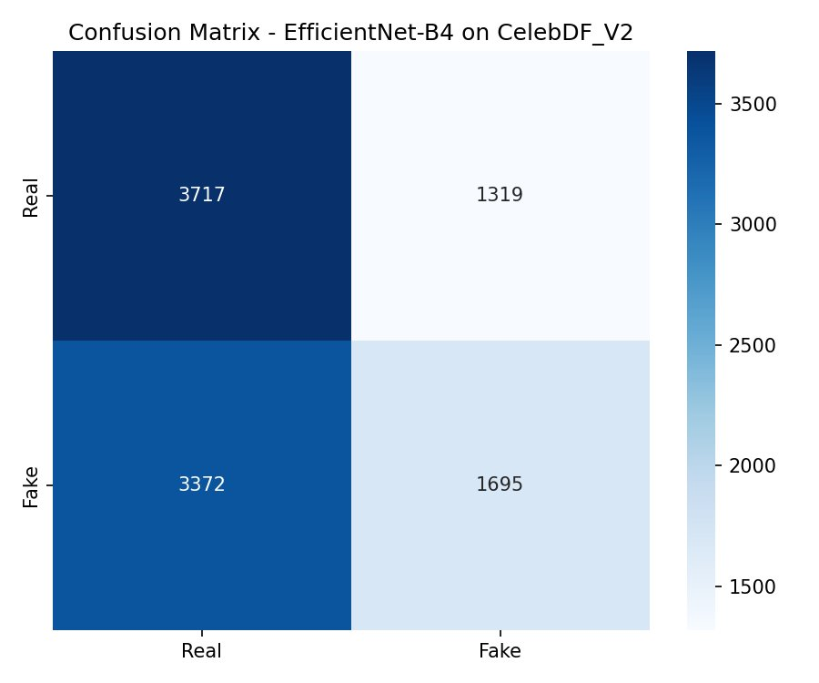

6.3 Sarra Dataset / UADFV (58.03% Accuracy, 63.98% AUC) - Below Average
Performed slightly better than CelebDF because UADFV uses older and simpler face swap techniques that leave more obvious visual artifacts, somewhat similar in style to FF++. The model accidentally picks up some of these familiar patterns, resulting in marginally better performance. However, since the model was never trained on UADFV data, performance remains unreliable and well below acceptable detection thresholds.

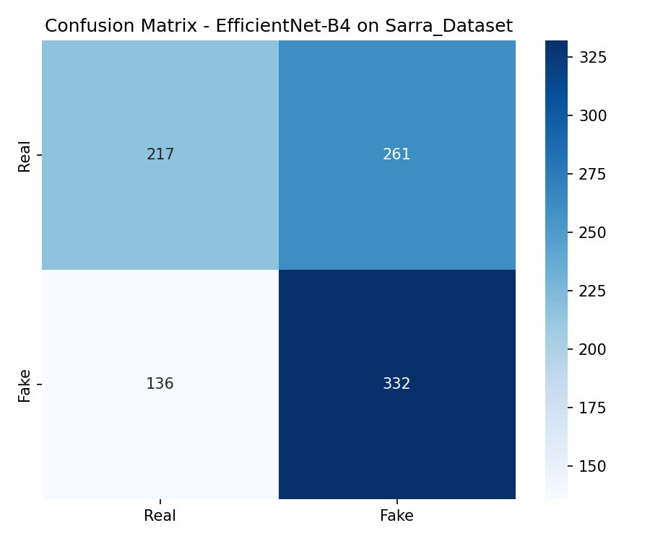

6.4 CIFAKE (52.12% Accuracy, 52.28% AUC) - Worst Performance (Near Random)
Performed worst at essentially random guessing level (50% = coin flip) because CIFAKE contains fully AI-generated images produced by diffusion models, not face swaps at all. The model was trained specifically to detect face manipulation artifacts from video frames and has no knowledge of what diffusion-generated image artifacts look like. This result confirms that CIFAKE is fundamentally outside the model training domain.

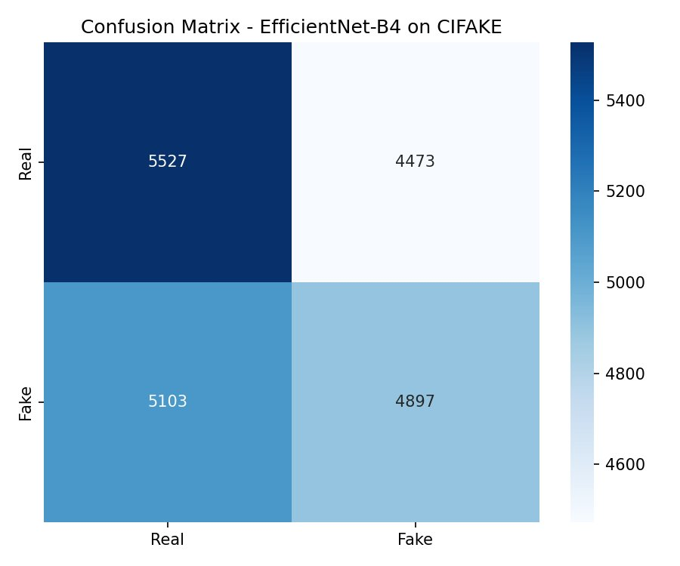

6.5 Domain Shift Conclusion
The significant drop in performance across all non-FF++ datasets confirms a well-known challenge in deepfake detection research called domain shift. Models trained on one dataset learn highly specific patterns tied to that dataset manipulation method, compression level, and visual style. When applied to unseen datasets with different characteristics, performance degrades substantially. This finding is consistent with published deepfake detection literature and represents an important limitation of single-dataset trained models.

7. Output Files Generated
File | Description | Location
cross_dataset_results.png | Bar chart comparing accuracy and AUC-ROC across all 4 datasets | /speed-scratch/ae_verma/
cm_FF++.png | Confusion matrix for FF++ testing | /speed-scratch/ae_verma/
cm_CelebDF_V2.png | Confusion matrix for CelebDF V2 testing | /speed-scratch/ae_verma/
cm_Sarra_Dataset.png | Confusion matrix for Sarra Dataset testing | /speed-scratch/ae_verma/
cm_CIFAKE.png | Confusion matrix for CIFAKE testing | /speed-scratch/ae_verma/
test_output.log | Full console output from the test job | /speed-scratch/ae_verma/
test.py | Cross-dataset testing script | /speed-scratch/ae_verma/
test_job.sh | SLURM batch job script for running test.py | /speed-scratch/ae_verma/

