- Controller Mahaswa
- <?php

- namespace App\Controllers;

- use App\Models\MahasiswaModel;
- use CodeIgniter\RESTful\ResourceController;

- class Mahasiswa extends ResourceController
- {
- protected $modelName = MahasiswaModel::class;
- protected $format = 'json';

- // Menampilkan semua data
- public function index()
- {
- $data = $this->model->findAll();

- return $this->respond($data);
- }

- // Menampilkan satu data berdasarkan id
- public function show($id = null)
- {
- $data = $this->model->find($id);

- if (!$data) {
- return $this->failNotFound('Data tidak ditemukan');
- }

- return $this->respond($data);
- }

- // Menambah data
- public function create()
- {
- $data = [
- 'nim' => $this->request->getPost('nim'),
- 'nama' => $this->request->getPost('nama'),
- 'jurusan' => $this->request->getPost('jurusan')
- ];

- $this->model->insert($data);

- return $this->respondCreated([
- 'status' => true,
- 'pesan' => 'Data berhasil ditambahkan'
- ]);
- }

- // Mengubah data
- public function update($id = null)
- {
- $data = $this->request->getRawInput();

- $this->model->update($id, $data);

- return $this->respond([
- 'status' => true,
- 'pesan' => 'Data berhasil diupdate'
- ]);
- }

- // Menghapus data
- public function delete($id = null)
- {
- $this->model->delete($id);

- return $this->respondDeleted([
- 'status' => true,
- 'pesan' => 'Data berhasil dihapus'
- ]);
- }
- }
2. mahasiswa model
<?php

namespace App\Models;

use CodeIgniter\Model;

class MahasiswaModel extends Model
{
protected $table = "mahasiswa";

protected $primaryKey = "id";

protected $allowedFields = [
"nim",
"nama",
"jurusan"
];
uji coba.
Get.
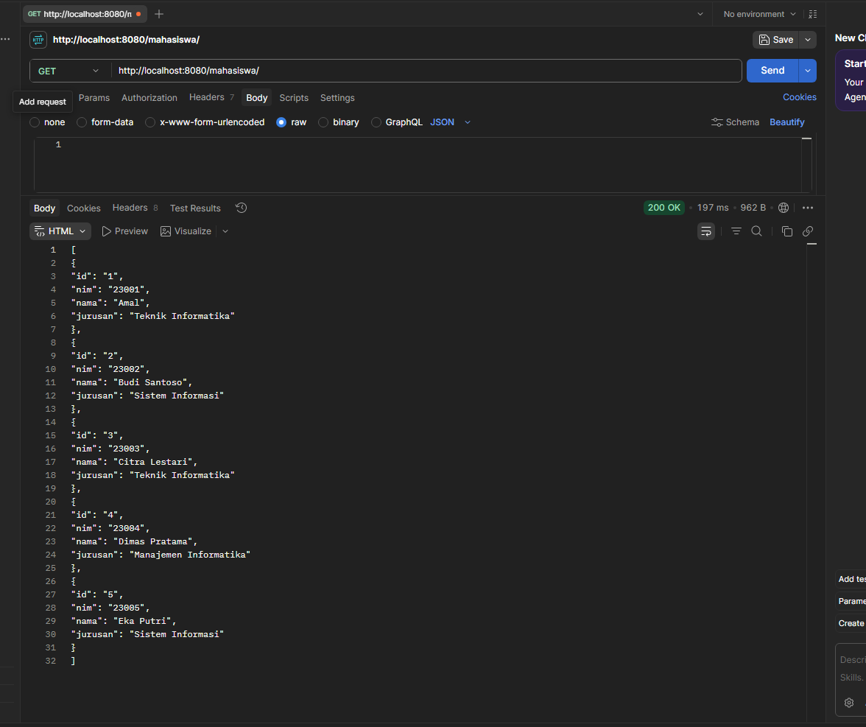

Post.
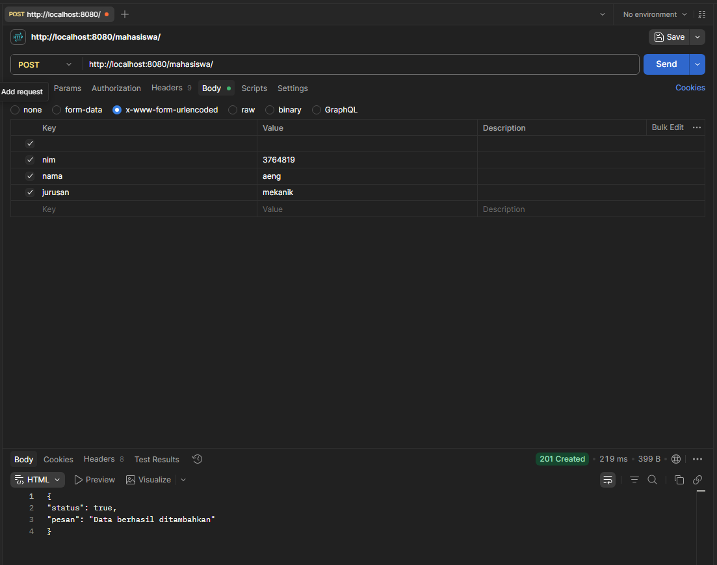
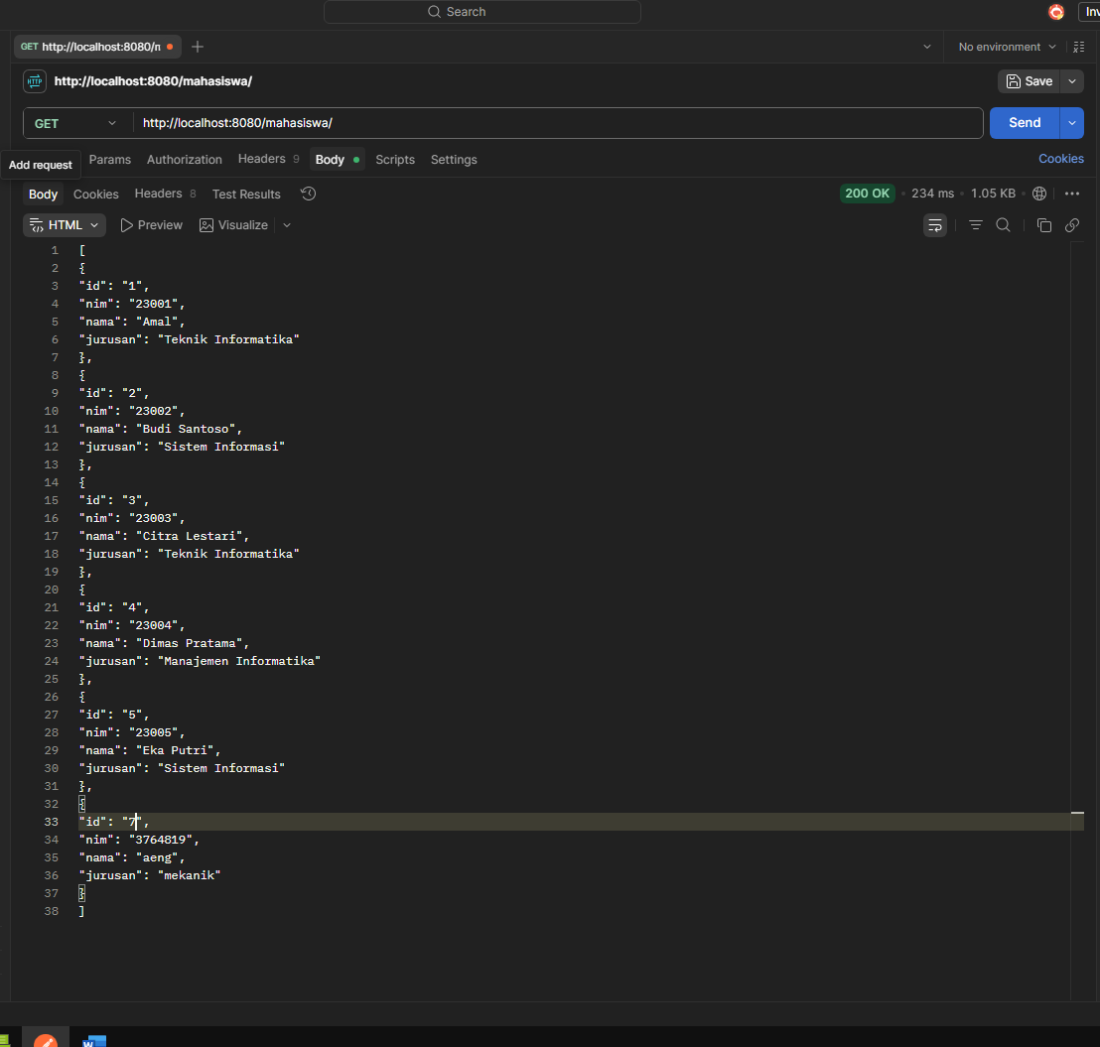

Delete.
