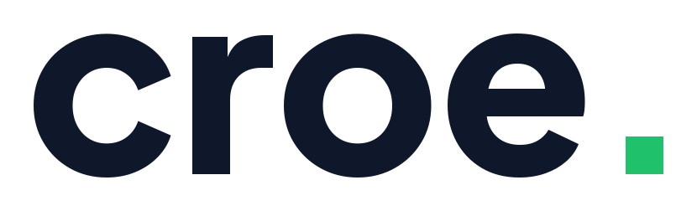 | STAKEHOLDER BRIEF · SEPTEMBER 2026
croe. - Executive Summary
Escrow for Social Commerce, on Mobile Money. Ghana-First.
――――――――――――――――――――――――――――――――――――――――――――――――――――――――――
1. The Problem: The Trust Standoff in Social Commerce
Structural Failure: Social commerce in Ghana runs on trust that does not exist. A buyer finds a smartphone, laptop, or designer sneakers on Instagram and is asked to send Mobile Money (MoMo) to a stranger. The vendor is asked to dispatch goods via dispatch rider to someone who may refuse to pay. Both positions are completely rational, and the sale dies between them.
Vendors routinely lose 25%–30% of qualified buyer inquiries to payment anxiety. Buyers who do pay upfront absorb recurring fraud with zero recourse - no enforceable receipt, no neutral arbiter, and no path to an automated refund.
2. The Solution: Frictionless Escrow on MoMo Rails
Step | Action | Customer Experience
1. Link | Vendor creates escrow link | Shared directly in WhatsApp or Instagram DM where the sale is already happening.
2. Pay | Buyer authorizes MoMo payment | Standard USSD prompt on their handset. Funds lock in escrow - vendor sees it, but cannot touch it.
3. Ship | Vendor dispatches order | Goods dispatched against guaranteed locked money rather than an empty promise.
4. Release | Buyer confirms delivery | Vendor paid automatically, less 2.0% commission. If an issue occurs, a structured dispute opens.
3. Why Escrow Is Hard - And Why Croe Is Ahead
1. Regulatory Compliance by Design: Holding third-party funds falls under the Bank of Ghana (BoG) and the Payment Systems and Services Act, 2019 (Act 987). Unlicensed platforms get shut down; full licences require millions in capital. Croe solves this through a Phased Custody Chain: Croe never holds client funds on its own balance sheet. In pilot (P1), funds settle via aggregator settlement; at scale (P2), via a licensed partner bank trust account. The CustodyProvider software abstraction means moving from pilot to institutional custody is a configuration switch, not a code rewrite.
2. Automated Impartial Dispute Triage: Manual arbitration destroys unit economics on small orders. Croe runs a 3-tier dispute engine: cryptographic SHA-256 media hashing (catches recycled scam imagery across vendors), deterministic SQL heuristics (velocity and Sybil tripwires), and a self-hosted open-weights LLM arbitrator that handles straightforward claims and escalates only ambiguous cases to human review. Customer dispute data never leaves self-hosted infrastructure.
4. Current Status: Built, Tested & Proven
Croe is not a mockup. The complete backend and React Native mobile application are finished, running on aggregator sandboxes with 354 automated tests passing (275 backend + 79 frontend), including concurrent-webhook race tests and NUMERIC(15,2) decimal precision verification.
5. Business Model & Unit Economics
Croe charges a standard 2.0% commission on successfully released transactions (0% on refunds). We lead with high-ticket electronics, smartphones, and streetwear where average tickets are ~GHS 1,200:
Commercial Segment | AOV | Gross (2%) | Net Margin (`C`) | Break-Even Vol.
Lead Vertical: Electronics & Streetwear | GHS 1,200.00 | GHS 24.00 | ≈ GHS 22.50 – 23.00 | ~22 txns / month
Baseline General Social Commerce | GHS 450.00 | GHS 9.00 | ≈ GHS 7.50 – 8.00 | ~63 txns / month
⚡ TICKET-SIZE LEVERAGE
By leading with high-ticket electronics and streetwear (AOV GHS 1,200), Croe triples net margin per transaction and reduces monthly break-even from 63 to just 22 transactions against lean pilot overhead (< GHS 500/mo).

6. The Ask: Dual-Track Pilot Funding
Funding Track | Capital Needed | Allocation Scope | Target Milestone
Track A: Lean Bootstrap | GHS 30,000 (~$2,500) | ORC company registration, TIN, DPC filing, T+2 working capital float, 3-mo lean infra. | First 100+ live transactions on compliant rails, measured conversion & dispute rate.
Track B: Institutional / Accelerated | GHS 150,000 (~$12,500) | Track A + formal fintech legal counsel (BoG PFTSP opinion & trust ToS), external pen test, multi-AZ cloud. | Complete institutional de-risking for P2 partner bank onboarding & accelerator entry.

