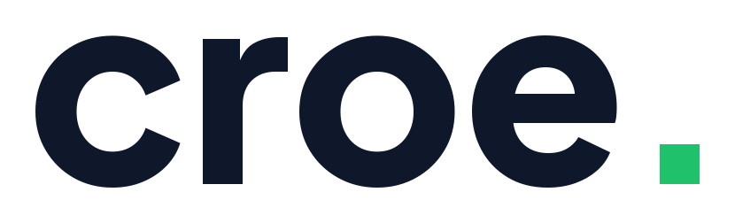 | INSTITUTIONAL PARTNERSHIP BRIEF · BOG ACT 987 COMPLIANT
croe. - Banking Partner & Custody Brief
Institutional Due-Diligence, Trust Architecture & Regulatory Compliance
――――――――――――――――――――――――――――――――――――――――――――――――――――――――――
1. Executive Summary & Partnership Proposition
The Opportunity: Croe is a mobile-first trust and escrow transaction service for emerging-market social commerce, launching Ghana-first on Mobile Money rails. Croe acts as a technology orchestration platform that channels high-velocity social commerce payments into a licensed partner bank trust account.
Value Delivered to Partner Bank | Operational Role of Partner Bank
Low-Cost Float Growth: Sticky, non-interest-bearing escrow deposits residing in a pooled trust account (CASA float). | Custodial Trust Account: Provide a dedicated pooled escrow trust account under Bank of Ghana guidelines.
Transactional Revenue: Transaction fee revenue on high-velocity inbound collections and outbound B2C wallet disbursements. | Automated Reconciliation: Automated electronic statement feed (MT940 / API) for daily 3-way balance matching.
2. Regulatory Architecture: The Non-Custodial Tech Provider
Act 987 Compliance: Croe is not a bank, does not issue electronic money, and never holds customer funds on its corporate balance sheet. Holding third-party funds in Ghana is governed by the Bank of Ghana under the Payment Systems and Services Act, 2019 (Act 987). Croe achieves compliance via a Phased Custody Architecture where float is held strictly by licensed institutions:
Phase | Legal Role of Croe | Float Holder | Compliance Standing
P0: Build | Software Developer | Nobody (Sandbox) | Development only; 354 automated tests.
P1: Pilot | Technology Merchant | Aggregator Settlement Account | Interim supervised pilot; capped volumes (~250 orders/month by month 6).
P2: Partner-Held | Payment Tech Provider (PFTSP) | Licensed Bank Pooled Trust Account | Fully compliant institutional launch; bank-held trust account.
3. Double-Spend Defense & Ledger Immutability
Triple-Lock Concurrency: Croe incorporates three structural layers of defense preventing financial double-spend or unauthorized disbursement:
1. Redis Distributed Fast Dedup: SETNX with 24-hour TTL guarantees instantaneous short-circuiting of duplicate webhooks.
2. Row Locking (SELECT ... FOR UPDATE): All state mutations serialize concurrent requests at the PostgreSQL database row level.
3. Partial Unique Indexes: Error 23505 traps guarantee that concurrent deposits or duplicate payouts fail structurally.
Append-Only Sub-Ledger: Balance history resides in an append-only transaction_ledger where UPDATE and DELETE privileges are permanently revoked at the database role level.
4. KYC & AML Compliance Controls
Tier | Verification Requirements | Per-Transaction Cap | Daily Limit
Tier 0 | Phone verified via MoMo OTP | GHS 500.00 | GHS 1,000.00
Tier 1 | Full Name + Ghana Card / Passport | GHS 5,000.00 | GHS 20,000.00
Tier 2 | Enhanced Due Diligence (EDD) + Address | GHS 50,000.00 | GHS 100,000.00
5. Automated Daily Three-Way Reconciliation
Circuit Breaker: Every 24 hours, Croe executes an automated three-way reconciliation matching: (1) Bank Partner Escrow Float Account statement balance, (2) Sum of active unreleased funds in the immutable transaction ledger, and (3) Physical payment rail transaction logs. If any non-zero variance occurs, the system logs a Priority 1 (P1) incident, halts automated disbursement workers, and alerts operations.
6. Projected Commercial Scale for Banking Partner
Milestone | Monthly Completed Txns | Monthly Processing Volume | Average Daily Float in Bank
Supervised Pilot (month 6) | 250 txns / mo | GHS 200,000.00 | GHS 13,000 – 20,000
Compliant Launch (month 18) | 5,000 txns / mo | GHS 4,000,000.00 | GHS 267,000 – 400,000
Scale (month 36) | 30,000 txns / mo | GHS 24,000,000.00 | GHS 1.6M – 2.4M

