I really like Microsoft Office Picture Manager from Office 2007. All updates and incarnations of image editing software from MS since then has been not bad but I still like Microsoft Office Picture Manager from Office 2007. Unfortunately it is not bundled with Windows or Office any more. You can, however install it as part of Office 2010/2013 Sharepoint Designer which can be found at:

2010 x86 - https://www.microsoft.com/en-gb/download/details.aspx?id=16573

2010 x64 - https://www.microsoft.com/en-us/download/details.aspx?id=24309

2013 - https://www.microsoft.com/en-GB/download/details.aspx?id=35491

This is fine as you can minimise the install to only include MOPM, However, during the next windows update you are hit with a tsunami of Office 2010 updates that are both not required and quite annoying, so I decide to extract MOPM from the Sharepoint install and have it as a single stand-alone app, which I’m afraid has not quite went according to plan as of yet.

However, during the process of attempting this I required an Installation Monitor program called Total Uninstall which offers a free version and can be found at:

https://raymondcc.r.worldssl.net/tun235.zip

TUN takes a snapshot of the file system and registry before and after an installation and then displays the differences. These differences can then be saved as a text file.

Total Uninstall does not however create an MSI package or allow copying of files/registry entries to another location. For this reason I developed this small app to do just that.

This app is developed under .NET Framework 4 Client profile since I am using it on XP, this can however simply be changed in the project properties to whatever you need.

The app looks like this :

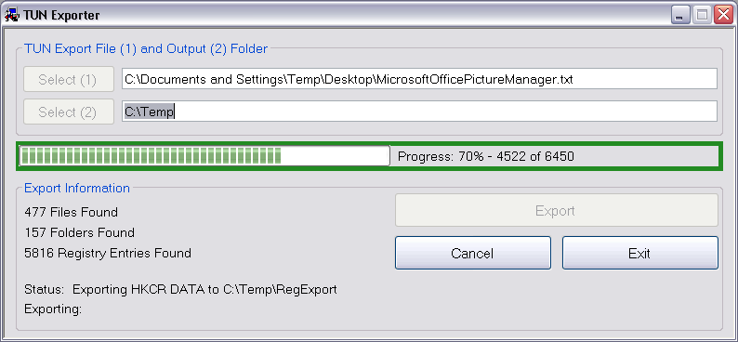

and the process is as follows:

I use XP on a VirtualBox creating snapshots of each stage should I need to go back and do it differently

Start Total Uninstall

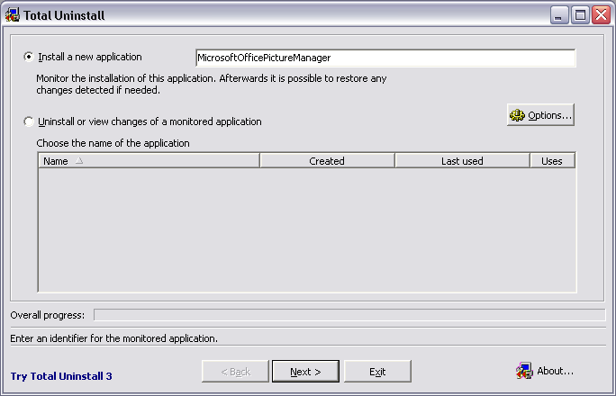

Enter a name for the project and press next

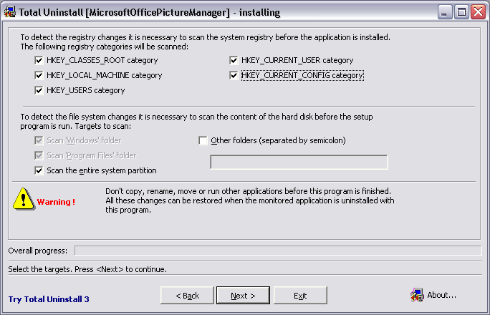

Configure as above and press Next

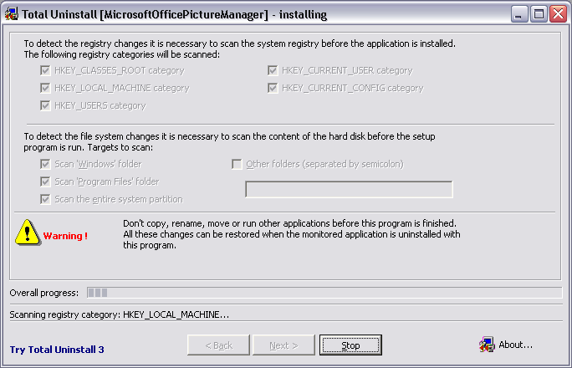

TUN will scan the registry

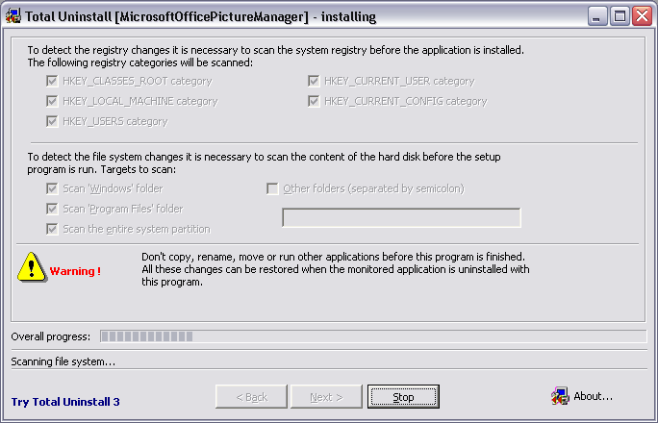

and the file system

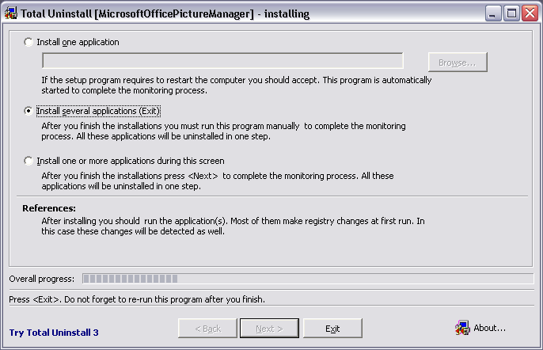

Since it is a good idea to restart after the installation option 2 is best then press Exit and run the Sharepoint Designer 2010 installer

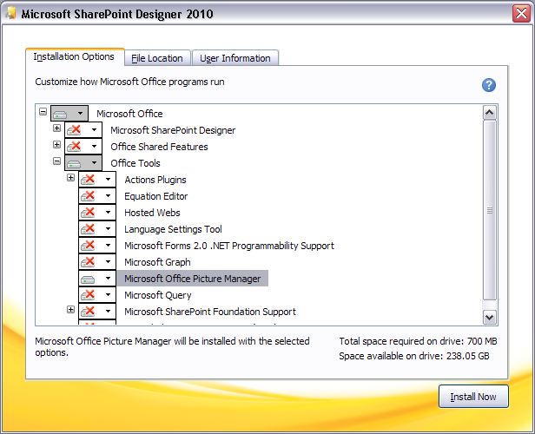

TUN will start the install and you should configure it any way you wish.

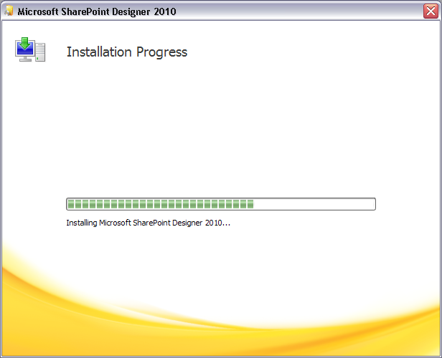

The app will install

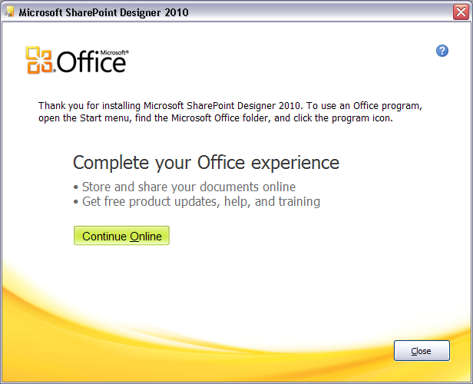

Press Close and restart

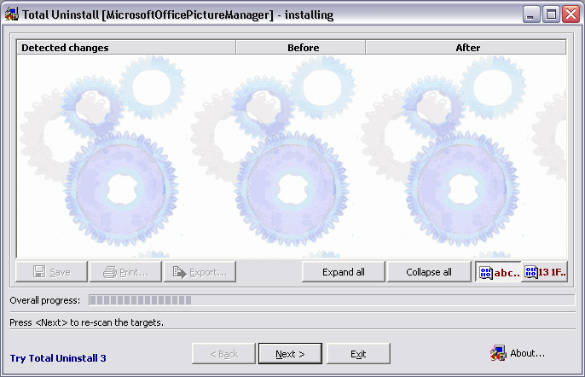

TUN should start automatically after restart, press Next

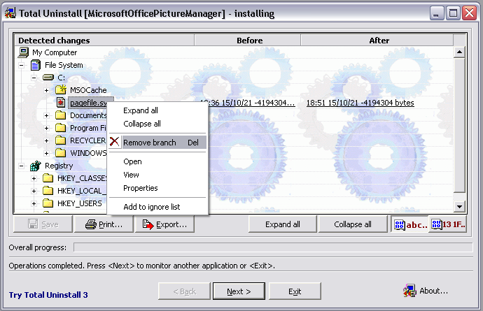

All changes will now be loaded, examine them as you see fit removing anything that is not needed like pagefile.sys, when done press Export

After Export exit the app saving as you do so

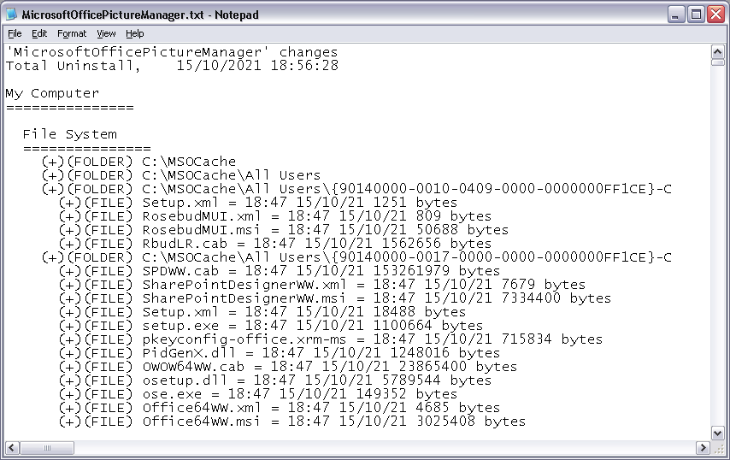

The exported text file will look like it does above

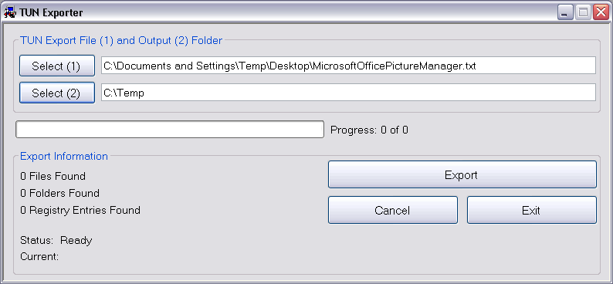

Start TUNExporter and select export file and output directory for files

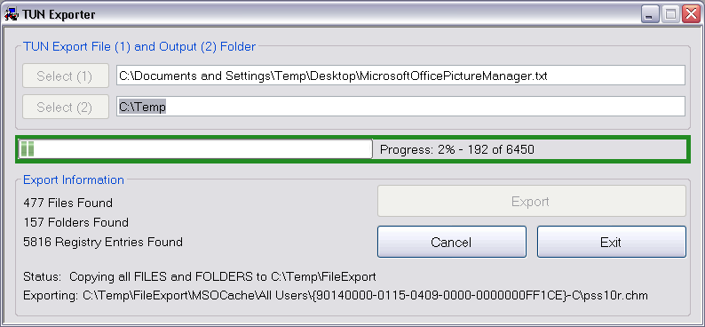

Files

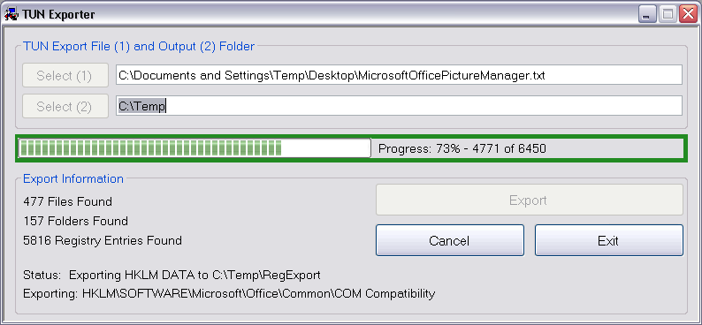

Registry

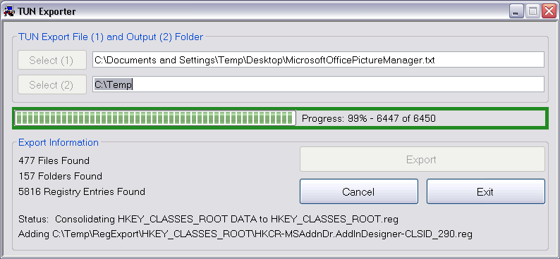

All individual registry entries are initially saved as individual files but are then all consolidated into one file for each hive, HLCR, HKCU, HKLM, HKU, HKCC

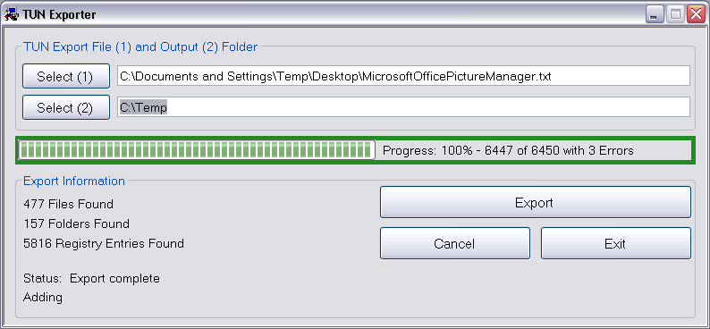

All Done

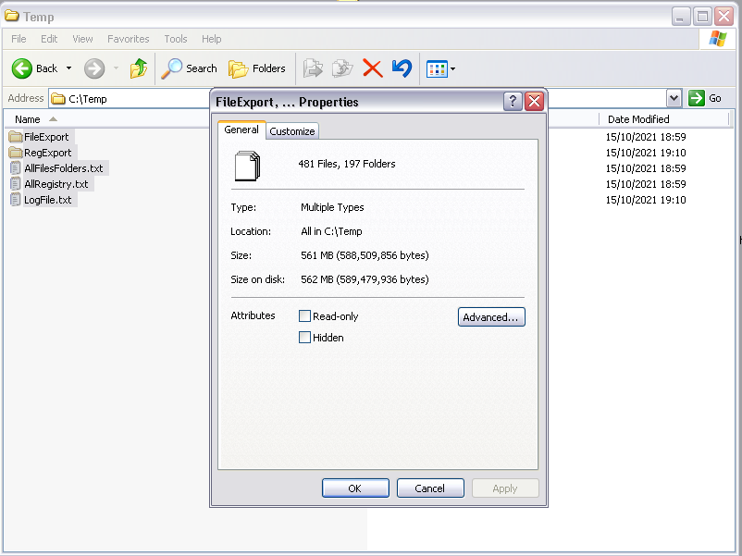

And so all files and registry entries from the Sharepoint 2010 installation are then copied to the output folder. Done

Total Uninstall, as the name suggests also allow the complete uninstall of the installed app, if you configure the options to log all successful operations then the resulting log file can also be used by TUNExporter but the Exported text file is best and produces the best results.

Thanks