Capstone Final Report

Samson Lei

May 2018

# Capstone Introduction

“PLAYERUNKNOWN’S BATTLEGROUNDS (PUBG) is a competitive survival shooter. Players are dropped into a wide, open area, and they must fight to the death - all while the battlefield shrinks, adding pressure to all in its grip.” -Reddit’s about PUBG statement

For this capstone I will analyze player statistics from the video game “PlayerUnknown’s Battlegrounds” aka PUBG. The original goal of this analysis was to recommend other players of this game possible strategies based on the datasets provided from posted on Kaggle, which originated from the PUBG developer’s own data collecting methods. A side goal that would have contributed to that idea would have been to present outliers in the player statistics that denoted significant difference in skill or ability in-game. However, through a more in-depth look at the data we have, I believe that the same anaylsis could serve the developers of the game much better.

As such, the primary goal of this analysis is to seek out notable outliers in the data. The objective of this goal is to provide insight into these players.

### Significance

The importance of the analysis of outliers can be placed into two major categories.

1. Outliers displaying overall greater skill

* The developers/publishers for PUBG has been known to seek out players / content makers as partners for the game as a form of advertisement and to promote the game.
* Identification of players with skill who are also csontent makers is an important form of markerting for the game.
* Skilled players that may not be content makers might also hold the possibility of being significant in terms of tournament participation for the game, which furthers promotion for the game.

1. Outliers displaying strange behaviors and patterns

* Identifying cheating.
* Cleaning out player statistics that are primarily caused by custom matches which do not contribute to player data with any real value.
* Custom match statistics tend to be overwhelmingly skewed due to the entertainment purpose of the match rather than actual gameplay.

## Overview of data sets/ files

The original dataset included a single file from Kaggle: * “PUBG_PLAYER_Statistics.csv”

Segregated files: * “PUBG_Player_Statistics_solo” * “PUBG_Player_Statistics_duo” * “PUBG_Player_Statistics_squad”

I broke down the original dataset into 3 primary categories wherein each represent a squad composition:

* Solo
* Duo (2 player squad)
* Squad (3+ player squad)

## X1 player_name solo_KillDeathRatio solo_WinRatio   
## Min. : 1 Length:87898 Min. : 0.000 Min. : 0.000   
## 1st Qu.:21975 Class :character 1st Qu.: 1.030 1st Qu.: 0.000   
## Median :43950 Mode :character Median : 1.470 Median : 2.000   
## Mean :43950 Mean : 1.866 Mean : 5.018   
## 3rd Qu.:65924 3rd Qu.: 2.140 3rd Qu.: 5.560   
## Max. :87898 Max. :100.000 Max. :100.000   
## solo_TimeSurvived solo_RoundsPlayed solo_Wins solo_WinTop10Ratio  
## Min. : 76.1 Min. : 1.00 Min. : 0.00 Min. :0.0000   
## 1st Qu.: 17897.0 1st Qu.: 17.00 1st Qu.: 0.00 1st Qu.:0.0000   
## Median : 45173.3 Median : 48.00 Median : 1.00 Median :0.1100   
## Mean : 69715.7 Mean : 79.28 Mean : 2.08 Mean :0.1793   
## 3rd Qu.: 92462.6 3rd Qu.: 105.00 3rd Qu.: 3.00 3rd Qu.:0.2500   
## Max. :1521200.1 Max. :1681.00 Max. :106.00 Max. :1.0000   
## solo_Top10s solo_Top10Ratio solo_Losses solo_Rating   
## Min. : 0.00 Min. : 0.00 Min. : 0.0 Min. : 984.6   
## 1st Qu.: 4.00 1st Qu.: 10.80 1st Qu.: 16.0 1st Qu.:1477.2   
## Median : 8.00 Median : 16.70 Median : 46.0 Median :1754.2   
## Mean : 12.11 Mean : 20.67 Mean : 77.2 Mean :1768.6   
## 3rd Qu.: 15.00 3rd Qu.: 25.90 3rd Qu.: 102.0 3rd Qu.:2041.1   
## Max. :386.00 Max. :100.00 Max. :1673.0 Max. :2967.1   
## solo_BestRating solo_DamagePg solo_HeadshotKillsPg solo_HealsPg   
## Min. :1200 Min. : 0.0 Min. : 0.0000 Min. : 0.000   
## 1st Qu.:1467 1st Qu.: 126.5 1st Qu.: 0.1800 1st Qu.: 0.930   
## Median :1760 Median : 169.9 Median : 0.2900 Median : 1.290   
## Mean :1769 Mean : 194.3 Mean : 0.3769 Mean : 1.416   
## 3rd Qu.:2053 3rd Qu.: 231.5 3rd Qu.: 0.4600 3rd Qu.: 1.730   
## Max. :2964 Max. :2029.4 Max. :13.7500 Max. :24.000   
## solo_KillsPg solo_MoveDistancePg solo_RoadKillsPg solo_TeamKillsPg   
## Min. : 0.000 Min. : 0 Min. :0.00000 Min. :0.00000   
## 1st Qu.: 1.010 1st Qu.: 2050 1st Qu.:0.00000 1st Qu.:0.00000   
## Median : 1.430 Median : 2625 Median :0.01000 Median :0.00000   
## Mean : 1.682 Mean : 2830 Mean :0.02242 Mean :0.00833   
## 3rd Qu.: 2.000 3rd Qu.: 3386 3rd Qu.:0.03000 3rd Qu.:0.01000   
## Max. :20.000 Max. :26737 Max. :7.00000 Max. :1.00000   
## solo_TimeSurvivedPg solo_Top10sPg solo_Kills solo_Assists   
## Min. : 76.1 Min. :0.0000 Min. : 0.0 Min. : 0.000   
## 1st Qu.: 812.7 1st Qu.:0.1100 1st Qu.: 30.0 1st Qu.: 1.000   
## Median : 945.2 Median :0.1700 Median : 70.0 Median : 4.000   
## Mean : 975.8 Mean :0.2066 Mean : 105.1 Mean : 6.355   
## 3rd Qu.:1105.0 3rd Qu.:0.2600 3rd Qu.: 133.0 3rd Qu.: 8.000   
## Max. :2196.8 Max. :1.0000 Max. :5531.0 Max. :227.000   
## solo_Suicides solo_TeamKills solo_HeadshotKills  
## Min. : 0.0000 Min. : 0.0000 Min. : 0.00   
## 1st Qu.: 0.0000 1st Qu.: 0.0000 1st Qu.: 6.00   
## Median : 0.0000 Median : 0.0000 Median : 14.00   
## Mean : 0.5689 Mean : 0.5689 Mean : 22.89   
## 3rd Qu.: 1.0000 3rd Qu.: 1.0000 3rd Qu.: 29.00   
## Max. :67.0000 Max. :67.0000 Max. :1494.00   
## solo_HeadshotKillRatio solo_VehicleDestroys solo_RoadKills   
## Min. :0.0000 Min. : 0.0000 Min. : 0.000   
## 1st Qu.:0.1600 1st Qu.: 0.0000 1st Qu.: 0.000   
## Median :0.2100 Median : 0.0000 Median : 1.000   
## Mean :0.2101 Mean : 0.7261 Mean : 1.545   
## 3rd Qu.:0.2600 3rd Qu.: 1.0000 3rd Qu.: 2.000   
## Max. :1.0000 Max. :138.0000 Max. :230.000   
## solo_DailyKills solo_WeeklyKills solo_RoundMostKills  
## Min. : 0.000 Min. : 0.0 Min. : 0.000   
## 1st Qu.: 1.000 1st Qu.: 3.0 1st Qu.: 5.000   
## Median : 4.000 Median : 7.0 Median : 7.000   
## Mean : 6.337 Mean : 13.5 Mean : 7.452   
## 3rd Qu.: 8.000 3rd Qu.: 17.0 3rd Qu.: 9.000   
## Max. :256.000 Max. :642.0 Max. :87.000   
## solo_MaxKillStreaks solo_Days solo_LongestTimeSurvived  
## Min. : 0.000 Min. : 1.00 Min. : 76.1   
## 1st Qu.: 1.000 1st Qu.: 8.00 1st Qu.:1888.6   
## Median : 2.000 Median : 17.00 Median :1961.7   
## Mean : 2.027 Mean : 19.56 Mean :1926.0   
## 3rd Qu.: 2.000 3rd Qu.: 28.00 3rd Qu.:2013.4   
## Max. :87.000 Max. :173.00 Max. :3218.6   
## solo_MostSurvivalTime solo_AvgSurvivalTime solo_WinPoints   
## Min. : 76.1 Min. : 76.1 Min. : 815   
## 1st Qu.:1888.6 1st Qu.: 817.0 1st Qu.: 1340   
## Median :1961.7 Median : 971.2 Median : 1837   
## Mean :1926.0 Mean : 996.5 Mean : 2308   
## 3rd Qu.:2013.4 3rd Qu.:1153.6 3rd Qu.: 2859   
## Max. :3218.6 Max. :2196.8 Max. :10143   
## solo_WalkDistance solo_RideDistance solo_MoveDistance  
## Min. : 0 Min. : 0 Min. : 0   
## 1st Qu.: 27147 1st Qu.: 19039 1st Qu.: 48752   
## Median : 68016 Median : 54898 Median : 126508   
## Mean : 103521 Mean : 102351 Mean : 205871   
## 3rd Qu.: 137830 3rd Qu.: 126472 3rd Qu.: 266391   
## Max. :2457887 Max. :4493014 Max. :6480220   
## solo_AvgWalkDistance solo_AvgRideDistance solo_LongestKill  
## Min. : 0 Min. : 0.0 Min. : 0.0   
## 1st Qu.: 1148 1st Qu.: 701.3 1st Qu.: 191.7   
## Median : 1431 Median : 1167.3 Median : 258.2   
## Mean : 1515 Mean : 1384.6 Mean : 264.1   
## 3rd Qu.: 1787 3rd Qu.: 1826.5 3rd Qu.: 329.4   
## Max. :68812 Max. :13855.0 Max. :4694.1   
## solo_Heals solo_Boosts solo_DamageDealt  
## Min. : 0.0 Min. : 0.0 Min. : 0   
## 1st Qu.: 22.0 1st Qu.: 23.0 1st Qu.: 3495   
## Median : 63.0 Median : 62.0 Median : 8388   
## Mean : 110.5 Mean : 102.1 Mean : 12664   
## 3rd Qu.: 140.0 3rd Qu.: 130.0 3rd Qu.: 16187   
## Max. :6341.0 Max. :2923.0 Max. :598378

In comparing the Maximum values to the mean values, we can already speculate that there are significant outliers in the datasets due to the difference in distance between the values.

## X1 player_name duo_KillDeathRatio duo_WinRatio   
## Min. : 1 Length:87898 Min. : 0.000 Min. : 0.000   
## 1st Qu.:21975 Class :character 1st Qu.: 0.920 1st Qu.: 1.500   
## Median :43950 Mode :character Median : 1.260 Median : 3.230   
## Mean :43950 Mean : 1.467 Mean : 4.643   
## 3rd Qu.:65924 3rd Qu.: 1.730 3rd Qu.: 5.880   
## Max. :87898 Max. :86.000 Max. :100.000   
## duo_TimeSurvived duo_RoundsPlayed duo_Wins duo_WinTop10Ratio  
## Min. : 120.9 Min. : 1 Min. : 0.000 Min. :0.0000   
## 1st Qu.: 48365.1 1st Qu.: 49 1st Qu.: 1.000 1st Qu.:0.0500   
## Median : 86858.5 Median : 91 Median : 3.000 Median :0.1200   
## Mean : 104369.8 Mean : 112 Mean : 4.268 Mean :0.1567   
## 3rd Qu.: 140583.1 3rd Qu.: 151 3rd Qu.: 5.000 3rd Qu.:0.2200   
## Max. :1105505.4 Max. :1584 Max. :152.000 Max. :1.0000   
## duo_Top10s duo_Top10Ratio duo_Losses duo_Rating   
## Min. : 0.00 Min. : 0.00 Min. : 0.0 Min. : 986.2   
## 1st Qu.: 13.00 1st Qu.: 20.00 1st Qu.: 47.0 1st Qu.:1659.0   
## Median : 23.00 Median : 25.60 Median : 87.0 Median :1832.8   
## Mean : 28.22 Mean : 27.53 Mean : 107.8 Mean :1826.0   
## 3rd Qu.: 37.00 3rd Qu.: 32.90 3rd Qu.: 146.0 3rd Qu.:2003.6   
## Max. :397.00 Max. :100.00 Max. :1566.0 Max. :2826.2   
## duo_BestRating duo_DamagePg duo_HeadshotKillsPg duo_HealsPg   
## Min. :1200 Min. : 0.0 Min. : 0.0000 Min. : 0.000   
## 1st Qu.:1680 1st Qu.: 125.2 1st Qu.: 0.1400 1st Qu.: 1.280   
## Median :1861 Median : 163.8 Median : 0.2100 Median : 1.650   
## Mean :1848 Mean : 178.0 Mean : 0.2593 Mean : 1.747   
## 3rd Qu.:2036 3rd Qu.: 212.4 3rd Qu.: 0.3200 3rd Qu.: 2.090   
## Max. :2808 Max. :3035.4 Max. :21.0000 Max. :17.000   
## duo_KillsPg duo_MoveDistancePg duo_RevivesPg duo_RoadKillsPg   
## Min. : 0.000 Min. : 0 Min. :0.0000 Min. :0.000000   
## 1st Qu.: 0.900 1st Qu.: 2477 1st Qu.:0.1100 1st Qu.:0.000000   
## Median : 1.220 Median : 2953 Median :0.1500 Median :0.000000   
## Mean : 1.355 Mean : 3087 Mean :0.1589 Mean :0.007716   
## 3rd Qu.: 1.630 3rd Qu.: 3540 3rd Qu.:0.2000 3rd Qu.:0.010000   
## Max. :30.000 Max. :23463 Max. :3.0000 Max. :1.000000   
## duo_TeamKillsPg duo_TimeSurvivedPg duo_Top10sPg duo_Kills   
## Min. :0.00000 Min. : 106.9 Min. :0.0000 Min. : 0.0   
## 1st Qu.:0.00000 1st Qu.: 859.2 1st Qu.:0.2000 1st Qu.: 57.0   
## Median :0.01000 Median : 955.1 Median :0.2600 Median : 109.0   
## Mean :0.01657 Mean : 971.7 Mean :0.2753 Mean : 142.6   
## 3rd Qu.:0.02000 3rd Qu.:1066.4 3rd Qu.:0.3300 3rd Qu.: 188.0   
## Max. :1.00000 Max. :2074.7 Max. :1.0000 Max. :2364.0   
## duo_Assists duo_Suicides duo_TeamKills duo_HeadshotKills  
## Min. : 0.00 Min. : 0.0000 Min. : 0.000 Min. : 0.0   
## 1st Qu.: 14.00 1st Qu.: 0.0000 1st Qu.: 0.000 1st Qu.: 9.0   
## Median : 26.00 Median : 0.0000 Median : 1.000 Median : 19.0   
## Mean : 33.28 Mean : 0.8083 Mean : 1.832 Mean : 26.6   
## 3rd Qu.: 44.00 3rd Qu.: 1.0000 3rd Qu.: 3.000 3rd Qu.: 35.0   
## Max. :582.00 Max. :24.0000 Max. :99.000 Max. :547.0   
## duo_HeadshotKillRatio duo_VehicleDestroys duo_RoadKills   
## Min. :0.0000 Min. : 0.000 Min. : 0.0000   
## 1st Qu.:0.1400 1st Qu.: 0.000 1st Qu.: 0.0000   
## Median :0.1800 Median : 1.000 Median : 0.0000   
## Mean :0.1802 Mean : 1.415 Mean : 0.8345   
## 3rd Qu.:0.2100 3rd Qu.: 2.000 3rd Qu.: 1.0000   
## Max. :1.0000 Max. :87.000 Max. :43.0000   
## duo_DailyKills duo_WeeklyKills duo_RoundMostKills duo_MaxKillStreaks  
## Min. : 0.000 Min. : 0.00 Min. : 0.000 Min. : 0.000   
## 1st Qu.: 2.000 1st Qu.: 5.00 1st Qu.: 6.000 1st Qu.: 2.000   
## Median : 6.000 Median : 12.00 Median : 7.000 Median : 2.000   
## Mean : 9.062 Mean : 19.47 Mean : 7.777 Mean : 2.484   
## 3rd Qu.: 12.000 3rd Qu.: 26.00 3rd Qu.:10.000 3rd Qu.: 3.000   
## Max. :235.000 Max. :496.00 Max. :51.000 Max. :40.000   
## duo_Days duo_LongestTimeSurvived duo_MostSurvivalTime  
## Min. : 1.00 Min. : 120.9 Min. : 120.9   
## 1st Qu.: 13.00 1st Qu.:1945.9 1st Qu.:1945.9   
## Median : 21.00 Median :1974.9 Median :1974.9   
## Mean : 22.42 Mean :1989.6 Mean :1989.6   
## 3rd Qu.: 30.00 3rd Qu.:2050.2 3rd Qu.:2050.2   
## Max. :140.00 Max. :5089.9 Max. :5089.9   
## duo_AvgSurvivalTime duo_WinPoints duo_WalkDistance duo_RideDistance   
## Min. : 106.9 Min. : 817 Min. : 0 Min. : 0   
## 1st Qu.: 862.9 1st Qu.:1513 1st Qu.: 73173 1st Qu.: 68800   
## Median : 980.6 Median :2330 Median : 131657 Median : 133324   
## Mean : 996.3 Mean :2550 Mean : 157801 Mean : 174293   
## 3rd Qu.:1117.4 3rd Qu.:3219 3rd Qu.: 212635 3rd Qu.: 231717   
## Max. :2074.7 Max. :9553 Max. :1734022 Max. :2326051   
## duo_MoveDistance duo_AvgWalkDistance duo_AvgRideDistance  
## Min. : 0 Min. : 0 Min. : 0   
## 1st Qu.: 146611 1st Qu.: 1250 1st Qu.: 1082   
## Median : 269913 Median : 1470 Median : 1509   
## Mean : 332095 Mean : 1518 Mean : 1658   
## 3rd Qu.: 444168 3rd Qu.: 1736 3rd Qu.: 2066   
## Max. :3761944 Max. :40969 Max. :13094   
## duo_LongestKill duo_Heals duo_Revives duo_Boosts   
## Min. : 0.0 Min. : 0 Min. : 0.00 Min. : 0.0   
## 1st Qu.: 233.0 1st Qu.: 76 1st Qu.: 7.00 1st Qu.: 56.0   
## Median : 300.8 Median : 149 Median : 14.00 Median : 108.0   
## Mean : 320.4 Mean : 195 Mean : 17.56 Mean : 140.5   
## 3rd Qu.: 379.5 3rd Qu.: 261 3rd Qu.: 24.00 3rd Qu.: 187.0   
## Max. :5738.9 Max. :3530 Max. :190.00 Max. :2247.0   
## duo_DamageDealt duo_DBNOs   
## Min. : 0 Min. : 0.0   
## 1st Qu.: 7729 1st Qu.: 36.0   
## Median : 14706 Median : 69.0   
## Mean : 19056 Mean : 89.4   
## 3rd Qu.: 25305 3rd Qu.: 119.0   
## Max. :265372 Max. :1301.0

## X1 player_name squad_KillDeathRatio squad_WinRatio   
## Min. : 1 Length:87898 Min. : 0.000 Min. : 0.000   
## 1st Qu.:21975 Class :character 1st Qu.: 0.880 1st Qu.: 3.090   
## Median :43950 Mode :character Median : 1.220 Median : 4.980   
## Mean :43950 Mean : 1.402 Mean : 6.301   
## 3rd Qu.:65924 3rd Qu.: 1.680 3rd Qu.: 7.810   
## Max. :87898 Max. :82.000 Max. :100.000   
## squad_TimeSurvived squad_RoundsPlayed squad_Wins   
## Min. : 102.3 Min. : 1.0 Min. : 0.00   
## 1st Qu.: 84441.8 1st Qu.: 83.0 1st Qu.: 4.00   
## Median : 147257.5 Median : 148.0 Median : 7.00   
## Mean : 181487.0 Mean : 181.8 Mean : 10.39   
## 3rd Qu.: 239062.7 3rd Qu.: 241.0 3rd Qu.: 13.00   
## Max. :1728930.0 Max. :1723.0 Max. :379.00   
## squad_WinTop10Ratio squad_Top10s squad_Top10Ratio squad_Losses   
## Min. :0.0000 Min. : 0.00 Min. : 0.00 Min. : 0.0   
## 1st Qu.:0.0700 1st Qu.: 33.00 1st Qu.: 33.30 1st Qu.: 78.0   
## Median :0.1300 Median : 57.00 Median : 39.00 Median : 139.0   
## Mean :0.1601 Mean : 71.27 Mean : 40.25 Mean : 171.4   
## 3rd Qu.:0.2100 3rd Qu.: 93.00 3rd Qu.: 45.70 3rd Qu.: 228.0   
## Max. :1.0000 Max. :796.00 Max. :100.00 Max. :1631.0   
## squad_Rating squad_BestRating squad_DamagePg squad_HeadshotKillsPg  
## Min. :1123 Min. :1200 Min. : 0.0 Min. : 0.0000   
## 1st Qu.:1800 1st Qu.:1840 1st Qu.: 124.0 1st Qu.: 0.1200   
## Median :1981 Median :2024 Median : 164.9 Median : 0.1900   
## Mean :1983 Mean :2018 Mean : 178.9 Mean : 0.2306   
## 3rd Qu.:2179 3rd Qu.:2211 3rd Qu.: 216.7 3rd Qu.: 0.2800   
## Max. :3212 Max. :3209 Max. :3136.5 Max. :26.0000   
## squad_HealsPg squad_KillsPg squad_MoveDistancePg squad_RevivesPg   
## Min. : 0.000 Min. : 0.000 Min. : 0 Min. :0.0000   
## 1st Qu.: 1.460 1st Qu.: 0.850 1st Qu.: 2790 1st Qu.:0.1600   
## Median : 1.830 Median : 1.160 Median : 3214 Median :0.2100   
## Mean : 1.918 Mean : 1.279 Mean : 3328 Mean :0.2192   
## 3rd Qu.: 2.280 3rd Qu.: 1.560 3rd Qu.: 3731 3rd Qu.:0.2600   
## Max. :28.000 Max. :30.000 Max. :10933 Max. :4.0000   
## squad_RoadKillsPg squad_TeamKillsPg squad_TimeSurvivedPg  
## Min. :0.000000 Min. :0.00000 Min. : 102.3   
## 1st Qu.:0.000000 1st Qu.:0.01000 1st Qu.: 922.0   
## Median :0.000000 Median :0.02000 Median :1003.4   
## Mean :0.006692 Mean :0.02857 Mean :1016.2   
## 3rd Qu.:0.010000 3rd Qu.:0.04000 3rd Qu.:1095.3   
## Max. :1.000000 Max. :3.00000 Max. :2029.3   
## squad_Top10sPg squad_Kills squad_Assists squad_Suicides   
## Min. :0.0000 Min. : 0.0 Min. : 0.0 Min. : 0.000   
## 1st Qu.:0.3300 1st Qu.: 89.0 1st Qu.: 30.0 1st Qu.: 0.000   
## Median :0.3900 Median : 165.0 Median : 54.0 Median : 1.000   
## Mean :0.4025 Mean : 218.6 Mean : 69.8 Mean : 1.239   
## 3rd Qu.:0.4600 3rd Qu.: 284.0 3rd Qu.: 91.0 3rd Qu.: 2.000   
## Max. :1.0000 Max. :3784.0 Max. :1295.0 Max. :76.000   
## squad_TeamKills squad_HeadshotKills squad_HeadshotKillRatio  
## Min. : 0.000 Min. : 0.00 Min. :0.0000   
## 1st Qu.: 1.000 1st Qu.: 14.00 1st Qu.:0.1400   
## Median : 3.000 Median : 27.00 Median :0.1700   
## Mean : 5.062 Mean : 37.86 Mean :0.1695   
## 3rd Qu.: 7.000 3rd Qu.: 49.00 3rd Qu.:0.2000   
## Max. :383.000 Max. :944.00 Max. :1.0000   
## squad_VehicleDestroys squad_RoadKills squad_DailyKills squad_WeeklyKills  
## Min. : 0.000 Min. : 0.000 Min. : 0.00 Min. : 0.00   
## 1st Qu.: 0.000 1st Qu.: 0.000 1st Qu.: 3.00 1st Qu.: 7.00   
## Median : 2.000 Median : 1.000 Median : 8.00 Median : 17.00   
## Mean : 3.186 Mean : 1.224 Mean : 11.46 Mean : 26.74   
## 3rd Qu.: 4.000 3rd Qu.: 2.000 3rd Qu.: 15.00 3rd Qu.: 35.00   
## Max. :81.000 Max. :57.000 Max. :253.00 Max. :704.00   
## squad_RoundMostKills squad_MaxKillStreaks squad_Days   
## Min. : 0.00 Min. : 0.000 Min. : 1.00   
## 1st Qu.: 6.00 1st Qu.: 3.000 1st Qu.: 17.00   
## Median : 8.00 Median : 3.000 Median : 26.00   
## Mean : 8.22 Mean : 3.435 Mean : 27.78   
## 3rd Qu.:10.00 3rd Qu.: 4.000 3rd Qu.: 37.00   
## Max. :81.00 Max. :74.000 Max. :128.00   
## squad_LongestTimeSurvived squad_MostSurvivalTime squad_AvgSurvivalTime  
## Min. : 102.3 Min. : 102.3 Min. : 102.3   
## 1st Qu.:1963.9 1st Qu.:1963.9 1st Qu.: 921.6   
## Median :2000.2 Median :2000.2 Median :1031.3   
## Mean :2027.1 Mean :2027.1 Mean :1041.5   
## 3rd Qu.:2134.8 3rd Qu.:2134.8 3rd Qu.:1155.5   
## Max. :3098.2 Max. :3098.2 Max. :2029.3   
## squad_WinPoints squad_WalkDistance squad_RideDistance squad_MoveDistance  
## Min. : 910 Min. : 0 Min. : 0 Min. : 0   
## 1st Qu.: 1710 1st Qu.: 132839 1st Qu.: 126609 1st Qu.: 266165   
## Median : 2742 Median : 229835 Median : 238068 Median : 474356   
## Mean : 3011 Mean : 280487 Mean : 316381 Mean : 596869   
## 3rd Qu.: 3948 3rd Qu.: 370052 3rd Qu.: 411672 3rd Qu.: 782044   
## Max. :11060 Max. :2634610 Max. :4323045 Max. :6057798   
## squad_AvgWalkDistance squad_AvgRideDistance squad_LongestKill  
## Min. : 0 Min. : 0 Min. : 0.0   
## 1st Qu.: 1377 1st Qu.:1226 1st Qu.: 282.8   
## Median : 1592 Median :1645 Median : 354.4   
## Mean : 1631 Mean :1773 Mean : 381.4   
## 3rd Qu.: 1847 3rd Qu.:2178 3rd Qu.: 443.6   
## Max. :47315 Max. :9633 Max. :4605.0   
## squad_Heals squad_Revives squad_Boosts squad_DamageDealt  
## Min. : 0.0 Min. : 0.0 Min. : 0.0 Min. : 0   
## 1st Qu.: 144.0 1st Qu.: 17.0 1st Qu.: 91.0 1st Qu.: 12828   
## Median : 266.0 Median : 31.0 Median : 169.0 Median : 23608   
## Mean : 345.9 Mean : 39.4 Mean : 226.1 Mean : 30960   
## 3rd Qu.: 456.0 3rd Qu.: 52.0 3rd Qu.: 295.0 3rd Qu.: 40426   
## Max. :4394.0 Max. :417.0 Max. :2769.0 Max. :484493   
## squad_DBNOs   
## Min. : 0.0   
## 1st Qu.: 82.0   
## Median : 153.0   
## Mean : 201.6   
## 3rd Qu.: 263.0   
## Max. :3334.0

Similarly the same trend from the solo statistics are noticed within both duo and squad datasets.

## Data Wrangling

Within the datasets, cleaning was primarily focused on the solo statistics due to some of the column names not being utilized while playing alone.

Categories removed primarily from solo dataset:

* Revivals were removed since in solo play there are no squadmates for you to revive.
* DBNO, which stands for “Down But Not Out”, is not used in solo play either. In PUBG, a player only goes DBNO when they are on a squad which can still save them before they completely die off. In PUBG, no matter what squad composition, a player will die instantly if there are no surviving or not DBNO squadmates.

Categories removed from all segregated datasets:

* TrackerID was also removed, since it wasn’t a value to be analyzed.
* WeaponAcquired wasn’t a very relevant statistic since every value was zero.

### Secondary datasets

Luckily a vast majority of the data, aside from the player names, were numeric. No conversions were made to statistics in the datasets due to this.

However I did make a significant breakdown of the data that involved the number of rounds played by each player. I had skimmed out the players who have played less than **200** rounds for this analysis. I believe that the players with another range of number of played rounds could also be analyzed further for a similar purpose as the current one, but I think that would take much too long to search through. Unfortunately this dataset is simply too vast to not cut down like this.

Similar to the original idea of breaking down the datasets based upon squad compositions:

### Solo dataset

## solo_KillDeathRatio solo_WinRatio solo_TimeSurvived solo_RoundsPlayed  
## Min. :0.100 Min. : 0.000 Min. : 83129 Min. : 201.0   
## 1st Qu.:0.820 1st Qu.: 0.470 1st Qu.: 185358 1st Qu.: 230.0   
## Median :1.050 Median : 1.080 Median : 227752 Median : 274.0   
## Mean :1.198 Mean : 1.801 Mean : 259892 Mean : 318.1   
## 3rd Qu.:1.410 3rd Qu.: 2.170 3rd Qu.: 297507 3rd Qu.: 356.0   
## Max. :6.420 Max. :28.140 Max. :1521200 Max. :1681.0   
## solo_Wins solo_WinTop10Ratio solo_Top10s solo_Top10Ratio  
## Min. : 0.000 Min. :0.000 Min. : 3.00 Min. : 1.40   
## 1st Qu.: 2.000 1st Qu.:0.040 1st Qu.: 22.00 1st Qu.: 8.00   
## Median : 3.000 Median :0.090 Median : 32.00 Median :10.80   
## Mean : 5.588 Mean :0.129 Mean : 39.69 Mean :12.68   
## 3rd Qu.: 6.000 3rd Qu.:0.180 3rd Qu.: 47.00 3rd Qu.:15.20   
## Max. :106.000 Max. :1.000 Max. :386.00 Max. :67.60   
## solo_Losses solo_Rating solo_BestRating solo_DamagePg   
## Min. : 174.0 Min. :1166 Min. :1289 Min. : 15.59   
## 1st Qu.: 226.0 1st Qu.:1987 1st Qu.:2042 1st Qu.:105.17   
## Median : 269.0 Median :2172 Median :2208 Median :130.41   
## Mean : 312.6 Mean :2149 Mean :2192 Mean :143.60   
## 3rd Qu.: 349.0 3rd Qu.:2310 3rd Qu.:2338 3rd Qu.:167.86   
## Max. :1673.0 Max. :2967 Max. :2964 Max. :551.98   
## solo_HeadshotKillsPg solo_HealsPg solo_KillsPg solo_MoveDistancePg  
## Min. :0.0100 Min. : 0.070 Min. :0.100 Min. : 637.3   
## 1st Qu.:0.1500 1st Qu.: 1.020 1st Qu.:0.810 1st Qu.: 1833.0   
## Median :0.2100 Median : 1.270 Median :1.040 Median : 2264.4   
## Mean :0.2506 Mean : 1.389 Mean :1.165 Mean : 2459.5   
## 3rd Qu.:0.3000 3rd Qu.: 1.610 3rd Qu.:1.380 3rd Qu.: 2848.8   
## Max. :1.6700 Max. :12.150 Max. :5.400 Max. :10864.2   
## solo_RoadKillsPg solo_TeamKillsPg solo_TimeSurvivedPg solo_Top10sPg   
## Min. :0.00000 Min. :0.00000 Min. : 367.4 Min. :0.0100   
## 1st Qu.:0.01000 1st Qu.:0.00000 1st Qu.: 709.1 1st Qu.:0.0800   
## Median :0.01000 Median :0.00000 Median : 806.6 Median :0.1100   
## Mean :0.01781 Mean :0.00585 Mean : 824.1 Mean :0.1269   
## 3rd Qu.:0.02000 3rd Qu.:0.01000 3rd Qu.: 918.9 3rd Qu.:0.1500   
## Max. :0.27000 Max. :0.16000 Max. :1624.0 Max. :0.6800   
## solo_Kills solo_Assists solo_Suicides solo_TeamKills   
## Min. : 45.0 Min. : 1.00 Min. : 0.000 Min. : 0.000   
## 1st Qu.: 222.0 1st Qu.: 15.00 1st Qu.: 1.000 1st Qu.: 1.000   
## Median : 303.0 Median : 21.00 Median : 2.000 Median : 2.000   
## Mean : 369.9 Mean : 24.28 Mean : 2.059 Mean : 2.059   
## 3rd Qu.: 432.0 3rd Qu.: 29.00 3rd Qu.: 3.000 3rd Qu.: 3.000   
## Max. :5531.0 Max. :227.00 Max. :67.000 Max. :67.000   
## solo_HeadshotKills solo_HeadshotKillRatio solo_VehicleDestroys  
## Min. : 3.00 Min. :0.0500 Min. : 0.000   
## 1st Qu.: 42.00 1st Qu.:0.1800 1st Qu.: 1.000   
## Median : 62.00 Median :0.2000 Median : 2.000   
## Mean : 79.74 Mean :0.2078 Mean : 2.953   
## 3rd Qu.: 94.00 3rd Qu.:0.2400 3rd Qu.: 4.000   
## Max. :1494.00 Max. :0.6100 Max. :138.000   
## solo_RoadKills solo_DailyKills solo_WeeklyKills solo_RoundMostKills  
## Min. : 0.000 Min. : 0.00 Min. : 0.00 Min. : 2.000   
## 1st Qu.: 2.000 1st Qu.: 3.00 1st Qu.: 10.00 1st Qu.: 7.000   
## Median : 4.000 Median : 8.00 Median : 21.00 Median : 8.000   
## Mean : 5.838 Mean : 11.71 Mean : 32.77 Mean : 8.802   
## 3rd Qu.: 7.000 3rd Qu.: 15.00 3rd Qu.: 42.00 3rd Qu.:10.000   
## Max. :171.000 Max. :147.00 Max. :491.00 Max. :60.000   
## solo_MaxKillStreaks solo_Days solo_LongestTimeSurvived  
## Min. : 1.000 Min. : 11.00 Min. :1733   
## 1st Qu.: 2.000 1st Qu.: 35.00 1st Qu.:1974   
## Median : 2.000 Median : 42.00 Median :2033   
## Mean : 2.766 Mean : 44.52 Mean :2059   
## 3rd Qu.: 3.000 3rd Qu.: 51.00 3rd Qu.:2175   
## Max. :59.000 Max. :173.00 Max. :3219   
## solo_MostSurvivalTime solo_AvgSurvivalTime solo_WinPoints   
## Min. :1733 Min. : 242.9 Min. : 959   
## 1st Qu.:1974 1st Qu.: 722.6 1st Qu.: 2000   
## Median :2033 Median : 852.1 Median : 3179   
## Mean :2059 Mean : 871.4 Mean : 3632   
## 3rd Qu.:2175 3rd Qu.:1004.8 3rd Qu.: 4714   
## Max. :3219 Max. :1728.4 Max. :10143   
## solo_WalkDistance solo_RideDistance solo_MoveDistance  
## Min. : 108234 Min. : 24700 Min. : 167115   
## 1st Qu.: 267965 1st Qu.: 212546 1st Qu.: 499889   
## Median : 331427 Median : 315534 Median : 655885   
## Mean : 377573 Mean : 400533 Mean : 778106   
## 3rd Qu.: 434798 3rd Qu.: 484257 3rd Qu.: 919497   
## Max. :2457887 Max. :4493014 Max. :6480220   
## solo_AvgWalkDistance solo_AvgRideDistance solo_LongestKill   
## Min. : 236.8 Min. : 83.42 Min. : 92.35   
## 1st Qu.: 1006.5 1st Qu.: 737.17 1st Qu.: 278.35   
## Median : 1224.8 Median :1138.99 Median : 337.04   
## Mean : 1276.7 Mean :1340.26 Mean : 358.17   
## 3rd Qu.: 1484.1 3rd Qu.:1718.54 3rd Qu.: 412.19   
## Max. :18511.3 Max. :7351.34 Max. :4694.11   
## solo_Heals solo_Boosts solo_DamageDealt  
## Min. : 25.0 Min. : 22.0 Min. : 7639   
## 1st Qu.: 274.0 1st Qu.: 226.0 1st Qu.: 28454   
## Median : 368.0 Median : 317.0 Median : 37944   
## Mean : 441.9 Mean : 380.4 Mean : 45573   
## 3rd Qu.: 516.0 3rd Qu.: 456.0 3rd Qu.: 52846   
## Max. :6341.0 Max. :2923.0 Max. :598378

### Duo dataset

## duo_KillDeathRatio duo_WinRatio duo_TimeSurvived duo_RoundsPlayed  
## Min. :0.170 Min. : 0.000 Min. : 102947 Min. : 201.0   
## 1st Qu.:0.890 1st Qu.: 1.400 1st Qu.: 197253 1st Qu.: 224.0   
## Median :1.160 Median : 2.400 Median : 229734 Median : 255.0   
## Mean :1.285 Mean : 3.236 Mean : 250162 Mean : 282.4   
## 3rd Qu.:1.530 3rd Qu.: 3.960 3rd Qu.: 281841 3rd Qu.: 311.0   
## Max. :9.440 Max. :39.060 Max. :1105505 Max. :1584.0   
## duo_Wins duo_WinTop10Ratio duo_Top10s duo_Top10Ratio   
## Min. : 0.000 Min. :0.0000 Min. : 15.00 Min. : 5.50   
## 1st Qu.: 4.000 1st Qu.:0.0600 1st Qu.: 46.00 1st Qu.:17.50   
## Median : 6.000 Median :0.1100 Median : 58.00 Median :21.50   
## Mean : 8.967 Mean :0.1431 Mean : 64.09 Mean :22.99   
## 3rd Qu.: 11.000 3rd Qu.:0.1900 3rd Qu.: 75.00 3rd Qu.:26.50   
## Max. :152.000 Max. :0.7700 Max. :397.00 Max. :83.40   
## duo_Losses duo_Rating duo_BestRating duo_DamagePg   
## Min. : 139.0 Min. :1246 Min. :1382 Min. : 28.41   
## 1st Qu.: 216.0 1st Qu.:1863 1st Qu.:1926 1st Qu.:123.80   
## Median : 247.0 Median :2000 Median :2058 Median :155.34   
## Mean : 273.5 Mean :2002 Mean :2057 Mean :165.78   
## 3rd Qu.: 302.0 3rd Qu.:2147 3rd Qu.:2192 3rd Qu.:196.46   
## Max. :1566.0 Max. :2826 Max. :2808 Max. :753.95   
## duo_HeadshotKillsPg duo_HealsPg duo_KillsPg duo_MoveDistancePg  
## Min. :0.0100 Min. : 0.430 Min. :0.160 Min. : 859.8   
## 1st Qu.:0.1400 1st Qu.: 1.350 1st Qu.:0.880 1st Qu.:2305.4   
## Median :0.2000 Median : 1.660 Median :1.130 Median :2699.8   
## Mean :0.2283 Mean : 1.744 Mean :1.229 Mean :2834.5   
## 3rd Qu.:0.2800 3rd Qu.: 2.030 3rd Qu.:1.480 3rd Qu.:3201.0   
## Max. :2.3200 Max. :12.880 Max. :5.760 Max. :8579.6   
## duo_RevivesPg duo_RoadKillsPg duo_TeamKillsPg duo_TimeSurvivedPg  
## Min. :0.0300 Min. :0.000000 Min. :0.00000 Min. : 480.0   
## 1st Qu.:0.1200 1st Qu.:0.000000 1st Qu.:0.01000 1st Qu.: 796.8   
## Median :0.1500 Median :0.000000 Median :0.01000 Median : 877.6   
## Mean :0.1555 Mean :0.006585 Mean :0.01585 Mean : 891.5   
## 3rd Qu.:0.1800 3rd Qu.:0.010000 3rd Qu.:0.02000 3rd Qu.: 966.6   
## Max. :0.4100 Max. :0.200000 Max. :0.29000 Max. :1653.4   
## duo_Top10sPg duo_Kills duo_Assists duo_Suicides   
## Min. :0.0600 Min. : 44.0 Min. : 13.00 Min. : 0.000   
## 1st Qu.:0.1700 1st Qu.: 226.0 1st Qu.: 54.00 1st Qu.: 1.000   
## Median :0.2200 Median : 303.0 Median : 70.00 Median : 1.000   
## Mean :0.2299 Mean : 345.6 Mean : 79.72 Mean : 2.081   
## 3rd Qu.:0.2600 3rd Qu.: 416.0 3rd Qu.: 94.00 3rd Qu.: 3.000   
## Max. :0.8300 Max. :2364.0 Max. :582.00 Max. :24.000   
## duo_TeamKills duo_HeadshotKills duo_HeadshotKillRatio  
## Min. : 0.000 Min. : 3.00 Min. :0.0400   
## 1st Qu.: 2.000 1st Qu.: 37.00 1st Qu.:0.1500   
## Median : 4.000 Median : 54.00 Median :0.1800   
## Mean : 4.627 Mean : 64.14 Mean :0.1804   
## 3rd Qu.: 6.000 3rd Qu.: 80.00 3rd Qu.:0.2100   
## Max. :99.000 Max. :547.00 Max. :0.5800   
## duo_VehicleDestroys duo_RoadKills duo_DailyKills duo_WeeklyKills   
## Min. : 0.000 Min. : 0.000 Min. : 0.00 Min. : 0.00   
## 1st Qu.: 1.000 1st Qu.: 1.000 1st Qu.: 5.00 1st Qu.: 13.00   
## Median : 3.000 Median : 2.000 Median : 11.00 Median : 27.00   
## Mean : 3.636 Mean : 2.077 Mean : 14.28 Mean : 36.83   
## 3rd Qu.: 5.000 3rd Qu.: 3.000 3rd Qu.: 19.00 3rd Qu.: 50.00   
## Max. :52.000 Max. :43.000 Max. :146.00 Max. :387.00   
## duo_RoundMostKills duo_MaxKillStreaks duo_Days   
## Min. : 2.000 Min. : 2.000 Min. : 11.00   
## 1st Qu.: 7.000 1st Qu.: 2.000 1st Qu.: 33.00   
## Median : 9.000 Median : 3.000 Median : 39.00   
## Mean : 9.243 Mean : 2.967 Mean : 40.59   
## 3rd Qu.:11.000 3rd Qu.: 3.000 3rd Qu.: 46.00   
## Max. :42.000 Max. :40.000 Max. :140.00   
## duo_LongestTimeSurvived duo_MostSurvivalTime duo_AvgSurvivalTime  
## Min. :1821 Min. :1821 Min. : 320.8   
## 1st Qu.:1979 1st Qu.:1979 1st Qu.: 810.7   
## Median :2038 Median :2038 Median : 915.8   
## Mean :2063 Mean :2063 Mean : 932.5   
## 3rd Qu.:2176 3rd Qu.:2176 3rd Qu.:1043.2   
## Max. :2661 Max. :2661 Max. :1672.4   
## duo_WinPoints duo_WalkDistance duo_RideDistance duo_MoveDistance   
## Min. :1089 Min. : 146031 Min. : 53833 Min. : 254026   
## 1st Qu.:1912 1st Qu.: 290363 1st Qu.: 278284 1st Qu.: 588297   
## Median :3106 Median : 343922 Median : 372574 Median : 722104   
## Mean :3450 Mean : 373416 Mean : 420823 Mean : 794238   
## 3rd Qu.:4428 3rd Qu.: 422344 3rd Qu.: 505219 3rd Qu.: 917342   
## Max. :9553 Max. :1734022 Max. :2326051 Max. :3761944   
## duo_AvgWalkDistance duo_AvgRideDistance duo_LongestKill   
## Min. : 300.7 Min. : 163.4 Min. : 63.02   
## 1st Qu.: 1164.7 1st Qu.: 1052.3 1st Qu.: 308.00   
## Median : 1352.4 Median : 1441.2 Median : 370.95   
## Mean : 1401.4 Mean : 1582.3 Mean : 406.87   
## 3rd Qu.: 1590.7 3rd Qu.: 1949.6 3rd Qu.: 452.87   
## Max. :40969.1 Max. :10030.4 Max. :5738.92   
## duo_Heals duo_Revives duo_Boosts duo_DamageDealt   
## Min. : 91.0 Min. : 6.00 Min. : 39.0 Min. : 8213   
## 1st Qu.: 346.0 1st Qu.: 31.00 1st Qu.: 235.0 1st Qu.: 31762   
## Median : 442.0 Median : 40.00 Median : 308.0 Median : 41564   
## Mean : 491.1 Mean : 43.81 Mean : 344.2 Mean : 46618   
## 3rd Qu.: 582.0 3rd Qu.: 52.00 3rd Qu.: 411.0 3rd Qu.: 55588   
## Max. :3530.0 Max. :190.00 Max. :2247.0 Max. :265372   
## duo_DBNOs   
## Min. : 28.0   
## 1st Qu.: 148.0   
## Median : 195.0   
## Mean : 219.6   
## 3rd Qu.: 263.0   
## Max. :1301.0

### Squad dataset

## squad_KillDeathRatio squad_WinRatio squad_TimeSurvived  
## Min. : 0.060 Min. : 0.000 Min. : 114731   
## 1st Qu.: 0.850 1st Qu.: 2.970 1st Qu.: 234387   
## Median : 1.140 Median : 4.380 Median : 288921   
## Mean : 1.262 Mean : 5.455 Mean : 330280   
## 3rd Qu.: 1.520 3rd Qu.: 6.450 3rd Qu.: 382585   
## Max. :12.290 Max. :63.320 Max. :1728930   
## squad_RoundsPlayed squad_Wins squad_WinTop10Ratio squad_Top10s   
## Min. : 201.0 Min. : 0.00 Min. :0.0000 Min. : 19.0   
## 1st Qu.: 238.0 1st Qu.: 9.00 1st Qu.:0.0700 1st Qu.: 88.0   
## Median : 291.0 Median : 14.00 Median :0.1200 Median :112.0   
## Mean : 334.2 Mean : 18.07 Mean :0.1515 Mean :129.1   
## 3rd Qu.: 384.0 3rd Qu.: 21.00 3rd Qu.:0.2000 3rd Qu.:151.0   
## Max. :1723.0 Max. :379.00 Max. :0.8300 Max. :796.0   
## squad_Top10Ratio squad_Losses squad_Rating squad_BestRating  
## Min. : 8.40 Min. : 103.0 Min. :1217 Min. :1363   
## 1st Qu.:32.50 1st Qu.: 225.0 1st Qu.:1969 1st Qu.:2037   
## Median :37.50 Median : 275.0 Median :2143 Median :2194   
## Mean :38.71 Mean : 316.1 Mean :2151 Mean :2206   
## 3rd Qu.:43.20 3rd Qu.: 364.0 3rd Qu.:2309 3rd Qu.:2346   
## Max. :93.70 Max. :1631.0 Max. :3212 Max. :3209   
## squad_DamagePg squad_HeadshotKillsPg squad_HealsPg squad_KillsPg   
## Min. : 13.16 Min. :0.0000 Min. : 0.360 Min. :0.060   
## 1st Qu.:120.67 1st Qu.:0.1200 1st Qu.: 1.500 1st Qu.:0.820   
## Median :156.63 Median :0.1700 Median : 1.820 Median :1.090   
## Mean :166.94 Mean :0.1997 Mean : 1.895 Mean :1.172   
## 3rd Qu.:201.81 3rd Qu.:0.2500 3rd Qu.: 2.220 3rd Qu.:1.420   
## Max. :709.16 Max. :3.1400 Max. :11.270 Max. :5.970   
## squad_MoveDistancePg squad_RevivesPg squad_RoadKillsPg   
## Min. : 946.2 Min. :0.0000 Min. :0.000000   
## 1st Qu.:2760.4 1st Qu.:0.1700 1st Qu.:0.000000   
## Median :3146.6 Median :0.2100 Median :0.000000   
## Mean :3262.8 Mean :0.2154 Mean :0.006071   
## 3rd Qu.:3615.4 3rd Qu.:0.2500 3rd Qu.:0.010000   
## Max. :8382.0 Max. :0.7300 Max. :0.100000   
## squad_TeamKillsPg squad_TimeSurvivedPg squad_Top10sPg squad_Kills   
## Min. :0.00000 Min. : 458.5 Min. :0.0800 Min. : 13.0   
## 1st Qu.:0.01000 1st Qu.: 905.2 1st Qu.:0.3300 1st Qu.: 234.0   
## Median :0.02000 Median : 977.9 Median :0.3800 Median : 332.0   
## Mean :0.02745 Mean : 990.1 Mean :0.3871 Mean : 389.9   
## 3rd Qu.:0.04000 3rd Qu.:1058.7 3rd Qu.:0.4300 3rd Qu.: 477.0   
## Max. :0.76000 Max. :1699.7 Max. :0.9400 Max. :3784.0   
## squad_Assists squad_Suicides squad_TeamKills squad_HeadshotKills  
## Min. : 7.0 Min. : 0.000 Min. : 0.000 Min. : 1.00   
## 1st Qu.: 79.0 1st Qu.: 1.000 1st Qu.: 4.000 1st Qu.: 36.00   
## Median : 106.0 Median : 2.000 Median : 7.000 Median : 54.00   
## Mean : 124.5 Mean : 2.315 Mean : 9.144 Mean : 66.09   
## 3rd Qu.: 149.0 3rd Qu.: 3.000 3rd Qu.: 12.000 3rd Qu.: 82.00   
## Max. :1295.0 Max. :76.000 Max. :383.000 Max. :944.00   
## squad_HeadshotKillRatio squad_VehicleDestroys squad_RoadKills   
## Min. :0.0300 Min. : 0.00 Min. : 0.000   
## 1st Qu.:0.1400 1st Qu.: 2.00 1st Qu.: 1.000   
## Median :0.1600 Median : 5.00 Median : 2.000   
## Mean :0.1649 Mean : 6.15 Mean : 2.281   
## 3rd Qu.:0.1900 3rd Qu.: 8.00 3rd Qu.: 3.000   
## Max. :0.5400 Max. :81.00 Max. :57.000   
## squad_DailyKills squad_WeeklyKills squad_RoundMostKills  
## Min. : 0.00 Min. : 0.00 Min. : 2.000   
## 1st Qu.: 5.00 1st Qu.: 14.00 1st Qu.: 7.000   
## Median : 11.00 Median : 28.00 Median : 9.000   
## Mean : 15.15 Mean : 39.01 Mean : 9.091   
## 3rd Qu.: 21.00 3rd Qu.: 52.00 3rd Qu.:11.000   
## Max. :185.00 Max. :704.00 Max. :81.000   
## squad_MaxKillStreaks squad_Days squad_LongestTimeSurvived  
## Min. : 1.000 Min. : 8.00 Min. :1847   
## 1st Qu.: 3.000 1st Qu.: 33.00 1st Qu.:1994   
## Median : 4.000 Median : 40.00 Median :2079   
## Mean : 3.901 Mean : 42.19 Mean :2085   
## 3rd Qu.: 4.000 3rd Qu.: 49.00 3rd Qu.:2181   
## Max. :45.000 Max. :128.00 Max. :3098   
## squad_MostSurvivalTime squad_AvgSurvivalTime squad_WinPoints  
## Min. :1847 Min. : 363.8 Min. : 1051   
## 1st Qu.:1994 1st Qu.: 904.0 1st Qu.: 2557   
## Median :2079 Median :1012.9 Median : 3588   
## Mean :2085 Mean :1020.8 Mean : 3772   
## 3rd Qu.:2181 3rd Qu.:1133.3 3rd Qu.: 4795   
## Max. :3098 Max. :1723.0 Max. :11060   
## squad_WalkDistance squad_RideDistance squad_MoveDistance  
## Min. : 154228 Min. : 40234 Min. : 270676   
## 1st Qu.: 360026 1st Qu.: 367178 1st Qu.: 743039   
## Median : 444770 Median : 497394 Median : 944086   
## Mean : 504221 Mean : 584984 Mean :1089205   
## 3rd Qu.: 584256 3rd Qu.: 704821 3rd Qu.:1279318   
## Max. :2634610 Max. :4323045 Max. :6057798   
## squad_AvgWalkDistance squad_AvgRideDistance squad_LongestKill  
## Min. : 314 Min. : 173.5 Min. : 46.12   
## 1st Qu.: 1334 1st Qu.:1257.8 1st Qu.: 338.05   
## Median : 1534 Median :1661.9 Median : 405.92   
## Mean : 1563 Mean :1783.4 Mean : 446.93   
## 3rd Qu.: 1762 3rd Qu.:2171.1 3rd Qu.: 500.22   
## Max. :47315 Max. :7673.2 Max. :4604.99   
## squad_Heals squad_Revives squad_Boosts squad_DamageDealt  
## Min. : 93 Min. : 0.00 Min. : 34.0 Min. : 2935   
## 1st Qu.: 412 1st Qu.: 48.00 1st Qu.: 263.0 1st Qu.: 34392   
## Median : 551 Median : 63.00 Median : 358.0 Median : 47900   
## Mean : 634 Mean : 71.78 Mean : 417.5 Mean : 55515   
## 3rd Qu.: 763 3rd Qu.: 86.00 3rd Qu.: 506.0 3rd Qu.: 67670   
## Max. :4394 Max. :417.00 Max. :2769.0 Max. :484493   
## squad_DBNOs   
## Min. : 10.0   
## 1st Qu.: 220.0   
## Median : 311.0   
## Mean : 360.6   
## 3rd Qu.: 442.0   
## Max. :3334.0

### Exploratory Data Analysis

**Although I do not think I will utilize some of the columns in this analysis I believe that information is still relevant enough that it should remain.**

## [1] "solo_KillDeathRatio" "solo_WinRatio"   
## [3] "solo_TimeSurvived" "solo_RoundsPlayed"   
## [5] "solo_Wins" "solo_WinTop10Ratio"   
## [7] "solo_Top10s" "solo_Top10Ratio"   
## [9] "solo_Losses" "solo_Rating"   
## [11] "solo_BestRating" "solo_DamagePg"   
## [13] "solo_HeadshotKillsPg" "solo_HealsPg"   
## [15] "solo_KillsPg" "solo_MoveDistancePg"   
## [17] "solo_RoadKillsPg" "solo_TeamKillsPg"   
## [19] "solo_TimeSurvivedPg" "solo_Top10sPg"   
## [21] "solo_Kills" "solo_Assists"   
## [23] "solo_Suicides" "solo_TeamKills"   
## [25] "solo_HeadshotKills" "solo_HeadshotKillRatio"   
## [27] "solo_VehicleDestroys" "solo_RoadKills"   
## [29] "solo_DailyKills" "solo_WeeklyKills"   
## [31] "solo_RoundMostKills" "solo_MaxKillStreaks"   
## [33] "solo_Days" "solo_LongestTimeSurvived"  
## [35] "solo_MostSurvivalTime" "solo_AvgSurvivalTime"   
## [37] "solo_WinPoints" "solo_WalkDistance"   
## [39] "solo_RideDistance" "solo_MoveDistance"   
## [41] "solo_AvgWalkDistance" "solo_AvgRideDistance"   
## [43] "solo_LongestKill" "solo_Heals"   
## [45] "solo_Boosts" "solo_DamageDealt"

## [1] "duo_KillDeathRatio" "duo_WinRatio"   
## [3] "duo_TimeSurvived" "duo_RoundsPlayed"   
## [5] "duo_Wins" "duo_WinTop10Ratio"   
## [7] "duo_Top10s" "duo_Top10Ratio"   
## [9] "duo_Losses" "duo_Rating"   
## [11] "duo_BestRating" "duo_DamagePg"   
## [13] "duo_HeadshotKillsPg" "duo_HealsPg"   
## [15] "duo_KillsPg" "duo_MoveDistancePg"   
## [17] "duo_RevivesPg" "duo_RoadKillsPg"   
## [19] "duo_TeamKillsPg" "duo_TimeSurvivedPg"   
## [21] "duo_Top10sPg" "duo_Kills"   
## [23] "duo_Assists" "duo_Suicides"   
## [25] "duo_TeamKills" "duo_HeadshotKills"   
## [27] "duo_HeadshotKillRatio" "duo_VehicleDestroys"   
## [29] "duo_RoadKills" "duo_DailyKills"   
## [31] "duo_WeeklyKills" "duo_RoundMostKills"   
## [33] "duo_MaxKillStreaks" "duo_Days"   
## [35] "duo_LongestTimeSurvived" "duo_MostSurvivalTime"   
## [37] "duo_AvgSurvivalTime" "duo_WinPoints"   
## [39] "duo_WalkDistance" "duo_RideDistance"   
## [41] "duo_MoveDistance" "duo_AvgWalkDistance"   
## [43] "duo_AvgRideDistance" "duo_LongestKill"   
## [45] "duo_Heals" "duo_Revives"   
## [47] "duo_Boosts" "duo_DamageDealt"   
## [49] "duo_DBNOs"

## [1] "squad_KillDeathRatio" "squad_WinRatio"   
## [3] "squad_TimeSurvived" "squad_RoundsPlayed"   
## [5] "squad_Wins" "squad_WinTop10Ratio"   
## [7] "squad_Top10s" "squad_Top10Ratio"   
## [9] "squad_Losses" "squad_Rating"   
## [11] "squad_BestRating" "squad_DamagePg"   
## [13] "squad_HeadshotKillsPg" "squad_HealsPg"   
## [15] "squad_KillsPg" "squad_MoveDistancePg"   
## [17] "squad_RevivesPg" "squad_RoadKillsPg"   
## [19] "squad_TeamKillsPg" "squad_TimeSurvivedPg"   
## [21] "squad_Top10sPg" "squad_Kills"   
## [23] "squad_Assists" "squad_Suicides"   
## [25] "squad_TeamKills" "squad_HeadshotKills"   
## [27] "squad_HeadshotKillRatio" "squad_VehicleDestroys"   
## [29] "squad_RoadKills" "squad_DailyKills"   
## [31] "squad_WeeklyKills" "squad_RoundMostKills"   
## [33] "squad_MaxKillStreaks" "squad_Days"   
## [35] "squad_LongestTimeSurvived" "squad_MostSurvivalTime"   
## [37] "squad_AvgSurvivalTime" "squad_WinPoints"   
## [39] "squad_WalkDistance" "squad_RideDistance"   
## [41] "squad_MoveDistance" "squad_AvgWalkDistance"   
## [43] "squad_AvgRideDistance" "squad_LongestKill"   
## [45] "squad_Heals" "squad_Revives"   
## [47] "squad_Boosts" "squad_DamageDealt"   
## [49] "squad_DBNOs"

Since we are seeking outliers, seeking out the maximum values of each column would be a good start. However, since there are so many columns I will focus primarily on some main categories:

* **KillDeathRatio**: Common measure of skill (even if the player does not win the game overall).
* **Killspg**: Solid kill count per game
  + Following a similar reasoning to K/D, it can also provide further insight on how well a player does in game per round.
* **WinRatio**: Win to loss ratio
  + May help identify cheaters as well as skilled players.
* **Wins**: Solid win count (since players can absolutely start off not very good at the game, their overall win count may help us see their growth overtime more than their win ratio).
* **RoundsPlayed**: The number of rounds played is important to determine actual experience among players.

The remaining statistics can be useful in supporting the analysis, but would not be overall primary focuses. They will be used to help augment any notable trends.

#### Notable players by solo statistics

**Top players by kill death ratio**

## # A tibble: 6 x 46  
## solo_KillDeathRatio solo_WinRatio solo_TimeSurvived solo_RoundsPlayed  
## <dbl> <dbl> <dbl> <int>  
## 1 6.42 15.9 178968 207  
## 2 6.14 23.1 514028 416  
## 3 6.00 18.8 405655 361  
## 4 5.46 10.2 407566 450  
## 5 5.41 12.0 267816 316  
## 6 5.33 28.1 350459 263  
## # ... with 42 more variables: solo_Wins <int>, solo_WinTop10Ratio <dbl>,  
## # solo_Top10s <int>, solo_Top10Ratio <dbl>, solo_Losses <int>,  
## # solo_Rating <dbl>, solo_BestRating <dbl>, solo_DamagePg <dbl>,  
## # solo_HeadshotKillsPg <dbl>, solo_HealsPg <dbl>, solo_KillsPg <dbl>,  
## # solo_MoveDistancePg <dbl>, solo_RoadKillsPg <dbl>,  
## # solo_TeamKillsPg <dbl>, solo_TimeSurvivedPg <dbl>,  
## # solo_Top10sPg <dbl>, solo_Kills <int>, solo_Assists <int>,  
## # solo_Suicides <int>, solo_TeamKills <int>, solo_HeadshotKills <int>,  
## # solo_HeadshotKillRatio <dbl>, solo_VehicleDestroys <int>,  
## # solo_RoadKills <int>, solo_DailyKills <int>, solo_WeeklyKills <int>,  
## # solo_RoundMostKills <int>, solo_MaxKillStreaks <int>, solo_Days <int>,  
## # solo_LongestTimeSurvived <dbl>, solo_MostSurvivalTime <dbl>,  
## # solo_AvgSurvivalTime <dbl>, solo_WinPoints <int>,  
## # solo_WalkDistance <dbl>, solo_RideDistance <dbl>,  
## # solo_MoveDistance <dbl>, solo_AvgWalkDistance <dbl>,  
## # solo_AvgRideDistance <dbl>, solo_LongestKill <dbl>, solo_Heals <int>,  
## # solo_Boosts <int>, solo_DamageDealt <dbl>

**Top players by win ratio**

## # A tibble: 6 x 46  
## solo_KillDeathRatio solo_WinRatio solo_TimeSurvived solo_RoundsPlayed  
## <dbl> <dbl> <dbl> <int>  
## 1 6.42 15.9 178968 207  
## 2 5.46 10.2 407566 450  
## 3 6.00 18.8 405655 361  
## 4 5.41 12.0 267816 316  
## 5 6.14 23.1 514028 416  
## 6 5.00 6.63 332473 528  
## # ... with 42 more variables: solo_Wins <int>, solo_WinTop10Ratio <dbl>,  
## # solo_Top10s <int>, solo_Top10Ratio <dbl>, solo_Losses <int>,  
## # solo_Rating <dbl>, solo_BestRating <dbl>, solo_DamagePg <dbl>,  
## # solo_HeadshotKillsPg <dbl>, solo_HealsPg <dbl>, solo_KillsPg <dbl>,  
## # solo_MoveDistancePg <dbl>, solo_RoadKillsPg <dbl>,  
## # solo_TeamKillsPg <dbl>, solo_TimeSurvivedPg <dbl>,  
## # solo_Top10sPg <dbl>, solo_Kills <int>, solo_Assists <int>,  
## # solo_Suicides <int>, solo_TeamKills <int>, solo_HeadshotKills <int>,  
## # solo_HeadshotKillRatio <dbl>, solo_VehicleDestroys <int>,  
## # solo_RoadKills <int>, solo_DailyKills <int>, solo_WeeklyKills <int>,  
## # solo_RoundMostKills <int>, solo_MaxKillStreaks <int>, solo_Days <int>,  
## # solo_LongestTimeSurvived <dbl>, solo_MostSurvivalTime <dbl>,  
## # solo_AvgSurvivalTime <dbl>, solo_WinPoints <int>,  
## # solo_WalkDistance <dbl>, solo_RideDistance <dbl>,  
## # solo_MoveDistance <dbl>, solo_AvgWalkDistance <dbl>,  
## # solo_AvgRideDistance <dbl>, solo_LongestKill <dbl>, solo_Heals <int>,  
## # solo_Boosts <int>, solo_DamageDealt <dbl>

**Players with the greatest amount of experience in terms of rounds played**

## # A tibble: 6 x 46  
## solo_KillDeathRatio solo_WinRatio solo_TimeSurvived solo_RoundsPlayed  
## <dbl> <dbl> <dbl> <int>  
## 1 5.33 28.1 350459 263  
## 2 3.32 24.1 686966 423  
## 3 5.16 23.8 397022 265  
## 4 6.14 23.1 514028 416  
## 5 3.85 21.2 441676 287  
## 6 2.86 20.9 370015 249  
## # ... with 42 more variables: solo_Wins <int>, solo_WinTop10Ratio <dbl>,  
## # solo_Top10s <int>, solo_Top10Ratio <dbl>, solo_Losses <int>,  
## # solo_Rating <dbl>, solo_BestRating <dbl>, solo_DamagePg <dbl>,  
## # solo_HeadshotKillsPg <dbl>, solo_HealsPg <dbl>, solo_KillsPg <dbl>,  
## # solo_MoveDistancePg <dbl>, solo_RoadKillsPg <dbl>,  
## # solo_TeamKillsPg <dbl>, solo_TimeSurvivedPg <dbl>,  
## # solo_Top10sPg <dbl>, solo_Kills <int>, solo_Assists <int>,  
## # solo_Suicides <int>, solo_TeamKills <int>, solo_HeadshotKills <int>,  
## # solo_HeadshotKillRatio <dbl>, solo_VehicleDestroys <int>,  
## # solo_RoadKills <int>, solo_DailyKills <int>, solo_WeeklyKills <int>,  
## # solo_RoundMostKills <int>, solo_MaxKillStreaks <int>, solo_Days <int>,  
## # solo_LongestTimeSurvived <dbl>, solo_MostSurvivalTime <dbl>,  
## # solo_AvgSurvivalTime <dbl>, solo_WinPoints <int>,  
## # solo_WalkDistance <dbl>, solo_RideDistance <dbl>,  
## # solo_MoveDistance <dbl>, solo_AvgWalkDistance <dbl>,  
## # solo_AvgRideDistance <dbl>, solo_LongestKill <dbl>, solo_Heals <int>,  
## # solo_Boosts <int>, solo_DamageDealt <dbl>

**Players with the most wins**

## # A tibble: 6 x 46  
## solo_KillDeathRatio solo_WinRatio solo_TimeSurvived solo_RoundsPlayed  
## <dbl> <dbl> <dbl> <int>  
## 1 3.38 15.9 850730 666  
## 2 4.91 8.38 839561 1229  
## 3 3.32 24.1 686966 423  
## 4 2.74 11.8 1147982 840  
## 5 6.14 23.1 514028 416  
## 6 3.82 14.5 778074 566  
## # ... with 42 more variables: solo_Wins <int>, solo_WinTop10Ratio <dbl>,  
## # solo_Top10s <int>, solo_Top10Ratio <dbl>, solo_Losses <int>,  
## # solo_Rating <dbl>, solo_BestRating <dbl>, solo_DamagePg <dbl>,  
## # solo_HeadshotKillsPg <dbl>, solo_HealsPg <dbl>, solo_KillsPg <dbl>,  
## # solo_MoveDistancePg <dbl>, solo_RoadKillsPg <dbl>,  
## # solo_TeamKillsPg <dbl>, solo_TimeSurvivedPg <dbl>,  
## # solo_Top10sPg <dbl>, solo_Kills <int>, solo_Assists <int>,  
## # solo_Suicides <int>, solo_TeamKills <int>, solo_HeadshotKills <int>,  
## # solo_HeadshotKillRatio <dbl>, solo_VehicleDestroys <int>,  
## # solo_RoadKills <int>, solo_DailyKills <int>, solo_WeeklyKills <int>,  
## # solo_RoundMostKills <int>, solo_MaxKillStreaks <int>, solo_Days <int>,  
## # solo_LongestTimeSurvived <dbl>, solo_MostSurvivalTime <dbl>,  
## # solo_AvgSurvivalTime <dbl>, solo_WinPoints <int>,  
## # solo_WalkDistance <dbl>, solo_RideDistance <dbl>,  
## # solo_MoveDistance <dbl>, solo_AvgWalkDistance <dbl>,  
## # solo_AvgRideDistance <dbl>, solo_LongestKill <dbl>, solo_Heals <int>,  
## # solo_Boosts <int>, solo_DamageDealt <dbl>

**Players with the most kills**

## # A tibble: 6 x 46  
## solo_KillDeathRatio solo_WinRatio solo_TimeSurvived solo_RoundsPlayed  
## <dbl> <dbl> <dbl> <int>  
## 1 0.540 0.480 1203034 1681  
## 2 1.37 0.710 979462 1552  
## 3 0.530 0.260 1012440 1545  
## 4 0.870 0.780 1243410 1541  
## 5 0.500 0 1154168 1537  
## 6 1.65 1.59 1068296 1507  
## # ... with 42 more variables: solo_Wins <int>, solo_WinTop10Ratio <dbl>,  
## # solo_Top10s <int>, solo_Top10Ratio <dbl>, solo_Losses <int>,  
## # solo_Rating <dbl>, solo_BestRating <dbl>, solo_DamagePg <dbl>,  
## # solo_HeadshotKillsPg <dbl>, solo_HealsPg <dbl>, solo_KillsPg <dbl>,  
## # solo_MoveDistancePg <dbl>, solo_RoadKillsPg <dbl>,  
## # solo_TeamKillsPg <dbl>, solo_TimeSurvivedPg <dbl>,  
## # solo_Top10sPg <dbl>, solo_Kills <int>, solo_Assists <int>,  
## # solo_Suicides <int>, solo_TeamKills <int>, solo_HeadshotKills <int>,  
## # solo_HeadshotKillRatio <dbl>, solo_VehicleDestroys <int>,  
## # solo_RoadKills <int>, solo_DailyKills <int>, solo_WeeklyKills <int>,  
## # solo_RoundMostKills <int>, solo_MaxKillStreaks <int>, solo_Days <int>,  
## # solo_LongestTimeSurvived <dbl>, solo_MostSurvivalTime <dbl>,  
## # solo_AvgSurvivalTime <dbl>, solo_WinPoints <int>,  
## # solo_WalkDistance <dbl>, solo_RideDistance <dbl>,  
## # solo_MoveDistance <dbl>, solo_AvgWalkDistance <dbl>,  
## # solo_AvgRideDistance <dbl>, solo_LongestKill <dbl>, solo_Heals <int>,  
## # solo_Boosts <int>, solo_DamageDealt <dbl>

#### Notable players by duo statistics

**Top players by kill death ratio**

## # A tibble: 6 x 49  
## duo_KillDeathRa~ duo_WinRatio duo_TimeSurvived duo_RoundsPlayed duo_Wins  
## <dbl> <dbl> <dbl> <int> <int>  
## 1 9.44 39.1 340643 233 91  
## 2 6.46 18.1 448657 342 62  
## 3 6.11 22.0 323637 255 56  
## 4 6.10 30.7 463246 319 98  
## 5 6.07 23.9 309958 247 59  
## 6 6.02 35.2 460909 318 112  
## # ... with 44 more variables: duo_WinTop10Ratio <dbl>, duo_Top10s <int>,  
## # duo_Top10Ratio <dbl>, duo_Losses <int>, duo_Rating <dbl>,  
## # duo_BestRating <dbl>, duo_DamagePg <dbl>, duo_HeadshotKillsPg <dbl>,  
## # duo_HealsPg <dbl>, duo_KillsPg <dbl>, duo_MoveDistancePg <dbl>,  
## # duo_RevivesPg <dbl>, duo_RoadKillsPg <dbl>, duo_TeamKillsPg <dbl>,  
## # duo_TimeSurvivedPg <dbl>, duo_Top10sPg <dbl>, duo_Kills <int>,  
## # duo_Assists <int>, duo_Suicides <int>, duo_TeamKills <int>,  
## # duo_HeadshotKills <int>, duo_HeadshotKillRatio <dbl>,  
## # duo_VehicleDestroys <int>, duo_RoadKills <int>, duo_DailyKills <int>,  
## # duo_WeeklyKills <int>, duo_RoundMostKills <int>,  
## # duo_MaxKillStreaks <int>, duo_Days <int>,  
## # duo_LongestTimeSurvived <dbl>, duo_MostSurvivalTime <dbl>,  
## # duo_AvgSurvivalTime <dbl>, duo_WinPoints <int>,  
## # duo_WalkDistance <dbl>, duo_RideDistance <dbl>,  
## # duo_MoveDistance <dbl>, duo_AvgWalkDistance <dbl>,  
## # duo_AvgRideDistance <dbl>, duo_LongestKill <dbl>, duo_Heals <int>,  
## # duo_Revives <int>, duo_Boosts <int>, duo_DamageDealt <dbl>,  
## # duo_DBNOs <int>

**Top players by win ratio**

## # A tibble: 6 x 49  
## duo_KillDeathRa~ duo_WinRatio duo_TimeSurvived duo_RoundsPlayed duo_Wins  
## <dbl> <dbl> <dbl> <int> <int>  
## 1 9.44 39.1 340643 233 91  
## 2 4.22 38.5 318326 226 87  
## 3 5.64 38.1 426667 289 110  
## 4 6.01 37.0 525723 319 118  
## 5 4.93 35.6 646468 391 139  
## 6 6.02 35.2 460909 318 112  
## # ... with 44 more variables: duo_WinTop10Ratio <dbl>, duo_Top10s <int>,  
## # duo_Top10Ratio <dbl>, duo_Losses <int>, duo_Rating <dbl>,  
## # duo_BestRating <dbl>, duo_DamagePg <dbl>, duo_HeadshotKillsPg <dbl>,  
## # duo_HealsPg <dbl>, duo_KillsPg <dbl>, duo_MoveDistancePg <dbl>,  
## # duo_RevivesPg <dbl>, duo_RoadKillsPg <dbl>, duo_TeamKillsPg <dbl>,  
## # duo_TimeSurvivedPg <dbl>, duo_Top10sPg <dbl>, duo_Kills <int>,  
## # duo_Assists <int>, duo_Suicides <int>, duo_TeamKills <int>,  
## # duo_HeadshotKills <int>, duo_HeadshotKillRatio <dbl>,  
## # duo_VehicleDestroys <int>, duo_RoadKills <int>, duo_DailyKills <int>,  
## # duo_WeeklyKills <int>, duo_RoundMostKills <int>,  
## # duo_MaxKillStreaks <int>, duo_Days <int>,  
## # duo_LongestTimeSurvived <dbl>, duo_MostSurvivalTime <dbl>,  
## # duo_AvgSurvivalTime <dbl>, duo_WinPoints <int>,  
## # duo_WalkDistance <dbl>, duo_RideDistance <dbl>,  
## # duo_MoveDistance <dbl>, duo_AvgWalkDistance <dbl>,  
## # duo_AvgRideDistance <dbl>, duo_LongestKill <dbl>, duo_Heals <int>,  
## # duo_Revives <int>, duo_Boosts <int>, duo_DamageDealt <dbl>,  
## # duo_DBNOs <int>

**Players with the greatest amount of experience in terms of rounds played**

## # A tibble: 6 x 49  
## duo_KillDeathRa~ duo_WinRatio duo_TimeSurvived duo_RoundsPlayed duo_Wins  
## <dbl> <dbl> <dbl> <int> <int>  
## 1 0.870 1.14 1105162 1584 18  
## 2 0.810 1.24 1105505 1531 19  
## 3 1.30 0.950 728186 1263 12  
## 4 0.490 0.600 912289 1158 7  
## 5 0.660 0.550 836448 1086 6  
## 6 1.80 1.23 651844 1057 13  
## # ... with 44 more variables: duo_WinTop10Ratio <dbl>, duo_Top10s <int>,  
## # duo_Top10Ratio <dbl>, duo_Losses <int>, duo_Rating <dbl>,  
## # duo_BestRating <dbl>, duo_DamagePg <dbl>, duo_HeadshotKillsPg <dbl>,  
## # duo_HealsPg <dbl>, duo_KillsPg <dbl>, duo_MoveDistancePg <dbl>,  
## # duo_RevivesPg <dbl>, duo_RoadKillsPg <dbl>, duo_TeamKillsPg <dbl>,  
## # duo_TimeSurvivedPg <dbl>, duo_Top10sPg <dbl>, duo_Kills <int>,  
## # duo_Assists <int>, duo_Suicides <int>, duo_TeamKills <int>,  
## # duo_HeadshotKills <int>, duo_HeadshotKillRatio <dbl>,  
## # duo_VehicleDestroys <int>, duo_RoadKills <int>, duo_DailyKills <int>,  
## # duo_WeeklyKills <int>, duo_RoundMostKills <int>,  
## # duo_MaxKillStreaks <int>, duo_Days <int>,  
## # duo_LongestTimeSurvived <dbl>, duo_MostSurvivalTime <dbl>,  
## # duo_AvgSurvivalTime <dbl>, duo_WinPoints <int>,  
## # duo_WalkDistance <dbl>, duo_RideDistance <dbl>,  
## # duo_MoveDistance <dbl>, duo_AvgWalkDistance <dbl>,  
## # duo_AvgRideDistance <dbl>, duo_LongestKill <dbl>, duo_Heals <int>,  
## # duo_Revives <int>, duo_Boosts <int>, duo_DamageDealt <dbl>,  
## # duo_DBNOs <int>

**Players with the most wins**

## # A tibble: 6 x 49  
## duo_KillDeathRa~ duo_WinRatio duo_TimeSurvived duo_RoundsPlayed duo_Wins  
## <dbl> <dbl> <dbl> <int> <int>  
## 1 3.87 22.5 909779 676 152  
## 2 4.93 35.6 646468 391 139  
## 3 4.13 17.8 866524 697 124  
## 4 3.82 25.6 728304 477 122  
## 5 6.01 37.0 525723 319 118  
## 6 3.57 30.8 623581 383 118  
## # ... with 44 more variables: duo_WinTop10Ratio <dbl>, duo_Top10s <int>,  
## # duo_Top10Ratio <dbl>, duo_Losses <int>, duo_Rating <dbl>,  
## # duo_BestRating <dbl>, duo_DamagePg <dbl>, duo_HeadshotKillsPg <dbl>,  
## # duo_HealsPg <dbl>, duo_KillsPg <dbl>, duo_MoveDistancePg <dbl>,  
## # duo_RevivesPg <dbl>, duo_RoadKillsPg <dbl>, duo_TeamKillsPg <dbl>,  
## # duo_TimeSurvivedPg <dbl>, duo_Top10sPg <dbl>, duo_Kills <int>,  
## # duo_Assists <int>, duo_Suicides <int>, duo_TeamKills <int>,  
## # duo_HeadshotKills <int>, duo_HeadshotKillRatio <dbl>,  
## # duo_VehicleDestroys <int>, duo_RoadKills <int>, duo_DailyKills <int>,  
## # duo_WeeklyKills <int>, duo_RoundMostKills <int>,  
## # duo_MaxKillStreaks <int>, duo_Days <int>,  
## # duo_LongestTimeSurvived <dbl>, duo_MostSurvivalTime <dbl>,  
## # duo_AvgSurvivalTime <dbl>, duo_WinPoints <int>,  
## # duo_WalkDistance <dbl>, duo_RideDistance <dbl>,  
## # duo_MoveDistance <dbl>, duo_AvgWalkDistance <dbl>,  
## # duo_AvgRideDistance <dbl>, duo_LongestKill <dbl>, duo_Heals <int>,  
## # duo_Revives <int>, duo_Boosts <int>, duo_DamageDealt <dbl>,  
## # duo_DBNOs <int>

**Players with the most kills**

## # A tibble: 6 x 49  
## duo_KillDeathRa~ duo_WinRatio duo_TimeSurvived duo_RoundsPlayed duo_Wins  
## <dbl> <dbl> <dbl> <int> <int>  
## 1 4.13 17.8 866524 697 124  
## 2 5.33 13.3 381449 467 62  
## 3 3.87 22.5 909779 676 152  
## 4 5.41 21.6 530268 473 102  
## 5 1.80 1.23 651844 1057 13  
## 6 4.19 6.30 378721 476 30  
## # ... with 44 more variables: duo_WinTop10Ratio <dbl>, duo_Top10s <int>,  
## # duo_Top10Ratio <dbl>, duo_Losses <int>, duo_Rating <dbl>,  
## # duo_BestRating <dbl>, duo_DamagePg <dbl>, duo_HeadshotKillsPg <dbl>,  
## # duo_HealsPg <dbl>, duo_KillsPg <dbl>, duo_MoveDistancePg <dbl>,  
## # duo_RevivesPg <dbl>, duo_RoadKillsPg <dbl>, duo_TeamKillsPg <dbl>,  
## # duo_TimeSurvivedPg <dbl>, duo_Top10sPg <dbl>, duo_Kills <int>,  
## # duo_Assists <int>, duo_Suicides <int>, duo_TeamKills <int>,  
## # duo_HeadshotKills <int>, duo_HeadshotKillRatio <dbl>,  
## # duo_VehicleDestroys <int>, duo_RoadKills <int>, duo_DailyKills <int>,  
## # duo_WeeklyKills <int>, duo_RoundMostKills <int>,  
## # duo_MaxKillStreaks <int>, duo_Days <int>,  
## # duo_LongestTimeSurvived <dbl>, duo_MostSurvivalTime <dbl>,  
## # duo_AvgSurvivalTime <dbl>, duo_WinPoints <int>,  
## # duo_WalkDistance <dbl>, duo_RideDistance <dbl>,  
## # duo_MoveDistance <dbl>, duo_AvgWalkDistance <dbl>,  
## # duo_AvgRideDistance <dbl>, duo_LongestKill <dbl>, duo_Heals <int>,  
## # duo_Revives <int>, duo_Boosts <int>, duo_DamageDealt <dbl>,  
## # duo_DBNOs <int>

#### Notable players by squad statistics

**Top players by kill death ratio**

## # A tibble: 6 x 49  
## squad_KillDeathRatio squad_WinRatio squad_TimeSurvived squad_RoundsPlay~  
## <dbl> <dbl> <dbl> <int>  
## 1 12.3 58.2 1007498 619  
## 2 11.1 57.3 698930 440  
## 3 10.1 57.0 736424 468  
## 4 9.70 63.3 505153 319  
## 5 9.05 51.9 322324 214  
## 6 8.37 50.2 471387 303  
## # ... with 45 more variables: squad_Wins <int>, squad_WinTop10Ratio <dbl>,  
## # squad_Top10s <int>, squad_Top10Ratio <dbl>, squad_Losses <int>,  
## # squad_Rating <dbl>, squad_BestRating <dbl>, squad_DamagePg <dbl>,  
## # squad_HeadshotKillsPg <dbl>, squad_HealsPg <dbl>, squad_KillsPg <dbl>,  
## # squad_MoveDistancePg <dbl>, squad_RevivesPg <dbl>,  
## # squad_RoadKillsPg <dbl>, squad_TeamKillsPg <dbl>,  
## # squad_TimeSurvivedPg <dbl>, squad_Top10sPg <dbl>, squad_Kills <int>,  
## # squad_Assists <int>, squad_Suicides <int>, squad_TeamKills <int>,  
## # squad_HeadshotKills <int>, squad_HeadshotKillRatio <dbl>,  
## # squad_VehicleDestroys <int>, squad_RoadKills <int>,  
## # squad_DailyKills <int>, squad_WeeklyKills <int>,  
## # squad_RoundMostKills <int>, squad_MaxKillStreaks <int>,  
## # squad_Days <int>, squad_LongestTimeSurvived <dbl>,  
## # squad_MostSurvivalTime <dbl>, squad_AvgSurvivalTime <dbl>,  
## # squad_WinPoints <int>, squad_WalkDistance <dbl>,  
## # squad_RideDistance <dbl>, squad_MoveDistance <dbl>,  
## # squad_AvgWalkDistance <dbl>, squad_AvgRideDistance <dbl>,  
## # squad_LongestKill <dbl>, squad_Heals <int>, squad_Revives <int>,  
## # squad_Boosts <int>, squad_DamageDealt <dbl>, squad_DBNOs <int>

**Top players by win ratio**

## # A tibble: 6 x 49  
## squad_KillDeathRatio squad_WinRatio squad_TimeSurvived squad_RoundsPlay~  
## <dbl> <dbl> <dbl> <int>  
## 1 9.70 63.3 505153 319  
## 2 8.15 61.1 1034344 620  
## 3 6.61 60.4 969884 583  
## 4 12.3 58.2 1007498 619  
## 5 11.1 57.3 698930 440  
## 6 10.1 57.0 736424 468  
## # ... with 45 more variables: squad_Wins <int>, squad_WinTop10Ratio <dbl>,  
## # squad_Top10s <int>, squad_Top10Ratio <dbl>, squad_Losses <int>,  
## # squad_Rating <dbl>, squad_BestRating <dbl>, squad_DamagePg <dbl>,  
## # squad_HeadshotKillsPg <dbl>, squad_HealsPg <dbl>, squad_KillsPg <dbl>,  
## # squad_MoveDistancePg <dbl>, squad_RevivesPg <dbl>,  
## # squad_RoadKillsPg <dbl>, squad_TeamKillsPg <dbl>,  
## # squad_TimeSurvivedPg <dbl>, squad_Top10sPg <dbl>, squad_Kills <int>,  
## # squad_Assists <int>, squad_Suicides <int>, squad_TeamKills <int>,  
## # squad_HeadshotKills <int>, squad_HeadshotKillRatio <dbl>,  
## # squad_VehicleDestroys <int>, squad_RoadKills <int>,  
## # squad_DailyKills <int>, squad_WeeklyKills <int>,  
## # squad_RoundMostKills <int>, squad_MaxKillStreaks <int>,  
## # squad_Days <int>, squad_LongestTimeSurvived <dbl>,  
## # squad_MostSurvivalTime <dbl>, squad_AvgSurvivalTime <dbl>,  
## # squad_WinPoints <int>, squad_WalkDistance <dbl>,  
## # squad_RideDistance <dbl>, squad_MoveDistance <dbl>,  
## # squad_AvgWalkDistance <dbl>, squad_AvgRideDistance <dbl>,  
## # squad_LongestKill <dbl>, squad_Heals <int>, squad_Revives <int>,  
## # squad_Boosts <int>, squad_DamageDealt <dbl>, squad_DBNOs <int>

**Players with the greatest amount of experience in terms of rounds played**

## # A tibble: 6 x 49  
## squad_KillDeathRatio squad_WinRatio squad_TimeSurvived squad_RoundsPlay~  
## <dbl> <dbl> <dbl> <int>  
## 1 1.10 5.34 1728930 1723  
## 2 0.560 1.45 1393170 1651  
## 3 1.17 2.89 1133507 1488  
## 4 0.990 1.53 1077342 1434  
## 5 1.21 4.14 1290189 1376  
## 6 0.560 2.14 1107234 1356  
## # ... with 45 more variables: squad_Wins <int>, squad_WinTop10Ratio <dbl>,  
## # squad_Top10s <int>, squad_Top10Ratio <dbl>, squad_Losses <int>,  
## # squad_Rating <dbl>, squad_BestRating <dbl>, squad_DamagePg <dbl>,  
## # squad_HeadshotKillsPg <dbl>, squad_HealsPg <dbl>, squad_KillsPg <dbl>,  
## # squad_MoveDistancePg <dbl>, squad_RevivesPg <dbl>,  
## # squad_RoadKillsPg <dbl>, squad_TeamKillsPg <dbl>,  
## # squad_TimeSurvivedPg <dbl>, squad_Top10sPg <dbl>, squad_Kills <int>,  
## # squad_Assists <int>, squad_Suicides <int>, squad_TeamKills <int>,  
## # squad_HeadshotKills <int>, squad_HeadshotKillRatio <dbl>,  
## # squad_VehicleDestroys <int>, squad_RoadKills <int>,  
## # squad_DailyKills <int>, squad_WeeklyKills <int>,  
## # squad_RoundMostKills <int>, squad_MaxKillStreaks <int>,  
## # squad_Days <int>, squad_LongestTimeSurvived <dbl>,  
## # squad_MostSurvivalTime <dbl>, squad_AvgSurvivalTime <dbl>,  
## # squad_WinPoints <int>, squad_WalkDistance <dbl>,  
## # squad_RideDistance <dbl>, squad_MoveDistance <dbl>,  
## # squad_AvgWalkDistance <dbl>, squad_AvgRideDistance <dbl>,  
## # squad_LongestKill <dbl>, squad_Heals <int>, squad_Revives <int>,  
## # squad_Boosts <int>, squad_DamageDealt <dbl>, squad_DBNOs <int>

**Players with the most wins**

## # A tibble: 6 x 49  
## squad_KillDeathRatio squad_WinRatio squad_TimeSurvived squad_RoundsPlay~  
## <dbl> <dbl> <dbl> <int>  
## 1 8.15 61.1 1034344 620  
## 2 12.3 58.2 1007498 619  
## 3 6.61 60.4 969884 583  
## 4 6.08 47.3 1166680 733  
## 5 5.73 46.8 1176987 722  
## 6 5.45 47.5 1064406 642  
## # ... with 45 more variables: squad_Wins <int>, squad_WinTop10Ratio <dbl>,  
## # squad_Top10s <int>, squad_Top10Ratio <dbl>, squad_Losses <int>,  
## # squad_Rating <dbl>, squad_BestRating <dbl>, squad_DamagePg <dbl>,  
## # squad_HeadshotKillsPg <dbl>, squad_HealsPg <dbl>, squad_KillsPg <dbl>,  
## # squad_MoveDistancePg <dbl>, squad_RevivesPg <dbl>,  
## # squad_RoadKillsPg <dbl>, squad_TeamKillsPg <dbl>,  
## # squad_TimeSurvivedPg <dbl>, squad_Top10sPg <dbl>, squad_Kills <int>,  
## # squad_Assists <int>, squad_Suicides <int>, squad_TeamKills <int>,  
## # squad_HeadshotKills <int>, squad_HeadshotKillRatio <dbl>,  
## # squad_VehicleDestroys <int>, squad_RoadKills <int>,  
## # squad_DailyKills <int>, squad_WeeklyKills <int>,  
## # squad_RoundMostKills <int>, squad_MaxKillStreaks <int>,  
## # squad_Days <int>, squad_LongestTimeSurvived <dbl>,  
## # squad_MostSurvivalTime <dbl>, squad_AvgSurvivalTime <dbl>,  
## # squad_WinPoints <int>, squad_WalkDistance <dbl>,  
## # squad_RideDistance <dbl>, squad_MoveDistance <dbl>,  
## # squad_AvgWalkDistance <dbl>, squad_AvgRideDistance <dbl>,  
## # squad_LongestKill <dbl>, squad_Heals <int>, squad_Revives <int>,  
## # squad_Boosts <int>, squad_DamageDealt <dbl>, squad_DBNOs <int>

**Players with the most kills**

## # A tibble: 6 x 49  
## squad_KillDeathRatio squad_WinRatio squad_TimeSurvived squad_RoundsPlay~  
## <dbl> <dbl> <dbl> <int>  
## 1 4.93 24.3 1209810 1014  
## 2 12.3 58.2 1007498 619  
## 3 4.82 7.06 613774 694  
## 4 4.62 27.4 1102488 828  
## 5 3.90 20.4 1175580 852  
## 6 3.83 27.4 1206308 933  
## # ... with 45 more variables: squad_Wins <int>, squad_WinTop10Ratio <dbl>,  
## # squad_Top10s <int>, squad_Top10Ratio <dbl>, squad_Losses <int>,  
## # squad_Rating <dbl>, squad_BestRating <dbl>, squad_DamagePg <dbl>,  
## # squad_HeadshotKillsPg <dbl>, squad_HealsPg <dbl>, squad_KillsPg <dbl>,  
## # squad_MoveDistancePg <dbl>, squad_RevivesPg <dbl>,  
## # squad_RoadKillsPg <dbl>, squad_TeamKillsPg <dbl>,  
## # squad_TimeSurvivedPg <dbl>, squad_Top10sPg <dbl>, squad_Kills <int>,  
## # squad_Assists <int>, squad_Suicides <int>, squad_TeamKills <int>,  
## # squad_HeadshotKills <int>, squad_HeadshotKillRatio <dbl>,  
## # squad_VehicleDestroys <int>, squad_RoadKills <int>,  
## # squad_DailyKills <int>, squad_WeeklyKills <int>,  
## # squad_RoundMostKills <int>, squad_MaxKillStreaks <int>,  
## # squad_Days <int>, squad_LongestTimeSurvived <dbl>,  
## # squad_MostSurvivalTime <dbl>, squad_AvgSurvivalTime <dbl>,  
## # squad_WinPoints <int>, squad_WalkDistance <dbl>,  
## # squad_RideDistance <dbl>, squad_MoveDistance <dbl>,  
## # squad_AvgWalkDistance <dbl>, squad_AvgRideDistance <dbl>,  
## # squad_LongestKill <dbl>, squad_Heals <int>, squad_Revives <int>,  
## # squad_Boosts <int>, squad_DamageDealt <dbl>, squad_DBNOs <int>

As a preliminary search across the separated datasets, these players would stand out the most due to their statistics in each field.

## Data exploration via visualizations

To further investigate outliers in the player statistics, we can also visualize the K/D ratios in a histogram to verify at what point a K/D becomes above average and notable.

### K/D visualization

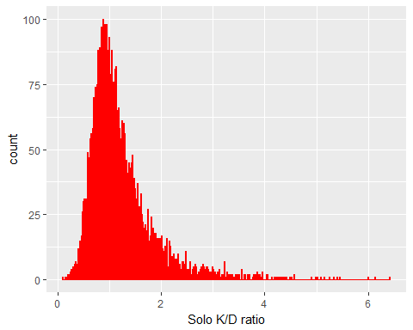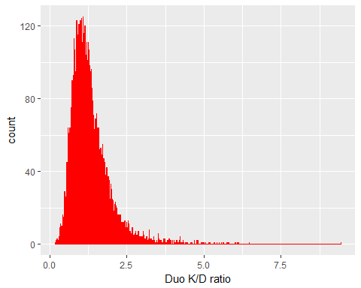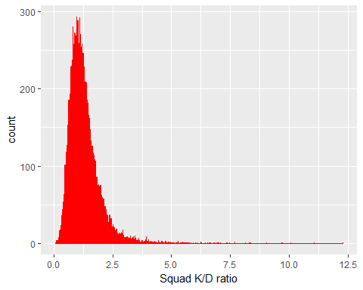

Utilizing the segregated dataset which has been further cut down to players with at least 200 rounds of gameplay experience, we can see that in this set a significant portion of experienced players have a K/D less than a 2.0.

Notes:

* A K/D with approximately a K/D of 4.0 indicates a high degree of skill.
* Those with a K/D of 5.0 seem to be a stable pool of highly skilled players
* Those with a K/D of around 6.0+ seem be the primary outliers to focus on for potential cheating as well since they are well beyond many other players.
* Squad statistics might need a bit of a focus on the further end of the ratios at approximately 6.0+ since the max ratio hits 12.5, well beyond the other datasets.

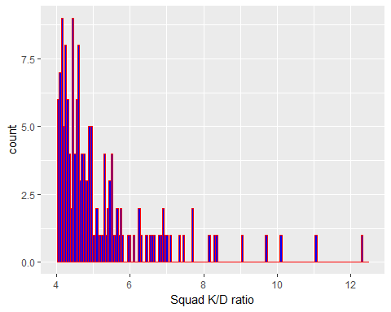

The data, at least on an individual level is precise to a thousandths place value. as such some of the data seems to mesh together on a higher binwidth. However, with this concentration of values we can see that an extremely few amount of players achieve a squad K/D of 8.0 and beyond. A stable pool, like the solo and duo datasets, appear around the 4.0 to 5.0 K/D range. How the values at apprximately 6.0+ are achieved should be put under scrutiny, since the pool is small enough to observe.

### Kills per Game Count Visualization

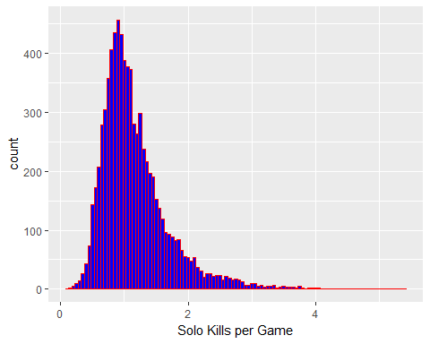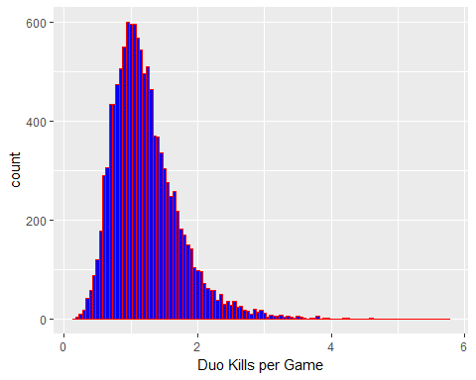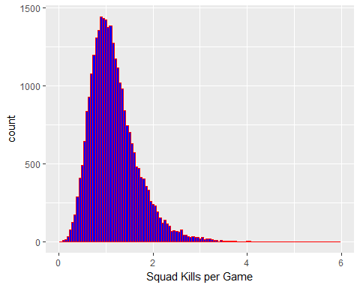

Luckily, the information on kills per game is much more grounded in terms of range.

Notes:

* Players mostly converge around the 1 kill per game area.
* More notable players seem to be around the 3.0+ range for kills per game
  + The population in at that range is where the outliers start to come out in terms of all team compositions.

### Win ratio visualization

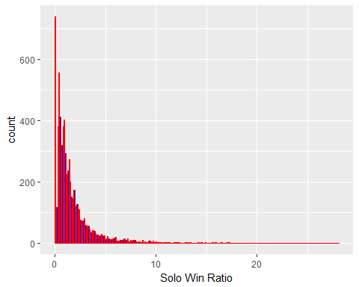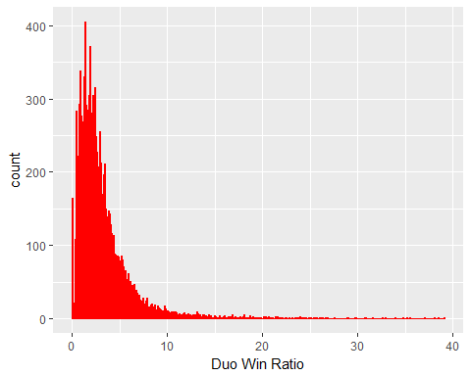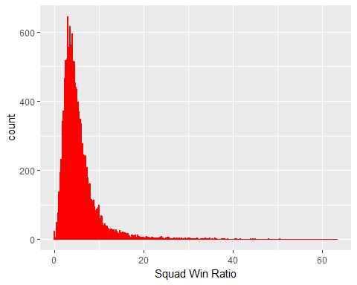

Notes:

* The win ratio average goes up depending on squad composition: Solo<Duo<Squad
  + This makes sense considering that a victory a squad extends to all members, including those that did not make it to the end alive.
* Overall this distribution is to be as expected, since only one squad can win each round, especially where each round can hold approximately 100 players
* Seems like there is data we can not really see at the higher end of the win ratios, so I will try to focus in on those to see the distribution.

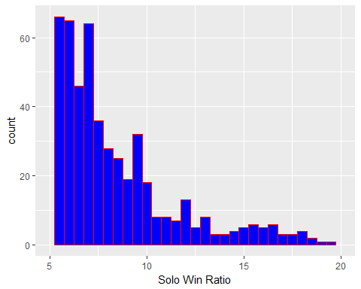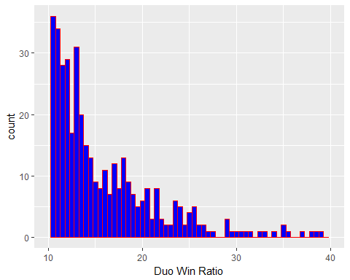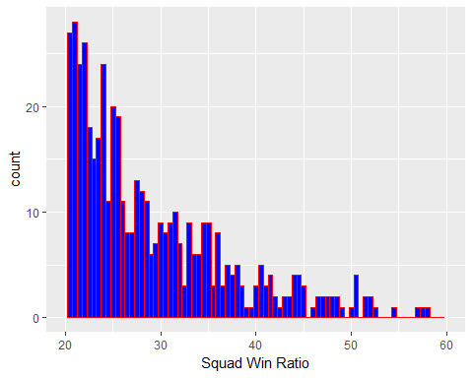

There are still quite a number of players in the higher end ratios, not too surprising considering that there are many players with a win ratio less than 1.0.

### Wins visualization

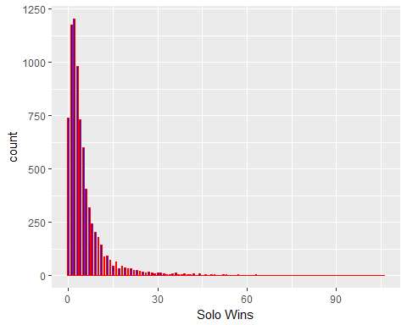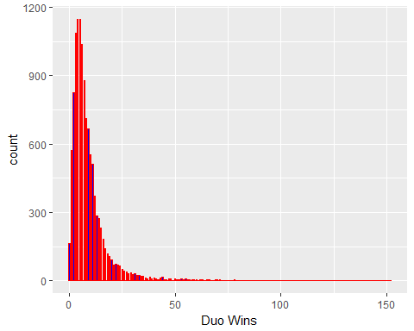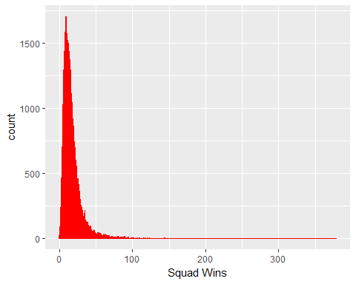

### Rounds Played Visualization

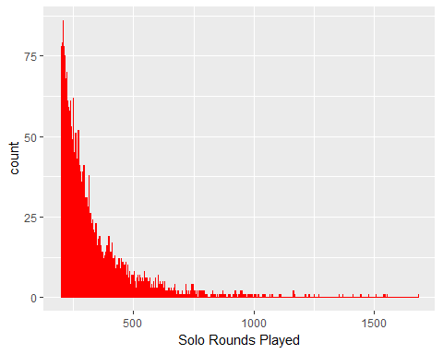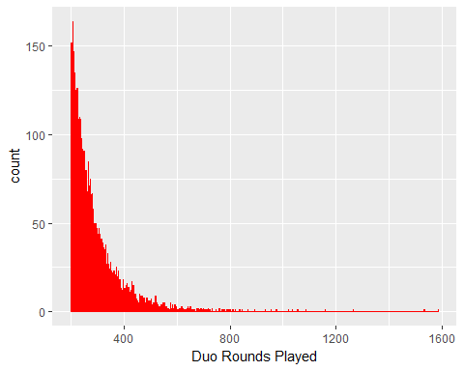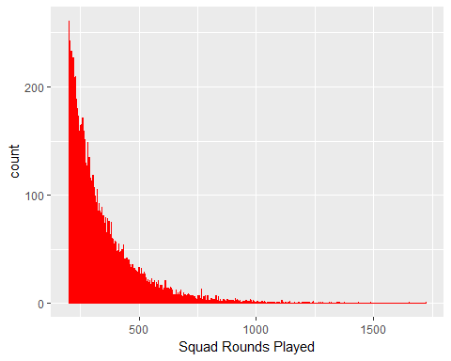

Upon inspecting the win data and the win ratio data, it appears that win ratio is not calculated how I expected it to be. My initial expectations for how win ratio is calculated was by Win/Loss. However it seems apparent throughout the data that this is not the case.

Throughout the datasets this is true: Example from squad statistics: Player: BreakNeck Rounds Played: 642 Squad Wins: 305 Squad Win Ratio: 47.51

## Data Modeling (Machine Learning)

The modeling type I will use for this capstone is the one shown in the curriculum, k-means and clustering.

To ensure that the wssplot function could be utilized on the statistics I have here, I cleaned the data a bit more.

* Changed the player_name column into the row names
* Removed the column player_name

Then I used the wssplot functions defined from the course curriculum to check the number of clusters to use.

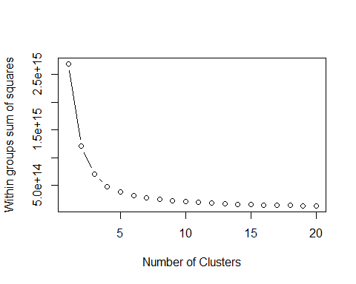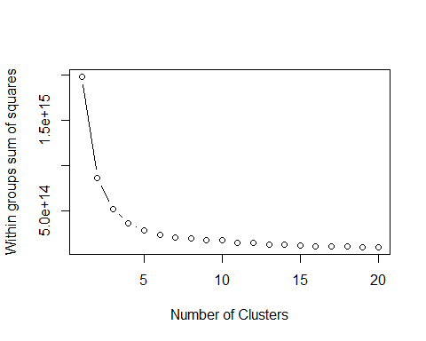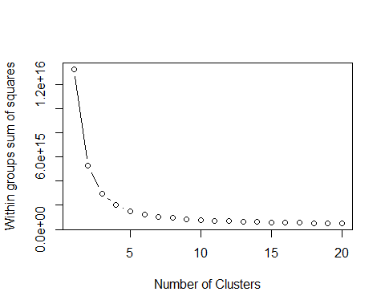

According to the given method for calculating clusters, the number of clusters to utilize is 2 to 3 for all datasets. This makes sense, since the trends in the data for each team composition are approximately the same.

Now applying k-means and plotting the clusters we get:

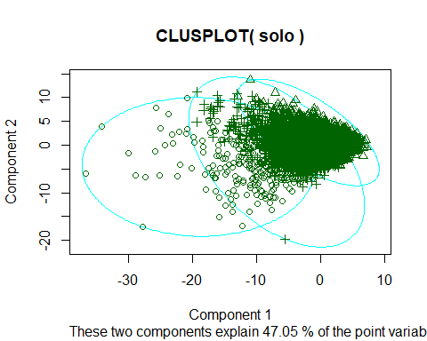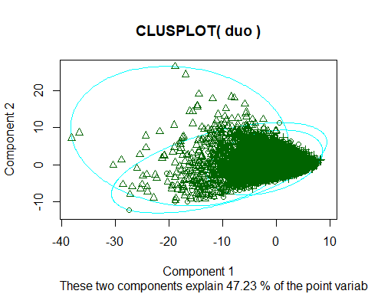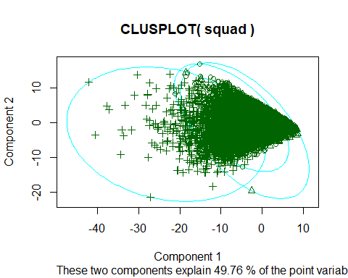

Unfortunately, there appears to be a significant cluster of concentrated values due to many players having quite similar statistics, creating a dense cluster on one end. However, the points I believe we need and would want to learn from are the outliers further out and away from the densely concentrated cluster, so this should be fine in terms of my objective.

As such I identified some sample outliers to analyze:

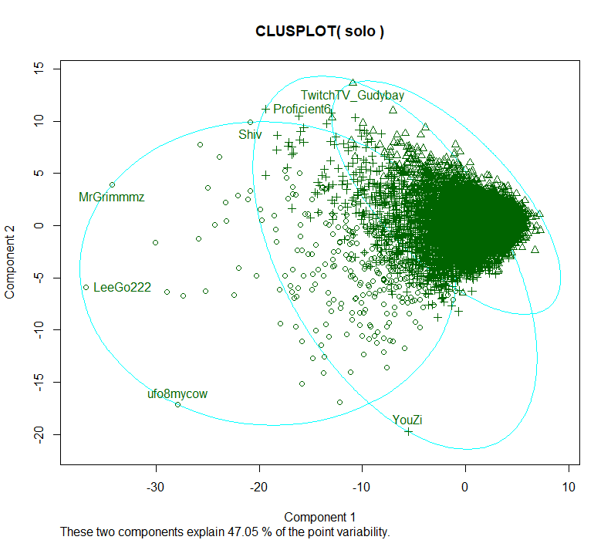

Alt text

## # A tibble: 7 x 5  
## solo_KillDeathRat~ solo_KillsPg solo_WinRatio solo_Wins solo_RoundsPlay~  
## <dbl> <dbl> <dbl> <int> <int>  
## 1 6.42 5.40 15.9 33 207  
## 2 6.00 4.87 18.8 68 361  
## 3 5.46 4.90 10.2 46 450  
## 4 4.91 4.50 8.38 103 1229  
## 5 3.50 3.32 5.19 63 1213  
## 6 1.32 1.28 3.22 44 1367  
## 7 0.540 0.540 0.490 2 407

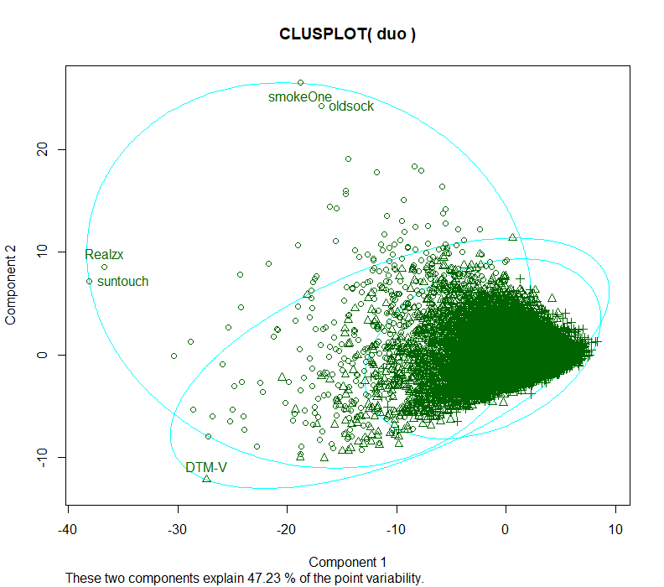

Alt text

## # A tibble: 5 x 5  
## duo_KillDeathRatio duo_KillsPg duo_WinRatio duo_Wins duo_RoundsPlayed  
## <dbl> <dbl> <dbl> <int> <int>  
## 1 0.810 0.800 1.24 19 1531  
## 2 0.870 0.860 1.14 18 1584  
## 3 4.13 3.39 17.8 124 697  
## 4 3.87 3.00 22.5 152 676  
## 5 9.44 5.76 39.1 91 233

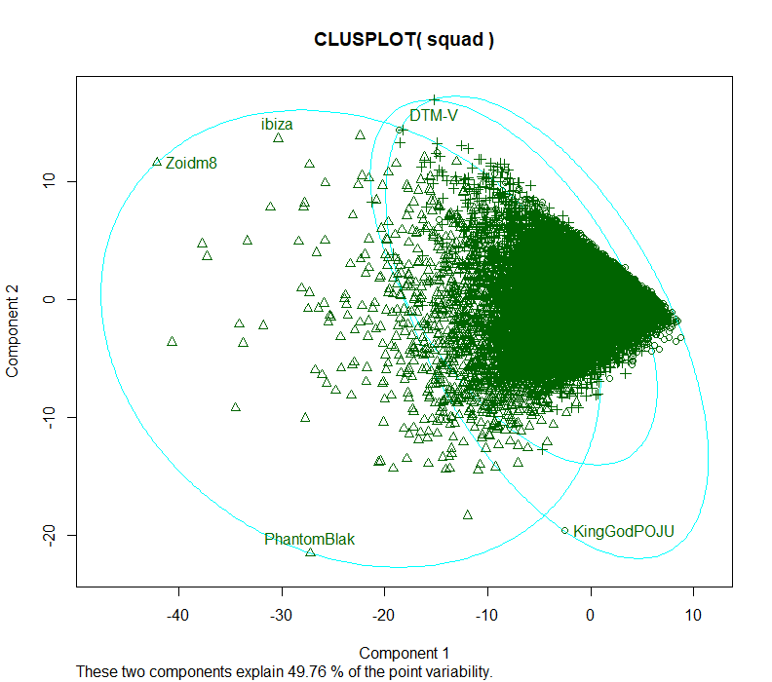

Alt text

## # A tibble: 5 x 5  
## squad_KillDeathRatio squad_KillsPg squad_WinRatio squad_Wins  
## <dbl> <dbl> <dbl> <int>  
## 1 9.05 4.36 51.9 111  
## 2 11.1 4.73 57.3 252  
## 3 12.3 5.14 58.2 360  
## 4 1.10 1.04 5.34 92  
## 5 1.04 1.03 1.20 6  
## # ... with 1 more variable: squad_RoundsPlayed <int>

By looking through the outliers along the cluster edges we see players that play a lot, but also do not do particularly well in the same cluster as those that do much better. It seems that it may be necessary to reduce the amount of columns to create cleaner clusters.

### Focused category clusters

I cleaned the datasets further by reducing the sample size based off of the histogram visualizations. After reducing the size of the datasets I ran wssplot again for cluster numbers.

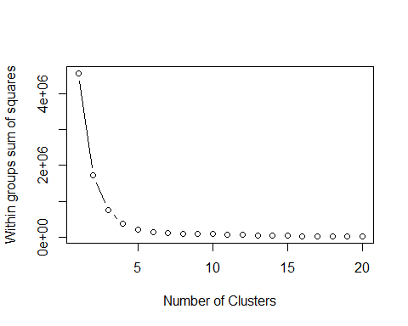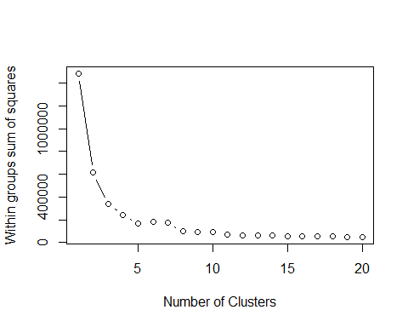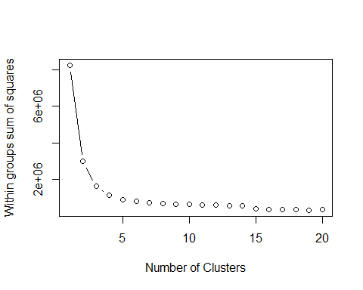

Notes

* Solo: 4 clusters
* Duo: 4 clusters
* Squad: 3 clusters

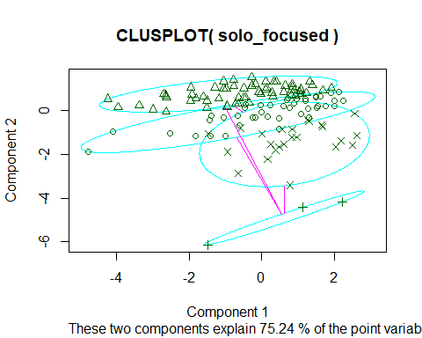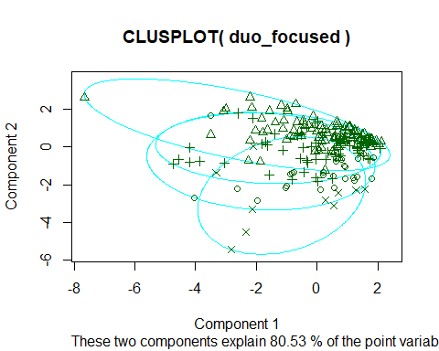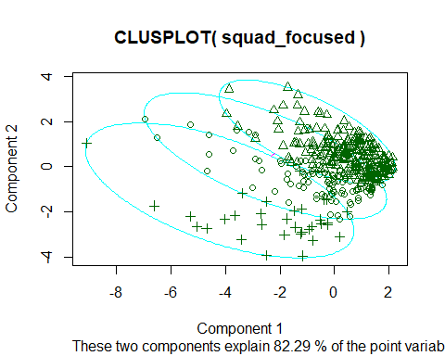

### New outliers

The clusters now look cleaner, and we can now see a better visualization of groups forming within the reduced sample sets.

Once again identifying outliers:

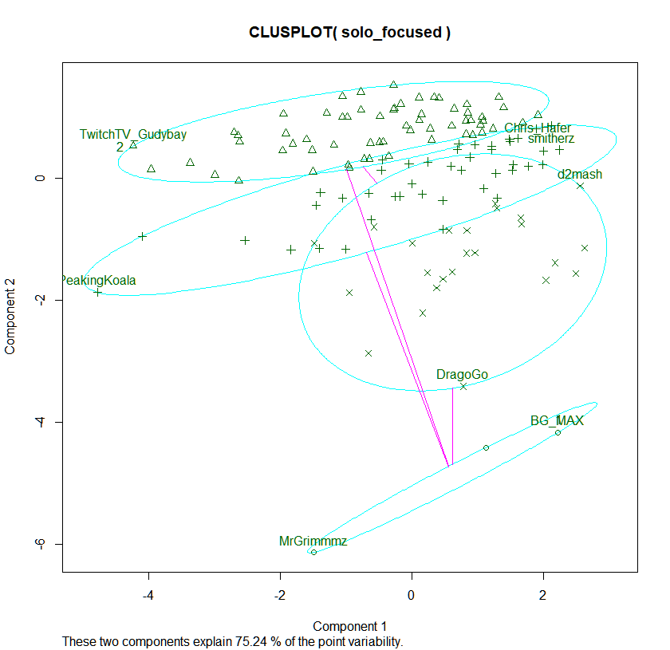

Alt text

## # A tibble: 8 x 6  
## player_name solo_KillDeathRat~ solo_KillsPg solo_WinRatio solo_Wins  
## <chr> <dbl> <dbl> <dbl> <int>  
## 1 TwitchTV_Gudybay 6.42 5.40 15.9 33  
## 2 Chris_Hafer 2.23 2.02 9.34 31  
## 3 PeakingKoala 6.14 4.72 23.1 96  
## 4 smitherz 2.16 1.98 8.47 31  
## 5 DragoGo 2.74 2.42 11.8 99  
## 6 d2mash 2.06 1.92 6.62 36  
## 7 MrGrimmmz 4.91 4.50 8.38 103  
## 8 BG_MAX 2.74 2.60 5.06 62  
## # ... with 1 more variable: solo_RoundsPlayed <int>

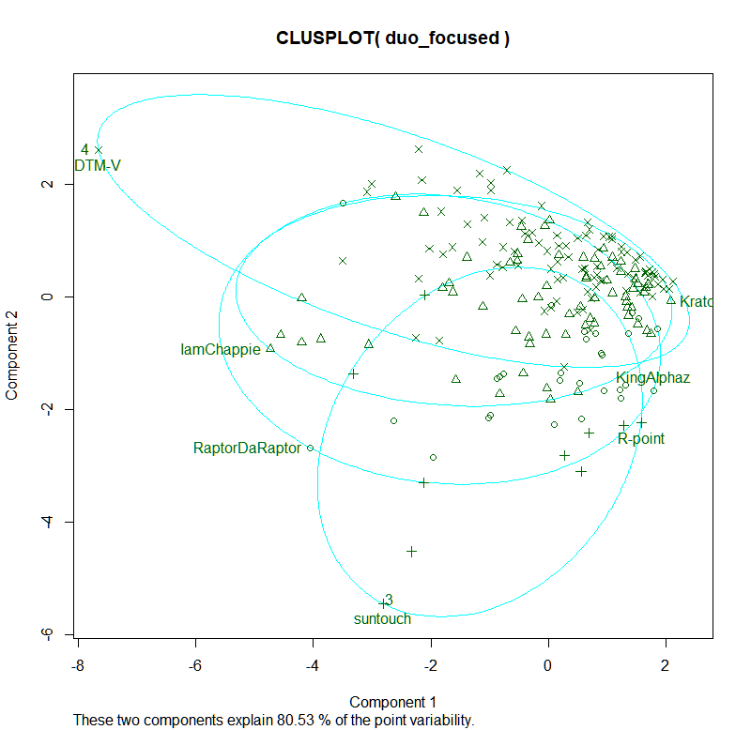

Alt text

## # A tibble: 7 x 6  
## player_name duo_KillDeathRatio duo_KillsPg duo_WinRatio duo_Wins  
## <chr> <dbl> <dbl> <dbl> <int>  
## 1 DTM-V 9.44 5.76 39.1 91  
## 2 KratoSD 2.55 2.26 11.5 33  
## 3 IamChappie 6.01 3.79 37.0 118  
## 4 KingAlphaz 2.52 2.26 10.2 46  
## 5 RaptorDaRaptor 4.93 3.18 35.6 139  
## 6 R-point 2.52 2.25 10.6 53  
## 7 suntouch 3.87 3.00 22.5 152  
## # ... with 1 more variable: duo_RoundsPlayed <int>

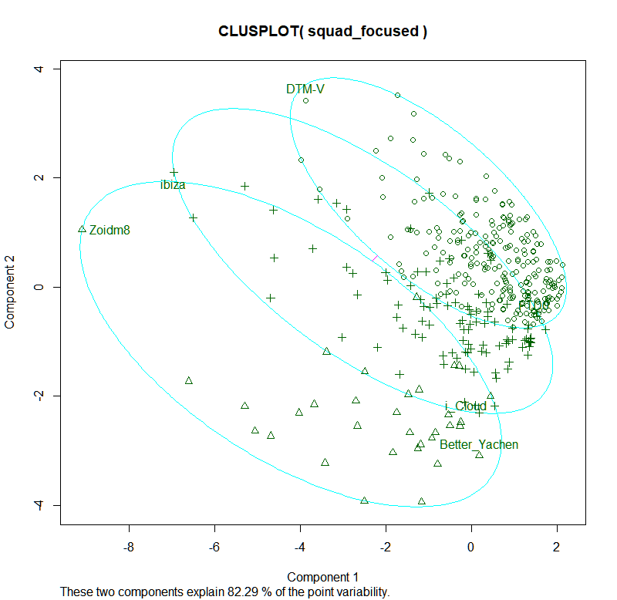

Alt text

## # A tibble: 5 x 6  
## player_name squad_KillDeathRa~ squad_KillsPg squad_WinRatio squad_Wins  
## <chr> <dbl> <dbl> <dbl> <int>  
## 1 DTM-V 9.05 4.36 51.9 111  
## 2 ibiza 11.1 4.73 57.3 252  
## 3 Zoidm8 12.3 5.14 58.2 360  
## 4 i_Cloud 2.56 1.91 25.5 139  
## 5 Better_Yachen 2.52 1.97 21.9 156  
## # ... with 1 more variable: squad_RoundsPlayed <int>

# Conclusion

The clustering did not fully shove consistently separated points. While the outliers were consistent between skimming the data to shrink the overall datasets, the remaining data and the clustering funciton did not give clean cut separations. The clustering did however show us a certain correlation between the number of rounds played compared to the other focused statistics. In the end the listed players from the upper most clusters likely can be observed for interesting gameplay since they stand out from the overall playerbase.

Alternatively another approach to cluster this data would be via player ratings that the game has in the data.