#### NIS T 5030548 a1"111c3h,GA

Description German

TURE

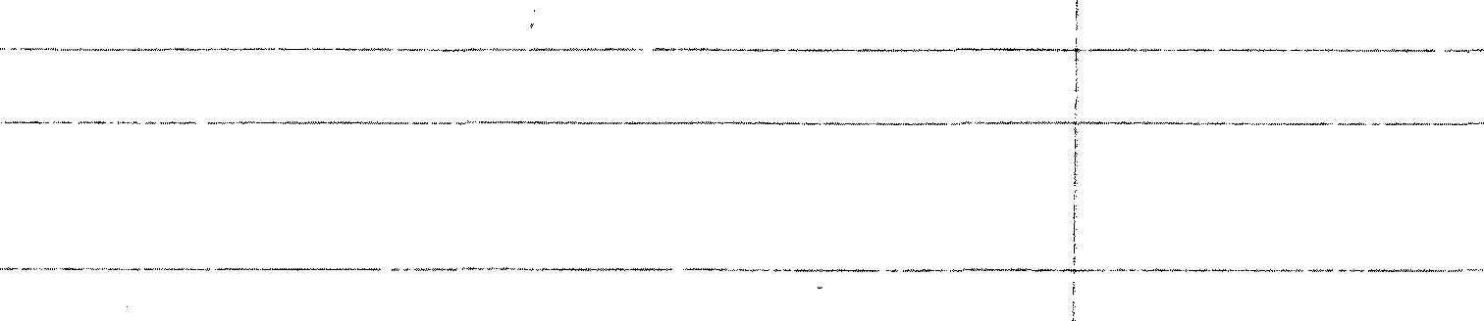CS

C D G H

Descrif)_ticm Engl_i_s

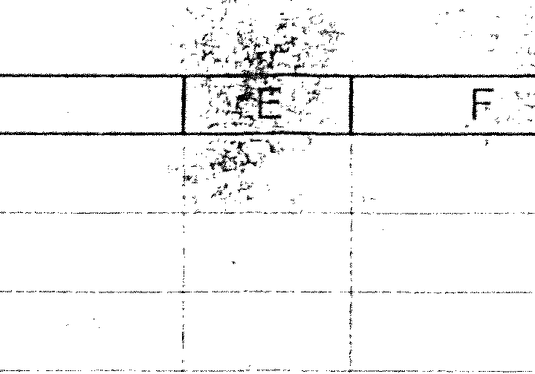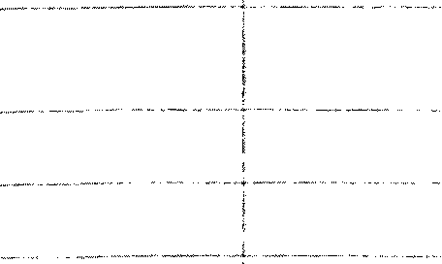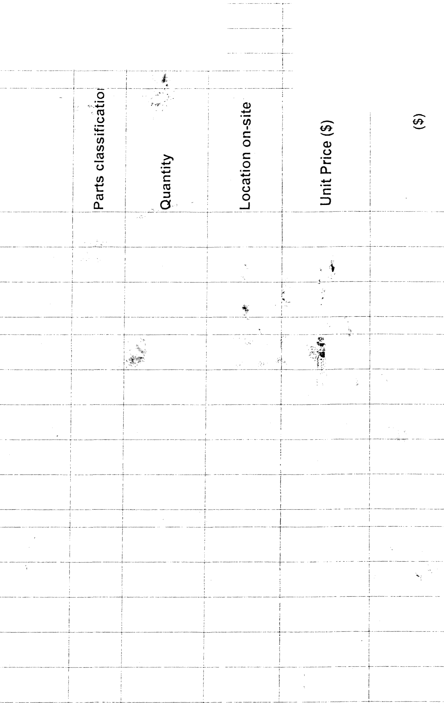

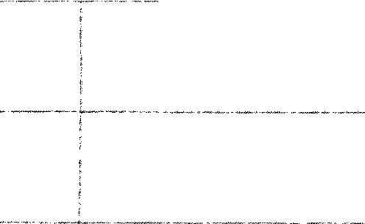

Y

tEM

ZYL SCHRAUBE NADELLAGER

0-RING

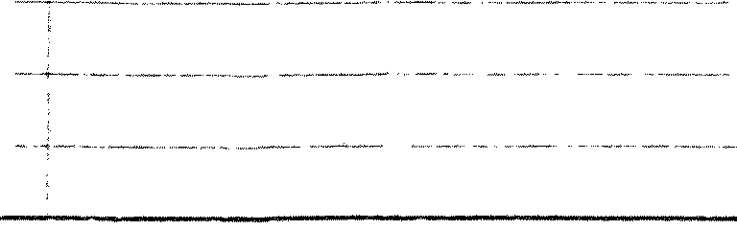- - _(,RUNDKLEMME . . -· GRUNDKLEMME r·..tRELAIS

GRUNDKLEMME M.RELAIS

-

-- -- ------

ALLEN CAP SCREW

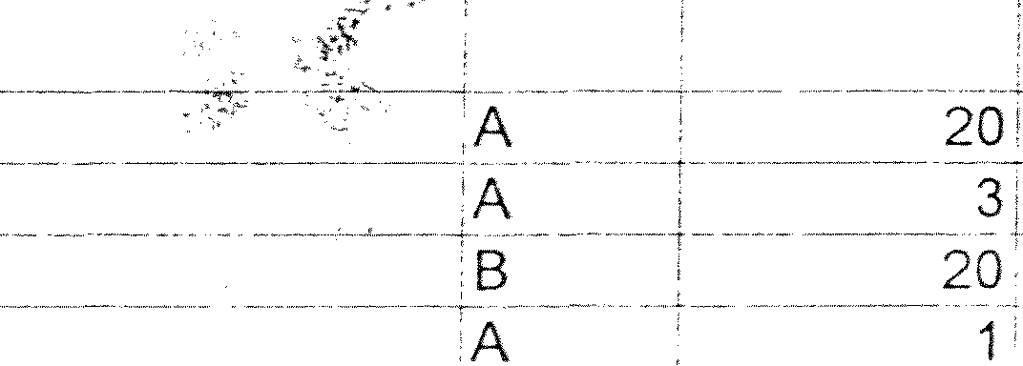- NEEDLE BEARING

O-RING

CLIP

CLIP A

CLIP A

A2 C56 AS 20

20

10

$0.84

$57.00

$0.05

$52.50

$40.30

$6016



·"c*t.)* :'

0.

iii

f-

*b*

$16 80

$171.00

$100

$52.50

$40.30

$60. iG

*i* S4294_9j

|  |  |  |  |  |
| --- | --- | --- | --- | --- |
|  | ==i-- B | | | |
|  | **Reserve spar part set for U** | | | |
| 2 | **Mor_ris Publ. Grol_l_p LLC, Sav** | | | |
| 3 |  | | | |
| 4 | 12/19/2007 | | | |
| 5 |  | | | |
| 6 | Part No. TEXT ENGUSCH  SURVEY RESERVE SET | | | |
| 7 |  | | | |
|  | MECHANICS | | | |
| 8 | .PRiNTINGUNTT --- | | | |
| 9 |  | | | |
| 10 | SPRUHFEUCHTWERK  FOLDER | | | |
| 11 |  | | | |
|  | FOLDER SUPERSTRUC | | | |
| 12 | BE[f§ | | | |
| 13 |  | | | |
|  | WEEfBINGUP DEVICE | | | |
| i4 |  | | | |
|  | REEL SPLICER | | | |
| 15 |  | | | |
| **16** |  | | | |
|  | ELECTRICS/ELECTRONI | | | |
| 17 | PRINTING UNIT | | | |
|  |
| 18 |  | | | |
|  | FOLDER | | | |
| **19** |  | | | |
|  | OPERATING ELEMENTS | | | |
| 20 |  | | | |
|  | SWITCHGEAR ASSEMBL | | | |
| 21 |  | | | |
|  | * CONTROCCONSOLE7 | | | |
|  | PPMSTATION | | | |
| 22 |  | | | |
|  | BAUMULLERDRIVEsVs | | | |
| 23 | .. MECHANICS | | | |
| 24 |  | | | |
|  | ;PRfffflNG UNIT | | | |
| 25 |  | | | |
| 26 06. 02099-0394 | | - | ----------- |  |
| 27 06 33729-0023 | |  |  |  |
| 28 06.56820-0110 | |  |  |  |
| 29 0791312-8-131 | |  |  | - |
| 30 07.91312-8134 | |  |  |  |
| 31 07.91312 8135 | |  |  |  |
| 32 07 91465-8523 | |  |  |  |

217PM

--D-IG-ITA-LE-IN/A-US-GA-BE-----------D-IGITAi. INPUT MODULE  A

7 **$429.49**

A B C D E F G H

**0**

.e

# -

·= § (I)

.!!!o c: u

- ,o

o

UJ C

I

t::

u ·.c..:,. 5

6 1:,1.!! t,J_e>.

TEXT ENGLISCH Description German .Description English */:._* _ --- o_

.3 "· ::> ---.':":- _

. **;SURVEY RESERVE SET** I . . . . . , ..... : I

=- -==- ==· =-:3M-=--L=-=

7 i;:::::::::_ - r6 D1!" -L-E;6HE = - -: - --lgg, ug tE . --- ;L-1 J-$1 :: r- _$1 :::

-t-

07.91614-8129 I ! ICABLES-DRIVESTATIONWEBUPCHAIN , ; 1, 159 , $19.21! $19.21

36 07.91690-9140··;--------·-------!SMART-UPS 1000VAUSB&.SER 12ov·-·------!FUSE . -tA -·i------·11 -Crate $2,197.62! -· $2,197.62

r-·

37 07.91690-9437 °i · --- 1EXT.-DVD **RAM** LAUFWERK ---------- ,STORAGE DEVICE ---·-·-·-·--,AZ ! J7_160C $905.01' ---$905.01

38 07.91690-9440 ,---------------··-----toss DONGLE ·---·-··---·-------·-·--tusBDONGLE MLU-60 MATRIX AM- :··- ---1:-1- :- $129.85 $129.85

39 07.91690-9765+·-

1 LSC -- · ·

* LSC 620 B&R

. _!A

r --- 1; Crate

J.-_

$6,3?8,_1?l

!C3,31 :.1_2

41 008-0010! . -·-- ------- MULTI-LOOK-LED LAMPE ----- . __JLAMP _· _ ---- !A _T 1:. 22 -1----- $5.30I-- -- $530

40 07.92008-0001 1 1MULTI-LOOK-LED LAMPE !LAMP A i 1 i 22 ! $7.23: $7.23

07.92

42 07.93011-8213 i ·G-SICHERUNG 5X20 SAFETY DEVICE 1 A i 11 23 : $0.61: $0.61

43 07.93100-9010. i ----·---- -----rcn-HIUM-BATTERIE --- ---------- BATTERY

1B T----- _1_ -- 15 _ ; $7Jtl:._ ·-·-·- $?6_5

44 07.93100-9016 _ _ -·---------· iLITHIUM-BA TTERIE -------------------·--IBUFFER BATTERY --------··--- y _j 1·-- 15 _ :_ $22.15L---·-:g '...1_5

45 07.93-111-0010-':-·-·····--------,.1SICHERU-NGSAU-TOMAT---------·-- t;I MO-TOR··P·R-O-TEC-TIO-N--C-IR·C-U-IT-B-R-E-A-K-E-R----!A.····-,i--------·-1--i r-- -8-----·--:t---···--$-3·0·.9-7··i •·-----$-3·0··.97-

46 07.93111-0011 '----·- :SICHERUNGSAUTOMAT ... ---+MOTOR PROTECTION CIRCUIT BREAKER _A --.+----· 1L._ 8 i $30.97L . $30.97

47 07.93111-0016 ; SICHERUNGSAUTOMAT ,AUTOMATIC FUSE 'A 1 1i 11 ' $28.49( $28.49

-1---- ! !:¥of·------:; :

··--···----·-·-··-·---··-··-·-····-----'-·-----·-· -· ---·· ..--------·---·-·---···-f-·· -- ······--·-·····------ -------------r:-·-·---J.---····--·+--------·1····-·····

:: g;::: i g;! -----------------+ :i i::L AAT.- -- . ·-------- ,: OS l g:usE·---------------; ---l----- },: 1!2

-------------------t ::;g ---- --- !!;::}--· :::: :

--····----+-----···-------- ---····------····-·-·--·-------------= ------------------+-----1-------------------+------··--

; g;:::g :::g g-:---------··----·--i g :c;EsiHALTER --+H------ :---1:2---i

------·-··· -··-·- ----- . .. ·-- ··------------------- ----------------------··-·-----j'·--····--r-----·---;-t--------...L---------------- ··-

52

07.94014-8071 i TASTER ·. 'BUTTON

,A I 11 4 I $60.49 $60.49

53 of94019:5/io2-,·---------·-- . 'FOLTAST-CP ILLU./ZEIT. 12FARBZ ,SEALED KEYBOARD --- ,- 11 1600 i $575.00: $575.00

54 07.94019-7202·r------ ---rFOLTAST-LS ZEIT. FAHRKOMMANDOS . -----,SEALED KEYBOARD

'A ! ----n 160D i $2,085 24 I .. --$2,085:24

55 07.94019-7402- -· ------ !FOLTAST-LS ZEIT. DIREKT-V. !SEALED KEYBOARD . . i 1 1 160D 1 $1,688.05: $1,688.05

**:A**

**":A**

. ... -·-------------- ---·---·---····--···--------------·--··-·-·--·-· --- ·------...L..C---l·---···-'-+--·--l--------····-··----·--·-

56 07.94·111-8122 : iDRUCKTASTER PRESS BUTTON I 1j-' 19 1 $6.67, $6.67

i

57 07.94112-0105-t--- ILEUCHTTASTER WEISS FLACH - ·-·-·- itLLUMINATED PUSH BUTTON ·- - - -- 1 A , 1, -17 . $10.03l $10.03.

,-----------------+-------- ----·----------· , -------- -- --- .------------1-----,-------------- ---·-----r----·-·--t------·--------

**1**

58 0 . 1 - 5 !

T

7 94 12

011

/

,L

_

1 1i 22 I $6.28: $6,28

59 01 12-:0121

LEUCHTELEMENT AMP _

iKoNTAKTELEMENYscHifESSER :cDN°l'Acr·r::rrrvfENT ____

-**A**-r-- --·---n--1·s--T---$'7-:MC_ $7 52

60 07.94112 0124:- iKONTAKTELEMENT iCONTACT ELEMENT :A ! 11 18 $13.31 i $13.31 6i 07.94112-0127. ISCHLAGTASTERM.RAST. :suiroN--·-----------------t-A--·-r-- 11 14 $64.00-i--$640()

62 07_09j ! 12-0j _50_L 1D RUCKTASTER_8CH',l\/ 2'.f LACH_. JPRJ:_8 - TJON _ _ _ _ **_ _ __ !A.** --r- 1i 19 i $5.30i . $5.30

07.94112-015.5 --

,LEUCHTTASTER WEISS FLACH

ilLLUMINATED PUSH BUTTON

**4A** -+---- 1I 19 --l---$6.6Zj

$6.67

07.94112-0162 , !LEUCHTMELDER WEISS HOCH iCONTROL LAMP **A** f 1: 19 , $6.441 $6.44

07.94511-8313 i · RELAISKLEMME ·

66

IRELAYCLIP iA i 1' 20 · - 6.77; $]ii7_7

07.94511-8314 ! ·- iRELAISKLEMME --------· RELAY CLIP --------------!A ---! --1, ··20·-:-· $53.001 $53.00

67 Q7_J 5_f1:s130 -- !SCHUETZ

·----- ;CONTAC.fQR

##### l\ :

1:·---35:::_:-·-r-_$86.311 $_86:.3_1

68 07.94521-8133 ! :$CHUETZ iCONTACTOR iA I 1l 156 i $5.7.161 •

$ 016

69 07.94523-0041 I .

:SCHUETZ 'CONTACTOR · . .A : 1i 12 ; - $31.131 $31.13

70 Q_7_: 523-8 ---·---------l.UJ:13ER_ fiNUNGSBE_ fiZ!=fL _rSAFETY [)!=_\/'lgL J t-:= 1j - -==..:._$§.,_32j.:.:_=-_ $6.3_2

71 07.94523-8041 L iUEBERSPANNUNGSBEGRENZER ;voLTAGE CONTROL RELAY ------ i -- i --- 1_l -- 18 -- ! !10_1_1: $103_!

72 07.94721-0092 I !POSITIONSSCHALTER ROLLENHEBEL 'POSITIONING SWITCH !A *T* 11 35 i $24.00, $24.00

73 ITT4721-8008: 'POSITIONSSCHALTER :POSITIONING.SWITCH ---·----- -- :------f"-:-·40--.---$55.30: _ $55.30

74 07.94721-8115 i iPOSITIONSSCHALTER ;POSITIONING SWITCH 'A l_ 1f 149 L $101.59' $101.59

iSICHERHEITSZUHALTUNG

,SAFETY DEVICE

_ A I

1i 15.Q -i _$145,75 $1_4575

76 07.94741-0092 ' ;NAEHERUNGSSCHALTER VARIKONT M PROXIMITY SWITCH A i 1 I 28 i $87.08; $87.08

77 07.94741-8019 L

AEH-INITIATOR

;PROXIMITY SWITCH

..

"7A ··--·-· I 1_;

149 _ 1 -- $108.12

$108,12

78 *-*0*6*7.*;*9*:*4*:*8*:*1*:*1-*;*83*6*20 i*+---* -------- -------.LMOTgO;RgSCHgUTZ;SCgHAL:TE;R ----------------- ,,MgOT;OgR gCIR:CgUIT :BrR:EAKER .--- -- ---- ../A --1 ' 1: 141 ' $73.83' $73.83

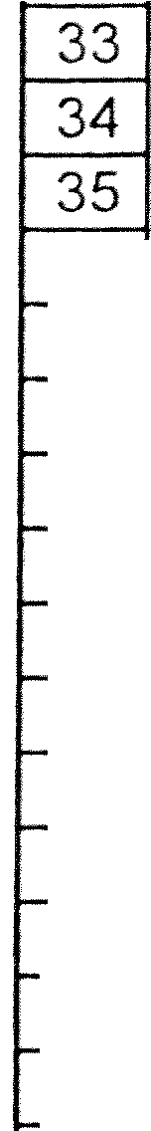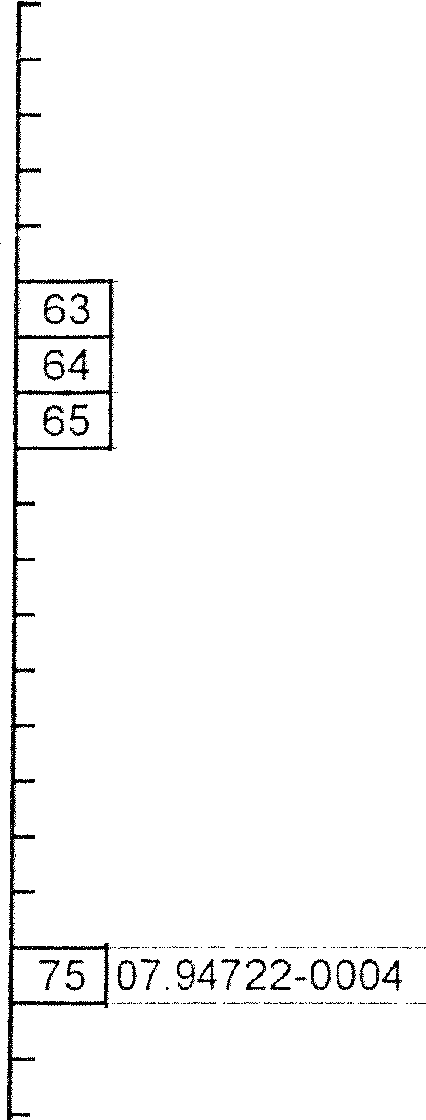

- · - -- - ! --- --- lj :l . ·· --: H

2:17 PM 2 of 7

A B C D E F

G H l

-

(.} I

|  |  |  |
| --- | --- | --- |
|  |  |  |
|  |  | |
|  | | |

"**c**' "'

**0** "' **0**

**C** &

**0**

(.}

**...J**

..,

**C**

,!

**<**-0**ii** !

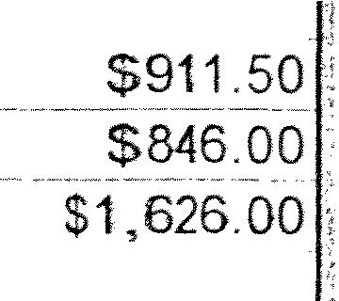

6 Part No. TEXT ENGLISCH

- SURVEY RESERVE SET-

7

81 07.94812-0016

07.94812-0018

07.94907-01

DescriptiCJn_c;_erman

----- --

MOTORSCHUTZSCHALTER

MOTORSCHUTZSCHALTER EINBAURACK

Description E_n}ilis_h

-- - - ··- - - --- --

MOTOR CIRCUIT BREAKER A

- - -MClfoR c1Rcu1TBREAKER- -- 'A

MOUNTING RACK A

**0** :::> **f-**

--------------

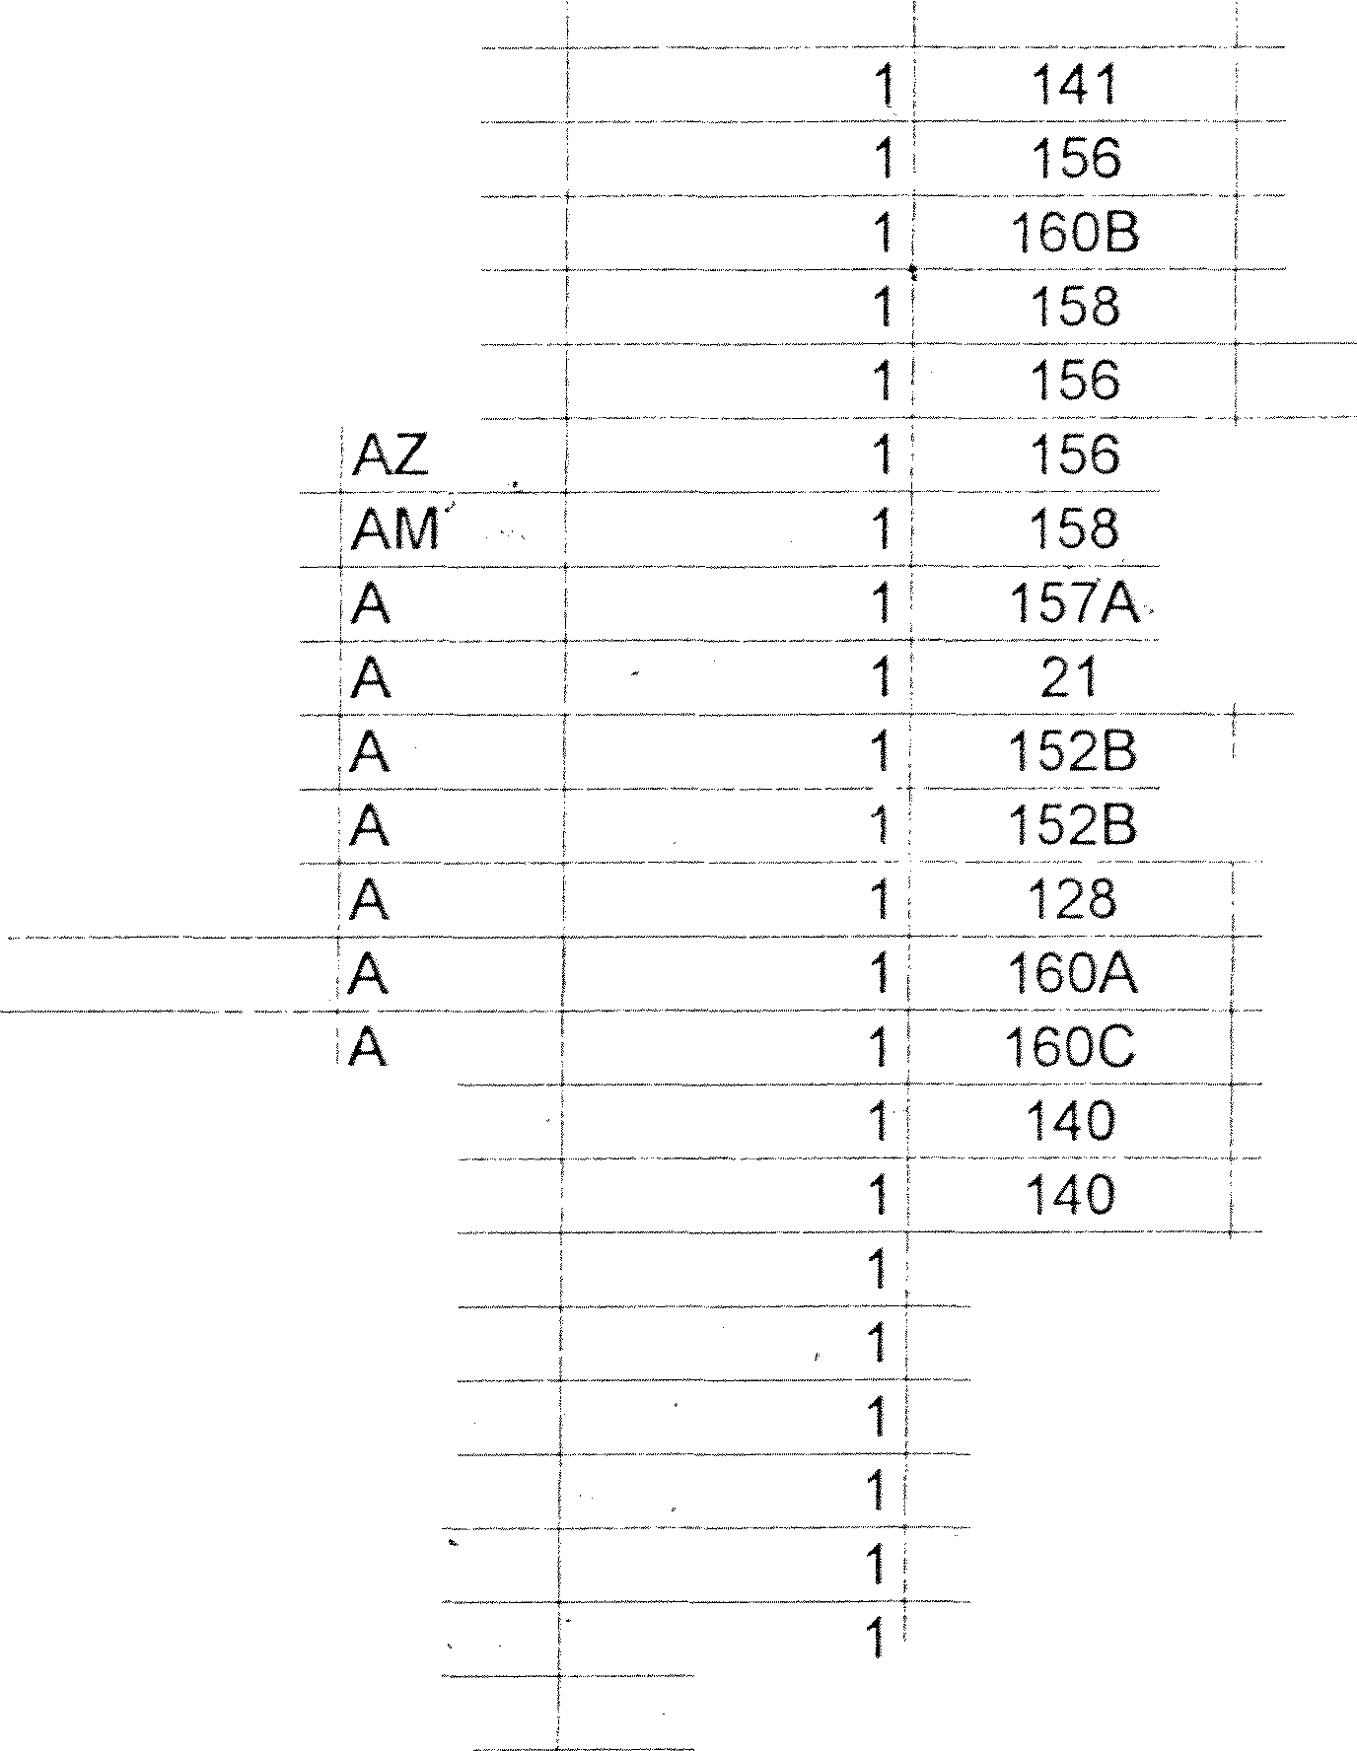

$57.48 $57.48

$63.12, $63.12

$1i884 201 -- $15,86420.

07.94907-0133

85 07.94907-0138

07.94907-0139

07.94907-0270

88 07.94907-0275

89 07 95103-8001

90 07.96303-8069

-- - - - ----- - -- --

91 07 96303-8070

92 0796305-0012

NETZTEIL *24V* DC, 10A ENTKOPPLUNGS-r>AobuL­ ELKO-PUFFERMODUL

_ NETZTEIL24V DC, 1DA

DIG.SERVO-FREQUENZUMFORMER

------ - . ------ --

GETR-MOTO.KOND

- . .

--------

GETR-MOT.O.KOND

- ----- - ---- --- -

' DREHSTROMREGELMOTOR

POVVER PACK LJNIT MODULE

MODULE

-•POWER PACK-UNIT

,. -- -- -- . -- --- -

FREQUENCY CONVERTER

----------- ----

OPTO C_Q,UPLIN_G

GEARED MOTOR

-- -----]GEARED MbfoR

* THREE-PHASE CONTROL MOTOR

,A-

AZ

$371 73. $371.73.

$100.82, $100.82

$47357 $473.57

$374,2_7, $374 27

$1,35961 $1_._35961

$84.02. $84.02

-- - ------- ---

o

SJ11

$846.QD.

$1 _(32'3,00

., -- - . --- ---- -- --

93 07. 96830-8017

94 0796830-8036

------ ----

95 07.96830-8054

* + FILTERLUEFTER

-------------

. FILTERLUEFTER

'FILTERMATTE

FILTER BLOWER

* FILTER BLOW_ER

FILTER MATE B

$286.00: $286.00

_ SZ3{[o-; -- -- $734.oo

$6,0_8. $6 08

96 07. 96830-8055

97 07 96830-8092

98 07 96830-8161

99 07-.-96-830-8170-----

10007.97203-8037

,FILTERMATTE

-

--

THERMOSTAT

Fil TERPATRONE FILTERPATRONE

- TRAFO

FILTER MATE

THE-Rrv10sr AT

FILTER CARTRIDGE

--·-

- ·-·

FILTER CARTRIDGE

TRANSFORMER

8

+A

·s8 --

A

16

G112

G112

151B

-

- -i 1

$21.79,

$63.91

-$6690'

$18206;

-

$323.3. 5

$21.79

$63.91

$66.90

$182.00•

$323.35

-,/ 101 27j72i5:3:soso-

,NETZTEIL

-POWER PACKLJNIT

A 158

- --- ---- -- -

$450.66

$450.66

----------

102 07.97203-8092

'NETZTEIL

POWER PACK UNIT 'AM _)_

158

$399.73

---- ---- ---

--

$399.73

103 07.97633-8000

·----·-

- -----· ---

1 10-WENDELPOTENTIOMETER

--- ------- -- ·---

..

-POTENTIOMETER- A •

2: 27

_L - $30.50

$61.00

10407 97633-8002

: 5-WENDELPOTENTIOMETER

HELICAL POTENTIOME_Tl::fs

_ _ .,.AA·-.----· 1 _

1 32

$49 14, $49.14

105 07.97633-8003

- -T10WENDELPOTENTIOMETER--

POTENTIOMETER

iT 26

-$42 01:- $42 01

106 07.97633-8231

107 07.97721-8003

- J];:fJ R 1 1 ==--- == -=-= =-==-= --_- rr ;0 iJiE EE: o I@==- --- { _

_- J

1 I-- 160A --1

24

$1,006 851 -- $1.006.85

---s::i126; -- s2T20

108 07 97]_21-801_,' L

109 07.98025-8056 •

ENTSTOERBAUSTEIN

, SINCOS - GEBER

ANTI-INTERFERENCE DEVICE A 1

-SPEED TRANSM1T'(ER 1 A 1

24

152A

$32.28' $32.28

- S{:250j3 C $_1_,2_5fi3

110 ()79802f8083- (., = -

111 07.98221-0031

ilNKRHOHLwELLENGEBER- ---- - =-JsPIErf'rRAN_s_r0fTfE-R Pts t;_65--::7;._f]l/ ())6[11) -1;

_ \'VARNSIREr·.fE MULTIFLJNKT ON, ROT AL/I.RM S'(STEM A 1

152A

##### 1578

$789.29 i $789.29

$61.13 $61.13

112 07.98231-0181

REFLE J()t'J? L_ C_f:lTTASTER_

_ --- IGHTJQ_ANl'-lER _ _

_ _ ,A

·39

$267.00

$257.00

113 07.98231-8042

.REFLEXIONSLICHTTASTER

: REFLECTED LIGHT BARRIER A

29 _ -- $401 28 _

$401.28

114 07.98241-0110

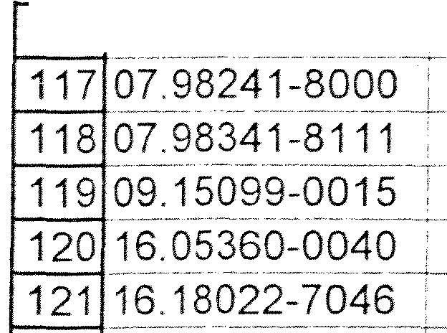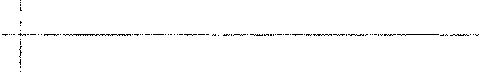

115 07.98241-0112

116 07.98241-0113

122 16.1850-0001

SWITCH GRUNDMODUL

AUTO CONFIGURATION ADAPTER MICE MEDIENMODUL

-----------------

RAIL SWITCH

FREQUENZTEILER DKPL SCHMIERFETT

MODULE ADAPTER

-- tv'JODULE

SWITCH

FREQUENCY CONVERTER

--- ---- ------

LUBRICATING GREASE

AM

-- AM

A

.A

A

c

- ------------

- 1T- 151A

- ------ ----------

1 151B

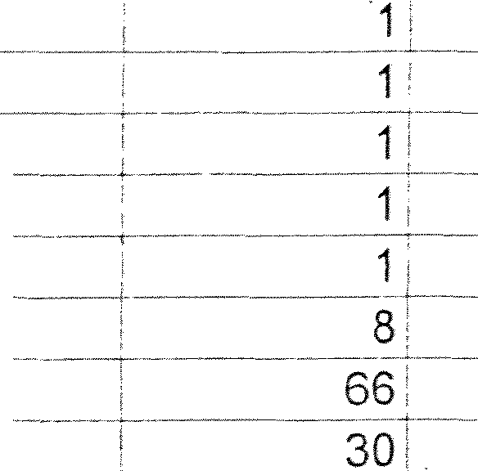151A

151A

13

D80

$2,794CD0i

$440.47:

$75873•

$897 50

$338.63

$69.00

$2,794.00

$440.47

$758.73

$897.50

$338.63

$69.00

:F/\RBZQNENQETFf 16'fM tE_[LRs§is9_f-l _

**BUSTLE WHEEL GEAR!NCfrvfOTOR WITH**

A 25

$813():

$81.30

123 16.18050-0004

124 16.18050-0009

125 16. 20422-0208

_,_ - -- ------

1216.20471-0014

127 16.20471-0154

'GESCHVULKOLLANSCHIENE

- -- ---- -----s

PUNKTURSCHRAUBE GERIFFELT

PUNKTURSCHRAUBE SCHNEIDLEISTE DREHSTABFEDER

DREHSTABFEDER

,FOAMED VULKOLLAN BAR rirTscREW- --- --- ----

- - -- - -- -- --- -- PIN SCREW SERRATED Pi .f SCRE-W -

CUT-OFF BAR

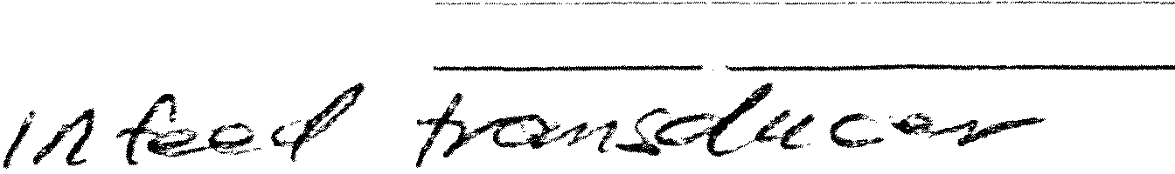TORSION BAR SPRING TORSION BARS-PRING

-------- -------

B

B B B

B

A- -

AZ

60

---------------

- - .

6

D86

A6 A7 D85 160

160

$14.84

$1.39

$2.21

$30.66

--- - -- -f-ios 1s'

$108.15

$118.72

$41.61

$13281

$183.96

$108.15

$108.15

128 16.20471-0178

DREHSTABFEDER

TORSION BAR SPRING AZ

160 $97.85 $97.85

2.11 PM *0* . ***·7*** •

***t. a***

***o_ v-or1- g-oos-***

*<;; 113* 3 of 7

E F G H

|  |  |  |  |  |  |  |
| --- | --- | --- | --- | --- | --- | --- |
|  | A | B |  | C |  | D |
| 6 | Part No. | **TEXT ENGLISCH** | De criJ)tion German |  | [)_c,s_crjJ)tion Eng_lish _ |  |

.r!o:?

•**SURVEY RESERVE SET**

1;9 16.50860-0028 1 ***1/-: ef ;._p-,***

--•- -

-··- , __.,_ -

- -- - -------

**(J**

:;:

'iii

**<J)**

.'.'!

**(J**

## f

' **f**"**l.**'

***./A.-***

'{'

C

0

C

0

(J

0

...J - ·1 ·

### ss4 4·ot· --------·ss4.4o

------- ----

130 16.52599-D128

131 16.52599-7013

132 16.64500-1109

133 16 64500-2211

134 16 64600-1195

135 16.64660-0057

OBERMESSER

LAUFRING

---·-· --------,-------

,1/ULK_OLLAN-RING 90 GRAD SHORE ZSB EINZIEHSPITZE HALBE BAHN 'ZSB.EINZIEHSPITZE GANZE BAHN

EZV-EINZIEHKETTE

-- -- -------

KURZHUBZYLINDER

,ll_PPER KNIFE 8

RACE B

<VULKOLLAN RING B

"TN-FEED -POINT(L.ONG) FOR WHOLE-WEB 1B}EE_Df'()IN'f (SHQRt)-FClffWHOLE-WEB-- WEBBING-UP CHAIN

CYLINDERVVITH SHORTRECIPFf6cATION-.

-·-

--· ------ -------

i 2,

2

3

1

1i

• ,.j

Crate 128 E99

_$168 30' _--- 3§6Q

$22.75< $45.50

_$312.001: -- -$312 00.

$231 oo: $693.00

s,r -

$1,326.51, .. $1,326 51

- $48 $48.55

136 16.64700-0560

-- ----- ----

137 16.64700-0561

138 16.64760-0057

.

---- ---

139 16.64760-0059

--· -

140 16.64760-0060

LAMELLENMOTOR PNEUMATIKVENTIL

. 1Pf\J.E:_UM A_J_I_K\I EN TIL

DRIVE STATION MECH. WEB UP CHAIN

-- ·-

- --

- D**M**R**C**I**i**V**f'O**E**R**ST-ATION ELE-C-.- -W- EB---U---P- CH.A.IN

PNEUMATIC VALVE

--·-··--

--·------ - ----------- -- --

"PNEUMATIC VALVE

2' F102

F104

1 ! .. E99

$1,e20.45 gsjo9o

S!,_9_7_(_3.1_ $3,_956J32.

$1,148.28 $1,14828

- ·si1cf62 $310.62

- $330 9_9,_ $330.99

141 16 64760-006-7 ;

INITIATORBLOCK

.INITIATOR BLOCK

**$_211._11f_** --- --- **s·2-f1.-1·s**

142 16.85330-0007

-----

-· ----·· ---

143 16. 85432-0003

144 16.86230-0055

145 16.86912-0023

146 16.86925-0023

147 16 86925-0032 L _

'ZSB.DCU-2 ZSB.Rl-2

--- zsB.Oc-100 -·-

zsB.IPS.DCP-2

•zsB.IPSCNT:2 ZSB.IPS D1-1C

03-9421B

-- - - - ---

--

735-035 03-9331

- - - - - ------

745-078 39469/70

745-089

CONDUCTOR CARD

---- REGISTERINTERFACE

-- -OPERATING PLATE 'PRINTED CIRCUIT SWITCHING

----- Ji1,9§_5_,_12, $1,965.12

$516.78, ... $516.78

$2 152 *60;* $2,152.00

si6r r- t

$ 2 --${;if

##### $458,981 _145&9_8

148 16.86926-0067

149 16 86926-0068

150 16.86926-0071

151 16.86958-0017

ZSB.IPS.DI0-1C 745-093 3-9481/82

'ZSB !PS D0-1C 745-094 3-9553/54

-- ----- -- ------ --·---

ZSB.IPS.DI0-3 03-9562/63

--------- ----- -- - - - -- ---

ZSB.IPS.BA-2 745-074 03-9467/68

'SWITCHING

SWITCHING 'PRINTED CIRCUIT

__-_),WT'rcHtNG·-

_ _

$540.58 $540.58

$639.17i $639 17

$705.26 $705.26

- ·1· - $1 02 0 : ff r - -s1:0.20-ii

152 16.86958-0051

--------- -

ZSB.IPS.BA-3C

745-092 3-9483184

'SWITCHING

sn4.3T _. -$7:34-37

153 16.86958-0052

- - -- -

154 16.86959-0010

155 16.86959-0012

156 16.87130-0003

157 16.87132-0004

-- -- - ----- ---- --

15816.97043-0207

ZSB IPS.BA-1C 745-091 3-9483/84 ZSB1PSfv1ClJ-2 745-067 39457/58A

----------- ---

,ZSE3 IPS MCU-3 745-070 39458A/9459 PcT'r,Tc-is - - - - - -

'zss --

- - - -- - ---------

:ZSBPCI.IBM-1 01-9540

WAHLSCHALTER

SWITCHING CONDUCTOR CARD

---- -

---· -

: POWER SELECTION

**--:PRINTED c1R·cu1r**

-cPR,fNTED CIRCUIT

-- -'SELECTO-R SWITCH

_1_6pC:

-·sssissi $557.58

§1:004 $1,004 85

es·---

$761 25i $761.25

$3 824.2f $3,824_:?2

$4,001.·ssi s4,001.s5

- ·s2r so·

$27.so

----··-·· ----------- -------- - -- -

|  |  |  |  |  |
| --- | --- | --- | --- | --- |
| 159 16.97043-0657 i | : SCHALTTAFELVENTIL | SWITCH BOARD VALVE  - -------------------- - | - 75 86 | $75.86 |
| 160 16.97043-0831 | . PNEUl'ii 1PULSVENTIL | PNEUMATIC VALVE | $100.82 | $100.82 |

-------- - - -

161 16.97043-0904

162 16 97043-0982

---- -----------+- -- -- - - - -- - -- --- -----

DROSSELRUECKSCHLAGVENTIL

5/2-WEGEMAGNETVENTIL

-- - - - -- -----

THROTTLE NON RETURN VALVE

5/2-WAY VALVE

$3!,-42

$113.05:

$35.42

$226.10

163 16.97043-0983

164 16 97043-0985 ;

- -- 5/2-WEGEMA---GNETVENTIL -

- ----- _ /2-WEGEMAGNETV(2X)

---------- ·---

5/2-WAYVALVE

**-;3/2-WAY VALVE** - -- ---------- ----

$145.13:

--$148 44!-

$145.13

$148.44

---------- ------

---- ------·------

---- --·--·-- ------ --- -- - . ------- -

165 16.97045-0425

166 16.97061.:-0120--

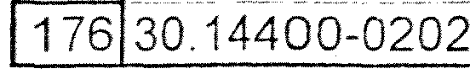

- - -· --

168 30 04010-0312

169 30.04010-0315

170 30.04010-0319

171 30.04010-0321

172 30.04010-0324 ,

173 30 04010-0326

174 30 04010-0329

175 30 04010-0350

----- -- - - --

- ---------- , -

'FEUCHTAUFTRAGWALZE

DAMPENING FORM ROLLER

1 Press Fir - - -$859 53_i

- -

- - -

-- -----·- -- ----

- !

---------- - . ---

- ---

FEUCHTUEBERTRAGWALZE

---

FARBAUFTRAGWALZE

DAMPING TRANSFER ROLLER

1' Press Fir . $754._74:

FARBAUFTRAGWALZE

------

-- - ---- -

FARBUEBERTRfa.GWALZE

,I_N_r(FORM RQLL_ER- : _

;lNK FORM ROLLER

INK TRANSFER ROLLER 'INK TRANSFER ROLLER INK TRANSFER ROLLER INK FORM ROLLER FLOW CONTROL

AZ AZ AZ AZ

Ai.

AZ AZ A

1 Press Fir

1 :_ Press Fir

1 i Press Fir - - Press Fir Press Fir

Press Fir

C65

, FARBUEBERTRAGWALZE

-- -FARBUEBERTRAG-WAL.ZE

-- FARBAUFTRAGWAt:zc·

ZSB.STROEMUNGSWAECHTER-DE

·

$758.92,

$936 86'·

-$7924:-i'

$9_95 90,

$999 91

_$2,141.92;

$475.00

$859.53'

$754.74

$758.92

$936.86

$792.43

$995.90

$99991

$2,1_41.5)2

$475 00

ERSATZFILT.ELEMENT,VALID.

-- - -- FELDBLJSKNOTEtT - -

SPARE-FILTERELEMENT

- --FIELD BlJS tk:ioE-

G111

135

$412.47

--------- --------

--

$535.00

$41247

$535.00

167 30.03400-0166

ZSB FILMVVALiEVl!D1300/RIL965

FILM ROLLER

1 Press Fir --· s:z:985 09--

$2,98509J

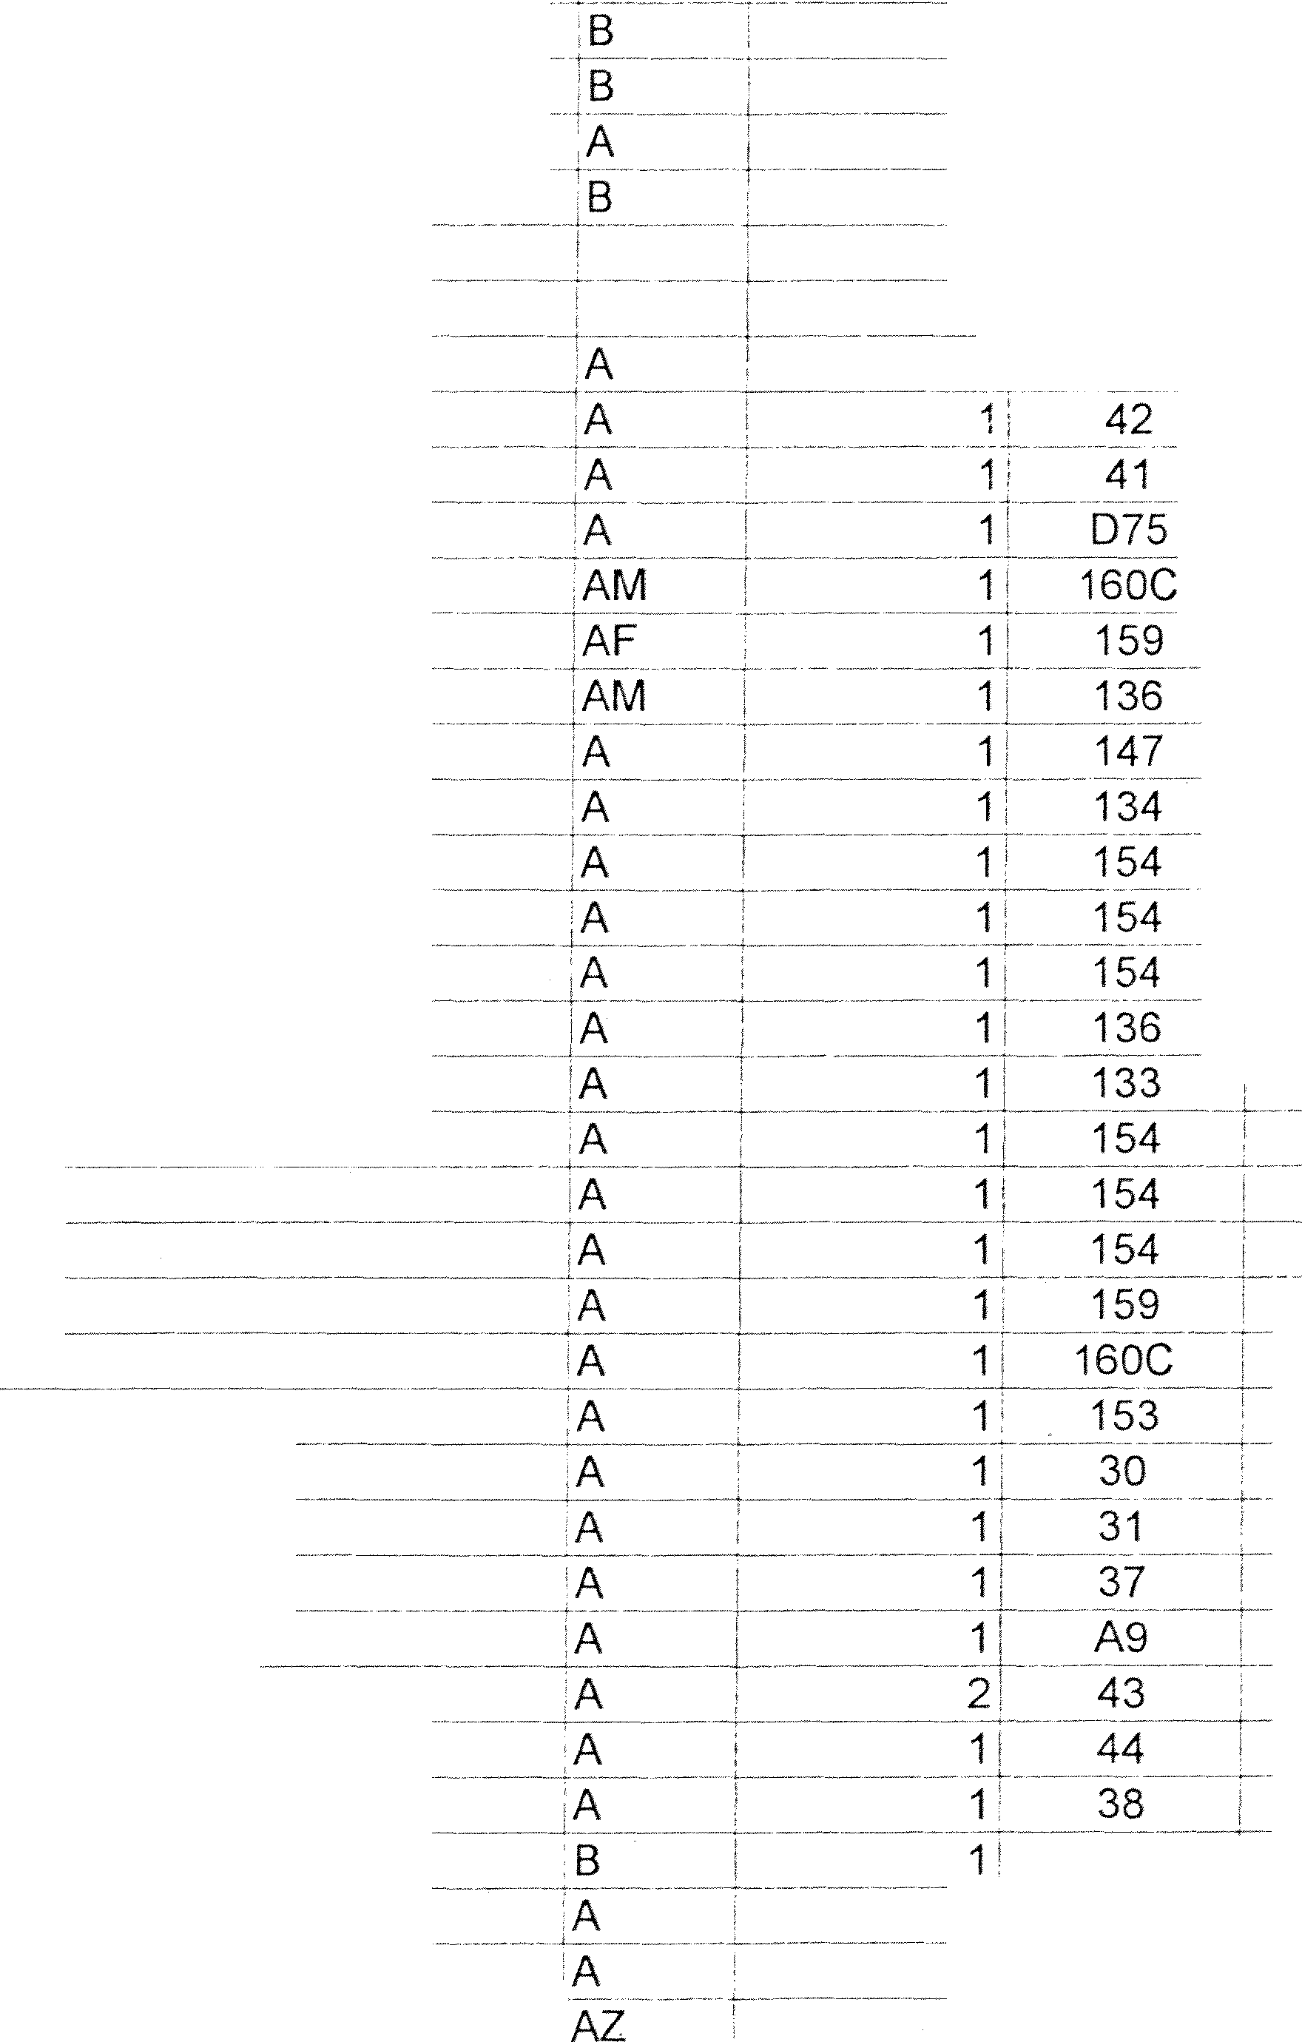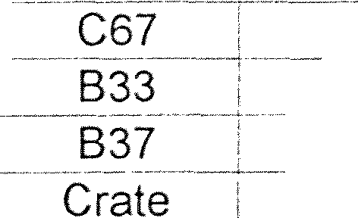

217 PM 4 of 7

|  |  |  |  |  |  |  |  |
| --- | --- | --- | --- | --- | --- | --- | --- |
|  | **A** B |  | C |  | D E |  | F G H |
| 6 | **Part No. •TEXT ENGLISCH**  - - - -- **[SffRVEY RESE-RVE sfi**  30.14400-0203 i--  30.16099-0102 1  30.17373-0242-;  30.18005-0108 |  | **_:o_esc_rip_tionGerman**  ZSB.DRUCKSENSOR-DE  ,ZSB MESSERBALKEN |  | , **Des_criptio_n English**  '  i  SENSOR­ A  .SLITTER CHEEK BZ  ---- -  DRAW ROLLER/ TROLLEY FOR FORMER  KNIFE SUPPORT . AZ |  | -  ***'9***  **C:**  **0**  **C:**  **0**  **u**  **0**  **...J**  1 34 _J 805.9_"7: -- _$805 97  1 E100 $1,548.47 $1,548A7  ji_ F101. . _$743i5_(3 $1,4_87_}2  1 Crate $1,§20 79' _$_1 5:20 79 |
| 7 |
| 177 |
| 178 |
| 179 |
| 180 |
| 181 30.18023-0101  182 30 20423-l)_lS!_-i  183 30.20423-0188 ,  184 30.20423-0189  185 30.20432-0147  186 30}0440-02_1<\ -'-  187 30.20440-0215  188 30.20473-0103  189 30 21022-0170,  190 3021023:0162 :  ---·- - ,.  191 30.21032-0120 :  192 30.21056-0105  193 30.21065-0116  194 30.23800-0106 | | - | ZACKENSCHNEIDMESSER  -- -- - - ------  FALZMESSER  ,FALZMESSER FALZMESSER  --- .. -- -- ·---  ZSB.ROLLENHEBEL  -:SEGMENT -  **--·--1S-EGMENt** -  ROLLE  ·ZSB.FALZLEISTE FALZKLAPPENBLECH ZSB.ROLLENHEBEL  ·suERSTE BEILAGE  ZSB BANDROLLE | - | SERRATED CUTTING KNIFE - -- Bfsz -  --------- ----- -- ------ - -- ---------  --*--: -=* _. •TUCKER BLADE . -sz  TUCKER-BLADE  :IUCKER BLADE --- ---.· --- BZ  , ROLLERLEVER AZ  SEGMENT BZ  ,SEGMENT BZ  'ROLLER.  < --- -- ·- -- .. ----  FOLDING BAR  'F'6Co1NG FLAP-SHEET f;/2ETAL  - ---  - SHIM  iTAPE PULLEY | - - | 2 D85 $51.60 $103.20  - -3- --A16 $22 10 $66.31  $11.23 $33 68  A16 $9.54 $28.61 1l C54 j g68()_,31 -- _$3,680.31  19 E93 . $128. 00 $2,432.00  - is: · E92 =- : ss756L _$1.66364  3 C58 _$9_1 ,l_1L $275.73  3 Crate $1,538.17i $4,614.51  --- -3 D86 . 5,§47.82i i1,943A5  1' C63 g 654086 $2,654,86  083 $5.55: $133.20  -$44-07' $13221  -$- **-**1**-$**2**7**9**.2**.**9**4**T**8 -- -- **-**$**--**7**$**7**8C**6.**f**8**1**8**9** |

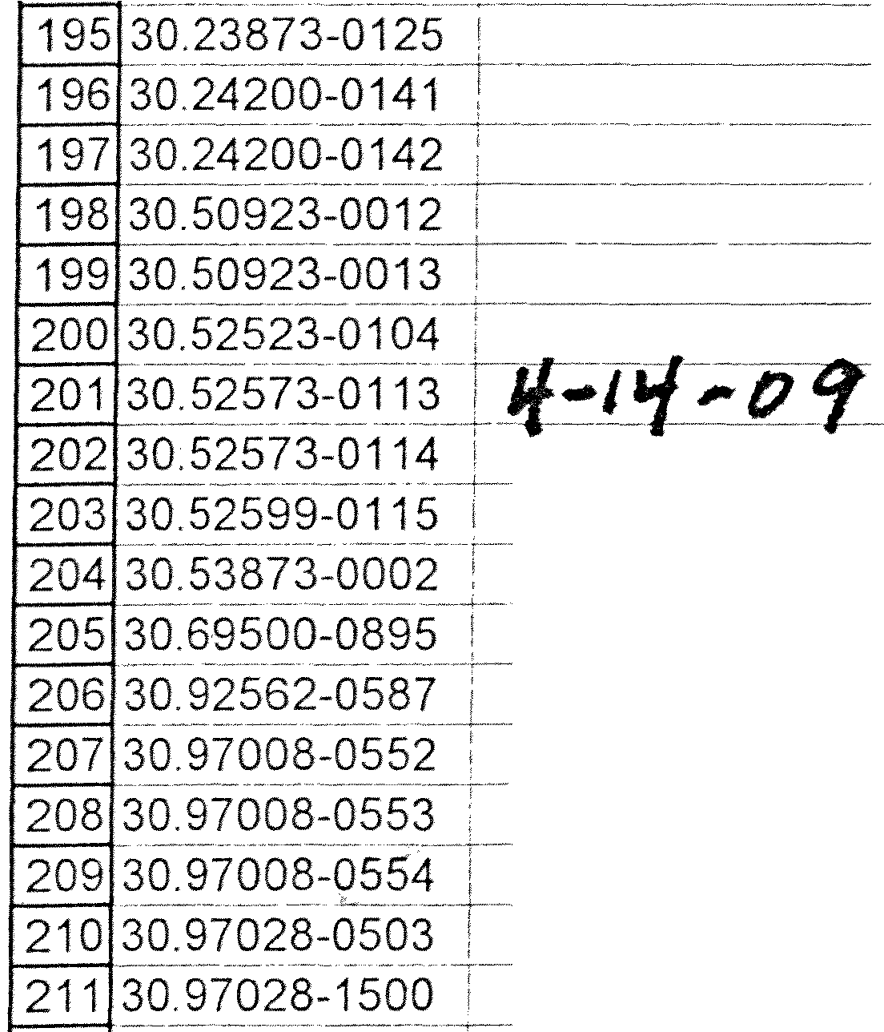BANDROLLE

zsssmc5EMUNGS1.IVAECHTER-F\V

,ZSB DRUCKSENSOR-FW SCHNEIDMESSER .

-- -

--·- ---- ---- - --·---- ..

SCHNEIDMESSER

LKREISME::_SSEcfs,UNGETEILT 'ROLLE

ROLLE SCHNEIDRING

. ...

TAPE PULLEY

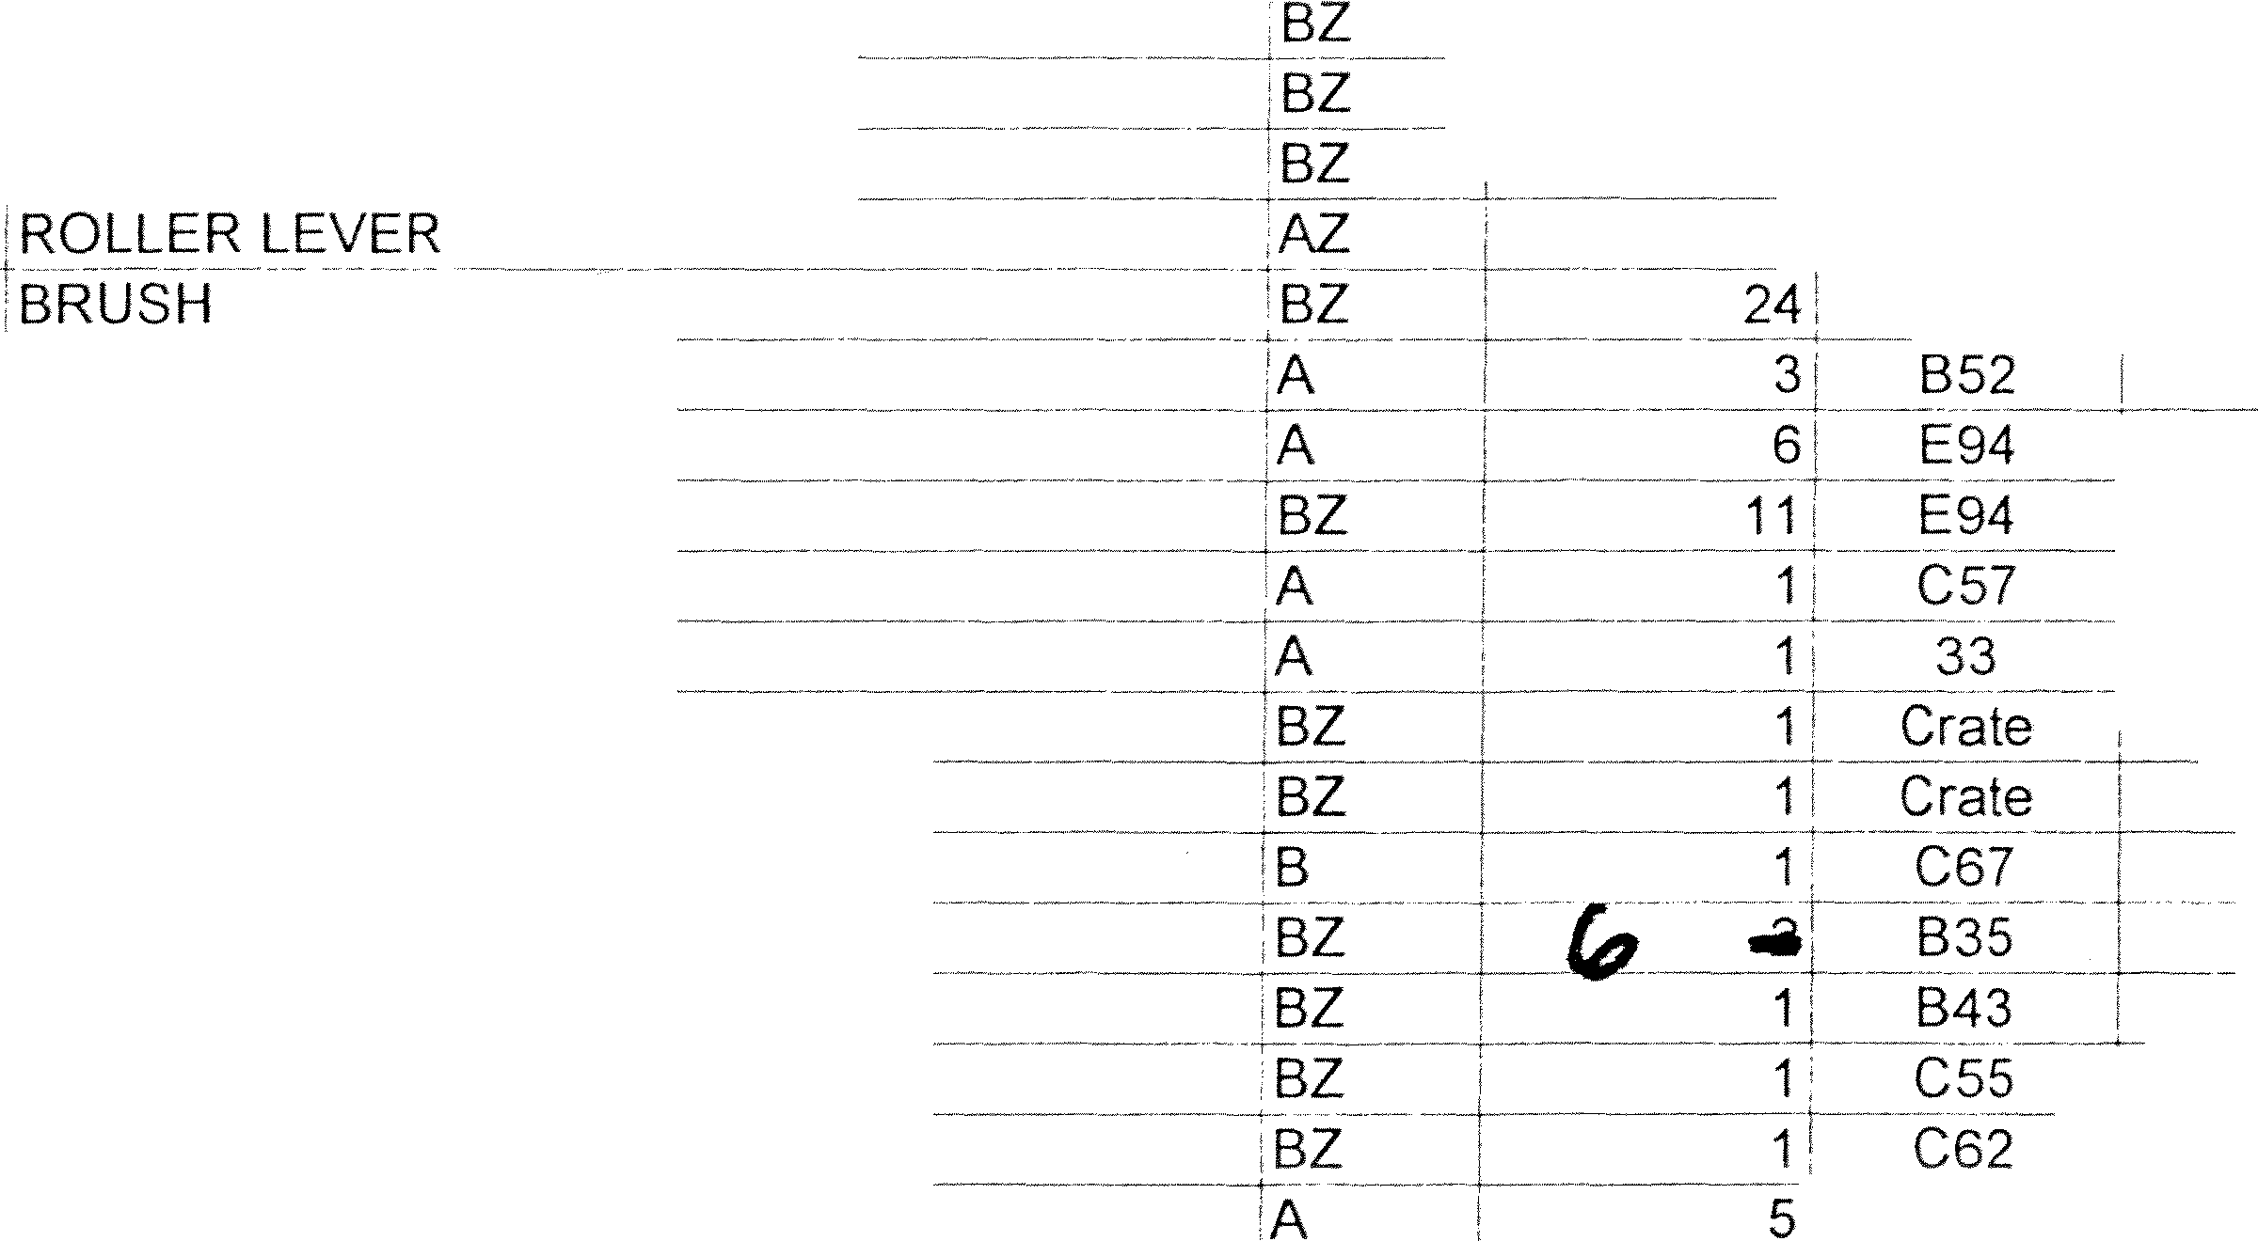- - -- ··---·

·FLOW CONTROL

-- - SENSOR ---

CUTTING KNIFE

CUTTING KNIFE 'c1RCULAR KNIFE-

--

------ ---

ROLLER

* - 'ROLLER

. 'SL.ITTER CHEEK

-----------------

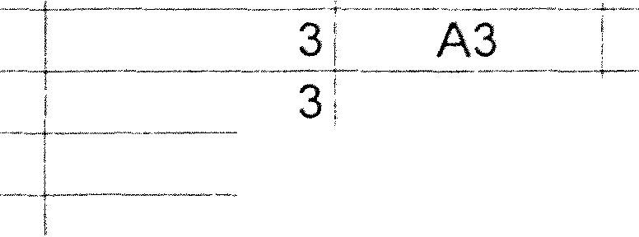! - $511.76! _!5_1_1J6

_ $8(J_J.11[ $807.11

$798.54! $798.54

--$703.64 I. $703.64

$48.10'. $4810

$96.90' $193.80

------ ----

- _$10355 --- $103.55

$548.56 $548.56

-- ---

----------- -- - ---- -

ROLLER

- --------------------------- --

_1_

*_ $2§§.* 6.5_ $286.65

BEDIENTAFEL

--- ---------- ------- ---- - -- -----

* + PNEUMATIKZYLINDER

**PIN** LEVER

. - ·oPERATING PLATE

PNEUMATIC CYLINDER

B34 $111.67: $558.35

A -- **-------------136 s2,11s.63**

**s-i-f76 63:-**

z C6CJ--· :·:§1595:ZL: _:_$159 52

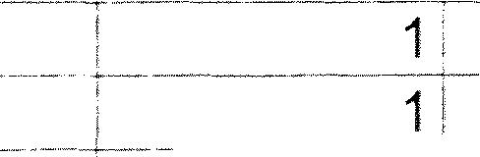

-

-- -- --

212 30.97046-0113

. -- - - ----

PNEUMATIKZYLINDER

PNEUMATIKZYLINDER

LAUFROLLE

----·-------,- -

SCHRAEGKUGELLAGER

###### : PNEU-fv1ATIKZYL:-fN-oE_R --

- - ·-· -PNEUMATIC-CYLINDER -· z

- +-PNELJMAT1ccYLiNDER- -- z

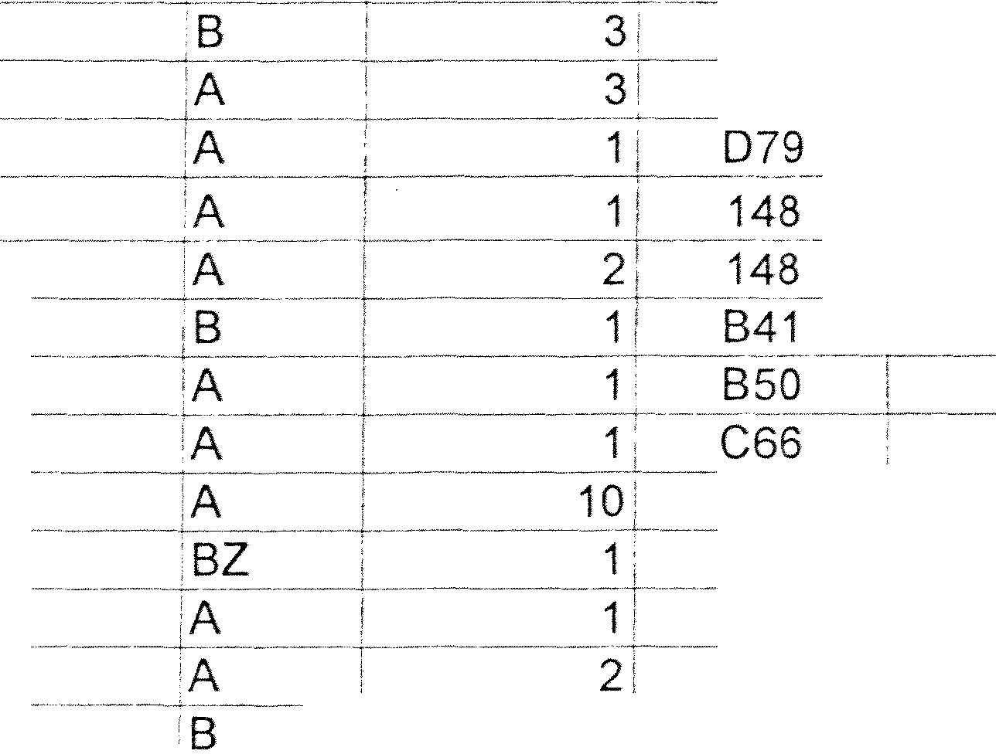CASTER

---· , NGULAR CONTACT BALL ElEARING

|  |  |  |
| --- | --- | --- |
| !PNEUMATIC CYLINDER | $152.50 | $152.50 |
| 'PROXIMITY SWITCH | $69.51 | $69.51 |

C:64 ; $163.75' $163.75

C68 ---s21s::i4: . s::ffi.i4

---·---·- ----- --

C69 $34.40' $103.20

----- -----

----- -- - -- ------------ ------ ----

838 i __§>. 9 9()_ _t119JO

213 30 97046-1027 ***V*** .. ... . ....

**---- )Lf -NQ_ SCHAL_T -** ------- ----

-------

**214 3-0.-97046---10-33-** r- - - - -- -- ---

NAEHERUNGSSCHALTER

iPROXIMITY SWITCH

-· _ ...- $57 701

$115.40

2130

--- -- ---- - ·

97046-5055

---- -FILTERPATRONE

* FILTER CARTRIDGE

- -$13.80:

$1380

216 30.97046-5128 :

-- -- -+--------

217

FILTERREGLER 'DRUCKREGEL VENTIL

FILTER REGULATOR - --cA

- ------------- ------ ------- --------- -----

$147.44'

##### $57 691

$147.44

$57.69

30.97047-0476

-------- ---

218 30.97047-2167

**219 30.97D4i-2233** i--s.·----

-- --------- - - - -

2230 97047-2470

221 30.97047-8266 i

222 30.97050-0001

----,- ---- --

RIEMEN

---·

- ---------- -···-------------- ---

DRUCKTRANSMITTER ST1OOPG1SPGF

**FOTOZELLE** ---- --------- --·

.PRESSURE REGULATING VALVE

·-- - - -----

-·

SAFETY DEVICE

BELT

--- --------------

TRANSFORMER

PHOTOCELL

PIN NEEDLE SMOOTH

'A

144

145

145

144

------ ------- ------

30: A1

$57 . -­

$581.07

$1,174.50

---. -- -

**-$'ff47.071**

. $1.67! -

$57.49

$581 07

$1,174.50

$1.094.14

$50.10

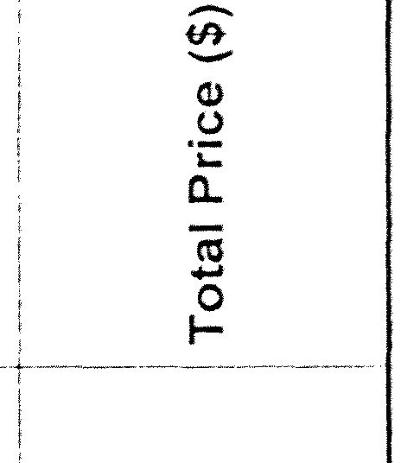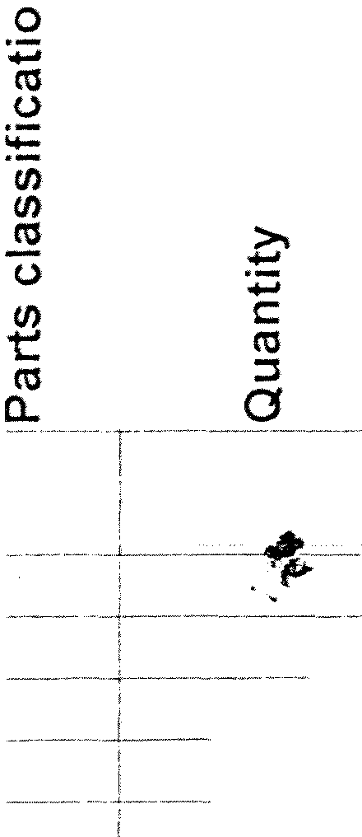223 30. 97055-1004

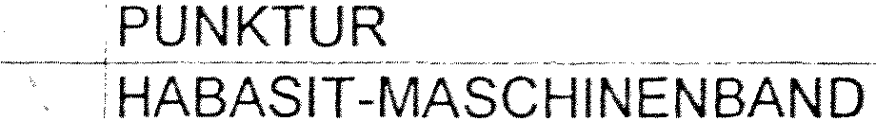

5 ,. SIEGLING-MASCHINENBAND

224 30.97055-108

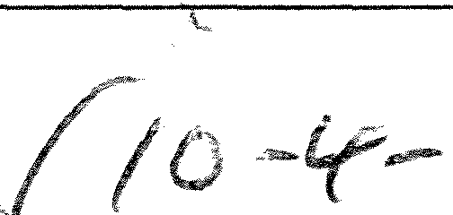217 PM

***11.fi.f(*** *-012--*

NP 5275

HABASIT-MACHINE TAPE SOLD IN METERS B 30;_ G110

'B

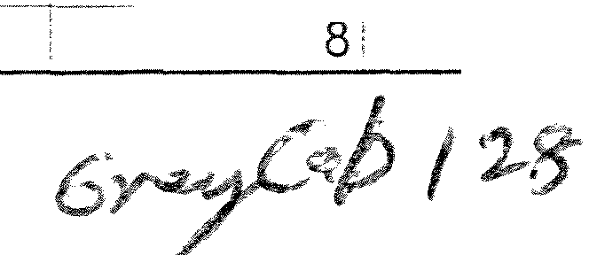

E98

. -$1-2 OB

$31.60

$362.40

$252.80



A B C D E F G H

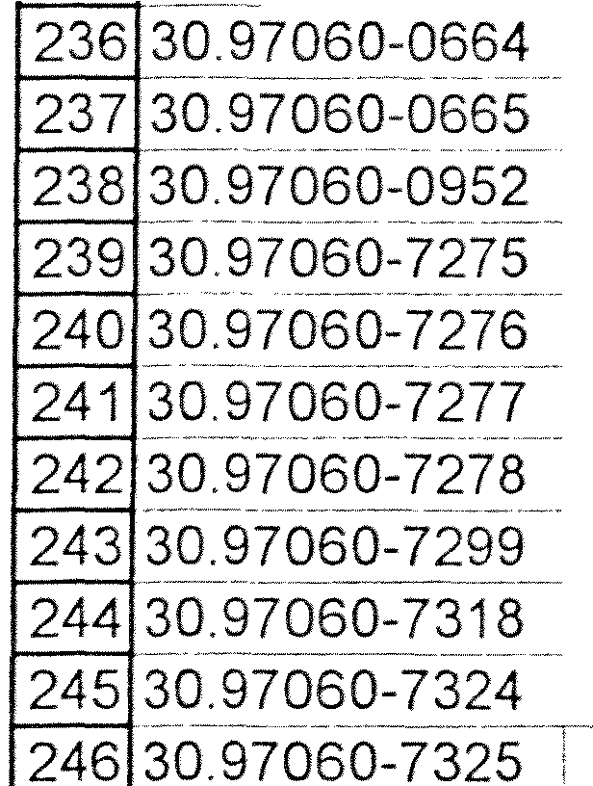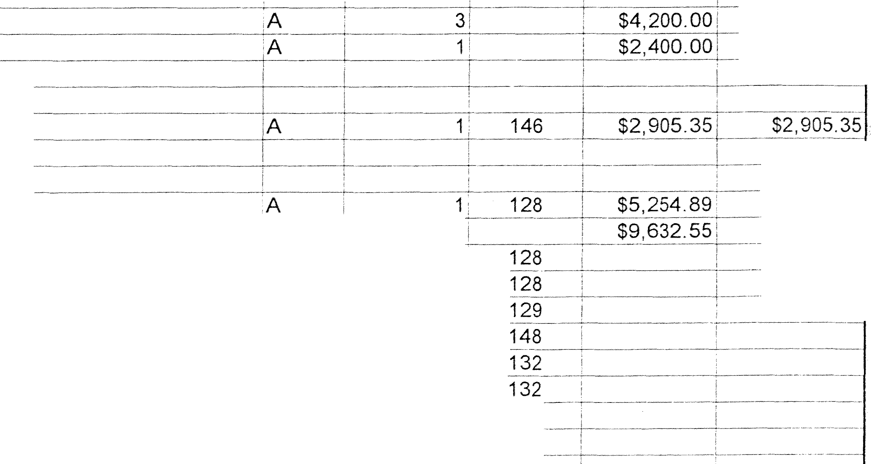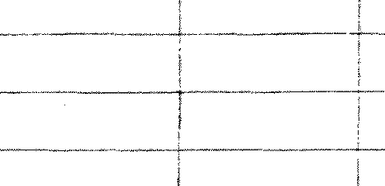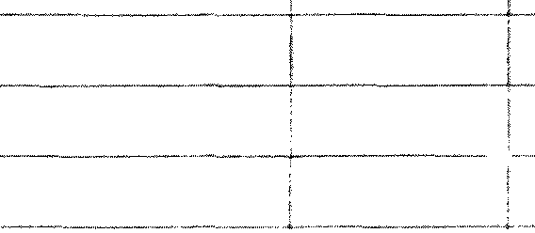

**.s**

·er

**C:**

-

6 **Part No. TEXT ENGLISCH**

- - -- **-SlJRVEYRESER\/ESET**

r **De**---**sc**-**ri**-**ption German**

_**De cription E_n_glish_**

**0**

**C:**

**0**

**0**

**0**

**..J**

**a,**

**a**-**:**

7

225 30.97055-1086

226 30.97055-5033

227 30.97055-5099

228 30.97055-5193

229 30.97055-5245

- - SIEGLING-fAASCHINEi,JBAND NP 5275 S!EGLING MACHINE TAPE B $771_5i - !S:38_5 I5

0 Zl\ HNRIEMEN HTD -- _j QG-BELT _- - --- -- ··-··, B -- -- $33.60: $33.60

,ZAHNRIEMEN HTD _ COG BELT B $281.001 $281.00,

. !ZAH_NRIEfJIEN HT_!)_ . - COG BELT - - - - ----- ,B -- -- $13 58! ---$6 58i

:ZAHNRIEMEN GT2 COG BELT • B $96AOt -··- $96 40'

-==-8 - ,

- --------------,

230 30 97055-5246

--- --J1 : { gH- ----

- - Jggf H +: -- - sf¼li6T -- $} *6*

231 30.97055-5327

232 30 97055-5363 °

233 30.97055-5381

234 30 97055-5382 '

--·-----------

ZAHNRIEMENHTD COG BELT B -- --- $53 191 -- --$53.19

_ :ZAH_N lf:: '1_ENi,_T2 _ !COG BELT ------ -- $69.3Cf -- $69 30

_ --- ZAHNRIEMEN ·cocfBELT BZ .. _$42686, $42686

235 30.97055-5403

:ZAHNRIEfv1EN COG BELT - . . . . -- _ -- -- -,-BZ 1 15_5_._

-- _$21,D_OL $21.00

---

_. -----··1 ----- --

.. ' l : :LEE r{=-=-- -- j 1it L t !+ER - --- --- +!-- -r- -- ----+ 1 : ; _c r- -: :

UMFANGSREGISTER iCIRCUMFERENTIAL REGISTER- A 1 G111 $980.24' $980.24

-·GRi.JNDEINHEifj°91l_199 Bl.JG 623} -:_54 :3 POWER CQff\/_ER_TER A 1 Crate -· ·· $3.843.oO; $3,843 00

GRUNDEINHEIT BUG 622-28-54-E /POWER CONVERTER 'A 1 Crate j:3,44 {) 65j $3,44_0,6_5

--- - -- 'LEISTUNGS1J10DUL 20012-isus 1324 POWER_(:_QN\/f:l'<T_ER_- -- A I - . Crate _J $3,935.66, $3,935.66

- --- LEISTUNGSrvioouC 198135 BUS622 ,£01/V_ER CONVERi:_ER A .. i-- ---- Crate $5._12800i .. - _$5, 128 00.

iFLASH-KARTE ii,1239 ,BOARD 'A t--- 3! 2 , _ -- O_OJ2 6Cl2016

247 30.97060-7343

-

---- , - ---

248 30.97060-7344

249 3o 97060-7366 :

--- 'UMRICHTER MONOEINHEIT 200792 sufv162T 1F'OWER CONVERTER-- *'f2_* 1! Crate -T $8,64_3 45 $8,64_345

--- ---- REGLEREINHEIT 211701 MOS G + Sercon - - -·susADAPTER iA --- - ----- 1• Crate , $4, 7062_,_ -- $4, 7Cl,62

0 TRAEG E:RM-6 5u l.. FUEff GEBEREfv1u CAf 10 N 21:32i SUPPORT PART _ - A_ _ _ _i:r:ale_ , $1,285.20, s1.2a5.20

----:.A:Eisbi..ufwERTGEBER --- .. - -- - ROTARY ENCODER- for PU A 1 153 $2,047 so:= --}2:047-c§CJ

----- - - ---llf\lKR-C,EBER_ INCREME:NTALSHAFTENCODER-forPU A - i 1: 153 $380.39 1 $380.39

iTIMING ADAPTER ADAPTER (CONTROLRELAY) A ! 2 3 ---$200.00i $400.00

250 30.97073-0004

251 **CGISpiirePa**

252 5100146-0-1- ·-·--·---------- ----- --

253 2000212

254

'F()_ERDE:R_RO(i..f --- -- ;CONYEYOR ROLLER - . --- **_;B**

; **Digital Injector**

'DnitrakA-ssembly

' _-- 2 C59 L_ $16.67 $33.33

. $12,600.00

_ $2,400 00

255

256 30.97061-2926

257

**Tolerans Stitcher**

POWER SUPPLY •POWER SUPPLY UNIT

258 .. , **Technotrans**

259 30.97047-8034

260 30.97047-8040

---

------

261 30.97047-8026

- - - -- -----------

262 30 97047-8027

263 30.97047-8029

|  |  |  |  |
| --- | --- | --- | --- |
| - 264 30.97047-8041 | iCab!e*155-1404-03 |  | |
| 265 30.97047-8042 | 'Korben'1ssA-1040-1s | 8 | 132 |
| 266 30.97047-8043 | Filter*1-5--5-1275-- -- -·- | 8 |  |

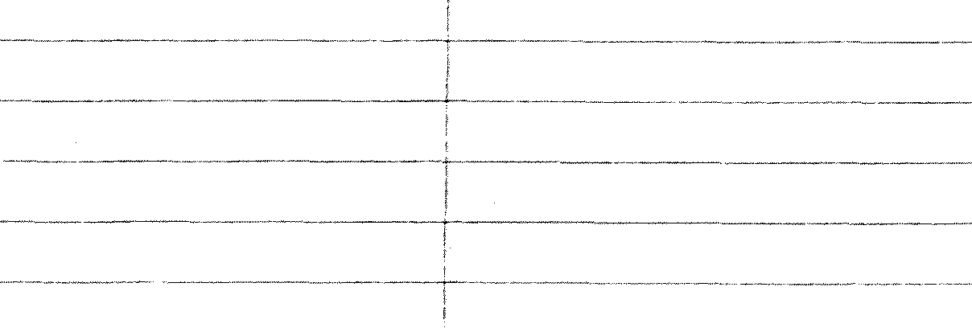------ - - ----- --

------- -------

ERSATZDUESENLEISTE

---- - Ef-:PAKET -. - - -



·Spray Bar

are P_c1_cf;c1ge co_nterit _below ;A

Spraybar controller ISC16*150A-525-2

- Unit controller TUC10*150A-515 ·-

- - ------ ·-·--- ---

Modul ADAM 6017*026-758-0

1:

1 128

- -i1'.' 129

_$§,254,89

$9,632.55

267 30.97047-8044

268 30 97047-8045

-··

0-ring 001-105-008

--Filter 1ss-io39 9·--

50 132

8' 132

|  |  |  |
| --- | --- | --- |
| 269 30 97047-8046 . ---· -- - . -- - i Duese* 155-1096-22-3 | 8 | 131 |
| 270 30.97047-8047 Dueskenkappe*155-1081-2 | 8 | 131 |
| 271 30.97047-8048 _ §pule*03_6-131-23 8 | | 130 |
| 272 30.97047-8049 ; Ventilstoessel*155-1122 8 | | 132 |

217 PM 6 of 7

A B C D E F G H

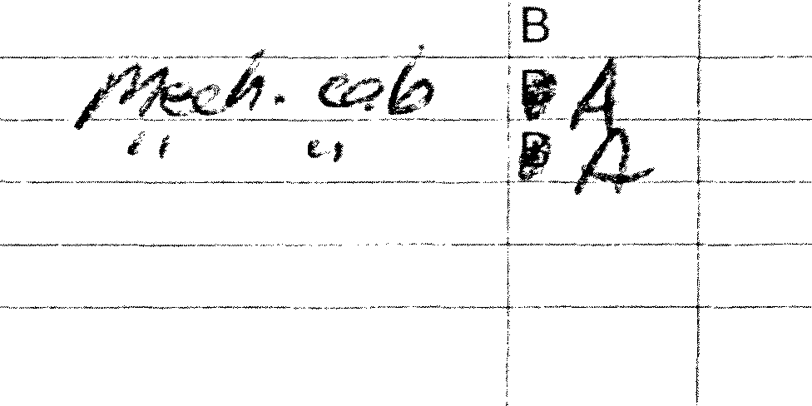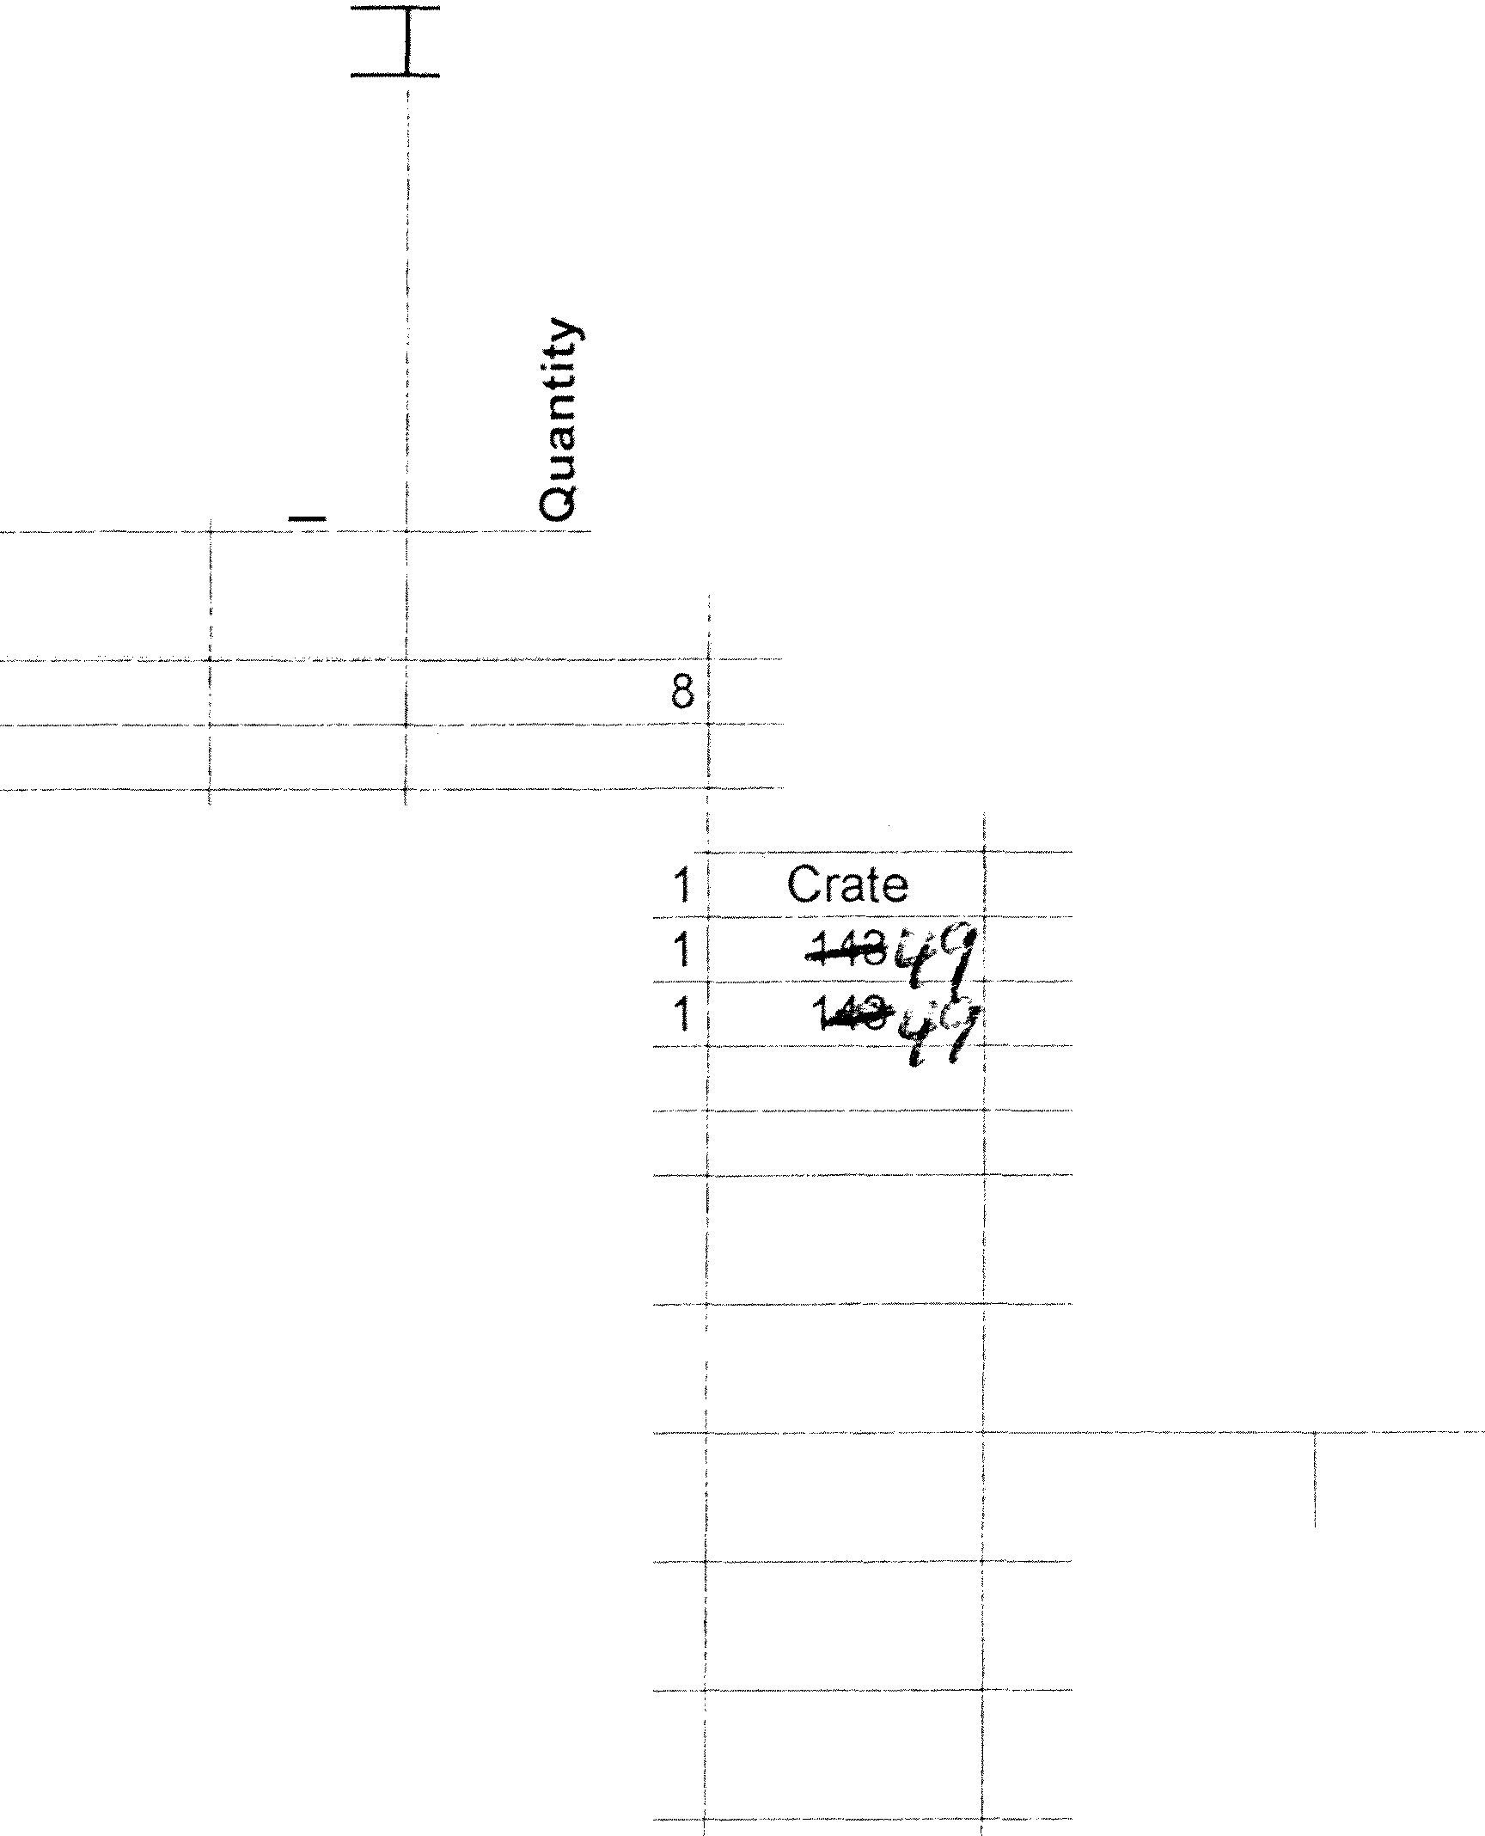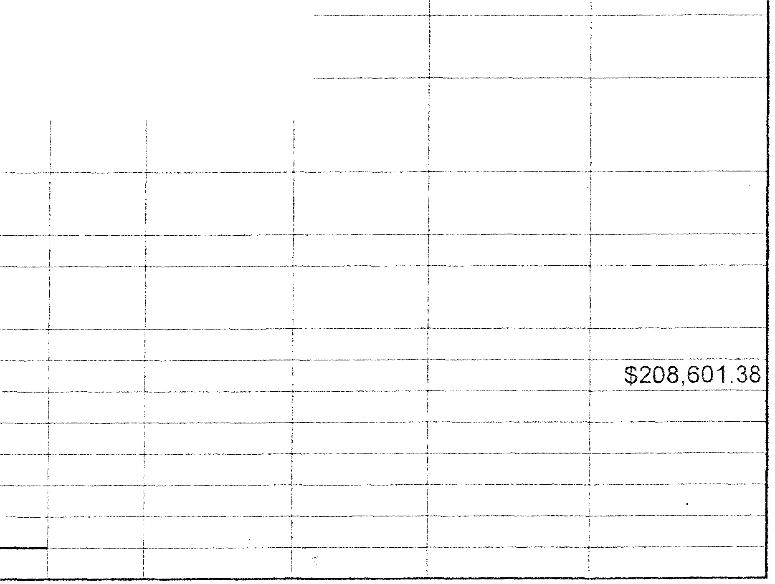

**0**

6 **Part No.**

7

273 30.97047-8050

274

275

276 945921 DE

277 971030DE

278 9i10400E

279

280

281

**TEXT ENGUSCH siJRVEY RESERVE sEt**

**MEGTEC**

**sP-RUHFEl.kHTWERK.**

**'.F6l..DER**

**DescripUon german _Description English**

'Duesen und Filterhuelle' 155-1078 'Tooth Rack 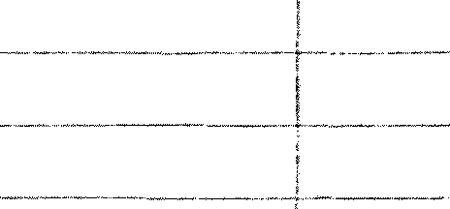

Pinion Block

-- r-P--inion Gear

:;:;

**ro**

**0**

***<I)***

***<I)***

**uro**

## f

**a**"**..**'

**.s**

·

**C:**

**0**

**C:**

**0**

:;:;

**0**"'

**0**

**...J**

131

-- ---

**Q)**

.

**a.**

*2*

**0**

I-

f ----- ----· --

$1.278.(l?; _ $1,278 9_7

$223 22' $223. 22

$180.06! $180.06

'FOLDER-SUPERSTRUCTURE..

282 .... - BELTS

283

..LWEBBiNGUP-DEYIC_E

284

. -"ELECTRlcsiELECTRONICS

285

- --PRINTING UNIT

286

FOLDER

287

**OPERATING ELEMENTS**

288



289

**CONTROL CONSOLE** / ---- . -

**PPMSTATION**

290

, **BAUMUCLER DRIVESYSTEM**

291

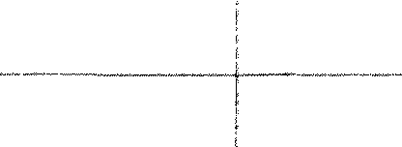

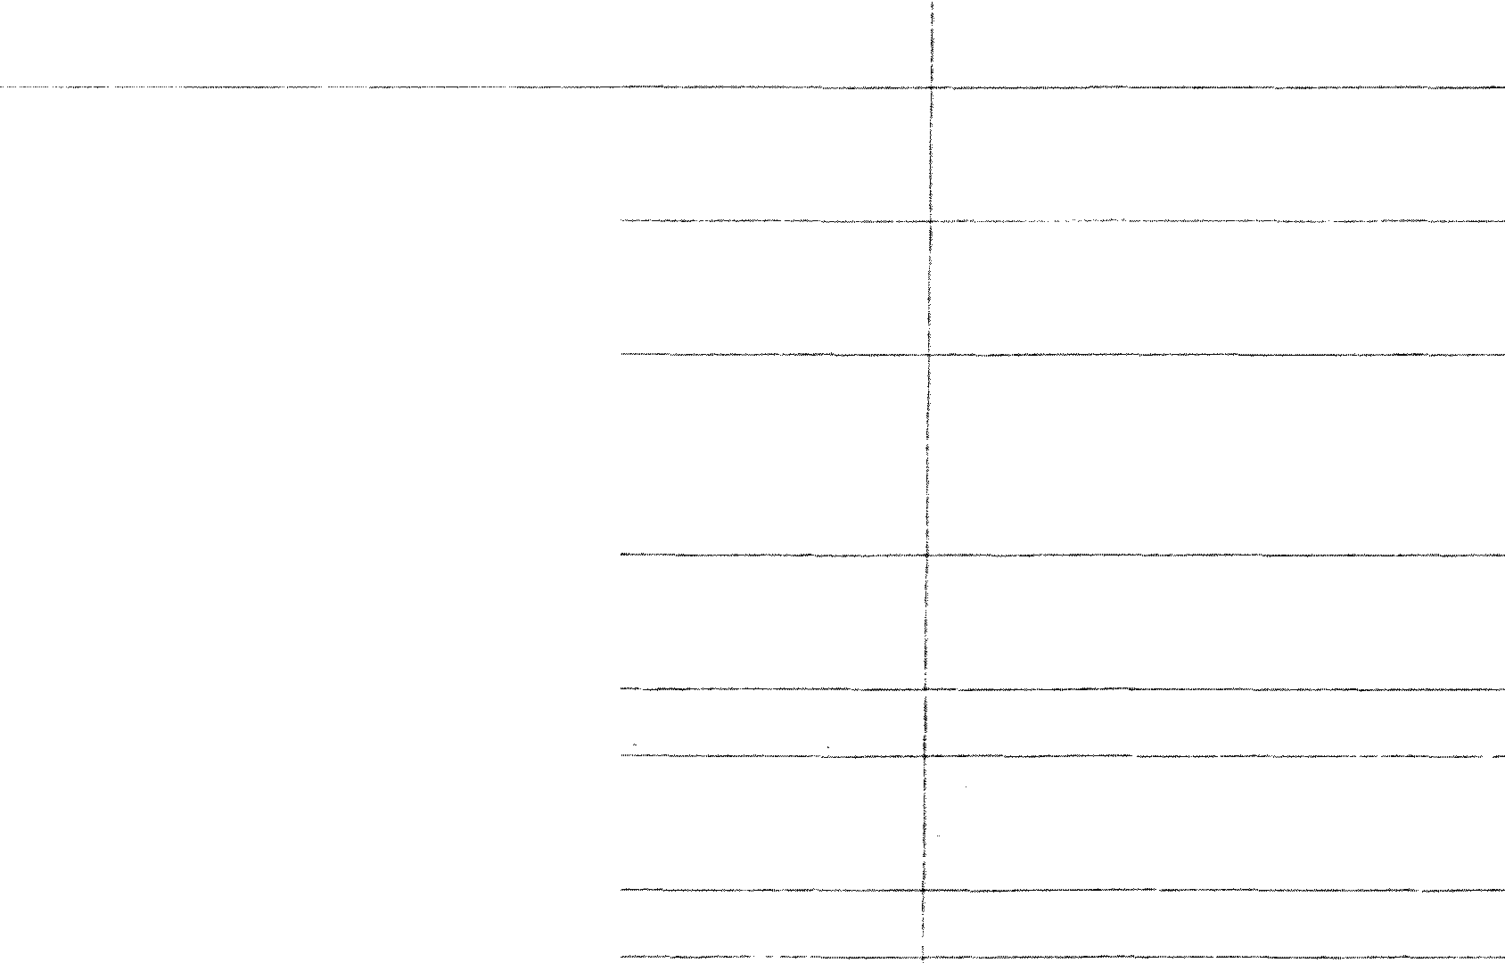---------------

-+--

292



293

'

294 - - **'RESERVESATZ HEFTER**

BAUMUELLER-ELECTRONIC-PACKAGE

--- -- --- -- - --

295

296

297 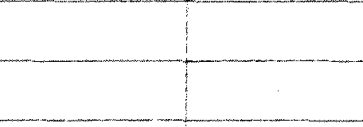

298

299



_ ...

300 .... l'a_r1:s re_c_eived_IJy: .. _ _ _

301

Brian Nutting, Savannah Morning News

2:17 PM 7 of 7