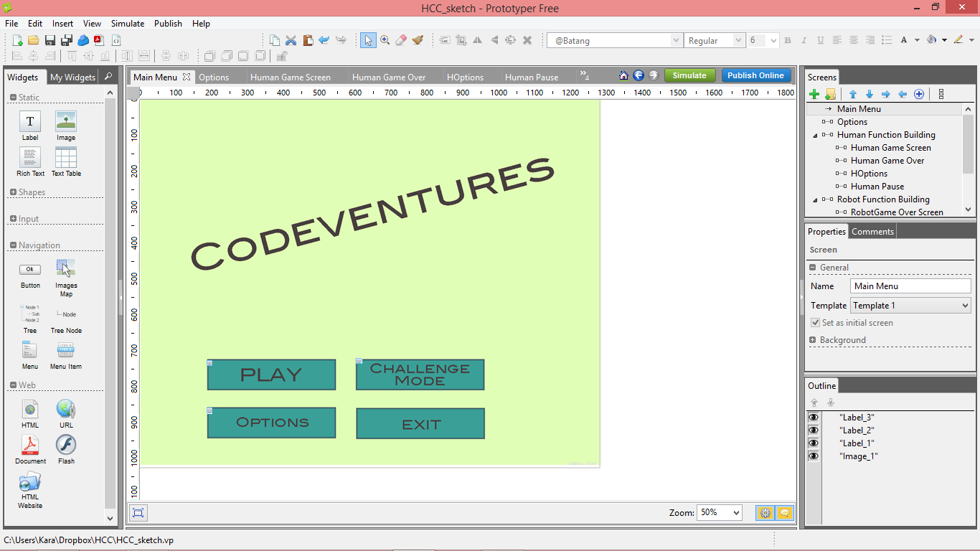
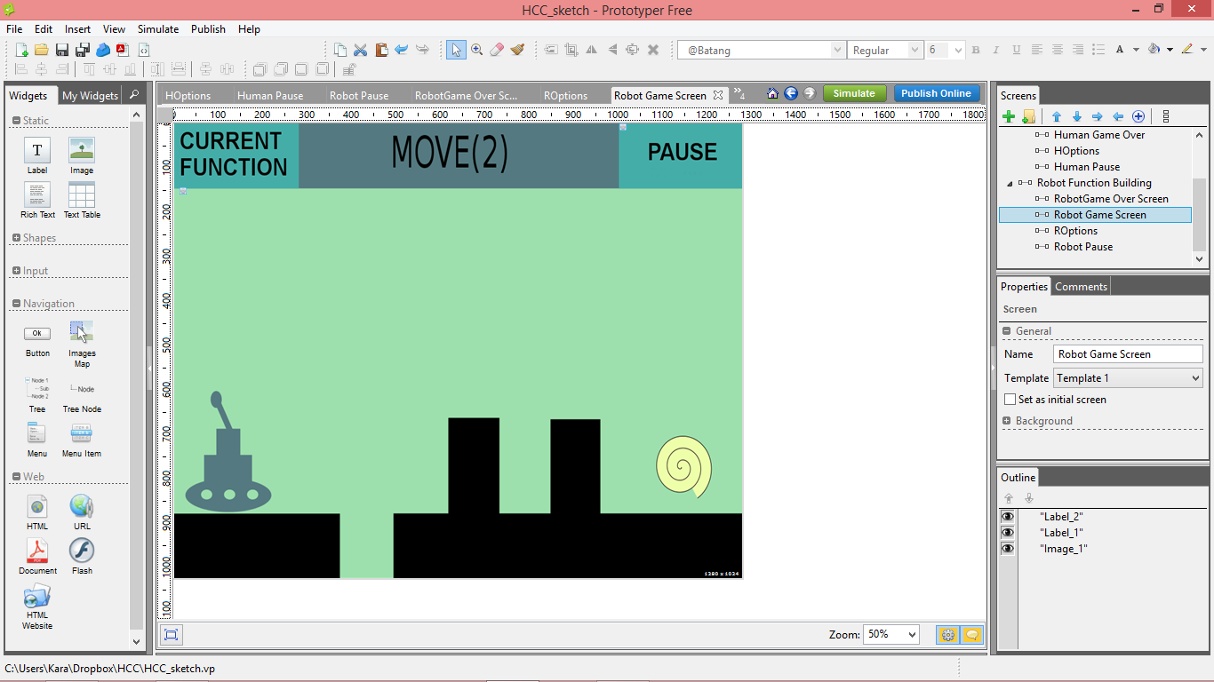
This is the main screen for our prototype. If you click 'play', it takes you to a function building screen for the human section of the campaign. If you click 'challenge mode' it takes you to the function building screen for the robot section of the campaign. These function building screens take you to their respective gameplay screens. The robot gameplay screen is shown above. Here you attempt to complete levels using the functions that you have written. If unsuccessful, a game over screen appears asking if you want to try again or return to the main menu. You can also click on 'pause' which will take you to the pause screen.
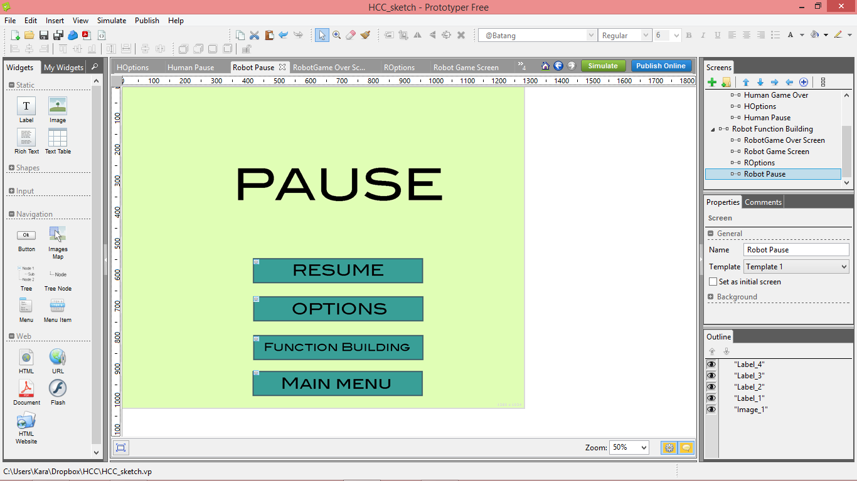
The pause screen allows you to resume the game, go into the options screen to change the game settings, or return to the respective campaign's function building screen.

