OPEN ELECTIVE
INTELLIGENT SYSTEMS REPORT

SUBMITTED BY: AARNA GUPTA
REGISTRATION NUMBER: 2427030695
SECTION: G
SUBMITTED TO : Dr. Linesh Raja

Fuzzy Logic System for Washing Machine Cycle Time
1. Input & Output Variables
Inputs:
Dirt Level → {Low, Medium, High}
Load Size → {Small, Medium, Large}
Output:
Wash Time (minutes) → {Short, Medium, Long}

DIRT LEVEL:

FUZZY SET | TYPE | RANGE
LOW | TRIANGULAR | [0 0 5]
MEDIUM | TRIANGULAR | [2 5 8]
HIGH | TRIANGULAR | [5 10 10]

LOAD LEVEL:

FUZZY SET | TYPE | RANGE
SMALL | TRIANGULAR | [0 0 5]
MEDIUM | TRIANGULAR | [2 5 8]
LARGE | TRIANGULAR | [5 10 10]

WASH TIME:

FUZZY SET | TYPE | RANGE
SHORT | TRIANGULAR | [0 0 30]
MEDIUM | TRIANGULAR | [15 30 45]
LONG | TRIANGULAR | [30 60 60]

FUZZY RULE BASE:

- IF Dirt is Low AND Load is Small → Wash Time is Short

- IF Dirt is Low AND Load is Medium → Wash Time is Medium

- IF Dirt is Low AND Load is Large → Wash Time is Medium

- IF Dirt is Medium AND Load is Small → Wash Time is Medium

- IF Dirt is Medium AND Load is Large → Wash Time is Long

- IF Dirt is High AND Load is Small → Wash Time is Medium

MATLAB IMPLEMENTATION:

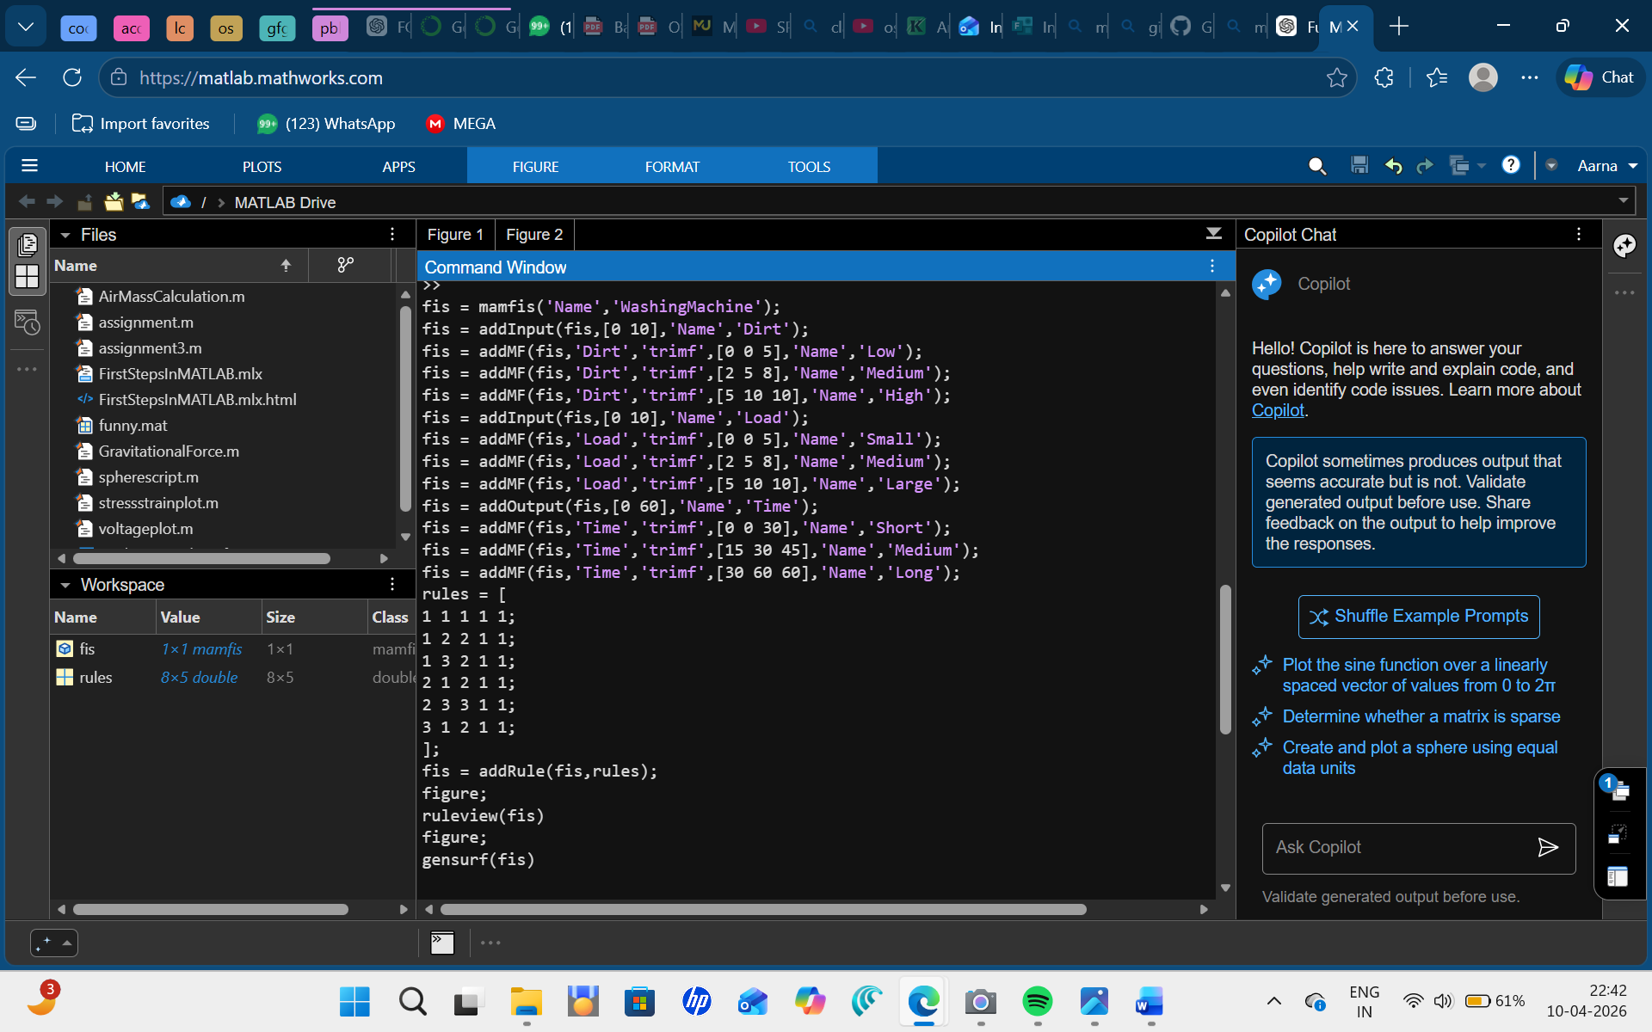

Rule Viewer
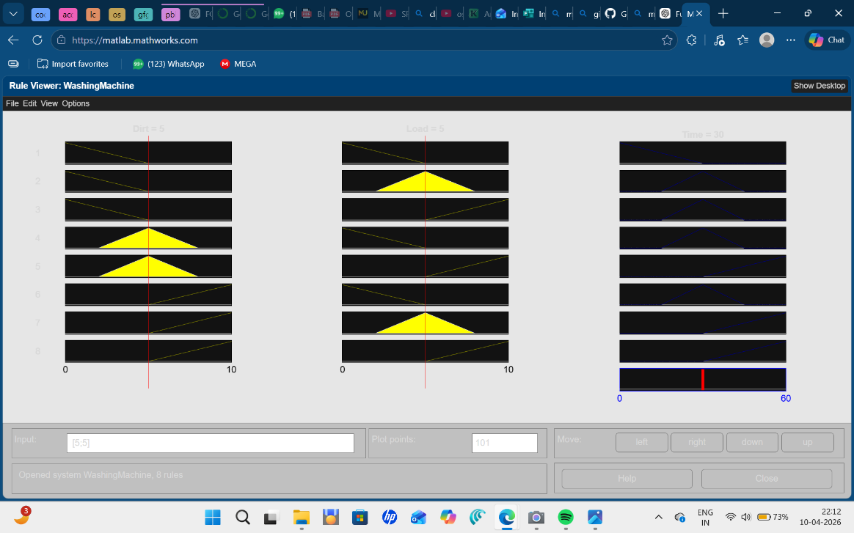
Surface Viewer (3D Graph)
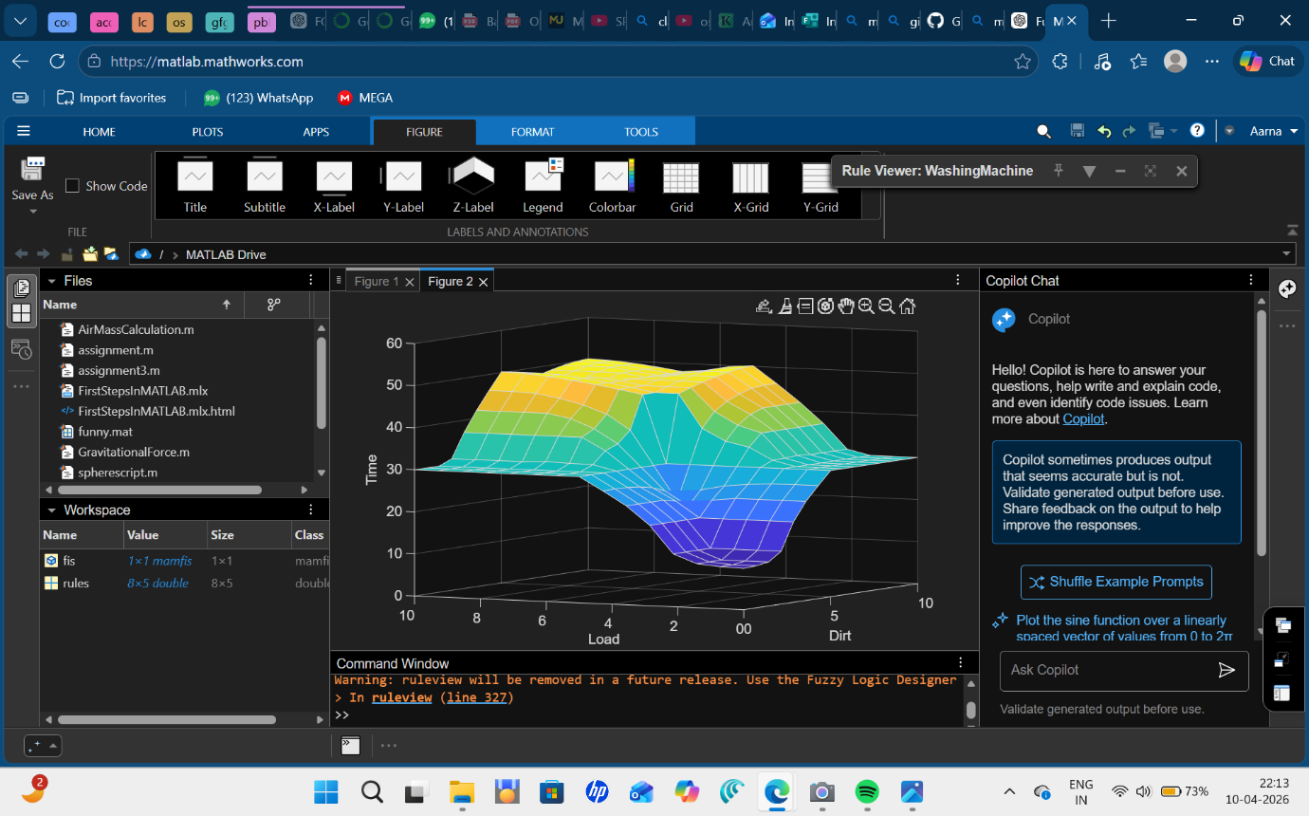
Dirt:
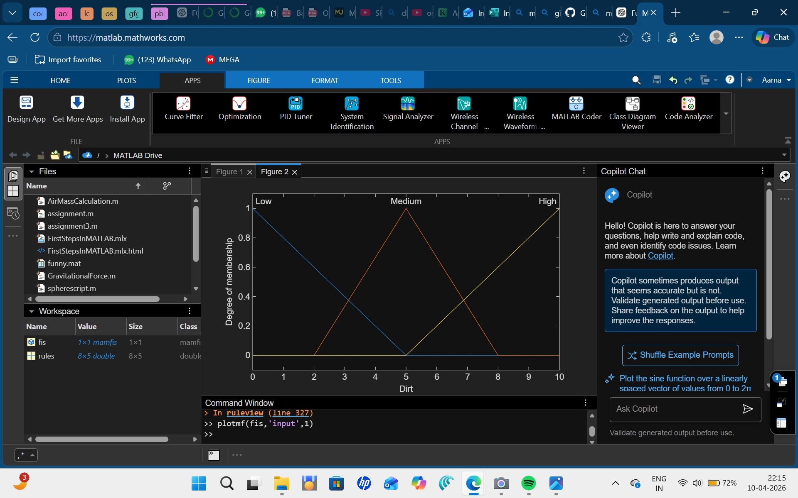

Load:

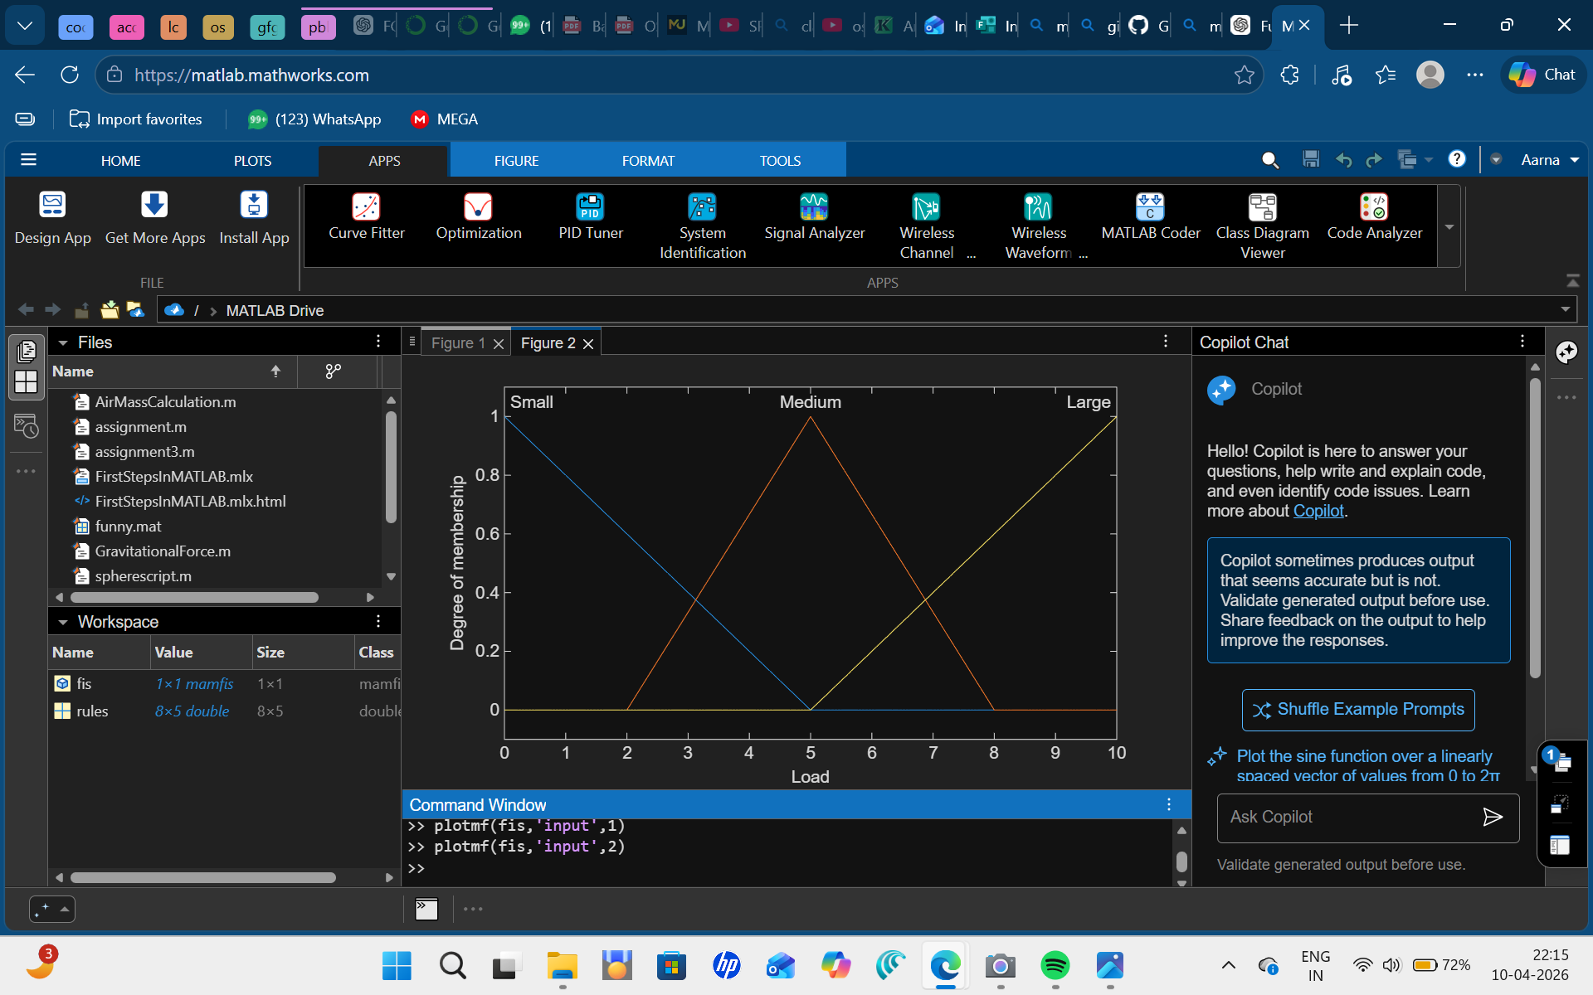

Time:
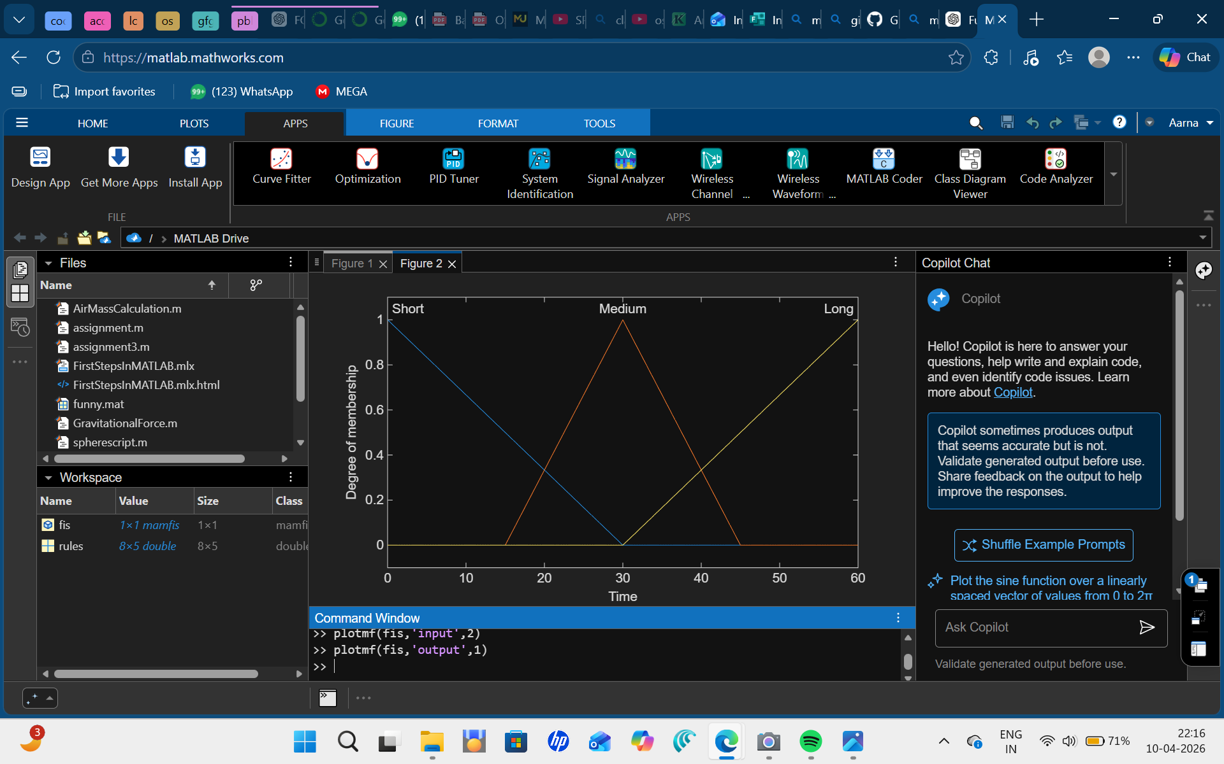
Type: Mamdani Fuzzy Inference System
Inputs: Dirt Level, Load Size
Output: Wash Time
Defuzzification: Centroid Method
Membership: Triangular functions

Question 2: Develop a hybrid intelligent system combining fuzzy logic and neural networks to predict student performance level.

A hybrid intelligent system is developed by combining fuzzy logic and neural networks to predict student performance. This approach utilizes the strengths of both techniques—fuzzy logic for handling uncertainty and neural networks for learning from data.

Inputs and Output
The system uses the following inputs:
- Attendance
- Assignment Marks
- Test Marks
The output of the system is:
- Performance Level: Poor, Average, Good

Fuzzy Logic Component
Fuzzy logic is used to model human-like reasoning. The input values are converted into linguistic variables such as Low, Medium, High using membership functions.
A set of IF–THEN rules is defined to determine the performance level. For example:
- IF Attendance is High AND Assignment is Good AND Test is High → Performance is Good
- IF Attendance is Medium → Performance is Average
- IF Attendance is Low → Performance is Poor
The fuzzy inference system processes these rules and produces an output, which is then converted into a crisp value using defuzzification.

Neural Network Integration (ANFIS)

The neural network is integrated using an Adaptive Neuro-Fuzzy Inference System (ANFIS). It enhances the fuzzy system by learning from data.
- The neural network adjusts the membership functions
- It optimizes the rule parameters
- It reduces the prediction error through training
This learning process improves the accuracy of the system over time.

Integration of Fuzzy Logic and Neural Network
The hybrid system works as follows:
Input → Fuzzification → Rule Evaluation → Neural Learning → Output
Fuzzy logic provides the structure and interpretability, while the neural network provides adaptability and learning capability.

MATLAB IMPLEMENTATION:

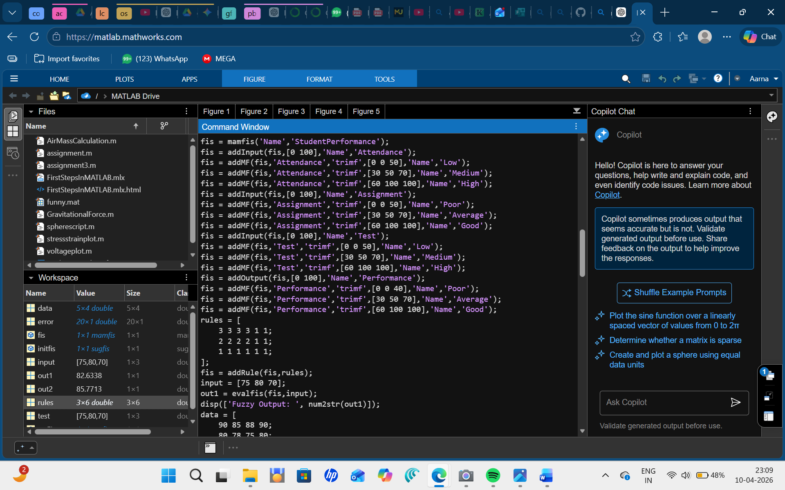
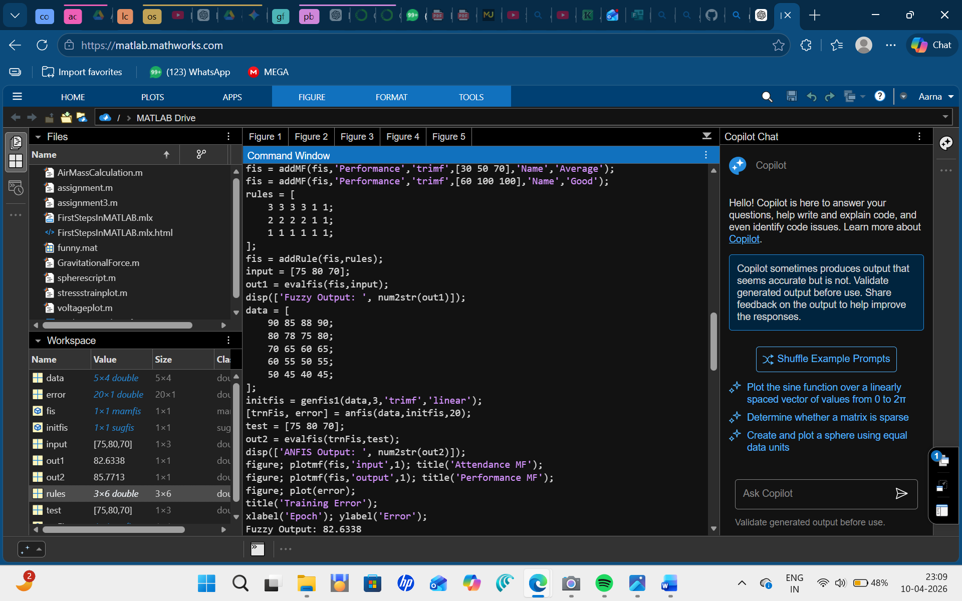

Input Membership Function (Attendance MF)

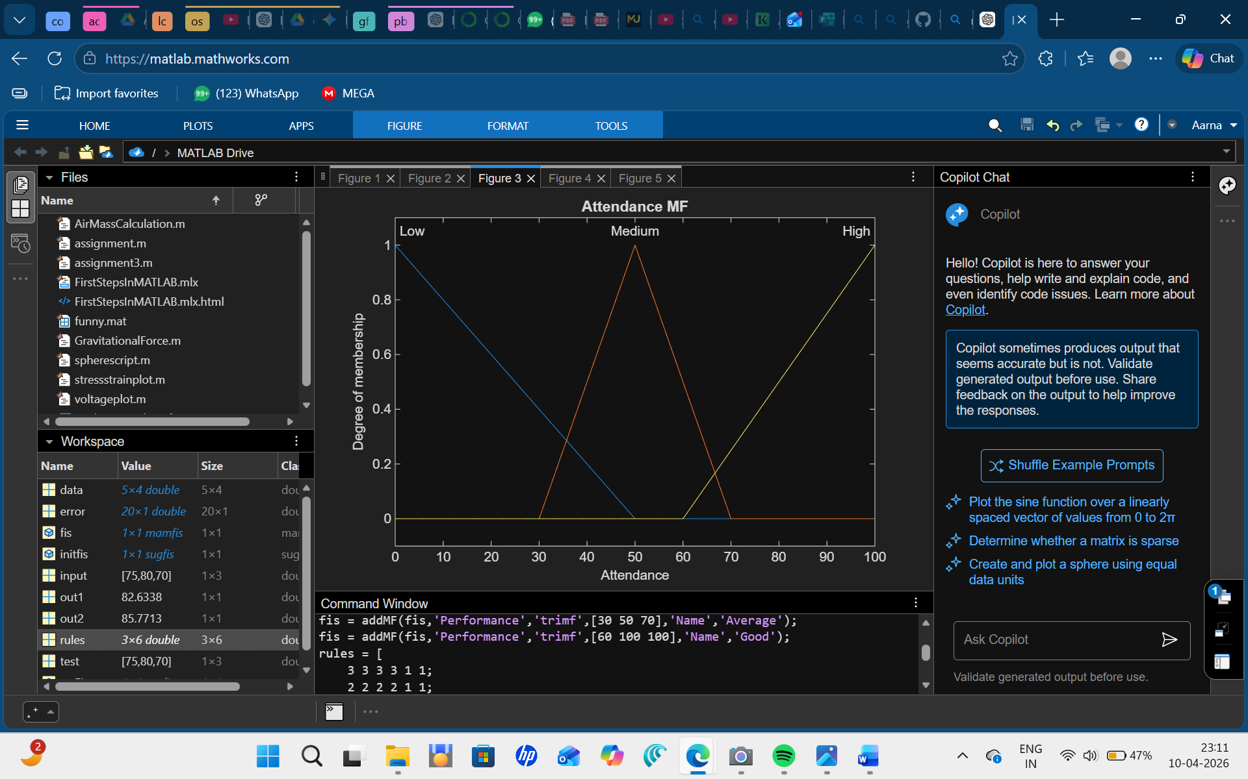
Output Membership Function (Performance MF)

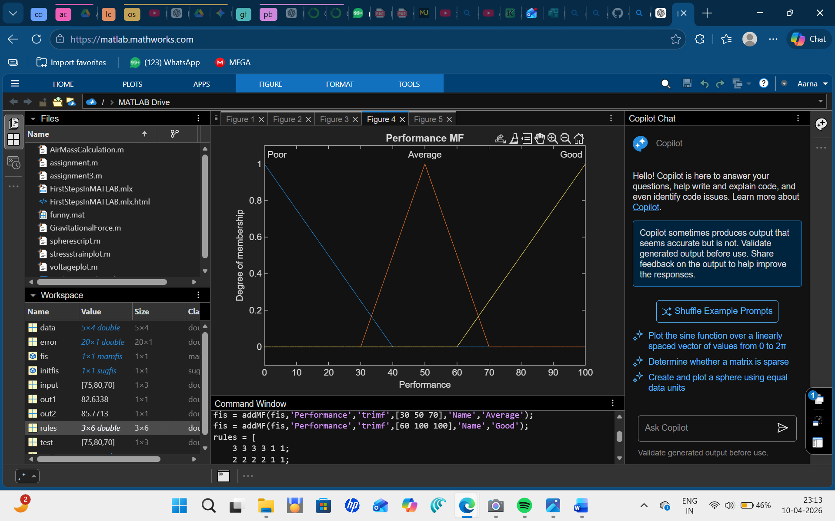
Training Error Graph (ANFIS)

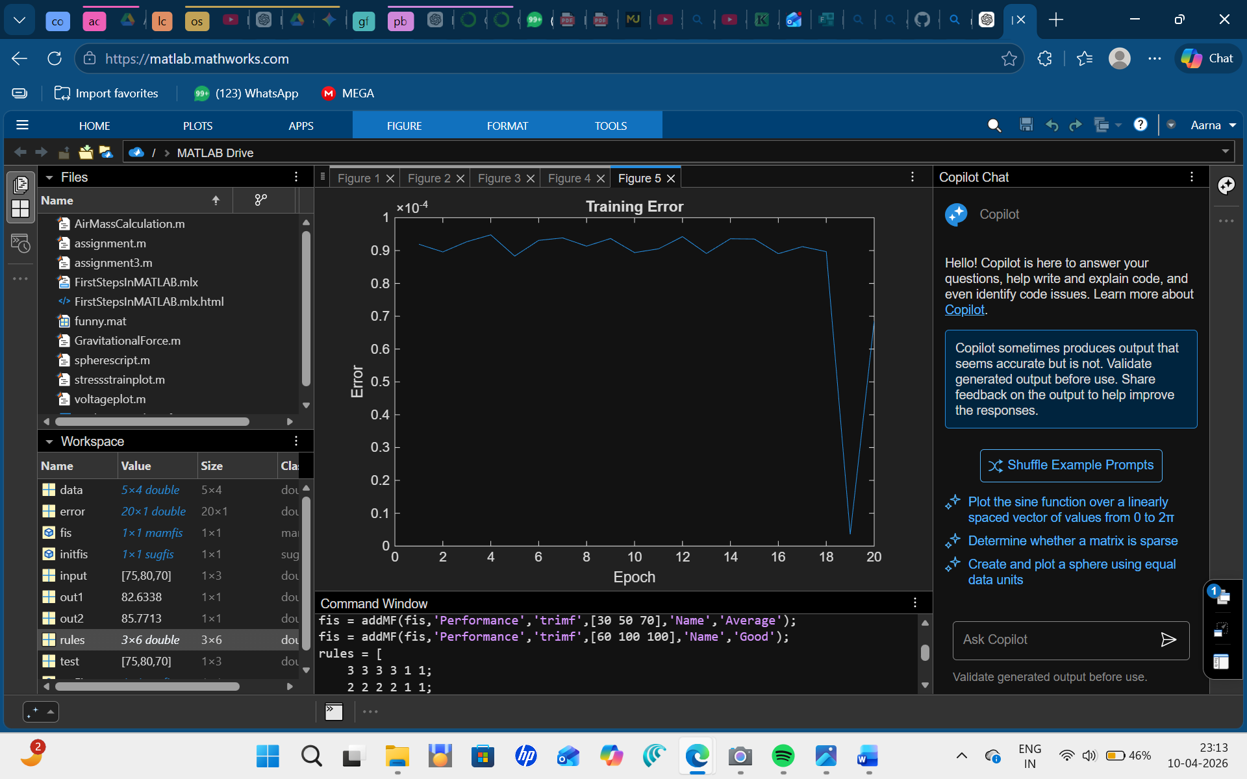
The hybrid fuzzy-neural system effectively predicts student performance by combining rule-based reasoning with data-driven learning. It produces accurate and flexible results compared to traditional methods.

