**In Class Problems**

**Class 1**

**Easy**

1.A fair coin is tossed 3 times. What is the probability of at least two consecutive heads?

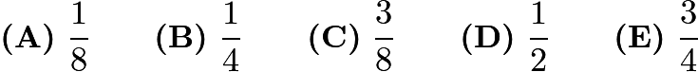

2.The Fort Worth Zoo has a number of two-legged birds and a number of four-legged mammals. On one visit to the zoo, Margie counted 200 heads and 522 legs. How many of the animals that Margie counted were two-legged birds?

$\textbf{(A)}\hspace{.05in}61\qquad\textbf{(B)}\hspace{.05in}122\qquad\textbf{(C)}\hspace{.05in}139\qquad\textbf{(D)}\hspace{.05in}150\qquad\textbf{(E)}\hspace{.05in}161$

3.How many 4-digit numbers greater than 1000 are there that use the four digits of 2012?

$\textbf{(A)}\hspace{.05in}6\qquad\textbf{(B)}\hspace{.05in}7\qquad\textbf{(C)}\hspace{.05in}8\qquad\textbf{(D)}\hspace{.05in}9\qquad\textbf{(E)}\hspace{.05in}12$

**Medium**

4.Jack wants to bike from his house to Jill's house, which is located three blocks east and two blocks north of Jack's house. After biking each block, Jack can continue either east or north, but he needs to avoid a dangerous intersection one block east and one block north of his house. In how many ways can he reach Jill's house by biking a total of five blocks?

$\textbf{(A) }4\qquad\textbf{(B) }5\qquad\textbf{(C) }6\qquad\textbf{(D) }8\qquad\textbf{(E) }10$

5.Jamar bought some pencils costing more than a penny each at the school bookstore and paid $\textdollar 1.43$. Sharona bought some of the same pencils and paid $\textdollar 1.87$. How many more pencils did Sharona buy than Jamar?

$\textbf{(A)}\hspace{.05in}2\qquad\textbf{(B)}\hspace{.05in}3\qquad\textbf{(C)}\hspace{.05in}4\qquad\textbf{(D)}\hspace{.05in}5\qquad\textbf{(E)}\hspace{.05in}6$

6.In the BIG N, a middle school football conference, each team plays every other team exactly once. If a total of 21 conference games were played during the 2012 season, how many teams were members of the BIG N conference?

$\textbf{(A)}\hspace{.05in}6\qquad\textbf{(B)}\hspace{.05in}7\qquad\textbf{(C)}\hspace{.05in}8\qquad\textbf{(D)}\hspace{.05in}9\qquad\textbf{(E)}\hspace{.05in}10$

7.The smallest number greater than 2 that leaves a remainder of 2 when divided by 3, 4, 5, or 6 lies between what numbers?

$\textbf{(A)}\hspace{.05in}40\text{ and }50\qquad\textbf{(B)}\hspace{.05in}51\text{ and }55\qquad\textbf{(C)}\hspace{.05in}56\text{ and }60\qquad\textbf{(D)}\hspace{.05in}\text{61 and 65}\qquad\textbf{(E)}\hspace{.05in}\text{66 and 99}$

8.Abe holds 1 green and 1 red jelly bean in his hand. Bea holds 1 green, 1 yellow, and 2 red jelly beans in her hand. Each randomly picks a jelly bean to show the other. What is the probability that the colors match?

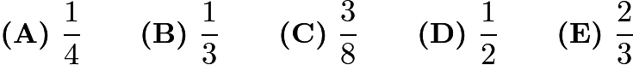

9.A magazine printed photos of three celebrities along with three photos of the celebrities as babies. The baby pictures did not identify the celebrities. Readers were asked to match each celebrity with the correct baby pictures. What is the probability that a reader guessing at random will match all three correctly?

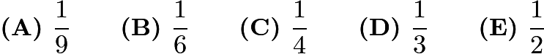

10.A number of students from Fibonacci Middle School are taking part in a community service project. The ratio of $8^\text{th}$-graders to $6^\text{th}$-graders is $5:3$, and the ratio of $8^\text{th}$-graders to $7^\text{th}$-graders is $8:5$. What is the smallest number of students that could be participating in the project?

$\textbf{(A)}\ 16 \qquad \textbf{(B)}\ 40 \qquad \textbf{(C)}\ 55 \qquad \textbf{(D)}\ 79 \qquad \textbf{(E)}\ 89$

**Hard**

11.The "Middle School Eight" basketball conference has 8 teams. Every season, each team plays every other conference team twice (home and away), and each team also plays 4 games against non-conference opponents. What is the total number of games in a season involving the "Middle School Eight" teams?

$\textbf{(A) }60\qquad\textbf{(B) }88\qquad\textbf{(C) }96\qquad\textbf{(D) }144\qquad\textbf{(E) }160$

12.Four children were born at City Hospital yesterday. Assume each child is equally likely to be a boy or a girl. Which of the following outcomes is most likely?

$\textbf{(A) }$ all 4 are boys $\textbf{(B) }$ all 4 are girls $\textbf{(C) }$ 2 are girls and 2 are boys $\textbf{(D) }$ 3 are of one gender and 1 is of the other gender $\textbf{(E) }$ all of these outcomes are equally likely

13.Samantha lives 2 blocks west and 1 block south of the southwest corner of City Park. Her school is 2 blocks east and 2 blocks north of the northeast corner of City Park. On school days she bikes on streets to the southwest corner of City Park, then takes a diagonal path through the park to the northeast corner, and then bikes on streets to school. If her route is as short as possible, how many different routes can she take?

$\textbf{(A)}\ 3 \qquad \textbf{(B)}\ 6 \qquad \textbf{(C)}\ 9 \qquad \textbf{(D)}\ 12 \qquad \textbf{(E)}\ 18$

14.Toothpicks are used to make a grid that is 60 toothpicks long and 32 toothpicks wide. How many toothpicks are used altogether?

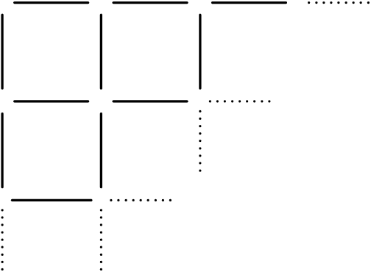

$\textbf{(A)}\ 1920 \qquad \textbf{(B)}\ 1952 \qquad \textbf{(C)}\ 1980 \qquad \textbf{(D)}\ 2013 \qquad \textbf{(E)}\ 3932$

1. **C**
2. **C**
3. **D**
4. **A**
5. **C**
6. **B**
7. **D**
8. **C**
9. **B**
10. **E**
11. **B**
12. **D**
13. **E**
14. **E**

**Class 2**

**Easy**

1.In a town of 351 adults, every adult owns a car, motorcycle, or both. If 331 adults own cars and 45 adults own motorcycles, how many of the car owners do not own a motorcycle?

$\textbf{(A) }20 \qquad\textbf{(B) }25 \qquad\textbf{(C) }45 \qquad\textbf{(D) }306 \qquad\textbf{(E) }351$

2.Bag A has three chips labeled 1, 3, and 5. Bag B has three chips labeled 2, 4, and 6. If one chip is drawn from each bag, how many different values are possible for the sum of the two numbers on the chips?

$\textbf{(A) }4 \qquad\textbf{(B) }5 \qquad\textbf{(C) }6 \qquad\textbf{(D) }7 \qquad\textbf{(E) }9$

3.Using only pennies, nickels, dimes, and quarters, what is the smallest number of coins Freddie would need so he could pay any amount of money less than a dollar?

$\textbf{(A)}\ 6 \qquad\textbf{(B)}\ 10\qquad\textbf{(C)}\ 15\qquad\textbf{(D)}\ 25\qquad\textbf{(E)}\ 99$

**Medium**

4.Angie, Bridget, Carlos, and Diego are seated at random around a square table, one person to a side. What is the probability that Angie and Carlos are seated opposite each other?

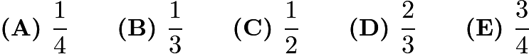

5.The Amaco Middle School bookstore sells pencils costing a whole number of cents. Some seventh graders each bought a pencil, paying a total of $1.43$. Some of the $30$ sixth graders each bought a pencil, and they paid a total of $1.95$. How many more sixth graders than seventh graders bought a pencil?

$\textbf{(A)}\ 1\qquad\textbf{(B)}\ 2\qquad\textbf{(C)}\ 3\qquad\textbf{(D)}\ 4\qquad\textbf{(E)}\ 5$

6.The two spinners shown are spun once and each lands on one of the numbered sectors. What is the probability that the sum of the numbers in the two sectors is prime?

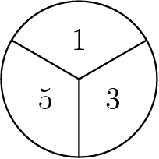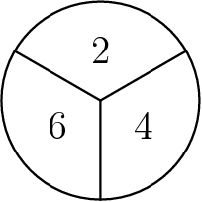

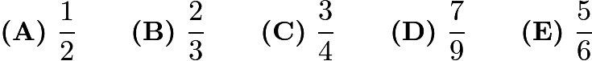

7.A three-digit integer contains one of each of the digits $1$, $3$, and $5$. What is the probability that the integer is divisible by $5$?

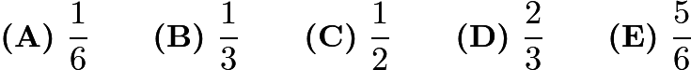

8.How many 3-digit positive integers have digits whose product equals $24$?

$\textbf{(A)}\ 12\qquad\textbf{(B)}\ 15\qquad\textbf{(C)}\ 18\qquad\textbf{(D)}\ 21\qquad\textbf{(E)}\ 24$

9.Each of the $39$ students in the eighth grade at Lincoln Middle School has one dog or one cat or both a dog and a cat. Twenty students have a dog and $26$ students have a cat. How many students have both a dog and a cat?

$\textbf{(A)}\ 7\qquad \textbf{(B)}\ 13\qquad \textbf{(C)}\ 19\qquad \textbf{(D)}\ 39\qquad \textbf{(E)}\ 46$

10.Ms.Osborne asks each student in her class to draw a rectangle with integer side lengths and a perimeter of $50$ units. All of her students calculate the area of the rectangle they draw. What is the difference between the largest and smallest possible areas of the rectangles?

$\textbf{(A)}\ 76\qquad \textbf{(B)}\ 120\qquad \textbf{(C)}\ 128\qquad \textbf{(D)}\ 132\qquad \textbf{(E)}\ 136$

**Hard**

11.A fair 6-sided die is rolled twice. What is the probability that the first number that comes up is greater than or equal to the second number?



12.How many 4-digit positive integers have four different digits, where the leading digit is not zero, the integer is a multiple of 5, and 5 is the largest digit?

$\textbf{(A) }24\qquad\textbf{(B) }48\qquad\textbf{(C) }60\qquad\textbf{(D) }84\qquad\textbf{(E) }108$

13.How many whole numbers between 1 and 1000 do not contain the digit 1?

$\textbf{(A)}\ 512\qquad\textbf{(B)}\ 648\qquad\textbf{(C)}\ 720\qquad\textbf{(D)}\ 728\qquad\textbf{(E)}\ 800$

14.On the last day of school, Mrs. Wonderful gave jelly beans to her class. She gave each boy as many jelly beans as there were boys in the class. She gave each girl as many jelly beans as there were girls in the class. She brought $400$ jelly beans, and when she finished, she had six jelly beans left. There were two more boys than girls in her class. How many students were in her class?

$\textbf{(A)}\ 26\qquad\textbf{(B)}\ 28\qquad\textbf{(C)}\ 30\qquad\textbf{(D)}\ 32\qquad\textbf{(E)}\ 34$

1. **D**
2. **B**
3. **B**
4. **B**
5. **D**
6. **D**
7. **B**
8. **D**
9. **A**
10. **D**
11. **D**
12. **D**
13. **D**
14. **B**

**Homework Problems**

**Easy**

How many triangles are in this figure? (Some triangles may overlap other triangles.)

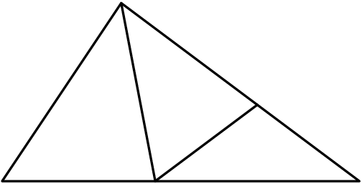

$\text{(A)}\ 9 \qquad \text{(B)}\ 8 \qquad \text{(C)}\ 7 \qquad \text{(D)}\ 6 \qquad \text{(E)}\ 5$

A group of children riding on bicycles and tricycles rode past Billy Bob's house. Billy Bob counted 7 children and 19 wheels. How many tricycles were there?

$\mathrm{(A)}\ 2 \qquad\mathrm{(B)}\ 4 \qquad\mathrm{(C)}\ 5 \qquad\mathrm{(D)}\ 6 \qquad\mathrm{(E)}\ 7$

When a fair six-sided die is tossed on a table top, the bottom face cannot be seen. What is the probability that the product of the numbers on the five faces that can be seen is divisible by 6?

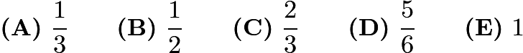

Fourteen white cubes are put together to form the figure on the right. The complete surface of the figure, including the bottom, is painted red. The figure is then separated into individual cubes. How many of the individual cubes have exactly four red faces?

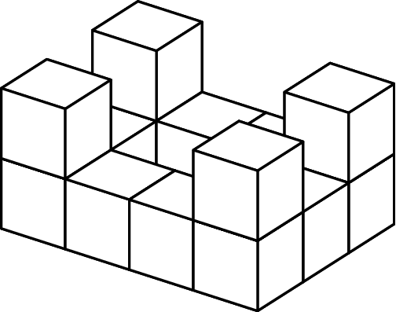

$\textbf{(A)}\ 4\qquad\textbf{(B)}\ 6\qquad\textbf{(C)}\ 8\qquad\textbf{(D)}\ 10\qquad\textbf{(E)}\ 12$

Three students, with different names, line up single file. What is the probability that they are in alphabetical order from front-to-back?

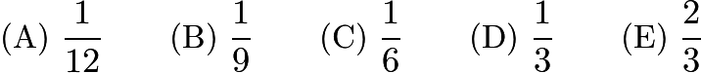

Ali, Bonnie, Carlo, and Dianna are going to drive together to a nearby theme park. The car they are using has 4 seats: 1 driver's seat, 1 front passenger seat, and 2 back passenger seats. Bonnie and Carlo are the only ones who know how to drive the car. How many possible seating arrangements are there?

$\textbf{(A)}\ 2 \qquad \textbf{(B)}\ 4 \qquad \textbf{(C)}\ 6 \qquad \textbf{(D)}\ 12 \qquad \textbf{(E)}\ 24$

How many different combinations of $5 bills and $2 bills can be used to make a total of $17? Order does not matter in this problem.

$\text{(A)}\ 2 \qquad \text{(B)}\ 3 \qquad \text{(C)}\ 4 \qquad \text{(D)}\ 5 \qquad \text{(E)}\ 6$

How many positive factors of 36 are also multiples of 4?

$\text{(A)}\ 2 \qquad \text{(B)}\ 3 \qquad \text{(C)}\ 4 \qquad \text{(D)}\ 5 \qquad \text{(E)}\ 6$

A circle and two distinct lines are drawn on a sheet of paper. What is the largest possible number of points of intersection of these figures?

$\text{(A)}\ 2 \qquad \text{(B)}\ 3 \qquad \text{(C)}\ 4 \qquad \text{(D)}\ 5 \qquad \text{(E)}\ 6$

**Medium**

An Annville Junior High School, $30\%$ of the students in the Math Club are in the Science Club, and $80\%$ of the students in the Science Club are in the Math Club. There are 15 students in the Science Club. How many students are in the Math Club?

$\text{(A)}\ 12 \qquad \text{(B)}\ 15 \qquad \text{(C)}\ 30 \qquad \text{(D)}\ 36 \qquad \text{(E)}\ 40$

A sequence of squares is made of identical square tiles. The edge of each square is one tile length longer than the edge of the previous square. The first three squares are shown. How many more tiles does the seventh square require than the sixth?

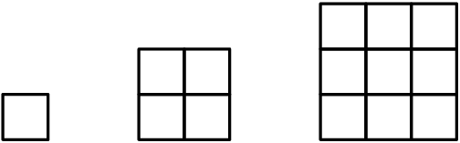

$\text{(A)}\ 11 \qquad \text{(B)}\ 12 \qquad \text{(C)}\ 13 \qquad \text{(D)}\ 14 \qquad \text{(E)}\ 15$

For how many three-digit whole numbers does the sum of the digits equal $25$?

$\text{(A)}\ 2 \qquad \text{(B)}\ 4 \qquad \text{(C)}\ 6 \qquad \text{(D)}\ 8 \qquad \text{(E)}\ 10$

A board game spinner is divided into three regions labeled $A$, $B$ and $C$. The probability of the arrow stopping on region $A$ is $\frac{1}{3}$ and on region $B$ is $\frac{1}{2}$. The probability of the arrow stopping on region $C$ is

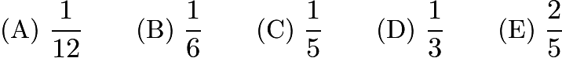

Last summer $100$ students attended basketball camp. Of those attending, $52$ were boys and $48$were girls. Also, $40$ students were from Jonas Middle School and $60$ were from Clay Middle School. Twenty of the girls were from Jonas Middle School. How many of the boys were from Clay Middle School?

$\text{(A)}\ 20 \qquad \text{(B)}\ 32 \qquad \text{(C)}\ 40 \qquad \text{(D)}\ 48 \qquad \text{(E)}\ 52$

A gumball machine contains $9$ red, $7$ white, and $8$ blue gumballs. The least number of gumballs a person must buy to be sure of getting four gumballs of the same color is

$\text{(A)}\ 8 \qquad \text{(B)}\ 9 \qquad \text{(C)}\ 10 \qquad \text{(D)}\ 12 \qquad \text{(E)}\ 18$

How many integers between 1000 and 2000 have all three of the numbers 15, 20, and 25 as factors?

$\textbf{(A)}\ 1 \qquad \textbf{(B)}\ 2 \qquad \textbf{(C)}\ 3 \qquad \textbf{(D)}\ 4 \qquad \textbf{(E)}\ 5$

**Hard**

Tamika selects two different numbers at random from the set $\{ 8,9,10 \}$ and adds them. Carlos takes two different numbers at random from the set $\{3, 5, 6\}$ and multiplies them. What is the probability that Tamika's result is greater than Carlos' result?

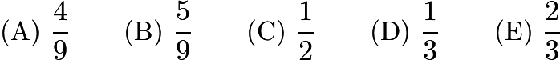

How many whole numbers between 99 and 999 contain exactly one 0?

$\text{(A)}\ 72 \qquad \text{(B)}\ 90 \qquad \text{(C)}\ 144 \qquad \text{(D)}\ 162 \qquad \text{(E)}\ 180$

A pair of 8-sided dice have sides numbered 1 through 8. Each side has the same probability (chance) of landing face up. The probability that the product of the two numbers that land face-up exceeds 36 is

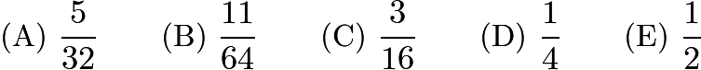

How many subsets containing three different numbers can be selected from the set\[\{ 89,95,99,132, 166,173 \}\]so that the sum of the three numbers is even?

$\text{(A)}\ 6 \qquad \text{(B)}\ 8 \qquad \text{(C)}\ 10 \qquad \text{(D)}\ 12 \qquad \text{(E)}\ 24$

A point is chosen at random from within a circular region. What is the probability that the point is closer to the center of the region than it is to the boundary of the region?

$\text{(A)}\ 1/4 \qquad \text{(B)}\ 1/3 \qquad \text{(C)}\ 1/2 \qquad \text{(D)}\ 2/3 \qquad \text{(E)}\ 3/4$

Diana and Apollo each roll a standard die obtaining a number at random from 1 to 6. What is the probability that Diana's number is larger than Apollo's number?

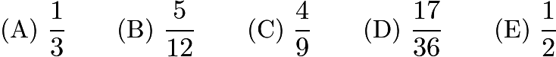

How many four-digit whole numbers are there such that the leftmost digit is odd, the second digit is even, and all four digits are different?

$\text{(A)}\ 1120 \qquad \text{(B)}\ 1400 \qquad \text{(C)}\ 1800 \qquad \text{(D)}\ 2025 \qquad \text{(E)}\ 2500$

The two wheels shown below are spun and the two resulting numbers are added. The probability that the sum is even is

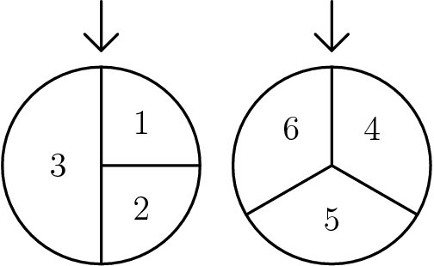

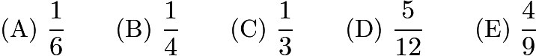

1. **E**
2. **C**
3. **E**
4. **B**
5. **C**
6. **D**
7. **A**
8. **B**
9. **D**
10. **E**
11. **C**
12. **C**
13. **B**
14. **B**
15. **C**
16. **C**
17. **A**
18. **D**
19. **A**
20. **D**
21. **A**
22. **B**
23. **B**
24. **D**