**In Class Problems**

**Class 1**

**Easy**

1.Paul owes Paula 35 cents and has a pocket full of 5-cent coins, 10-cent coins, and 25-cent coins that he can use to pay her. What is the difference between the largest and the smallest number of coins he can use to pay her?

$\textbf{(A) }1\qquad\textbf{(B) }2\qquad\textbf{(C) }3\qquad\textbf{(D) }4\qquad \textbf{(E) }5$

2.In July 1861, $366$ inches of rain fell in Cherrapunji, India. What was the average rainfall in inches per hour during that month?



3.Isabella had a week to read a book for a school assignment. She read an average of 36 pages per day for the first three days and an average of 44 pages per day for the next three days. She then finished the book by reading 10 pages on the last day. How many pages were in the book?

$\textbf{(A) }240\qquad\textbf{(B) }250\qquad\textbf{(C) }260\qquad\textbf{(D) }270\qquad \textbf{(E) }280$

**Medium**

4.The sale ad read: "Buy three tires at the regular price and get the fourth tire for three dollars;." Sam paid $240\text{ dollars}$ for a set of four tires at the sale. What was the regular price of one tire?

$\text{(A)}\ 59.25\text{ dollars} \qquad \text{(B)}\ 60\text{ dollars} \qquad \text{(C)}\ 70\text{ dollars} \qquad \text{(D)}\ 79\text{ dollars} \qquad \text{(E)}\ 80\text{ dollars}$

5.Joyce made $12$ of her first $30$ shots in the first three games of this basketball game, so her seasonal shooting average was $40\%$. In her next game, she took $10$ shots and raised her seasonal shooting average to $50\%$. How many of these $10$ shots did she make?

$\text{(A)}\ 2 \qquad \text{(B)}\ 3 \qquad \text{(C)}\ 5 \qquad \text{(D)}\ 6 \qquad \text{(E)}\ 8$

6.Abby, Bret, Carl, and Dana are seated in a row of four seats numbered #1 to #4. Joe looks at them and says:

"Bret is next to Carl."  
"Abby is between Bret and Carl."

However each one of Joe's statements is false. Bret is actually sitting in seat #3. Who is sitting in seat #2?

$\text{(A)}\ \text{Abby} \qquad \text{(B)}\ \text{Bret} \qquad \text{(C)}\ \text{Carl} \qquad \text{(D)}\ \text{Dana} \qquad \text{(E)}\ \text{There is not enough information to be sure.}$

7.$\diamondsuit$ and $\Delta$ are whole numbers and $\diamondsuit \times \Delta =36$. The largest possible value of $\diamondsuit + \Delta$ is

$\text{(A)}\ 12 \qquad \text{(B)}\ 13 \qquad \text{(C)}\ 15 \qquad \text{(D)}\ 20\ \qquad \text{(E)}\ 37$

8.The average weight of $6$ boys is $150$ pounds and the average weight of $4$ girls is $120$ pounds. The average weight of the $10$ children is

$\text{(A)}\ 135\text{ pounds} \qquad \text{(B)}\ 137\text{ pounds} \qquad \text{(C)}\ 138\text{ pounds} \qquad \text{(D)}\ 140\text{ pounds} \qquad \text{(E)}\ 141\text{ pounds}$

**Hard**

9.One day the Beverage Barn sold 252 cans of soda to 100 customers, and every customer bought at least one can of soda. What is the maximum possible median number of cans of soda bought per customer on that day?

$\textbf{(A) }2.5\qquad\textbf{(B) }3.0\qquad\textbf{(C) }3.5\qquad\textbf{(D) }4.0\qquad\textbf{(E) }4.5$

10.A calculator has a squaring key $\boxed{x^2}$ which replaces the current number displayed with its square. For example, if the display is $\boxed{000003}$ and the $\boxed{x^2}$ key is depressed, then the display becomes $\boxed{000009}$. If the display reads $\boxed{000002}$, how many times must you depress the $\boxed{x^2}$key to produce a displayed number greater than $500$?

$\text{(A)}\ 4 \qquad \text{(B)}\ 5 \qquad \text{(C)}\ 8 \qquad \text{(D)}\ 9 \qquad \text{(E)}\ 250$

11.A multiple choice examination consists of $20$ questions. The scoring is $+5$ for each correct answer, $-2$ for each incorrect answer, and $0$ for each unanswered question. John's score on the examination is $48$. What is the maximum number of questions he could have answered correctly?

$\text{(A)}\ 9 \qquad \text{(B)}\ 10 \qquad \text{(C)}\ 11 \qquad \text{(D)}\ 12 \qquad \text{(E)}\ 16$

12.A **palindrome** is a whole number that reads the same forwards and backwards. If one neglects the colon, certain times displayed on a digital watch are palindromes. Three examples are: $\boxed{1:01}$, $\boxed{4:44}$, and $\boxed{12:21}$. How many times during a $12$-hour period will be palindromes?

$\text{(A)}\ 57 \qquad \text{(B)}\ 60 \qquad \text{(C)}\ 63 \qquad \text{(D)}\ 90 \qquad \text{(E)}\ 93$

1. **E**
2. **A**
3. **B**
4. **D**
5. **E**
6. **D**
7. **E**
8. **C**
9. **C**
10. **A**
11. **D**
12. **A**

**Class 2**

**Easy**

1.Betty used a calculator to find the product $0.075 \times 2.56$. She forgot to enter the decimal points. The calculator showed $19200$. If Betty had entered the decimal points correctly, the answer would have been

$\text{(A)}\ .0192 \qquad \text{(B)}\ .192 \qquad \text{(C)}\ 1.92 \qquad \text{(D)}\ 19.2 \qquad \text{(E)}\ 192$

2.There are $2$ boys for every $3$ girls in Ms. Johnson's math class. If there are $30$ students in her class, what percent of them are boys?



3.A can of soup can feed $3$ adults or $5$ children. If there are $5$ cans of soup and $15$ children are fed, then how many adults would the remaining soup feed?

$\text{(A)}\ 5 \qquad \text{(B)}\ 6 \qquad \text{(C)}\ 7 \qquad \text{(D)}\ 8 \qquad \text{(E)}\ 25$

4.During the softball season, Judy had $35$ hits. Among her hits were $1$ home run, $1$ triple and $5$doubles. The rest of her hits were singles. What percent of her hits were singles?

$\text{(A)}\ 28\% \qquad \text{(B)}\ 35\% \qquad \text{(C)}\ 70\% \qquad \text{(D)}\ 75\% \qquad \text{(E)}\ 80\%$

**Medium**

5.Let $\text{o}$ be an odd whole number and let $\text{n}$ be any whole number. Which of the following statements about the whole number $(\text{o}^2+\text{no})$ is always true?

$\text{(A)}\ \text{it is always odd} \qquad \text{(B)}\ \text{it is always even}$

$\text{(C)}\ \text{it is even only if n is even} \qquad \text{(D)}\ \text{it is odd only if n is odd}$

$\text{(E)}\ \text{it is odd only if n is even}$

6.Five test scores have a mean (average score) of $90$, a median (middle score) of $91$ and a mode (most frequent score) of $94$. The sum of the two lowest test scores is

$\text{(A)}\ 170 \qquad \text{(B)}\ 171 \qquad \text{(C)}\ 176 \qquad \text{(D)}\ 177 \qquad \text{(E)}\ \text{not determined by the information given}$

7.What is the $1992^\text{nd}$ letter in this sequence?

\[\text{ABCDEDCBAABCDEDCBAABCDEDCBAABCDEDC}\cdots\]

$\text{(A)}\ \text{A} \qquad \text{(B)}\ \text{B} \qquad \text{(C)}\ \text{C} \qquad \text{(D)}\ \text{D} \qquad \text{(E)}\ \text{E}$

8.If the length of a rectangle is increased by $20\%$ and its width is increased by $50\%$, then the area is increased by

$\text{(A)}\ 10\% \qquad \text{(B)}\ 30\% \qquad \text{(C)}\ 70\% \qquad \text{(D)}\ 80\% \qquad \text{(E)}\ 100\%$

**Hard**

9.Alan, Beth, Carlos, and Diana were discussing their possible grades in mathematics class this grading period. Alan said, "If I get an A, then Beth will get an A." Beth said, "If I get an A, then Carlos will get an A." Carlos said, "If I get an A, then Diana will get an A." All of these statements were true, but only two of the students received an A. Which two received A's?

$\text{(A)}\ \text{Alan, Beth} \qquad \text{(B)}\ \text{Beth, Carlos} \qquad \text{(C)}\ \text{Carlos, Diana}$

$\text{(D)}\ \text{Alan, Diana} \qquad \text{(E)}\ \text{Beth, Diana}$

10.The $600$ students at King Middle School are divided into three groups of equal size for lunch. Each group has lunch at a different time. A computer randomly assigns each student to one of three lunch groups. The probability that three friends, Al, Bob, and Carol, will be assigned to the same lunch group is approximately

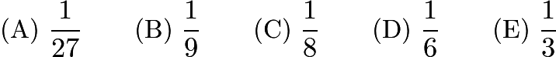

11.Which of the following sets of whole numbers has the largest average?

$\text{(A)}\ \text{multiples of 2 between 1 and 101} \qquad \text{(B)}\ \text{multiples of 3 between 1 and 101}$

$\text{(C)}\ \text{multiples of 4 between 1 and 101} \qquad \text{(D)}\ \text{multiples of 5 between 1 and 101}$

$\text{(E)}\ \text{multiples of 6 between 1 and 101}$

12.One half of the water is poured out of a full container. Then one third of the remainder is poured out. Continue the process: one fourth of the remainder for the third pouring, one fifth of the remainder for the fourth pouring, etc. After how many pourings does exactly one tenth of the original water remain?

$\text{(A)}\ 6 \qquad \text{(B)}\ 7 \qquad \text{(C)}\ 8 \qquad \text{(D)}\ 9 \qquad \text{(E)}\ 10$

1. **B**
2. **C**
3. **B**
4. **E**
5. **E**
6. **B**
7. **C**
8. **D**
9. **C**
10. **B**
11. **D**
12. **D**

**Homework Problems**

**Easy**

1.A "stair-step" figure is made of alternating black and white squares in each row. Rows $1$ through$4$ are shown. All rows begin and end with a white square. The number of black squares in the $37\text{th}$ row is

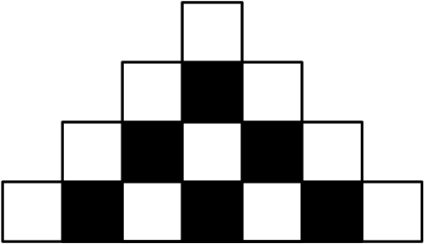

$\text{(A)}\ 34 \qquad \text{(B)}\ 35 \qquad \text{(C)}\ 36 \qquad \text{(D)}\ 37 \qquad \text{(E)}\ 38$

2.Suppose that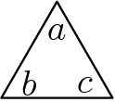means $a+b-c$. For example,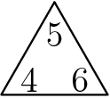is $5+4-6 = 3$. Then the sum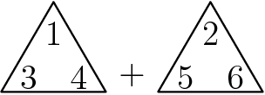is

$\text{(A)}\ -2 \qquad \text{(B)}\ -1 \qquad \text{(C)}\ 0 \qquad \text{(D)}\ 1 \qquad \text{(E)}\ 2$

3.The population of a small town is $480$. The graph indicates the number of females and males in the town, but the vertical scale-values are omitted. How many males live in the town?

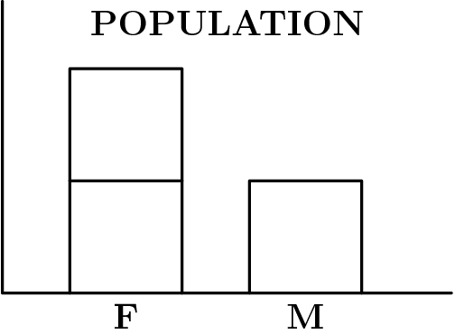

$\text{(A)}\ 120 \qquad \text{(B)}\ 160 \qquad \text{(C)}\ 200 \qquad \text{(D)}\ 240 \qquad \text{(E)}\ 360$

4.If $\text{A}$ and $\text{B}$ are nonzero digits, then the number of digits (not necessarily different) in the sum of the three whole numbers is

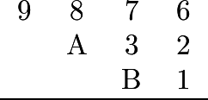

$\text{(A)}\ 4 \qquad \text{(B)}\ 5 \qquad \text{(C)}\ 6 \qquad \text{(D)}\ 9 \qquad \text{(E)}\ \text{depends on the values of A and B}$

5.What is the smallest result that can be obtained from the following process?

* Choose three different numbers from the set $\{3,5,7,11,13,17\}$.
* Add two of these numbers.
* Multiply their sum by the third number.

$\text{(A)}\ 15 \qquad \text{(B)}\ 30 \qquad \text{(C)}\ 36 \qquad \text{(D)}\ 50 \qquad \text{(E)}\ 56$

6.Brent has goldfish that quadruple (become four times as many) every month, and Gretel has goldfish that double every month. If Brent has 4 goldfish at the same time that Gretel has 128 goldfish, then in how many months from that time will they have the same number of goldfish?

$\text{(A)}\ 4 \qquad \text{(B)}\ 5 \qquad \text{(C)}\ 6 \qquad \text{(D)}\ 7 \qquad \text{(E)}\ 8$

7.Jose, Thuy, and Kareem each start with the number 10. Jose subtracts 1 from the number 10, doubles his answer, and then adds 2. Thuy doubles the number 10, subtracts 1 from her answer, and then adds 2. Kareem subtracts 1 from the number 10, adds 2 to his number, and then doubles the result. Who gets the largest final answer?

$\text{(A)}\ \text{Jose} \qquad \text{(B)}\ \text{Thuy} \qquad \text{(C)}\ \text{Kareem} \qquad \text{(D)}\ \text{Jose and Thuy} \qquad \text{(E)}\ \text{Thuy and Kareem}$

8.The 64 whole numbers from 1 through 64 are written, one per square, on a checkerboard (an 8 by 8 array of 64 squares). The first 8 numbers are written in order across the first row, the next 8 across the second row, and so on. After all 64 numbers are written, the sum of the numbers in the four corners will be

$\text{(A)}\ 130 \qquad \text{(B)}\ 131 \qquad \text{(C)}\ 132 \qquad \text{(D)}\ 133 \qquad \text{(E)}\ 134$

**Medium**

9.A piece of paper containing six joined squares labeled as shown in the diagram is folded along the edges of the squares to form a cube. The label of the face opposite the face labeled $\text{X}$ is

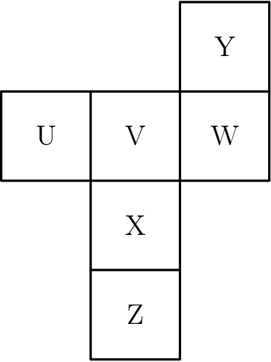

$\text{(A)}\ \text{Z} \qquad \text{(B)}\ \text{U} \qquad \text{(C)}\ \text{V} \qquad \text{(D)}\ \ \text{W} \qquad \text{(E)}\ \text{Y}$

10.In the fall of 1996, a total of 800 students participated in an annual school clean-up day. The organizers of the event expect that in each of the years 1997, 1998, and 1999, participation will increase by 50% over the previous year. The number of participants the organizers will expect in the fall of 1999 is

$\text{(A)}\ 1200 \qquad \text{(B)}\ 1500 \qquad \text{(C)}\ 2000 \qquad \text{(D)}\ 2400 \qquad \text{(E)}\ 2700$

11.When placing each of the digits $2,4,5,6,9$ in exactly one of the boxes of this subtraction problem, what is the smallest difference that is possible?

$\text{(A)}\ 58 \qquad \text{(B)}\ 123 \qquad \text{(C)}\ 149 \qquad \text{(D)}\ 171 \qquad \text{(E)}\ 176$

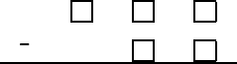

12.A rectangular grazing area is to be fenced off on three sides using part of a $100$ meter rock wall as the fourth side. Fence posts are to be placed every $12$ meters along the fence including the two posts where the fence meets the rock wall. What is the fewest number of posts required to fence an area $36$ m by $60$ m?

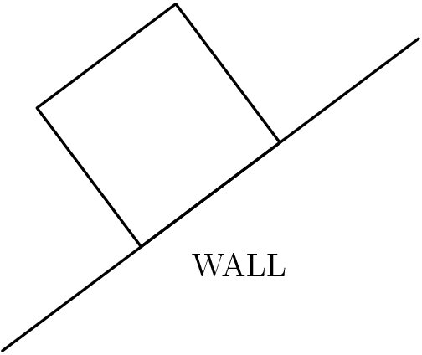

$\text{(A)}\ 11 \qquad \text{(B)}\ 12 \qquad \text{(C)}\ 13 \qquad \text{(D)}\ 14 \qquad \text{(E)}\ 16$

13.At the beginning of a trip, the mileage odometer read $56,200$ miles. The driver filled the gas tank with $6$ gallons of gasoline. During the trip, the driver filled his tank again with $12$ gallons of gasoline when the odometer read $56,560$. At the end of the trip, the driver filled his tank again with $20$ gallons of gasoline. The odometer read $57,060$. To the nearest tenth, what was the car's average miles-per-gallon for the entire trip?

$\text{(A)}\ 22.5 \qquad \text{(B)}\ 22.6 \qquad \text{(C)}\ 24.0 \qquad \text{(D)}\ 26.9 \qquad \text{(E)}\ 27.5$

14.The table below displays the grade distribution of the $30$ students in a mathematics class on the last two tests. For example, exactly one student received a 'D' on Test 1 and a 'C' on Test 2 (see circled entry). What percent of the students received the same grade on both tests?

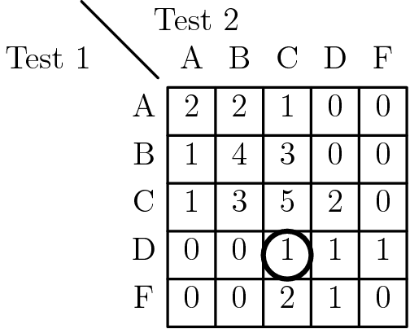



15.A bar graph shows the number of hamburgers sold by a fast food chain each season. However, the bar indicating the number sold during the winter is covered by a smudge. If exactly $25\%$ of the chain's hamburgers are sold in the fall, how many million hamburgers are sold in the winter?

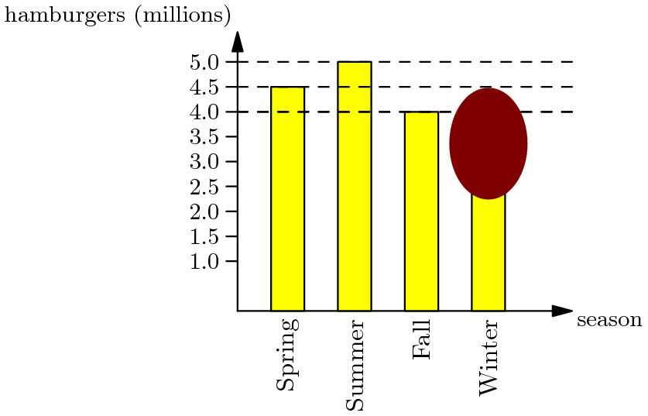

$\text{(A)}\ 2.5 \qquad \text{(B)}\ 3 \qquad \text{(C)}\ 3.5 \qquad \text{(D)}\ 4 \qquad \text{(E)}\ 4.5$

**Hard**

16.Three members of the Euclid Middle School girls' softball team had the following conversation.

Ashley: I just realized that our uniform numbers are all 2-digit primes.

Bethany: And the sum of your two uniform numbers is the date of my birthday earlier this month.

Caitlin: That's funny. The sum of your two uniform numbers is the date of my birthday later this month.

Ashley: And the sum of your two uniform numbers is today's date.

What number does Caitlin wear?

$\textbf{(A) }11\qquad\textbf{(B) }13\qquad\textbf{(C) }17\qquad\textbf{(D) }19\qquad\textbf{(E) }23$

17.Suppose one of the eight lettered identical squares is included with the four squares in the T-shaped figure outlined. How many of the resulting figures can be folded into a topless cubical box?

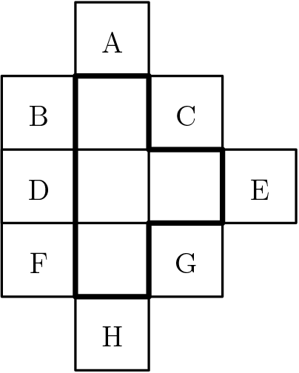

$\text{(A)}\ 2 \qquad \text{(B)}\ 3 \qquad \text{(C)}\ 4 \qquad \text{(D)}\ 5 \qquad \text{(E)}\ 6$

18.King Middle School has $1200$ students. Each student takes $5$ classes a day. Each teacher teaches $4$ classes. Each class has $30$ students and $1$ teacher. How many teachers are there at King Middle School?

$\text{(A)}\ 30 \qquad \text{(B)}\ 32 \qquad \text{(C)}\ 40 \qquad \text{(D)}\ 45 \qquad \text{(E)}\ 50$

19.Northside's Drum and Bugle Corps raised money for a trip. The drummers and bugle players kept separate sales records. According to the double bar graph, in what month did one group's sales exceed the other's by the greatest percent?

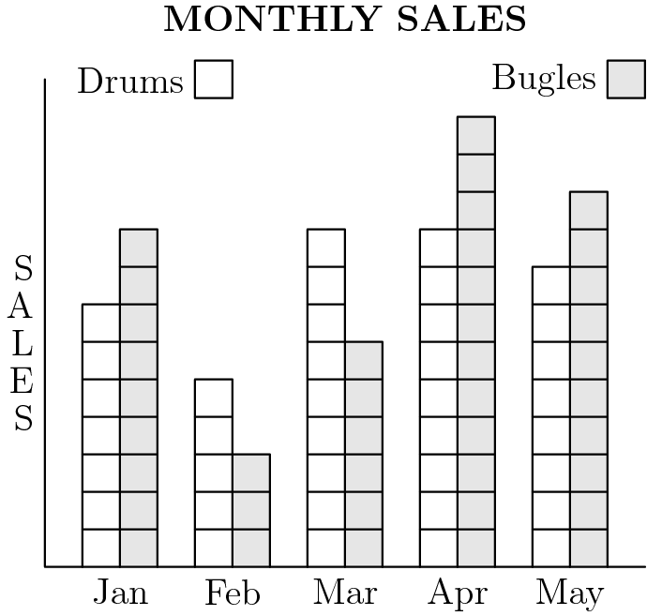

$\text{(A)}\ \text{Jan} \qquad \text{(B)}\ \text{Feb} \qquad \text{(C)}\ \text{Mar} \qquad \text{(D)}\ \text{Apr} \qquad \text{(E)}\ \text{May}$

20.Suppose there is a special key on a calculator that replaces the number $x$ currently displayed with the number given by the formula $1/(1-x)$. For example, if the calculator is displaying 2 and the special key is pressed, then the calculator will display -1 since $1/(1-2)=-1$. Now suppose that the calculator is displaying 5. After the special key is pressed 100 times in a row, the calculator will display

$\text{(A)}\ -0.25 \qquad \text{(B)}\ 0 \qquad \text{(C)}\ 0.8 \qquad \text{(D)}\ 1.25 \qquad \text{(E)}\ 5$

21.Five cards are lying on a table as shown.

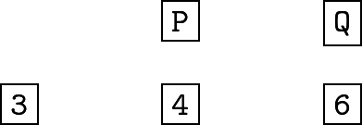

Each card has a letter on one side and a whole number on the other side. Jane said, "If a vowel is on one side of any card, then an even number is on the other side." Mary showed Jane was wrong by turning over one card. Which card did Mary turn over?

$\text{(A)}\ 3 \qquad \text{(B)}\ 4 \qquad \text{(C)}\ 6 \qquad \text{(D)}\ \text{P} \qquad \text{(E)}\ \text{Q}$

22.Pat Peano has plenty of 0's, 1's, 3's, 4's, 5's, 6's, 7's, 8's and 9's, but he has only twenty-two 2's. How far can he number the pages of his scrapbook with these digits?

$\text{(A)}\ 22 \qquad \text{(B)}\ 99 \qquad \text{(C)}\ 112 \qquad \text{(D)}\ 119 \qquad \text{(E)}\ 199$

23.The pie charts below indicate the percent of students who prefer golf, bowling, or tennis at East Junior High School and West Middle School. The total number of students at East is 2000 and at West, 2500. In the two schools combined, the percent of students who prefer tennis is

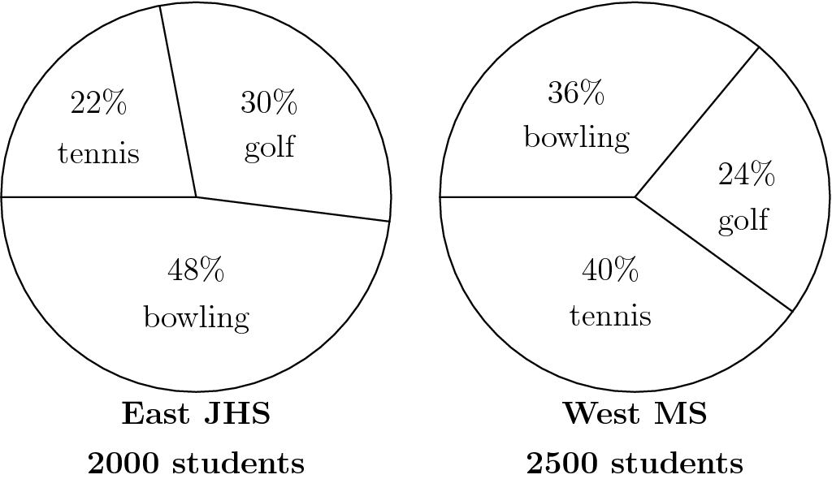

$\text{(A)}\ 30\% \qquad \text{(B)}\ 31\% \qquad \text{(C)}\ 32\% \qquad \text{(D)}\ 33\% \qquad \text{(E)}\ 34\%$

24.Ana's monthly salary was $2000 in May. In June she received a 20% raise. In July she received a 20% pay cut. After the two changes in June and July, Ana's monthly salary was

$\text{(A)}\ 1920\text{ dollars} \qquad \text{(B)}\ 1980\text{ dollars} \qquad \text{(C)}\ 2000\text{ dollars} \qquad \text{(D)}\ 2020\text{ dollars} \qquad \text{(E)}\ 2040\text{ dollars}$

1. **C**
2. **D**
3. **B**
4. **B**
5. **C**
6. **B**
7. **C**
8. **A**
9. **E**
10. **E**
11. **C**
12. **B**
13. **D**
14. **D**
15. **A**
16. **A**
17. **E**
18. **E**
19. **B**
20. **A**
21. **A**
22. **D**
23. **C**
24. **A**