**In Class Problems**

**Class 1**

**Easy**

1.How many square yards of carpet are required to cover a rectangular floor that is $12$ feet long and $9$ feet wide? (There are $3$ feet in a yard.)

$\textbf{(A) }12\qquad\textbf{(B) }36\qquad\textbf{(C) }108\qquad\textbf{(D) }324\qquad \textbf{(E) }972$

2.Extend the square pattern of 8 black and 17 white square tiles by attaching a border of black tiles around the square. What is the ratio of black tiles to white tiles in the extended pattern?

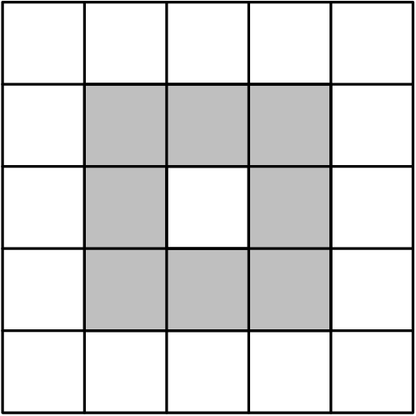$\textbf{(A) }8:17 \qquad\textbf{(B) }25:49 \qquad\textbf{(C) }36:25 \qquad\textbf{(D) }32:17 \qquad\textbf{(E) }36:17$

3.Point $O$ is the center of the regular octagon $ABCDEFGH$, and $X$ is the midpoint of the side$\overline{AB}.$ What fraction of the area of the octagon is shaded?

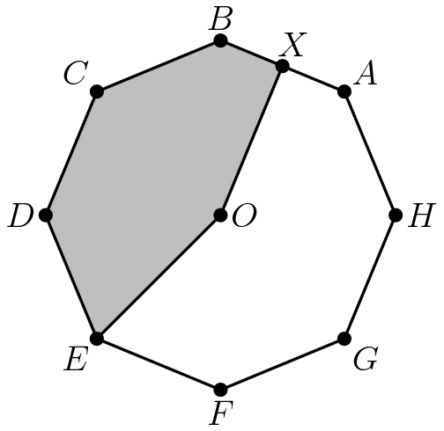

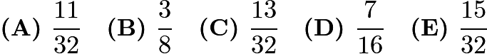

4.A rectangular photograph is placed in a frame that forms a border two inches wide on all sides of the photograph. The photograph measures 8 inches high and 10 inches wide. What is the area of the border, in square inches?

$\textbf{(A)}\hspace{.05in}36\qquad\textbf{(B)}\hspace{.05in}40\qquad\textbf{(C)}\hspace{.05in}64\qquad\textbf{(D)}\hspace{.05in}72\qquad\textbf{(E)}\hspace{.05in}88$

5.In $\bigtriangleup ABC$, $AB=BC=29$, and $AC=42$. What is the area of $\bigtriangleup ABC$?

$\textbf{(A) }100\qquad\textbf{(B) }420\qquad\textbf{(C) }500\qquad\textbf{(D) }609\qquad \textbf{(E) }701$

6.Six rectangles each with a common base width of 2 have lengths of 1, 4, 9, 16, 25, and 36. What is the sum of the areas of the six rectangles?

$\textbf{(A) }91\qquad\textbf{(B) }93\qquad\textbf{(C) }162\qquad\textbf{(D) }182\qquad\textbf{(E) }202$

**Medium**

7.How many pairs of parallel edges, such as $\overline{AB}$ and $\overline{GH}$ or $\overline{EH}$ and $\overline{FG}$, does a cube have?

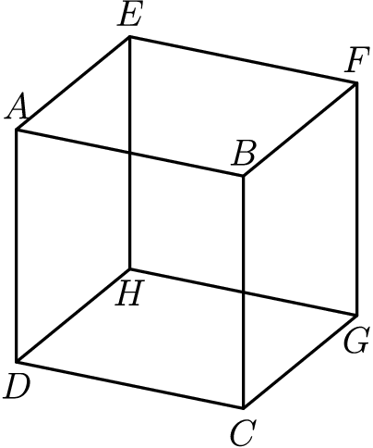$\textbf{(A) }6 \quad\textbf{(B) }12 \quad\textbf{(C) } 18 \quad\textbf{(D) } 24 \quad \textbf{(E) } 36$

8.Two congruent squares, $ABCD$ and $PQRS$, have side length $15$. They overlap to form the $15$ by $25$ rectangle $AQRD$ shown. What percent of the area of rectangle

$AQRD$ is shaded?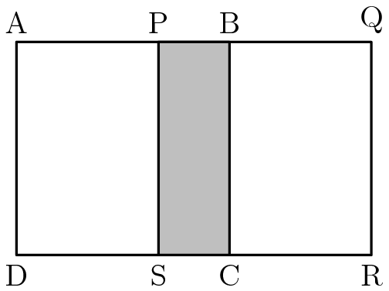

$\textbf{(A)}\ 15\qquad\textbf{(B)}\ 18\qquad\textbf{(C)}\ 20\qquad\textbf{(D)}\ 24\qquad\textbf{(E)}\ 25$

9.Rectangle ABCD and right triangle DCE have the same area. They are joined to form a trapezoid, as shown. What is DE?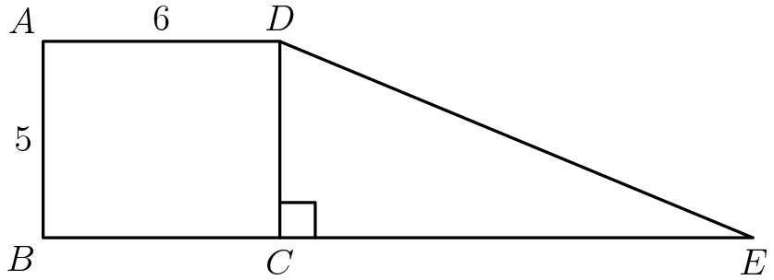

$\textbf{(A) }12\qquad\textbf{(B) }13\qquad\textbf{(C) }14\qquad\textbf{(D) }15\qquad\textbf{(E) }16$

**Hard**

10.A cube with 3-inch edges is to be constructed from 27 smaller cubes with 1-inch edges. Twenty-one of the cubes are colored red and 6 are colored white. If the 3-inch cube is constructed to have the smallest possible white surface area showing, what fraction of the surface area is white?



11.In the given figure hexagon $ABCDEF$ is equiangular, $ABJI$ and $FEHG$ are squares with areas $18$ and $32$ respectively, $\triangle JBK$ is equilateral and $FE=BC$. What is the area of $\triangle KBC$?

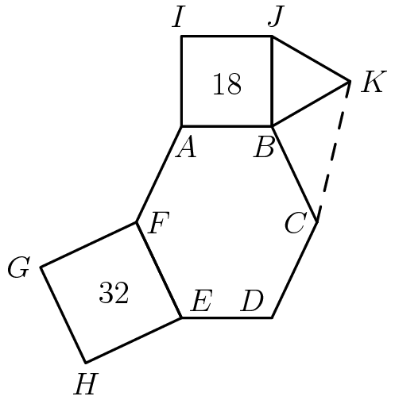

$\textbf{(A) }6\sqrt{2}\qquad\textbf{(B) }9\qquad\textbf{(C) }12\qquad\textbf{(D) }9\sqrt{2}\qquad\textbf{(E) }32$

12.Rectangle ABCD has sides CD=3 and DA=5. A circle of radius 1 is centered at A, a circle of radius 2 is centered at B, and a circle of radius 3 is centered at C. Which of the following is closest to the area of the region inside the rectangle but outside all three circles?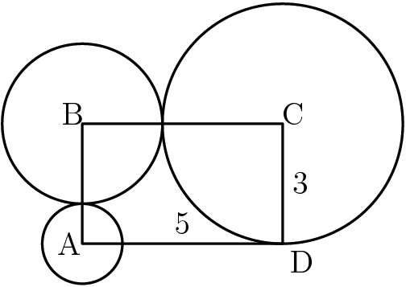$\textbf{(A) }3.5\qquad\textbf{(B) }4.0\qquad\textbf{(C) }4.5\qquad\textbf{(D) }5.0\qquad\textbf{(E) }5.5$

13.A straight one-mile stretch of highway, 40 feet wide, is closed. Robert rides his bike on a path composed of semicircles as shown. If he rides at 5 miles per hour, how many hours will it take to cover the one-mile stretch?

Note: 1 mile= 5280 feet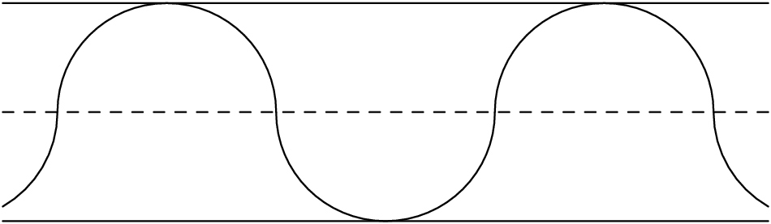



1. **A**
2. **D**
3. **D**
4. **E**
5. **B**
6. **D**
7. **C**
8. **C**
9. **B**
10. **A**
11. **C**
12. **B**
13. **B**

**Class 2**

**Easy**

1.The length of a rectangle is increased by 10% and the width is decreased by 10%. What percent of the old area is the new area?

$\textbf{(A)}\ 90\qquad\textbf{(B)}\ 99\qquad\textbf{(C)}\ 100\qquad\textbf{(D)}\ 101\qquad\textbf{(E)}\ 110$

2.Construct a square on one side of an equilateral triangle. One on non-adjacent side of the square, construct a regular pentagon, as shown. On a non-adjacent side of the pentagon, construct a hexagon. Continue to construct regular polygons in the same way, until you construct an octagon. How many sides does the resulting polygon have?

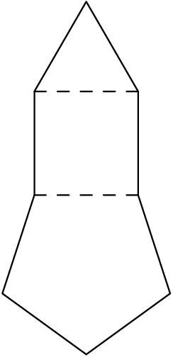

$\textbf{(A)} \ 21\qquad\textbf{(B)}\ 23\qquad\textbf{(C)}\ 25\qquad\textbf{(D)}\ 27\qquad\textbf{(E)}\ 29$

3.In trapezoid $ABCD$, $AD$ is perpendicular to $DC$, $AD$ = $AB$ = $3$, and $DC$ = $6$. In addition, $E$is on $DC$, and $BE$ is parallel to $AD$. Find the area of $\triangle BEC$.

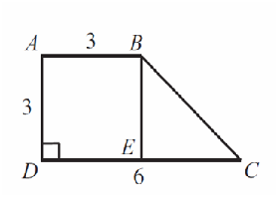

$\text{(A)}\ 3 \qquad \text{(B)}\ 4.5 \qquad \text{(C)}\ 6 \qquad \text{(D)}\ 9 \qquad \text{(E)}\ 18$

4.Six trees are equally spaced along one side of a straight road. The distance from the first tree to the fourth is 60 feet. What is the distance in feet between the first and last trees?

$\text{(A)}\ 90 \qquad \text{(B)}\ 100 \qquad \text{(C)}\ 105 \qquad \text{(D)}\ 120 \qquad \text{(E)}\ 140$

5.Figure $ABCD$ is a square. Inside this square three smaller squares are drawn with the side lengths as labeled. The area of the shaded L-shaped region is

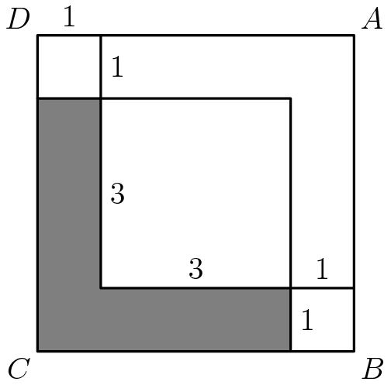

$\text{(A)}\ 7 \qquad \text{(B)}\ 10 \qquad \text{(C)}\ 12.5 \qquad \text{(D)}\ 14 \qquad \text{(E)}\ 15$

**Medium**

6.The top of one tree is $16$ feet higher than the top of another tree. The heights of the two trees are in the ratio $3:4$. In feet, how tall is the taller tree?

$\textbf{(A)}\ 48 \qquad\textbf{(B)}\ 64 \qquad\textbf{(C)}\ 80 \qquad\textbf{(D)}\ 96\qquad\textbf{(E)}\ 112$

7.The lengths of the sides of a triangle in inches are three consecutive integers. The length of the shortest side is $30\%$ of the perimeter. What is the length of the longest side?

$\textbf{(A)}\ 7 \qquad\textbf{(B)}\ 8\qquad\textbf{(C)}\ 9\qquad\textbf{(D)}\ 10\qquad\textbf{(E)}\ 11$

8.A square and a circle have the same area. What is the ratio of the side length of the square to the radius of the circle?



9.A decorative window is made up of a rectangle with semicircles on either end. The ratio of $AD$to $AB$ is $3:2$, and $AB$ is 30 inches. What is the ratio of the area of the rectangle to the combined areas of the semicircles?

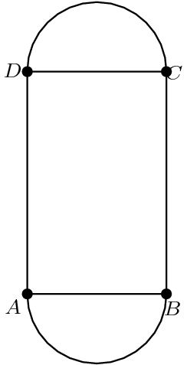

$\textbf{(A)}\ 2:3 \qquad\textbf{(B)}\ 3:2\qquad\textbf{(C)}\ 6:\pi \qquad\textbf{(D)}\ 9: \pi \qquad\textbf{(E)}\ 30 : \pi$

**Hard**

10.One-inch squares are cut from the corners of this $5$ inch square. What is the area in square inches of the largest square that can be fitted into the remaining space?

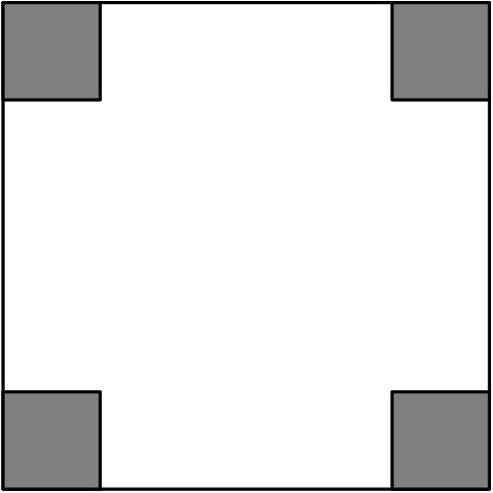



11.Quadrilateral $ABCD$ is a trapezoid, $AD = 15$, $AB = 50$, $BC = 20$, and the altitude is $12$. What is the area of the trapezoid?

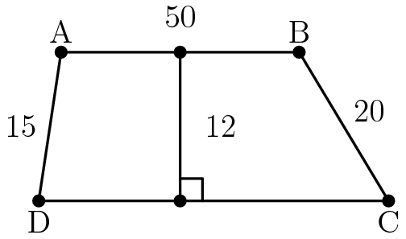

$\textbf{(A) }600\qquad\textbf{(B) }650\qquad\textbf{(C) }700\qquad\textbf{(D) }750\qquad\textbf{(E) }800$

12.A triangle with vertices as $A=(1,3)$, $B=(5,1)$, and $C=(4,4)$ is plotted on a $6\times5$ grid. What fraction of the grid is covered by the triangle?

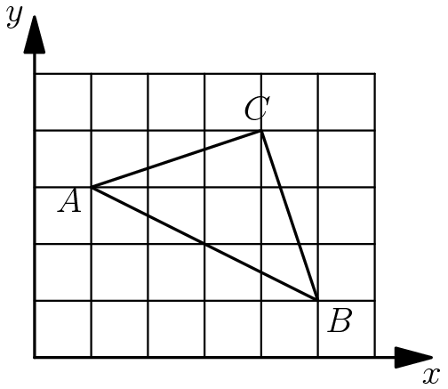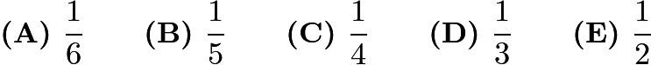

1. **B**
2. **B**
3. **B**
4. **B**
5. **A**
6. **B**
7. **E**
8. **B**
9. **C**
10. **C**
11. **D**
12. **A**

**Homework Problems**

**Easy**

1.How many triangles are in this figure? (Some triangles may overlap other triangles.)

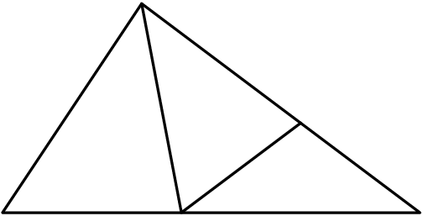

$\text{(A)}\ 9 \qquad \text{(B)}\ 8 \qquad \text{(C)}\ 7 \qquad \text{(D)}\ 6 \qquad \text{(E)}\ 5$

2.A circle of diameter $1$ is removed from a $2\times 3$ rectangle, as shown. Which whole number is closest to the area of the shaded region?

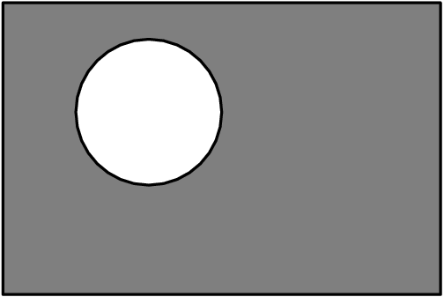

$\text{(A)}\ 1 \qquad \text{(B)}\ 2 \qquad \text{(C)}\ 3 \qquad \text{(D)}\ 4 \qquad \text{(E)}\ 5$

3.The area in square units of the region enclosed by parallelogram $ABCD$ is

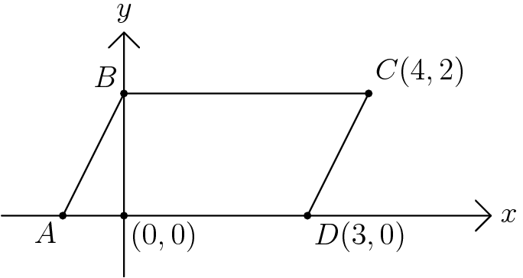

$\text{(A)}\ 6 \qquad \text{(B)}\ 8 \qquad \text{(C)}\ 12 \qquad \text{(D)}\ 15 \qquad \text{(E)}\ 18$

4. Dots are spaced one unit apart, horizontally and vertically. The number of square units enclosed by the polygon is

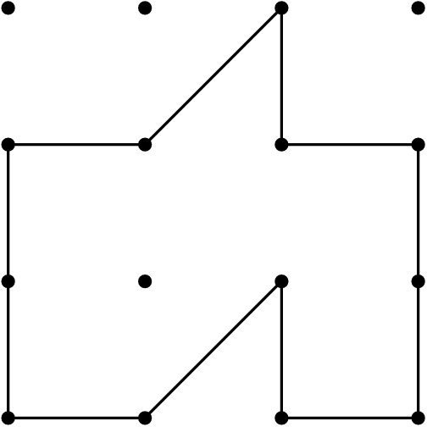

$\text{(A)}\ 5 \qquad \text{(B)}\ 6 \qquad \text{(C)}\ 7 \qquad \text{(D)}\ 8 \qquad \text{(E)}\ 9$

5.An isosceles right triangle with legs of length $8$ is partitioned into $16$ congruent triangles as shown. The shaded area is

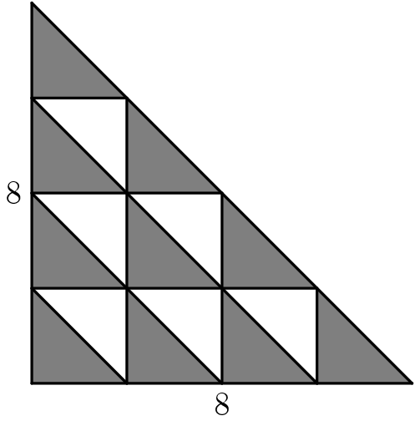

$\text{(A)}\ 10 \qquad \text{(B)}\ 20 \qquad \text{(C)}\ 32 \qquad \text{(D)}\ 40 \qquad \text{(E)}\ 64$

6.What fraction of the square is shaded?

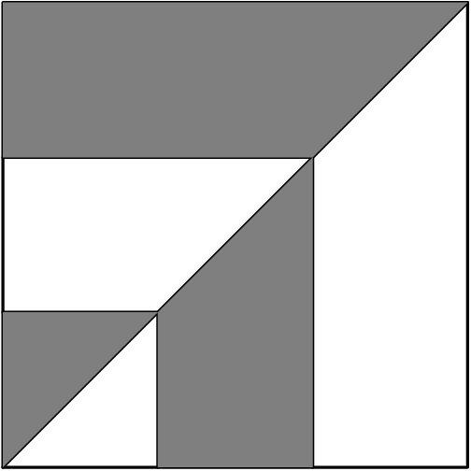

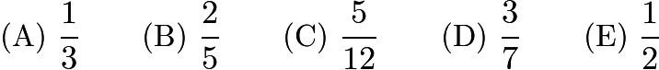

7.What is the number of degrees in the smaller angle between the hour hand and the minute hand on a clock that reads seven o'clock?

$\text{(A)}\ 50^\circ \qquad \text{(B)}\ 120^\circ \qquad \text{(C)}\ 135^\circ \qquad \text{(D)}\ 150^\circ \qquad \text{(E)}\ 165^\circ$

8.The numbers on the faces of this cube are consecutive whole numbers. The sums of the two numbers on each of the three pairs of opposite faces are equal. The sum of the six numbers on this cube is

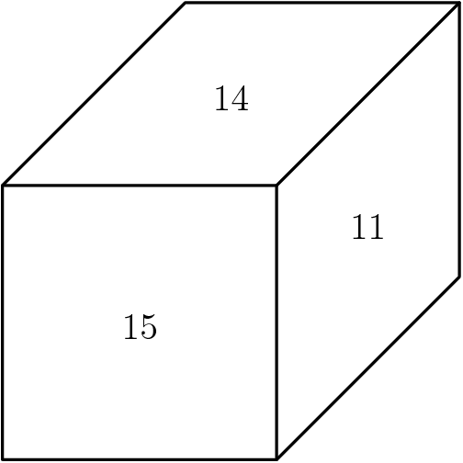

$\text{(A)}\ 75 \qquad \text{(B)}\ 76 \qquad \text{(C)}\ 78 \qquad \text{(D)}\ 80 \qquad \text{(E)}\ 81$

9.The sides of a triangle have lengths $6.5$, $10$, and $s$, where $s$ is a whole number. What is the smallest possible value of $s$?

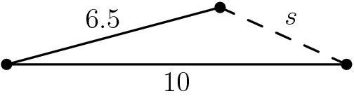

$\text{(A)}\ 3 \qquad \text{(B)}\ 4 \qquad \text{(C)}\ 5 \qquad \text{(D)}\ 6 \qquad \text{(E)}\ 7$

10.If $\angle A = 60^\circ$, $\angle E = 40^\circ$ and $\angle C = 30^\circ$, then $\angle BDC =$

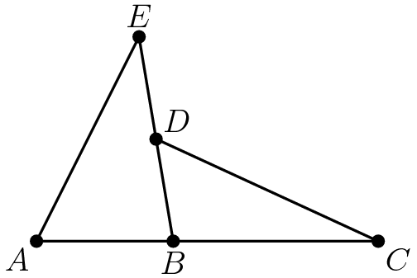

$\text{(A)}\ 40^\circ \qquad \text{(B)}\ 50^\circ \qquad \text{(C)}\ 60^\circ \qquad \text{(D)}\ 70^\circ \qquad \text{(E)}\ 80^\circ$

**Medium**

11.What is the ratio of the area of the shaded square to the area of the large square? (The figure is drawn to scale)

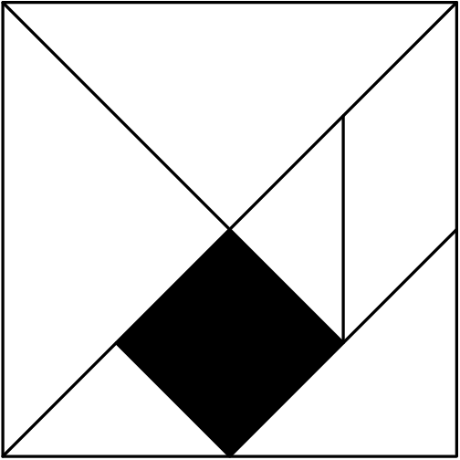

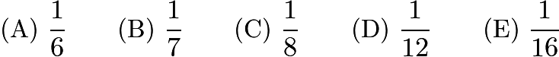

12.The perimeter of one square is $3$ times the perimeter of another square. The area of the larger square is how many times the area of the smaller square?

$\text{(A)}\ 2 \qquad \text{(B)}\ 3 \qquad \text{(C)}\ 4 \qquad \text{(D)}\ 6 \qquad \text{(E)}\ 9$

13.The area of the shaded region $\text{BEDC}$ in parallelogram $\text{ABCD}$ is

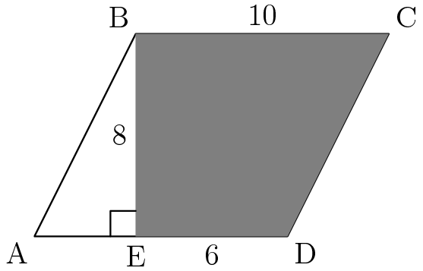

$\text{(A)}\ 24 \qquad \text{(B)}\ 48 \qquad \text{(C)}\ 60 \qquad \text{(D)}\ 64 \qquad \text{(E)}\ 80$

14.The distance between the $5^\text{th}$ and $26^\text{th}$ exits on an interstate highway is $118$ miles. If any two exits are at least $5$ miles apart, then what is the largest number of miles there can be between two consecutive exits that are between the $5^\text{th}$ and $26^\text{th}$ exits?

$\text{(A)}\ 8 \qquad \text{(B)}\ 13 \qquad \text{(C)}\ 18 \qquad \text{(D)}\ 47 \qquad \text{(E)}\ 98$

**Hard**

15.Let $PQRS$ be a square piece of paper. $P$ is folded onto $R$ and then $Q$ is folded onto $S$. The area of the resulting figure is 9 square inches. Find the perimeter of square $PQRS$.

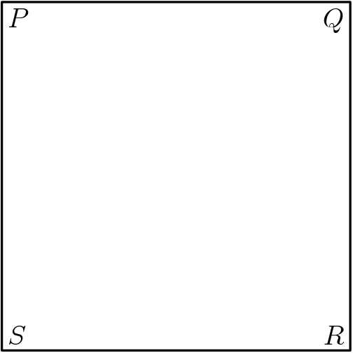

$\text{(A)}\ 9 \qquad \text{(B)}\ 16 \qquad \text{(C)}\ 18 \qquad \text{(D)}\ 24 \qquad \text{(E)}\ 36$

16.An artist has $14$ cubes, each with an edge of $1$ meter. She stands them on the ground to form a sculpture as shown. She then paints the exposed surface of the sculpture. How many square meters does she paint?

$\text{(A)}\ 21 \qquad \text{(B)}\ 24 \qquad \text{(C)}\ 33 \qquad \text{(D)}\ 37 \qquad \text{(E)}\ 42$

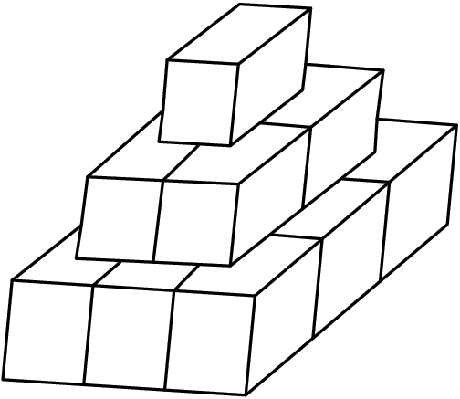

17.Each corner of a rectangular prism is cut off. Two (of the eight) cuts are shown. How many edges does the new figure have?

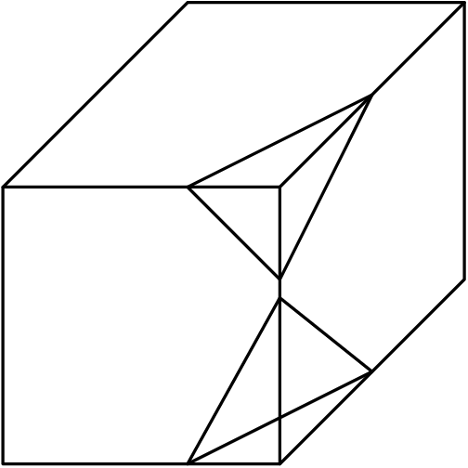

$\text{(A)}\ 24 \qquad \text{(B)}\ 30 \qquad \text{(C)}\ 36 \qquad \text{(D)}\ 42 \qquad \text{(E)}\ 48$

*Assume that the planes cutting the prism do not intersect anywhere in or on the prism.*

18.A cube of edge $3$ cm is cut into $N$ smaller cubes, not all the same size. If the edge of each of the smaller cubes is a whole number of centimeters, then $N=$

$\text{(A)}\ 4 \qquad \text{(B)}\ 8 \qquad \text{(C)}\ 12 \qquad \text{(D)}\ 16 \qquad \text{(E)}\ 20$

19.An equilateral triangle is originally painted black. Each time the triangle is changed, the middle fourth of each black triangle turns white. After five changes, what fractional part of the original area of the black triangle remains black?

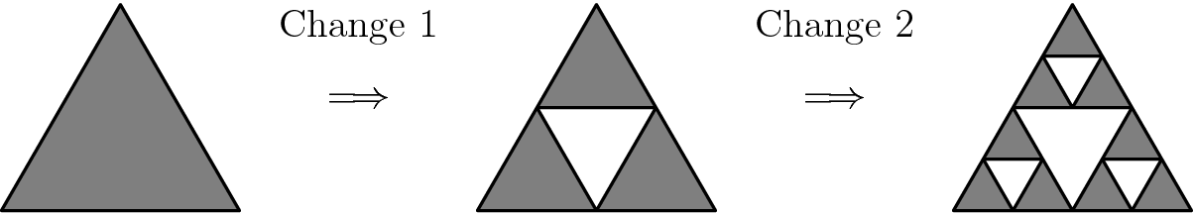



20.Four circles of radius $3$ are arranged as shown. Their centers are the vertices of a square. The area of the shaded region is closest to

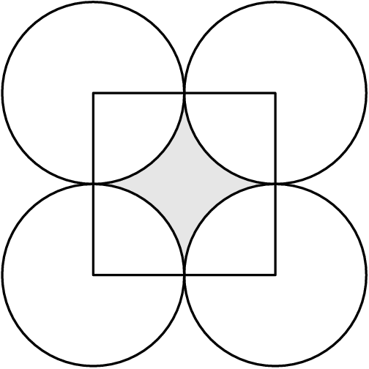

$\text{(A)}\ 7.7 \qquad \text{(B)}\ 12.1 \qquad \text{(C)}\ 17.2 \qquad \text{(D)}\ 18 \qquad \text{(E)}\ 27$

21.One half of the water is poured out of a full container. Then one third of the remainder is poured out. Continue the process: one fourth of the remainder for the third pouring, one fifth of the remainder for the fourth pouring, etc. After how many pourings does exactly one tenth of the original water remain?

$\text{(A)}\ 6 \qquad \text{(B)}\ 7 \qquad \text{(C)}\ 8 \qquad \text{(D)}\ 9 \qquad \text{(E)}\ 10$

22.Around the outside of a $4$ by $4$ square, construct four semicircles (as shown in the figure) with the four sides of the square as their diameters. Another square, $ABCD$, has its sides parallel to the corresponding sides of the original square, and each side of $ABCD$ is tangent to one of the semicircles. The area of the square $ABCD$ is

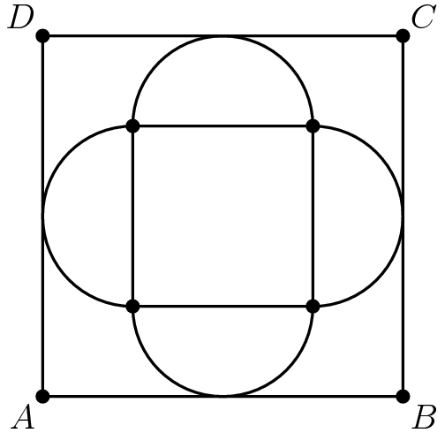

$\text{(A)}\ 16 \qquad \text{(B)}\ 32 \qquad \text{(C)}\ 36 \qquad \text{(D)}\ 48 \qquad \text{(E)}\ 64$

23.A $4\times 4\times 4$ cubical box contains 64 identical small cubes that exactly fill the box. How many of these small cubes touch a side or the bottom of the box?

$\text{(A)}\ 48 \qquad \text{(B)}\ 52 \qquad \text{(C)}\ 60 \qquad \text{(D)}\ 64 \qquad \text{(E)}\ 80$

24.If the pattern in the diagram continues, what fraction of the interior would be shaded in the eighth triangle?

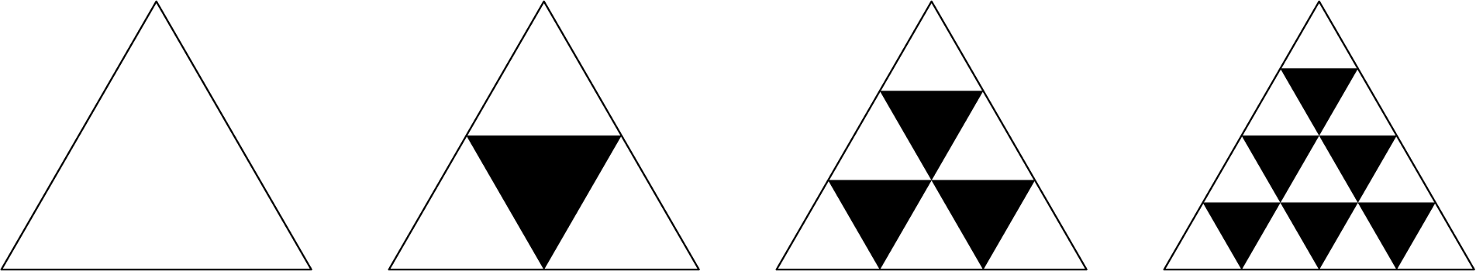

1. **E**
2. **E**
3. **B**
4. **B**
5. **B**
6. **E**
7. **D**
8. **E**
9. **B**
10. **B**
11. **C**
12. **E**
13. **D**
14. **C**
15. **D**
16. **C**
17. **C**
18. **E**
19. **C**
20. **B**
21. **D**
22. **E**
23. **B**
24. **C**