# Lab 2.03 – triangle program

## In your notebook

### Follow the flow of execution in the following programs and predict what will happen for each one

### Example 1

1. Follow the flow of execution in the following programs and predict what will happen for each one:

### Example 2

a = input("What... is your quest")  
 b = "to seek the holy grail"  
 if a != b:  
 print("Go On. Off you go")  
 else:  
 b = input("What...is the air-speed velocity of an unladen swallow?")  
 if b == "What do you mean? An African or European swallow?":  
 print("I don't know that...AHHH [Bridgekeeper was thrown over bridge]")  
 else:  
 print("[you were thrown over bridge]")

### Example 3

user_input = input("What is your favorite color"):  
 if user_input == 'blue':  
 print("Blueskadoo")  
 elif user_input == "red":  
 print("Roses are red!")  
 elif user_input == "yellow":  
 print("Mellow Yellow")  
 elif user_input == "green":  
 print("Green Machine")  
 elif user_input == "orange":  
 print("Orange you glad I didn't say banana.")  
 elif user_input == "black":  
 print("I see a red door and I want it painted black")  
 elif user_input == "purple":  
 print("And we'll never be royalllssss")  
 elif user_input == "pink":  
 print("Pinky- and the Brain")  
 else:  
 print("I don't recognize that color. Is it even...??")

## In your Console, translate this Snap! program into a Python program

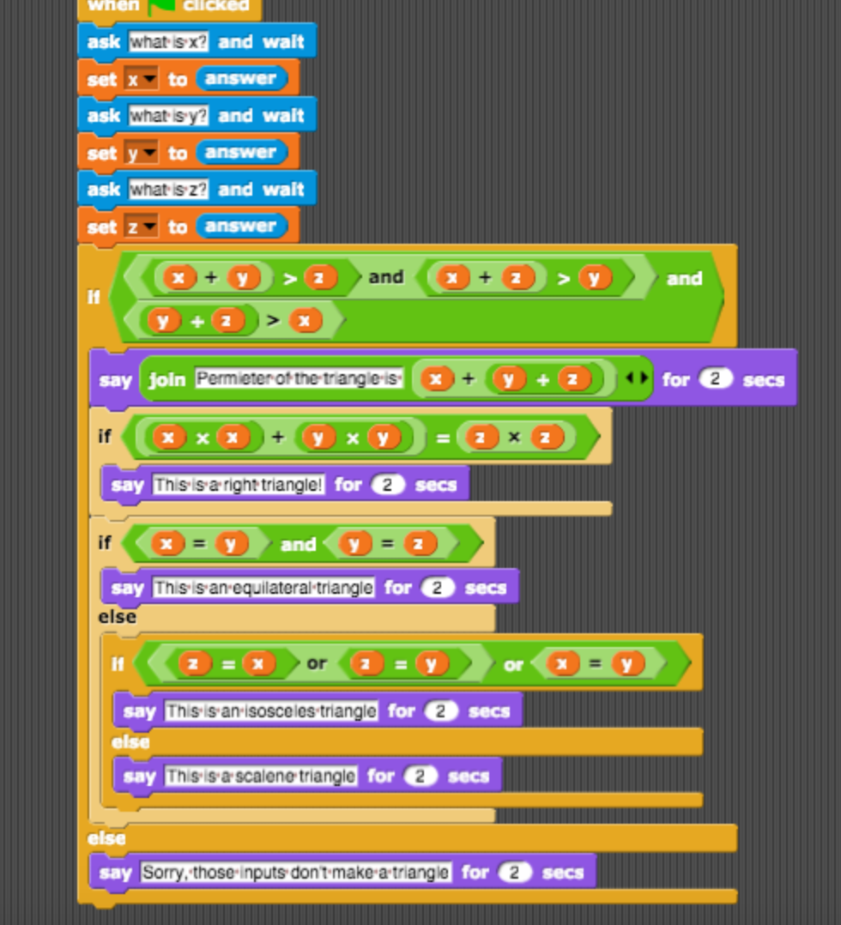

### Create a triangle program

* The program will ask for the lengths of all three sides of a triangle.
* The program will find the perimeter.
* The program will display what kind of triangle it is or if it is a triangle

## Bonus

Research lists in Python. Re-implement problem 2 using lists.