# Lab 3.03 - War (Card Game)

Create a program that lets a user play a **simplified** version of the card game [‘War’](http://www.pagat.com/war/war.html). In this version, the users will share a single deck of cards and cards will not be added back to the deck after they have been played.

## Video Explanation of the Card Game War

[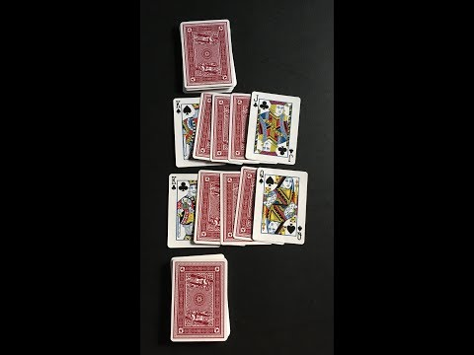](https://youtu.be/yX-jOVer758)

### Your game should

* start with a given shuffled deck variable (shuffle function comes from python’s random library, more details below)
* ask for player1 and player2’s names.
* have a function player_turn, with the contract shown below:

# Name: player_turn  
 # Purpose: takes in a player name,  
 # draws/removes a card from the deck,  
 # prints "user drew card x", and returns the value  
 # Arguments: player_name as string, deck as list  
 # Returns: integer

* Have a function compare_scores that takes in the two integers representing the cards drawn and compares the card values. Make sure to write the contract for compare_scores!
* For simplicity Jacks will be represented as 11, Queens will be represented as 12, Kings will be represented as 13, and Aces will be represented as 14
* For simplicity the suit does not matter
* Include a while loop that keeps the game running until there are no cards in the deck.
* If there is a tie, there is “war”. Take the next two cards an whoever wins that gets all four cards (including the previous tied cards).
* If there is another tie, continue taking the next two cards until there a winner.
* The winner takes all the “war” cards.
* Keep track of the score.
* The player who takes the greatest number of cards wins.
* Declare the name of the winner and final score at the end of the game.

## Sample Output

Player 1’s name: Pat  
Player 2’s name: Sam

Pat drew card 8  
Sam drew card 9  
Sam has high card  
Pat: 0  
Sam: 2

Pat drew card 9  
Sam drew card 8  
Pat has high card  
Pat: 2  
Sam: 2

Pat drew card 7  
Sam drew card 7  
War  
Pat: 2  
Sam: 2

Pat drew card 5  
Sam drew card 6  
Sam has high card  
Sam wins war of 4 cards  
Pat: 2  
Sam: 6

…

Pat drew card 10  
Sam drew card 13  
Sam has high card  
Pat: 18  
Sam: 24

Pat drew card 2  
Sam drew card 2  
War  
Pat: 18  
Sam: 24

Pat drew card 14  
Sam drew card 14  
War  
Pat: 18  
Sam: 24

Pat drew card 2  
Sam drew card 5  
Sam has high card  
Sam wins war of 6 cards  
Pat: 18  
Sam: 30

Pat drew card 11  
Sam drew card 14  
Sam has high card  
Pat: 18  
Sam: 32

Pat drew card 10  
Sam drew card 3  
Pat has high card  
Pat: 20  
Sam: 32

Final Score  
Pat: 20  
Sam: 32  
Winner: Sam

### Deck Shuffling

While seemingly simple, shuffling a deck is a somewhat complicated problem. Luckily, Python’s random library has a built-in shuffle algorithm. Feel free to read the documentation, but we have provided a simple wrapper function that will return to you a shuffled deck of cards.

import random  
  
 # Name: shuffled_deck  
 # Purpose: will return a shuffled deck to the user  
 # Input:  
 # Returns: a list representing a shuffled deck  
 def shuffled_deck():  
 basic_deck = list(range(2, 15)) * 4  
 random.shuffle(basic_deck)  
 return basic_deck

### Bonus

Instead of closing the program when the deck is empty, create a way for the user to play again.