**COMP-3300 Operating Systems Fundamentals**

**Assignment 4**

**Andrea Bonato**

**104760390**

**Acknowledgement**

“I confirm that I will keep the content of this assignment confidential. I confirm that I have not received any unauthorized assistance in preparing for or writing this assignment. I acknowledge that a mark of 0 may be assigned for copied work.” – Andrea Bonato 104760390

**Implementation**

**Program 1**

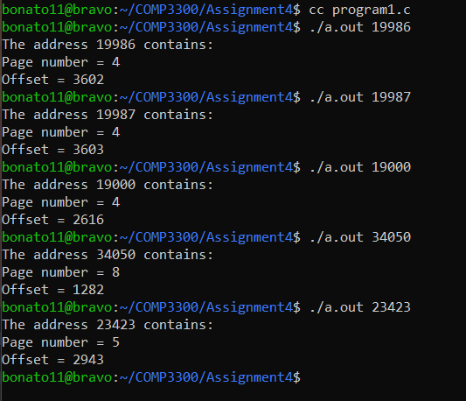

In this section, when implementing the ability to output the page number and offset for a given address, I utilized the atoi() method and the inputed arguments to take in an integer. It was then offset by 12, to get the page number, and then the offset itself was calculated given a defaulted value of 4095. This default value was globally defined at the beginning of the program. This software then prints out the address, page number and offset after running.

**Program 2**

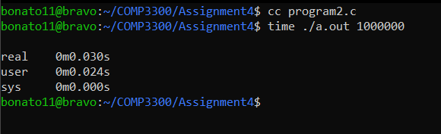

Similar to program 1, this program uses an address (which in this case is randomly generated using the rand() function in math.h) which is then used to calculate the page number and offset. The same offset is defined globally and the random values are determine by time, given the srand() function. The biggest difference is that it inputs the number of random addresses we wish to run. It loops it up to this value and creates that many random addresses. When running it, we use the time feature in terminal to determine the amount of time it takes to run this program, then prints it to terminal.

**Program 3**

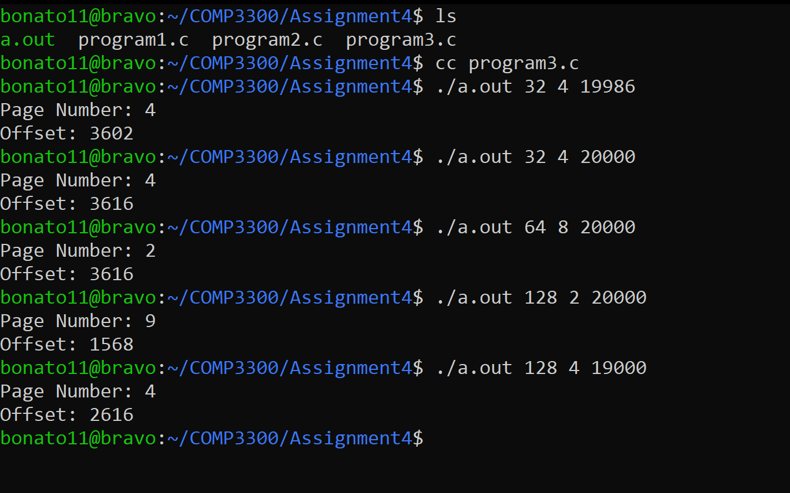

The final program is a little different. This program takes in an address space, a page size, and an address. It using the Boolean logic (m != 0) && (m & (m - 1)) to determine if the variable is the power of 2. It also makes sure that each value is greater than 0. It then using the built in arguments for main, and atoi() to take in each value. With the predefined KILO definition of 1024, it calculates the offset and page number. It does this by first determining what power of 2 that the page size is, and then how much we must offset the page by. It then prints it out at the very end.