第一次实验报告
姓名 | 阳光伟 | 学号 | 20201152056 | 班级 | 计科2020级

第1题
- 用递归的方式和非递归的方式实现阶乘
#include <stdio.h>
int main(int argc, char *argv[]) {
int n;
printf("Input a number for n:");
scanf("%d", &n);

int result = 1;
for (int i = 1; i <= n; i++) {
result *= i;
}

printf("%d的阶乘是%d\n", n, result);
}
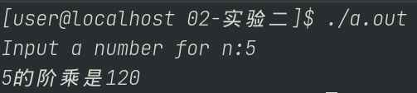

#include <stdio.h>
int factorial(int n) {
if (n <= 0) {
return 0;
} else if (n == 1) {
return 1;
} else {
return n * factorial(n - 1);
}
}

int main(int argc, char *argv[]) {
int n;
printf("Input a number for n:");
scanf("%d", &n);

int result = factorial(n);

printf("%d的阶乘是%d\n", n, result);
}

- 用递归的方式和非递归的方式实现Fibonacci
#include <stdio.h>
int main(int argc, char *argv[]) {
int n;
printf("Input a number for n:");
scanf("%d", &n);

int buffer[1024];

for (int i = 0; i < n; i++) {
if (i == 0) {
buffer[i] = 1;
} else if (i == 1) {
buffer[i] = 1;
} else {
buffer[i] = buffer[i - 1] + buffer[i - 2];
}
}

printf("Fibonacci数列：\n");
for (int j = 0; j < n; j++) {
printf("第%d项：%d\n", j, buffer[j]);
}
}
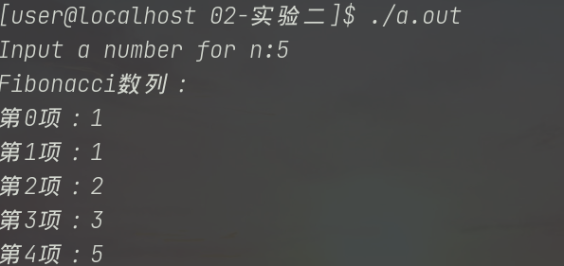

#include <stdio.h>
int Fibonacci(int n) {
if (n == 0 || n == 1) {
return 1;
}
return Fibonacci(n - 1) + Fibonacci(n - 2);
}
int main(int argc, char *argv[]) {
int n;
printf("Input a number for n:");
scanf("%d", &n);
int result = Fibonacci(n);
printf("Fibonacci数列第%d项：%d\n", n, result);
}

- 排列问题
#include <iostream>
using namespace std;

template <class Type> inline void Swap(Type &a, Type &b) {
Type temp = a;
a = b;
b = temp;
}
template <class Type> void Perm(Type list[], int k, int m) {
if (k == m) {
for (int i = 0; i <= m; i++) {
cout << list[i];
}
cout << endl;
} else {
for (int i = k; i <= m; i++) {
Swap(list[k], list[i]);
Perm(list, k + 1, m);
Swap(list[k], list[i]);
}
}
}
int main(int argc, char *argv[]) {

int list[] = {1, 2, 3};
Perm(list, 0, 2);
}
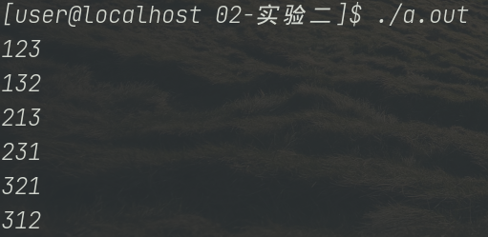

(4)Hannoi塔问题
#include <stdio.h>

void move(char A, char B) { printf("%c ------> %c\n", A, B); }

void Hannoi(int n, char a, char b, char c) {
if (n == 1) {
move(a, b);
} else {
Hannoi(n - 1, a, c, b);
move(a, b);
Hannoi(n - 1, c, b, a);
}
}

int main(int argc, char *argv[]) {
Hannoi(3, 'A', 'B', 'C');
return 0;
}
