1. 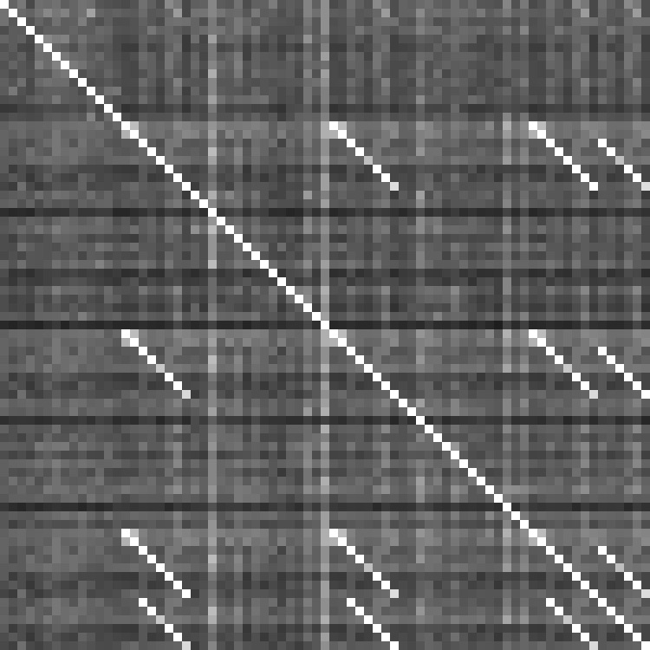Now this @#$%'s about to kick off, this party looks wack
2. Let's take it back to straight hip-hop and start it from scratch
3. I'm 'bout to bloody this track up, everybody get back

**(15,38)**

1. That's why my pen needs a pad cause my rhymes on the ra-hag
2. Just like I did with addiction I'm 'bout to kick it
3. Like a magician, critics I turn to crickets
4. Got 'em still on the fence whether to pick it
5. But quick to get impaled when I tell 'em stick it
6. So sick I'm looking pale, well that's my pigment
7. 'Bout to go ham, ya bish, shout out to Kendrick
8. Let's bring it back to that vintage Slim, @#$%!
9. The art of the MCing mixed with da Vinci and MC Ren
10. And I don't mean Stimpy's friend, @#$%
11. Been Public Enemy since you thought PE was gym, @#$%
12. **Take your shoes off, let your hair down and (go berserk), all night long**
13. **Grow your beard out, just weird out and (go berserk), all night long**
14. **We're gonna rock this house until we knock it down**
15. **So turn the volume loud, cause it's mayhem 'til the a.m.**
16. **So baby make just like K-Fed and let yourself go, let yourself go**
17. **Say @#$% it before we kick the bucket**
18. **Life's too short to not go for broke**
19. **So everybody, everybody, (go berzerk) shake your body**
20. Guess it's just the way that I'm dressed, ain't it?

Khaki's pressed, Nike shoes just crispy and fresh laced

1. So I guess it ain't
2. That aftershave or cologne that made Em just faint
3. Plus I just showed up with a coat fresher than wet paint

This similarity matrix represents pairwise similarity between each pair of lines in the lyrics. Note that groups of consecutive line repetitions (i.e. the chorus) show up as bright diagonal lines.

1. So if love is a chess game, check mate
2. But girl your body's banging, jump me in dang, bang bang
3. Yessiree Bob I was thinking the same thang
4. So come get on this kid's rock, baw with da baw, dang dang
5. P-p-p-pow chicka pow chicka wow wow
6. Got your gal blowin' up a val-v-v-v-val-valve
7. Ain't slowin' down, throw in the towel, t-t-towel towel
8. Dumb it down, I don't know how,(huh huh) how, how,
9. At least I know that I don't know
10. Question is are you bozos smart enough to feel stupid
11. 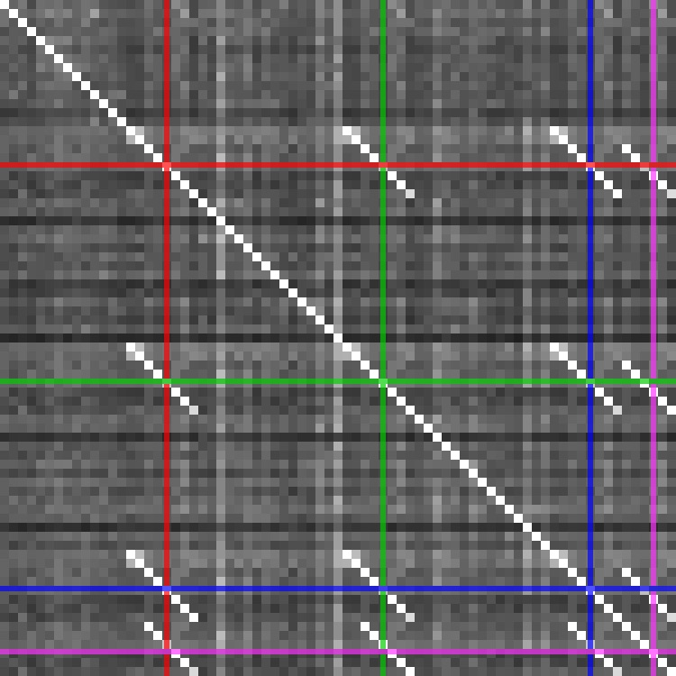Hope so, now hoe
12. **Take your shoes off, let your hair down and (go berserk), all night long**
13. **Grow your beard out, just weird out and (go berserk), all night long**
14. **We're gonna rock this house until we knock it down**
15. **So turn the volume loud, cause it's mayhem 'til the a.m.**
16. **So crank the bass up like crazy and let yourself go, let yourself go**
17. **Say @#$% it before we kick the bucket**
18. **Life's too short to not go for broke**
19. **So everybody, everybody, (go berzerk) get your vials**
20. And they say that love is powerful as cough syrup in Styrofoam
21. All I know is I fell asleep and woke up in that Monte Carlo
22. With the ugly Kardashian
23. Lamar, oh sorry yo, we done both set the bar low
24. Far as hard, drugs are though that's the past
25. But I done did enough codeine to knock Future into tomorrow
26. And girl I ain't got no money to borrow
27. But I am tryin' to find a way to get you a loan, car note
28. Oh, Marshall Mathers, @#$% head with a potty mouth
29. Get the bar soap lathered, Kangol's and Carheartless Cargos
30. Girl you’re fixin' to get your heart broke, don’t be absurd man
31. You birdbrain baby I ain’t called anybody baby since Birdman
32. Unless you’re a swallow
33. Word, Rick word man you heard, but don’t be discouraged girl
34. This is your jam, unless you got toe jam
35. **Take your shoes off, let your hair down and (go berserk), all night long**
36. **Grow your beard out, just weird out and (go berserk), all night long**
37. **We're gonna rock this house until we knock it down**

Segmenting these diagonal groups allows us to identify the position of each chorus group (indicated by color).

1. **So turn the volume loud, cause it's mayhem 'til the a.m.**
2. **So baby make just like K-Fed and let yourself go, let yourself go**
3. **Say @#$% it before we kick the bucket**
4. **Life's too short to not go for broke**
5. **So everybody, everybody, (go berzerk) shake your body**
6. **We're gonna rock this house until we knock it down**
7. **So turn the volume loud, cause it's mayhem 'til the a.m.**
8. **So crank the bass up like crazy and let yourself go, let yourself go**
9. **Say @#$% it before we kick the bucket**
10. **Life's too short to not go for broke**
11. **So everybody, everybody, (go berzerk) get your vials**