AENG 411: Aerospace Laboratory

Wind Tunnel Testing of a Complete Aircraft

by

Tom Moline

Member of Group NO. 2

Date Experiment Performed: September 27, 2013

Date Report Submitted: October 10, 2013

Submitted to: Mr. Larry Boyer

Department of Aerospace and Mechanical Engineering

Parks College of Engineering, Aviation, and Technology

Saint Louis University

Table of Contents

1. Summary 3

2. Nomenclature 4

3. Introduction 6

4. Design of Test 11

5. Test Procedure 12

6. Test Results 12

# Summary

# Nomenclature

*B* Test Section Width

*(Value)w* Wing Coefficient, Value, or Parameter

*(Value)tail* Tail Coefficient, Value, or Parameter

*(Coefficient)u* Uncorrected Coefficient

*(Coefficient)c* Corrected Coefficient

*b* Geometric Span

*be* Effective Span

*C* Test Section Cross Sectional Area

*d* Maximum Diameter of Fuselage

*H* Test Section Height

*k* Ratio of Effective Span to Tunnel Width

*K1* Body Shape Factor for Blockage

*K2* Fuselage Shape Factor for Blockage

*l* Length of Body

*lt* Distance from CG to ¼ MAC of Tail

*q* Freestream Dynamic Pressure

*qc* Corrected Freestream Dynamic Pressure

*Re* Reynolds Number

*S*Area

*αg* Geometric Angle of Attack

*αc* Corrected Angle of Attack

*δ* Boundary Correction Factor

*εT* Total Solid Blockage Correction Factor

*εsbB* Body Solid Blockage Correction Factor

*εsbW* Wing Solid Blockage Correction Factor

*εstuts,windshields* Strut and Windshields Solid Blockage Correction Factor

*τ1* Tunnel Correction Factor for Blockage

*τ2* Downwash Correction Factor

*c­t* Tip Chord

*cr* Root Chord

*λ* Taper Ratio

*MAC* Mean Aerodynamic Chord

*CM* Moment Coefficient about ¼ Chord of MACwing

*CD* Coefficient of Drag

*CL* Coefficient of Lift

*L* Lift

*D* Drag

*M* Moment about ¼ Chord of MACwing

*AR* Aspect Ratio

Mean Aerodynamic Chord

*V* Freestream Velocity

*CG* Center of Gravity

*CLW* Wing-Only Lift Coefficient

Variation in Pitching Moment Coefficient with Horizontal Tail Incidence Angle

*a* 2-D Lift Curve Slope

Horizontal Tail Velocity Coefficient

*FA* Strut Frontal Area

*tstrut* Strut Thickness

*hstrut* Strut Height

*P* Ambient Pressure

*T* Ambient Temperature

*ρ* Ambient Density

Volume

# Introduction

­­­There exist two standard methods of calculating the flight characteristics associated with a given aircraft: flight simulation of the whole aircraft through the use of potential flow theory and computational fluid dynamics and wind tunnel testing on a model representation of a given aircraft, where the flow characteristics are scaled up to the full size aircraft through the use of dimensional analysis. Each method has its advantages and disadvantages, with the former offering a quick, oftentimes highly accurate, representation all of the characteristics associated with an aircraft’s lift, drag, and moment coefficients for a wide range of angle of attacks. The accuracy of this method, though substantial and improving all the time, is highly reliant on the proper running of and collection of data from real-life wind tunnel testing. This report serves as documentation for one particular wind tunnel test that was run within the Low-Speed Tunnel within Oliver Hall on the campus of Saint Louis University.

For any given wind tunnel test, the main method of calculating the lift, drag, and moments associated with an aircraft is through the use of Six-Component-Pyramidal balance, an example of which is shown in Figure 3-1 below. Through the use of stain gauges, this device is able to calculate the force and moments that an aircraft attached to its struts experiences in all six flight directions (yaw, pitch, roll, lift, drag, thrust).

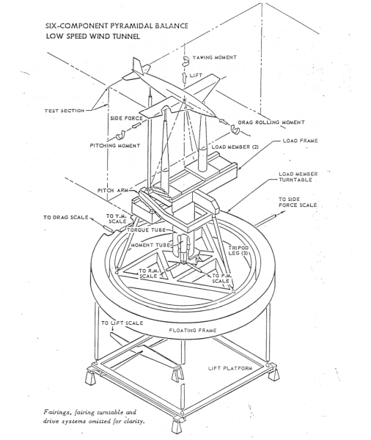

**Figure 3-1. Six-Component-Pyramidal Wind Tunnel Balance Drawing[1]**

Though most tunnel balances are fairly precise, no tunnel balance in existence can be considered perfectly calibrated. The reason for this rests in the generally small forces associated with lift, drag, etc. for a given aircraft versus the inherent instability of the balance itself, due to its large mass and inverted pendulum configuration. Thus, small errors in the motion of the balance in any direction due to instabilities leads to noticeable differences between the force values that the balance outputs versus the ones that the test aircraft actually experienced. In order to account for this difference, it is necessary to run wind tunnel tests both with no wind and the model just sitting on the balance and with full speed wind and no model sitting on the balance whatsoever. Based on the results obtained from this process, the data collected during testing can be corrected through the use of the following relation:

(1,2)

Where the coefficients with no u subscript are the raw coefficients calculated directly from the information recorded by the balance for a given test run and the coefficients with No Model and No Wind tare run being those collected when the tunnel is run at full speed with no model for the former and when the tunnel is run with no speed with the model on the balance. This, combined with the first order error calculations made within the LabView software used to interpret the data collected by the balance, would give an uncorrected representation of the flight coefficients at each angle of attack. In order to obtain a full representation of the flight characteristics of the aircraft, it is necessary to include several other corrections for each coefficient obtained during a given experiment.

The first error correction that is usually calculated is that associated with solid blockage of the wing, body, and tail of the aircraft. Each of these aspects of the aircraft disrupt the freestream flow running through the test section, thus interfering with the local flow around the aircraft, and thus, adding to the dynamic pressure that the aircraft experiences. This correction factor is calculated based on the cross-sectional area of the test section, *C*, the volume associated with the maximum frontal area of the aircraft component being accounted for, and three coefficients (K1, K2, τ1) that are found based on the graphs listed in Figure 3-2 below.

(3)

The way that these K1, K3, and τ1 values are obtained is through the calculation of the equivalent span of and thickness ratio of each element, as shown below, where t is the maximum thickness of an element, c is the Mean Aerodynamic Chord (MAC) of the element, b is the span of the element, and B is the width of the test section. For the graph on the left, it can be assumed that the airfoil used on a given model is of the 4 digit series variety, while the contour chosen on the right depended on the ratio of the test section width to its height.

(4,5)

|  |  |
| --- | --- |
|  |  |
| Figure 3-2. K1 , τ1, and K3 Calculation Charts | |

Once each solid blockage correction factor is found, the correction factor for wake blockage can be calculated. This correction factor accounts for the disruption of freestream flow through the test section of the wind tunnel due to the drag build up on the wing of the model itself. It can be calculated based on the area of the wing (Sw), the cross-sectional area of the test section (C) and the coefficient of drag at zero lift of the aircraft (CDO), as outlined below.

(6)

Where CDo is found based on the y-axis intersection of the plot of CL2 vs. CD, each of which can be found based on lift and drag values found from experimentation, as well as the dynamic pressure experienced by the aircraft and the area of the wing itself, as calculated based on the tip and root chords of the wing, as well as the wingspan itself, (ct, cr, and b respectively), as measured before the beginning of experimentation, and by assuming that the wing is straight and tapered, thus forming a trapezoidal shape, the area of which can be found fairly trivially.

With this in mind, the final part of the blockage correction factor can be found. This is accomplished by accounting for the wake disruption associated with the struts holding the model within the test section itself. This factor is based on the frontal area of each strut in relation to the area of the test section as a whole, as shown.

(7)

With each of these factors calculated, the total blockage correction factor can be found by summing each of the individual correction factors. The total factor is then used to calculate the rise in dynamic pressure exerted on the model for each given test as shown. It is this dynamic pressure that is then used for each subsequent calculation of drag, lift, and moment coefficients for any given part of the experiment.

(8)

This error correction only accounts for that associated with the disruption of the freestream flow through the test section. The error associated with interaction between the freestream flow and the wall still has to be accounted for. This is accomplished by calculating the downwash angle of attack associated with wall interaction, as specified below.

(9)

The first step in solving Equation (9) rests in finding the wing-only lift coefficient (CLW) associated with the model. This is accomplished be calculating the slope of the CL vs alpha curve for a test in which the aircraft is fully assembled. The next step then involves calculating δ, which can be found by first calculating bv/b based on the aspect ratio (AR=b/S2) of the wing of the aircraft and the taper ratio associated with said wing (λ=ct/cr), each of which are used to look up bv/b from Figure 3-3 below.

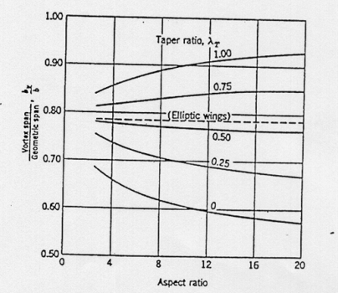

**Figure 3-3. bv/b Calculation Chart**

Once this value has been calculated, the effective span of the wing can be found by adding bv to b and taking the average of the two. After this, δ can be looked up through the use of Figure 3-4, which can be found on the next page, where k is found by dividing the result of the previous calculation by the width of the test section and the contour used is based on the taper ratio of the wing itself. τ2 is then found from Figure 3-5, which can also be found on the next page.

|  |  |
| --- | --- |
|  |  |
| **Figure 3-4. δ and τ2 Calculation Charts** | |

The result of this calculation is then added to each angle of attack used within a given test run, thus correcting for the actual angle of attack that the aircraft experienced versus that expected by the LabView software.

Another correction factor that has to be accounted for is the effect on CD due to wake disruption, This is found simply through a relation of the values just found in the previous analysis. The result of this calculation is added to the uncorrected value found in Equation (1), thus producing a corrected value that can be used in data reduction and analysis.

(10)

The final correction factor that is to be calculated is that of the moment coefficient. This is accomplished through the use of the relation below, where is the variation in pitching moment coefficient with horizontal tail incidence angle, which can be found through the use of a separate relation, which can be found on the next page.

(11)

(12)

Where can be approximated at 0.0533 and is found through the use of the below relation, where lt is the distance between the ¼ point of the MAC of the wing and the MAC of the tail..

(13)

This result is added to the uncorrected cm value found through the use of Equation (2) and is subsequently used for all calculations and analyses associated with cm.

With all of these error calculations defined and accounted for, it is now possible to conduct an accurate analysis of the values collected over the course of wind tunnel testing.

# Design of Test

The main testing item used throughout this particular experiment is the Parks College Low Speed Wind Tunnel, as shown in Figure 4-1 below. This tunnel is capable of achieving freestream speeds between 0 and 150 mph and is of the open circuit tunnel type, meaning that air is freely returned from the end of the tunnel to the beginning through the space of Oliver Hall itself, as opposed to any sort of constructed recirculation system.

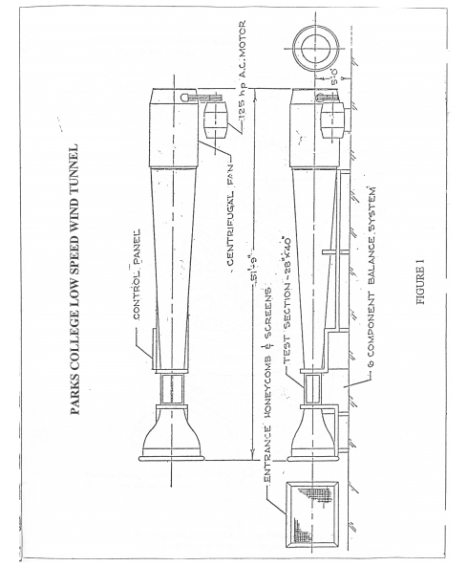

Figure 4-1. Parks College Low Speed Wind Tunnel

As discussed in the introduction, a six-axis pyramidal tunnel balance was used to collect all force and moment data from a model aircraft attached to its top. This model aircraft consisted of several printed sections, thus allowing for the removal/addition of various control surfaces, such as horizontal and vertical stabilizers. LabView software was used to manage and display all of the data outputted by the tunnel balance, while a slanted pressure gauge was used to indicate the velocity of air passing through the test section of the tunnel.

# Test Procedure

The procedure for conducting the Wind Tunnel Test of a Complete Aircraft is listed below:

1. The model was installed in the test section of the wind tunnel, which involved the assembly of aluminum floor sections to the floor of the chamber as to prevent the flow of air from the bottom of the tunnel into the tunnel itself, and the securing of the model to three struts that ran down to the six-axis pyramidal balance.
2. The zero geometric angle of attack and side-slip angle were then found based on visual observation from the side and top of the model respectively. When this was done, the angle of attack indicator on the LabView data visualization program was tared.
3. After this, the tunnel balance was unlocked and the balance readings were tared.
4. Once this was completed, the test section doors were sealed and the tunnel was turned on and set to 65 mph.
5. For the first test, the tail of the model was still attached and several measurements were taken for angles of attack between -8 and 16 degrees.
6. This same process was then repeated with the tail of the model removed.
7. Then the model was run through the same angles of attack with no wind whatsoever
8. After this, the same process was repeated at a wind speed of 65 mph with no model whatsoever.
9. The data collected from each run consisted of lift, drag, and pitch forces/moments.
10. Finally, several measurements were made of the model itself, including wingspan, tailspan, root and tip chords, thicknesses, lengths, diameters, etc.

# Test Results

Before any data was collected from experimentation, the geometry of the model aircraft being used was recorded and the sizing characteristics of the tunnel balance struts and the wind tunnel test section were found. Each of these values are recorded in Tables 6-1 through 6-3 below.

**Table 6-1. Tunnel Balance Strut Geometry**

|  |  |
| --- | --- |
| **Strut Characteristics** | |
| Wing Strut Thickness (in) | 0.38 |
| Wing Strut Height (in) | 12.375 |
| Tail Strut Thickness (in) | 0.136 |
| Tail Strut Height (in) | 12.125 |
| Frontal Area (in^2) | 11.054 |

**Table 6-2. Airplane Geometry**

|  |  |
| --- | --- |
| **Airplane Characteristics** | |
| Tip Chord (in) | 1.289 |
| Root Chord (in) | 2.579 |
| Wingspan (in) | 24.375 |
| Wing Thickness (in) | 0.35 |
| Tail Root Chord (in) | 1.75 |
| Tail Tip Chord (in) | 1 |
| Tail Thickness (in) | 0.17 |
| Fuselage Diameter (in) | 2 |
| Fuselage Length (in) | 12 |

**Table 6-3. Wind Tunnel Test Section Geometry**

|  |  |
| --- | --- |
| **Wind Tunnel Characteristics** | |
| Width (in) | 40 |
| Height (in) | 28 |
| Length (in) | 54 |

Based on the values recorded in each of these tables, various correction factors and flight characteristics associated with the model can be found, as discussed in the next section.

Finally, for each case discussed in the procedure section, angle of attack, force, and moment measurements were taken. Due to the number of these values, and thus the relative size of the tables associated with them, the data has been stored in the appendix.

# Discussion of Results

Based on the airplane characteristics listed in Table 6-2, the wing aspect ratio, taper ratios, volumes, and areas were calculated and stored in Table 7-1 below.

**Table 7-1. Extended Aircraft Characteristics of Wing, Tail, and Fuselage Sections**

|  |  |
| --- | --- |
| **Aircraft Characteristics** | |
| Wing Taper Ratio | 0.50 |
| Center Chord (in) | 2.76 |
| Wing Area (in^2) | 49 |
| Wing Volume (in^3) | 17.3 |
| Tail Taper Ratio | 0.571 |
| Tail Area (in^2) | 7.56 |
| Tail Volume (in^3) | 1.29 |
| Wing MAC (in) | 2.01 |
| Tail MAC (in) | 1.41 |
| Wing CG Relative to MACw (in) | 0.50 |
| (in) | 9.5 |
| Volume (in^3) | 21.60 |

Once these values were found, the lift, drag, and moment coefficients associated with each test run were calculated. This was accomplished through the use of the standard CD, CL, and CM equations, based on the drag, lift, and pitching moments found in Tables 9-1 through 9-4, SW, MACw, and the temperature and pressure found within Oliver Hall during testing, which was found to be 70 ⁰F and 101 kPa respectively, which translated to a density of 0.002377 slugs/ft3.

After this, the process of correcting these raw coefficient values began, which involved running through the process described in detail in the introduction. The first step in this process involved plotting CL2 vs. CD in the wing on, full speed test run. The results of this process are plotted in Figure 7-1 below. This plot, which theoretically should show a linear increase in CD over CL2, clearly did not. This is likely due to the fact that the corrections that are to be put into place later in this section have not yet been accounted for, meaning that the raw data is not a good representation of what the aircraft would actually experience in a real world scenario. However, it was necessary to find a CDo value in order to begin the correction process, so a linear curve was fit to the data, and a value of 0.00001551 was found.

**Figure 7-1. CL2 vs CD Plot for an Airspeed of 65 mph and with the Tail Attached**

Based on this value, the total blockage correction factor was found through the use of Equations (3-7) in the Introduction. From this blockage factor, a corrected dynamic pressure was calculated through the use of Equation (8). The results and intermediated steps of this process are recorded in table 7-2 on the next page.

**Table 7-2. Blockage Correction Factor Buildup and Results**

|  |  |
| --- | --- |
| **Blockage Correction Factor Calculations** | |
| K1 | 1.04 |
| K3 | 0.93 |
| εsbwing | 0.000412 |
| τw | 0.86 |
| τ1 | 0.855 |
| b/B | 0.61 |
| εSBF | 0.000458 |
| εstruts | 0.00247 |
| CD0 | 0.00001549 |
| εwbTail | 1.71E-07 |
| εtotal | 0.00334 |
| Dyanmic Pressure Correction (lbf/in^2) | 727.9 |

With this corrected dynamic pressure value in mind, each flight characteristic coefficient was recalculated, resulting in uncorrected versions of each coefficient. The next step in refining these values then involved accounting for the effect of the tunnel walls on the angle of attack that the aircraft experienced. This was accomplished by finding the lift curve slope of the aircraft from the test run where the wing was detached. This slope, calculated from the uncorrected values shown in Figure 7-2, was found to be 0.00048316 /rad. Based on this value, and through the use of Equation (9) in the Introduction, the change in angle of attack imparted by the tunnel on the aircraft was 0.108 degrees. The results and steps involved with this process are shown in Table 7-3 below.

**Table 7-3. Angle of Attack Correction Factor Buildup and Results**

|  |  |
| --- | --- |
| **Angle of Attack Corrections** | |
| Clw (/rad) | 0.00048316 |
| bv/b | 0.78 |
| be | 12.58 |
| k | 0.314 |
| δ | 0.115 |
| τ2 | 0.49 |
| Δα | 0.108 |

1. Image Obtained from Parks College of Engineering, Aviation and Technology Aerodynamics Laboratory Manual