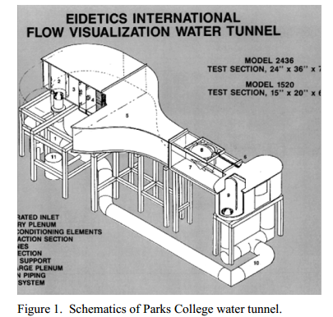
Introduction
Water has a different kinematic viscosity than air, which means lower flow velocities can be used for flow visualization and experiments. To correctly match the conditions, the flow velocity has to be accurate. The water tunnel comes equipped with a digital flow meter for this purpose.
Figure 1 shows Park's water tunnel. Water comes from downstream of the test section and is pumped to the settling reservoir. The water then passes through several screens to smooth the flow out. From there the water goes through the contraction section to the test section.
The digital flow meter needs to be precise in order to accurate represent the needed flow conditions, which means it needs to be recalibrated regularly. There are several ways to recalibrate it. The two methods used in the experiment are timing a drop of dye over a set distance and using a laser doppler anemometer (LDA).
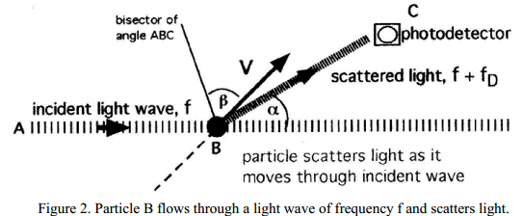
LDA is used to optically measure the velocity of a flow at a specific point. This device is based on the Doppler effect, as the source of waves move towards or away from an observer the frequency observed shifts. The frequency shift can be used to determine the velocity of the signal source.

Figure 2 demonstrates how the LDA works. Light is shown at a particle and it is scatter. The scattering of the light causes a frequency shift, which is detected by a photo-detector. To increase the accuracy two beams of equal size and frequency are used.
Design of Test
Objective
A water tunnel flow meter will be calculated with a laser doppler anemometer and a dye-stopwatch method.
Test Apparatus and Function
- Water tunnel: closed circuit, 15”x20”x60” test section with open top
- dye dropper
- stopwatch
- laser doppler anemometer
- computer

