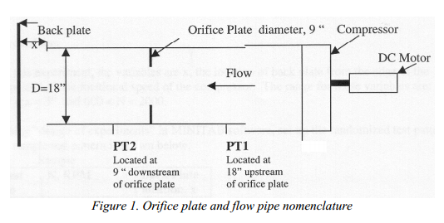
Introduction
Park's axial compressor consists of a set of stater blades and a set of compressor blades. The stater blades straighten and smooth out the flow before it enters the compressor. The compressor blades then compress the air.
The location of the back plate affects several properties of the flow leaving the compressor. The relationship of these properties is given by:
f (P, ω, D, Q, Δp, ρ, μ) = 0 (1)
Several dimensionless variables can be derived from this functional form using the Buckingham Pi Theorem. The first of these is the power coefficient. It relates the power of motor to it's rotational velocity, the density of the air, and the diameter of the pipe. It is given by:
C_{w} = P/ρω³D⁵ (2)
The second dimensionless number is the pressure coefficient. It relates the change in pressure between the two pressure taps to the density of the air, rotational velocity of the compressor, and the diameter of the pipe. It is given by:
C_{P} = ∆p/ρω²D² (3)
The flow coefficient is the next dimensionless number. It relates the volume flow rate to the compressor's rotational velocity and the pipes diameter. It is given by:
C_{Q} = Q/ωD³ (4)
The final dimensionless number is the Reynolds number, which relates the inertial forces to the viscous forces and its given by:
Re = ρVD/μ (5)
V is the average velocity, given by:
V = Q/A (6)
To find the pressure difference between the two pressure taps all that is required is the distance between the pressure taps and the density of water. The formula is given by:
∆p = ρ_{H2O}g∆h (7)
The volume flow rate is dependent on the coefficient of drag of the pipe, its area, the pressure difference, the air density, and the diameter change from the orifice to the pipe. The drag coefficient is calculated using the location of the pressure taps, the Reynolds number, and the diameter ratio. The formulas are given by:
Q = C_{d}A₂sqrt(∆p/ρ)sqrt(1/1-β⁴) (8)
C_{d} = 0.5959 +0.0312β^{2.1}−0.184β⁸+0.029β^{2.5}(10^{6/}Re)+(0.09L₁β⁴)/(1-ββ⁴)-0.037L₂β³ (9)

Design of Test

Objective
This experiment will analyze the performance of a single-stage axial compressor.

Test Apparatus and Function
- Single-stage axial flow compressor
- orifice meter
- ruler and
- dynamo-meter

