ProofChain
Verifiable Records and Tamper Detection
Project brief for problem B-01 | Domain 3: Blockchain and Decentralized Trust | 11 October 2026, revised after all six build stages, salted leaves and custodian sign-in
This brief explains the problem, the concepts you need, what the problem statement really asks for, how the system flows, how we plan to build it, and which extra features would make the project stand out. It was written before any code existed and has been revised now that all six build stages are complete. Where the working code settled a detail that the first version left open, the brief now states what was built. Three things were added after the six stages: salted leaves, custodian sign-in with a token on the ledger's append endpoint, and one batch per custodian.
Contents
- Summary
- The problem statement, clarified
- Background concepts
- Prerequisites
- System architecture
- Flow structure
- Implementation plan
- Standout features
- Risks, limits and honest claims
- Demo script and judge questions
- Glossary and references

1. Summary

The problem
Certificates, contracts and official records usually sit in one organisation's database, and everyone else has to trust that database. Storing a hash next to each record does not help: whoever can change the record can change the hash too, and the two will still match. An outsider learns nothing from that check.

The idea
Give every document a SHA-256 fingerprint. Group fingerprints into batches and summarise each batch with a Merkle tree, so one short value (the root) commits to every document in it. Publish that root in a separate, append-only, signed ledger that the registry cannot quietly rewrite. Hand each document holder a small proof file. Anyone can then check a single document against the published root, without the registry's database and without downloading the other records.

What gets built
Part | Job
Core library | Canonical form, SHA-256 fingerprint, Merkle tree, proof format. Python standard library only.
Independent verifier | Command-line tool (and a static browser page) that takes document + proof + published root and says exactly which check failed.
Ledger service | Separate process with its own signing key. Stores roots in an append-only hash chain. Appending needs a shared token; reading is open to everyone.
Registry service and web UI | Staff sign in, then upload, confirm metadata, seal their own batches, download proofs and run a self-audit. The Verify page needs no account.
AI helper | Suggests metadata and categories, explains failures in plain language. Advisory only; a person confirms.
Tamper demo | Script that edits the registry database directly to show the verifier still rejects.

Decisions already taken
- Stack: Python 3.11+, FastAPI, SQLite, server-rendered web pages.
- Root store: separate hash-chained ledger signed with Ed25519, with checkpoints pinned by verifiers. No public blockchain.
- AI: Claude API with a rule-based fallback, kept outside the verification path.

Build status
Part | Status
Core library | Built and tested (stage 1)
Independent verifier and command line | Built and tested (stage 2)
Ledger service | Built and tested (stage 3)
Registry, self-audit and web pages | Built and tested (stage 4)
AI helper | Built and tested against a simulated API (stage 5)
Demo scripts, static browser verifier, README | Built and tested (stage 6)
Salted leaves | Built and tested (after stage 6)
Custodian sign-in and the ledger append token | Built and tested (after stage 6)
Batches per custodian, with an admin role | Built and tested (after stage 6)

The automated test suite has 697 passing tests. The whole base build described in this brief now exists. Of the standout features in Section 8, the static browser verifier and salted leaves are built, and the tamper demo exists as a command-line script; the rest are not built.
What a pass means. Verification proves that a document matches a reference registered at a known point in the ledger. It does not prove who created the document or that what it says is true. The product must say this wherever it shows a result.
What signing in means. Staff sign in so that each confirmation and each seal names the account that made it. That is accountability inside the registry. It does not make a record more trustworthy and it does not change the trust model: the guarantee still comes from the published root and the independent verifier. Verifying never needs an account.

2. The problem statement, clarified
The statement is short but every sentence carries a requirement. The table below splits it into ten testable requirements, says what each one means in practice, and shows how we meet and demonstrate it.
Requirement | What it means | How we meet it | How we demonstrate it
R1. SHA-256 fingerprint from a defined, reproducible form | Anyone holding the same document gets the same hash on any machine. | Two named canonical forms. Every proof records which one was used. | Hash the same file with an outside tool (certutil or sha256sum) and get the same value.
R2. Batches summarised by a Merkle tree, root published | One short value commits to every record in the batch. | Domain-separated Merkle tree. Sealing a batch sends the root to the ledger. | Batch page shows the root; the same root appears in the ledger.
R3. Every record can produce a membership proof | A single record can be proved without the others. | Downloadable proof bundle (JSON) per record. | Open the bundle: about log2(n) sibling hashes, nothing else from the batch.
R4. Roots stored where the registry cannot silently rewrite them | A change to history must be visible to outsiders. | Separate ledger process and key, hash chain, signatures, pinned checkpoints. | Edit one ledger entry by hand; the verifier reports LEDGER_INVALID.
R5. Independent verifier using only document, proof and published root | No call to the registry and no read of its database. | Verifier package imports only the core library. CLI and static page. | Stop the registry service, then verify successfully.
R6. Report which check failed | Modified document, invalid proof and root mismatch are different answers. | Five named result codes, each with computed and expected hashes. | Three tamper demos give three different codes.
R7. Detect a stored record that no longer matches its published reference | The registry must notice drift in its own storage. | Audit job recomputes fingerprints and roots from stored content and compares with the ledger. | Run the tamper script, open the Audit page, see the flagged record and batch.
R8. Reject a tampered document even if the registry database was altered | An attacker with full database access still loses. | The verdict depends on the ledger root, never on registry data. | Tamper script rewrites content, fingerprint and root in SQLite; the verifier reports ROOT_MISMATCH.
R9. AI assists; a person confirms; AI cannot affect verification | AI is an assistant, not a judge. | Suggestion then confirmation gate, recorded under the signed-in account. Verifier has no AI import. Metadata is not hashed into the leaf. | Remove the API key: verdicts are identical. An automated test checks the import rule.
R10. No public blockchain; genuine cryptographic checking | Real recomputation, not a green tick. | Verifier prints every computed hash and returns an exit code. | Show computed versus expected hex for each check.

What is explicitly out of scope
- A public blockchain, tokens, mining or smart contracts.
- Proving authorship. That would need issuer signatures, listed later as an optional extra.
- Proving the contents are true. No cryptography can do that.

Common ways to miss the brief
Mistake | Why it fails
Hash stored in the same database as the record, and verification compares the two | This is the exact weakness the problem describes. An insider edits both.
Verifier is an API endpoint on the registry that looks up the record | It is not independent, and it trusts the database it is supposed to check.
A single "valid / invalid" result | The brief requires the reason: document, proof or root.
A UI badge that turns green without recomputing hashes | The brief says verification must be genuine cryptographic checking.
AI classifies a document as genuine or fake | AI must not affect whether verification succeeds.
AI-extracted metadata saved straight into the record | Extracted data must be confirmed by a person.
Root published only inside the registry | The registry could rewrite it silently.

3. Background concepts

3.1 Hash functions and SHA-256
A cryptographic hash function turns any input, of any size, into a fixed-length output. SHA-256 outputs 256 bits, written as 64 hexadecimal characters. It is specified in FIPS 180-4. Four properties matter here:
- Deterministic: the same bytes always give the same hash.
- Preimage resistant: given a hash, you cannot find an input that produces it.
- Second-preimage resistant: given a document, you cannot find a different document with the same hash. This is what stops a forger swapping in a new document.
- Collision resistant: you cannot find any two different inputs with the same hash.
It also shows the avalanche effect: a tiny change in the input changes about half the output bits. The two inputs below differ in one character.
"Certificate of Completion: Asha Rao, 2026"
d1e9b977c3a3ecaaa8499d445ba43f8569cd57ff288ec8518e70bf5c0e7409cb

"Certificate of Completion: Asha Rao, 2027"
07ae032dd691a3f8983386253f912dcfe95525e63c9b383015a603647b4cfa85

117 of 256 output bits differ.
So a matching fingerprint means the document is the same, bit for bit, as the one that was fingerprinted. A different fingerprint means something changed, but does not say what.

3.2 Canonical form
A hash covers bytes, not meaning. The same logical record can be written as different bytes: different key order, spacing, line endings or Unicode encoding of the same character. If two parties serialise the record differently they get different hashes for the same content, and verification fails for no real reason. The fix is to define one exact byte form, called the canonical form, and always hash that.
We define two canonical forms, and each proof names the one it used:
Name | Used for | Rule
raw-bytes-v1 | Files such as PDF, images, Word documents | The exact bytes of the file, unchanged.
json-sorted-v1 | Structured records entered as fields | UTF-8, Unicode NFC, object keys sorted by code point, no whitespace between tokens, integers only. Input containing a floating-point number or a duplicate key is rejected. Modelled on RFC 8785.

Worked example: the same record written two ways gives two different raw hashes, but one canonical form and one fingerprint.
Written one way:
{"name": "Asha Rao", "course": "Data Structures", "year": 2026}
raw SHA-256 4052a5132e3df1a9d3f9c7b5c039845c5838f14fa5ea2b7eba49b173972e2e00

Written another way (keys reordered, pretty-printed):
raw SHA-256 230892b6ae35ee9af0f66c128216d3f979b0f5ef7f1ff44cb378124c601f010f

Canonical form of both:
{"course":"Data Structures","name":"Asha Rao","year":2026}
fingerprint cec7f2f6b8ebc0a612fdb3b5fadaa380d1d85be7a6c0412708814054796faba5
Design rule. Never normalise binary files. Re-saving a PDF changes its bytes, and that is correct behaviour: the registered artefact is the exact file that was issued.

3.3 Merkle trees
Publishing one hash per document would work but does not scale, and it reveals how many documents exist and when each was added. A Merkle tree compresses a whole batch into one value.
- Each document's fingerprint becomes a leaf: leaf = SHA-256(0x00 || fingerprint).
- Leaves are paired left to right. Each pair becomes a node: node = SHA-256(0x01 || left || right).
- Nodes are paired again, level by level, until one value remains. That value is the root.
- If a level has an odd number of entries, the last one moves up unchanged. It is never duplicated.
Changing any document changes its leaf, which changes every node above it, which changes the root. So the root is a commitment to every document in the batch and to their order.
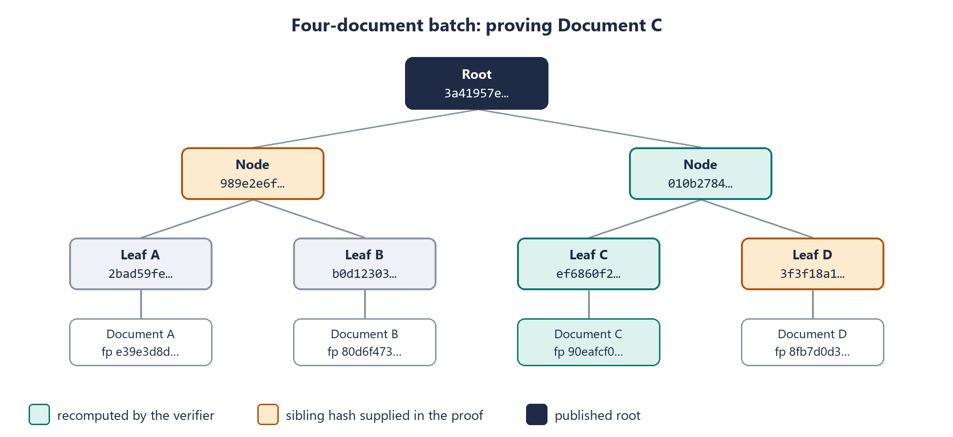
Figure 1. A four-document batch with real SHA-256 values (first 8 hex characters shown).

Why the 0x00 and 0x01 prefixes
Without them, an attacker could present an internal node as if it were a leaf (or the reverse) and build a valid-looking proof for data that was never registered. Tagging leaves and nodes differently, called domain separation, removes that ambiguity. Certificate Transparency (RFC 6962) uses the same technique.

Why the odd entry is promoted, not duplicated
Some designs duplicate the last entry to make a pair. That lets two different lists of leaves produce the same root, which caused a real vulnerability in Bitcoin (CVE-2012-2459). Promoting the unpaired entry avoids it.
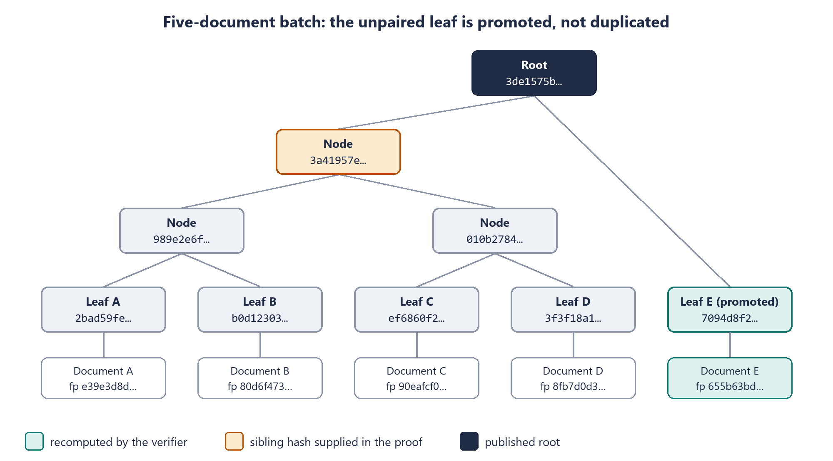
Figure 2. Five documents. Leaf E has no partner, so it moves up until it meets the left subtree. Its proof needs one hash.

Salted leaves
The rules above take a 32-byte leaf value for each record. In the simplest form, used in the figures and worked examples of this section, the leaf value is the document's fingerprint. The built system adds one step: every record is given a random 32-byte salt when it is uploaded, and its leaf value is SHA-256(0x02 || salt || fingerprint). The 0x02 prefix keeps a salted value from ever being read as a leaf or a node.
Salting does two things. Two registrations of the same content become two different leaves, each with its own proof, so every registration is distinct. And a sibling hash in one holder's proof can no longer be matched against a guess at another holder's document, because the guesser does not have that record's salt. The tree, the root, the proof path and the ledger work exactly as described; only the value at the bottom changes.

3.4 Membership proofs
To prove a document is in a batch, you supply the sibling hash at each level on the way from its leaf to the root, plus which side each sibling is on. The verifier recomputes upward and compares the result with the published root. For a batch of n documents the proof holds about log2(n) hashes: 10 for 1,000 documents, 20 for a million.
Worked example: proving Document C in Figure 1. The proof holds two sibling hashes.
fingerprint(C)
90eafcf01a14b00bf7d8e2ab6abd10b1e6944ad0fc3d7ac1dfeacff8976ba4aa
leaf = H(0x00 || fingerprint)
ef6860f2459adc96d870eddcf98b4b01437abfb3044db6cfc19786ee44cd53b0

step 1: sibling on the RIGHT
3f3f18a16988ee47522a0f08f4c21bd7687b126030323cb2d3c60b38cae7f494
node = H(0x01 || leaf || sibling)
010b2784e33a8d696e6e1c92bdc8663f5b26d581f1508f6ccc6c9dab5aa6f0e1

step 2: sibling on the LEFT
989e2e6fd32d70ca8443ba766cb386a3750c114c5ed75dd38ff84495447a4ff1
root = H(0x01 || sibling || node)
3a41957e48b5aeb1eb57ad1ef8f84e13c2d430783215c136b8effeda95e98c40

published root
3a41957e48b5aeb1eb57ad1ef8f84e13c2d430783215c136b8effeda95e98c40 MATCH
If Document C is edited, its fingerprint changes and the same two siblings lead somewhere else:
fingerprint(edited C)
8396bf8447a9109974bf98046d1ef80aa62867afb2d5c007753fd495a11207e6
recomputed root
338d1757c00018ae214501b90edc1f8748fb0b67580b4ce191521cd163054b4e NO MATCH
The verifier never sees Documents A, B or D. It sees two hashes that reveal nothing about them.

3.5 Making published roots hard to rewrite
The root is only useful if it lives somewhere the registry cannot quietly change. We use three layers.

Layer 1: hash chain
Every ledger entry includes the hash of the previous entry. Altering an old entry changes its hash, which breaks the link in the next entry, and so on to the end. A verifier walking the chain notices immediately.
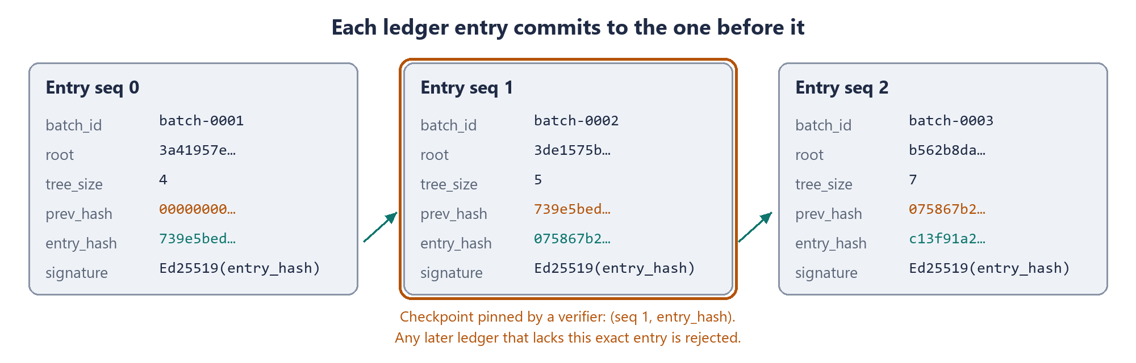
Figure 3. Three ledger entries. Each prev_hash equals the previous entry_hash.

Layer 2: digital signature
Each entry hash is signed with the ledger's private Ed25519 key (RFC 8032). Anyone with the public key can check the signature; only the key holder can produce it. The ledger runs as its own process with its own key, so the registry cannot forge entries. The signature covers the 32 raw bytes of the entry hash and is stored as base64. The public key is published as 64 hexadecimal characters.

Layer 3: pinned checkpoints
A chain plus signatures still leaves one gap: whoever holds the ledger key could rebuild the entire chain from the start and sign it again. The defence is that verifiers remember. Each verifier saves a checkpoint, the sequence number and entry hash of the latest entry it has seen. From then on it rejects any ledger that does not contain that exact entry. A rewrite therefore cannot stay hidden from anyone who looked before. The verifier's pin command saves the checkpoint together with the ledger's public key, so later runs do not rely on a key served by the ledger they are checking.
Honest limit. A verifier that has never seen the ledger before has no checkpoint to compare against. Independent witnesses that co-sign ledger heads close this gap; see Section 8.

How this compares with other approaches
 | Public blockchain | Our signed ledger | Certificate Transparency
Who can write | Anyone, by consensus | One ledger operator | One log operator
Rewrite prevented by | Economic cost of redoing consensus | Detection: chain, signature, pinned checkpoints | Detection: Merkle log, gossip, monitors
Cost and speed | Fees and confirmation delays | Free and instant | Free and fast
Needs network of nodes | Yes | No | Monitors and auditors
Fits this brief | Allowed but not required | Yes | Closest real-world model

3.6 Threat model
Assume the attacker may be an insider with full read and write access to the registry database. The table lists what each attacker can try and what catches it.
Attack | Caught by | Result
Holder edits a document after it was issued | Verifier, fingerprint check | DOCUMENT_MODIFIED
Someone edits or invents the proof path | Verifier, proof check | PROOF_INVALID
Insider changes a record and its stored fingerprint, rebuilds the batch, issues a fresh proof | Verifier, root check | ROOT_MISMATCH
Insider changes only the stored content | Registry audit | STORED_CONTENT_CHANGED; the holder's original still verifies
Insider issues a proof for a batch that was never published | Verifier, publication check | BATCH_NOT_PUBLISHED
Someone edits one ledger entry | Verifier, ledger check | LEDGER_INVALID (broken link or bad signature)
Ledger key holder rebuilds and re-signs the whole ledger | Verifier, pinned checkpoint | LEDGER_INVALID for anyone who pinned earlier

4. Prerequisites

4.1 Knowledge
Topic | Level needed | Where it is used
Python basics (functions, modules, bytes versus text) | Comfortable | Everything
Command line and virtual environments | Basic | Running services, tests and the verifier CLI
HTTP and REST APIs | Basic | Registry and ledger services (FastAPI)
SQL | Basic | Registry tables in SQLite; the tamper demo edits rows directly
HTML and a little JavaScript | Basic | Registry pages and the static browser verifier
Hashing, Merkle trees, signatures | Section 3 of this brief | Core library, verifier, ledger
Testing with pytest | Basic | Proving each failure code fires for the right reason

4.2 Software
Item | Purpose
Python 3.11 or newer | Runtime for all components
pip and venv (included with Python) | Installing packages in an isolated environment
A modern web browser | Registry UI and the static verifier (needs WebCrypto, present in all current browsers)
A code editor | Any; VS Code is fine
Git (optional) | Version history for the submission
Anthropic API key (optional) | Live AI suggestions. Without it the rule-based fallback is used and everything else works.
Node.js (optional) | Only for the two tests that run the browser verifier's rules outside a browser. They are skipped without it.

4.3 Python packages
Package | Purpose
hashlib (standard library) | SHA-256. The core and verifier need nothing else for hashing.
fastapi, uvicorn | The registry and ledger web services
jinja2, python-multipart | HTML pages and file uploads
cryptography | Ed25519 signing in the ledger and signature checking in the verifier
pypdf | Extracting text from PDFs so the AI helper can read them
anthropic | Claude API client for the AI helper
pytest | Automated tests
httpx | Lets the tests call the services in-process, without opening a port

4.4 Setup commands (Windows)
python --version
python -m venv .venv
.venv\Scripts\activate
pip install -e ".[dev]"
The packages are declared in pyproject.toml. The dev extra adds pytest and httpx.
Create a staff account first. There is no sign-up page: an account is made on the machine that runs the registry, and the password is asked for, never passed as an argument. Add --admin for an account that may seal any custodian's batch.
python -m proofchain.registry.staff add <username>
The two services start in separate terminals, with the same ledger token set in both. Start the ledger first: the registry needs it to seal a batch.
$env:PROOFCHAIN_LEDGER_TOKEN = "<a long random string>"
uvicorn proofchain.ledger.app:app --port 8001

$env:PROOFCHAIN_LEDGER_TOKEN = "<the same string>"
uvicorn proofchain.registry.app:app --port 8000
Settings are environment variables, listed in .env.example. Each has a default except the ledger token. A ledger started without it still serves every read, but refuses appends and says why, so no batch can be sealed until it is set.
Setting | Default | Used by
ANTHROPIC_API_KEY | empty | AI helper (optional)
PROOFCHAIN_DB_PATH | data/registry.db | Registry
PROOFCHAIN_LEDGER_PATH | data/ledger.jsonl | Ledger
PROOFCHAIN_LEDGER_KEY_PATH | data/ledger_key.pem | Ledger. The key is created on first start.
PROOFCHAIN_LEDGER_URL | http://localhost:8001 | Registry: where it finds the ledger
PROOFCHAIN_AI_MODEL | claude-opus-5-5 | AI helper: which Claude model to ask
PROOFCHAIN_LEDGER_TOKEN | none; must be set | Ledger, registry and seed script: the shared secret for appending a root
PROOFCHAIN_SESSION_SECRET | generated into data/session_secret | Registry: signs the session cookies

The services do not read a .env file by themselves. To use Claude, set the key in the terminal that starts the registry; the ledger does not need it.
$env:ANTHROPIC_API_KEY = "<your key>"
uvicorn proofchain.registry.app:app --port 8000

4.5 Hardware, accounts and cost
- Any laptop is enough. SHA-256 over a few megabytes takes milliseconds.
- No cloud account, database server or blockchain node is required. Everything runs locally.
- The only paid item is optional Claude API usage, billed per request. A demo uses very little. The key goes in a local .env file and is never committed to Git.

5. System architecture
Four components, separated so that the one being checked (the registry) has no control over the thing it is checked against (the ledger), and no part in the checking (the verifier).
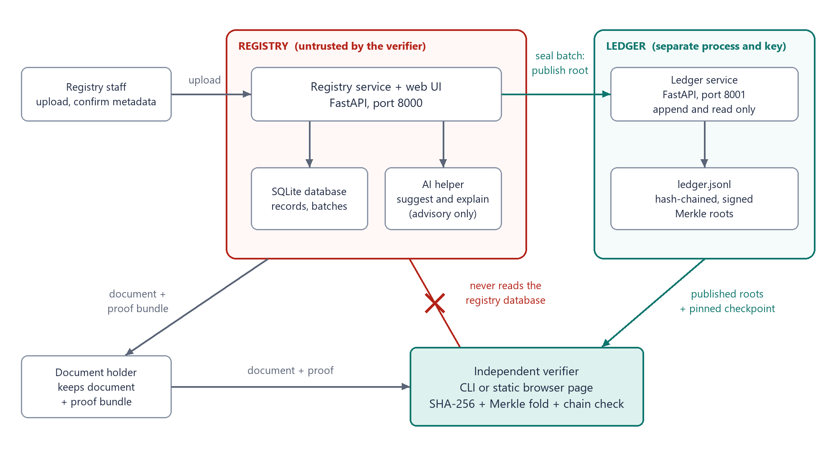
Figure 4. Components and trust boundaries.
Component | Holds | Can do | Cannot do
Registry | Documents, fingerprints, metadata, batch membership and ownership, staff accounts | Sign staff in, accept uploads, build trees, request publication, issue proofs, audit itself | Sign ledger entries, edit or delete ledger entries, influence a verifier's verdict
Ledger | Published roots, its own private key | Append a signed entry for a caller that presents the token, serve entries and its public key to anyone, refuse to start if its own file fails the chain check | Update or delete an entry (no such endpoint exists)
Verifier | Ledger public key, pinned checkpoint | Recompute hashes, fold the proof, check the chain, report the result | Read the registry database, call the AI helper
AI helper | Nothing persistent | Suggest metadata and categories, explain a finished result | Write confirmed metadata, change a verdict

One import crosses these lines on purpose: the registry imports the verifier, so that its Verify page and its audit run exactly the same checks as the command line. The reverse never happens. A check run by the registry is a convenience, not an independent one, because it takes the ledger key and checkpoint from the registry's own records; the page says so.
The key separation. The verifier and core packages import nothing from the registry or AI packages. An automated test enforces this, so the independence claim is checked on every test run, not just promised.
Staff sign in to the registry with a username and password, and a signed session cookie carries the account from page to page. Each custodian has their own open batch and seals it themselves; an admin may seal any open batch. The ledger accepts a new root only from a caller that presents a shared token. None of this reaches the verifier: the Verify page, every read of the ledger, the command-line verifier and the browser verifier need no account and no token. Who owns a batch and who sealed it are kept in the registry's database only, never in a proof or a ledger entry.

6. Flow structure

6.1 Registering a record and sealing a batch
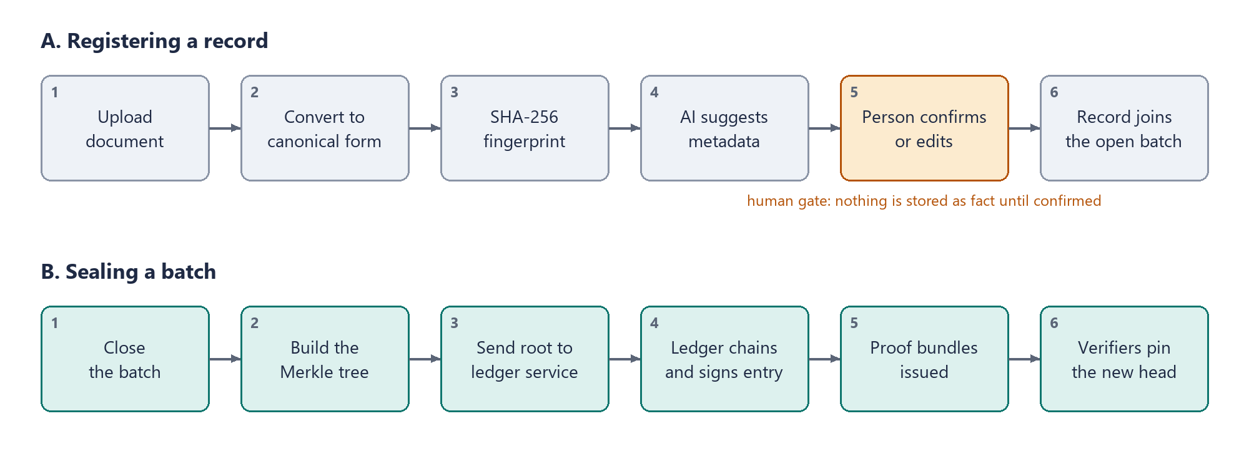
Figure 5. Registration (A) and batch sealing (B).

A. Registering a record
- A signed-in staff member uploads a file, or fills in a structured record.
- The registry converts it to its canonical form (raw-bytes-v1 or json-sorted-v1).
- It computes the SHA-256 fingerprint and shows it on screen, and gives the record a random salt. If the same content is already registered, it says so and names the earlier record, but still stores the upload.
- The AI helper reads the text and suggests issuer, date, document type and category. These are marked as suggestions.
- The staff member checks, corrects and confirms the metadata. The confirmation is recorded under the account they are signed in with. Until then the record cannot enter a batch.
- The confirmed record joins that staff member's own open batch at the next leaf position. Each custodian has one open batch, and the first confirmation after a seal opens a new one.

B. Sealing a batch
- The batch's owner, or an admin, closes the batch with the Seal button. No more records can join it.
- The registry builds the Merkle tree over the salted fingerprints in leaf order and obtains the root.
- It sends the batch id, root and tree size to the ledger service, with the ledger token.
- The ledger adds the previous entry's hash, computes the new entry hash, signs it and appends the entry.
- The registry generates a proof bundle for every record in the batch, ready to download with the document.
- Verifiers that are watching the ledger pin the new head as their checkpoint.
The root is sent to the ledger before the batch is marked sealed. If the registry stops between the two steps, sealing again adopts the entry that is already there when it carries the same root, and refuses when it carries a different one: a published root cannot be replaced. At its first seal the registry records the ledger's public key, and with every seal the entry hash it was given. Together these are the registry's own checkpoint. The batch also records who sealed it. Batch ids are numbered in order of creation and name nobody.

6.2 Verifying a document
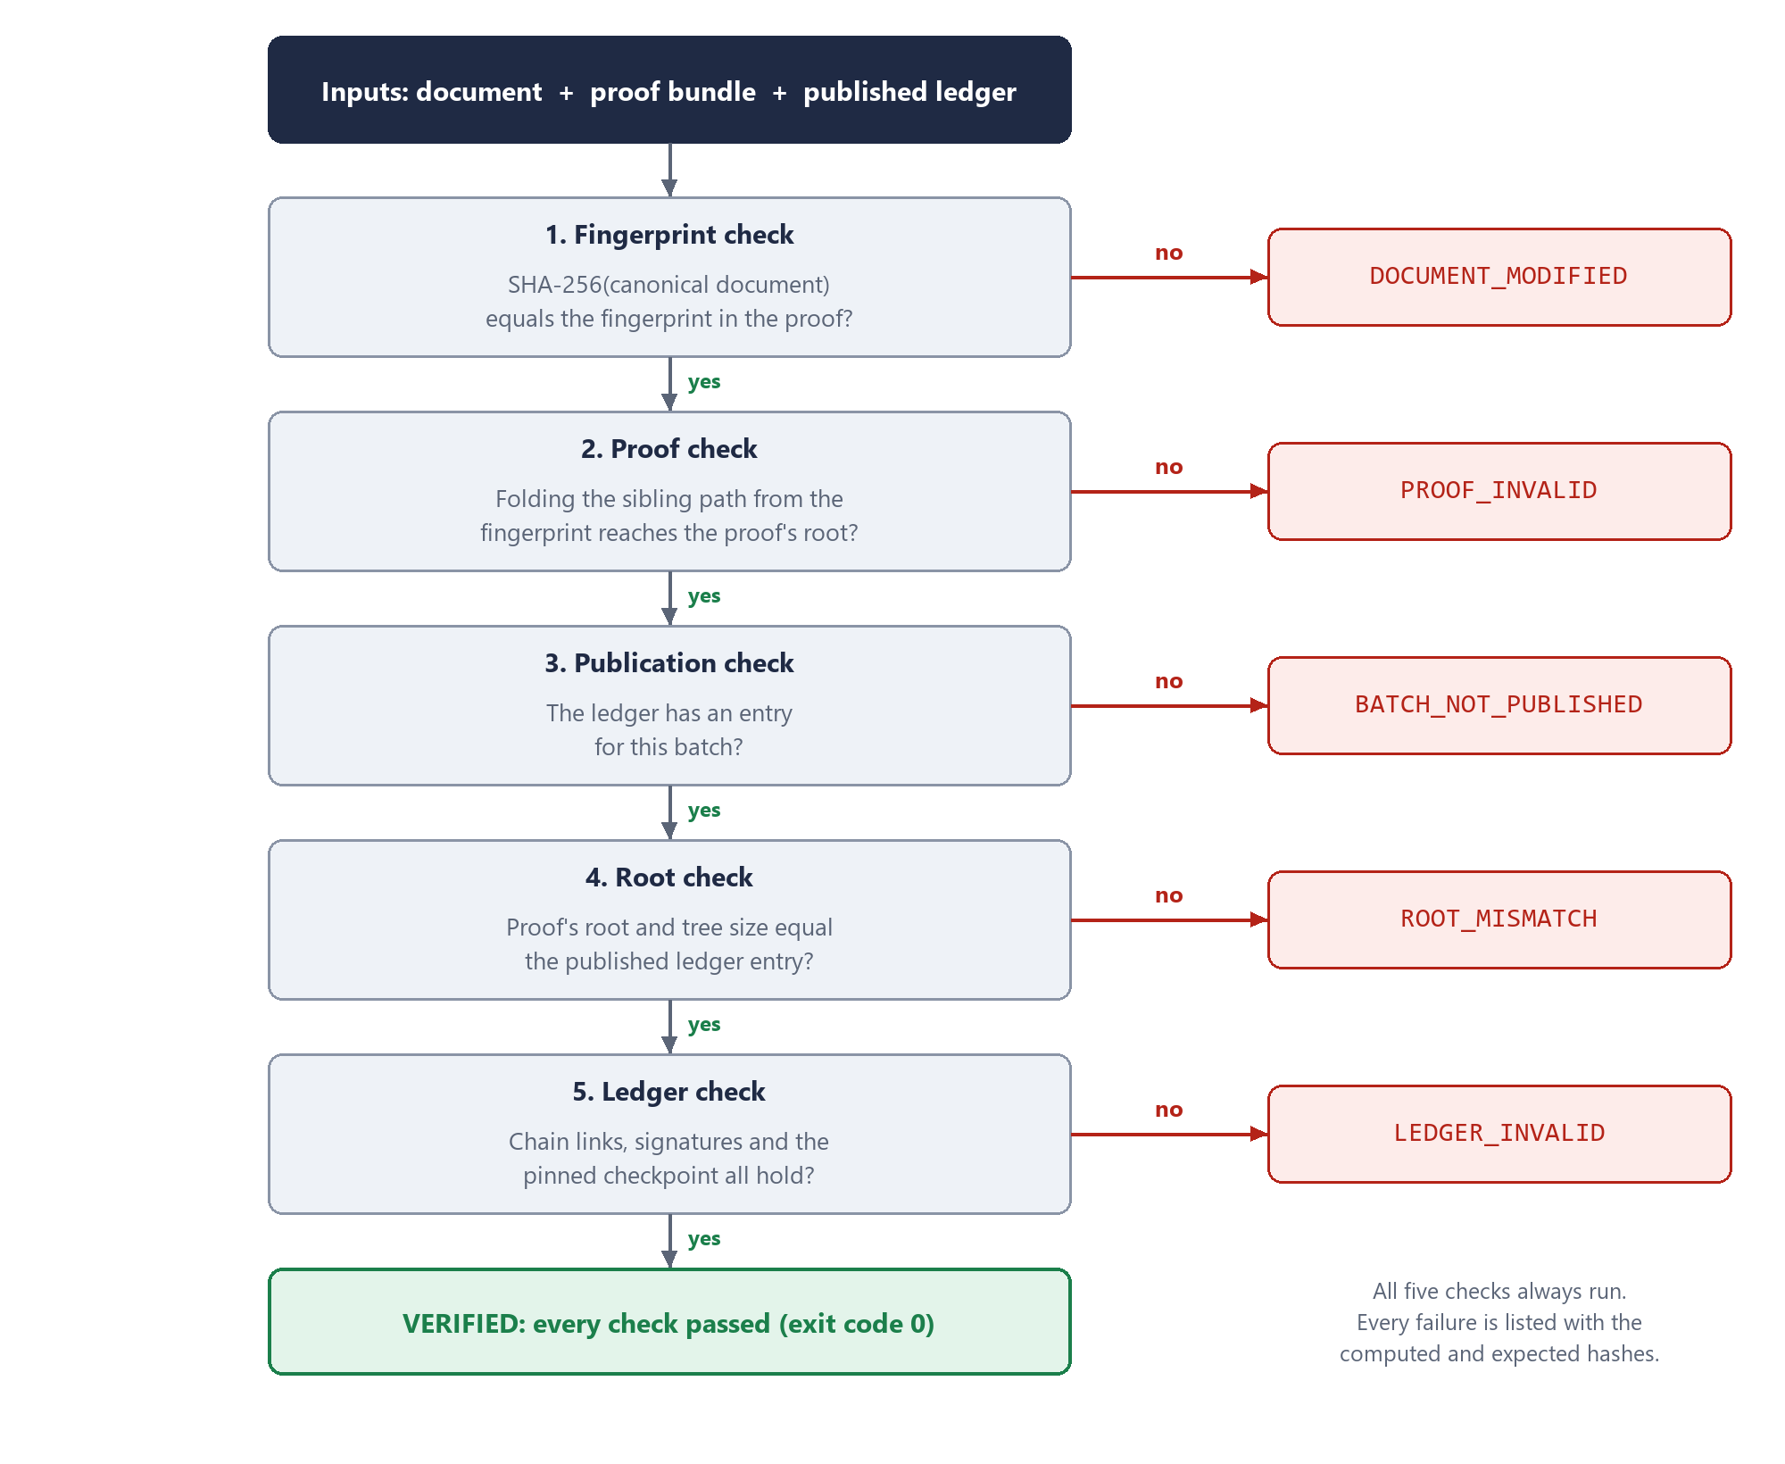
Figure 6. The five verification checks and the code each one reports.
Two details make the failure reasons trustworthy:
- All checks run every time. The verifier does not stop at the first failure, so a report can list several causes.
- Each check isolates one cause. The proof bundle carries the registered fingerprint and the claimed root. Check 1 compares the document with the fingerprint. Check 2 uses the bundle's own fingerprint, not the document, so an edited document does not also raise a proof error. Check 4 compares the bundle's root with the ledger, so a re-issued proof from an altered database is caught there.
- Three outcomes per check. A check passes, fails or is skipped. It is skipped only when there is nothing reliable to compare: the root check when the batch was never published, and the fingerprint, publication and root checks when the proof bundle is malformed. A skipped check never occurs without a failed one, so the overall result is still a failure.

6.3 Registry self-audit
The registry also checks itself against the ledger, each time the Audit page is opened:
- For each record, recompute the fingerprint from the stored content and compare it with the stored fingerprint.
- For each sealed batch, rebuild the Merkle root from the stored fingerprints and salts.
- Fetch the batch's entry from the ledger and compare roots and tree sizes.
- Report any difference on the Audit page.
Audit code | Meaning
STORED_CONTENT_CHANGED | The stored file no longer hashes to the stored fingerprint.
STORED_FINGERPRINT_CHANGED | The content still fits the published root, but the stored fingerprint does not.
BATCH_ROOT_DIVERGED | The root rebuilt from storage differs from the root in the ledger.

When content and fingerprint are changed together so that they still agree, the audit flags the batch with BATCH_ROOT_DIVERGED and marks its records as not confirmed. It cannot say which record was changed, because the ledger holds only the root. The audit also checks the ledger's chain and signatures against the key and checkpoint the registry recorded when it sealed, and it keeps working, without crashing, on a database that holds invalid values.

6.4 Tamper scenarios, end to end
What is changed | Verifier says | Registry audit says
One byte of the holder's document | DOCUMENT_MODIFIED | Clean (storage untouched)
One sibling hash in the proof file | PROOF_INVALID | Clean
Stored content only, in SQLite | Original document still verifies | STORED_CONTENT_CHANGED
Stored content, fingerprint and batch root, with a new proof issued | ROOT_MISMATCH | BATCH_ROOT_DIVERGED
One entry in the ledger file | LEDGER_INVALID | Ledger check fails
Whole ledger rebuilt and re-signed | LEDGER_INVALID with a pin. Without a pin it is not noticed. | Ledger check fails against the registry's own pin

7. Implementation plan

7.1 Project layout
proofchain/
core/ canonical.py merkle.py proof.py ledger_format.py standard library only
verifier/ verify.py cli.py __main__.py imports core only
ledger/ app.py store.py keys.py FastAPI on port 8001, JSONL file, Ed25519
registry/ app.py db.py models.py batching.py audit.py ledger_client.py
staff.py sessions.py accounts and session cookies
templates/ static/ FastAPI on port 8000, SQLite
ai/ extract.py explain.py fallback.py
scripts/ demo_seed.py tamper.py
tests/ test_*.py conftest.py helpers.py web_verifier_runner.mjs
vectors/examples.json
data/ registry.db ledger.jsonl ledger_key.pem session_secret not in Git
context/ this brief and the file structure guide
web-verifier/ index.html static page, WebCrypto, no backend
README.md pyproject.toml .env.example CLAUDE.md

7.2 Data formats

Proof bundle (given to the document holder)
There are two versions, and both verify. Version 1 is unsalted and is the form used in the worked example of Section 3.4:
{
"version": 1,
"canon": "raw-bytes-v1",
"fingerprint": "90eafcf01a14b00bf7d8e2ab6abd10b1e6944ad0fc3d7ac1dfeacff8976ba4aa",
"batch_id": "batch-0001",
"leaf_index": 2,
"tree_size": 4,
"path": [
{"side": "right",
"hash": "3f3f18a16988ee47522a0f08f4c21bd7687b126030323cb2d3c60b38cae7f494"},
{"side": "left",
"hash": "989e2e6fd32d70ca8443ba766cb386a3750c114c5ed75dd38ff84495447a4ff1"}
],
"root": "3a41957e48b5aeb1eb57ad1ef8f84e13c2d430783215c136b8effeda95e98c40"
}
Version 2 is what the registry issues. It adds the record's own salt, and the path and root are those of the salted tree. Below is the same Document C, in the same position, with salts:
{
"version": 2,
"canon": "raw-bytes-v1",
"fingerprint": "90eafcf01a14b00bf7d8e2ab6abd10b1e6944ad0fc3d7ac1dfeacff8976ba4aa",
"salt": "5ef89eab6ed3ff1d4f8a65a207418cb47a2c7fab138a6e75c12e91dbf2cefe92",
"batch_id": "batch-0001",
"leaf_index": 2,
"tree_size": 4,
"path": [
{"side": "right",
"hash": "6a004d3ae16e160694d06f03100c10c734af722f49ff7a85afb0e35be4472354"},
{"side": "left",
"hash": "aed11db21d0722ca46af87e5275cd8e28d7345202d632cac1601efa43dbec96d"}
],
"root": "903f08390e93da3222e78f2b66e3d7eea6339456da49759ea30fec7447ff2038"
}
The verifier computes the leaf value from the bundle's fingerprint and salt, then folds the path as before. A wrong salt, or a salted proof with its salt removed and its version set back to 1, gives PROOF_INVALID. A version 1 bundle that carries a salt, a version 2 bundle without one, and any other version are malformed. The bundle holds no other record's salt or fingerprint.
The loader is strict. It rejects unknown fields, uppercase hex, and a path whose length or sides do not fit the stated leaf_index and tree_size. The shape of a path is fixed by those two numbers, so a proof cannot claim a position it does not have.

Ledger entry
{
"seq": 1,
"batch_id": "batch-0002",
"root": "3de1575b7131b491d8e4fa6a9bc83aa648776f8be745e1ef1eaae8ec8443316e",
"tree_size": 5,
"published_at": "2026-10-12T09:00:00Z",
"prev_hash": "739e5bedf4deac095f461dbe1ac530539945a5c34974bf0afc5c908285c5f57d",
"entry_hash": "075867b2f3e05b9e5413590b2a3c6ae2be637f344be8bde9332b9dbe90d74bec",
"signature": "<Ed25519 signature of entry_hash, base64>"
}
entry_hash is the SHA-256 of the canonical JSON of the six fields above it. The signature is Ed25519 over the 32 raw bytes of entry_hash, stored as base64. seq starts at 0, and the first entry's prev_hash is 64 zeros. published_at is UTC to the second. The ledger file holds one entry per line.
The version field in the proof lets us change hash function or tree rules later without breaking old proofs.

Pin file
Written by the verifier's pin command. It keeps the checkpoint and the ledger's public key together, so one file is all a verifier needs to carry forward.
{
"ledger": "http://localhost:8001",
"public_key": "<the ledger public key, 64 hex characters>",
"seq": 1,
"entry_hash": "075867b2f3e05b9e5413590b2a3c6ae2be637f344be8bde9332b9dbe90d74bec"
}

Registry tables
Table | Columns
records | id, filename, content (blob), canon, fingerprint, salt, suggested_metadata (JSON), metadata (JSON), metadata_confirmed, confirmed_by, batch_id, leaf_index, created_at
batches | id, status (open or sealed), root, tree_size, ledger_seq, ledger_entry_hash, sealed_at, owner, sealed_by. One open batch per owner.
meta | key, value. Holds the ledger public key recorded at the first seal.
staff | username, password_hash (salted scrypt; the password itself is never stored), created_at, is_admin

7.3 Verifier result codes
Code | Exact condition
DOCUMENT_MODIFIED | SHA-256 of the canonical document differs from the fingerprint in the bundle.
PROOF_INVALID | Folding the path from the bundle's fingerprint does not give the bundle's root, or the bundle is malformed (bad hex, index outside tree size, path too long).
BATCH_NOT_PUBLISHED | The ledger has no entry for the bundle's batch id.
ROOT_MISMATCH | The bundle's root or tree size differs from the ledger entry for that batch.
LEDGER_INVALID | A prev_hash link is broken, an entry hash or signature is wrong, or the pinned checkpoint is missing.

Each check reports pass, fail or skipped, with the computed and expected hashes where there are any. If the proof bundle is malformed the result is PROOF_INVALID: the fingerprint, publication and root checks are skipped, and the ledger check still runs.

Command line
python -m proofchain.verifier pin --ledger http://localhost:8001 --out data/pin.json
python -m proofchain.verifier verify --doc degree.pdf --proof degree.proof.json \
--ledger http://localhost:8001 --pin-file data/pin.json
Option | Meaning
--doc, --proof | The document and its proof bundle
--ledger | The ledger service URL, or a local copy of the ledger file, so verification also works offline
--pin SEQ:HASH | Checkpoint to require, with the full 64-character entry hash
--pin-file FILE | A file written by the pin command. Supplies both the checkpoint and the public key.
--pubkey HEX | The ledger's public key. A ledger file needs this or a pin file.
--json | Print the result as JSON instead of text

Exit code | Meaning
0 | Every check passed
1 | Verification failed. The failed codes are printed.
2 | An input could not be read: a missing file, an unreachable ledger or no public key. This is not a verdict.

If no key is supplied and the ledger is a URL, the verifier fetches the key from the ledger and says so in its output. A key served by the ledger being checked is weaker evidence than one obtained earlier.

7.4 Service endpoints and pages
Service | Endpoint | Purpose
Ledger | POST /entries | Append a root. The service adds prev_hash, entry_hash and signature. Returns 201 with the signed entry, 409 if the batch already has a root, 422 if the input is malformed. Needs the ledger token as a bearer token: 401 without the right one, 503 if the ledger was started without one.
Ledger | GET /entries, GET /entries/{batch_id} | Read the whole chain as a list, or one entry (404 if the batch is not published). No credential needed.
Ledger | GET /head, GET /pubkey | Latest checkpoint as seq and entry_hash (404 while the ledger is empty), and the public key as hex
Registry | GET /login, POST /login, POST /logout | Sign in with a username and password, and sign out. Signing in sets a signed, HttpOnly, SameSite=Lax session cookie. 401 for a wrong username or password, with one message for both.
Registry | POST /records | Upload and fingerprint; ask the AI helper for suggestions. Warns, but does not refuse, when the same content is already registered. Refuses an empty file (422), a file over 10 MB (413) and content that does not fit the chosen canonical form (422).
Registry | POST /records/{id}/confirm | The signed-in account confirms the metadata; the record joins that account's own open batch. A name posted with the form is ignored. 409 if it was already confirmed.
Registry | POST /records/{id}/discard | Remove an upload that was never confirmed. 409 once it has been confirmed: a registered record cannot be removed.
Registry | POST /batches/{id}/seal | Build the tree and publish the root. 403 unless the caller owns the batch or is an admin. 502 if the ledger cannot be reached or refuses the token (the batch stays open); 409 if the ledger holds a different root.
Registry | GET /records/{id}/proof | Download the proof bundle. 409 until the batch is sealed.
Registry | GET /records/{id}/document | Download the stored document
Registry | POST /verify | Run the five checks on an uploaded document and proof. 502, with no verdict, if the ledger cannot be read. Public: no account needed.
Registry | GET /audit | Run and show the self-audit

All of these are built. A form post redirects to a page on success, and a request that cannot be carried out returns a page with the matching status code. The ledger checks its whole file at startup and does not start if a link, entry hash or signature is wrong. It allows cross-origin GET requests, and only GET, so the static browser verifier can read it.
Every registry route except /verify, /login and the static files needs a session. Without one, a page redirects to the login page and returns to where it was asked for after signing in. Every GET on the ledger is open.
Page | What the user sees
Custodian Login | Username and password. Accounts are created from the command line; there is no sign-up page.
Register | Upload form, live fingerprint, a warning when the content is already registered, AI suggestions beside editable fields, the account the confirmation will be recorded under, Confirm and Discard buttons
Records and batches | Your batches first and other custodians' batches below, each with its owner, who sealed it, root and ledger sequence. A Seal button on the open batches you may seal; proof download per record.
Audit | Per-record and per-batch status against the ledger
Verify | Upload document and proof; five checks with computed and expected hashes; an explanation underneath, tagged "written by AI" or "standard wording"

Demo scripts
Command | What it does
python scripts/demo_seed.py | Registers four sample documents (one is a structured JSON record), seals them into a batch, leaves a fifth waiting on the Register page, and writes documents, proofs and pin.json to data/demo/. Creates a staff account named demo, which owns and seals the batch, and prints its random password once. Needs the ledger token in its terminal, and an empty database or --add.
python scripts/tamper.py content | Changes one record's stored content with plain SQL. Audit: STORED_CONTENT_CHANGED.
python scripts/tamper.py fingerprint | Changes one record's stored fingerprint. Audit: STORED_FINGERPRINT_CHANGED and BATCH_ROOT_DIVERGED.
python scripts/tamper.py rewrite | Changes content, fingerprint and batch root together so the database agrees with itself, and writes the forged document with a fresh proof. Verifier: ROOT_MISMATCH.
python scripts/tamper.py ledger | Writes a rewritten copy of the ledger, re-signed with the ledger key, that agrees with the altered database. The real ledger file is not touched. Verifier with a pin: LEDGER_INVALID.
python scripts/tamper.py restore | Puts the database back from the copy taken before the first change.

The seed script confirms its sample records itself, under the demo account, standing in for the person who would normally check them. That is acceptable for demo data only.

Account command
Command | What it does
python -m proofchain.registry.staff add <username> | Creates an account and asks for its password. --admin makes it an admin; --reset changes the password of an existing account.
python -m proofchain.registry.staff admin <username> | Makes an existing account an admin, who may seal any open batch. --revoke undoes it.
python -m proofchain.registry.staff list | Shows the accounts and which are admins.

Nothing reachable over HTTP can create an account or make one an admin.

Static browser verifier
web-verifier/index.html is one file that is opened straight from disk. It takes the document, the proof, a copy of the ledger file or the ledger's URL, and a pin file or public key, and runs the same five checks with WebCrypto. Nothing is uploaded. It is a second implementation of the rules, written independently of the Python code, so a mistake shared by registry and verifier would show up as a disagreement. The tests run its rules under Node.js and require its verdicts, check results and hashes to equal the command-line verifier's on every result code.

7.5 Keeping AI out of the verdict
- The verifier and core packages do not import the AI package. A test fails the build if they ever do.
- Metadata is not part of the leaf hash, so nothing the AI suggests can change a fingerprint, proof or root.
- AI output is stored as a suggestion. Only the Confirm action, taken by a signed-in staff member, writes metadata, and the record keeps that account's name.
- Explanations are generated after the verifier has finished, from its result codes. The explanation is displayed below the verdict and tagged "written by AI", or "standard wording" when it comes from the fallback.
- If the API key is missing or a call fails, a rule-based fallback produces suggestions and templated explanations.
- The registry reaches the helper through two hooks, suggest and explain. A hook that fails is ignored: registration and verification carry on without it.
- With a key set, Claude (claude-opus-5-5 at low effort) is sent PDFs and images as files and text files as text, up to the first 20,000 characters. It is told to treat the document as material to read, not as instructions.
- An AI-written explanation cannot change the verdict, which is printed separately, but its wording is not machine-checked.
- The helper has been tested against a simulated API, with every failure path covered. It has not yet been run with a real key.

7.6 Build order
Stage | Deliverable | Done when | Rough effort | Status
1 | Core library | Unit tests pass for canonical forms and for trees of 1 to 9 leaves, checked against hand-computed values | 3 to 4 hours | Done
2 | Verifier and CLI | Each of the five codes has a test that triggers it and only it | 3 hours | Done
3 | Ledger service | Append works; edited, reordered and re-signed chains are rejected | 3 hours | Done
4 | Registry, audit and UI | Upload, confirm, seal, download proof and audit all work in the browser | 6 to 8 hours | Done
5 | AI helper | Suggestions and explanations work with and without an API key | 2 to 3 hours | Done
6 | Demo scripts, static verifier, README | The demo in Section 10 runs start to finish | 3 to 4 hours | Done

Effort figures are estimates for one developer who knows Python. All six stages are complete.

7.7 Test plan
- Unit: canonical forms; tree construction; proof generation and folding for every leaf in trees of 1 to 9 leaves.
- Negative: each failure code triggered separately; malformed bundles; wrong side flags; truncated paths.
- Ledger: edited entry, deleted entry, swapped entries, fully re-signed chain against a pin.
- Isolation: verifier and core import nothing from registry or AI.
- End to end: the tamper script against a running system, with the verifier and audit results asserted.
- AI independence: the same verification inputs give identical results with the API key present and absent.

Where the tests stand
Test file | Covers | Status
test_canonical.py | Canonical forms and fingerprints against the worked examples | Passing
test_merkle.py | Tree building, paths and folding for 1 to 9 leaves | Passing
test_proof.py | Bundle creation, strict loading, malformed bundles | Passing
test_verifier.py | Every result code alone and combined, ledger attacks, the command line | Passing
test_ledger.py | Entry format, chain rules, the service endpoints, damaged files, concurrent appends | Passing
test_isolation.py | Core and verifier import nothing from registry or AI | Passing
test_salted_leaves.py | The salted leaf value, version 2 proofs, distinct leaves for repeated content, the duplicate warning | Passing
test_registry.py | Upload, confirm, seal, proofs, the Verify page, the AI hooks, the real HTTP client | Passing
test_auth.py | Sign-in, protected routes, forged and expired cookies, the confirmer taken from the session, the ledger token, and everything that must stay public | Passing
test_batches.py | One open batch per custodian, confirming at the same time, who may seal, admin accounts, upgrading an older database | Passing
test_audit.py | The three audit codes, a diverged or unknown batch, a rewritten ledger, invalid stored values | Passing
test_ai_independence.py | Rules and fixed wording, requests sent to Claude, every fallback, same verdict with and without a key | Passing
test_end_to_end.py | The demo scripts and the CLI as separate processes against a real ledger; the browser verifier against the CLI | Passing

697 tests pass. The two that run the browser verifier's rules need Node.js and are skipped without it. The expected values come from tests/vectors/examples.json, which holds the worked examples printed in Section 3 of this brief.

8. Standout features
The base build meets the brief. These additions are ordered by how much they strengthen the project for the effort involved. The static in-browser verifier and salted leaves are built. The tamper demo exists as a command-line script, not yet as a page. Nothing else in this table has been built.
Feature | What it adds | Effort | Priority
Static in-browser verifier | One HTML file using WebCrypto. Verifies with no server and no project code installed. The strongest proof of independence. | Medium | Built
Tamper lab page | Flip a byte, edit a proof hash or alter the database from the UI and watch the specific check fail with live hash values. | Low | Script built; page not
QR code on issued documents | QR links to the proof and the batch id, so a phone can verify a printed certificate. | Low | High
Witness co-signing | One or more independent witness processes sign each ledger head. Covers verifiers with no earlier checkpoint. | Medium | High
Revocation and supersession | A record is revoked or replaced by a new signed ledger entry, never by deletion. The verifier reports "valid but revoked". | Medium | High
Consistency proofs | The ledger becomes a Merkle log, so it can prove a new head extends an old one without sending every entry (as in RFC 6962). | High | Medium
Selective disclosure | Each field is hashed with its own random salt. A holder can prove one field (for example, the degree title) and keep the rest private. | High | Medium
Salted leaves | A random salt per record makes every registration a distinct leaf and stops anyone matching a sibling hash against a guessed document. | Low | Built
Issuer signatures | The issuer signs each fingerprint, adding evidence of who registered it. Presented as a separate layer from the base claim. | Medium | Medium
Trusted timestamps or public anchoring | An RFC 3161 timestamp, or the ledger head published somewhere public, gives outside evidence of when a root existed. | Medium | Low
Bulk verification | Verify a folder of documents and proofs in one run, with a summary report. | Low | Low
Verification receipt | A downloadable report of the checks run and the hashes computed, itself hashed. | Low | Low

The four to prioritise
Static in-browser verifier. Judges can open one file, drop in a document and a proof, and see every hash computed on their own machine. It is a second, separate implementation of the verification rules, which also guards against a bug shared by registry and verifier.
Tamper lab. The brief is about detection, so make detection visible. A page with three buttons (modify document, corrupt proof, alter database) that shows the before and after hashes turns the threat table in Section 3.6 into a live demo.
Witness co-signing. This answers the hardest question a judge can ask: what if the ledger operator is the attacker? With witnesses, a rewrite needs the operator and every witness to collude.
Revocation by ledger entry. Real registries need to withdraw records. Doing it with a new signed entry, never a deletion, shows the append-only principle applied to a real requirement.

9. Risks, limits and honest claims
Risk or limit | Consequence | Mitigation
Ledger key is stolen or misused | The key holder can append false entries or rebuild the chain | Separate process and key file; pinned checkpoints; witnesses as an extension
First-time verifier has no checkpoint | Cannot detect a rewrite that happened before first contact | Publish heads through a second channel; witness co-signing
Canonical form defined loosely | Honest documents fail to verify | Raw bytes for files; strict rules and test vectors for JSON; canon name recorded in each proof
Re-saved or re-exported files | Bytes change, so verification fails although the text looks the same | State clearly that the registered artefact is the exact file; holders keep the original
Hashes of predictable documents | Someone could guess contents by hashing candidates | Every record is salted, so the sibling hashes in a proof cannot be matched against guesses. A holder's own proof still contains the plain fingerprint of their own document.
The same content is registered twice | Two records and two proofs exist for one document, and either proof verifies it | The Register page warns and names the earlier record; salts make the two registrations distinct leaves; a pass means the content was registered, not which copy this is
A database created before salting | Its batches were built unsalted and cannot be continued | The registry refuses to start on it and says to begin from empty data; unsalted version 1 proofs still verify
Registry registers a false document | It verifies, because it matches what was registered | State the claim precisely; issuer signatures add accountability, not truth
AI suggests wrong metadata | Wrong labels on a record | Human confirmation gate; metadata never affects verification
SHA-256 weakened in future | Fingerprints lose strength | Version field in proofs and ledger entries allows migration
The ledger token leaks | Whoever holds it can publish a root for a new batch id. No existing entry can be changed or replaced. | It is sent only with an append and is kept out of Git; change it on both services if it leaks
Ledger file cut short at the end | The shorter file is still a sound chain, so the ledger itself starts normally | A verifier whose pin lies beyond the cut reports LEDGER_INVALID; witnesses and backups
Public key fetched from the ledger being checked | A replaced ledger could serve its own key | Use a pin file or the --pubkey option; the verifier prints a note whenever it had to fetch the key
Sign-in is deliberately small | No password recovery, no lockout after failed attempts, one admin flag and no finer roles. Over plain HTTP the password, the session cookie and the ledger token can be read in transit. | Enough for accountability on one machine; run both services behind HTTPS before using them across a network
A staff account is read as proof of truth | An account shows who confirmed a record. It does not show that what they confirmed is true. | Say so wherever sign-in is described; the trust model is unchanged
Who confirmed, owns or sealed is edited in the database | These names are registry records only. They are not covered by the root, so the audit does not notice a change to them. | They are not part of any proof or verdict; the audit covers content, fingerprints and roots
AI-written explanation is wrong or misleading | A reader could be misled by the words, although the verdict and codes beside them are correct | The verdict is printed separately; the prompt forbids contradicting it; the fallback wording is fixed
Browser and Python verifiers drift apart | The two implementations could give different answers | Parity tests compare verdicts, check results and hashes; a rule change must be made in both
Loss of the ledger file | Published roots are gone | Verifiers and witnesses hold copies; routine backups

Wording to use, and to avoid
Say | Do not say
"This document matches the record registered in batch 12." | "This certificate is authentic."
"Any change to the ledger is detectable by anyone who pinned an earlier checkpoint." | "The ledger is immutable."
"AI suggested this metadata; a person confirmed it." | "AI verified this document."
"Tamper-evident." | "Tamper-proof."

10. Demo script and judge questions

Five-minute demo
- Set the scene. Show a database row where the record and its hash sit side by side, and explain why matching them proves nothing.
- Register. Sign in, then upload two or three documents. Show the fingerprint, the suggestions, and a person confirming them under their own account. To save time, python scripts/demo_seed.py prepares four sealed documents, leaves one waiting, and prints a demo account to sign in with.
- Seal. Seal the batch. Show the root in the registry and the same root appearing as a new signed entry in the ledger. Pin the new ledger head with the verifier's pin command.
- Verify honestly. Stop the registry service. Run the verifier on an untouched document: five checks pass, with hashes shown.
- Modify the document. Change one character. Result: DOCUMENT_MODIFIED.
- Corrupt the proof. Change one sibling hash. Result: PROOF_INVALID.
- Attack the database. Run python scripts/tamper.py rewrite, which rewrites content, fingerprint and root in SQLite and issues a fresh proof. Result: ROOT_MISMATCH, and the Audit page flags the batch.
- Attack the ledger. Run python scripts/tamper.py ledger, which writes a rebuilt, re-signed copy. Without a pin the forged document passes; with the pin the result is LEDGER_INVALID.
- Close. Show the plain-language explanation, then state what a pass does and does not prove.
The exact commands for each step are in README.md. python scripts/tamper.py restore puts the database back afterwards. Start the demo from empty data: the seed script refuses a database that already holds records. Set the same ledger token in the terminals that run the ledger, the registry and the seed script.

Questions to expect
Question | Answer
Why not use a blockchain? | The brief does not need one. What matters is that roots are published somewhere the registry cannot silently rewrite. A signed hash chain with pinned checkpoints gives that, with no fees or network. The ledger head could be anchored publicly later without changing the design.
What if the ledger operator is malicious? | They cannot alter history without breaking the chain for everyone who pinned a checkpoint. Witness co-signing extends this to first-time verifiers.
Does a pass mean the certificate is genuine? | It means the document is identical to one registered in a published batch. Authorship and truth are outside what hashing can show.
How do you tell a modified document from a bad proof? | The proof carries the registered fingerprint. The document is checked against that fingerprint, and the path is checked from that fingerprint, as two separate steps.
Why batches and not one hash per document? | One published value per batch keeps the ledger small, and a proof stays around log2(n) hashes however large the batch is.
What exactly does the AI do? | It suggests metadata and categories for a person to confirm and writes a plain-language explanation after the verdict. The verifier contains no AI code.
Who can register and seal records? | Staff with an account. Each confirmation and each seal names the account that made it, and a custodian seals only their own batch unless they are an admin. Verifying a document needs no account.
Does signing in make the records more trustworthy? | No. It records who did what inside the registry. The guarantee still comes from the published root and the independent verifier, which hold even against someone who can edit the database file.
What if the registry database is wiped or rewritten? | Holders still have their documents and proofs, and the ledger still has the roots. Verification keeps working without the registry.
What if the same file is registered twice? | The fingerprint depends on content only, so the Register page warns and names the earlier record. If it is confirmed anyway, its own random salt makes it a separate leaf with a separate proof. The document verifies with either proof, because a pass means this content was registered, not which copy this is.
Can two different batches give the same root? | Not in practice: leaf and node hashes are domain-separated, unpaired entries are promoted, and the tree size is published with the root.

11. Glossary and references
Term | Meaning
Fingerprint | SHA-256 hash of a document's canonical form
Canonical form | The single agreed byte representation of a document that is hashed
Leaf value | What a record contributes to the tree: its fingerprint, or in a salted batch the hash of its salt and fingerprint with the 0x02 prefix
Salt | A random 32-byte value given to each record at upload, so that every registration is a distinct leaf
Leaf | Hash of a leaf value with the 0x00 prefix; the bottom level of the tree
Node | Hash of two child hashes with the 0x01 prefix
Root | The single hash at the top of a Merkle tree; commits to the whole batch
Batch | A group of records sealed together under one root
Custodian | A member of staff with an account on the registry, who registers and confirms records
Batch owner | The custodian whose confirmations fill a batch, and who seals it
Admin | An account that may seal any custodian's open batch
Ledger token | The shared secret the registry presents to the ledger when it appends a root
Membership proof | The sibling hashes needed to recompute the root from one leaf
Proof bundle | The JSON file holding fingerprint, batch id, leaf index, path and root
Ledger | Append-only, hash-chained, signed list of published roots
Checkpoint (pin) | A ledger sequence number and entry hash that a verifier remembers
Pin file | A saved checkpoint together with the ledger's public key, written by the verifier's pin command
Witness | An independent party that co-signs ledger heads
Domain separation | Using different prefixes so leaf and node hashes cannot be confused
Ed25519 | A fast, widely used digital signature scheme
Tamper-evident | Changes can be detected, as opposed to being impossible

References
- FIPS 180-4, Secure Hash Standard (SHA-256).
- RFC 6962, Certificate Transparency (Merkle tree hashing, audit and consistency proofs).
- RFC 8785, JSON Canonicalization Scheme.
- RFC 8032, Edwards-Curve Digital Signature Algorithm (Ed25519).
- RFC 3161, Time-Stamp Protocol.
- CVE-2012-2459, duplicate-leaf weakness in Bitcoin's Merkle tree construction.

