b2)

Based on the DOE (see part b3) performed, we have chosen an initial design which consists of a promising architecture (low mass, high science value) and baseline technology parameters. Architecture 1400 has operating base location at Amazonis with photovoltaic power generation and 25% of food grown in-situ.

(b3) DOE

The design space for the 2040 Mars Mission is developed from the consideration of six different design variables, or factors, each with numerous levels as indicated below. The levels of the first three factors were assigned to characterize the reasonable range of technological development achievable for a 2040 time frame Mars mission. The research justification for these levels may be found in the appendix of this submission, as well as a fourth potential factor, “electric propulsion Isp”. The levels for the mission architecture factor represent the 10,561 unique architectures considered by the previous SDM term project. Finally, the levels for the surface crew size and transit crew size factors were chosen to represent the crew requirements for a small, medium, and large human outpost on Mars.

The resulting design space contains 3,421,764 points. Each execution of the model requires roughly one second to complete. Therefore, evaluating the entire design space would require 951 hours of computation time which is beyond the capabilities of this research effort. A Design of Experiments (DOE) is necessary to develop a rough impression of the design space. Using the knowledge obtained from this initial DOE a variety of actions may be taken before applying the optimization code:

1. Some factors or levels may be disregarded to simplify the design space
2. The relative sensitivity of the objectives to the factors may be assessed
3. A promising initial start point may be identified for the optimizer
4. Potential local minima may be flagged to inform confirmation or rejection of the optimizer solutions

Rather than conducting a DOE on the entire design space of six factors and all their levels, our team concluded that the most effective way to reduce the complexity of the design space was to significantly reduce the number of levels in the “mission architecture” factor and understand the impacts of the three technology development factors: LH2 Isp, NTR Isp, and ISRU efficiency. The crew factors are expected to be especially impactful on the design and may not be appropriate as design variables, but rather as parameters for three different size missions; the consideration of the crew sizes is under further consideration in the group and were neglected in this initial DOE.

As a result, a full factorial DOE (10561 points) was conducted for the mission architecture factor using the nominal levels for the other design variables as provided by the DRA-5 and previously used by the SDM term project. Figure 1 displays the resulting design space of infrastructure setup mass (kg) versus resupply IMLEO mass (kg) for each of the mission architectures, color coded by the type of ISRU utilized. The infrastructure setup mass represents the initial effort of our team to capture the development cost of the program, one of our objectives, while the IMLEO resupply mass captures the resupply costs of the program, the second of our objectives. The pareto frontier extends along the left and bottom edge of the design space indicating architectures that are efficient in terms of these two objective functions, being most efficient in the direction of the golden arrow.

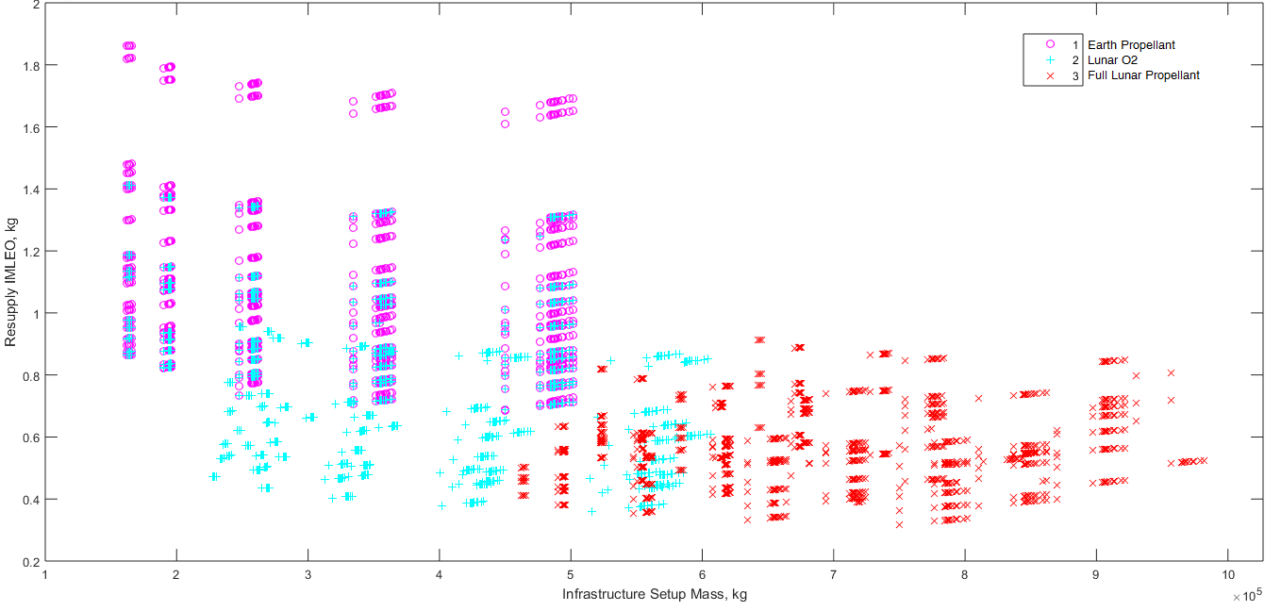

Figure 1. Infrastructure setup mass versus resupply IMLEO costs.

Figure 2 displays the design space for the science value of the missions versus the resupply IMLEO costs. The science value of the mission is our team’s first attempt to capture the utility of the mission, our third and final objective function. The pareto frontier extends along the bottom and rights sides of the design space indicating architectures that are efficient in terms of these two objective functions, being most efficient in the direction of the golden arrow.

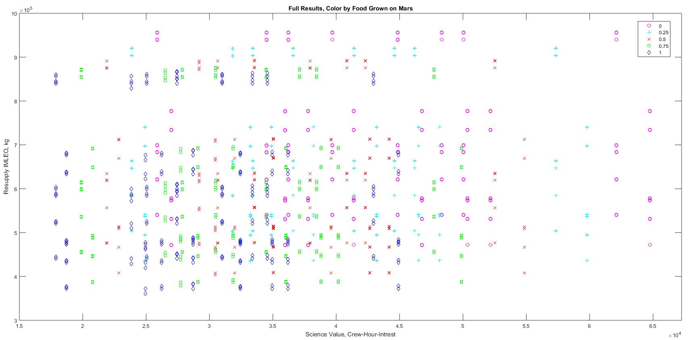

Figure 2. Mission science value versus resupply IMLEO costs.

Finally, three promising mission architectures from the pareto frontier of Figure 2 were extracted and a new DOE was conducted with simplified levels from the LH2 Isp and NTR Isp factors. Figure 3 displays the result of this second DOE suggesting that the IMLEO resupply mass is highly sensitive to both improved LH2 Isp and NTR Isp, depending upon the level of Lunar ISRU in the mission architecture; this supports the further investigation of these factors through this research.

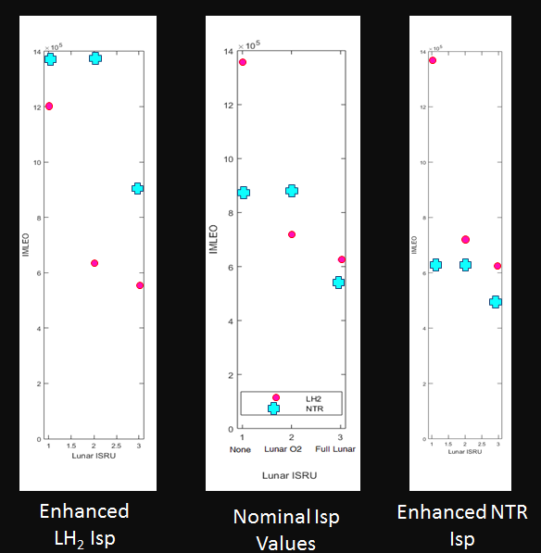

Figure 3. Sensitivity of resupply IMLEO costs to Isp variations in LH2 and NTR propulsion.

Based upon this initial DOE, an initial starting point for the optimizer may be determined by selecting a mission architecture that lies on or near the pareto frontier “knee” point in Figures 1 & 2. Reviewing the figures, architecture #1400 was selected as the starting point.

For the Isp and ISRU efficiency factors, is appears that enhanced Isp’s provide clear IMLEO benefits, but potential high developmental costs as suggested in the appendix. Therefore the starting point will use ISRU efficiency and Isp levels that appear at the anticipated “knee” point in the development cost curves for the technology development. This corresponds to LH2 Isp = 465 s, NTR Isp = 950 s, and εISRU = 1.0.

**Appendix**

**Proposed Cost Model**

Effective cost modelling is a very difficult topic often involving a great degree of uncertainty, particulary in areas involving “reach” technological developments and long developmental timeframes. As such, the effective prediction of development costs for the technology investments considered through this research optimization question will be a significant focus of our team moving forward. At this time we propose to develop an “expense attribute” that captures the various costs associated with the maturation of a technology, including raw cost, political will costs, schedule/time costs, and perhaps infrastructure costs. For example, from our initial research our team anticipates that nuclear propulsion will be a very expensive technology to mature as the support infrastructure currently does not exist in the US, there are few research groups working on the technology, and there is a societal and political stigma associated with nuclear activities.

The remainder of this appendix provides our teams initial reviews of the costing factors relevant for each technological development program dependent variable. At this time the relative TRL level for each technology level has been provided as well as development costs that could be found. A notional expense attribute curve has been provided for each technology outlining the cost trend we expect to see based upon our initial research. Please note that the expense attributes are not baselined at this time, and an expense attribute of zero for LH2 likely corresponds to significantly less cost than an expense attribute of zero for nuclear propulsion, for example. Our team will further refine and coordinate the expense attributes moving forward.

***Liquid Hydrogen/Oxygen (LH2) Isp Review***

LH2 Engine Reviews

|  |  |  |  |  |
| --- | --- | --- | --- | --- |
| Engine | Isp (vacuum) | Thrust | Country | First Flight/Last Fight |
| Vinci | 465 | 180,000 N | Europe | In Development |
| RL-10B-2 | 462 | 109,890 N | USA | Operational |
| SSME (RS-25) | 452 | 2,279,000 lbs | USA | Inactive until STS |
| RL-10A-4-2 | 451 | 99,100 N | USA | Operational |
| J-2X | 448 | 1,310,000 N | USA | In Development |
| LE-5B | 447 | 137,000 N | Japan | Operational |
| HM7B | 446 | 64,800 N | Europe | Operational |
| LE-7A | 438 | 1,098,000 N | Japan | Operational |
| Vulcain II (HM60) | 429 | 1,359,000 N | Europe | Operational |
| RS-68A | 414 | 3,560,000 N | USA | Operational |

Proposed Development Cost Curve

Numerous engines have operational TRL-9 capabilities of very high thrust up to Isp = 452 seconds, and moderate thrust up to 465 seconds. Therefore the following initial technology development curve may be proposed

* Isp <= 445 🡪 Low Cost
* 445 < Isp <= 452 🡪 Medium Cost
* 452 < Isp <= 465 🡪 High Cost
* 465 < Isp <= 480 🡪 Very High Cost

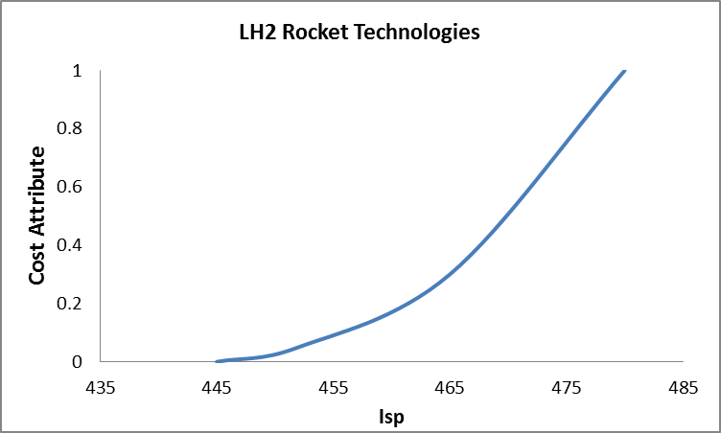

|  |  |  |
| --- | --- | --- |
| Isp | Cost Attribute | TRL |
| 445 | 0 | 9 |
| 452 | 0.05 | 9 |
| 465 | 0.3 | 8 |
| 480 | 1 | 7 |

***Nuclear Thermal Rocket (NTR) Review***

* Capable of providing thrust up to 25,000 lbf with an Isp greater than 900 seconds using LH2 as a propellant. Significant costs may be associated with improving these capabilities and developing test facilities on earth (NASA TA-2, 2015, pg 24, pg 73)
* Listed as TRL-4 from NASA programs in the 60’s and 70’s where a prototype flight design was conducted. However, facing new technologies, fuel forms, and materials has reduced the TRL to Level 3.
* The NASA Rover/NERVA program that ran from 1995-1973 developed 20 rocket reactors and achieved TRL-4 with a cost ~$10billion 1992 dollars (<http://trajectory.grc.nasa.gov/aboutus/papers/AIAA-93-4170.pdf>)
* The Russians also began and have kept going with NTR work, including extensive test facilities

Proposed Development Cost Curve

The 60’s and 70’s engines were of older design, but had a maximum thrust level of 250,000N and operated for long burn durations with Isp of 850 sec. Significant challenges exist in terms of developing new test facilities, increase material temperatures, and acquiring nuclear material

* Isp = 850 was displayed at TRL-4 with old technology 🡪 High Cost
* Isp = 950 was suggested as developable in 1999 with then technology 🡪 High Cost
* Isp = 1000 is commonly cited as achievable and was proposed to be met through Project Timberwind with a solid reactor 🡪 Very High Cost
* ISP 1300 – 1500 may be possible with a liquid-core engine, however these have not been seriously considered by NASA 🡪 Not achievable in near future
* ISP 1500 – 2000 (even up to 5000) could be possible in the far future with a gas core reactor (<https://en.wikipedia.org/wiki/Nuclear_thermal_rocket>) 🡪 Not achievable in near future

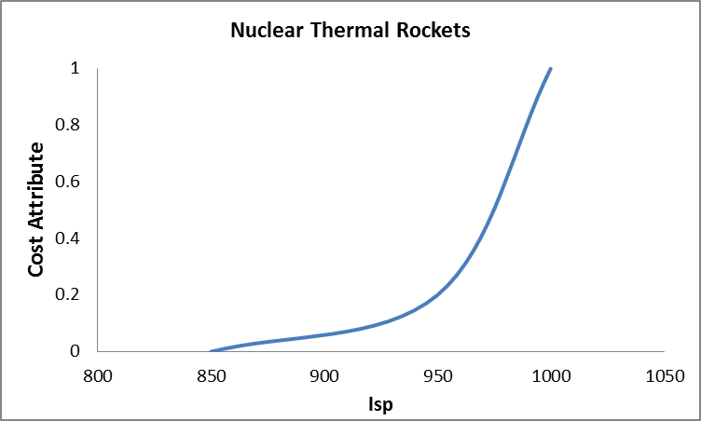

|  |  |  |
| --- | --- | --- |
| Isp | Cost Attribute | TRL |
| 850 | 0 | 4 |
| 950 | 0.2 | 3 |
| 1000 | 1 | 2 |

***Solar-Electric Propulsion (SEP) Review***

* Current projections are Isp greater than 4000 seconds, and sizes up to 100 kW. Major challenges include scaling these engines up to over a MW and providing long operation lifetime (NASA TA-2, 2015, pg 22, pg 59)
* Energy generation will be a significant problem for large thrust applications requiring nuclear generation or very large solar collection

SEP Engine Reviews

|  |  |  |  |  |  |
| --- | --- | --- | --- | --- | --- |
| Engine | Isp (vacuum) | Thrust | Energy Use | Country | First Flight/Last Fight |
| HiPep | 9000 | 0.67 N | 39.3 kW | USA | TRL 4 |
| VASIMR | 5000 | 5.7 N | 200 kW | USA | Development – TRL 4 |
| NEXT | 4100 | 0.236 N | 6.8 kW | USA | Development – TRL 5 |
| Boeing 702 | 3800 | 0.165 N | 4.5 kW | USA | Operational |
| NSTAR | 3100 | 0.0920 N | 2.3 kW | USA | Operational |

Proposed Development Cost Curve

Numerous electric propulsion technologies are already in the pipeline and significant investment and future mission plans already rely on the development of these technologies. We will assume that the any of these systems can produce roughly 5N of thrust at 200KW of draw simply by using multiple, smaller units.

* 3000 < Isp <= 3800 🡪 Low Cost
* 3800 < Isp <= 5000 🡪 High Cost
* 5000 < Isp <= 9000 🡪 Very High Cost

|  |  |  |
| --- | --- | --- |
| Isp | Cost Attribute | TRL |
| 3000 | 0 | 9 |
| 3800 | 0.1 | 9 |
| 5000 | 0.7 | 4 |
| 9000 | 1 | 4 |

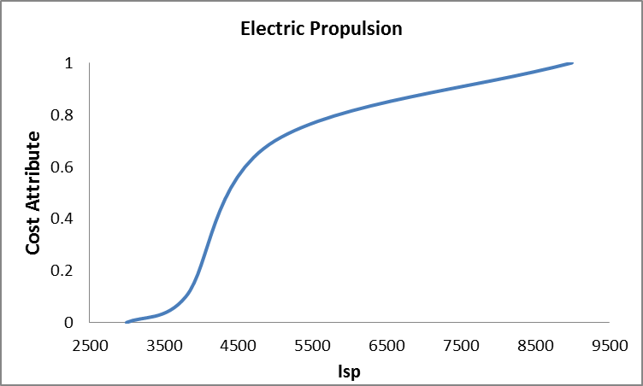

***Lunar ISRU Efficiency Reviews***

* Lunar ISRU sizing current accomplished in Lunar_ISRU.m function.

Results.Lunar_ISRU.Mass = (6.50 * O2_Per_Month) + 11800; %kg

Results.Lunar_ISRU.Power = (58.2 * (O2_Per_Month/1000)) + 30.8; %kW

This is equivalent to 78 * O2_Per_Year + 11800 kg. We can adjust this sizing to account for potential technology developments in the future.

“Human Exploration Destination Systems” is NASA Technology Area (TA) 7.1 and has a dedicated technology development roadmap covering 2015 – 2035.

Current Capabilities

* TRL levels for subsystems required to accomplish lunar ISRU for propellant production are approximately 2 as of 2011.

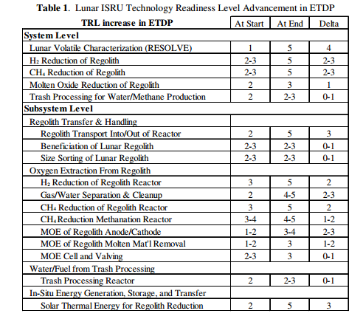

Larson, William, Gerald Sanders, and Mark Hyatt. "ISRU–From Concept to Reality: NASA Accomplishments and Future Plans." *AIA a space 2011 conference and exposition, Long Beach, California, AIAA*. Vol. 7114. 2011.

* Total cost to develop technology for lunar ISRU is approximate $19 billion.
  + Rapp, Donald. Human Missions to Mars. Praxis Publishing Limited, Chichester, UK, 2007.
* Recent similar sensitivity study found break-point to be around efficiency of 1.9 O2_Per_Year/ISRU_Mass.
  + Ishimatsu, Takuto, et al. "A Generalized Multi-Commodity Network Flow Model for Space Exploration Logistics." SPACE (2013).

**Proposed Development Cost Curve**

|  |  |  |  |
| --- | --- | --- | --- |
| Lunar ISRU | |  |  |
| Efficiency | Cost Attriubute | TRL | Cost B$ |
| Low | 0 | 2 | 19 |
| Med | 0.3 |  |  |
| High | 1 |  |  |

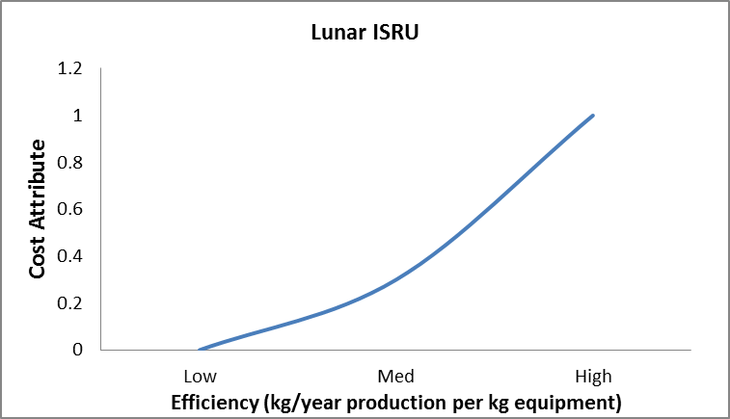

**Alternative Cost Model: Advanced Mission Cost Model**

As an alternative to using our own cost model, we will investigate NASA’s Advanced Mission Cost Model, which has been used for over 15 years for predicting development, launch, and operations costs for a variety of missions. The model is a function of many parameters which have been empirically determined, as well as a subjective ‘Difficulty’ parameter, D, which accounts for the relative efforts of each technology.

|  |  |
| --- | --- |
|  |  |

where

α = 5.56 x 10-4

β = 0.5941

Ξ= 0.6604

δ = 80.599

ε = 3.8085 x 10-55

φ = -0.3553

γ = 1.5691

Q = Quantity

M = Dry Mass (lbs)

S = Specification

IOC = Initial Operating Capability

B = Block Number

D = Difficulty

Larson, Wiley J., and Linda K. Pranke, eds. *Human spaceflight: mission analysis and design*. McGraw-Hill Companies, 1999.

Purdue, AAE 450 Senior Spacecraft Design Project Final Report, Spring 2004