Vascik – 3/13/16

Propulsion Isp reviews

Currently the Isp values for all propulsion types are input as parameters as part of the mission architecture “morph” matrix.

* From the “Propulsion” class we can get the current values assumed by the program. They are currently read into the class from the table “propulsionTypes.dat” seen below

|  |  |  |  |  |
| --- | --- | --- | --- | --- |
| PropulsionType | Isp | FuelOxidizerRatio | InertMassRatio | StaticMass |
| LH2 | 448 | 6.0 | 0.17 | 0 |
| NTR | 850 | 0 | 0.10 | 34500 |
| CH4 | 363 | 2.93 | .2 | 0 |

“In-Space Propulsion Technologies” is NASA Technology Area (TA) 2 and has a dedicated technology development roadmap covering 2015 – 2035.

**Liquid Hydrogen/Oxygen (LH2)**

* The SSME is the current most advanced LH2 engine developed deliver 512,00lbs of thrust with an Isp of 452 sec in a vacuum (<http://www.rocket.com/space-shuttle-main-engine>)
* SSME was contracted in 1972 and put into the first flight in 1981 (<http://www.alternatewars.com/BBOW/Space_Engines/SSME_Pursuit_Improvement.pdf>)
* This site provides some equations and discussion about maximum achievable Isp and shows that if the engine is only operating in a vacuum, it may be possible to bring Isp over 480 with very large expansion ratios (<http://www.alternatewars.com/BBOW/Space/Propellants.htm>)

LH2 Engine Reviews

|  |  |  |  |  |
| --- | --- | --- | --- | --- |
| Engine | Isp (vacuum) | Thrust | Country | First Flight/Last Fight |
| Vinci | 465 | 180,000 N | Europe | In development |
| [RL-10B-2](http://www.astronautix.com/engines/rl10b2.htm) | 462 | 109,890 N | USA | Operational |
| SSME (RS-25) | 452 | 2,279,000 lbs | USA | 1981/inactive until STS |
| RL-10A-4-2 | 451 | 99,100 N | USA | Operational |
| J-2X | 448 | 1,310,000 N | USA | In Development |
| LE-5B | 447 | 137,000 N | Japan | Operational |
| HM7B | 446 | 64,800 N | Europe | Operational |
| LE-7A | 438 | 1,098,000 N | Japan | Operational |
| Vulcain II (HM60) | 429 | 1,359,000 N | Europe | Operational |
| RS-68A | 414 | 3,560,000 N | USA | Operational |

**Proposed Development Cost Curve**

* Numerous engines have operational TRL-9 capabilities of very high thrust at 454 Isp, and moderate thrust at 465 Isp.
  + Isp <= 445 🡪 Low Cost
  + 445 < Isp <= 452 🡪 Medium Cost
  + 452 < Isp <= 465 🡪 High Cost
  + 465 < Isp <= 480 🡪 Very High Cost

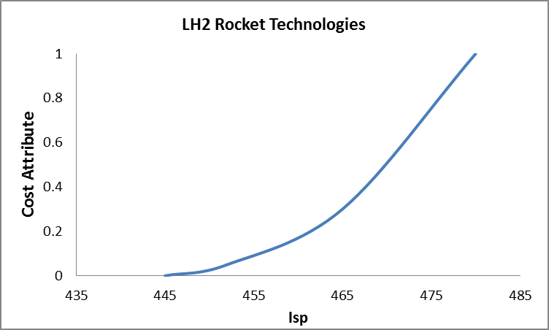

|  |  |  |
| --- | --- | --- |
| Isp | Cost Attribute | TRL |
| 445 | 0 | 9 |
| 452 | 0.05 | 9 |
| 465 | 0.3 | 8 |
| 480 | 1 | 7 |

**Questions**

* What are the thrust requirements of our engines?
* How do we want to baseline this cost attribute to compare to the other engine types. Conversely, we could do something going completely off of TRL… but then we need to associate costs of changes in TRL

**Nuclear Thermal Rocket (NTR)**

* Can provide high thrust up to 25,000 lbf with an Isp greater than 900 seconds using H2 as a propellant. Significant costs may be associated with improving these capabilities and developing test facilities on earth (NASA TA-2, 2015, pg 24, pg 73)
* General Isp’s seem to be quoted as 850-1000s
* Listed as TRL-4 from NASA programs in the 60’s and 70’s where a prototype flight design was conducted. However, they also say current modifications, fuel forms, and materials have reduced the TRL to 3.
* The NASA Rover/NERVA program that ran from 1995-1973 and developed 20 rocket reactors and got to TRL-4 cost ~$10billion 1992 dollars (<http://trajectory.grc.nasa.gov/aboutus/papers/AIAA-93-4170.pdf>)
* The Russians also began and have kept going with NTR work, including extensive test facilities

**Proposed Development Cost Curve**

* The 60’s and 70’s engines were of older design, but had a maximum thrust level of 250,000N and operated for long burn durations with Isp of 850 sec. Significant challenges exist in terms of developing new test facilities, increase material temperatures, and acquiring nuclear material
  + Isp = 850 was displayed at TRL-4 with old technology 🡪 High Cost
  + Isp = 950 was suggested as developable in 1999 with then technology 🡪 High Cost
  + Isp = 1000 is commonly cited as achievable and was proposed to be met through Project Timberwind with a solid reactor 🡪 Very High Cost
  + ISP 1300 – 1500 may be possible with a liquid-core engine, however these have not been seriously considered by NASA 🡪 Not achievable in near future
  + ISP 1500 – 2000 (even up to 5000) could be possible in the far future with a gas core reactor (<https://en.wikipedia.org/wiki/Nuclear_thermal_rocket>)

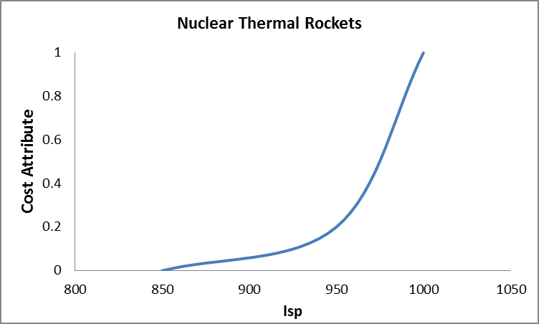

|  |  |  |
| --- | --- | --- |
| Isp | Cost Attribute | TRL |
| 850 | 0 | 4 |
| 950 | 0.2 | 3 |
| 1000 | 1 | 2 |

**Questions**

* None of these systems could be ready by 2020 if that is the goal. NASA estimates they will take at least 7 years to mature
* Unlike electric or chemical propulsion, the 0 cost attributes still face significant development costs and are not immediately ready for implementation

**Solar-Electric Propulsion (SEP)**

* Current projections are Isp greater than 4000 seconds, and sizes up to 100 kW. Major challenges include scaling these engines up to over a MW and providing long operation lifetime (NASA TA-2, 2015, pg 22, pg 59)
* Energy generation will be a significant problem for large thrust applications requiring nuclear generation or very large solar collection

SEP Engine Reviews

|  |  |  |  |  |  |
| --- | --- | --- | --- | --- | --- |
| Engine | Isp (vacuum) | Thrust | Energy Use | Country | First Flight/Last Fight |
| HiPep | 9000 | 0.67 N | 39.3 kW | USA | TRL 4 |
| VASIMR | 5000 | 5.7 N | 200 kW | USA | Development – TRL 4 |
| NEXT | 4100 | 0.236 N | 6.8 kW | USA | Development – TRL 5 |
| Boeing 702 | 3800 | 0.165 N | 4.5 kW | USA | Operational |
| NSTAR | 3100 | 0.0920 N | 2.3 kW | USA | Operational |

**Proposed Development Cost Curve**

* Numerous electric propulsion technologies are already in the pipeline and significant investment and future mission plans already rely on the development of these technologies. We will assume that the any of these systems can produce roughly 5N of thrust at 200KW of draw simply by using multiple, smaller units.
  + 3000 < Isp <= 3800 🡪 Low Cost
  + 3800 < Isp <= 5000 🡪 High Cost
  + 5000 < Isp <= 9000 🡪 Very High Cost

|  |  |  |
| --- | --- | --- |
| Isp | Cost Attribute | TRL |
| 3000 | 0 | 9 |
| 3800 | 0.1 | 9 |
| 5000 | 0.7 | 4 |
| 9000 | 1 | 4 |

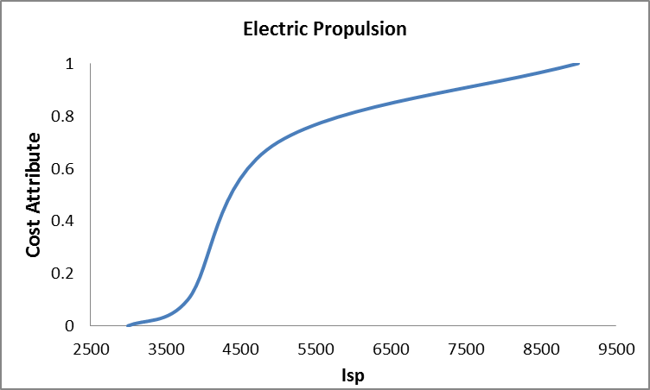

**Questions**

* How will the low thrust, but long burn time of these engines alter our orbital predictions in the code?
* These engines require a significant amount of power (indicated in the new column) and therefore would require some sort of energy generation not in our code whether it be solar or a nuclear reactor

**Liquid Methane (CH4)**

* Target performance levels are an Isp = 355 seconds (NASA TA-2, 2015, pg 15)
* Space-X is currently working on their Raptor engine which they propose will produce 2300 kN of force with an Isp of 363 s.