3DSFERA User Manual
China Mainland Source Code Copyright Submission - English Version
Interface screenshots, operation flow, interaction behavior, and function descriptions
This manual documents the customer, player, supplier, and merchant-facing functions of the 3DSFERA platform. It is prepared for mainland China source code copyright review and includes complete interface screenshots with explanatory text for the main screens, secondary screens, product interfaces, pavilion interactions, arcade functions, dashboards, forms, pop-ups, editing/saving flows, and display behavior.
Screenshot language: English. Public entry and login screens were captured from https://3dsfera.vercel.app. Protected dashboards, product overlays, pavilion sub-functions, and Unreal/3D event overlays were captured from the same source-code build in a local review environment so that every functional page can be shown completely even when the production account redirects during supplier session authentication.

1. Scope And Six Major Functions
Function area | Covered pages and screenshots
Account login and authentication | Home entry, supplier password login, player password login, auth-gated inbox state
Main menu and role entry | Landing/main menu, role selection, onboarding guide
3D world and points of interaction | Fast view HUD, AI chat, product hotspots, supplier pavilions, contact actions
Customer shopping and product browsing | Product cards, catalogue overlay, pavilion product grids, product detail modal, shopper dashboard
Player rewards, delivery, and arcade | Quest dashboard, reward queue, delivery acceptance form, Neon Runner, Prize Drop, Signal Match
Supplier and merchant management | Business dashboard, supplier dashboard, upload form, product/inbox workflow

2. Operation Overview
- Open the 3DSFERA site and choose the desired entry path from the main interface.
- Log in with the corresponding role account. The role determines whether the user sees customer, player, supplier, or business dashboard functions.
- After entry, use the role selection screen or the in-world menu to switch between shopping, arena/player, supplier, and world-map areas.
- Inside the 3D world, click or trigger product hotspots, pavilions, AI chat, reward terminals, or arcade cabinets. Each interaction opens a focused overlay or secondary panel.
- For product and supplier interactions, view details, add products, request quotes, open chat, send contact forms, or book meetings.
- For reward interactions, review quests, rewards, wallet activity, and enter delivery information before accepting physical delivery.
- For supplier functions, review dashboard metrics, manage products, upload product data, and handle supplier communication states.

3. Account Login And Authentication

3.1 Home And Main Function Menu
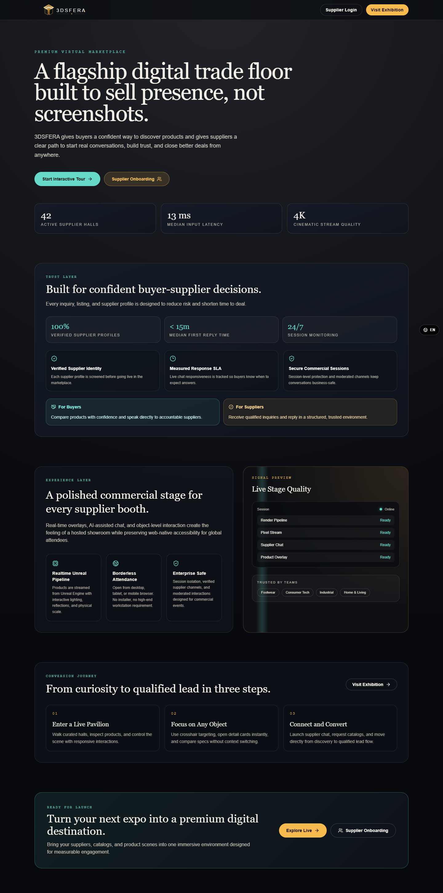
Figure: 3.1 Home And Main Function Menu
The landing interface is the first screen shown to visitors. It provides the brand entry point, language control, and primary navigation toward the 3D scene, role workflows, and authentication paths.
Interactive elements and behavior:
- Click the main scene/start control to enter the 3D experience or role flow.
- Use the language selector to switch interface language; the screenshot confirms the English UI state.
- Navigation controls route users to login, role selection, or platform areas depending on session state.

3.2 Supplier Password Login
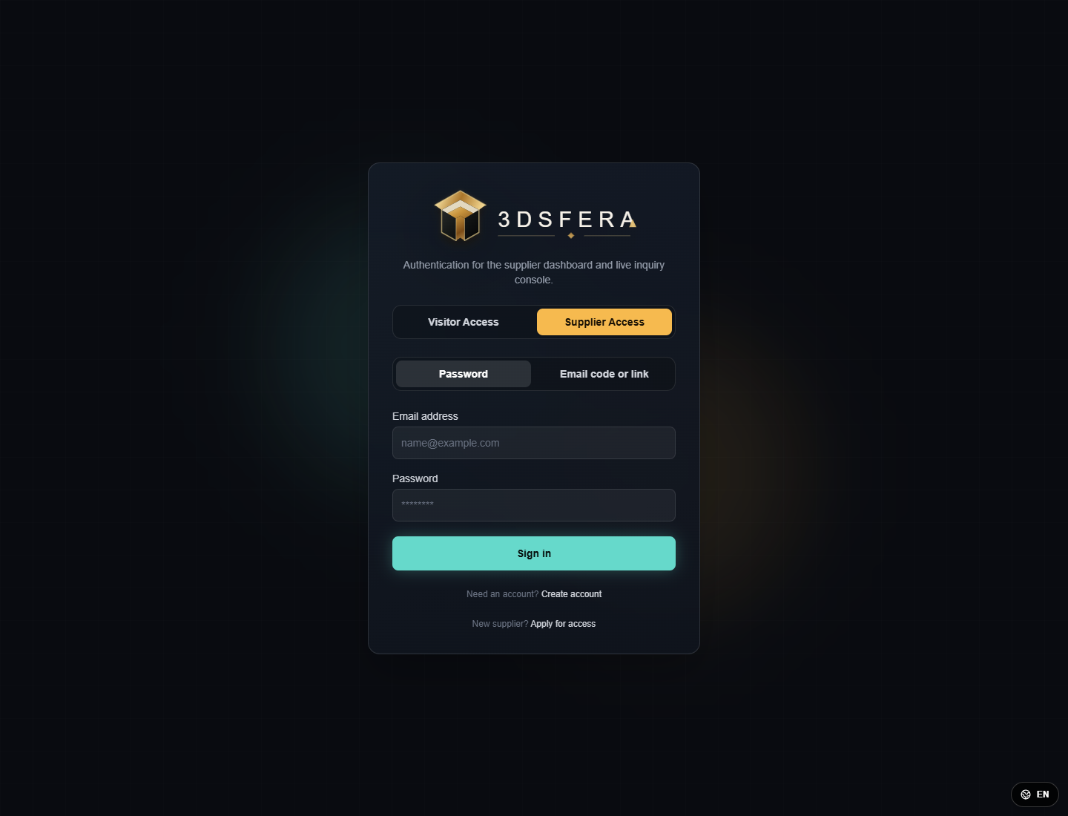
Figure: 3.2 Supplier Password Login
The supplier login screen collects credentials for merchant-side management functions. The visible password field state demonstrates the password authentication method used for supplier accounts.
Interactive elements and behavior:
- Email field accepts the supplier account identifier.
- Password field masks or reveals input depending on the eye/icon control.
- Submit starts session authentication; validation messages appear if credentials or role authorization fail.

3.3 Player Password Login
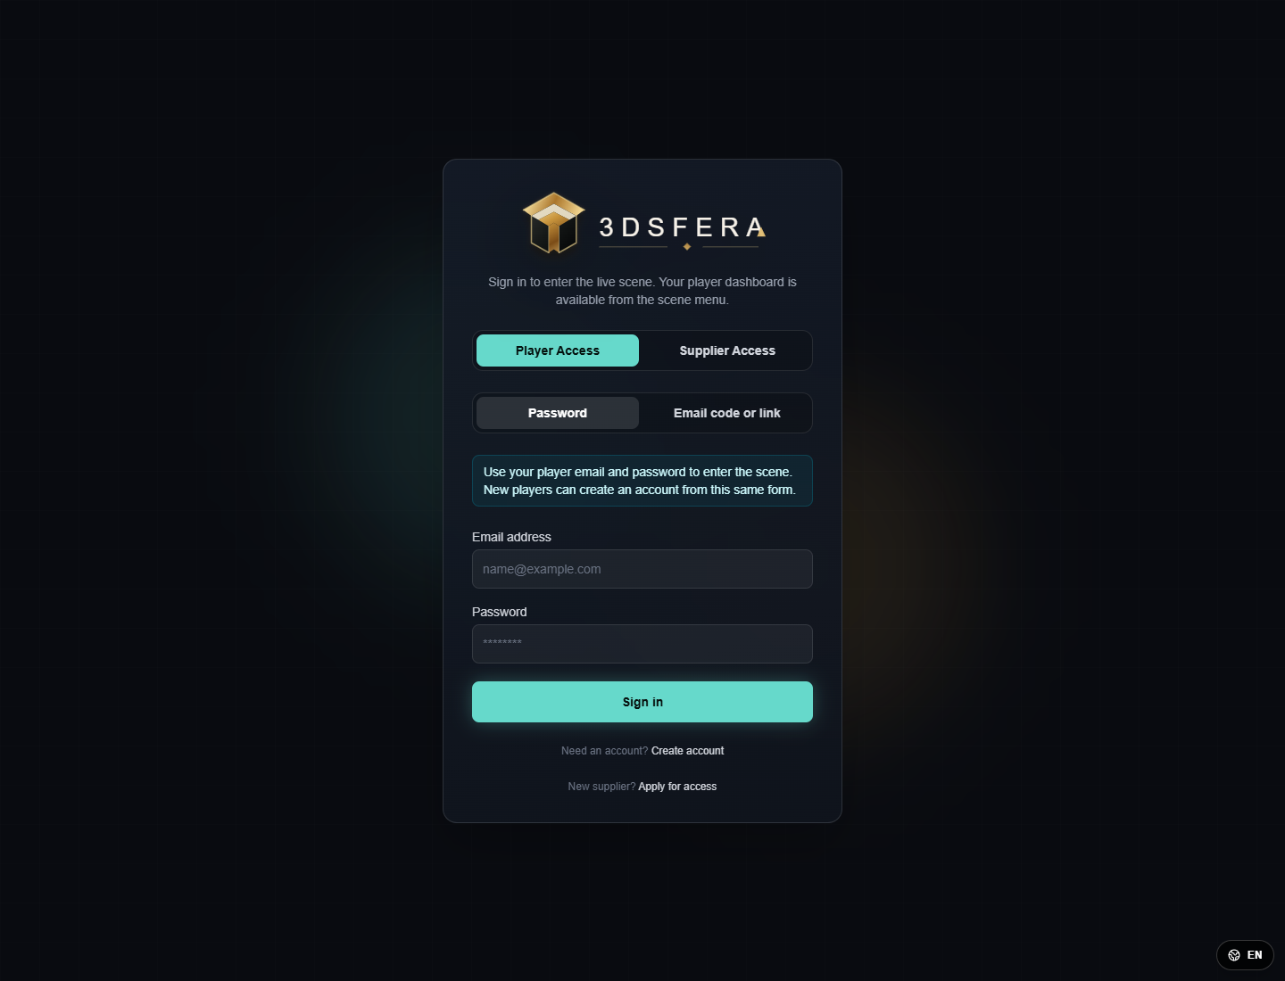
Figure: 3.3 Player Password Login
The player login screen authenticates the customer/player role before quests, rewards, dashboard, and delivery functions become available.
Interactive elements and behavior:
- Email and password fields collect player credentials.
- Submit signs in the player and redirects to the player dashboard or requested protected route.
- Secondary links allow role switching or returning to the public entry flow.

3.4 Auth-Gated Supplier Inbox State
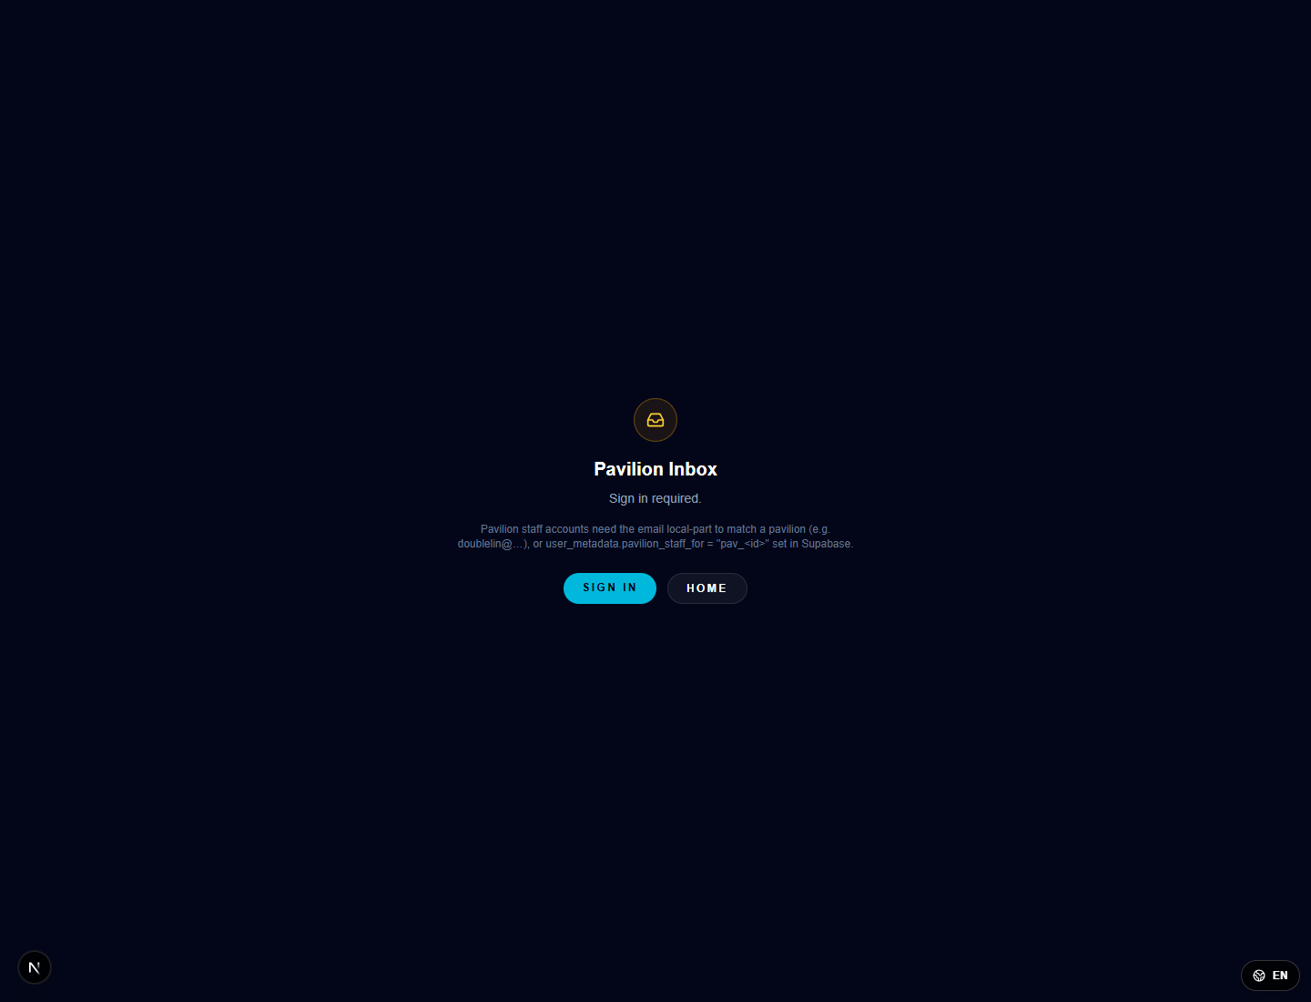
Figure: 3.4 Auth-Gated Supplier Inbox State
When a protected supplier communication page is opened without a valid supplier session, the interface shows an authentication state instead of private messages.
Interactive elements and behavior:
- The message explains that sign-in is required before the inbox can display protected supplier content.
- The user must return to login or restore a valid supplier session.
- No private supplier data is shown in the unauthenticated state.

4. Main Menu, Role Selection, And Onboarding

4.1 Role Selection Screen
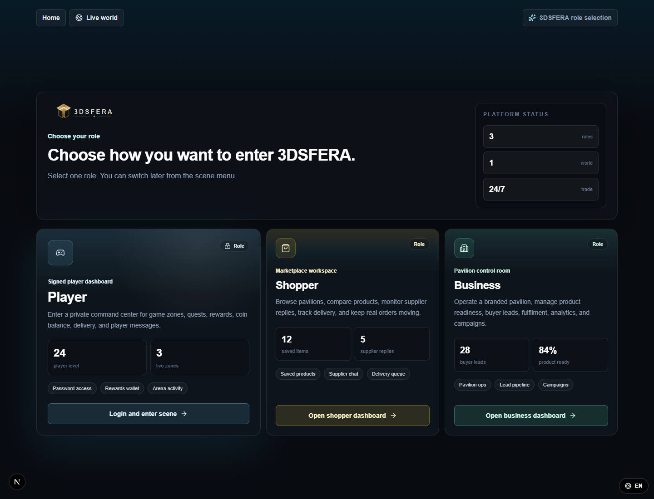
Figure: 4.1 Role Selection Screen
The role selection interface separates the main functional modules of the application. It allows users to choose shopper/customer, player, supplier, or business workflows.
Interactive elements and behavior:
- Click a role card to enter that role's dashboard or scene mode.
- Back-to-scene navigation returns the user to the 3D environment.
- Role-specific access determines which panels, menus, and actions are shown next.

4.2 Onboarding Guide
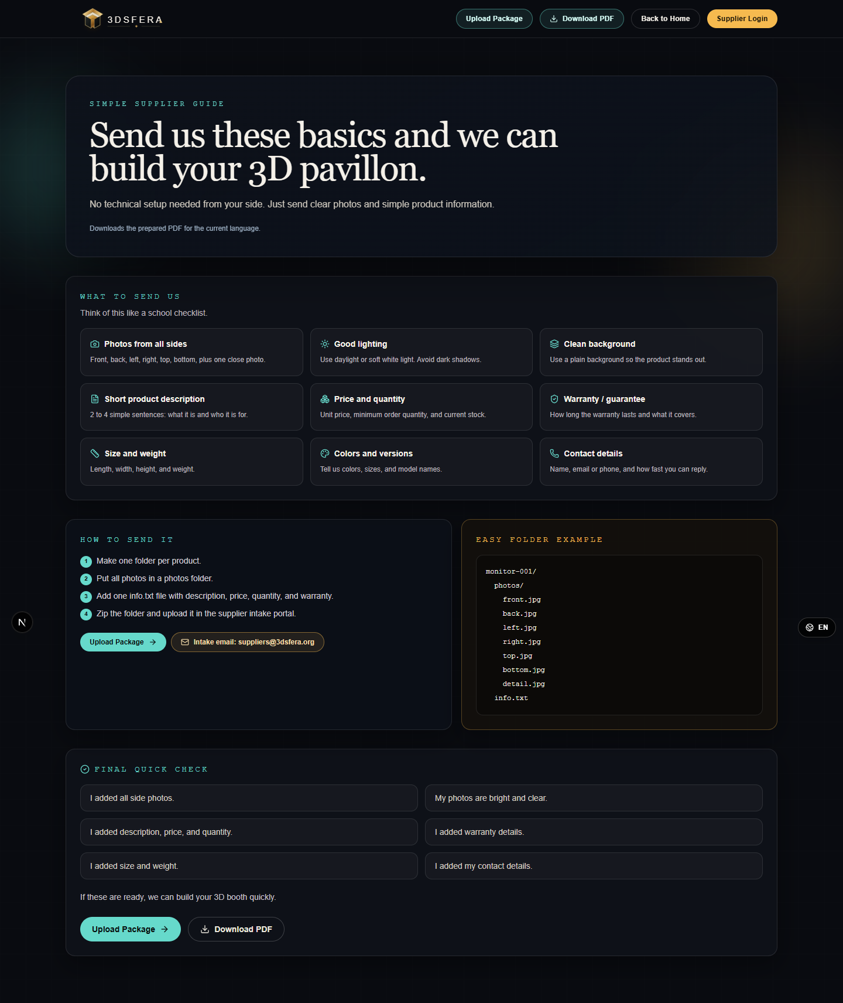
Figure: 4.2 Onboarding Guide
The onboarding guide introduces the first-use flow and gives structured entry steps for new users before they begin interacting with 3D points of interest.
Interactive elements and behavior:
- Step controls advance through onboarding content.
- Close/continue actions dismiss the guide and return to the active page.
- The guide explains the relationship between scene navigation, pavilions, products, and dashboard functions.

5. 3D World And Points Of Interest

5.1 Fast View HUD And AI Chat
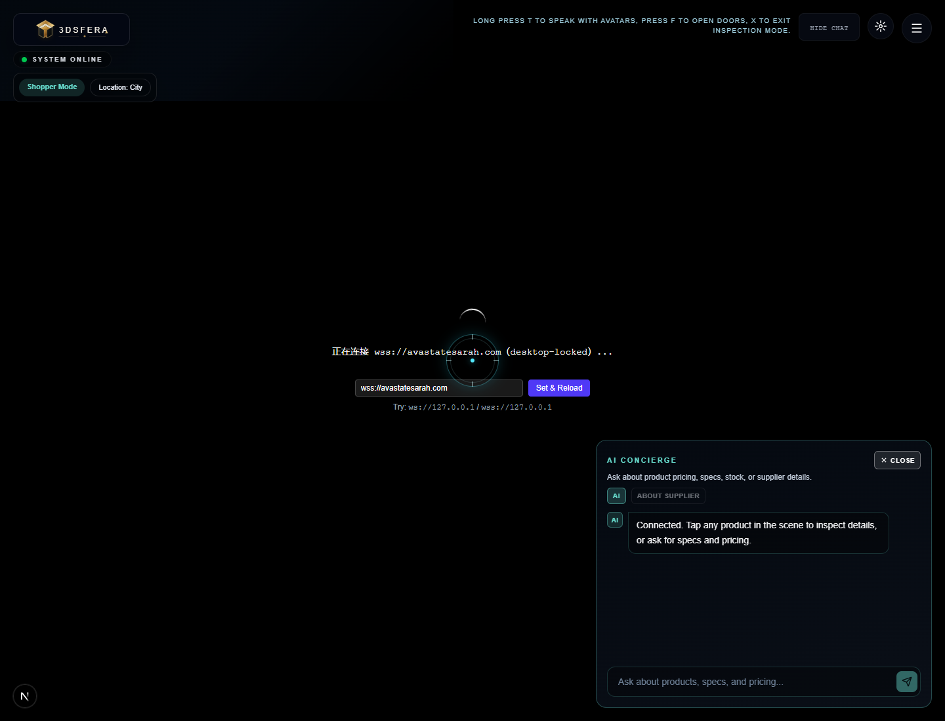
Figure: 5.1 Fast View HUD And AI Chat
The 3D world HUD places navigation, menu, chat, and interaction controls over the streaming/scene area. It is used for live exploration and quick assistance.
Interactive elements and behavior:
- AI chat accepts typed questions and displays assistant responses in the chat panel.
- HUD buttons open menus, dashboards, pavilions, arcade, or other scene tools.
- Clickable in-world points of interest can open product cards, pavilion pages, or functional overlays.

5.2 Youbo Pavilion Product Grid
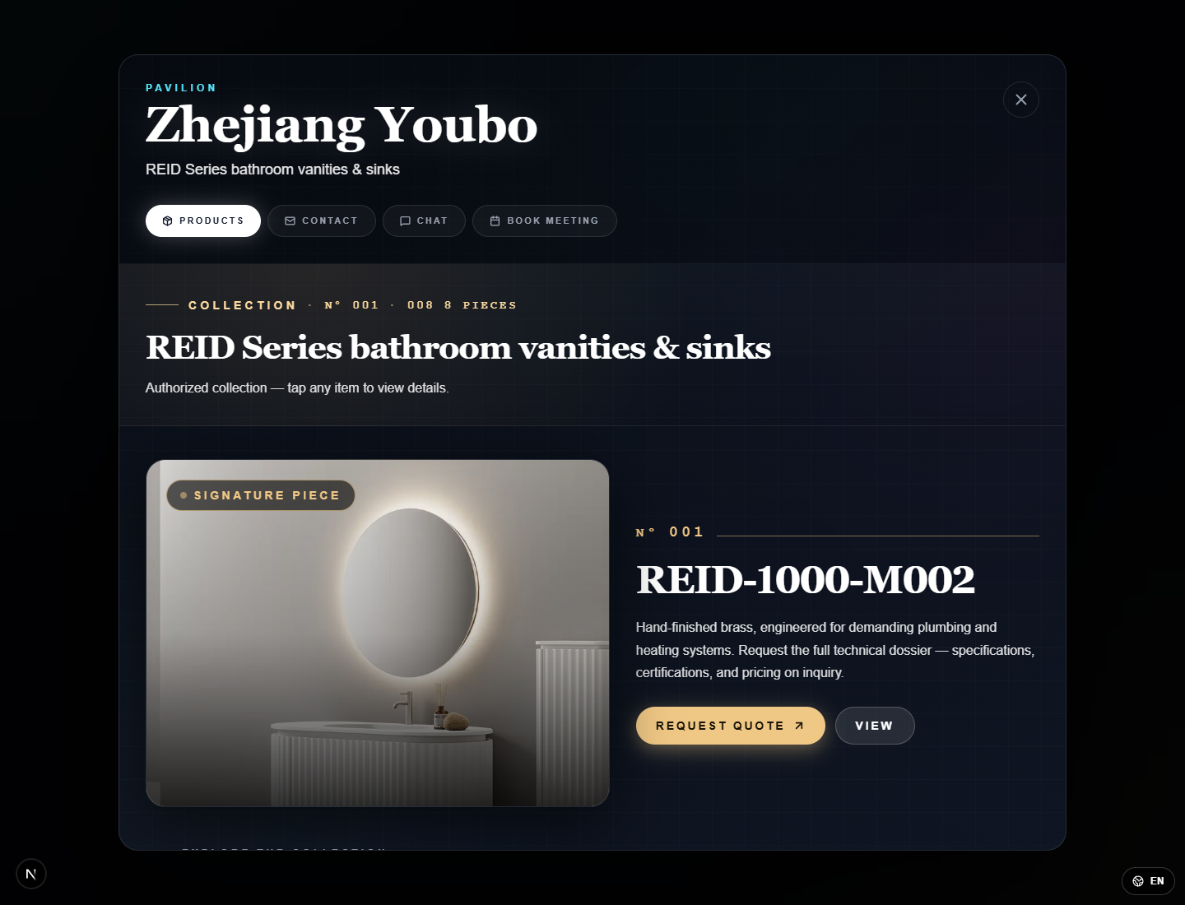
Figure: 5.2 Youbo Pavilion Product Grid
Supplier pavilions are interactive 3D commerce points. The product grid lists available supplier products and opens secondary views for detail, quote, contact, or meeting actions.
Interactive elements and behavior:
- Product cards show names, availability, and supplier context.
- View/detail controls open a product detail modal.
- Contact, chat, and meeting controls launch separate communication sub-functions.

5.3 Double Lin Pavilion Product Grid
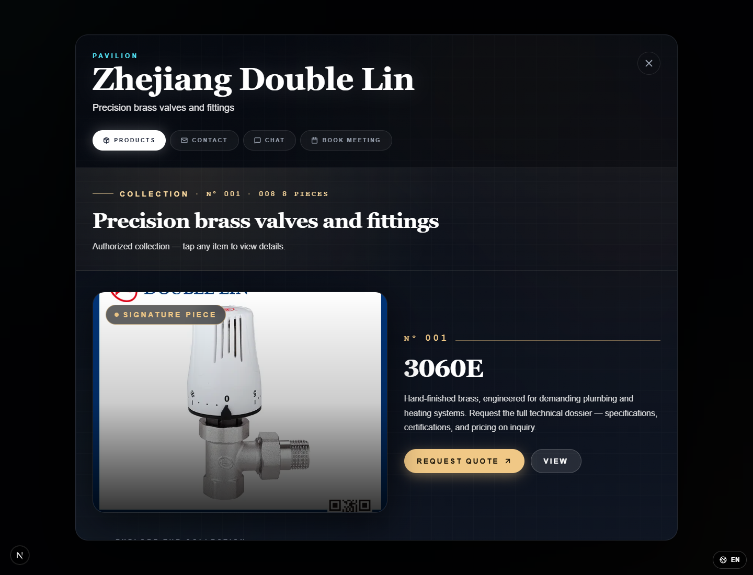
Figure: 5.3 Double Lin Pavilion Product Grid
A second supplier pavilion is included to show that pavilion logic is reusable across different companies and product catalogues.
Interactive elements and behavior:
- Each pavilion loads supplier-specific products and branding.
- Clicking product actions opens the corresponding detail or contact workflow.
- The user can close the pavilion and return to the 3D scene.

6. Customer Shopping And Product Browsing

6.1 Product Card - Techway Gaming G15
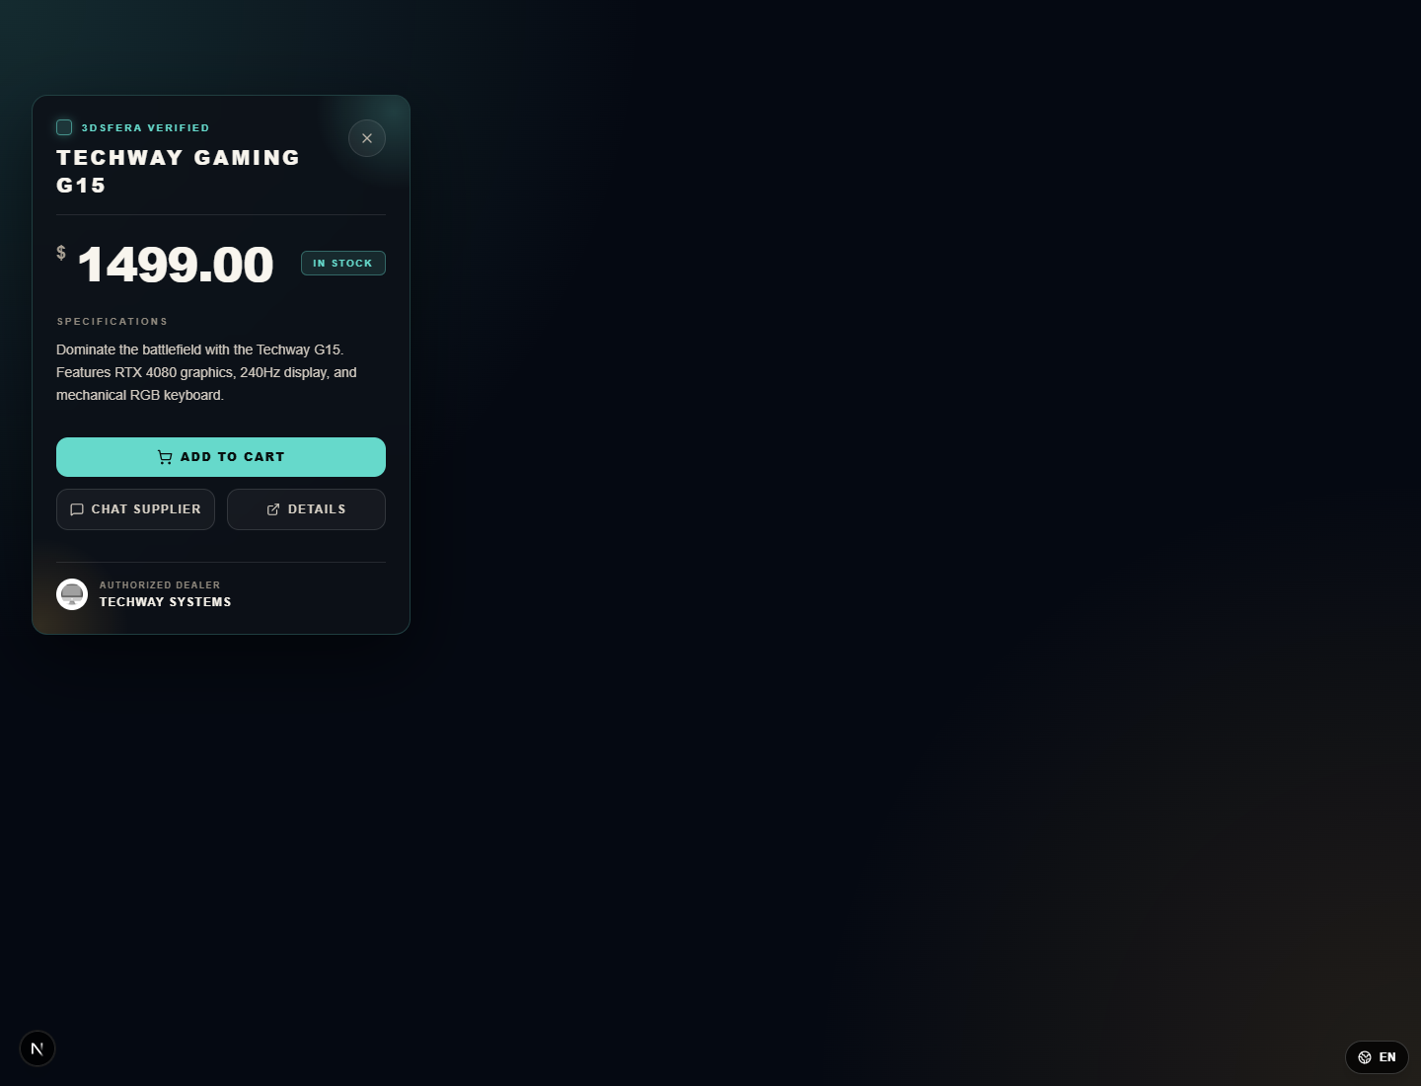
Figure: 6.1 Product Card - Techway Gaming G15
The product card is a compact overlay opened from product hotspots. It displays the product name, price, inventory status, specifications, dealer, and purchase/chat actions.
Interactive elements and behavior:
- Add to cart records the product for customer purchase flow.
- Chat Supplier opens supplier communication for the listed dealer.
- Details opens a fuller product detail page or overlay.
- Close returns to the underlying 3D or catalogue interface.

6.2 Product Card - Nonagon Phone
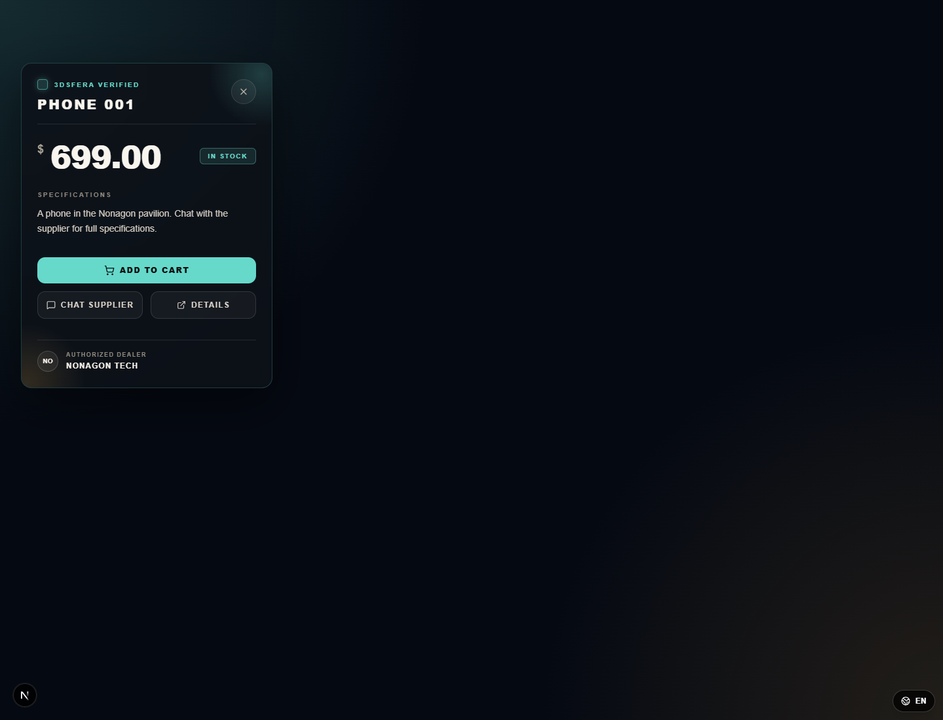
Figure: 6.2 Product Card - Nonagon Phone
This second product card demonstrates the same interaction pattern for a different supplier/product type, confirming that the overlay is product-data driven.
Interactive elements and behavior:
- Price and inventory update according to product data.
- Dealer identity changes with the selected product.
- Primary and secondary actions remain consistent for customer usability.

6.3 Catalogue Overlay
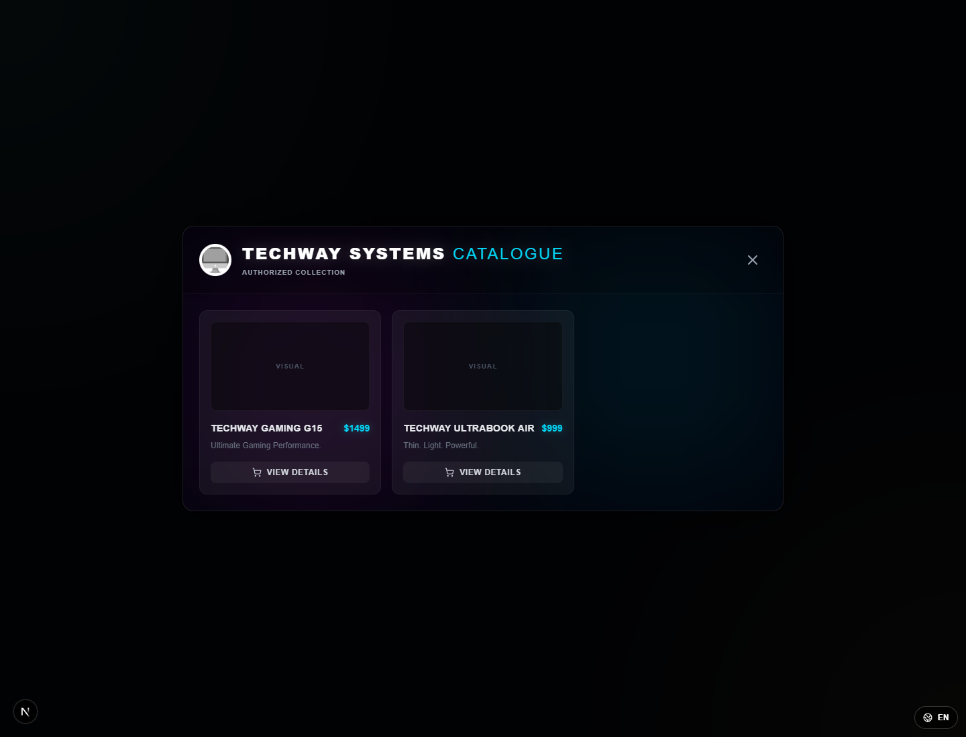
Figure: 6.3 Catalogue Overlay
The catalogue overlay lists multiple products from a supplier or category. It supports browsing beyond a single hotspot and allows the user to open individual product details.
Interactive elements and behavior:
- Product rows/cards display catalogue items with pricing and availability.
- Search or category controls refine displayed items when available.
- Selecting an item opens product details; close returns to the prior scene.

6.4 Pavilion Product Detail Modal
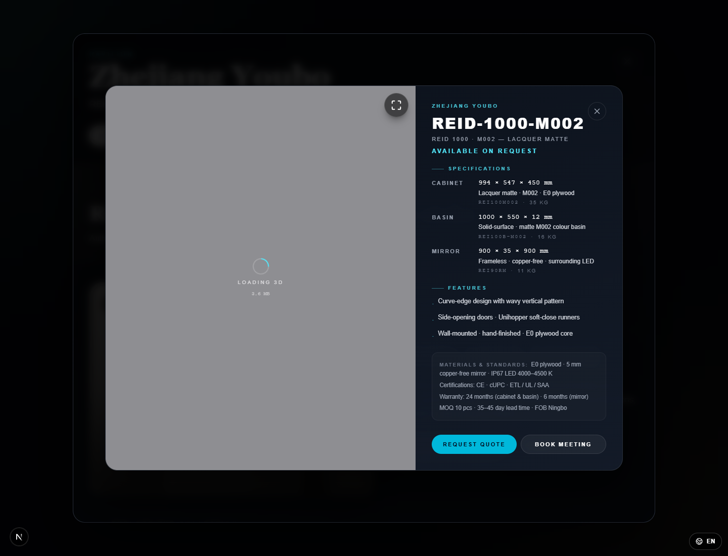
Figure: 6.4 Pavilion Product Detail Modal
The product detail modal is a secondary page for detailed inspection. It combines a 3D/model preview area with structured specifications, features, standards, and commercial action buttons.
Interactive elements and behavior:
- Request Quote opens quote/contact handling for the selected item.
- Book Meeting starts a scheduling workflow for supplier follow-up.
- Fullscreen/expand controls enlarge the preview area when a model is available.
- Close returns to the pavilion product grid without losing context.

6.5 Shopper Dashboard - Orders And Shopping State
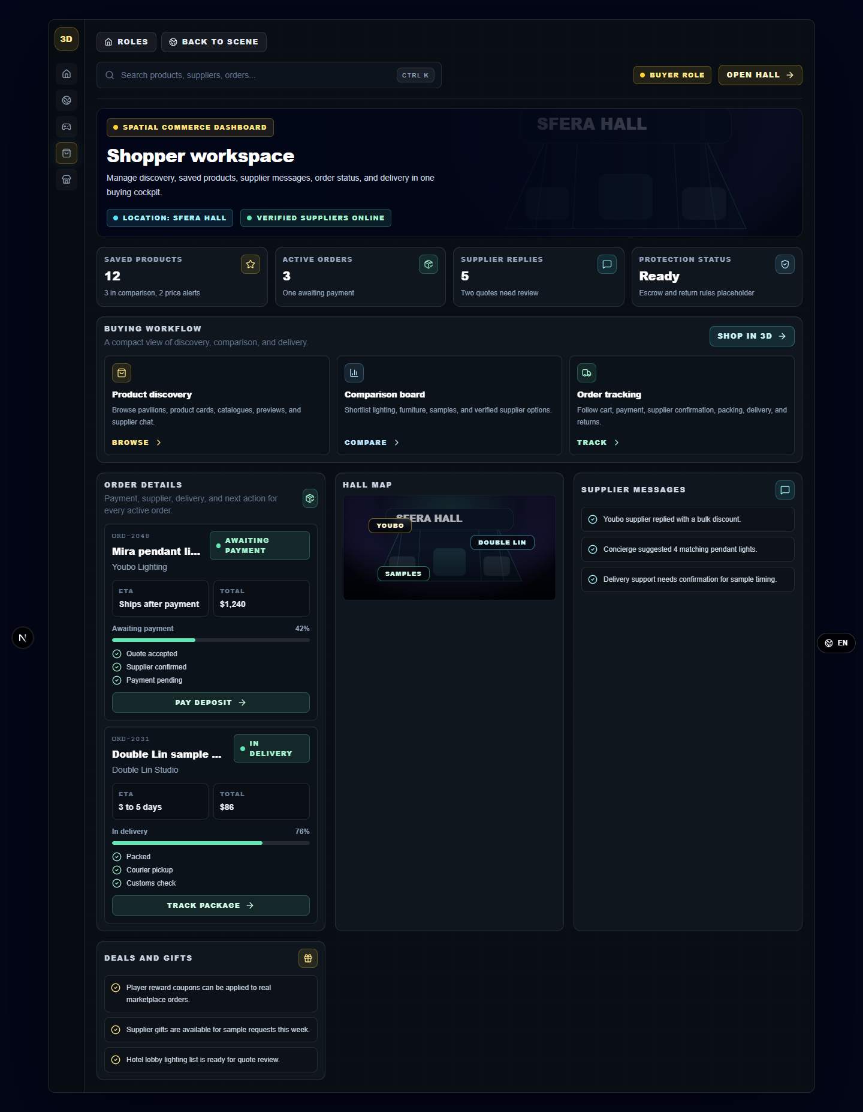
Figure: 6.5 Shopper Dashboard - Orders And Shopping State
The shopper dashboard summarizes customer-facing shopping state, including orders, relevant activity, supplier messages, or delivery-related customer records.
Interactive elements and behavior:
- Sidebar navigation switches between customer dashboard sections.
- Search filters customer-facing records.
- Cards and tables display orders, status, and recent actions.

7. Pavilion Communication Sub-Functions

7.1 Pavilion Contact Form
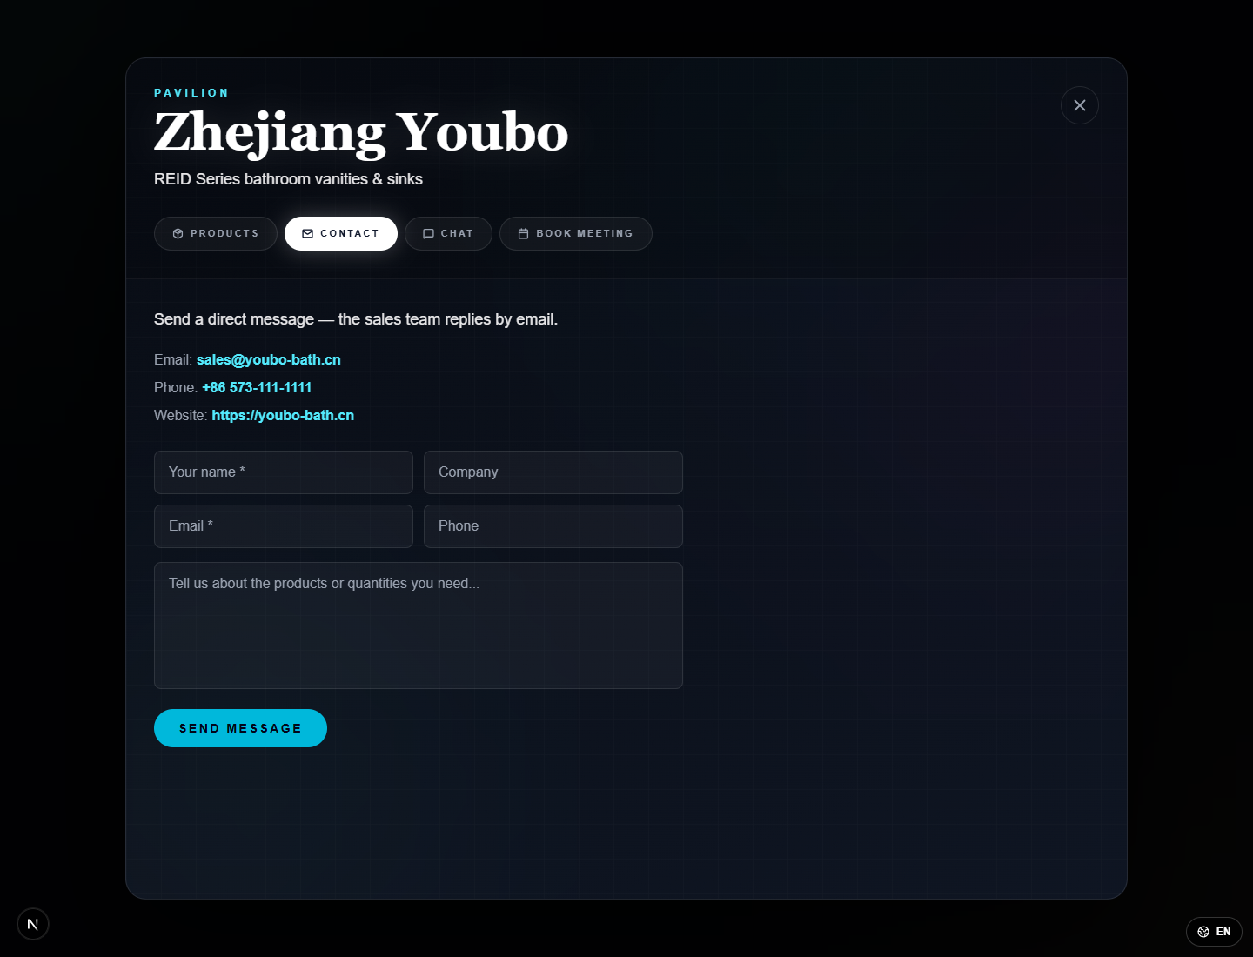
Figure: 7.1 Pavilion Contact Form
The contact form is used to submit supplier inquiries from within a pavilion. It collects structured message details rather than relying only on chat.
Interactive elements and behavior:
- Text fields collect visitor name/contact data and message content.
- Submit sends the inquiry; validation appears if required fields are missing.
- Cancel or close returns to the pavilion page.

7.2 Pavilion Chat Window
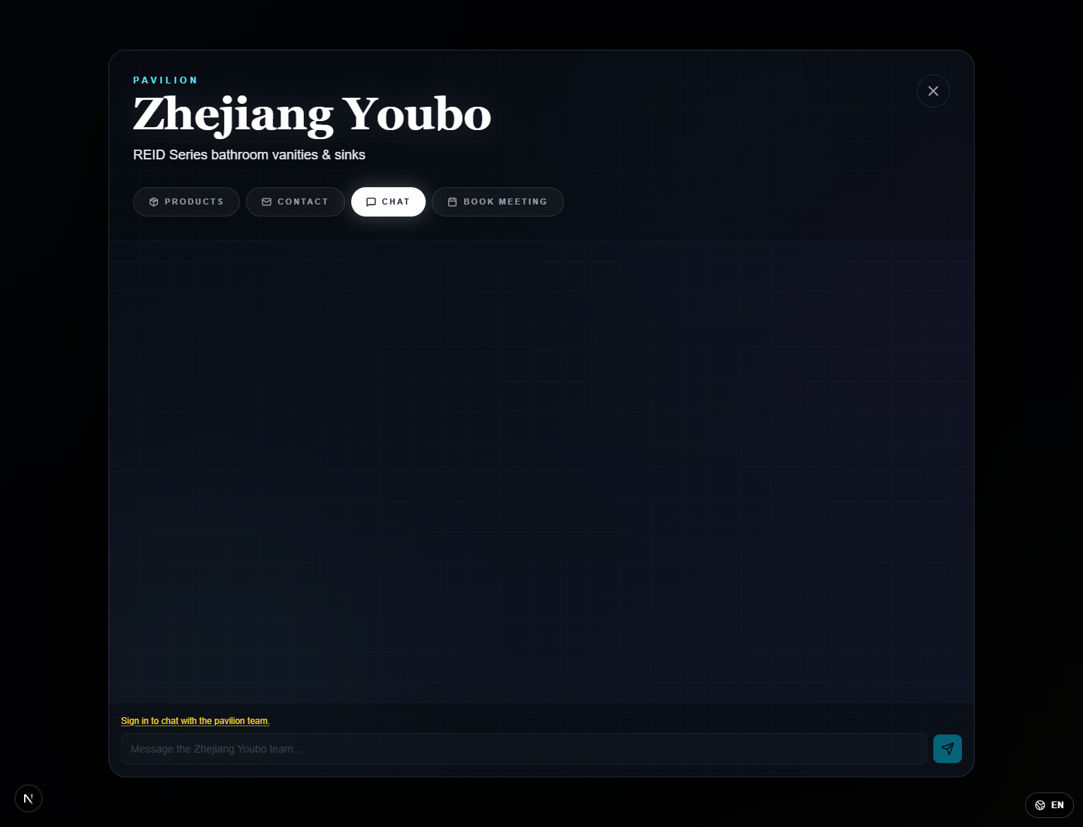
Figure: 7.2 Pavilion Chat Window
The chat interface supports direct conversational communication with the supplier from the pavilion context.
Interactive elements and behavior:
- Message input sends a chat message to the supplier conversation.
- Chat history displays prior messages in the panel.
- Close returns to the pavilion without leaving the supplier context.

7.3 Book Meeting Dialog
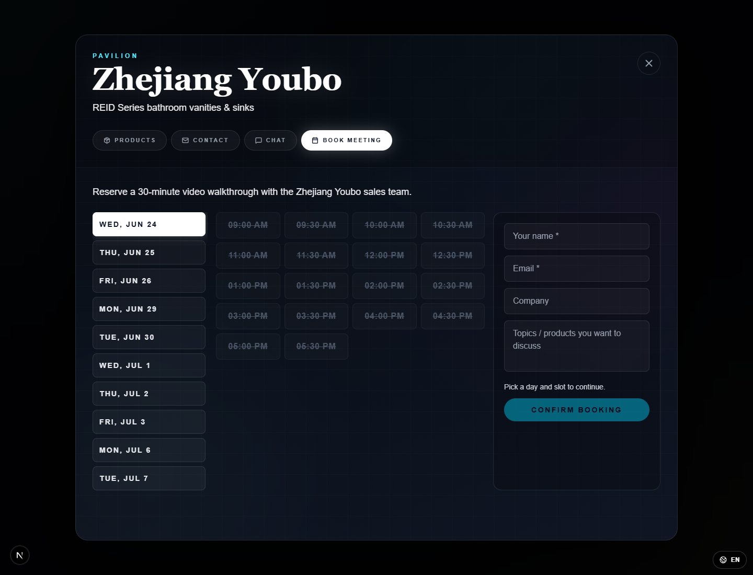
Figure: 7.3 Book Meeting Dialog
The meeting dialog collects scheduling information for supplier follow-up. It is a secondary workflow launched from a pavilion or product detail action.
Interactive elements and behavior:
- Date/time and contact fields define the requested meeting slot.
- Save/submit records the meeting request and displays confirmation or validation feedback.
- Cancel closes the dialog without saving changes.

8. Player Rewards, Delivery, And Arcade

8.1 Player Dashboard - Quest Progress
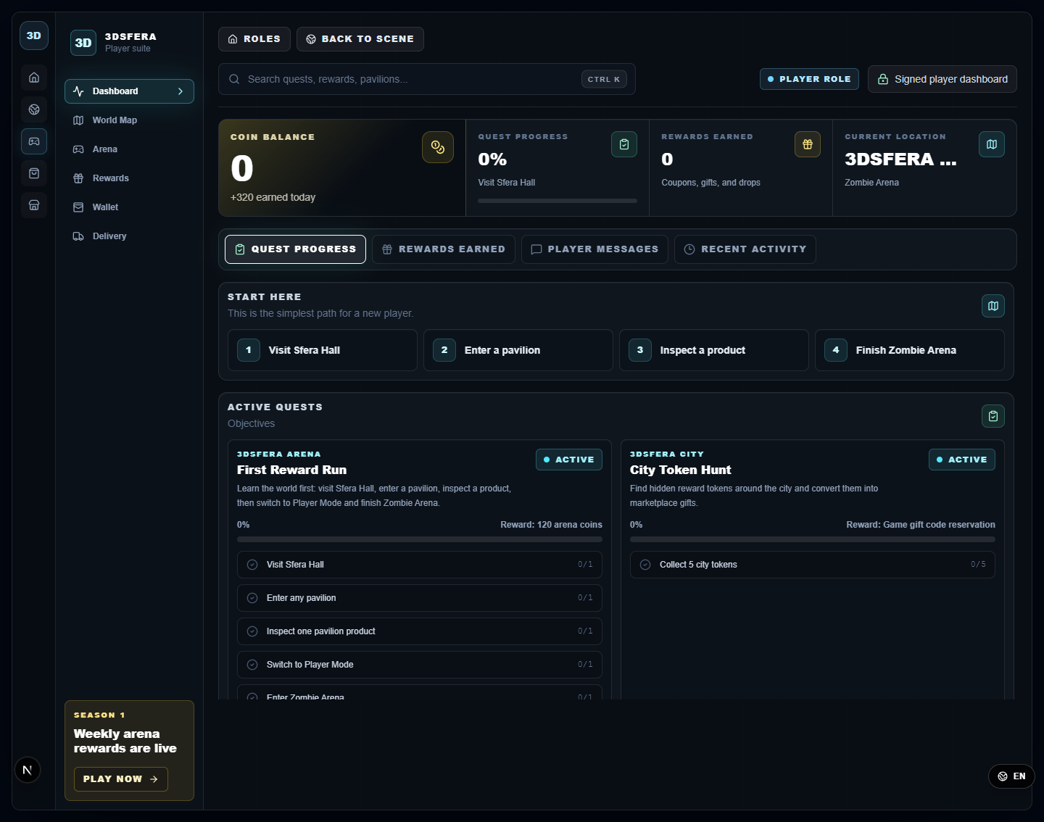
Figure: 8.1 Player Dashboard - Quest Progress
The player dashboard tracks quest status, coin balance, rewards, current location, and activity in the gamified 3D experience.
Interactive elements and behavior:
- Quest tabs display active and completed quest progress.
- Dashboard navigation switches to rewards, wallet, delivery, arena, and messages.
- Progress bars and reward cards update when gameplay events are completed.

8.2 Player Rewards And Delivery - Empty State
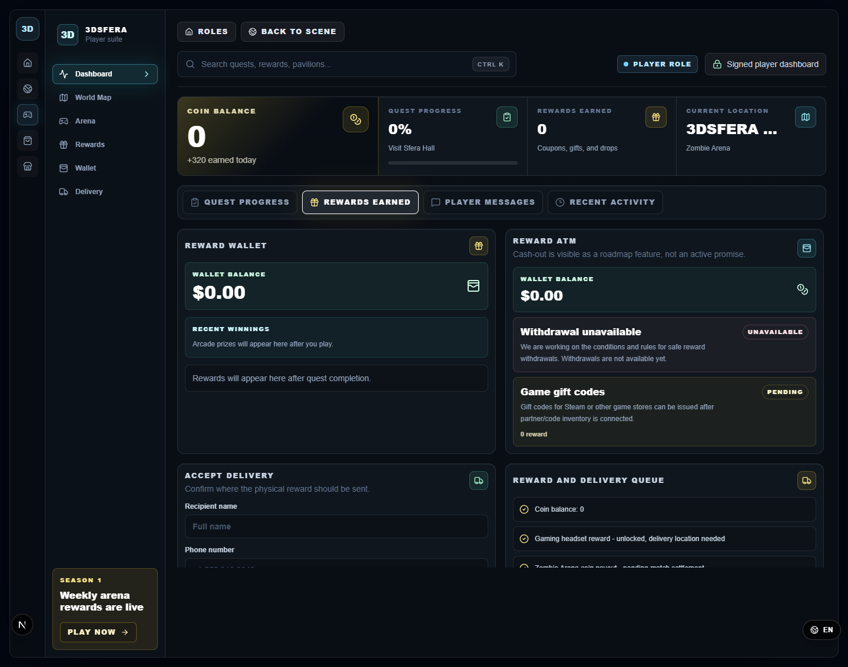
Figure: 8.2 Player Rewards And Delivery - Empty State
The rewards tab shows earned reward state and physical-delivery requirements. The empty/initial state explains that rewards appear after quest completion.
Interactive elements and behavior:
- Reward cards display pending, earned, or unavailable rewards.
- Delivery area prompts for required recipient details before claim fulfillment.
- Activity queue displays wallet and reward history.

8.3 Delivery Acceptance Form
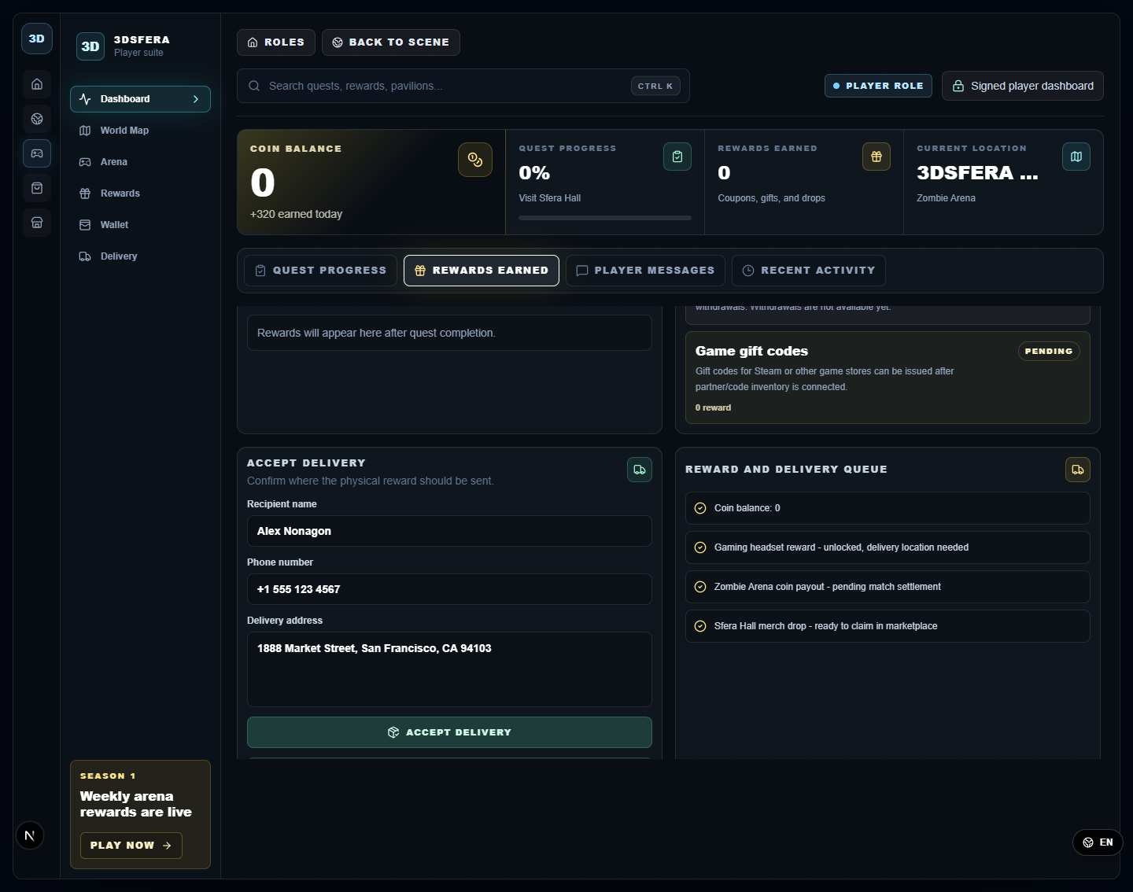
Figure: 8.3 Delivery Acceptance Form
The delivery acceptance panel collects the added recipient fields required by the customer/player before physical reward fulfillment: name, phone number, and delivery address.
Interactive elements and behavior:
- Recipient name field records the delivery receiver.
- Phone number field records the contact number for fulfillment.
- Delivery address field records the shipping destination.
- Accept Delivery saves the provided values and moves the claim into a delivery/fulfillment state.

8.4 Arcade - Neon Runner
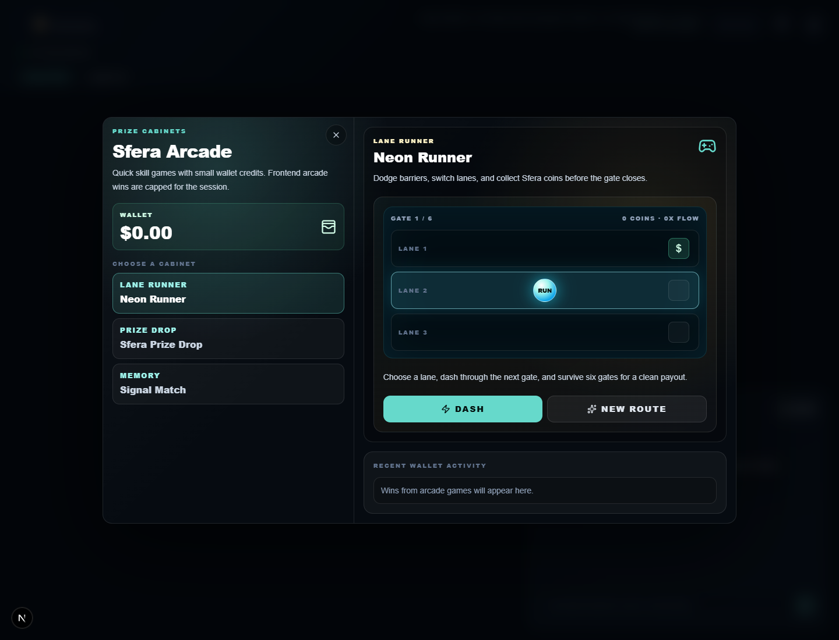
Figure: 8.4 Arcade - Neon Runner
Neon Runner is a lane-switching arcade cabinet. The screenshot shows wallet balance capped at zero before play and a more restrained payout design.
Interactive elements and behavior:
- Choose a lane and press Dash to advance through gates.
- New Route resets or changes the lane challenge.
- Wallet activity remains visible below the game and records wins only after completion.

8.5 Arcade - Sfera Prize Drop
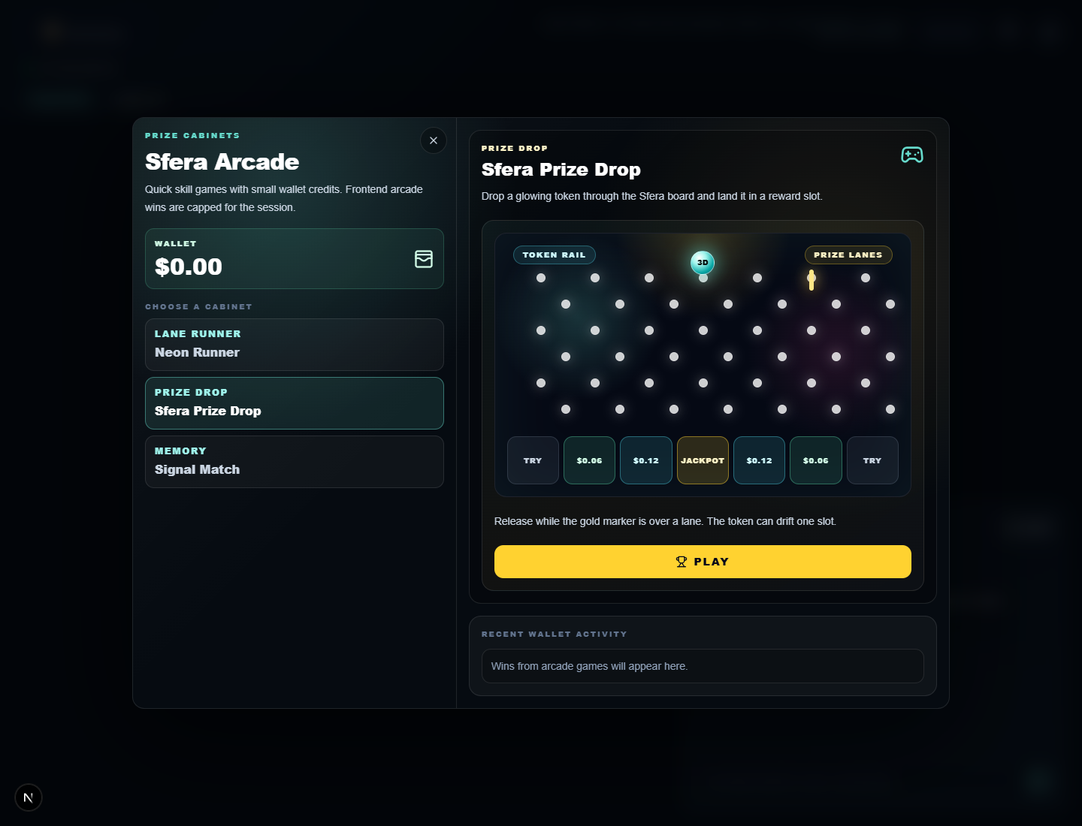
Figure: 8.5 Arcade - Sfera Prize Drop
Sfera Prize Drop is a timing and selection arcade cabinet where users choose a drop target and attempt a limited reward outcome.
Interactive elements and behavior:
- Cabinet tabs switch between arcade games without leaving the arcade overlay.
- Drop/start controls begin a round.
- Payouts are shown as small session credits rather than large unrestricted rewards.

8.6 Arcade - Signal Match
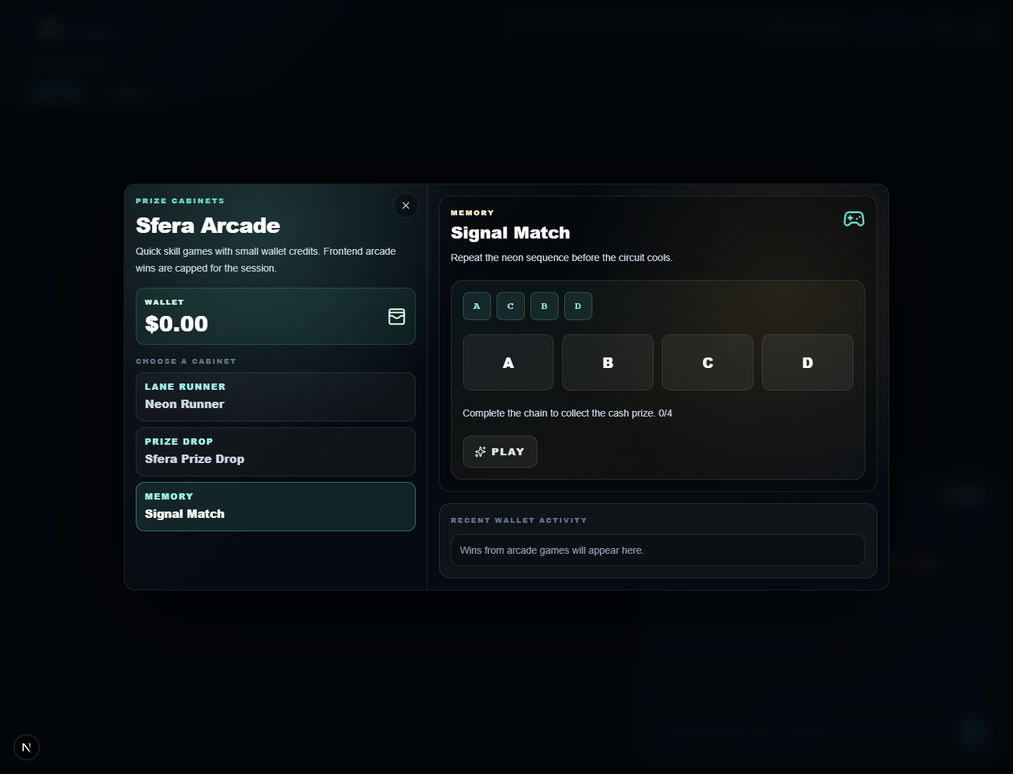
Figure: 8.6 Arcade - Signal Match
Signal Match is a memory/sequence arcade cabinet. The interface shows a distinct game layout and a different interaction model from the runner and prize drop games.
Interactive elements and behavior:
- Players select or repeat signal tiles according to the prompt.
- Game status displays attempt progress and result feedback.
- Wallet activity logs completed arcade outcomes.

9. Supplier And Merchant Management

9.1 Business Dashboard
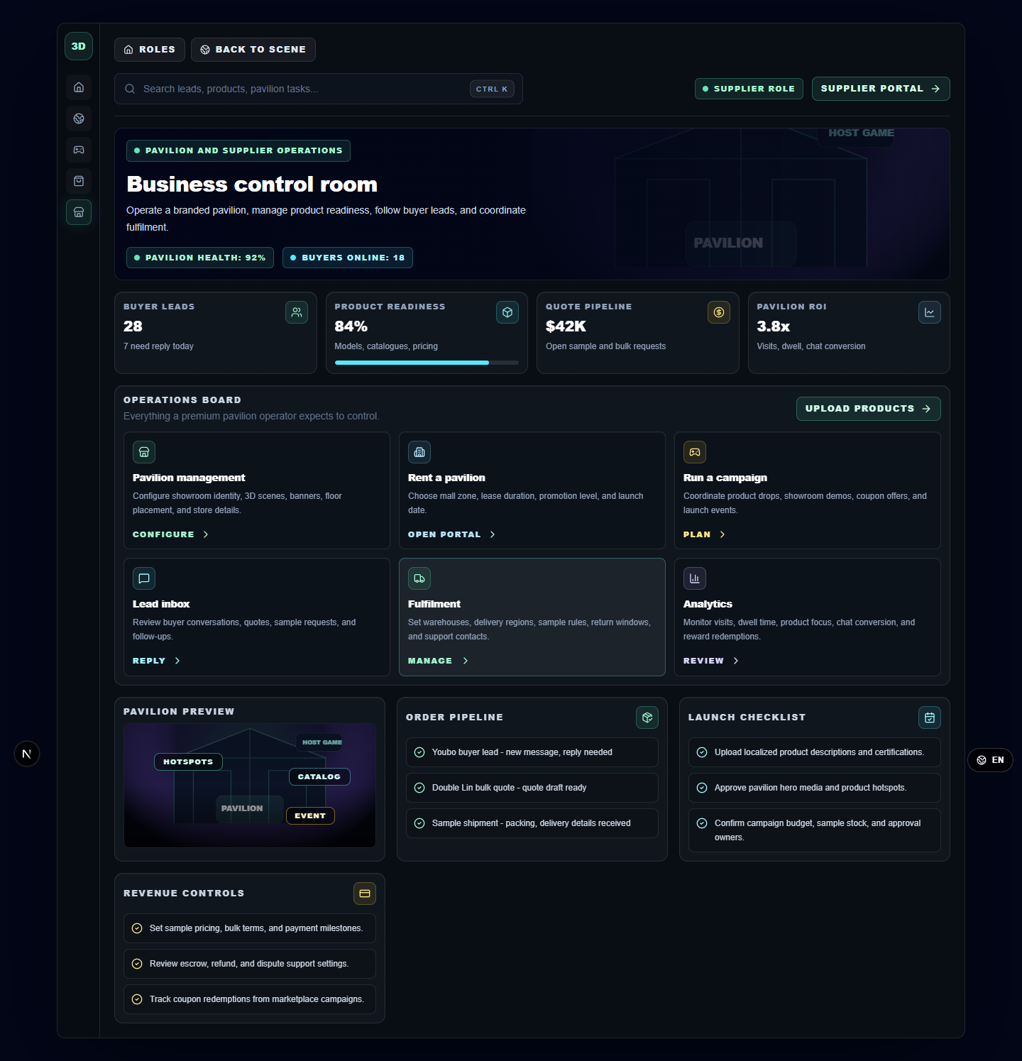
Figure: 9.1 Business Dashboard
The business dashboard provides an administrative view of platform, merchant, or commercial metrics for broader management workflows.
Interactive elements and behavior:
- Summary cards display business indicators and recent activity.
- Sidebar navigation changes management sections.
- Search and action controls allow review of records shown in the dashboard.

9.2 Supplier Dashboard
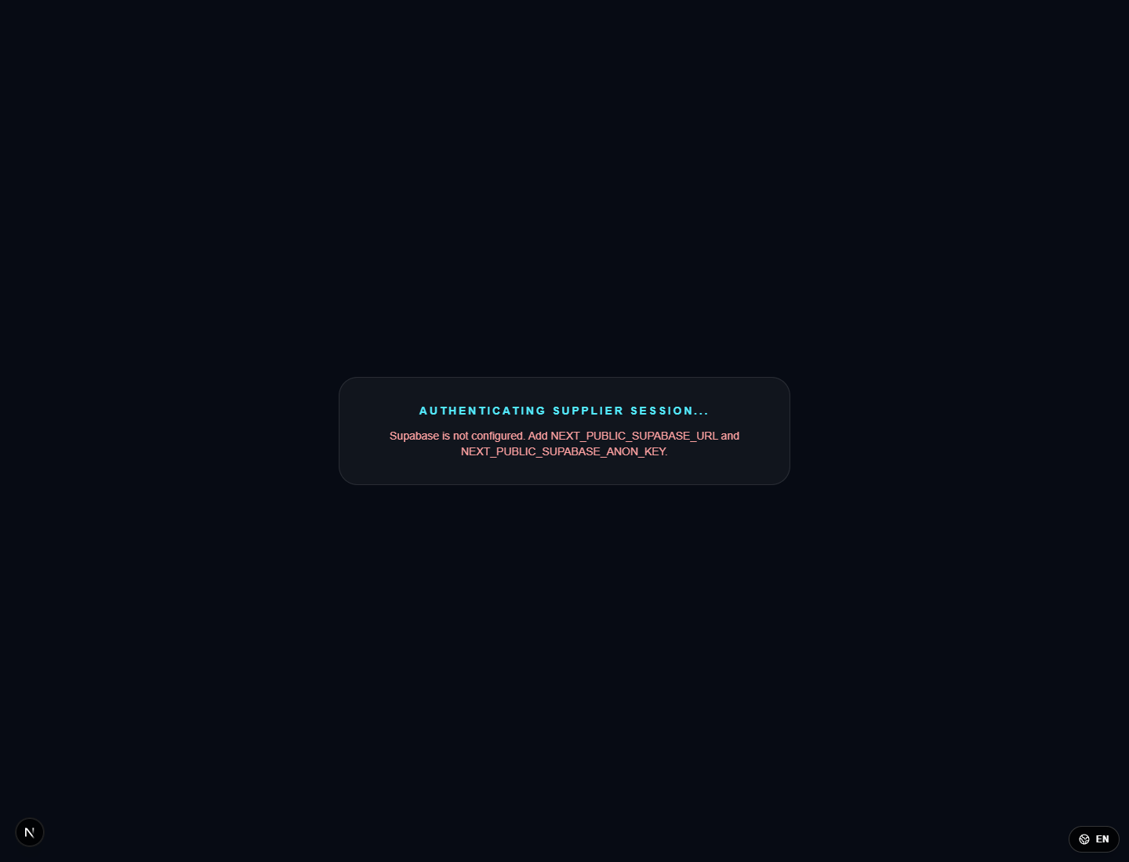
Figure: 9.2 Supplier Dashboard
The supplier dashboard is the merchant entry point after supplier authentication. It shows the supplier management shell and protected route behavior.
Interactive elements and behavior:
- Supplier navigation leads to product, inbox, upload, and management pages.
- Protected dashboard content requires a valid supplier session.
- Status messages indicate whether authentication is still being checked.

9.3 Supplier Upload Form
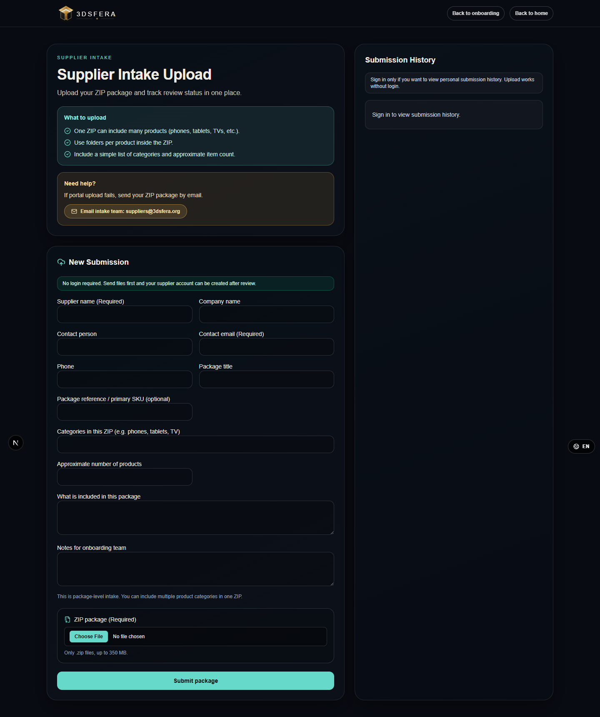
Figure: 9.3 Supplier Upload Form
The upload form lets suppliers add or modify product content for the 3D commerce experience. It is the main editing/saving workflow for merchant product data.
Interactive elements and behavior:
- Text inputs collect product name, category, description, pricing, and related metadata.
- File/model inputs attach product assets used by catalogue or 3D previews.
- Save/submit validates the form and stores the new or modified product record.
- Cancel or navigation away leaves the form without committing changes.

10. Interaction And Pop-Up Behavior Matrix
Area | Button / option | Resulting screen or pop-up | Save / modify / display behavior
Login | Submit | Authentication progress or validation message | Valid sessions redirect to protected page; invalid sessions remain on login with feedback.
Role selection | Role card | Role dashboard or 3D scene mode | Displayed modules change according to selected role.
3D HUD | AI chat | Chat drawer/panel | Messages are displayed in the conversation area; close keeps scene state.
Product card | Add to cart | Cart/customer state update | Product is recorded for shopping flow and displayed in customer context.
Product card | Chat Supplier | Supplier chat panel | Messages are sent to the selected product supplier thread.
Catalogue | Product item | Product detail/card overlay | Selected product data is displayed without leaving the catalogue context.
Pavilion | View product | Product detail modal | Specifications, features, standards, and action buttons are displayed.
Pavilion | Contact | Contact form pop-up | Required fields validate before message submission.
Pavilion | Chat | Chat pop-up | Typed messages display in the chat history after sending.
Pavilion | Book Meeting | Meeting request dialog | Date/contact details are saved after validation or cancelled without changes.
Player rewards | Accept Delivery | Delivery submission/claim state | Name, phone, and address are saved for fulfillment after required fields are complete.
Arcade | Game tab | Selected arcade cabinet | Current game view changes while wallet and activity remain visible.
Supplier upload | Save/submit | Validation or saved-product state | Product data and attached assets are persisted if all required data is valid.

11. 3D World Points Of Interest
Point of interest | User action | Displayed interface | Purpose
Product hotspot | Click/interact | Product card or product detail | Inspect product, add to cart, open supplier chat, or view more details.
Supplier pavilion | Enter/open | Pavilion product grid | Browse supplier catalogue and open product/contact sub-functions.
Pavilion product | View | Product detail modal | Inspect specifications, model preview, features, standards, quote, and meeting options.
AI assistant | Open chat and type | AI chat panel | Ask navigation, product, or platform questions while staying in the 3D scene.
Reward terminal/dashboard | Open rewards | Quest/rewards/delivery dashboard | Check quest progress and submit delivery details for physical rewards.
Arcade cabinet | Open arcade | Neon Runner, Prize Drop, Signal Match | Play capped front-end arcade games and record small wallet activity.
Supplier inbox | Open protected inbox | Authentication state or inbox | Display supplier messages only after valid supplier authentication.

12. Notes For Copyright Review
- The manual includes primary and secondary screens for the six major function areas listed in Section 1.
- Customer-side functions are documented through product cards, catalogue, pavilion products, shopper dashboard, player dashboard, delivery acceptance, and arcade screens.
- Supplier-side functions are documented through supplier login, dashboard, upload form, pavilion product pages, contact form, chat, meeting request, and auth-gated inbox behavior.
- Screenshots are included in English as requested; the companion Chinese manual remains in the same folder for Chinese-language review materials.

Appendix A. Additional Customer Delivery Editing Screen

A.1 Delivery Form Entry State

Figure: Delivery Form Entry State
This screenshot documents the delivery acceptance form while recipient information is being entered. It complements the accepted-delivery state and shows the editable name, phone number, and delivery address fields before the delivery claim is submitted.
Interactive elements and behavior: the recipient name field records the receiver, the phone number field records fulfillment contact information, the address field records the physical shipping location, and the Accept Delivery button validates and saves the entered information when clicked.

