HRIQ Internal Payments Guide
From Timesheet Approval to Contractor Payout
Remote Leverage | March 2026 | For RL Admins

Overview
This guide covers the full payment lifecycle for RL internal contractors: approving timesheets, generating payments, and paying contractors via Wise or manual methods.

1. Submit Timesheet | 2. Approve in Payroll | 3. Payment Created | 4. Pay or Mark Paid | 5. Completed

Wise (Automated)  International transfer via Wise API. Platform handles currency conversion. | Mark Paid (Manual)  For off-platform payments (bank, PayPal, Zelle, crypto). Record it in HRIQ after sending.

Part 1: Timesheet Submission & Approval
Before any payment can be made, the contractor must submit a timesheet and an admin must approve it.

1.1 Contractors Submit Timesheets
Each contractor fills in their hours for the pay period. They can either enter hours manually or click 'Fill from Time Doctor' to auto-populate from tracked time.
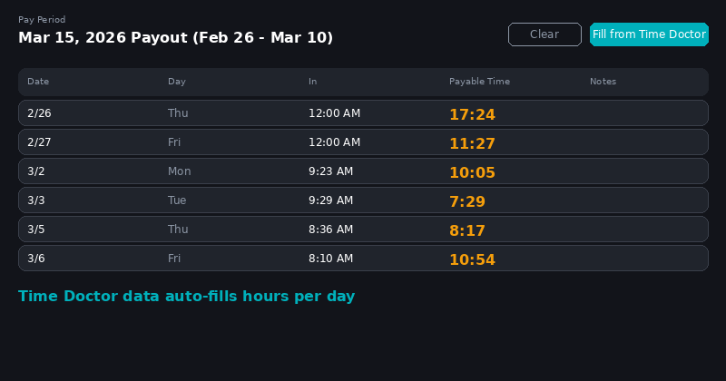
Timesheet form with Time Doctor auto-fill. Each day shows clock-in time and payable hours.
Key points: Hours are entered per day. The 'Fill from Time Doctor' button pulls tracked hours automatically. Contractors click 'Submit' when done. Saturday/Sunday rows are marked as weekend (WE).

1.2 Admin Reviews in Payroll
Navigate to Payroll > RL Internal from the sidebar. The payroll page shows all contractors for the selected pay period with their submitted hours, rate, and estimated pay.
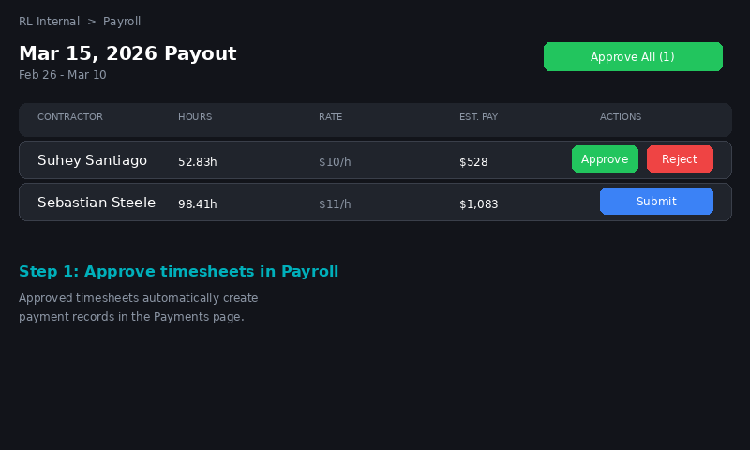
Payroll page showing submitted timesheets with Approve, Reject, and Submit buttons per contractor.
1 | Select the Pay Period  Use the dropdown at the top to select the correct pay period (e.g., 'Mar 15, 2026 Payout').  - Periods show: hours total, pending count, draft count, and total estimated cost.  - Missing timesheets are flagged at the top with contractor names.

2 | Review Each Contractor  Check the hours, rate, and estimated pay for each contractor. Ensure the numbers match expectations.  - Submitted timesheets show an 'Approve' button (green) and 'Reject' button (red).  - Unsubmitted timesheets show a 'Submit' button (blue) for admin force-submit.

3 | Approve Timesheets  Click 'Approve' on each contractor, or use 'Approve All' to batch-approve all submitted timesheets.  - Approved timesheets automatically create a Payment record in the Payments page.  - The payment amount = hours x hourly rate from the contractor's profile.  - Rejected timesheets go back to the contractor for correction.

What Happens After Approval
Once approved, a payment record is automatically created with status 'pending' in the Payments page. The contractor also receives a paystub if configured. You do not need to manually create payments.

Missing Timesheets
Contractors listed in the 'missing timesheets' banner have not submitted for the period. You can click 'Send Reminders' to email them, or use the 'Submit' button to force-submit on their behalf.

Part 2: Processing Payments
After timesheets are approved, payment records appear in Payments > RL Internal. Each pending payment has two action buttons:
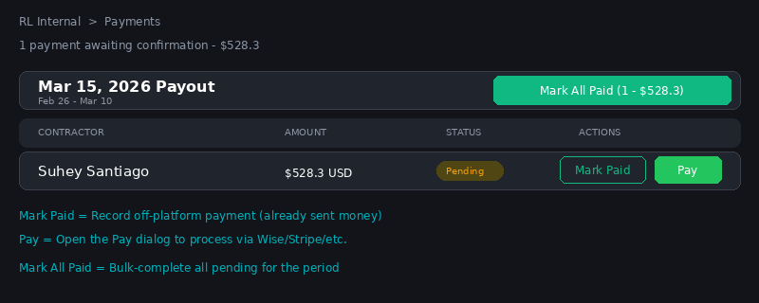
Payments page with Mark Paid and Pay buttons per contractor, plus Mark All Paid for bulk.

2.1 Navigate to Payments
In the sidebar, click Payments > RL Internal.
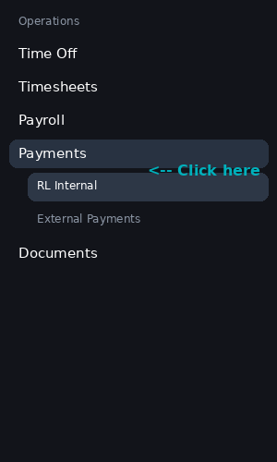
Sidebar: Payments > RL Internal.
Pending payments are grouped by pay period. Each period card shows the total amount and a 'Mark All Paid' bulk button.

2.2 Option A: Pay with Wise (Automated)
Use this for automated international transfers processed through the Wise API.

1 | Click 'Pay' on the Contractor  Click the green 'Pay' button on the contractor's row. This opens the Pay Contractor wizard.

2 | Select Wise  On Step 1, choose 'Wise' from the method grid, then click Continue.
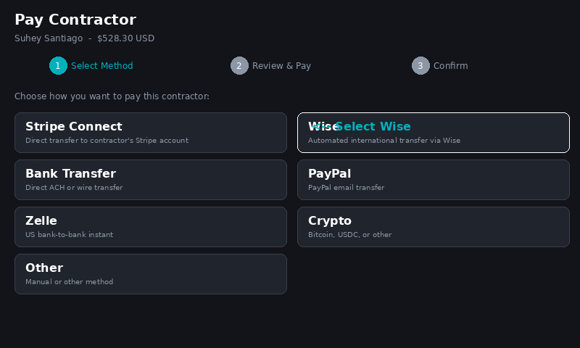
Step 1: Select Wise from the payment method options.
3 | Review & Confirm  On Step 2, verify the amount, period, and hours. If Wise is set up, click Continue to process the transfer.  - If you see 'Wise payout not set up yet', the contractor must log in to complete bank setup.  - You can click 'Pay manually instead' to enter an off-platform reference instead.
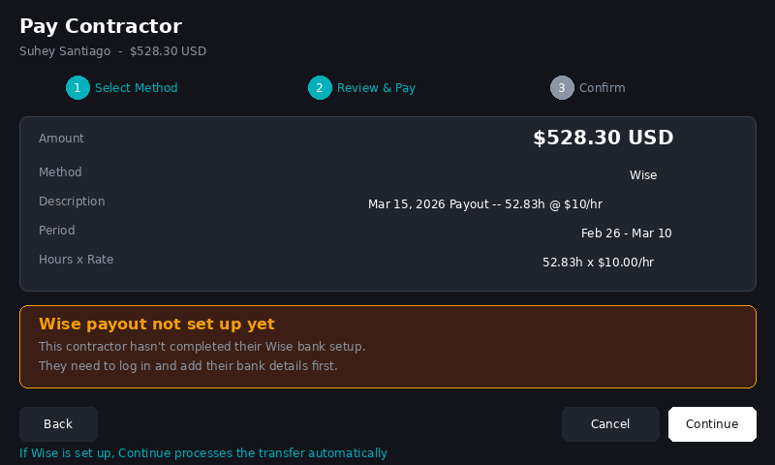
Step 2: Review details. Warning shown if Wise bank setup is incomplete.
4 | Transfer Processes  The Wise API creates the transfer automatically. Status moves to 'processing', then 'completed' within 1-3 business days.

Wise Setup Gate
All RL contractors are now prompted to set up Wise on first login. If a contractor still shows 'not set up', ask them to log into HRIQ -- the gate will redirect them automatically.

2.3 Option B: Mark Paid (Off-Platform)
Use this when you have already paid the contractor outside HRIQ (Wise dashboard, PayPal, Zelle, bank wire, Western Union, crypto, etc.).

1 | Click 'Mark Paid'  Click the outlined 'Mark Paid' button on the contractor's payment row.  - This immediately marks the payment as completed with today's date.  - No transfer is initiated -- it records that payment was made externally.

2 | Done  The payment moves to the Completed section. If you need to undo, click 'Requeue' on the completed payment.

When to Use Mark Paid
You paid via Wise dashboard directly, you sent PayPal/Zelle/wire, the contractor requested a specific method, or you used Western Union/crypto. Any payment made outside HRIQ should be recorded with Mark Paid.

2.4 Option C: Pay via Other Methods
The Pay dialog (green button) supports 7 methods. For non-automated methods, you will enter a transaction reference:

Method | Type | When to Use
Stripe Connect | Auto | US contractors with Stripe Express accounts
Wise | Auto | International contractors (most common for RL)
Bank Transfer | Manual | Direct ACH/wire -- enter transaction reference
PayPal | Manual | Enter PayPal transaction ID
Zelle | Manual | Enter Zelle confirmation number
Crypto | Manual | Enter blockchain transaction hash
Other | Manual | Any other method -- describe in reference field

Manual methods: After selecting the method and clicking Continue, paste the transaction ID or reference from your external payment. This is stored for audit purposes.

2.5 Bulk: Mark All Paid
To complete all pending payments for a period at once, click 'Mark All Paid' on the period card header. Confirm when prompted. This is useful when you have processed all payments externally (e.g., via a Wise batch transfer).

Troubleshooting

'Wise payout not set up yet'
- Ask the contractor to log into HRIQ -- they get redirected to Wise setup automatically.
- Or use 'Pay manually instead' in the Pay dialog.
- Or click 'Mark Paid' if you already paid them externally.

Payment stuck in 'processing'
Wise transfers take 1-3 business days. Check wise.com if stuck 3+ days. Use 'Requeue' if the transfer failed.

Wrong amount
Click the dollar amount in the pending table to edit inline. Only works for pending payments.

Need to reverse a payment
Click 'Requeue' on any completed payment to send it back to pending.

Quick Reference
I want to... | Do this
Approve a timesheet | Payroll > RL Internal > Approve (or Approve All)
Pay via Wise (automated) | Payments > RL Internal > Pay > Wise > Continue > Confirm
Record off-platform payment | Payments > RL Internal > Mark Paid
Pay via PayPal/Zelle/crypto | Payments > RL Internal > Pay > Select method > Enter ref
Bulk-complete a period | Payments > RL Internal > Mark All Paid on period card
Edit a payment amount | Click the dollar amount in pending table > edit inline
Reverse a completed payment | Completed section > Requeue button
Force-submit a timesheet | Payroll > RL Internal > Submit button on unsubmitted row
Send timesheet reminders | Payroll > RL Internal > Send Reminders button

