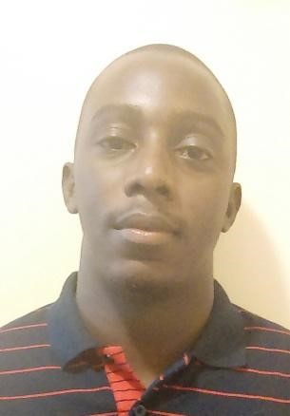

Fabrice BASSENE

10/08/1988 Diakène Diola.

MARRAKECH(MAROC)

Mobile: +212 700571982

Mail: bassenefabrice@yahoo.fr

I would be pleased and motivated for an opportunity to work and share my professional skills and team spirit in your company. I feel like I’m ready to step forword by learning different methods and procedures.

# Professional Experience

I’ve been working as a Dealer for 6 years in different Casino based in Morocco and,

Senegal. I have an experience and a fully knowledge of various games as such as

English Roulette, Black-jack, Stud-Poker, Casino Texas Hold’em, Ultimate Poker. I also got experience in dealing tournament and cash games including dealer choice.

## Studies

**2013/2014**: DTS2 in Project Management at Dakar University-level College that prepares students in Applied Economy. (Ex ENEA)

**2012/2013**: DTS1 in Project Management at Dakar University-level College that prepares students in Applied Economy. (Ex ENEA)

**2009/2010**: Registered in 2nd year at Cheikh Anta Diop Dakar University (UCAD) at the Private Law Department.

**2007/2008**: Registered in 2nd year at Cheikh Anta Diop Dakar University (UCAD) at the Private Law Department.

**2006/2007**: Baccalaureate L2 at Dakar Sacré Cœur College.

**2003/2004**: BFEM at Aline Sitoé Diatta high school Oussouye.

### Languages

### *French and Wolof* as native language

### *English* fluent

***Spanish*** notions

***Mandarin*** notions

### Others

Swimming

Internet

Football