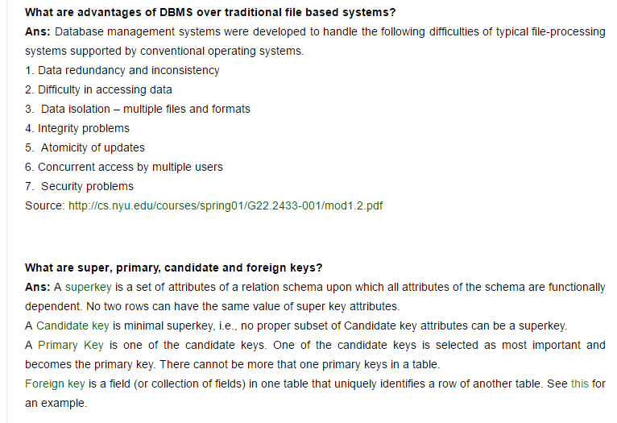

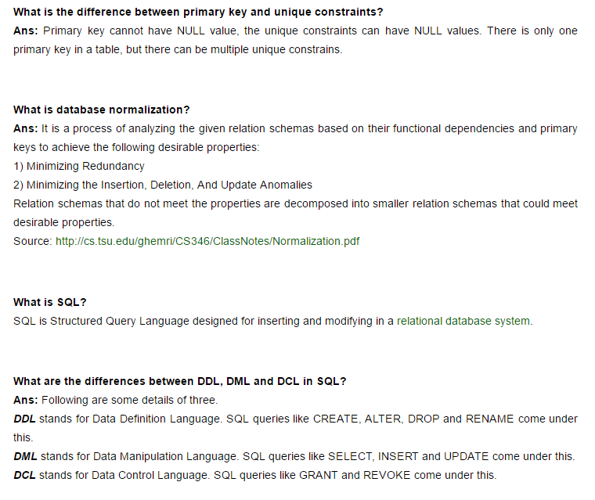

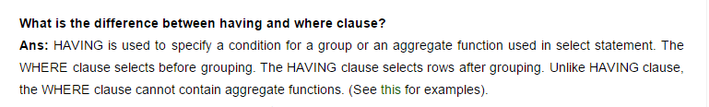

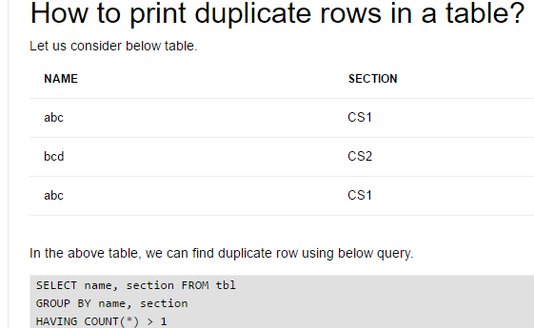

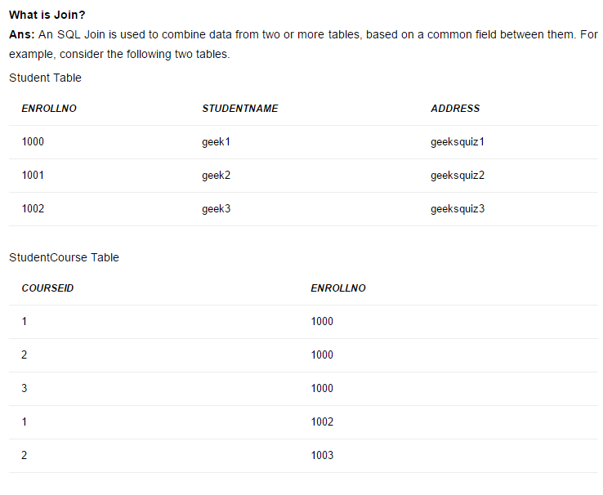



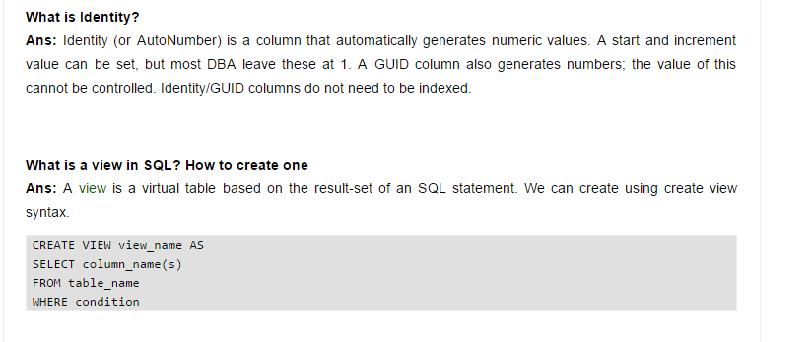

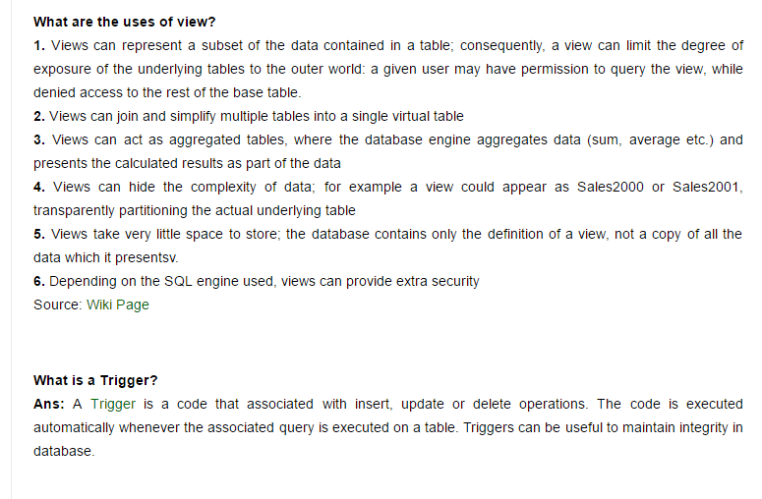

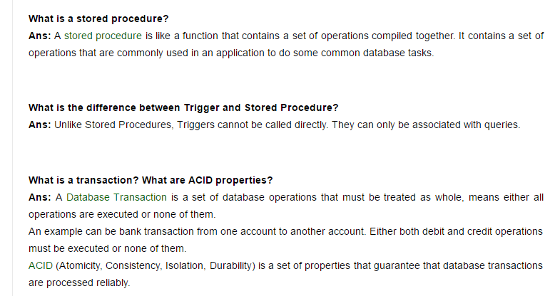

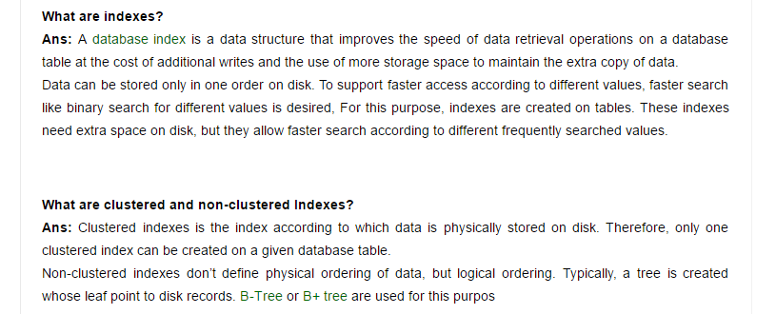

he collection of database and DBMS software together is known as database system.

4) What are the advantages of DBMS?

* Redundancy control
* Restriction for unauthorized access
* Provides multiple user interfaces
* Provides backup and recovery
* Enforces integrity constraints

5) How many types of database languages are?

There are four types of database languages:

* **Data Definition Language (DDL)** e.g. CREATE, ALTER, DROP etc.
* **Data Manipulation Language (DML)** e.g. SELECT, UPDATE, INSERT etc.
* **DATA Control Language (DCL)** e.g. GRANT and REVOKE.
* **Transaction Control Language (TCL)** e.g. COMMIT and ROLLBACK.

6) What is normalization?

Normalization is a process of analyzing the given relation schemas according to their functional dependencies. It is used to minimize redundancy and also minimize insertion, deletion and update distractions.

7) What is Denormalization?

Denormalization is the process of boosting up database performance and adding of redundant data which helps to get rid of complex data.

8) What is functional Dependency?

Functional Dependency is the starting point of normalization. It exists when a relation between two attributes allows you to uniquely determine the corresponding attribute's value.

9) What is E-R model?

E-R model is a short name for Entity Relationship model. This model is based on real world. It contains basic objects (known as entities) and relationship among these objects.

10) What is entity?

Entity is a set of attributes in a database.

11) What is data independence?

Data independence specifies that the application is independent of the storage structure and the access strategy of data. It means the ability to modify the schema definition in one level should not affect the schema definition in the next higher level.

There are two types of data independence:

* Physical data independence
* Logical data independence

12) What are the three levels of data abstraction?

**Physical level:** It is the lowest level of abstraction. It describes how data are stored.

**Logical level:** It is the next higher level of abstraction. It describes what data are stored in database and what relationship among those data.

**View level:** It is the highest level of abstraction. It describes only part of entire database.

13) What is stored procedure?

A stored procedure is a named group of SQL statements that have been previously created and stored in the server database.

14) What is 1NF?

1NF is the first normal form. It is the simplest type of normalization that you can implement in a database. The main objectives of 1NF are to:

* Remove duplicate columns from the same table
* Create separate tables for each group of related data and identify each row with a unique column

Database is a logical, consistent and organized collection of data that it can easily be accessed, managed and updated

#### Functions of DBMS

* Provides data Independence
* Concurrency Control
* Provides Recovery services
* Provides Utility services
* Provides a clear and logical view of the process that manipulates data.

#### Advantages of DBMS

* Segregation of applicaion program.
* Minimal data duplicacy.
* Easy retrieval of data.
* Reduced development time and maintainance need.

