December 3, 2019

Jean-Phillippe Durand

40052679

Concordia University

TEXT CORRECTOR PROJECT REPORT

COEN 352

# Table of Content

PROBLEM DESCRIPTION: 3

PROBLEM BREAKDOWN: 4

SOLUTION & DESIGN: 5

Solution Overview: 5

Word Frequency: 5

Whitespace Corrector 7

Mutated Character Corrector 11

RESULTS AND ANALYSIS 14

Word Frequency 14

Whitespace Corrector 16

Mutated Character Corrector 19

USER MANUAL: 21

# PROBLEM DESCRIPTION:

The goal of the project is to develop a simple text corrector. The final solution shall focus on typographical and orthography errors. The user shall provide a word bank using a plain text file (.txt), which will be used by the program as a dictionary.

The input file used as a dictionary will contain an unknown number of words; each word (separated by a whitespace character). To prevent long computing times when analyzing the text to be corrected, the dictionary will be stored into a binary search tree (BST). Due to its low time complexity in the order of O(LogN), where N is the number of words stored in the BST, the BST will prevent the program from slowing down noticeably when inputting dictionaries containing a large number of words.

The BST created from the user inputted dictionary will constitute the foundation of the text corrector, as all correction operations will require searching in the dictionary for the validity of the word, or the closest match.

The corrector has three (3) functions. It will correct word separation in the case where the user forgot to add space between two know (to the dictionary) words. It will then correct words containing a mutated character (e.g. d=ctionary will be corrected to the dictionary) and warn the user of the correction by providing him with the initial word and its correction. For the last step, the corrector will analyze the frequency of known words in the text and output a list of the words found, sorted by their frequency and then alphabetically.

# PROBLEM BREAKDOWN:

**TEXT CORRECTOR WBS**

# SOLUTION & DESIGN:

This section will cover the design and solution for each part of the project; starting with the main function.

## Solution Overview:

*Figure 1: High-level Diagram of Information Processing Activities*

The main function of the program takes care of the setup for each processing activity. The program starts by storing the words found in the dictionary.txt file into the Red-Black BST.

All three parts of the project are treated independently, and use their own algorithms, however, all three parts use the word frequency analysis algorithm. These three parts are run alphabetically and will be covered with more details in the next sections.

## Word Frequency:

The word frequency was designed to meet the objectives of part A of the project but is also used in part B and C after the respective algorithms are run to correct the initial inputted text.

Pseudo-code:

**procedure** AnalyseFile()

**foreach** (Word in InputText)

**if** Dictionary.contains(Word) **then**

**if !**WordHashMap.contains(Word) **then**

WordHashMap.put(Word, 1)

**end if**

**else then**

WordHashMap.put(Word, Value++)

**end else**

**end if**

**end foreach**

PrintOutputFile(WordHashMap, FileName)

**end procedure**

**procedure** PrintOutputFile(HashMap FoundWords, String FileName)

FoundWords.sort()

**foreach**(Pair in FoundWords)

Outputfile.append(Pair.key + “ “ + Pair.value + “\n”)

**end foreach**

**end procedure**

**procedure** Sort()

**if** a.value > b.value **then return** 1

**else if** a.value < b.value **then return** -1

**else if** a.key > b.key **then return** 1

**else return -**1

**end procedure**

## Whitespace Corrector

The whitespace corrector’s algorithm searches each unknown word to the dictionary for a substring of a word contained in the dictionary. Using the Beyond Compare 4 software, the whitespace removed texts were compared with their clean text counterparts. This analysis concluded that all errors found in the customer’s input texts were composed of two words merged. Therefore, the algorithm was designed to only allow one split; or, in other words, the addition of a single whitespace character. To achieve this, the algorithm splits the unknown word into two substrings. If there is no split resulting in two known words, the algorithm will weigh each split containing one known word and pick the one with the biggest weight. The weight of a split is determined by the length of the word found. If the unknown substring is smaller than 5, it will be tested against a second dictionary of common words in the English language; words like “the”, “he”, “she” and more. If the word is not found, points will be deducted, if it is found the weight will increase substantially. A one-letter word like “I” and “a” will be divided if and only if the second substring is also a known word. This is due to the high probability of creating a false correction. During testing, this design lead to a ~5% corrector inaccuracy, versus an approximate 20%-30% error when allowing the “a” and “I” to be split from a second unknown word.

Pseudo-code:

**procedure** CorrectWhiteSpaces()

**foreach** (word in Input)

**if**(!Dictionary.contains(word)) **then**

CorrectedWords = AnalyseWord(word)

Print(CorrectedWords)

**end if**

**end foreach**

**end procedure**

**procedure** String[] AnalyseWord(String iWord)

String wWord = iWord.toLowerCase()

HashMap PossibleSplits

**for**(int i = wWord.length/2 i < wWord.length i++)

leftSS = wWord.substring(0, i)

rightSS = wWord.substring(i)

leftHit = Dictionary.contains(leftSS)

rightHit = Dictionary.contains(rightSS)

**if**(leftHit && rightHit) **then**

wOutput[0] = leftSS

wOutput[1] = rightSS

return wOutput

**end if**

**else if** (leftHit && i < wWord.length - 1) **then**

PossibleSplits.put(leftSS, i)

**end else if**

**else if** (rightHit && i < wWord.length - 1) **then**

PossibleSplits.put(rightSS, i)

**end else if**

**if**(j>1) **then**

--j

leftSS = wWord.substring(0, j)

rightSS = wWord.substring(j)

leftHit = Dictionary.contains(leftSS)

rightHit = Dictionary.contains(rightSS)

**if**(leftHit && rightHit) **then**

wOutput[0] = leftSS

wOutput[1] = rightSS

return wOutput

**end if**

**else if** (leftHit && j > 1) **then**

PossibleSplits.put(leftSS, j)

**end else if**

**else if** (rightHit && j > 1) **then**

PossibleSplits.put(rightSS, j)

**end else if**

**end if**

**end forloop**

**if**(!PossibleSplits.isEmpty()) wOutput = PickBestSplit(PossibleSplits, wWord)

**return** wOutput

**end procedure**

**procedure** String[] PickBestSplit(HashMap<String, Integer> iOptions, String iWord)

String[] wOutput = new String[2]

int MaxWeight = 0

int tempWeight, tempSplit

int SplitIndex = iWord.length()

String SS1, SS2

boolean SS1Hit

**for**( Map.Entry<String, Integer> entry : iOptions.entrySet())

tempSplit = entry.getValue()

SS1 = iWord.substring(0, tempSplit)

SS2 = iWord.substring(tempSplit)

SS1Hit = (Dictionary.contains(SS1))

**if**(SS1Hit) **then**

tempWeight = SS1.length() - 2

**if** (CommonWords.containsKey(SS1) && (!(SS2.length() < 6) || CommonWords.containsKey(SS2))) **then**

tempWeight += CommonWords.get(SS1)

**end if**

**if** (SS2.length() < 4 && !CommonWords.containsKey(SS2)) **then**

tempWeight -= 6

**end if**

**end if**

**else then**

tempWeight = SS2.length() - 2

**if**(SS2.length() >=3) **then**

**if** (SS2.substring(SS2.length() - 3).equalsIgnoreCase("ing")) **then**

tempWeight -= 6

**end if**

**end if**

**if** (CommonWords.containsKey(SS2) && !((SS1.length() < 5) || CommonWords.containsKey(SS1))) **then**

tempWeight += CommonWords.get(SS2)

**end if**

**if** (SS1.length() < 4 && !CommonWords.containsKey(SS1)) **then**

tempWeight -= 6

**end if**

**end else**

**if**(tempWeight > MaxWeight)

MaxWeight = tempWeight

SplitIndex = tempSplit

**end if**

**end forloop**

wOutput[0] = iWord.substring(0, SplitIndex)

wOutput[1] = iWord.substring(SplitIndex)

**if**(MaxWeight <= 0 || wOutput[0].lastIndexOf('-') == (wOutput[0].length() - 1) || wOutput[1].indexOf('-') == 0) **then**

wOutput[0] = iWord

wOutput[1] = ""

**end if**

**return** wOutput

**end procedure**

## Mutated Character Corrector

The mutated character corrector utilizes the Levenshtein distance method to measure the distance between two strings. The Levenshtein distance algorithm finds the minimum amount of insertion, deletion or swaps required to modify the one input string into the reference string. By modifying this algorithm to only allow swaps, and comparing a word unknown to the dictionary to a word included in the dictionary, it can be assumed that the unknown word has been mutated from the reference word in the dictionary and thus, will be replaced in the text. By using the standard Levenshtein distance algorithm, the mutated character corrector could also be used to correct words containing an extra character, or a word with a missing character. For example, using the standard Levenshtein distance algorithm, the word “assumtion” and “aessumption" would both have a distance of 1 with the reference word “assumption” and therefore would be corrected.

Pseudo-code:

**procedure** CorrectMutatedChars()

File file = new File(FilePath)

String[] test = FilePath.split(Matcher.quoteReplacement(System.getProperty("file.separator")))

String FileName = test[test.length-1]

String sts

String CorrectedWord = ""

**foreach**( word in inputFile)

String wWord = word.toLowerCase()

**if**(!Dictionary.contains(word) && !Dictionary.contains(wWord) && !CommonWords.containsKey(wWord)) **then**

Dictionary.BSTIterator()

**while**(Dictionary.hasNext())

String wKey = Dictionary.next()

**if**(wKey.length() == wWord.length() && wKey.length() > 1) **then**

**if**(LevenshteinDistance.getLevenshteinDistance(wKey, wWord) == 1) **then**

CorrectedWord = wKey

break

**end if**

**end if**

**end while**

**if**(CorrectedWord != "") **then**

outSuggestions.println(word +", " + CorrectedWord)

outCorrectedText.append(CorrectedWord + " ")

**end if**

**else then** outCorrectedText.append(word + " ")

**end if**

**else then** outCorrectedText.append(word + " ")

CorrectedWord = ""

**end foreach**

**end procedure**

**procedure** getLevenshteinDistance(String s, String t)

int n = s.length()

int m = t.length()

**if** (n == 0) **then**

**return** m

**end if**

**else if** (m == 0)

**return** n

**end else if**

**if** (n > m)

String tmp = s

s = t

t = tmp

n = m

m = t.length()

**end if**

int p[] = new int[n+1]

int d[] = new int[n+1]

int _d[]

int i

int j

char t_j

int cost

**for** (i = 0 i<=n i++)

p[i] = i

**end forloop**

**for** (j = 1 j<=m j++)

t_j = t.charAt(j-1)

d[0] = j

**for** (i=1 i<=n i++)

cost = s.charAt(i-1)==t_j ? 0 : 1

d[i] = Math.min(Math.min(d[i-1]+1, p[i]+1), p[i-1]+cost)

**end forloop**

_d = p

p = d

d = _d

**end forloop**

**return** p[n]

**end procedure**

# RESULTS AND ANALYSIS

This section will cover the results and analysis for each part of the project. To analyze the accuracy of the whitespace and the mutated character corrector, I will compare the frequencies obtained with the clean text input (18.txt) to the frequencies obtained after correction of part B and C (18.txt).

## Word Frequency

The results for word frequency of input text 18.txt are as follows (excluding prepositions):

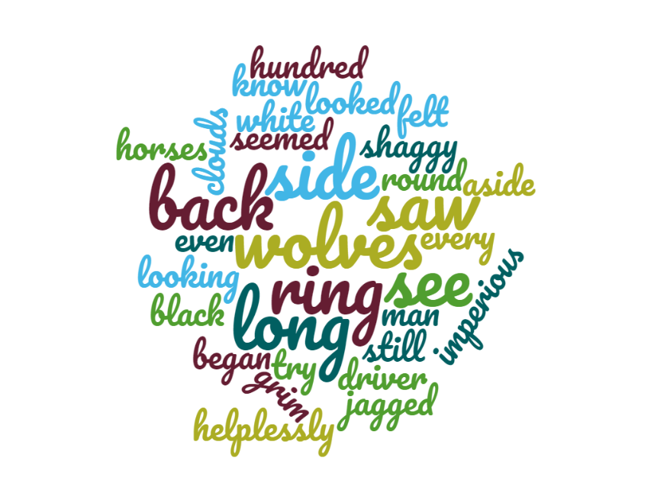*Figure 2: Results of Word Frequency Analysis for Text 18 of Part A*

*Figure 3: Word Cloud for Text 18 of Part A*

Algorithm Runtime:

*Figure 4: Word Frequency Analysis Runtime*

The best fitting trend line for the results of the word frequency analysis points toward an algorithm with a time complexity of order O(N). The intercept at 115.87, indicates shows the overhead cost for the creation of the dictionary.

## Whitespace Corrector

The results for word frequency of input text 18.txt of part B are as follows (excluding prepositions):

*Figure 5: Results of Word Frequency Analysis for Text 18 of Part 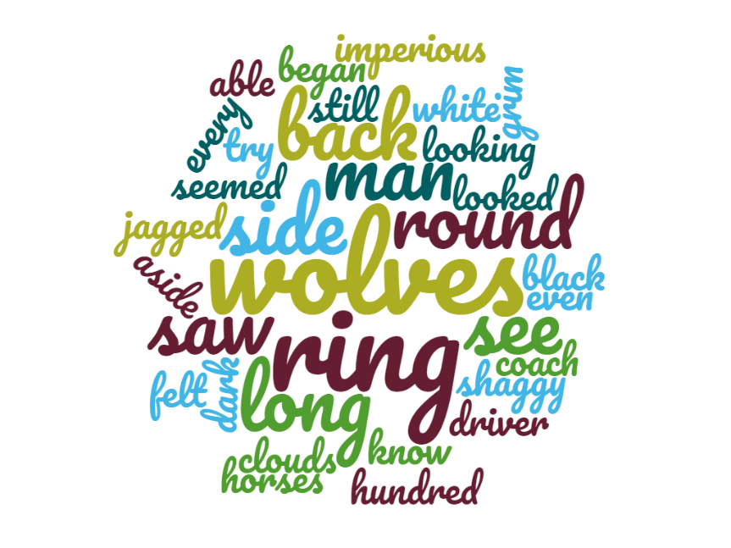B*

*Figure 6: Word Cloud for Text 18 of Part B*

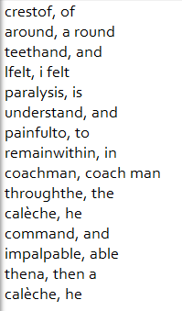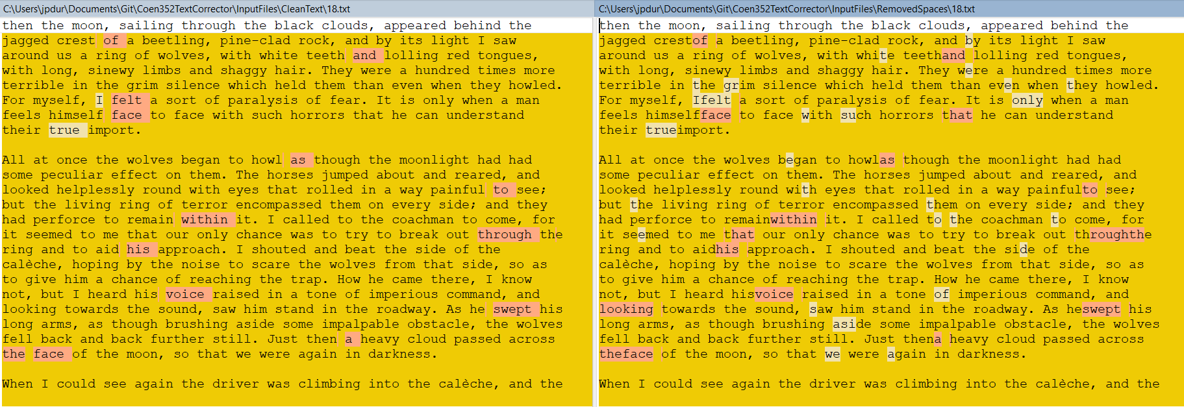*Figure 7: Comparing both Inputs Using WinMerge*

*Figure 8: Corrections Found by Whitespace Corrector*

At first look, it seems like the corrector missed multiple errors, however, when debugging, I found that the errors missed by the corrector are to be expected as these words do not appear in the dictionary. Notice also that the corrector split around into two words, as “around” does not appear in the dictionary, but “a” and “round” does.

Algorithm Runtime:

*Figure 9: Whitespace Corrector Runtime*

For the whitespace corrector, the overhead cost is low as the dictionary has already been created. The best fitting trend line for this algorithm is a polynomial of power 2; hinting towards a time complexity of O(N2)

## Mutated Character Corrector

The results for word frequency of input text 18.txt of part C are as follows (excluding prepositions):

*Figure 10: Results of Word Frequency Analysis for Text 18 of Part C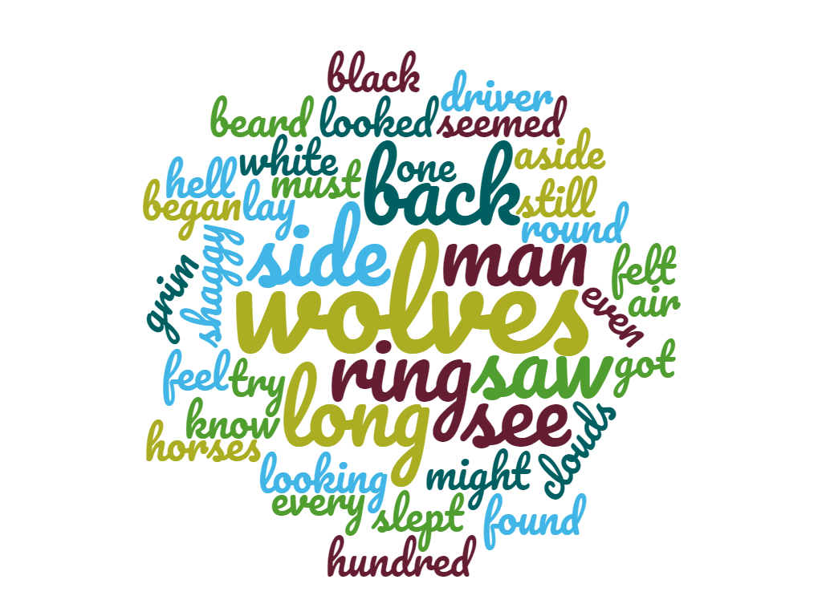*

*Figure 11: Word Cloud for Text 18 of Part C*

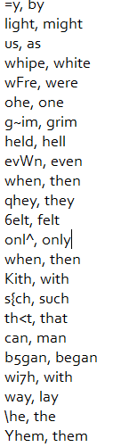 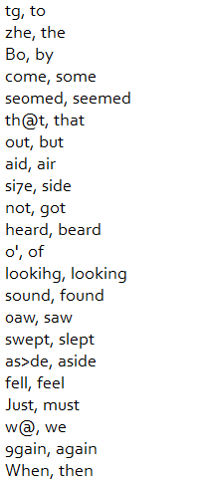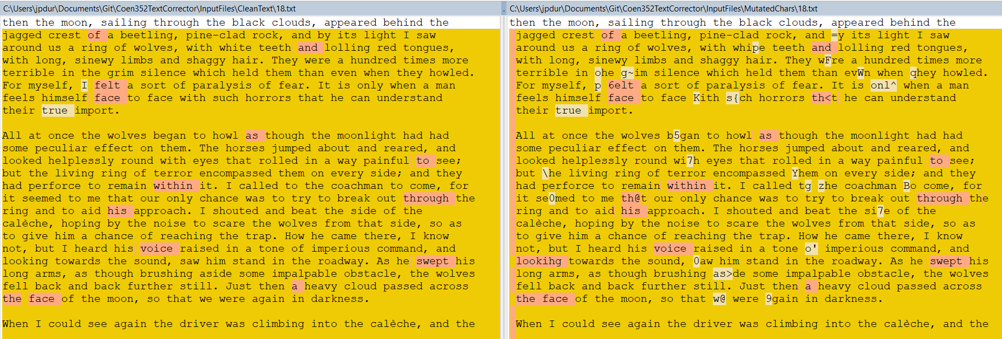*Figure 12: Comparing both Inputs Using WinMerge*

*Figure 13: Mutated Character Corrected*

The mutated character corrector was able to correct every error, and while it is to be expected, it also corrected words that do not appear in the dictionary but that had a distance of 1 with a word contained in the dictionary; e.g. way was corrected into lay.

# USER MANUAL:

The Text Corrector has three functions; using a user provided dictionary, the program can analyze the usage frequency of the words contained in the dictionary in each input text. It can divide unknown words by adding a whitespace to possibly correct a forgotten whitespace between one or two words contained in the dictionary. Finally, the corrector can correct a mutated character within a word known to the dictionary.

SETUP:

1. In the source folder of the text corrector, locate the InputFiles folder.
2. Copy the dictionary you wish to use in the InputFiles folder. Make sure each word is separate by one (1) whitespace character.
3. Copy the texts you wish to analyze or correct in one of the three subfolders (CleanText, RemovedSpaces, MutatedChars). Each folder represents one of the functions described above the setup.
4. Rename all files from 0 to N. (N being the number of files to analyze – 1)
5. Using your preferred IDE, open the source files located in the SourceFiles folder.
6. In main.java, modify the FilesToCorrect integer to match the number of files you wish to correct.
7. Run main.java.
8. The results will be saved in the OutputFiles folder.