Justin La

Su24 ECE 131A Project

1a

|  |  |
| --- | --- |
| Toss | Probability |
| 10 | 0.80 |
| 50 | 0.68 |
| 100 | 0.55 |
| 500 | 0.61 |
| 1000 | 0.60 |

1b.

1c.

As the number of tosses increases, the estimated results approach the mathematical analysis.

1d.

|  |  |
| --- | --- |
| Toss | Probability |
| 10 | 0.20 |
| 50 | 0.48 |
| 100 | 0.60 |
| 500 | 0.5580 |
| 1000 | 0.5460 |

As the number of tosses increases, the estimated results approach the mathematical analysis.

2a.

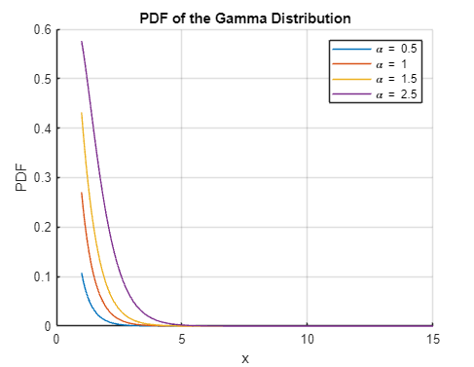

2b.

2c

3a.

3b.

|  |  |
| --- | --- |
| Condition (Survived) | Probability |
| P(S=1) | 0.3856 |
| P(C=1 | S=1) | 0.3977 |
| P(C=2 | S=1) | 0.2544 |
| P(C=3 | S=1) | 0.3480 |
| P(G=0 | S=1) | 0.6813 |
| P(G=1 | S=1) | 0.3187 |
| P(0≤A<5 | S=1) | 0.0965 |
| P(5≤A<10 | S=1) | 0.0234 |
| P(10≤A<15 | S=1) | 0.0322 |
| P(15≤A<20 | S=1) | 0.1199 |
| P(20≤A<25 | S=1) | 0.1550 |
| P(25≤A≤<30 | S=1) | 0.1491 |
| P(30≤A≤<35 | S=1) | 0.1404 |
| P(35≤A≤<40 | S=1) | 0.0936 |
| P(40≤A≤<45 | S=1) | 0.0614 |
| P(45≤A≤<50 | S=1) | 0.0643 |
| P(50≤A≤<55 | S=1) | 0.0292 |
| P(55≤A≤<60 | S=1) | 0.0205 |
| P(60≤A≤<65 | S=1) | 0.0117 |
| P(65≤A≤<70 | S=1) | 0 |
| P(70≤A≤<75 | S=1) | 0 |
| P(75≤A≤<80 | S=1) | 0.0029 |

|  |  |
| --- | --- |
| Condition (Not Survived | Probability |
| P(S=0) | 0.6144 |
| P(C=1 | S=0) | 0.1468 |
| P(C=2 | S=0) | 0.1780 |
| P(C=3 | S=0) | 0.6752 |
| P(G=0 | S=0) | 0.1486 |
| P(G=1 | S=0) | 0.8514 |
| P(0≤A<5 | S=0) | 0.0294 |
| P(5≤A<10 | S=0) | 0.0294 |
| P(10≤A<15 | S=0) | 0.0183 |
| P(15≤A<20 | S=0) | 0.1596 |
| P(20≤A<25 | S=0) | 0.1945 |
| P(25≤A≤<30 | S=0) | 0.1706 |
| P(30≤A≤<35 | S=0) | 0.0954 |
| P(35≤A≤<40 | S=0) | 0.0954 |
| P(40≤A≤<45 | S=0) | 0.0679 |
| P(45≤A≤<50 | S=0) | 0.0477 |
| P(50≤A≤<55 | S=0) | 0.0294 |
| P(55≤A≤<60 | S=0) | 0.0239 |
| P(60≤A≤<65 | S=0) | 0.0220 |
| P(65≤A≤<70 | S=0) | 0.0092 |
| P(70≤A≤<75 | S=0) | 0.0073 |
| P(75≤A≤<80 | S=0) | 0 |

3c.

3d.

4a.

4b.

4d.

