Deliverable II: PCA, K-Means, Hierarchical Clustering, CA and MCA

Soukaïna Mahboub Mehboub

November 26th, 2023

# 1. Principal Component Analysis

## 1.1 Eigenvalues and dominant axes analysis:

We are asked to perform a PCA taking into account also supplementary that can be quantitative and/or categorical.

We previously applied imputation on our dataframe, and now will apply PCA, passing all categorical/factor variable as qualitative supplementary variables, and pass the target variable “price” is our quantitative supplementary variable. We will also pass the detected multivariant outliers as supplementary individuals to avoid any anomalies.

We deduce from the following graph of variables and the results:

* The two first dimensions explain the 70% of inertia.
* The first component agglutinates 40,8% of variability meanwhile the second component has 30% of variability. We can sense that more than two--thirds of the variability are already inside the first and second component.
* The variables “mileage”, “year” and “price” have a significant impact on the first component, meanwhile “tax” and “engineSize” have an important effect on the second component.
* The variable “mpg” has an insignificant impact on both component compared to the rest.
* “mileage” and “year” are negatively correlated.

library(FactoMineR)  
res.pca<-FactoMineR::PCA(df, quali.sup=c(1,4,6,10:17), quanti.sup= c(3), ind.sup = mouts)

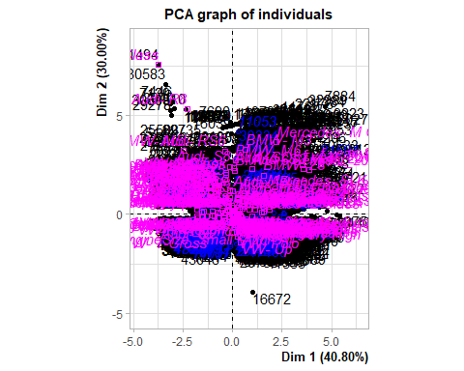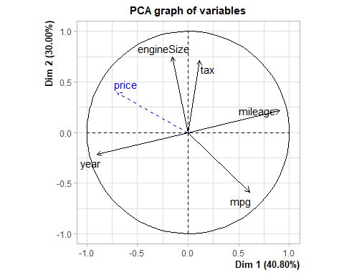

* The following graph shows the relationship between individuals with the two axes. Proximity of points in the scatter plot indicates similarity between individuals. Individuals closer together are more similar in terms of the variables used in the analysis.
* In our case, we can spot graphically few individuals that do not follow the common pattern (11053 as an example). But we have many individuals that contribute almost equally to the inertia of each component.
* For example individuals with a model type “Audi-R8” contributes in the variability of the second dimension more than it does in the first component.

plot.PCA(res.pca,choix=c("ind"),invisible=c("ind"))

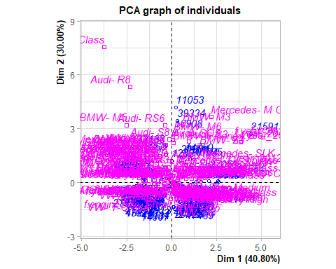

* As we can see below, 6 components have been created. The choice of retaining the most informative axes in a PCA analysis can be made using various methods, including but not limited to the Kaiser criterion and the Elbow method. These approaches assist in determining the optimal number of principal components to capture and retain, contributing to a more robust interpretation of the underlying patterns in the data.

**Kaiser Criteria:**

* The PCA function yields an eigenvector with normalized eigenvalues. Employing the Kaiser criterion, we opt to retain the first two components, given that their eigenvalues surpass the mean of all components’ eignevalues, in our case 0.8.
* The two first componenets meet this criteria and have 70.79% of cumulative percentage of variance. This strategic selection ensures a focused representation of the data’s principal components, enhancing the interpretability of the analysis.

res.pca$eig

## eigenvalue percentage of variance cumulative percentage of variance  
## comp 1 2.0400311 40.800622 40.80062  
## comp 2 1.4998421 29.996842 70.79746  
## comp 3 0.7775353 15.550706 86.34817  
## comp 4 0.4842705 9.685410 96.03358  
## comp 5 0.1983210 3.966419 100.00000

barplot(res.pca$eig[,1],main="Eigenvalues",names.arg=paste("dim",1:nrow(res.pca$eig)))

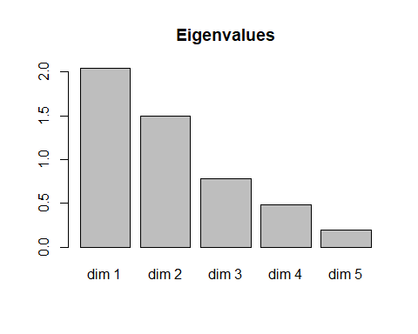

**Elbow Method:**

* The following graph shows the Eignevalues in a downward curve, from highest to lowest, and by using the Elbow Method we can determine the number of significant axes in this case, we would retain 3 axes.
* The three components englobe 86,4% of the information.

library("factoextra")

## Loading required package: ggplot2

## Welcome! Want to learn more? See two factoextra-related books at https://goo.gl/ve3WBa

fviz_eig(res.pca, addlabels = TRUE)

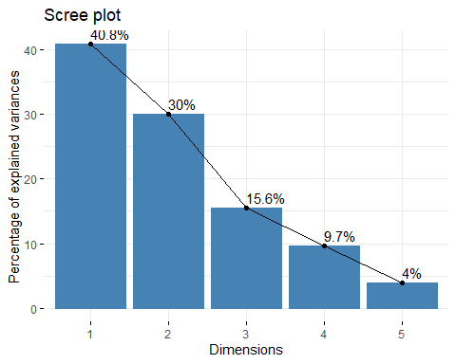

## 1.2 Interpreting the axes: Variables point of view coordinates, quality of representation, contribution of the variables:

**Variables Coordinates:**

* The values in this matrix indicate the strength of the relationship between each variable and the principal components through coordinates values. Notably, the first principal component (Dim.1) exhibits a strong correlation with the ‘year’ and ‘mileage’ variables. This also implies that Dim.1 captures information variability related to the year and mileage of the vehicles. Additionally, the second principal component (Dim.2) shows a notable positive correlation with ‘tax’ and ‘engineSize,’ while being negatively correlated with ‘mpg.’

res.pca$var$cor

## Dim.1 Dim.2 Dim.3 Dim.4 Dim.5  
## year -0.9019085 -0.2175046 0.065892602 0.1974954 0.309687823  
## mileage 0.9051392 0.2158777 -0.120017923 -0.1357201 0.318269585  
## tax 0.1145254 0.7101830 0.659940352 0.2167192 0.005963566  
## mpg 0.6085550 -0.5878186 0.007666642 0.5325378 -0.021791581  
## engineSize -0.1544665 0.7456809 -0.568514845 0.3102941 -0.024666706

**Quality of representation:**

* To measure the quality of representation of each variable on the principal components we use the squared cosines. It provides insights into how well each variable is represented in the reduced-dimensional space created by the principal components.
* In the first dimension, both “year” and “mileage” exhibit strong representation, indicating that they play a substantial role in shaping this principal component. Conversely, “tax” contributes minimally, accounting for only 1% of the representation in this specific dimension. This insight underscores the differential impact of these variables on the overall structure captured by the principal components, emphasizing the significance of “year” and “mileage” in this particular dimension.
* When it comes to the second dimension, “tax,” “mpg,” and “engineSize” showcase some representation, contributing to the structure of the second principal component. However, it’s important to note that “year” and “mileage” have limited influence in this specific dimension.

res.pca$var$cos2[,1:2]

## Dim.1 Dim.2  
## year 0.81343893 0.04730826  
## mileage 0.81927706 0.04660318  
## tax 0.01311608 0.50435989  
## mpg 0.37033916 0.34553069  
## engineSize 0.02385990 0.55604007

**Contribution of variables:**

* Analyzing variable contributions provides insights into which variables strongly influence the selected axes. This information aids in interpreting the meaning of each dimension and helps focus on key variables.

res.pca$var$contrib[,1:2]

## Dim.1 Dim.2  
## year 39.8738488 3.154216  
## mileage 40.1600274 3.107206  
## tax 0.6429352 33.627533  
## mpg 18.1536037 23.037805  
## engineSize 1.1695850 37.073241

* In the context of the first principal component, it’s evident that “year” and “mileage” exhibit the highest contributions, aligning with our earlier observation from squared cosines. Conversely, “tax” and “engine size” make minimal contributions, indicating their limited impact on this principal component.
* Regarding the second principal component, “tax” and “engine size” are contributing more significantly compared to other variables. In contrast, “year” and “mileage” show comparatively lower contributions, underscoring their reduced influence on the second principal component. This also matches with previous result we got during the quality representations of variables.

To double-check our earlier findings, we can examine the correlation between each variable and the principal components. This additional step ensures consistency with our previous results:

res.des<-dimdesc(res.pca)  
res.des$Dim.1$quanti

## correlation p.value  
## mileage 0.9051392 0.000000e+00  
## mpg 0.6085550 0.000000e+00  
## tax 0.1145254 9.323124e-16  
## engineSize -0.1544665 1.647409e-27  
## price -0.6998279 0.000000e+00  
## year -0.9019085 0.000000e+00

## 1.3 Individuals point of view

Individual analysis in PCA is crucial for understanding how each observation or individual contributes to the overall variation in the dataset and how they are positioned in the reduced-dimensional space defined by the principal components.

**Coordinates analysis:**

* These coordinates express the position of each individual in the reduced-dimensional space created by the principal components. Examining these coordinates helps in visualizing the distribution of individuals in the PCA plot and understanding the relationships and patterns in the data captured by the principal components.
* Examining the top records based on Dim.1 reveals that individuals with IDs 44400, 39750, and 9823 have notably high positive scores on this component. This suggests that these individuals contribute significantly to the variance captured by Dim.1. On the other hand, reviewing the top records based on Dim.2, individuals with IDs 31494, 30583, and 7446 exhibit high positive values, indicating their substantial influence on the variability captured by Dim.2. Conversely, individual 7884 stands out with a high positive value on Dim.2 but in the opposite direction.

head(res.pca$ind$coord[order(-res.pca$ind$coord[, 1]), 1:2])

## Dim.1 Dim.2  
## 44400 5.389572 -0.08979279  
## 39750 5.259954 -0.01982767  
## 9823 5.093414 4.58639116  
## 49012 5.050768 2.76506994  
## 18027 4.915824 4.24685363  
## 39721 4.870095 1.36117104

head(res.pca$ind$coord[order(-res.pca$ind$coord[, 2]), 1:2])

## Dim.1 Dim.2  
## 31494 -3.746077 7.550192  
## 30583 -3.365387 6.583066  
## 7446 -3.018995 5.698159  
## 7129 -3.148974 5.595183  
## 7884 4.685884 5.426009  
## 3940 -2.936287 5.331234

**Quality of representation:**

* Analyzing the top records based on Dim.1 squared cosines, it is evident that individuals with IDs 45095, 45035, and 15725 have extremely high values close to 1. This indicates a strong and accurate representation of these individuals along Dim.1. Similarly, reviewing the top records based on Dim.2 squared cosines, individuals 17858, 12277, and 10417 exhibit high values close to 1, signifying an excellent representation along Dim.2.

head(res.pca$ind$cos2[order(-res.pca$ind$cos2[, 1]), 1:2])

## Dim.1 Dim.2  
## 45095 0.9980150 0.0009537204  
## 45035 0.9978836 0.0007616075  
## 15725 0.9977419 0.0011239939  
## 13995 0.9973703 0.0012454965  
## 45847 0.9968652 0.0005337368  
## 45291 0.9967720 0.0023149888

head(res.pca$ind$cos2[order(-res.pca$ind$cos2[, 2]), 1:2])

## Dim.1 Dim.2  
## 17858 0.0000280509 0.9560961  
## 12277 0.0056296341 0.9525162  
## 10417 0.0008819556 0.9512128  
## 19334 0.0101927703 0.9381894  
## 14597 0.0059806467 0.9242056  
## 49398 0.0067977334 0.9233736

**Contribution of individuals:**

* Analyzing the top records based on Dim.1 contributions, it is notable that individuals with IDs 44400, 39750, and 9823 have the highest contributions to the variability along Dim.1. In particular, individual 44400 stands out with a substantial contribution of approximately 29.1%, emphasizing its significant role in explaining the variance along Dim.1. Similarly, reviewing the top records based on Dim.2 contributions, individuals 31494, 30583, and 7446 exhibit the highest contributions, suggesting their prominent influence on the variability captured by Dim.2.

head(res.pca$ind$contrib[order(-res.pca$ind$contrib[, 1]), 1:2])

## Dim.1 Dim.2  
## 44400 0.2910023 1.098657e-04  
## 39750 0.2771736 5.357010e-06  
## 9823 0.2598998 2.866299e-01  
## 49012 0.2555658 1.041817e-01  
## 18027 0.2420921 2.457615e-01  
## 39721 0.2376090 2.524670e-02

head(res.pca$ind$contrib[order(-res.pca$ind$contrib[, 2]), 1:2])

## Dim.1 Dim.2  
## 31494 0.14058576 0.7767751  
## 30583 0.11346400 0.5905215  
## 7446 0.09130881 0.4424338  
## 7129 0.09934044 0.4265872  
## 7884 0.21997383 0.4011809  
## 3940 0.08637441 0.3872886

**Analyzing 6 individuals that have a significant contribution to the first component:**

* This results matches the outcome of the variable analysis we did previously, where we concluded that mileage and year are the variables that contributed more in the first component.
* Its observed that cars that mostly contributed to the first component have a really high mileage and and their year is very far so they are very old.

df[which(row.names(df) %in% c(39721 , 18027 , 49012, 9823, 39750, 44400 )), ]

## model year price transmission mileage fuelType tax  
## 18027 BMW- 1 Series 2010.79 2495 f.Trans-Manual 112000.00 Diesel 200.0000  
## 49012 VW- Touran 2008.00 2300 f.Trans-Manual 112304.00 Petrol 162.4420  
## 39721 VW- Golf 2010.00 4995 f.Trans-Manual 111913.00 Diesel 145.0000  
## 9823 Audi- A6 2008.00 2490 f.Trans-Manual 95062.65 Diesel 200.0000  
## 39750 VW- Golf 2011.00 4295 f.Trans-Manual 105000.00 Diesel 147.1385  
## 44400 VW- Polo 2009.00 2995 f.Trans-Manual 89000.00 Diesel 147.4458  
## mpg engineSize manufacturer f.year f.price f.miles f.tax f.mpg  
## 18027 49.6 2.0 BMW 2011 Very Cheap Very Old High Moderate  
## 49012 34.5 1.6 VW 2008 Very Cheap Very Old High Low  
## 39721 52.3 2.0 VW 2010 Very Cheap Very Old Low Moderate  
## 9823 44.1 2.0 Audi 2008 Very Cheap Very Old High Low  
## 39750 74.3 1.6 VW 2011 Very Cheap Very Old Medium Very High  
## 44400 72.4 1.4 VW 2009 Very Cheap Very Old High Very High  
## f.engineSize Audi  
## 18027 Medium Audi No  
## 49012 Medium Audi No  
## 39721 Medium Audi No  
## 9823 Medium Audi Yes  
## 39750 Medium Audi No  
## 44400 Small Audi No

# 2 K-Means Classification:

## 2.1 Optimal Number of Clusters:

* At this point, after applying the PCA, and retaining the the first and second axes based on Kaiser Criteria we will process with clustering our data by using K-Means:

res.pca<-FactoMineR::PCA(df, quali.sup=c(1,4,6,10:17), quanti.sup= c(3), ind.sup = mouts, graph = FALSE)  
ppcc<-res.pca$ind$coord[,1:2] # 2 components principals (based on kaiser criteria)  
dim(ppcc)

## [1] 4893 2

* Using the elbow method we can expect that the optimal number of cluster is 5, as the graph shows that the total of within sum of square starts to slow down.

#Optimal number of clusters  
library("factoextra")  
fviz_nbclust(ppcc, kmeans, method = "wss")

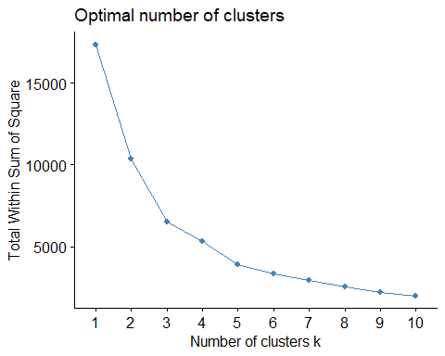

* To understand how the K-means Algorithm was used with 5 clusters, we can see in which iteration it starts to converge, in our case it was in the 4th iteration.

dist<-dist(ppcc) # coordenates are real - Euclidean metric  
kc<-kmeans(dist,5,iter.max=30,trace=TRUE)

## KMNS(*, k=5): iter= 1, indx=3  
## QTRAN(): istep=4893, icoun=2  
## QTRAN(): istep=9786, icoun=28  
## QTRAN(): istep=14679, icoun=287  
## QTRAN(): istep=19572, icoun=76  
## QTRAN(): istep=24465, icoun=65  
## QTRAN(): istep=29358, icoun=7  
## QTRAN(): istep=34251, icoun=2  
## QTRAN(): istep=39144, icoun=148  
## QTRAN(): istep=44037, icoun=15  
## QTRAN(): istep=48930, icoun=132  
## QTRAN(): istep=53823, icoun=18  
## QTRAN(): istep=58716, icoun=419  
## QTRAN(): istep=63609, icoun=517  
## QTRAN(): istep=68502, icoun=2574  
## KMNS(*, k=5): iter= 2, indx=4  
## QTRAN(): istep=4893, icoun=46  
## QTRAN(): istep=9786, icoun=28  
## QTRAN(): istep=14679, icoun=14  
## QTRAN(): istep=19572, icoun=45  
## QTRAN(): istep=24465, icoun=242  
## QTRAN(): istep=29358, icoun=684  
## QTRAN(): istep=34251, icoun=160  
## QTRAN(): istep=39144, icoun=68  
## QTRAN(): istep=44037, icoun=2038  
## KMNS(*, k=5): iter= 3, indx=324  
## QTRAN(): istep=4893, icoun=655  
## QTRAN(): istep=9786, icoun=566  
## QTRAN(): istep=14679, icoun=394  
## QTRAN(): istep=19572, icoun=1329  
## KMNS(*, k=5): iter= 4, indx=4893

* As we set the number of clusters at 5, we can display the number of observations in each cluster as follows:

barplot(table(factor(kc$cluster)),main= " Number of observations per cluster")

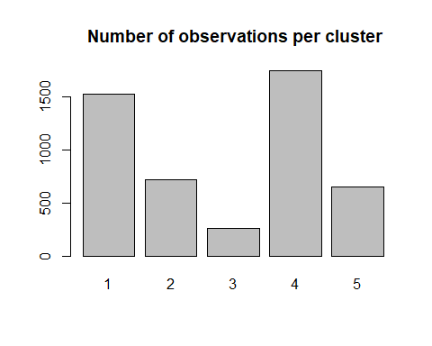

## 2.2 Clustering Quality:

* The next chunk shows the quality of clustering. 77.84% is a higher percentage that suggests good and meaningful separation of clusters, indicating that the clustering is explaining a significant portion of the variance in the data.
* 100*(kc$betweenss/kc$totss)
* ## [1] 77.84432

## 2.3 Clusters Description:

* We will proceed with describing and analyzing each cluster.
* We will assign to each individual in our original datafram with its own K-Means Cluster number. We are not considering Any Multivariant Outliers to avoid anomalies.

df<-df[-mouts,] # We use a dataframe without Multivariant Outliers.  
df$claKM<-kc$cluster  
df$claKM<-factor(df$claKM)  
  
#res.cat <-catdes(df,18) #!8 is claKM variables, representing each individuals corresponding cluster.

### 2.3.1 **Description of clusters in relation with catgorical variables:**

* As we can see below (Please check 7. Annex:, as the output was very long), we find some categorical variables and factor very related to the cluster variable that we recently created. The low p-values show evidence how some variables have been significant to cluster our data.
* Regarding the first cluster, 78,78% are not Audi cars, 68,09% of the individuals are categorized as “**Low-Tax**”, 50,52% are categorized as “Medium Engine-size” and 56,48% have Diesel as Fuel-Type. Cluster 1 exhibits a distinct profile characterized by a prevalence of newer cars (**2019** and **2020** models) with **low** taxation, **moderate** mpg, and **moderate** pricing. Specific models like **VW-T-Cross** and **VW-T-Roc** show a perfect association with this cluster. Conversely, **very old** category as mpg, **low-price** cars, and certain models like **BMW-X6** and **BMW-M3** are notably absent.
* When it comes to Cluster 2: 83.71% of the cars in this cluster sample, were labelled as **Low-MPG**, 80,34% are labelled as Expensive and 73,27% have **Large Engine-size**. This make sense as cars with large engine size and low mpg are meant to be expensive. Cluster 2 is characterized by several distinct features. It has a strong association with low fuel efficiency (**f.mpg=Low**), expensive pricing (**f.price=Expensive**), and large engine sizes (**f.engineSize=Large**). Specific car models such as VW Touareg, Audi Q7, and BMW M4 are highly prevalent in this cluster. Vehicles in this cluster often have **new** or **nearly new** caracterisitcs. (**f.miles=New/Nearly New**). The presence of semi-automatic transmissions (**transmission=f.Trans-SemiAuto**) is also notable.
* Moreover, the cluster exhibits preferences for specific years, especially 2019 (**f.year=2019**). High tax rates (**f.tax=High**) and certain fuel types like Petrol (**fuelType=Petrol**) are significant features. Luxury brands such as BMW and Mercedes-Benz are well-represented in this cluster. Additionally, there is a prevalence of diesel fuel type (**fuelType=Diesel**) and hybrid fuel type (**fuelType=Hybrid**).
* Overall, Cluster 2 gathers expensive, fuel-inefficient vehicles with large engine sizes, especially those from luxury brands.
* Cluster 3: 70% are **Low Tax**, 27,92% have small Engine-Size Type, and 50,52% have a **medium Engine-Size**, 56,48 are **Diesel** in Fuel-type and 41,89% are **Petrol** cars, an d around 3 quarters fall in the catgegories combined “**Used**”, “**Old**” and “**Very Old**”, this also makes sense with the previous stated categories.
* Cluster 3 is characterized by older vehicles (**f.miles=Old**) and an emphasis on specific years, notably 2017 and 2016 (**f.year=2017**, **f.year=2016**). High fuel efficiency (**f.mpg=High**) and affordability (**f.price=Affordable**) are prominent features. This cluster also includes manual transmissions (**transmission=f.Trans-Manual**) and smaller engine sizes (**f.engineSize=Small**). Noteworthy associations involve manufacturers like VW and specific models such as VW Polo.
* Overall, this cluster represents a distinct group with a focus on older, fuel-efficient, and affordable vehicles.
* Cluster 4 exhibits distinctive features such as very old vehicles (**f.miles=Very Old**) and low-priced options (**f.price=Low-priced**), both strongly associated with the cluster. The statistical significance is evident with low p-values, notably for variables like **f.miles=Very Old** (p=0.0). Specific manufacturers (**manufacturer=Mercedes**, **manufacturer=BMW**) and models (**model=VW- Passat**, **model=BMW- 1 Series**) contribute significantly.
* Cluster 5 is characterized by high tax rates (**f.tax=High**) and a preference for very old vehicles (**f.miles=Very Old**). Large engine sizes (**f.engineSize=Large**) and low fuel efficiency (**f.mpg=Low**) are notable features. The cluster is associated with specific years, especially 2011 and 2009 (**f.year=2011**, **f.year=2009**). Automatic transmissions (**transmission=f.Trans-Automatic**) and moderate fuel efficiency (**f.mpg=Moderate**) are also prevalent. This cluster includes luxury models like Mercedes-M Class and Audi Q5. Notably, the presence of **Audi Yes** indicates a distinction for Audi vehicles. Overall, Cluster 5 represents a group with a focus on high tax rates, older vehicles, and larger engine sizes.

### 2.3.2 **Description of clusters in relation with numerical variables:**

* In Cluster 1, the average price is 16190.02, which is lower than the overall mean of 21,600. These cars have a lower tax rate of 143.09 compared to the overall mean of 146.92. The engine size is smaller, with an average of 1.71, and the fuel efficiency (MPG) is slightly higher at 59.97. The mileage is relatively higher, with an average of 26134 These results match with the cluster description with categorical variables which makes sense. This cluster gathers mainly low tax cars with low prices small engine sizes.
* Cluster 2 is characterized by cars with an average engine size (1.84) and lower-than-average prices (11786). The tax rate is slightly lower than the overall mean at 146.92. Mileage is higher (54501), and the fuel efficiency (MPG) is higher 62.68.
* Cluster 3 includes cars with lowe fuel efficiency (MPG) at 42.59 and high mileage, around 52520. Tax rates are higher than average at 180.35, and the engine size is bigger (2.59). The average price is 16,190, significantly lower than the overall mean.
* Cluster 4 consists of cars with very low mileage (7013.41), slightly low fuel efficiency (MPG) at 48.79, and a relatively small engine size (1.73). Tax rates are low at 145.53, and prices are a bit higher than average.
* Cluster 5 features cars with a an average tax rate, very low mileage (11669.23), and big engine sizes (2.71). Fuel efficiency (MPG) is low at 37.56, and prices are significantly higher than the overall mean.

# 3 Hierarchical Clustering:

## 3.1 Number of Clusters :

* As we observe below, using HCPC, has implicitly detected the optimal number of clusters through the inertia gain barplot, in this case we have three clusters. The quality of this partition is around 41.08%, so we will try to increase it.

res.hcpc <- HCPC(res.pca,nb.clust = -1, order = TRUE)

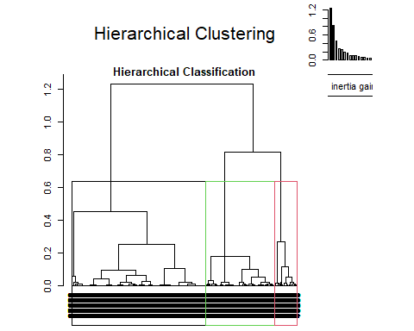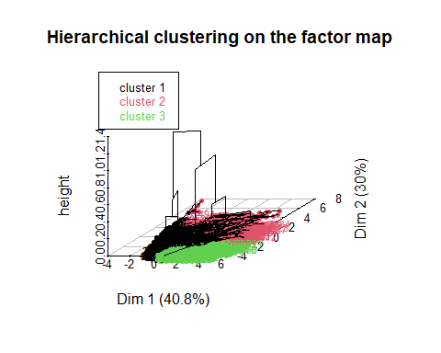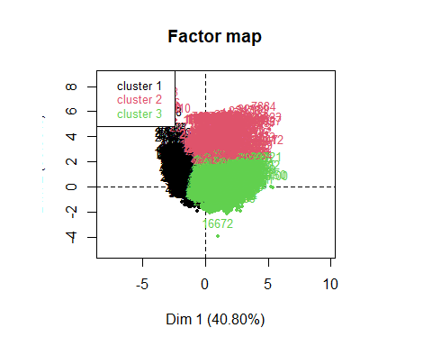

((res.hcpc$call$t$within[1]-res.hcpc$call$t$within[3])/  
res.hcpc$call$t$within[1])*100

## [1] 41.0832

## 3.2 Clustering Quality:

We will try now with 5 clusters:

* As we can see the quality of partition has now increased to 55.55%, in case if we want to achieve a quality of 80%, we need 16 clusters at least. In our study, we will keep data in 5 cluster to facilitate the process of study, comparison and analysis.

res.hcpc <- HCPC(res.pca,nb.clust = 5, order = TRUE)

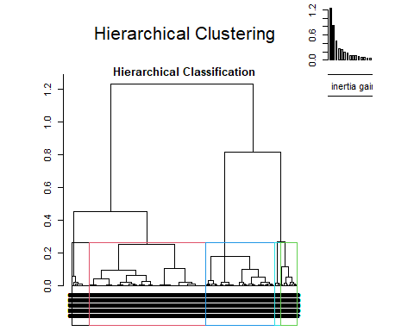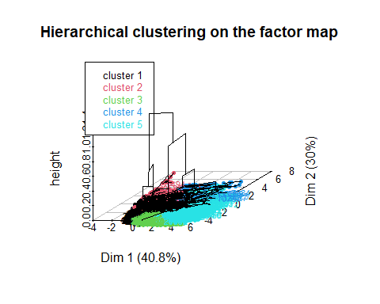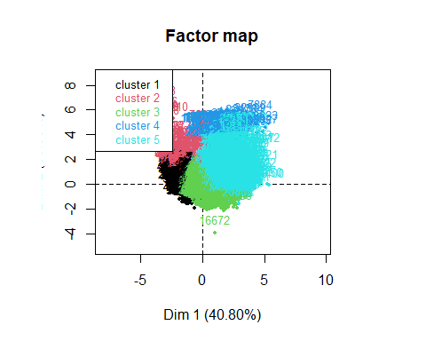

((res.hcpc$call$t$within[1]-res.hcpc$call$t$within[5])/  
res.hcpc$call$t$within[1])*100

## [1] 55.5504

* We can visualize hos many individuals has each cluster:
* table(res.hcpc$data.clust$clust)
* ##   
  ## 1 2 3 4 5   
  ## 1850 527 1658 143 715
* barplot(table(res.hcpc$data.clust$clust), main = "Number of individuals per cluster")
* 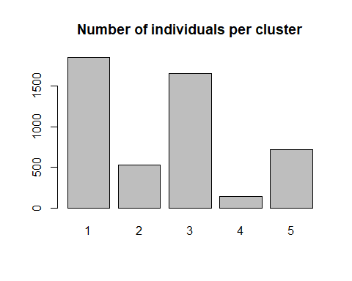

## 3.3 Clusters Description:

* We will assign to each individual of our dataframe the number of its cluster.

### 3.3.1 **Description of clusters in relation with categorical variables:**

* Description of each cluster in relation with other categorical/factor variables, please check 7. Annex: for the following output.
  + Notably, Cluster 1 (Cla/Mod) exhibits a strong association with cars from the year 2019, emphasizing a preference for new or nearly new vehicles. Characteristics such as low mileage (**f.miles=New/Nearly New**), moderate fuel efficiency (**f.mpg_Moderate**), and an inclination towards expensive cars (**f.price=Expensive**) contribute to the distinctive profile of this cluster. Additionally, there is a notable dominance of Volkswagen (**manufacturer=VW**) models, particularly VW-T-Roc and VW-T-Cross. Transmission type (**f.Trans-SemiAuto**) and medium engine size (**f.engineSize_Medium**) These cars often have **low** tax rates and run on **petrol**.
  + In Cluster 2, the analysis reveals a distinct automotive profile. Cars with **large engine size**, specifically the BMW M4 and Mercedes GLS Class, dominate, showcasing a 100% modulation score. High-end features like **expensive** pricing, **low** fuel efficiency (mpg), and **semi-automatic** transmissions are strongly associated. Notably, the VW Touareg, Audi Q7, BMW M4, and Mercedes GLS Class are the top contributing models. **Diesel** fuel types and **manual transmissions** play a significant role. **BMW** and **Mercedes** emerge as the primary manufacturers, especially in the year **2019** with **New/Nearly New** based on mileage. **High tax** brackets and **expensive** pricing align with this cluster, emphasizing luxury and performance in vehicle characteristics.
  + Cluster 3 reflects a car segment characterized by specific features. **Old** vehicles with **high** mileage dominate. Cars with very **high** fuel efficiency (mpg) are prevalent. The year **2017** and **2016** stand out, indicating a preference for recent models. **Affordable** and **low-priced** options are significant, aligning with a budget-conscious consumer base. **Manual transmissions** and **small** engine sizes are notable features. **Diesel** fuel types are prevalent. The VW Polo emerges as a popular model, epitomizing the practical and efficient characteristics of this cluster.
  + Cluster 4 represents a distinct car segment characterized by specific attributes. **High tax** rates are a defining feature, suggesting a preference for luxury or high-performance vehicles. **Moderate fuel efficiency** (mpg) is observed, indicating a balance between performance and economy. **Very old** cars are significant in this cluster. The Audi Q5 and BMW X5 emerge as prominent models. The year **2015** stands out, reflecting a preference for relatively recent models. **Large engine sizes** are notable. Low fuel efficiency (**Low mpg**) and **high prices** characterize this cluster, aligning with a segment that values performance and luxury over fuel economy and affordability.
  + Cluster 5 is characterized by **very old**, **low-priced** cars with model years **2013**-**2015**, **high** tax rates, and a preference for **diesel** fuel. These cars exhibit very **high** fuel efficiency (mpg) and often feature **manual transmissions**. Prominent models include Audi A6, BMW 5 Series, and Mercedes SLK, reflecting diversity in manufacturers. The cluster encompasses a mix of **diesel** and **petrol** fuel types, various transmission preferences, and a range of budget options. Cars from both **used** and **new/nearly new** categories contribute to this cluster, highlighting a diverse set of preferences.

### 3.3.2 **Description of clusters in relation with numerical variables:**

* Now we will proceed to describe the relationship between numerical variables and these hierarchical clusters:
* # res.hcpc$desc.var$quanti Please check annex.
  + This cluster represents vehicles with a relatively recent manufacturing year (2018.91), higher prices (25074.78), lower taxes (145.86), smaller engine sizes (1.75), lower fuel efficiency (46.63 MPG), and lower mileage (7082.22). This cluster represents recent models (mean year 2018.91) with higher prices and smaller engine sizes. Despite lower taxes, these vehicles have lower fuel efficiency and mileage, suggesting a preference for newer cars.
  + Vehicles in this cluster have larger engine sizes (3.08), higher prices (40327.40), slightly higher manufacturing years (2017.93), slightly higher taxes (148.47), lower mileage (14545.83), and lower fuel efficiency (38.94 MPG). Cluster 2 showcases larger, more powerful vehicles with higher prices and slightly newer manufacturing years. Despite slightly higher taxes, these cars exhibit lower mileage and fuel efficiency, appealing to those seeking performance and modern features.
  + this cluster is characterized by vehicles with higher fuel efficiency (61.75 MPG), higher mileage (25448.23), lower manufacturing years (2016.64), lower taxes (143.08), smaller engine sizes (1.70), and lower prices (16126.43). Vehicles in this cluster stand out for their higher fuel efficiency and mileage, lower manufacturing years, and smaller engine sizes. With lower taxes and prices, these cars are likely more economical and environmentally friendly, attracting a conscious consumer base.
  + Vehicles in this cluster have higher taxes (199.93), higher mileage (42536.34), larger engine sizes (2.36), slightly lower fuel efficiency (44.60 MPG), and manufacturing years slightly below the overall mean. Cluster 4 is characterized by higher taxes, elevated mileage, and larger engine sizes. Although slightly below the overall mean in fuel efficiency, these cars may appeal to those valuing power and durability, especially with manufacturing years slightly below average.
  + This cluster includes vehicles with significantly higher mileage (60750.74), moderately higher fuel efficiency (57.71 MPG), slightly smaller engine sizes (1.96), lower prices (11852.06), and manufacturing years notably below the overall mean (2014.28). This cluster represents vehicles with significantly higher mileage, moderately improved fuel efficiency, and slightly smaller engine sizes. With notably lower prices and manufacturing years below the mean, these cars may appeal to budget-conscious consumers seeking reliable, efficient transportation.

# 4. Correspondence Analysis

* Correspondence Analysis is a statistical technique for exploring relationships between categorical variables.
* In our pervious deliverablle, we have already created a factor variable f.price with 7 levels.
* In our case study we will try to find the relationship between f.price and two categorical factor variables f.yearand f.miles

## 4.1 F.Price vs F.Year

x<-table(df[,c("f.price", "f.year")])  
res.ca<-CA(x)

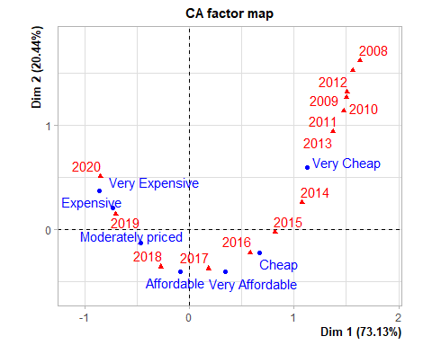

* We apply Chi Square’s test and check the p-value, as we can see, it is very small and very close to zero, so we have evidence to reject the null hypothesis, and prove the existence of a strong relationship between two factor variables.

chisq.test(x)

##   
## Pearson's Chi-squared test  
##   
## data: x  
## X-squared = 3197, df = 72, p-value < 2.2e-16

* As we can see, the first components has 73,1% of variability, we could consider this ax enough to explain data. This also explain how these are related.

fviz_eig(res.ca, addlabels = TRUE)

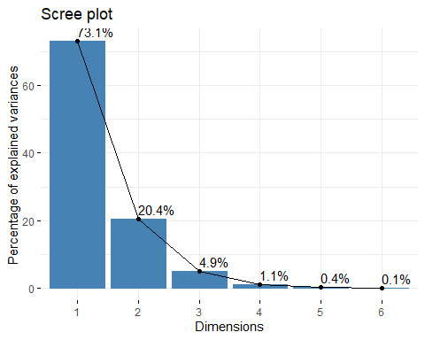

* As the graph below shows us, the close relationship that f.price catgeories and f.year categories have.
* As time elapses since a car’s initial release, it tends to be perceived as more affordable, while conversely, newly released models often carry a higher price tag.

plot( res.ca, cex=0.8, graph.type = "classic" )  
lines( res.ca$row$coord[,1], res.ca$row$coord[,2], col="blue", lwd = 2 )  
lines( res.ca$col$coord[,1], res.ca$col$coord[,2], col="red", lwd = 2 )

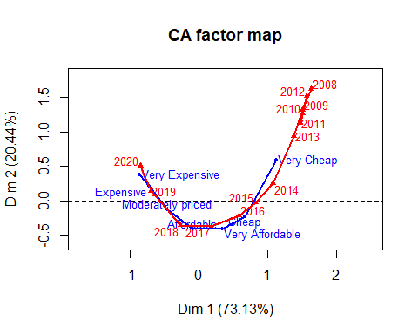

fviz_ca_biplot(res.ca,repel=TRUE)+theme_bw()

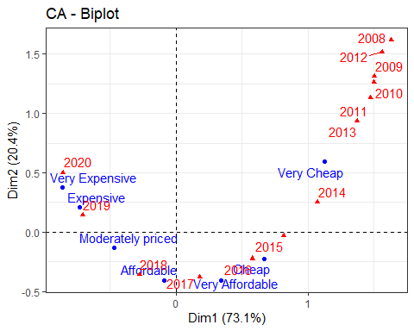

## 4.2 F.Price vs F.Miles

* Now we will try to do the same seteps but with f.miles:

x<-table(df[,c("f.price", "f.miles")])  
res.ca<-CA(x)

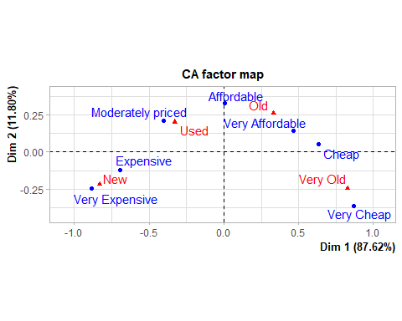

* We apply Chi Square’s test and check the p-value, as we can see, it is very small and very close to zero, so we have evidence to reject the null hypothesis, and prove the existence of a strong relationship between two factor variables.

chisq.test(x)

##   
## Pearson's Chi-squared test  
##   
## data: x  
## X-squared = 2234.3, df = 18, p-value < 2.2e-16

* As we can see, the first components has 87,6% of variability, we could consider this ax enough to explain data. This also explain how these are related.

fviz_eig(res.ca, addlabels = TRUE)

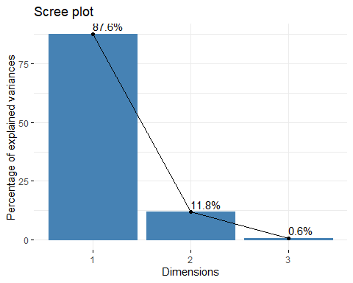

* As the graph below shows us, the close relationship that f.price categories and f.miles categories have.

plot( res.ca, cex=0.8, graph.type = "classic" )  
lines( res.ca$row$coord[,1], res.ca$row$coord[,2], col="blue", lwd = 2 )  
lines( res.ca$col$coord[,1], res.ca$col$coord[,2], col="red", lwd = 2 )

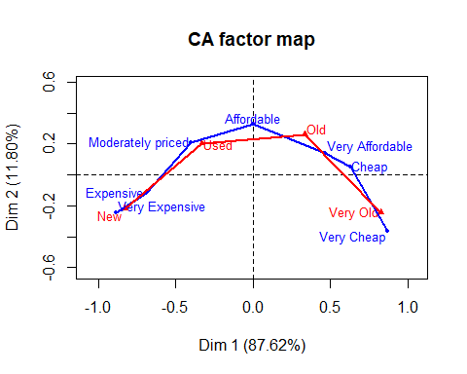

fviz_ca_biplot(res.ca,repel=TRUE)+theme_bw()

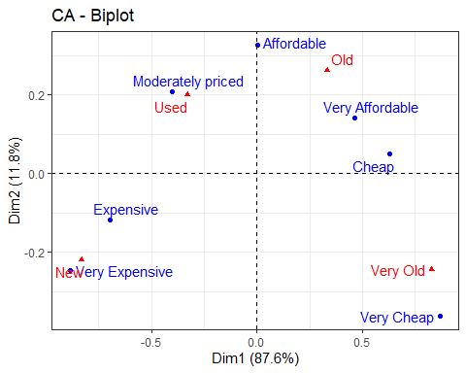

## 4.3 Conclusion

* Can these categories that can be combined/avoided to explain transformed price target into f.price ? Yes, they are related, as we saw both are very related to f.price and combined to explain target variable.

# 5 Multiple Correspondence Analysis

## 5.1 MCA & Eigenvalues & dominant axes analysis

* We’ll utilize a dataframe free of previously identified multivariate outliers to avoid anomalies. The variable “price” will serve as a supplementary quantitative variable, while “f.price” and the binary target “Audi” will function as supplementary qualitative variables. We will also discard f.year and f.miles as they are very related to f.price as we spotted previously.

library(FactoMineR)  
library(factoextra)  
x<-df[,c(3,4,6,10, 12, 14:17)] #Does not include Multivariant Outliers  
res.mca<-MCA(x, quanti.sup = c(1), quali.sup = c(5,9))

## Warning: ggrepel: 5 unlabeled data points (too many overlaps). Consider  
## increasing max.overlaps

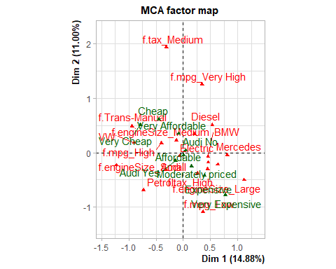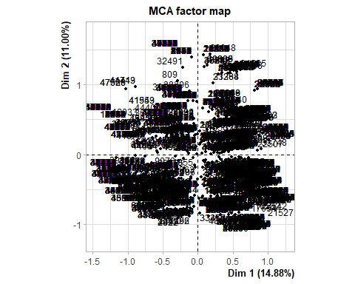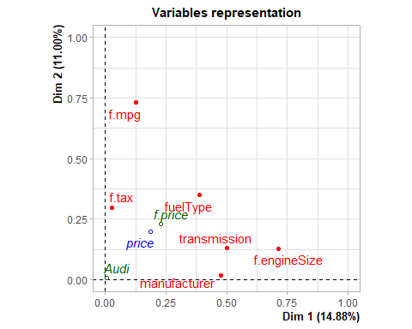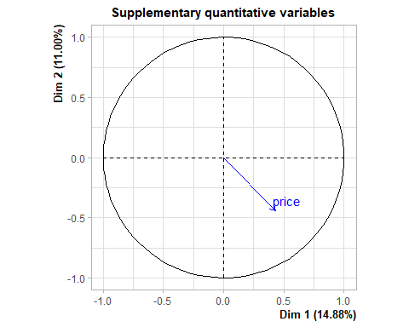

* Based on Kaiser Criteria, 7 components should be retained.

length(which(res.mca$eig[,1] > mean(res.mca$eig[,1])))

## [1] 7

* In 7 components, it is accumulated 63.13% of variance.

res.mca$eig[1:7,]

## eigenvalue percentage of variance cumulative percentage of variance  
## dim 1 0.3720484 14.881936 14.88194  
## dim 2 0.2749617 10.998467 25.88040  
## dim 3 0.2149726 8.598904 34.47931  
## dim 4 0.1914684 7.658736 42.13804  
## dim 5 0.1855535 7.422138 49.56018  
## dim 6 0.1712492 6.849968 56.41015  
## dim 7 0.1681320 6.725282 63.13543

fviz_eig(res.mca)

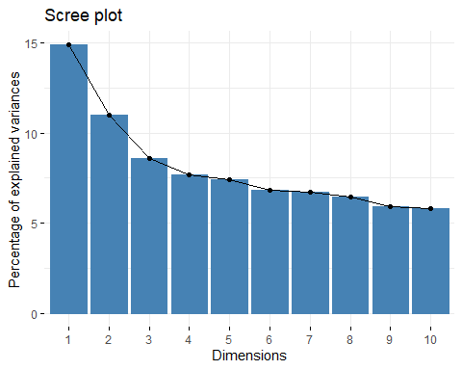

## 5.2 Individuals Point of View

* **Are there any individuals “too contributive”?**
* As we can see, There are some individuals that contribute more in the first component, and others that that do the same in the second component. We can also state the existence of many individuals that contribute equally in both components.

head(res.mca$var$contrib)

## Dim 1 Dim 2 Dim 3 Dim 4 Dim 5  
## f.Trans-Manual 14.230537100 4.995352406 0.144201279 0.39499747 0.8403473  
## f.Trans-SemiAuto 3.384360417 2.095304738 0.189452350 1.14790817 14.6726170  
## f.Trans-Automatic 4.801247965 0.763308902 0.005830079 4.00449538 12.1444109  
## Diesel 7.188179794 9.026447366 0.128761533 0.01841018 0.9294524  
## Electric 0.002234618 0.009781518 0.785092872 16.91707441 5.7819808  
## Hybrid 0.123107592 0.025577876 0.258945485 17.78290994 0.3586737

fviz_mca_ind(res.mca, geom=c("point"),col.ind="contrib", gradient.cols =  
c("yellow", "red"))

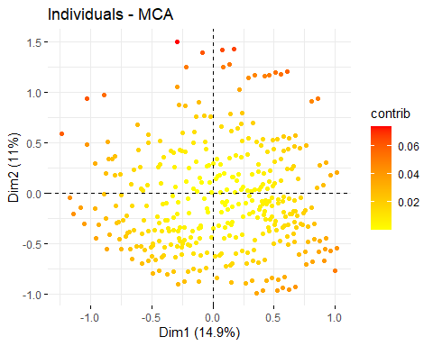

* **Are there any groups?**
* From the the previous graph, we can spot there a few individuals that can form a group as they are scattered equally without any specific pattern.
* As we can see in the following output table, categories tend to contribute equally or contribute very low in different dimensions, so there is not grouping pattern in the plots.

head(res.mca$var$cos2)

## Dim 1 Dim 2 Dim 3 Dim 4  
## f.Trans-Manual 4.950141e-01 0.1284207229 0.0028983381 0.007071121  
## f.Trans-SemiAuto 1.209621e-01 0.0553467943 0.0039125169 0.021114334  
## f.Trans-Automatic 1.460783e-01 0.0171634467 0.0001024919 0.062701358  
## Diesel 3.687816e-01 0.3422471333 0.0038169816 0.000486078  
## Electric 5.003657e-05 0.0001618688 0.0101575466 0.194942738  
## Hybrid 2.784541e-03 0.0004275687 0.0033842366 0.206999464  
## Dim 5  
## f.Trans-Manual 0.014578898  
## f.Trans-SemiAuto 0.261547000  
## f.Trans-Automatic 0.184279709  
## Diesel 0.023781925  
## Electric 0.064569937  
## Hybrid 0.004046112

fviz_cos2(res.mca, choice = "var", axes = 1:2)+theme_bw()

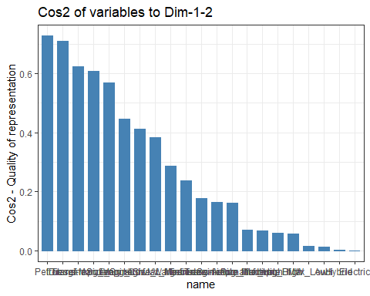

* We can see through the graph that no individual groups are spotted base on each variable, the only one that can show a better grouping is if we depend on transmission types, we can split individuals into two groups Manual and Automatic/Semi-Automatic.
* Please check Annex, to chaeck the other grouping graphs of individuals:

grp<- df$transmission  
fviz_mca_ind(res.mca, label="none", habillage = grp, addEllipses = TRUE)

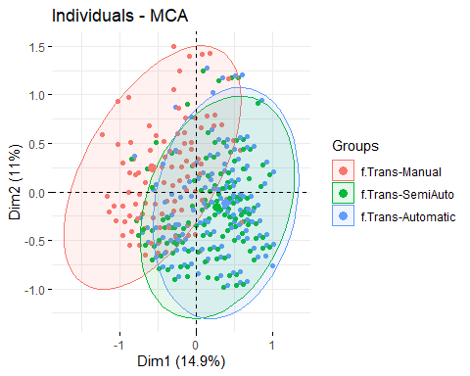

## 5.3 Interpreting map of categories:

* Map of variables: **transmission**, **manufacturer** and **f.engineSize** are better represented in Dim1 , meanwhile **f.tax** and **f.mpg** are better represented in Dim2.
* **f.fueltype** is represented equally and insignificantly compared to other variables.
* fviz_mca_var(res.mca, choice="mca.cor", repel=TRUE)
* 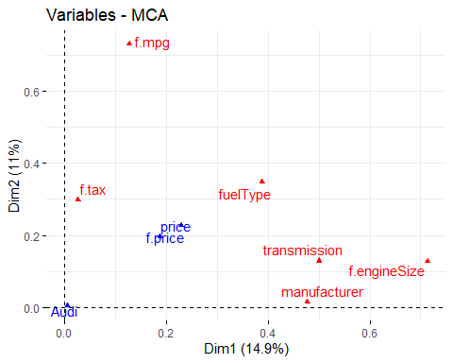
* **f.tax_Mediumf.mpg_Very High** categories are better represented in Dim2 is represented
* We can see that **Cheap/Very Chea** **Manual** Transmission and **Small** EngineSize are close to each other and contribute negatively at same way in Dim1.
* **Mercedes**, **Automatic** transmission, **Hybrid** and **Large Engine Size**, **very Expensive** are also gathered in the same area of the Map which makes sense, and contribute positvely in Dim1.

fviz_mca_var(res.mca, repel=TRUE)

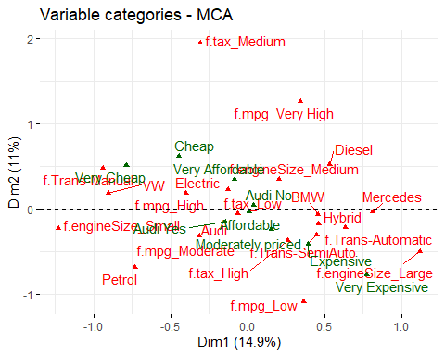

## 5.4 Interpreting the axes associations to factor map

* The following result gives us an insight regarding the variables and categories that are related to the two retained axes:
* Dim1:
  + Variables: **f.engineSize** with R-Squared value of 0.71 and **transmission type** (0.50)
  + Categories: **f.engineSize= f.engineSize_Large** and **transmission=f.Trans-Manual**

res.desc <- dimdesc(res.mca, axes = c(1,2))  
#res.desc[[1]]

* Dim2:
  + Variables: **f.mpg** with a R-Squared value of 0.73 and **fuelType** (0.35)
  + Categories: **f.mpg=f.mpg_Very High** and **fuelType=Petrol**

#res.desc[[2]]

## 5.5 MCA with all variables

* We will try MCA taking into account all numerical variables:
* res.mca2 <- MCA(df, quanti.sup=c(2,3,5,7:9),  
  quali.sup=c(12,17))
* 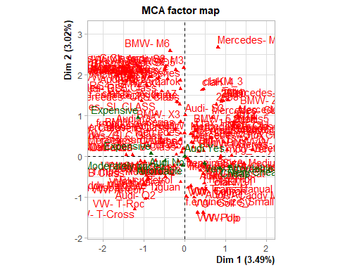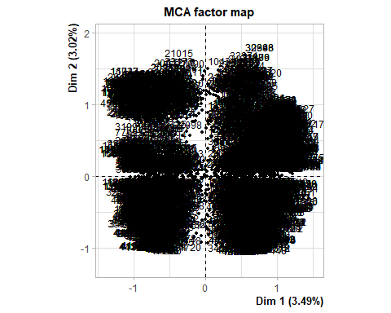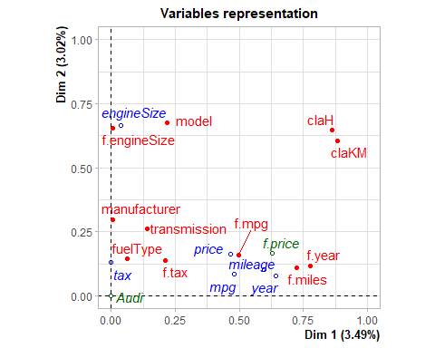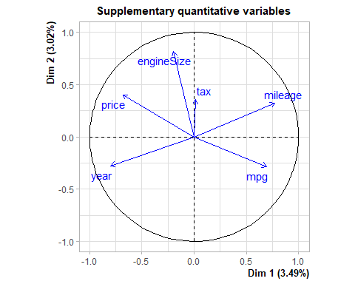
* Dim1:
  + Variables: **f.engineSize** has a Rsquared value of 0.72 and **transmission** (0.50)
  + Categories: **f.engineSize= f.engineSize_Large** and **transmission=f.Trans-Manual**

res.desc2 <- dimdesc(res.mca2, axes = c(1,2))  
#res.desc2[[1]]

* Dim2:
  + Variables: **f.mpg** with a R-Squared value of 0.73 and **fuelType** (0.35)
  + Categories: **f.mpg=f.mpg_Very High** and **fuelType=Petrol**

#res.desc2[[2]]

**Conclusions:**

* Both MCA analysis (either with all numerical variables as supplementary or not) has the same results on both axes. So there was no enhancement in the axis interpretation.

# 6 Hierarchical Clustering from MCA

## 6.1 Hierarchical Clustering

* We will make 5 clusters to facilitate the process of further comparision and analysis:

res.hcpcMCA <- HCPC(res.mca,nb.clust = 5, order = TRUE)

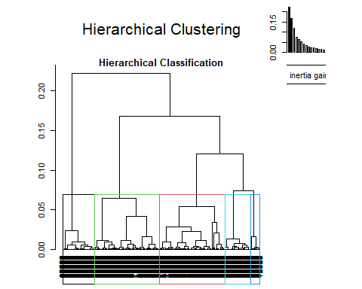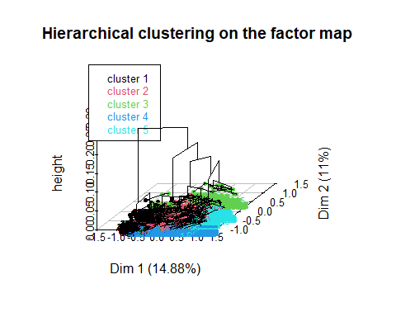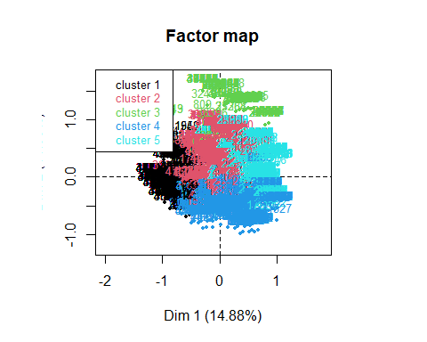

## 6.2 Clustering Quality

* This clustering has a total gain of inertia of 47.25%, in case if we wanted to achieve at least 80% we will be needing 23 clusters, which makes the study more complicated.
* ((res.hcpcMCA$call$t$within[1]-res.hcpcMCA$call$t$within[5])/  
  res.hcpcMCA$call$t$within[1])*100
* ## [1] 47.24876
* ((res.hcpcMCA$call$t$within[1]-res.hcpcMCA$call$t$within[23])/  
  res.hcpcMCA$call$t$within[1])*100
* ## [1] 80.35592

## 6.3 Clustering Description:

* We can see the following barplot describing the individuals distribution through different clusters

table(res.hcpcMCA$data.clust$clust)

##   
## 1 2 3 4 5   
## 1117 1608 237 1094 837

barplot(table(res.hcpcMCA$data.clust$clust), main= "observations/cluster")

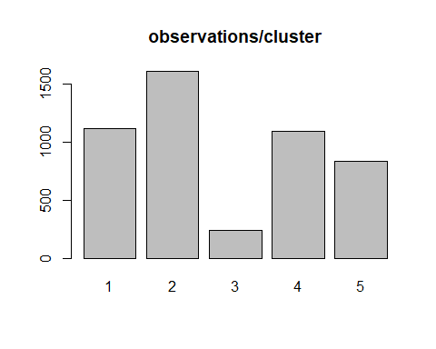

* The extremely low p-values (approaching zero) suggest a significant association between the categories of the variables, indicating that these variables contribute significantly to the formation of clusters.

res.hcpcMCA$desc.var$test.chi2

## p.value df  
## fuelType 0.000000e+00 12  
## manufacturer 0.000000e+00 12  
## f.price 0.000000e+00 24  
## f.tax 0.000000e+00 8  
## f.mpg 0.000000e+00 12  
## f.engineSize 0.000000e+00 8  
## transmission 5.879381e-322 8  
## Audi 1.429662e-67 4

**Describing each cluster in relation with different categories:**

1. Cluster 1 is characterized by a dominance of smaller engine sizes, with an overwhelming 80.31% of cars falling into the “**Small**” category. The fuel type for this cluster is predominantly **petrol**, constituting 54% of the vehicles. **Manual** transmission is strongly associated, with 47.52% of cars in this cluster featuring this type. The cluster is notably linked to the manufacturer **Volkswagen** 47.47%). Furthermore, high miles per gallon (MPG) is a defining characteristic, as 41.08% of the cars in this cluster fall into the “**High**” category. The pricing spectrum in this cluster is diverse, with a substantial portion (47.43%) classified as “**Very Cheap**.” The tax levels are also noteworthy, with a strong association (25.9%) with the “**Low**” tax band
2. Cluster 2 exhibits a preeminence of **medium-sized engine** cars, representing 60.6% of the vehicles in this category. **Diesel** fuel type is prevalent, constituting 49.1% of the cars. **BMW** stands out as the dominant manufacturer, with 56.41% of vehicles in this cluster associated with the brand. The cluster features a balanced distribution across various miles per gallon (MPG) categories, with a significant presence in both “**Moderate**” (50.2%) and “**Very High**” (42.27%) MPG ranges. **Hybrid** fuel type and **manual transmission** are notably associated with this cluster, each representing 81.25% and 37.54%, respectively. Additionally, there is a considerable concentration of cars with **high tax** (38.76%).
3. In Cluster 3, there is a strong association (69.23%) with cars having a “**Medium**” tax level. **Very high** miles per gallon (MPG) is a defining characteristic, representing 18.97% of the vehicles in this cluster. **Diesel** fuel type is predominant, accounting for 8.43% of the cars. The pricing landscape varies, with a significant presence of cars classified as “**Very Affordable**” (13.01%) and “**Cheap**” (11.73%) and “**Very Cheap**” (6.57%). **Manual transmission** is notable in this cluster, with 7.42% of cars featuring this type. The cluster is also marked by **medium-size engine** cars (6.51%).
4. Cluster 4 is characterized by a dominant association with low miles per gallon (MPG), with 79.69% of cars falling into the “**Low**” category. **Very expensive** cars constitute a substantial portion of this cluster (62.80%). The cluster is strongly associated with **large engine size** (48.06%) and **petrol** fuel type (36.59%). **High** taxes (40.88%) and **automatic transmission** (36.30%) are also notable features. **Audi** emerges as a prominent manufacturer in this cluster
5. Cluster 5 is distinguished by a strong association with **Mercedes** as the manufacturer (60.37%). **Diesel** fuel type is prevalent, constituting 29.88% of the cars in this cluster. **Large engine sizes** (41.90%) are also notable features. The cluster is characterized by a medium association with **low** taxes (22.33%) and **very high** miles per gallon (MPG) (30.25%). Additionally, **automatic** and **semi-automatic** transmissions are significant in this cluster, representing 26.02% and 25.88%, respectively. The pricing spectrum is diverse, with a notable presence of cars in various price ranges.

When it comes to numerical target variable price it a low effect in this clustering creation compared but as p-vale is 0 we can say that this variable has somehow an effect on the this clustering. Note that, we passed this variable as supplementary during MCA.

res.hcpcMCA$desc.var$quanti.var

## Eta2 P-value  
## price 0.2759604 0

We can aslo see how **price** behaves in each cluster:

res.hcpcMCA$desc.var$quanti

## $`1`  
## v.test Mean in category Overall mean sd in category Overall sd  
## price -20.95335 15308.06 21600.83 5663.189 11424.62  
## p.value  
## price 1.748742e-97  
##   
## $`2`  
## v.test Mean in category Overall mean sd in category Overall sd  
## price -10.79771 19079.93 21600.83 7331.854 11424.62  
## p.value  
## price 3.528903e-27  
##   
## $`3`  
## v.test Mean in category Overall mean sd in category Overall sd  
## price -10.48262 14011.54 21600.83 3161.378 11424.62  
## p.value  
## price 1.038271e-25  
##   
## $`4`  
## v.test Mean in category Overall mean sd in category Overall sd  
## price 31.66146 31238.13 21600.83 15382.38 11424.62  
## p.value  
## price 5.274243e-220  
##   
## $`5`  
## v.test Mean in category Overall mean sd in category Overall sd  
## price 7.768682 24394.22 21600.83 9709.727 11424.62  
## p.value  
## price 7.930705e-15

1. In Cluster 1, the “**price**” variable exhibits a significant negative v-test value of -20.95, suggesting a considerable difference in mean prices compared to the overall dataset. The mean price in this cluster is notably lower at 15,308.06, with a standard deviation of 5,663.19. This substantial deviation is highly significant (p-value = 1.75e-97), emphasizing a distinct pricing pattern in this cluster cheap and affordable.
2. Cluster 2 shows a significant negative v-test value of -10.80 for the “price” variable, indicating a noteworthy difference in mean prices. The mean price in this cluster is $19,079.93, with a standard deviation of $7,331.85. The low p-value (3.53e-27) underscores the significance of the observed price difference in this cluster.
3. For Cluster 3, the “price” variable demonstrates a significant negative v-test value of -10.48, highlighting a substantial difference in mean prices. The mean price in this cluster is $14,011.54, with a standard deviation of $3,161.38. The p-value (1.04e-25) reinforces the significance of the observed pricing distinction. This cluster has cheap and affordable pricing.
4. In Cluster 4, the “price” variable exhibits a substantial positive v-test value of 31.66, indicating a significant difference in mean prices. The mean price in this cluster is $31,238.13, with a standard deviation of $15,382.38. The extremely low p-value (5.27e-220) emphasizes the highly significant pricing difference in this cluster. This cluster has expensive/very expensive pricing.
5. Cluster 5 shows a positive v-test value of 7.77 for the “price” variable, indicating a significant difference in mean prices. The mean price in this cluster is $24,394.22, with a standard deviation of $9,709.73. The p-value (7.93e-15) underscores the significance of the observed price difference in this cluster. This cluster ha affordable pricing.

## 6.4 Paragons & Class-Specific individuals:

We can spot the most contributing individuals and extreme ones as following:

res.hcpcMCA$desc.ind$para

## Cluster: 1  
## 1458 1843 9045 744 8133   
## 0.2775853 0.2775853 0.2775853 0.2775853 0.2775853   
## ------------------------------------------------------------   
## Cluster: 2  
## 41190 34791 48501 40692 48482   
## 0.2275709 0.2275709 0.2275709 0.2275709 0.2275709   
## ------------------------------------------------------------   
## Cluster: 3  
## 23048 39308 40889 39685 40252   
## 0.3067358 0.3345007 0.3345007 0.3345007 0.3918839   
## ------------------------------------------------------------   
## Cluster: 4  
## 27151 26274 24132 23750 29095   
## 0.2044436 0.2044436 0.2044436 0.2044436 0.2044436   
## ------------------------------------------------------------   
## Cluster: 5  
## 21992 24734 21781 22539 23757   
## 0.342757 0.342757 0.342757 0.342757 0.342757

res.hcpcMCA$desc.ind$dist

## Cluster: 1  
## 44654 38893 41013 36869 36382   
## 4.078156 2.111689 2.111689 1.863859 1.707719   
## ------------------------------------------------------------   
## Cluster: 2  
## 21321 21018 46369 21396 20755   
## 4.661003 4.661003 4.424310 4.390496 4.320743   
## ------------------------------------------------------------   
## Cluster: 3  
## 1810 2689 8031 1636 71   
## 1.743984 1.743984 1.743984 1.743984 1.743984   
## ------------------------------------------------------------   
## Cluster: 4  
## 16582 21527 10426 10150 9145   
## 2.070595 1.972220 1.899207 1.899207 1.899207   
## ------------------------------------------------------------   
## Cluster: 5  
## 33748 23542 17654 22507 27276   
## 1.862962 1.857509 1.848511 1.723642 1.578554

para1<-which(rownames(res.mca$ind$coord)%in%names(res.hcpcMCA$desc.ind$para[[1]]))  
dist1<-which(rownames(res.mca$ind$coord)%in%names(res.hcpcMCA$desc.ind$dist[[1]]))  
para2<-which(rownames(res.mca$ind$coord)%in%names(res.hcpcMCA$desc.ind$para[[2]]))  
dist2<-which(rownames(res.mca$ind$coord)%in%names(res.hcpcMCA$desc.ind$dist[[2]]))  
para3<-which(rownames(res.mca$ind$coord)%in%names(res.hcpcMCA$desc.ind$para[[3]]))  
dist3<-which(rownames(res.mca$ind$coord)%in%names(res.hcpcMCA$desc.ind$dist[[3]]))  
para4<-which(rownames(res.mca$ind$coord)%in%names(res.hcpcMCA$desc.ind$para[[4]]))  
dist4<-which(rownames(res.mca$ind$coord)%in%names(res.hcpcMCA$desc.ind$dist[[4]]))  
para5<-which(rownames(res.mca$ind$coord)%in%names(res.hcpcMCA$desc.ind$para[[5]]))  
dist5<-which(rownames(res.mca$ind$coord)%in%names(res.hcpcMCA$desc.ind$dist[[5]]))  
plot(res.mca$ind$coord[,1],res.mca$ind$coord[,2],col="grey50",cex=0.5,pch=16)  
points(res.mca$ind$coord[para1,1],res.mca$ind$coord[para1,2],col="pink",cex=1,pch=16)  
points(res.mca$ind$coord[dist1,1],res.mca$ind$coord[dist1,2],col="turquoise",cex=1,pch=16)  
points(res.mca$ind$coord[para2,1],res.mca$ind$coord[para2,2],col="darkviolet",cex=1,pch=16)  
points(res.mca$ind$coord[dist2,1],res.mca$ind$coord[dist2,2],col="darkred",cex=1,pch=16)  
points(res.mca$ind$coord[para3,1],res.mca$ind$coord[para3,2],col="yellow",cex=1,pch=16)  
points(res.mca$ind$coord[dist3,1],res.mca$ind$coord[dist3,2],col="gold",cex=1,pch=16)  
points(res.mca$ind$coord[para4,1],res.mca$ind$coord[para4,2],col="orange",cex=1,pch=16)  
points(res.mca$ind$coord[dist4,1],res.mca$ind$coord[dist4,2],col="lightblue",cex=1,pch=16  
)  
points(res.mca$ind$coord[para5,1],res.mca$ind$coord[para5,2],col="lightgreen",cex=1,pch=16)  
points(res.mca$ind$coord[dist5,1],res.mca$ind$coord[dist5,2],col="violet",cex=1,pch=16)

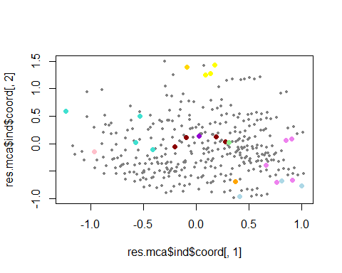

## 6.5 Comparison of clusters obtained after K-Means (based on PCA) and/or Hierarchical Clustering (based on PCA) focusing on targets

### 6.5.1 General Comparision

* The accuracy of approximately 26.12% suggests a moderate level of alignment between the hierarchical clustering and the actual classes. This indicates that the clusters generated by the hierarchical clustering algorithm capture some of the underlying patterns present in the HC-MCA classes, but there is room for improvement.
* The low accuracy of approximately 18.10% indicates a poor alignment between the hierarchical clustering and these HC-MCA clusters. This raises questions about the effectiveness of the clustering algorithm in capturing the patterns inherent in the **claKM** variable. It’s essential to scrutinize the reasons behind this discrepancy. Potential issues could include the sensitivity of the hierarchical clustering algorithm to certain data patterns, the appropriateness of the clustering parameters chosen, etc.
* If we had a greater concordance, this would mean that they would be more similar.

df$hcpckMCA<-res.hcpcMCA$data.clust$clust  
# With Hierarchical Clustering (PCA)  
t1<-table(df$claH,df$hcpckMCA)  
t2<-table(df$claKM,df$hcpckMCA)  
t1

##   
## 1 2 3 4 5  
## 1 515 596 0 494 245  
## 2 0 29 0 402 96  
## 3 537 602 135 15 369  
## 4 0 39 0 92 12  
## 5 65 342 102 91 115

t2

##   
## 1 2 3 4 5  
## 1 521 528 110 24 337  
## 2 92 355 124 37 112  
## 3 5 66 3 172 15  
## 4 498 613 0 328 302  
## 5 1 46 0 533 71

100*sum(diag(t1)/sum(t1))

## [1] 18.1075

100*sum(diag(t2)/sum(t2))

## [1] 26.11895

### 6.5.2 Comparison based on quantitative target: Price

* The results unveil distinctive patterns in the relationship between the “price” variable and the clustering variable across three clustering methods. Hierarchical Clustering based on PCA exhibits the most substantial association, influencing price variation by 51%. In K-Means Clustering, the “price” variable shows a noteworthy 45% impact, indicating a robust relationship. On the other hand, MCA Hierarchical Clustering reveals a comparatively modest influence, with an Eta2 value of 0.28. These numerical insights shed light on the varying degrees of impact that different clustering methodologies exert on the variable of interest, providing a quantitative understanding of their implications.

### 6.5.3 Comparison based on binary target: Audi

* The variable “Audi” consistently shows significant associations within different cluster methods, and it plays a meaningful role in distinguishing clusters and sometimes note.
* The Audi variable exhibits a noteworthy association exclusively in one only cluster during Hierarchical Clustering based on PCA, evident from its considerably higher p-value in comparison to other categorical variables. This elevated p-value implies a diminished linkage and contribution to the formation of these clusters using this method. In contrast, during K-Means clustering, despite a higher p-value of 8.045414e-03, Audi’s impact is relatively modest, particularly in clusters 3 and 4. Surprisingly, this contribution is more substantial than the prior method, despite the lower p-value. Notably, MCA Hierarchical Clustering stands out with the lowest p-value of 1.429662e-67, underscoring the pivotal role played by Audi categories (Yes and No) in shaping clusters 2, 4, and 5, thereby contributing significantly to the underlying structure.

**Conclusion:**

* In conclusion, the optimal clustering method is contingent on our research objectives, emphasizing the nuanced nature of this decision. Rather than asserting superiority of one method over another, the selection should align with the desired data interpretation, research goals, and study conditions. A judicious choice rooted in a comprehensive understanding of these factors ensures a rigorous application of clustering techniques, fostering a more insightful and robust data analysis.

# 7. Annex:

* K.Means Clustering Description:

res.cat <-catdes(df,18)

* Hierarchical Clustering Description:

res.hcpc$desc.var$category

## $`1`  
## Cla/Mod Mod/Cla Global  
## f.year=f.year_2019 79.7331639 67.83783784 32.16840384  
## f.miles=New 81.4693878 53.94594595 25.03576538  
## f.price=Expensive 76.5379113 28.91891892 14.28571429  
## f.mpg=f.mpg_Moderate 63.1037213 43.08108108 25.81238504  
## f.tax=f.tax_Low 46.6386555 84.00000000 68.09728183  
## f.year=f.year_2020 85.6250000 14.81081081 6.53995504  
## fuelType=Petrol 51.4146341 56.97297297 41.89658696  
## f.miles=Used 57.7269011 38.16216216 24.99489066  
## f.mpg=f.mpg_Low 56.3915858 37.67567568 25.26057633  
## f.engineSize=f.engineSize_Medium 47.4919094 63.45945946 50.52115267  
## f.price=Moderately priced 60.3448276 22.70270270 14.22440221  
## model=VW- T-Roc 90.9090909 3.24324324 1.34886573  
## transmission=f.Trans-SemiAuto 44.6924333 44.37837838 37.54342939  
## manufacturer=VW 45.0361604 37.02702703 31.08522379  
## model=VW- T-Cross 100.0000000 1.45945946 0.55180871  
## f.engineSize=f.engineSize_Small 45.2415813 33.40540541 27.91743307  
## model=BMW- X2 95.8333333 1.24324324 0.49049663  
## model=Audi- Q2 71.8309859 2.75675676 1.45105252  
## f.price=Very Expensive 47.3533619 17.89189189 14.28571429  
## model=VW- Tiguan 55.7894737 5.72972973 3.88309830  
## model=VW- Golf 48.0961924 12.97297297 10.19824239  
## model=VW- Arteon 85.7142857 0.97297297 0.42918455  
## model=Mercedes- C Class 47.0588235 9.51351351 7.64357245  
## model=Audi- Q5 55.8823529 3.08108108 2.08461067  
## model=VW- Caravelle 85.7142857 0.64864865 0.28612303  
## f.year=f.year_2018 45.0854701 11.40540541 9.56468424  
## model=Mercedes- V Class 75.0000000 0.81081081 0.40874719  
## model=VW- Shuttle 90.0000000 0.48648649 0.20437359  
## model=BMW- Z4 100.0000000 0.37837838 0.14306152  
## model=Mercedes- B Class 60.0000000 1.62162162 1.02186797  
## model=VW- Tiguan Allspace 100.0000000 0.32432432 0.12262416  
## model=Mercedes- GLC Class 50.4587156 2.97297297 2.22767218  
## model=VW- Sharan 62.5000000 0.81081081 0.49049663  
## model=BMW- 2 Series 48.6486486 2.91891892 2.26854690  
## model=VW- Caddy Maxi Life 100.0000000 0.21621622 0.08174944  
## f.price=Affordable 41.7027417 15.62162162 14.16309013  
## model=Mercedes- X-CLASS 66.6666667 0.54054054 0.30656039  
## model=BMW- 6 Series 13.3333333 0.10810811 0.30656039  
## model=Audi- A7 9.0909091 0.05405405 0.22481095  
## model=BMW- X6 0.0000000 0.00000000 0.14306152  
## model=BMW- M3 0.0000000 0.00000000 0.14306152  
## model=VW- Beetle 8.3333333 0.05405405 0.24524831  
## f.year=f.year_2008 0.0000000 0.00000000 0.16349888  
## model=Mercedes- M Class 0.0000000 0.00000000 0.16349888  
## f.year=f.year_2009 0.0000000 0.00000000 0.18393624  
## model=VW- CC 0.0000000 0.00000000 0.18393624  
## model=BMW- 5 Series 26.1682243 1.51351351 2.18679747  
## model=BMW- 4 Series 24.7058824 1.13513514 1.73717556  
## model=VW- Amarok 0.0000000 0.00000000 0.20437359  
## model=BMW- 7 Series 0.0000000 0.00000000 0.24524831  
## model=Audi- A8 0.0000000 0.00000000 0.24524831  
## model=VW- Polo 29.7213622 5.18918919 6.60126712  
## model=Audi- A6 20.7792208 0.86486486 1.57367668  
## f.year=f.year_2010 0.0000000 0.00000000 0.28612303  
## model=Mercedes- SLK 0.0000000 0.00000000 0.28612303  
## model=Mercedes- GLS Class 0.0000000 0.00000000 0.30656039  
## model=Mercedes- GL Class 0.0000000 0.00000000 0.30656039  
## model=BMW- X4 4.5454545 0.05405405 0.44962191  
## model=VW- Scirocco 7.4074074 0.10810811 0.55180871  
## model=BMW- 1 Series 26.2910798 3.02702703 4.35315757  
## model=Mercedes- S Class 4.3478261 0.05405405 0.47005927  
## model=Mercedes- CLS Class 4.3478261 0.05405405 0.47005927  
## model=BMW- M4 0.0000000 0.00000000 0.42918455  
## f.year=f.year_2011 0.0000000 0.00000000 0.49049663  
## model=Audi- Q7 0.0000000 0.00000000 0.79705702  
## model=VW- Touareg 0.0000000 0.00000000 0.83793174  
## model=BMW- X5 0.0000000 0.00000000 0.83793174  
## model=Mercedes- E Class 16.8604651 1.56756757 3.51522583  
## f.year=f.year_2012 0.0000000 0.00000000 0.87880646  
## transmission=f.Trans-Manual 31.8311466 30.16216216 35.82669119  
## manufacturer=BMW 28.9296046 16.21621622 21.19354179  
## f.price=Very Affordable 23.9038190 9.13513514 14.44921316  
## f.year=f.year_2013 0.0000000 0.00000000 2.67729409  
## f.tax=f.tax_High 24.2027800 16.00000000 24.99489066  
## f.mpg=f.mpg_High 23.5695986 14.91891892 23.93214797  
## f.year=f.year_2014 0.0000000 0.00000000 3.74003679  
## fuelType=Diesel 27.6410999 41.29729730 56.48886164  
## f.price=Cheap 10.7296137 4.05405405 14.28571429  
## f.tax=f.tax_Medium 0.0000000 0.00000000 6.90782751  
## f.year=f.year_2017 10.8796296 5.08108108 17.65787860  
## f.year=f.year_2015 0.2331002 0.05405405 8.76762722  
## f.price=Very Cheap 4.4285714 1.67567568 14.30615165  
## f.miles=Old 11.4027892 7.51351351 24.91314122  
## f.engineSize=f.engineSize_Large 5.4976303 3.13513514 21.56141427  
## f.year=f.year_2016 1.8159806 0.81081081 16.88125894  
## f.mpg=f.mpg_Very High 6.5412919 4.32432432 24.99489066  
## f.miles=Very Old 0.5709625 0.37837838 25.05620274  
## p.value v.test  
## f.year=f.year_2019 0.000000e+00 Inf  
## f.miles=New 9.054345e-293 36.568524  
## f.price=Expensive 5.436758e-113 22.589984  
## f.mpg=f.mpg_Moderate 1.201081e-100 21.297358  
## f.tax=f.tax_Low 3.962510e-82 19.196452  
## f.year=f.year_2020 1.273655e-74 18.276489  
## fuelType=Petrol 2.835983e-62 16.653881  
## f.miles=Used 2.178113e-60 16.392094  
## f.mpg=f.mpg_Low 1.516369e-53 15.404937  
## f.engineSize=f.engineSize_Medium 1.322979e-45 14.174224  
## f.price=Moderately priced 1.017905e-38 13.014057  
## model=VW- T-Roc 1.568277e-19 9.039891  
## transmission=f.Trans-SemiAuto 1.712776e-14 7.670537  
## manufacturer=VW 3.343833e-12 6.962459  
## model=VW- T-Cross 3.495599e-12 6.956206  
## f.engineSize=f.engineSize_Small 3.382551e-11 6.628875  
## model=BMW- X2 2.784597e-09 5.943817  
## model=Audi- Q2 5.963887e-09 5.817767  
## f.price=Very Expensive 2.725222e-08 5.558231  
## model=VW- Tiguan 3.242609e-07 5.108771  
## model=VW- Golf 7.906234e-07 4.937668  
## model=VW- Arteon 9.202101e-06 4.435120  
## model=Mercedes- C Class 1.495352e-04 3.791840  
## model=Audi- Q5 1.989866e-04 3.720300  
## model=VW- Caravelle 3.524085e-04 3.573376  
## f.year=f.year_2018 7.236676e-04 3.380452  
## model=Mercedes- V Class 9.356915e-04 3.309182  
## model=VW- Shuttle 1.089515e-03 3.266329  
## model=BMW- Z4 1.096743e-03 3.264457  
## model=Mercedes- B Class 1.562442e-03 3.162829  
## model=VW- Tiguan Allspace 2.906606e-03 2.977446  
## model=Mercedes- GLC Class 6.825704e-03 2.705230  
## model=VW- Sharan 1.599385e-02 2.409056  
## model=BMW- 2 Series 1.905461e-02 2.344461  
## model=VW- Caddy Maxi Life 2.039432e-02 2.319013  
## f.price=Affordable 2.319641e-02 2.270184  
## model=Mercedes- X-CLASS 2.781873e-02 2.199833  
## model=BMW- 6 Series 4.725239e-02 -1.984031  
## model=Audi- A7 4.656026e-02 -1.990279  
## model=BMW- X6 3.588828e-02 -2.098191  
## model=BMW- M3 3.588828e-02 -2.098191  
## model=VW- Beetle 3.094971e-02 -2.157719  
## f.year=f.year_2008 2.229980e-02 -2.285222  
## model=Mercedes- M Class 2.229980e-02 -2.285222  
## f.year=f.year_2009 1.385464e-02 -2.461010  
## model=VW- CC 1.385464e-02 -2.461010  
## model=BMW- 5 Series 1.070091e-02 -2.552317  
## model=BMW- 4 Series 1.045025e-02 -2.560564  
## model=VW- Amarok 8.606667e-03 -2.627295  
## model=BMW- 7 Series 3.320107e-03 -2.936433  
## model=Audi- A8 3.320107e-03 -2.936433  
## model=VW- Polo 1.689264e-03 -3.140037  
## model=Audi- A6 1.355007e-03 -3.204068  
## f.year=f.year_2010 1.280124e-03 -3.220399  
## model=Mercedes- SLK 1.280124e-03 -3.220399  
## model=Mercedes- GLS Class 7.947317e-04 -3.354623  
## model=Mercedes- GL Class 7.947317e-04 -3.354623  
## model=BMW- X4 4.354185e-04 -3.517630  
## model=VW- Scirocco 4.307676e-04 -3.520479  
## model=BMW- 1 Series 2.981034e-04 -3.616943  
## model=Mercedes- S Class 2.808161e-04 -3.632383  
## model=Mercedes- CLS Class 2.808161e-04 -3.632383  
## model=BMW- M4 4.538248e-05 -4.078217  
## f.year=f.year_2011 1.082645e-05 -4.399973  
## model=Audi- Q7 8.223980e-09 -5.763802  
## model=VW- Touareg 3.149396e-09 -5.923615  
## model=BMW- X5 3.149396e-09 -5.923615  
## model=Mercedes- E Class 1.218028e-09 -6.077852  
## f.year=f.year_2012 1.205457e-09 -6.079516  
## transmission=f.Trans-Manual 9.374541e-11 -6.476708  
## manufacturer=BMW 1.689528e-11 -6.730610  
## f.price=Very Affordable 2.510196e-17 -8.467359  
## f.year=f.year_2013 3.219447e-28 -11.015444  
## f.tax=f.tax_High 5.025377e-31 -11.583004  
## f.mpg=f.mpg_High 3.830964e-32 -11.801570  
## f.year=f.year_2014 2.104352e-39 -13.133934  
## fuelType=Diesel 9.248006e-63 -16.720793  
## f.price=Cheap 1.399035e-66 -17.237090  
## f.tax=f.tax_Medium 1.019639e-73 -18.162659  
## f.year=f.year_2017 1.423965e-83 -19.368481  
## f.year=f.year_2015 4.230220e-92 -20.354561  
## f.price=Very Cheap 1.414228e-109 -22.239852  
## f.miles=Old 4.874084e-121 -23.394391  
## f.engineSize=f.engineSize_Large 8.841815e-162 -27.103965  
## f.year=f.year_2016 2.267324e-162 -27.154061  
## f.mpg=f.mpg_Very High 5.632251e-179 -28.525652  
## f.miles=Very Old 4.824196e-288 -36.269914  
##   
## $`2`  
## Cla/Mod Mod/Cla Global  
## f.engineSize=f.engineSize_Large 49.95260664 100.0000000 21.56141427  
## f.price=Very Expensive 51.21602289 67.9316888 14.28571429  
## f.mpg=f.mpg_Low 31.87702265 74.7628083 25.26057633  
## model=VW- Touareg 92.68292683 7.2106262 0.83793174  
## model=Audi- Q7 89.74358974 6.6413662 0.79705702  
## manufacturer=BMW 20.73288332 40.7969639 21.19354179  
## model=BMW- M4 100.00000000 3.9848197 0.42918455  
## transmission=f.Trans-SemiAuto 16.11322809 56.1669829 37.54342939  
## transmission=f.Trans-Automatic 17.19109747 42.5047438 26.62987942  
## model=Mercedes- GLS Class 100.00000000 2.8462998 0.30656039  
## model=BMW- X5 60.97560976 4.7438330 0.83793174  
## model=Mercedes- GLE Class 50.98039216 4.9335863 1.04230533  
## model=Audi- A8 91.66666667 2.0872865 0.24524831  
## model=Mercedes- S Class 65.21739130 2.8462998 0.47005927  
## model=BMW- 7 Series 83.33333333 1.8975332 0.24524831  
## f.tax=f.tax_High 15.29026983 35.4838710 24.99489066  
## f.miles=New 15.18367347 35.2941176 25.03576538  
## model=BMW- X4 59.09090909 2.4667932 0.44962191  
## model=Mercedes- SL CLASS 50.00000000 2.6565465 0.57224607  
## model=BMW- 4 Series 30.58823529 4.9335863 1.73717556  
## f.year=f.year_2019 13.85006353 41.3662239 32.16840384  
## model=BMW- X6 85.71428571 1.1385199 0.14306152  
## model=BMW- X7 100.00000000 0.9487666 0.10218680  
## model=Audi- Q8 100.00000000 0.9487666 0.10218680  
## model=Mercedes- CLS Class 43.47826087 1.8975332 0.47005927  
## model=Audi- RS6 100.00000000 0.7590133 0.08174944  
## model=Audi- R8 100.00000000 0.7590133 0.08174944  
## model=VW- Amarok 60.00000000 1.1385199 0.20437359  
## model=BMW- M3 71.42857143 0.9487666 0.14306152  
## fuelType=Diesel 12.15629522 63.7571157 56.48886164  
## model=BMW- M5 100.00000000 0.5692600 0.06131208  
## model=BMW- 8 Series 100.00000000 0.5692600 0.06131208  
## model=BMW- 6 Series 40.00000000 1.1385199 0.30656039  
## model=Audi- A7 45.45454545 0.9487666 0.22481095  
## f.year=f.year_2018 14.74358974 13.0929791 9.56468424  
## model=BMW- M6 100.00000000 0.3795066 0.04087472  
## model=BMW- M2 100.00000000 0.3795066 0.04087472  
## model=Mercedes- E Class 16.86046512 5.5028463 3.51522583  
## model=BMW- X3 22.44897959 2.0872865 1.00143062  
## f.miles=Used 12.59198692 29.2220114 24.99489066  
## model=Mercedes- X-CLASS 33.33333333 0.9487666 0.30656039  
## model=BMW- 3 Series 15.45064378 6.8311195 4.76190476  
## model=Audi- SQ5 66.66666667 0.3795066 0.06131208  
## manufacturer=Mercedes 12.33616037 30.3605313 26.50725526  
## f.year=f.year_2020 14.37500000 8.7286528 6.53995504  
## model=VW- T-Cross 0.00000000 0.0000000 0.55180871  
## model=VW- Scirocco 0.00000000 0.0000000 0.55180871  
## model=Audi- TT 0.00000000 0.0000000 0.65399550  
## model=BMW- 2 Series 4.50450450 0.9487666 2.26854690  
## model=Mercedes- C Class 7.21925134 5.1233397 7.64357245  
## f.year=f.year_2014 5.46448087 1.8975332 3.74003679  
## f.year=f.year_2012 0.00000000 0.0000000 0.87880646  
## f.price=Moderately priced 7.90229885 10.4364326 14.22440221  
## model=Mercedes- CL Class 0.00000000 0.0000000 1.02186797  
## model=Mercedes- B Class 0.00000000 0.0000000 1.02186797  
## fuelType=Petrol 9.17073171 35.6736243 41.89658696  
## f.year=f.year_2016 7.74818402 12.1442125 16.88125894  
## model=BMW- X1 0.00000000 0.0000000 1.30799101  
## model=VW- T-Roc 0.00000000 0.0000000 1.34886573  
## f.year=f.year_2015 6.06060606 4.9335863 8.76762722  
## model=Audi- Q2 0.00000000 0.0000000 1.45105252  
## model=Mercedes- GLA Class 0.00000000 0.0000000 1.55323932  
## f.mpg=f.mpg_Moderate 7.83847981 18.7855787 25.81238504  
## f.year=f.year_2013 1.52671756 0.3795066 2.67729409  
## model=VW- Up 0.00000000 0.0000000 1.79848764  
## model=VW- Passat 0.00000000 0.0000000 2.04373595  
## model=Audi- Q3 0.71428571 0.1897533 2.86123033  
## model=Audi- A1 0.00000000 0.0000000 2.75904353  
## model=Mercedes- A Class 2.02429150 0.9487666 5.04802779  
## model=Audi- A3 0.00000000 0.0000000 3.86266094  
## f.price=Affordable 4.47330447 5.8823529 14.16309013  
## model=VW- Tiguan 0.00000000 0.0000000 3.88309830  
## model=VW- Polo 0.00000000 0.0000000 6.60126712  
## f.miles=Very Old 4.64926591 10.8159393 25.05620274  
## f.tax=f.tax_Medium 0.00000000 0.0000000 6.90782751  
## f.price=Very Affordable 2.12164074 2.8462998 14.44921316  
## model=VW- Golf 0.00000000 0.0000000 10.19824239  
## f.mpg=f.mpg_High 2.81810418 6.2618596 23.93214797  
## f.price=Cheap 0.28612303 0.3795066 14.28571429  
## f.price=Very Cheap 0.00000000 0.0000000 14.30615165  
## manufacturer=VW 2.89283366 8.3491461 31.08522379  
## f.mpg=f.mpg_Very High 0.08176615 0.1897533 24.99489066  
## f.engineSize=f.engineSize_Small 0.00000000 0.0000000 27.91743307  
## transmission=f.Trans-Manual 0.39931546 1.3282732 35.82669119  
## f.engineSize=f.engineSize_Medium 0.00000000 0.0000000 50.52115267  
## p.value v.test  
## f.engineSize=f.engineSize_Large 0.000000e+00 Inf  
## f.price=Very Expensive 3.906655e-210 30.936109  
## f.mpg=f.mpg_Low 5.812966e-144 25.547771  
## model=VW- Touareg 3.897545e-34 12.181560  
## model=Audi- Q7 2.631539e-30 11.440241  
## manufacturer=BMW 1.689398e-27 10.865153  
## model=BMW- M4 3.313306e-21 9.452343  
## transmission=f.Trans-SemiAuto 4.392724e-20 9.177975  
## transmission=f.Trans-Automatic 5.977821e-17 8.365662  
## model=Mercedes- GLS Class 2.544051e-15 7.911451  
## model=BMW- X5 7.913748e-15 7.768953  
## model=Mercedes- GLE Class 7.923875e-13 7.162466  
## model=Audi- A8 2.254158e-10 6.342944  
## model=Mercedes- S Class 5.767131e-10 6.196667  
## model=BMW- 7 Series 1.071172e-08 5.719056  
## f.tax=f.tax_High 1.267772e-08 5.690353  
## f.miles=New 2.603074e-08 5.566232  
## model=BMW- X4 4.870793e-08 5.455964  
## model=Mercedes- SL CLASS 2.541436e-07 5.154622  
## model=BMW- 4 Series 5.216470e-07 5.018175  
## f.year=f.year_2019 2.642021e-06 4.696852  
## model=BMW- X6 9.841005e-06 4.420638  
## model=BMW- X7 1.424953e-05 4.339981  
## model=Audi- Q8 1.424953e-05 4.339981  
## model=Mercedes- CLS Class 6.832758e-05 3.982035  
## model=Audi- RS6 1.332045e-04 3.820457  
## model=Audi- R8 1.332045e-04 3.820457  
## model=VW- Amarok 2.325979e-04 3.680696  
## model=BMW- M3 2.580915e-04 3.654094  
## fuelType=Diesel 3.394126e-04 3.583198  
## model=BMW- M5 1.243072e-03 3.228808  
## model=BMW- 8 Series 1.243072e-03 3.228808  
## model=BMW- 6 Series 3.718259e-03 2.901125  
## model=Audi- A7 4.214465e-03 2.861647  
## f.year=f.year_2018 5.079633e-03 2.801940  
## model=BMW- M6 1.158070e-02 2.524670  
## model=BMW- M2 1.158070e-02 2.524670  
## model=Mercedes- E Class 1.367985e-02 2.465562  
## model=BMW- X3 1.790697e-02 2.367536  
## f.miles=Used 1.927832e-02 2.340105  
## model=Mercedes- X-CLASS 2.029379e-02 2.320871  
## model=BMW- 3 Series 2.424570e-02 2.253213  
## model=Audi- SQ5 3.349902e-02 2.126051  
## manufacturer=Mercedes 3.587954e-02 2.098290  
## f.year=f.year_2020 3.774649e-02 2.077597  
## model=VW- T-Cross 4.570408e-02 -1.998116  
## model=VW- Scirocco 4.570408e-02 -1.998116  
## model=Audi- TT 2.575931e-02 -2.229821  
## model=BMW- 2 Series 2.061485e-02 -2.314965  
## model=Mercedes- C Class 1.667251e-02 -2.393851  
## f.year=f.year_2014 1.194788e-02 -2.513680  
## f.year=f.year_2012 7.280010e-03 -2.683757  
## f.price=Moderately priced 6.656704e-03 -2.713547  
## model=Mercedes- CL Class 3.252423e-03 -2.942815  
## model=Mercedes- B Class 3.252423e-03 -2.942815  
## fuelType=Petrol 2.055386e-03 -3.082110  
## f.year=f.year_2016 1.517118e-03 -3.171389  
## model=BMW- X1 6.467644e-04 -3.411205  
## model=VW- T-Roc 5.132885e-04 -3.473724  
## f.year=f.year_2015 4.652142e-04 -3.500025  
## model=Audi- Q2 2.878770e-04 -3.625972  
## model=Mercedes- GLA Class 1.613527e-04 -3.772913  
## f.mpg=f.mpg_Moderate 6.120584e-05 -4.008113  
## f.year=f.year_2013 4.405769e-05 -4.085101  
## model=VW- Up 4.010622e-05 -4.106867  
## model=VW- Passat 9.932173e-06 -4.418645  
## model=Audi- Q3 1.793982e-06 -4.775346  
## model=Audi- A1 1.658898e-07 -5.233990  
## model=Mercedes- A Class 9.264494e-08 -5.340589  
## model=Audi- A3 2.821133e-10 -6.308302  
## f.price=Affordable 2.608232e-10 -6.320438  
## model=VW- Tiguan 2.505075e-10 -6.326670  
## model=VW- Polo 2.689731e-17 -8.459306  
## f.miles=Very Old 7.502882e-18 -8.606952  
## f.tax=f.tax_Medium 4.267941e-18 -8.671412  
## f.price=Very Affordable 9.909277e-21 -9.337010  
## model=VW- Golf 7.382188e-27 -10.729717  
## f.mpg=f.mpg_High 1.289427e-29 -11.301536  
## f.price=Cheap 1.630331e-34 -12.252432  
## f.price=Very Cheap 2.726767e-38 -12.938565  
## manufacturer=VW 9.959367e-40 -13.190446  
## f.mpg=f.mpg_Very High 1.023274e-68 -17.519159  
## f.engineSize=f.engineSize_Small 7.239824e-81 -19.044919  
## transmission=f.Trans-Manual 1.071429e-95 -20.756475  
## f.engineSize=f.engineSize_Medium 6.859810e-176 -28.275794  
##   
## $`3`  
## Cla/Mod Mod/Cla Global  
## f.miles=Old 71.9442166 52.89505428 24.9131412  
## f.mpg=f.mpg_Very High 67.8659035 50.06031363 24.9948907  
## f.year=f.year_2017 71.5277778 37.27382388 17.6578786  
## f.year=f.year_2016 67.4334140 33.59469240 16.8812589  
## f.mpg=f.mpg_High 56.1912895 39.68636912 23.9321480  
## transmission=f.Trans-Manual 46.3776383 49.03498191 35.8266912  
## f.price=Cheap 56.5092990 23.82388420 14.2857143  
## f.engineSize=f.engineSize_Small 47.5841874 39.20386007 27.9174331  
## f.tax=f.tax_Medium 65.0887574 13.26899879 6.9078275  
## f.price=Very Affordable 53.8896747 22.97949337 14.4492132  
## model=VW- Polo 63.7770898 12.42460796 6.6012671  
## f.price=Affordable 45.4545455 18.99879373 14.1630901  
## f.price=Very Cheap 45.0000000 18.99879373 14.3061516  
## fuelType=Diesel 37.1924747 62.00241255 56.4888616  
## model=Audi- A1 57.0370370 4.64414958 2.7590435  
## model=VW- Up 57.9545455 3.07599517 1.7984876  
## manufacturer=VW 38.5272847 35.34378770 31.0852238  
## model=Mercedes- GLA Class 56.5789474 2.59348613 1.5532393  
## f.tax=f.tax_Low 35.7442977 71.83353438 68.0972818  
## model=Mercedes- E Class 47.6744186 4.94571773 3.5152258  
## model=Mercedes- A Class 44.1295547 6.57418577 5.0480278  
## f.year=f.year_2018 39.9572650 11.27864897 9.5646842  
## model=BMW- 1 Series 41.3145540 5.30759952 4.3531576  
## model=Audi- A3 41.7989418 4.76477684 3.8626609  
## model=BMW- X1 46.8750000 1.80940893 1.3079910  
## model=Mercedes- GL Class 60.0000000 0.54282268 0.3065604  
## f.year=f.year_2008 0.0000000 0.00000000 0.1634989  
## model=Mercedes- M Class 0.0000000 0.00000000 0.1634989  
## f.year=f.year_2009 0.0000000 0.00000000 0.1839362  
## model=VW- Shuttle 0.0000000 0.00000000 0.2043736  
## model=VW- Amarok 0.0000000 0.00000000 0.2043736  
## model=BMW- 5 Series 22.4299065 1.44752714 2.1867975  
## model=BMW- X4 9.0909091 0.12062726 0.4496219  
## model=BMW- 7 Series 0.0000000 0.00000000 0.2452483  
## model=Audi- A8 0.0000000 0.00000000 0.2452483  
## model=BMW- X5 14.6341463 0.36188179 0.8379317  
## model=BMW- 3 Series 25.3218884 3.55850422 4.7619048  
## f.year=f.year_2010 0.0000000 0.00000000 0.2861230  
## model=VW- Caravelle 0.0000000 0.00000000 0.2861230  
## model=Mercedes- X-CLASS 0.0000000 0.00000000 0.3065604  
## model=Mercedes- GLS Class 0.0000000 0.00000000 0.3065604  
## model=BMW- 6 Series 0.0000000 0.00000000 0.3065604  
## model=Mercedes- S Class 4.3478261 0.06031363 0.4700593  
## model=BMW- X2 4.1666667 0.06031363 0.4904966  
## model=Mercedes- B Class 12.0000000 0.36188179 1.0218680  
## model=Mercedes- V Class 0.0000000 0.00000000 0.4087472  
## model=BMW- M4 0.0000000 0.00000000 0.4291845  
## f.year=f.year_2011 0.0000000 0.00000000 0.4904966  
## model=VW- T-Cross 0.0000000 0.00000000 0.5518087  
## f.miles=Used 28.6999182 21.17008444 24.9948907  
## f.engineSize=f.engineSize_Medium 30.8252427 45.95898673 50.5211527  
## model=VW- T-Roc 9.0909091 0.36188179 1.3488657  
## manufacturer=BMW 27.6759884 17.31001206 21.1935418  
## model=Mercedes- GLE Class 3.9215686 0.12062726 1.0423053  
## model=Audi- Q7 0.0000000 0.00000000 0.7970570  
## f.price=Moderately priced 25.1436782 10.55488540 14.2244022  
## model=VW- Touareg 0.0000000 0.00000000 0.8379317  
## f.year=f.year_2012 0.0000000 0.00000000 0.8788065  
## fuelType=Petrol 29.3170732 36.24849216 41.8965870  
## transmission=f.Trans-SemiAuto 28.8513881 31.96622437 37.5434294  
## f.year=f.year_2014 14.7540984 1.62846803 3.7400368  
## model=Audi- Q5 4.9019608 0.30156815 2.0846107  
## f.year=f.year_2013 6.8702290 0.54282268 2.6772941  
## f.engineSize=f.engineSize_Large 23.3175355 14.83715320 21.5614143  
## transmission=f.Trans-Automatic 24.1749808 18.99879373 26.6298794  
## f.tax=f.tax_High 20.1962388 14.89746683 24.9948907  
## f.price=Expensive 10.1573677 4.28226779 14.2857143  
## f.year=f.year_2020 0.0000000 0.00000000 6.5399550  
## f.mpg=f.mpg_Moderate 13.2224861 10.07237636 25.8123850  
## f.price=Very Expensive 0.8583691 0.36188179 14.2857143  
## f.miles=New 3.3469388 2.47285887 25.0357654  
## f.year=f.year_2019 6.4167726 6.09167672 32.1684038  
## f.mpg=f.mpg_Low 0.2427184 0.18094089 25.2605763  
## p.value v.test  
## f.miles=Old 5.199869e-223 31.879119  
## f.mpg=f.mpg_Very High 3.424678e-178 28.462380  
## f.year=f.year_2017 3.334542e-139 25.115896  
## f.year=f.year_2016 8.916728e-105 21.738286  
## f.mpg=f.mpg_High 2.500854e-73 18.113344  
## transmission=f.Trans-Manual 1.248215e-42 13.684992  
## f.price=Cheap 3.151559e-40 13.276904  
## f.engineSize=f.engineSize_Small 1.944097e-35 12.423680  
## f.tax=f.tax_Medium 7.244880e-34 12.130900  
## f.price=Very Affordable 2.517998e-32 11.836827  
## model=VW- Polo 8.234755e-30 11.340843  
## f.price=Affordable 9.243621e-12 6.817814  
## f.price=Very Cheap 4.328353e-11 6.592379  
## fuelType=Diesel 2.351801e-08 5.583903  
## model=Audi- A1 2.657038e-08 5.562653  
## model=VW- Up 3.560886e-06 4.635493  
## manufacturer=VW 4.605820e-06 4.581985  
## model=Mercedes- GLA Class 4.955702e-05 4.057706  
## f.tax=f.tax_Low 5.492911e-05 4.033599  
## model=Mercedes- E Class 1.492075e-04 3.792385  
## model=Mercedes- A Class 6.179091e-04 3.423629  
## f.year=f.year_2018 3.908955e-03 2.885417  
## model=BMW- 1 Series 2.095743e-02 2.308750  
## model=Audi- A3 2.098211e-02 2.308306  
## model=BMW- X1 3.138535e-02 2.152152  
## model=Mercedes- GL Class 4.365353e-02 2.017402  
## f.year=f.year_2008 3.640132e-02 -2.092416  
## model=Mercedes- M Class 3.640132e-02 -2.092416  
## f.year=f.year_2009 2.404648e-02 -2.256386  
## model=VW- Shuttle 1.588328e-02 -2.411587  
## model=VW- Amarok 1.588328e-02 -2.411587  
## model=BMW- 5 Series 9.582822e-03 -2.590530  
## model=BMW- X4 9.356529e-03 -2.598745  
## model=BMW- 7 Series 6.927564e-03 -2.700306  
## model=Audi- A8 6.927564e-03 -2.700306  
## model=BMW- X5 6.314675e-03 -2.730978  
## model=BMW- 3 Series 3.968684e-03 -2.880640  
## f.year=f.year_2010 3.020214e-03 -2.965673  
## model=VW- Caravelle 3.020214e-03 -2.965673  
## model=Mercedes- X-CLASS 1.993874e-03 -3.091143  
## model=Mercedes- GLS Class 1.993874e-03 -3.091143  
## model=BMW- 6 Series 1.993874e-03 -3.091143  
## model=Mercedes- S Class 9.939384e-04 -3.292237  
## model=BMW- X2 6.801245e-04 -3.397468  
## model=Mercedes- B Class 4.650584e-04 -3.500114  
## model=Mercedes- V Class 2.496372e-04 -3.662632  
## model=BMW- M4 1.647001e-04 -3.767789  
## f.year=f.year_2011 4.726847e-05 -4.068738  
## model=VW- T-Cross 1.355298e-05 -4.350981  
## f.miles=Used 8.171261e-06 -4.460647  
## f.engineSize=f.engineSize_Medium 4.900596e-06 -4.568999  
## model=VW- T-Roc 2.911985e-06 -4.676932  
## manufacturer=BMW 1.487722e-06 -4.812878  
## model=Mercedes- GLE Class 2.393985e-07 -5.165811  
## model=Audi- Q7 9.072595e-08 -5.344382  
## f.price=Moderately priced 8.139836e-08 -5.364001  
## model=VW- Touareg 3.932775e-08 -5.493844  
## f.year=f.year_2012 1.704044e-08 -5.639642  
## fuelType=Petrol 8.813943e-09 -5.752104  
## transmission=f.Trans-SemiAuto 6.715218e-09 -5.797896  
## f.year=f.year_2014 3.094060e-09 -5.926528  
## model=Audi- Q5 1.118370e-12 -7.115094  
## f.year=f.year_2013 1.225433e-13 -7.414003  
## f.engineSize=f.engineSize_Large 5.530591e-17 -8.374825  
## transmission=f.Trans-Automatic 1.317820e-18 -8.804206  
## f.tax=f.tax_High 2.323778e-33 -12.035091  
## f.price=Expensive 1.399504e-54 -15.558214  
## f.year=f.year_2020 1.092460e-60 -16.433981  
## f.mpg=f.mpg_Moderate 8.217710e-81 -19.038283  
## f.price=Very Expensive 7.064570e-126 -23.865065  
## f.miles=New 1.991107e-191 -29.512483  
## f.year=f.year_2019 2.618304e-203 -30.424337  
## f.mpg=f.mpg_Low 4.676413e-259 -34.382055  
##   
## $`4`  
## Cla/Mod Mod/Cla Global p.value  
## f.tax=f.tax_High 11.6925593 100.0000000 24.9948907 1.118337e-89  
## f.mpg=f.mpg_Moderate 6.3341251 55.9440559 25.8123850 1.006561e-14  
## f.miles=Very Old 6.3621533 54.5454545 25.0562027 2.482426e-14  
## model=Audi- Q5 18.6274510 13.2867133 2.0846107 6.046558e-11  
## f.year=f.year_2015 8.8578089 26.5734266 8.7676272 2.144493e-10  
## f.engineSize=f.engineSize_Large 6.0663507 44.7552448 21.5614143 3.551538e-10  
## f.mpg=f.mpg_Low 5.0970874 44.0559441 25.2605763 7.517987e-07  
## model=BMW- X5 21.9512195 6.2937063 0.8379317 2.081033e-06  
## f.year=f.year_2016 5.5690073 32.1678322 16.8812589 5.664433e-06  
## f.price=Moderately priced 5.7471264 27.9720280 14.2244022 1.458114e-05  
## model=Mercedes- M Class 50.0000000 2.7972028 0.1634989 4.574562e-05  
## model=Mercedes- S Class 21.7391304 3.4965035 0.4700593 4.747952e-04  
## f.miles=Old 4.4298605 37.7622378 24.9131412 5.658125e-04  
## Audi=Audi Yes 4.5279383 32.8671329 21.2139792 1.023749e-03  
## manufacturer=Audi 4.5279383 32.8671329 21.2139792 1.023749e-03  
## transmission=f.Trans-Automatic 4.1442824 37.7622378 26.6298794 3.172268e-03  
## f.year=f.year_2011 16.6666667 2.7972028 0.4904966 5.252822e-03  
## f.year=f.year_2013 7.6335878 6.9930070 2.6772941 6.091919e-03  
## model=BMW- 6 Series 20.0000000 2.0979021 0.3065604 9.335075e-03  
## manufacturer=BMW 4.1465767 30.0699301 21.1935418 1.131994e-02  
## model=Mercedes- CL Class 10.0000000 3.4965035 1.0218680 1.773562e-02  
## model=Mercedes- GLE Class 9.8039216 3.4965035 1.0423053 1.928523e-02  
## model=Mercedes- V Class 15.0000000 2.0979021 0.4087472 2.170699e-02  
## f.price=Affordable 4.3290043 20.9790210 14.1630901 2.406948e-02  
## f.year=f.year_2014 6.0109290 7.6923077 3.7400368 2.427379e-02  
## model=Audi- Q7 10.2564103 2.7972028 0.7970570 3.119031e-02  
## f.year=f.year_2012 9.3023256 2.7972028 0.8788065 4.358762e-02  
## model=VW- Passat 0.0000000 0.0000000 2.0437359 4.993760e-02  
## model=Mercedes- GLC Class 0.0000000 0.0000000 2.2276722 3.801342e-02  
## model=Audi- A1 0.0000000 0.0000000 2.7590435 1.723276e-02  
## Audi=Audi No 2.4902724 67.1328671 78.7860208 1.023749e-03  
## model=Mercedes- C Class 0.2673797 0.6993007 7.6435725 1.375749e-04  
## f.year=f.year_2020 0.0000000 0.0000000 6.5399550 5.434501e-05  
## model=VW- Polo 0.0000000 0.0000000 6.6012671 4.940354e-05  
## f.tax=f.tax_Medium 0.0000000 0.0000000 6.9078275 3.064325e-05  
## f.price=Very Expensive 0.5722461 2.7972028 14.2857143 3.783779e-06  
## transmission=f.Trans-Manual 1.4261266 17.4825175 35.8266912 1.099347e-06  
## f.year=f.year_2018 0.0000000 0.0000000 9.5646842 4.560775e-07  
## f.miles=Used 0.8994276 7.6923077 24.9948907 7.705448e-08  
## manufacturer=VW 0.9204471 9.7902098 31.0852238 9.858960e-10  
## f.mpg=f.mpg_High 0.0000000 0.0000000 23.9321480 5.268749e-18  
## f.mpg=f.mpg_Very High 0.0000000 0.0000000 24.9948907 6.771796e-19  
## f.miles=New 0.0000000 0.0000000 25.0357654 6.254288e-19  
## f.engineSize=f.engineSize_Small 0.0000000 0.0000000 27.9174331 2.053046e-21  
## f.year=f.year_2019 0.0000000 0.0000000 32.1684038 2.863254e-25  
## f.tax=f.tax_Low 0.0000000 0.0000000 68.0972818 1.102990e-73  
## v.test  
## f.tax=f.tax_High 20.079357  
## f.mpg=f.mpg_Moderate 7.738425  
## f.miles=Very Old 7.622794  
## model=Audi- Q5 6.542582  
## f.year=f.year_2015 6.350620  
## f.engineSize=f.engineSize_Large 6.272563  
## f.mpg=f.mpg_Low 4.947481  
## model=BMW- X5 4.745392  
## f.year=f.year_2016 4.538543  
## f.price=Moderately priced 4.334923  
## model=Mercedes- M Class 4.076363  
## model=Mercedes- S Class 3.494587  
## f.miles=Old 3.447494  
## Audi=Audi Yes 3.283918  
## manufacturer=Audi 3.283918  
## transmission=f.Trans-Automatic 2.950532  
## f.year=f.year_2011 2.791106  
## f.year=f.year_2013 2.742792  
## model=BMW- 6 Series 2.599533  
## manufacturer=BMW 2.532664  
## model=Mercedes- CL Class 2.371092  
## model=Mercedes- GLE Class 2.339971  
## model=Mercedes- V Class 2.295456  
## f.price=Affordable 2.256018  
## f.year=f.year_2014 2.252768  
## model=Audi- Q7 2.154636  
## f.year=f.year_2012 2.018035  
## model=VW- Passat -1.960498  
## model=Mercedes- GLC Class -2.074710  
## model=Audi- A1 -2.381704  
## Audi=Audi No -3.283918  
## model=Mercedes- C Class -3.812488  
## f.year=f.year_2020 -4.036109  
## model=VW- Polo -4.058431  
## f.tax=f.tax_Medium -4.168633  
## f.price=Very Expensive -4.622919  
## transmission=f.Trans-Manual -4.872967  
## f.year=f.year_2018 -5.043925  
## f.miles=Used -5.373893  
## manufacturer=VW -6.111677  
## f.mpg=f.mpg_High -8.647397  
## f.mpg=f.mpg_Very High -8.878582  
## f.miles=New -8.887422  
## f.engineSize=f.engineSize_Small -9.502300  
## f.year=f.year_2019 -10.386272  
## f.tax=f.tax_Low -18.158345  
##   
## $`5`  
## Cla/Mod Mod/Cla Global  
## f.miles=Very Old 56.68841762 97.2027972 25.0562027  
## f.price=Very Cheap 48.71428571 47.6923077 14.3061516  
## f.year=f.year_2014 73.77049180 18.8811189 3.7400368  
## f.year=f.year_2013 83.96946565 15.3846154 2.6772941  
## f.year=f.year_2015 47.78554779 28.6713287 8.7676272  
## f.tax=f.tax_High 28.61815209 48.9510490 24.9948907  
## fuelType=Diesel 20.07959479 77.6223776 56.4888616  
## f.mpg=f.mpg_Very High 25.51103843 43.6363636 24.9948907  
## f.price=Cheap 30.18597997 29.5104895 14.2857143  
## f.year=f.year_2012 90.69767442 5.4545455 0.8788065  
## f.tax=f.tax_Medium 34.91124260 16.5034965 6.9078275  
## f.engineSize=f.engineSize_Medium 18.48705502 63.9160839 50.5211527  
## transmission=f.Trans-Manual 19.96577296 48.9510490 35.8266912  
## f.year=f.year_2011 83.33333333 2.7972028 0.4904966  
## f.year=f.year_2010 85.71428571 1.6783217 0.2861230  
## f.year=f.year_2009 100.00000000 1.2587413 0.1839362  
## model=Audi- A6 37.66233766 4.0559441 1.5736767  
## model=BMW- 5 Series 32.71028037 4.8951049 2.1867975  
## model=Mercedes- SLK 71.42857143 1.3986014 0.2861230  
## model=VW- Passat 32.00000000 4.4755245 2.0437359  
## f.year=f.year_2008 87.50000000 0.9790210 0.1634989  
## transmission=f.Trans-Automatic 18.34228703 33.4265734 26.6298794  
## manufacturer=BMW 18.51494696 26.8531469 21.1935418  
## model=BMW- 3 Series 24.03433476 7.8321678 4.7619048  
## model=VW- CC 66.66666667 0.8391608 0.1839362  
## model=VW- Beetle 58.33333333 0.9790210 0.2452483  
## model=VW- Scirocco 40.74074074 1.5384615 0.5518087  
## f.mpg=f.mpg_High 17.42100769 28.5314685 23.9321480  
## f.year=f.year_2016 17.43341404 20.1398601 16.8812589  
## model=Mercedes- M Class 50.00000000 0.5594406 0.1634989  
## f.price=Very Affordable 17.39745403 17.2027972 14.4492132  
## model=Mercedes- CLA Class 60.00000000 0.4195804 0.1021868  
## model=BMW- X1 25.00000000 2.2377622 1.3079910  
## model=Mercedes- B Class 26.00000000 1.8181818 1.0218680  
## model=Audi- TT 28.12500000 1.2587413 0.6539955  
## model=VW- Arteon 0.00000000 0.0000000 0.4291845  
## model=BMW- M4 0.00000000 0.0000000 0.4291845  
## model=BMW- X2 0.00000000 0.0000000 0.4904966  
## model=Mercedes- GLE Class 3.92156863 0.2797203 1.0423053  
## model=VW- T-Cross 0.00000000 0.0000000 0.5518087  
## model=BMW- X5 2.43902439 0.1398601 0.8379317  
## manufacturer=VW 12.62327416 26.8531469 31.0852238  
## model=Audi- Q5 5.88235294 0.8391608 2.0846107  
## model=Audi- Q7 0.00000000 0.0000000 0.7970570  
## model=Mercedes- GLC Class 3.66972477 0.5594406 2.2276722  
## model=VW- T-Roc 0.00000000 0.0000000 1.3488657  
## model=Audi- Q2 0.00000000 0.0000000 1.4510525  
## model=VW- Polo 6.50154799 2.9370629 6.6012671  
## f.mpg=f.mpg_Moderate 9.50118765 16.7832168 25.8123850  
## f.price=Affordable 4.04040404 3.9160839 14.1630901  
## f.engineSize=f.engineSize_Small 7.17423133 13.7062937 27.9174331  
## f.year=f.year_2020 0.00000000 0.0000000 6.5399550  
## f.mpg=f.mpg_Low 6.39158576 11.0489510 25.2605763  
## f.year=f.year_2017 3.81944444 4.6153846 17.6578786  
## f.year=f.year_2018 0.21367521 0.1398601 9.5646842  
## transmission=f.Trans-SemiAuto 6.85900925 17.6223776 37.5434294  
## fuelType=Petrol 7.12195122 20.4195804 41.8965870  
## f.price=Moderately priced 0.86206897 0.8391608 14.2244022  
## f.price=Expensive 0.85836910 0.8391608 14.2857143  
## f.price=Very Expensive 0.00000000 0.0000000 14.2857143  
## f.miles=Old 1.55865463 2.6573427 24.9131412  
## f.tax=f.tax_Low 7.41296519 34.5454545 68.0972818  
## f.miles=Used 0.08176615 0.1398601 24.9948907  
## f.miles=New 0.00000000 0.0000000 25.0357654  
## f.year=f.year_2019 0.00000000 0.0000000 32.1684038  
## p.value v.test  
## f.miles=Very Old 0.000000e+00 Inf  
## f.price=Very Cheap 9.692688e-128 24.043799  
## f.year=f.year_2014 1.127303e-76 18.532589  
## f.year=f.year_2013 4.168479e-73 18.085201  
## f.year=f.year_2015 5.025022e-68 17.428379  
## f.tax=f.tax_High 1.390201e-51 15.110057  
## fuelType=Diesel 4.730096e-37 12.717456  
## f.mpg=f.mpg_Very High 1.939831e-32 11.858691  
## f.price=Cheap 7.571757e-31 11.547819  
## f.year=f.year_2012 7.530026e-29 11.145523  
## f.tax=f.tax_Medium 2.462599e-22 9.720627  
## f.engineSize=f.engineSize_Medium 6.570014e-15 7.792492  
## transmission=f.Trans-Manual 6.810827e-15 7.787944  
## f.year=f.year_2011 9.578546e-14 7.446588  
## f.year=f.year_2010 6.144075e-09 5.812788  
## f.year=f.year_2009 2.909517e-08 5.546796  
## model=Audi- A6 5.381293e-07 5.012194  
## model=BMW- 5 Series 1.898738e-06 4.763914  
## model=Mercedes- SLK 2.544932e-06 4.704497  
## model=VW- Passat 9.175018e-06 4.435755  
## f.year=f.year_2008 9.892610e-06 4.419507  
## transmission=f.Trans-Automatic 1.282988e-05 4.362987  
## manufacturer=BMW 9.070853e-05 3.914189  
## model=BMW- 3 Series 9.619047e-05 3.900006  
## model=VW- CC 5.780624e-04 3.441704  
## model=VW- Beetle 6.170544e-04 3.424005  
## model=VW- Scirocco 1.015588e-03 3.286172  
## f.mpg=f.mpg_High 2.139613e-03 3.070136  
## f.year=f.year_2016 1.339872e-02 2.472992  
## model=Mercedes- M Class 2.191169e-02 2.291895  
## f.price=Very Affordable 2.597801e-02 2.226540  
## model=Mercedes- CLA Class 2.669570e-02 2.215939  
## model=BMW- X1 2.773065e-02 2.201076  
## model=Mercedes- B Class 3.434155e-02 2.116038  
## model=Audi- TT 4.797842e-02 1.977560  
## model=VW- Arteon 3.597975e-02 -2.097156  
## model=BMW- M4 3.597975e-02 -2.097156  
## model=BMW- X2 2.234757e-02 -2.284408  
## model=Mercedes- GLE Class 1.753418e-02 -2.375311  
## model=VW- T-Cross 1.387600e-02 -2.460457  
## model=BMW- X5 1.357953e-02 -2.468198  
## manufacturer=VW 7.606856e-03 -2.669039  
## model=Audi- Q5 6.323650e-03 -2.730510  
## model=Audi- Q7 2.055964e-03 -3.082027  
## model=Mercedes- GLC Class 2.135195e-04 -3.702459  
## model=VW- T-Roc 2.748221e-05 -4.193385  
## model=Audi- Q2 1.232464e-05 -4.371765  
## model=VW- Polo 3.374437e-06 -4.646604  
## f.mpg=f.mpg_Moderate 5.970495e-10 -6.191208  
## f.price=Affordable 7.090281e-22 -9.612363  
## f.engineSize=f.engineSize_Small 2.673835e-22 -9.712244  
## f.year=f.year_2020 1.705476e-23 -9.988851  
## f.mpg=f.mpg_Low 3.095583e-24 -10.156641  
## f.year=f.year_2017 5.045644e-29 -11.181107  
## f.year=f.year_2018 1.180824e-32 -11.900187  
## transmission=f.Trans-SemiAuto 1.044567e-35 -12.473265  
## fuelType=Petrol 5.201282e-39 -13.065251  
## f.price=Moderately priced 1.724967e-42 -13.661457  
## f.price=Expensive 1.015521e-42 -13.699980  
## f.price=Very Expensive 8.026719e-53 -15.296834  
## f.miles=Old 1.676291e-68 -17.491054  
## f.tax=f.tax_Low 1.524117e-89 -20.063971  
## f.miles=Used 4.249957e-96 -20.800874  
## f.miles=New 9.250908e-99 -21.092854  
## f.year=f.year_2019 1.686283e-133 -24.588273

res.hcpc$desc.var$quanti

## $`1`  
## v.test Mean in category Overall mean sd in category Overall sd  
## year 45.234126 2018.905232 2017.246195 0.7357840 2.000175e+00  
## price 16.582901 25074.781081 21600.826282 7067.7181670 1.142462e+04  
## tax -5.142459 145.862702 146.920948 2.7007337 1.122261e+01  
## engineSize -16.946450 1.745029 1.923473 0.3470648 5.742532e-01  
## mpg -27.879835 46.631058 52.486120 7.5563474 1.145300e+01  
## mileage -40.290589 7082.224865 22988.026706 6535.1599248 2.152931e+04  
## p.value  
## year 0.000000e+00  
## price 9.264639e-62  
## tax 2.711652e-07  
## engineSize 2.044321e-64  
## mpg 4.685481e-171  
## mileage 0.000000e+00  
##   
## $`2`  
## v.test Mean in category Overall mean sd in category Overall sd  
## engineSize 49.046959 3.082541 1.923473 5.053058e-01 5.742532e-01  
## price 39.831194 40327.404175 21600.826282 1.747549e+04 1.142462e+04  
## year 8.255946 2017.925756 2017.246195 1.506943e+00 2.000175e+00  
## tax 3.349796 148.468002 146.920948 5.493506e+00 1.122261e+01  
## mileage -9.528662 14545.833017 22988.026706 1.346436e+04 2.152931e+04  
## mpg -28.733789 38.943409 52.486120 8.530238e+00 1.145300e+01  
## p.value  
## engineSize 0.000000e+00  
## price 0.000000e+00  
## year 1.507032e-16  
## tax 8.087100e-04  
## mileage 1.593235e-21  
## mpg 1.444133e-181  
##   
## $`3`  
## v.test Mean in category Overall mean sd in category Overall sd  
## mpg 40.504768 61.750730 52.486120 7.283690e+00 1.145300e+01  
## mileage 5.721895 25448.233520 22988.026706 1.104960e+04 2.152931e+04  
## year -15.267894 2016.636309 2017.246195 1.084960e+00 2.000175e+00  
## tax -17.148169 143.077568 146.920948 7.099659e+00 1.122261e+01  
## engineSize -19.592585 1.698777 1.923473 3.820558e-01 5.742532e-01  
## price -23.993459 16126.429433 21600.826282 5.009113e+03 1.142462e+04  
## p.value  
## mpg 0.000000e+00  
## mileage 1.053423e-08  
## year 1.251503e-52  
## tax 6.486396e-66  
## engineSize 1.788721e-85  
## price 3.254298e-127  
##   
## $`4`  
## v.test Mean in category Overall mean sd in category Overall sd  
## tax 57.321974 199.93007 146.920948 8.333130e-01 1.122261e+01  
## mileage 11.019040 42536.34421 22988.026706 2.320909e+04 2.152931e+04  
## engineSize 9.198070 2.35872 1.923473 4.780786e-01 5.742532e-01  
## mpg -8.361379 44.59510 52.486120 3.343490e+00 1.145300e+01  
## year -12.665493 2015.15870 2017.246195 1.688722e+00 2.000175e+00  
## p.value  
## tax 0.000000e+00  
## mileage 3.093403e-28  
## engineSize 3.644356e-20  
## mpg 6.198918e-17  
## year 9.184174e-37  
##   
## $`5`  
## v.test Mean in category Overall mean sd in category Overall sd  
## mileage 50.751059 60750.736051 22988.026706 1.770243e+04 2.152931e+04  
## mpg 13.202584 57.712082 52.486120 1.040875e+01 1.145300e+01  
## engineSize 2.085988 1.964874 1.923473 3.786708e-01 5.742532e-01  
## price -24.689926 11852.062937 21600.826282 4.198904e+03 1.142462e+04  
## year -42.844088 2014.284455 2017.246195 1.742333e+00 2.000175e+00  
## p.value  
## mileage 0.000000e+00  
## mpg 8.477666e-40  
## engineSize 3.697975e-02  
## price 1.372122e-134  
## year 0.000000e+00

* MCA Groups Graphs:

grp<- df$fuelType  
fviz_mca_ind(res.mca, label="none", habillage = grp, addEllipses = TRUE)

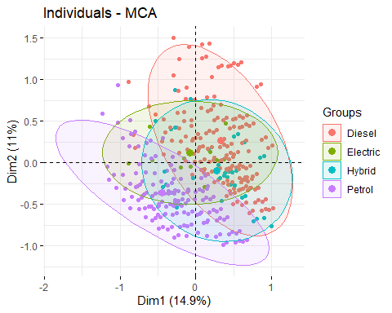

grp<- df$manufacturer  
fviz_mca_ind(res.mca, label="none", habillage = grp, addEllipses = TRUE)

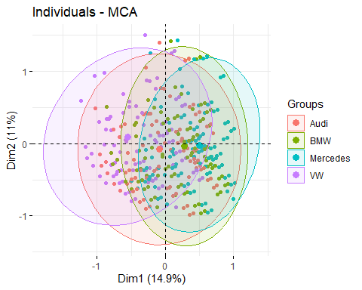

grp<- df$f.price  
fviz_mca_ind(res.mca, label="none", habillage = grp, addEllipses = TRUE)

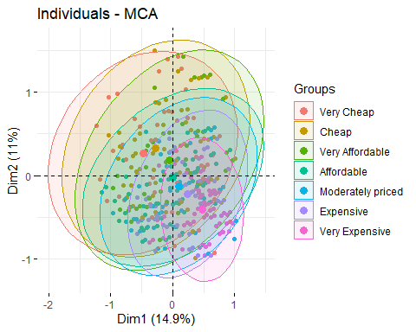

grp<- df$f.tax  
fviz_mca_ind(res.mca, label="none", habillage = grp, addEllipses = TRUE)

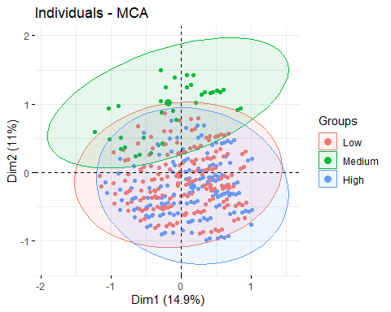

grp<- df$f.mpg  
fviz_mca_ind(res.mca, label="none", habillage = grp, addEllipses = TRUE)

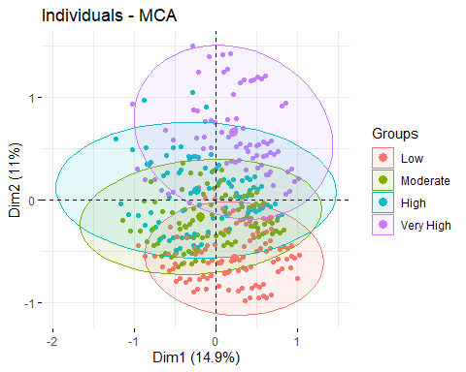

grp<- df$f.engineSize  
fviz_mca_ind(res.mca, label="none", habillage = grp, addEllipses = TRUE)

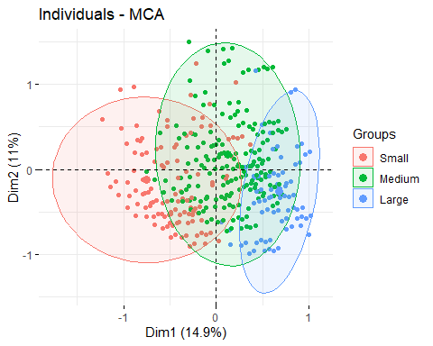

grp<- df$Audi  
fviz_mca_ind(res.mca, label="none", habillage = grp, addEllipses = TRUE)

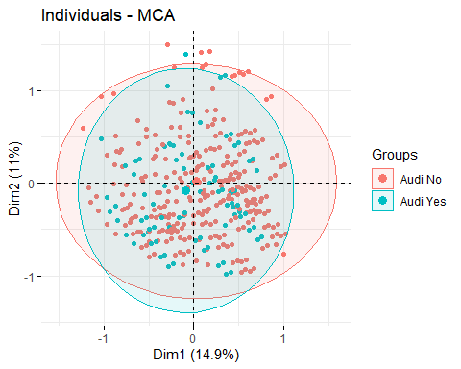

* Interpreting the axes associations to factor map

res.desc <- dimdesc(res.mca, axes = c(1,2))  
res.desc[[1]]

##   
## Link between the variable and the continuous variables (R-square)  
## =================================================================================  
## correlation p.value  
## price 0.4333698 3.079652e-223  
##   
## Link between the variable and the categorical variable (1-way anova)  
## =============================================  
## R2 p.value  
## transmission 0.500393475 0.000000e+00  
## fuelType 0.387737097 0.000000e+00  
## manufacturer 0.476737231 0.000000e+00  
## f.engineSize 0.713940633 0.000000e+00  
## f.price 0.229509790 3.717331e-272  
## f.mpg 0.127163933 8.116179e-144  
## f.tax 0.026318082 4.784331e-29  
## Audi 0.005712787 1.201614e-07  
##   
## Link between variable and the categories of the categorical variables  
## ================================================================  
## Estimate p.value  
## f.engineSize=f.engineSize_Large 0.66400322 0.000000e+00  
## fuelType=Diesel 0.30499133 0.000000e+00  
## manufacturer=Mercedes 0.46125573 7.930684e-290  
## transmission=f.Trans-Automatic 0.35822037 5.718638e-170  
## transmission=f.Trans-SemiAuto 0.24487816 3.853775e-139  
## f.price=Very Expensive 0.47167778 8.508481e-114  
## manufacturer=BMW 0.24531305 2.191018e-63  
## f.mpg=f.mpg_Low 0.22316681 1.959442e-50  
## f.engineSize=f.engineSize_Medium 0.10542846 1.264347e-47  
## f.mpg=f.mpg_Very High 0.21109754 1.504594e-44  
## f.price=Expensive 0.23936934 1.493852e-29  
## f.tax=f.tax_High 0.18171767 4.657403e-26  
## Audi=Audi No 0.05638429 1.201614e-07  
## f.price=Moderately priced 0.09223269 1.547102e-05  
## fuelType=Hybrid 0.25948749 2.217962e-04  
## f.price=Very Affordable -0.05304838 1.282133e-02  
## Audi=Audi Yes -0.05638429 1.201614e-07  
## manufacturer=Audi -0.12216809 1.201614e-07  
## f.tax=f.tax_Medium -0.16574973 3.453170e-09  
## f.tax=f.tax_Low -0.01596794 5.456507e-11  
## f.price=Cheap -0.27301830 6.168560e-38  
## f.mpg=f.mpg_Moderate -0.19013312 4.153646e-39  
## f.mpg=f.mpg_High -0.24413124 1.048808e-57  
## f.price=Very Cheap -0.48139333 1.149873e-118  
## f.engineSize=f.engineSize_Small -0.76943168 0.000000e+00  
## manufacturer=VW -0.58440068 0.000000e+00  
## fuelType=Petrol -0.46657351 0.000000e+00  
## transmission=f.Trans-Manual -0.60309854 0.000000e+00

res.desc[[2]]

##   
## Link between the variable and the continuous variables (R-square)  
## =================================================================================  
## correlation p.value  
## price -0.4444756 4.485633e-236  
##   
## Link between the variable and the categorical variable (1-way anova)  
## =============================================  
## R2 p.value  
## fuelType 0.348008359 0.000000e+00  
## f.tax 0.297594276 0.000000e+00  
## f.mpg 0.730417631 0.000000e+00  
## f.price 0.228163051 2.618173e-270  
## transmission 0.129572378 4.429596e-148  
## f.engineSize 0.127618156 1.065815e-145  
## manufacturer 0.016559232 1.362419e-17  
## Audi 0.006125277 4.215294e-08  
##   
## Link between variable and the categories of the categorical variables  
## ================================================================  
## Estimate p.value  
## f.mpg=f.mpg_Very High 0.65646580 0.000000e+00  
## f.tax=f.tax_Medium 0.75437404 0.000000e+00  
## fuelType=Diesel 0.28562774 0.000000e+00  
## transmission=f.Trans-Manual 0.25870963 3.332843e-148  
## f.engineSize=f.engineSize_Medium 0.24697478 2.063511e-136  
## f.price=Cheap 0.32209790 7.560801e-71  
## f.price=Very Cheap 0.26850581 2.306570e-49  
## f.price=Very Affordable 0.18302824 8.449621e-24  
## manufacturer=VW 0.10557032 7.565483e-18  
## f.mpg=f.mpg_High 0.08963439 2.339628e-12  
## Audi=Audi No 0.05019186 4.215294e-08  
## manufacturer=BMW -0.02547266 1.453365e-02  
## Audi=Audi Yes -0.05019186 4.215294e-08  
## manufacturer=Audi -0.06923692 4.215294e-08  
## f.tax=f.tax_Low -0.29514779 7.888569e-10  
## f.price=Moderately priced -0.12835226 2.328684e-12  
## transmission=f.Trans-Automatic -0.10681278 3.531788e-20  
## f.engineSize=f.engineSize_Small -0.05251687 7.504753e-24  
## f.price=Expensive -0.21861878 2.928340e-33  
## f.mpg=f.mpg_Moderate -0.17040971 6.922545e-40  
## f.tax=f.tax_High -0.45922625 2.065416e-52  
## transmission=f.Trans-SemiAuto -0.15189684 1.632419e-62  
## f.engineSize=f.engineSize_Large -0.19445791 5.583814e-78  
## f.price=Very Expensive -0.40582983 3.888364e-114  
## f.mpg=f.mpg_Low -0.57569049 0.000000e+00  
## fuelType=Petrol -0.34454498 0.000000e+00

* MCA with all variables : description of axes

res.desc2[[1]]

##   
## Link between the variable and the continuous variables (R-square)  
## =================================================================================  
## correlation p.value  
## mileage 0.7714721 0.000000e+00  
## mpg 0.6939729 0.000000e+00  
## engineSize -0.1956661 2.010079e-43  
## price -0.6822682 0.000000e+00  
## year -0.8019459 0.000000e+00  
##   
## Link between the variable and the categorical variable (1-way anova)  
## =============================================  
## R2 p.value  
## f.year 0.776603002 0.000000e+00  
## f.price 0.630042018 0.000000e+00  
## f.miles 0.725691117 0.000000e+00  
## f.mpg 0.498784627 0.000000e+00  
## claKM 0.885154307 0.000000e+00  
## claH 0.863263792 0.000000e+00  
## f.tax 0.210340555 1.739382e-251  
## model 0.218225313 3.444845e-193  
## transmission 0.142023616 2.224289e-163  
## fuelType 0.060828841 3.270172e-66  
## f.engineSize 0.007694202 6.285181e-09  
## manufacturer 0.004972625 2.086534e-05  
##   
## Link between variable and the categories of the categorical variables  
## ================================================================  
## Estimate p.value  
## claH=claH_5 0.74639213 0.000000e+00  
## claH=claH_3 0.38913877 0.000000e+00  
## claKM=claKM_2 0.79312868 0.000000e+00  
## f.mpg=f.mpg_Very High 0.55561048 0.000000e+00  
## f.miles=Very Old 0.69809891 0.000000e+00  
## claKM=claKM_1 0.38048486 1.988745e-294  
## f.price=Very Cheap 0.69306121 1.158787e-239  
## f.tax=f.tax_Medium 0.60682055 3.152768e-184  
## f.year=2016 0.20856871 3.054221e-183  
## transmission=f.Trans-Manual 0.30541858 4.807201e-149  
## f.price=Cheap 0.55383859 3.414288e-147  
## f.year=2015 0.33362580 1.633519e-127  
## f.miles=Old 0.31337346 1.440199e-92  
## f.mpg=f.mpg_High 0.28748842 4.123432e-77  
## fuelType=Diesel 0.05895882 3.086674e-65  
## f.year=2014 0.41443216 1.281734e-63  
## f.price=Very Affordable 0.31384322 6.588749e-47  
## f.year=2013 0.40883437 1.517142e-44  
## f.year=2012 0.42223561 9.279396e-16  
## claKM=claKM_3 0.21189457 1.158983e-14  
## model=Audi- A1 0.51400426 5.807757e-10  
## model=VW- Scirocco 0.92981640 6.666924e-10  
## model=VW- Passat 0.56565690 8.264756e-10  
## model=VW- Polo 0.38273179 3.461089e-09  
## model=Audi- A6 0.59146392 9.745254e-09  
## model=Audi- A3 0.42911578 4.162940e-08  
## claH=claH_4 0.19286810 1.876402e-07  
## model=BMW- 1 Series 0.39984563 2.696629e-07  
## model=VW- CC 1.23273395 5.847529e-07  
## f.year=2011 0.22287953 9.517263e-06  
## model=VW- Up 0.47006349 1.603582e-05  
## model=VW- Beetle 0.91150987 6.217999e-05  
## manufacturer=VW 0.05569777 6.948117e-05  
## model=Mercedes- SLK 0.85266812 6.978860e-05  
## model=Mercedes- C Class 0.06238408 1.341663e-04  
## model=BMW- X1 0.47796389 1.634502e-04  
## f.year=2010 0.25450942 3.641616e-04  
## model=VW- Golf 0.27660786 4.305692e-04  
## f.engineSize=f.engineSize_Medium 0.04632873 7.386062e-04  
## model=BMW- 3 Series 0.31608270 9.225361e-04  
## model=Mercedes- CLA Class 1.02156974 2.961609e-03  
## f.year=2009 0.22344317 6.762607e-03  
## model=Mercedes- GL Class 0.61447672 7.975888e-03  
## model=BMW- 5 Series 0.33060648 1.407846e-02  
## model=Mercedes- M Class 0.70014850 2.035569e-02  
## fuelType=Electric 0.29365680 2.390496e-02  
## f.year=2008 0.14568421 2.748545e-02  
## model=Mercedes- CL Class 0.37296037 3.198030e-02  
## model=BMW- 4 Series 0.03740297 3.303621e-02  
## model=Mercedes- E Class 0.28122031 3.655418e-02  
## model=Mercedes- A Class 0.26003703 4.715358e-02  
## model=VW- Shuttle -0.26573781 2.483918e-02  
## model=VW- Sharan -0.11399752 2.132835e-02  
## model=BMW- M2 -0.86054696 1.959532e-02  
## model=BMW- X4 -0.17001497 8.778689e-03  
## model=BMW- X5 -0.07788913 8.119508e-03  
## model=BMW- 8 Series -0.81031455 6.500296e-03  
## model=Audi- Q8 -0.65929648 2.886089e-03  
## model=BMW- 7 Series -0.36328898 2.748712e-03  
## model=Mercedes- S Class -0.21644780 2.418920e-03  
## model=VW- Tiguan Allspace -0.64291617 1.369391e-03  
## model=BMW- X7 -0.76903251 7.555745e-04  
## model=BMW- X6 -0.63775272 5.892944e-04  
## model=Mercedes- SL CLASS -0.26601076 1.660531e-04  
## model=Audi- A8 -0.52867450 9.477625e-05  
## model=VW- Caravelle -0.48145876 8.244030e-05  
## model=Mercedes- GLS Class -0.49414786 3.265780e-05  
## model=BMW- Z4 -0.82302506 2.506465e-05  
## transmission=f.Trans-Automatic -0.06173067 2.458219e-05  
## manufacturer=Mercedes -0.06206705 1.905854e-05  
## model=VW- Arteon -0.43831795 6.392105e-06  
## model=Mercedes- X-CLASS -0.59460096 1.820722e-06  
## model=Mercedes- GLE Class -0.24518404 1.174006e-06  
## model=Mercedes- GLC Class -0.15524805 1.639171e-08  
## model=BMW- M4 -0.62974783 3.431206e-09  
## model=VW- Touareg -0.40445981 2.247714e-09  
## model=Audi- Q2 -0.26301294 2.103903e-09  
## f.engineSize=f.engineSize_Large -0.08954220 8.031476e-10  
## f.year=2018 -0.51792075 6.394475e-10  
## model=Audi- Q7 -0.45384191 2.581717e-10  
## model=VW- T-Cross -0.58877874 1.909749e-10  
## model=Audi- Q5 -0.24531584 4.509172e-12  
## model=BMW- X2 -0.71911960 2.215996e-12  
## model=VW- T-Roc -0.42446521 3.402576e-15  
## f.tax=f.tax_High -0.13345837 4.213456e-31  
## f.year=2017 -0.08072673 5.024003e-43  
## f.price=Moderately priced -0.30279598 2.008118e-43  
## f.mpg=f.mpg_Moderate -0.26641309 2.469394e-66  
## fuelType=Petrol -0.25607331 2.397082e-67  
## transmission=f.Trans-SemiAuto -0.24368792 7.325306e-103  
## f.miles=Used -0.33118683 5.168382e-104  
## f.year=2020 -1.07304263 3.268567e-105  
## claH=claH_2 -0.65650278 2.432842e-115  
## f.price=Expensive -0.51517902 2.666275e-127  
## f.tax=f.tax_Low -0.47336219 1.348306e-157  
## claKM=claKM_5 -0.74352831 2.312685e-198  
## f.price=Very Expensive -0.71895993 4.473422e-261  
## claH=claH_1 -0.67189622 0.000000e+00  
## claKM=claKM_4 -0.64197980 0.000000e+00  
## f.mpg=f.mpg_Low -0.57668581 0.000000e+00  
## f.miles=New -0.68028554 0.000000e+00  
## f.year=2019 -0.96252287 0.000000e+00

res.desc2[[2]]

##   
## Link between the variable and the continuous variables (R-square)  
## =================================================================================  
## correlation p.value  
## engineSize 0.8163326 0.000000e+00  
## price 0.4008106 2.869377e-188  
## tax 0.3586543 1.835918e-148  
## mileage 0.3207057 1.902398e-117  
## year -0.2771224 5.597946e-87  
## mpg -0.2876402 7.521860e-94  
##   
## Link between the variable and the categorical variable (1-way anova)  
## =============================================  
## R2 p.value  
## model 0.6757261 0.000000e+00  
## manufacturer 0.2970509 0.000000e+00  
## f.engineSize 0.6546015 0.000000e+00  
## claKM 0.6041314 0.000000e+00  
## claH 0.6471157 0.000000e+00  
## transmission 0.2601004 1.341388e-320  
## f.price 0.1655752 7.311615e-188  
## f.mpg 0.1602250 9.240626e-185  
## fuelType 0.1440126 1.749220e-164  
## f.tax 0.1370877 2.744921e-157  
## f.miles 0.1096413 9.527374e-123  
## f.year 0.1171497 1.497487e-122  
##   
## Link between variable and the categories of the categorical variables  
## ================================================================  
## Estimate p.value  
## claH=claH_2 0.644841125 0.000000e+00  
## claKM=claKM_5 0.512020231 0.000000e+00  
## f.engineSize=f.engineSize_Large 0.722243510 0.000000e+00  
## claKM=claKM_3 0.680266316 8.627597e-180  
## f.price=Very Expensive 0.564099808 6.279733e-179  
## fuelType=Diesel 0.230708718 6.132220e-161  
## f.mpg=f.mpg_Low 0.378023339 1.537638e-159  
## f.tax=f.tax_High 0.327441584 1.191072e-158  
## transmission=f.Trans-Automatic 0.306571406 1.905662e-133  
## f.miles=Very Old 0.333535279 1.004941e-122  
## claH=claH_5 0.071126573 2.868686e-110  
## manufacturer=BMW 0.299958075 5.135316e-100  
## claH=claH_4 0.591385604 2.175007e-91  
## manufacturer=Mercedes 0.212536186 4.072892e-73  
## transmission=f.Trans-SemiAuto 0.107275896 2.218153e-35  
## model=BMW- X5 0.693251827 4.616272e-35  
## model=Audi- Q7 0.707050206 3.409659e-34  
## model=VW- Touareg 0.604359279 6.483811e-30  
## f.year=2014 0.138929571 7.904000e-30  
## model=Mercedes- GLE Class 0.457411244 1.529133e-27  
## model=Mercedes- S Class 0.709629351 9.655890e-21  
## model=BMW- M4 0.730414616 1.052669e-19  
## f.year=2013 0.086726986 2.154663e-17  
## model=Mercedes- GLS Class 0.798432047 4.838147e-16  
## model=BMW- 5 Series 0.013320614 3.300429e-15  
## model=Audi- Q5 0.015492554 1.113885e-14  
## model=Mercedes- M Class 1.148890046 2.719880e-14  
## model=BMW- X4 0.513227421 4.495282e-14  
## model=BMW- 6 Series 0.671946940 3.487592e-13  
## model=Mercedes- X-CLASS 0.648112946 1.113253e-12  
## f.year=2011 0.475155802 8.105844e-12  
## model=BMW- 7 Series 0.716804588 1.316601e-11  
## model=Mercedes- CLS Class 0.324112702 7.239899e-10  
## model=Audi- A8 0.583602477 2.276086e-09  
## model=BMW- X3 0.067694775 2.783878e-09  
## model=BMW- M3 0.849429398 8.410584e-09  
## f.year=2012 0.159939855 1.823516e-08  
## model=Mercedes- SL CLASS 0.178764303 4.124513e-08  
## model=BMW- X6 0.784184874 4.628356e-08  
## model=VW- Amarok 0.547421940 1.458369e-07  
## model=Mercedes- SLK 0.385518235 2.091913e-07  
## f.year=2010 0.458311304 3.337450e-07  
## model=BMW- X7 0.865765214 8.346775e-07  
## model=Audi- A7 0.360933647 8.219951e-06  
## model=Audi- Q8 0.722511283 1.183440e-05  
## model=Audi- RS6 0.830210093 1.834633e-05  
## f.year=2009 0.453085921 4.886680e-05  
## model=Audi- R8 0.723336003 8.862884e-05  
## model=BMW- M5 0.851988916 1.611864e-04  
## model=Mercedes- GL Class 0.130698780 2.250192e-04  
## model=Audi- SQ5 0.820058667 2.341924e-04  
## model=BMW- M6 1.096551587 2.438455e-04  
## f.year=2008 0.412870085 2.789514e-04  
## model=BMW- 8 Series 0.762688015 4.486177e-04  
## model=BMW- M2 0.735728338 5.112256e-03  
## model=Audi- RS3 0.695207440 6.885025e-03  
## model=Mercedes- G Class 0.884924542 2.555173e-02  
## model=Audi- S8 0.872544713 2.697351e-02  
## model=Mercedes- CLA Class 0.142640741 2.984135e-02  
## f.price=Expensive 0.044573921 3.050403e-02  
## model=VW- Caravelle -0.117672722 4.770174e-02  
## f.engineSize=f.engineSize_Medium -0.080723412 4.648974e-02  
## model=BMW- 1 Series -0.349797542 4.575230e-02  
## model=VW- Sharan -0.716663912 1.616021e-02  
## model=Mercedes- V Class -0.108123947 1.464596e-02  
## model=Audi- Q3 -0.552208985 1.161441e-02  
## model=VW- Passat -0.600352985 3.165012e-03  
## f.year=2020 -0.437089992 2.789689e-03  
## f.price=Moderately priced -0.062087606 2.636535e-03  
## model=Mercedes- GLA Class -0.221241004 1.954703e-03  
## model=VW- Arteon -0.829874494 1.726171e-03  
## f.tax=f.tax_Medium -0.149475659 1.222476e-03  
## model=Mercedes- CL Class -0.146873652 6.633005e-04  
## model=VW- Touran -0.847809785 4.629993e-04  
## model=Mercedes- GLC Class -0.230088598 3.660014e-04  
## model=Audi- A6 -0.164672915 7.198925e-05  
## model=Mercedes- C Class -0.298608039 8.651905e-06  
## f.miles=New -0.065953019 5.242599e-06  
## model=VW- Golf SV -1.018723655 4.007111e-06  
## model=Audi- A3 -0.624910528 2.812348e-06  
## f.price=Very Affordable -0.101013368 7.760131e-07  
## f.year=2018 -0.484040182 3.845928e-08  
## model=BMW- 4 Series -0.038063348 6.246478e-10  
## f.price=Affordable -0.131705580 1.851975e-10  
## f.year=2019 -0.422684497 3.694689e-11  
## model=VW- T-Cross -1.188566928 1.524443e-11  
## model=Audi- Q2 -0.907559671 4.314518e-12  
## f.year=2017 -0.469140205 2.319094e-12  
## f.price=Very Cheap -0.145232961 1.522913e-12  
## model=Mercedes- E Class -0.104347529 1.622128e-13  
## model=BMW- 3 Series -0.134110779 4.117189e-15  
## f.price=Cheap -0.168634215 2.168687e-16  
## model=VW- T-Roc -1.038728429 1.693965e-17  
## f.miles=Old -0.124219275 1.160716e-17  
## model=VW- Tiguan -0.795391319 1.370796e-18  
## model=Audi- A1 -0.898076932 3.569767e-21  
## f.mpg=f.mpg_Moderate -0.131637605 3.254880e-21  
## f.miles=Used -0.143362985 3.894148e-23  
## f.year=2015 -0.004675746 4.942460e-36  
## model=VW- Up -1.236421118 2.853644e-39  
## claKM=claKM_2 -0.006170830 3.691670e-46  
## f.mpg=f.mpg_High -0.249383133 3.464326e-65  
## model=VW- Golf -0.855704121 1.243538e-67  
## f.tax=f.tax_Low -0.177965924 7.248952e-116  
## claKM=claKM_1 -0.586236279 3.559030e-129  
## claH=claH_3 -0.660119409 2.708955e-142  
## claH=claH_1 -0.647233893 9.008244e-155  
## model=VW- Polo -1.239635621 1.821740e-155  
## fuelType=Petrol -0.223117673 1.833746e-165  
## claKM=claKM_4 -0.599879439 2.100275e-176  
## transmission=f.Trans-Manual -0.413847301 6.127533e-297  
## f.engineSize=f.engineSize_Small -0.641520098 0.000000e+00  
## manufacturer=VW -0.484380312 0.000000e+00

* Hierarchical clustering from MCA

res.hcpcMCA$desc.var$category

## $`1`  
## Cla/Mod Mod/Cla Global p.value  
## f.engineSize=f.engineSize_Small 80.3074671 98.2094897 27.917433 0.000000e+00  
## fuelType=Petrol 54.0000000 99.1047449 41.896587 0.000000e+00  
## transmission=f.Trans-Manual 47.5185396 74.5747538 35.826691 6.810492e-203  
## manufacturer=VW 47.4687705 64.6374217 31.085224 1.131895e-157  
## f.mpg=f.mpg_High 41.0760034 43.0617726 23.932148 5.234681e-60  
## f.price=Very Cheap 47.4285714 29.7224709 14.306152 3.642975e-55  
## f.mpg=f.mpg_Moderate 34.1250990 38.5854969 25.812385 4.011255e-27  
## f.price=Cheap 37.0529328 23.1871083 14.285714 2.626764e-20  
## f.tax=f.tax_Low 25.9003601 77.2605192 68.097282 2.185594e-14  
## f.tax=f.tax_Medium 29.8816568 9.0420770 6.907828 1.856244e-03  
## f.price=Moderately priced 18.5344828 11.5487914 14.224402 3.044140e-03  
## fuelType=Hybrid 4.6875000 0.2685765 1.307991 8.511049e-05  
## f.tax=f.tax_High 12.5102208 13.6974038 24.994891 2.638593e-25  
## f.price=Expensive 8.2975680 5.1924799 14.285714 3.143445e-27  
## manufacturer=BMW 7.2324012 6.7144136 21.193542 2.479195e-49  
## f.mpg=f.mpg_Very High 8.3401472 9.1316025 24.994891 4.204653e-51  
## f.mpg=f.mpg_Low 8.3333333 9.2211280 25.260576 8.059706e-52  
## transmission=f.Trans-SemiAuto 10.3973870 17.0993733 37.543429 3.854547e-63  
## transmission=f.Trans-Automatic 7.1373753 8.3258729 26.629879 8.237365e-66  
## manufacturer=Mercedes 6.0138782 6.9829902 26.507255 1.790981e-76  
## f.price=Very Expensive 0.5722461 0.3581021 14.285714 2.350768e-78  
## f.engineSize=f.engineSize_Large 0.0000000 0.0000000 21.561414 4.990869e-137  
## f.engineSize=f.engineSize_Medium 0.8090615 1.7905103 50.521153 0.000000e+00  
## fuelType=Diesel 0.2170767 0.5371531 56.488862 0.000000e+00  
## v.test  
## f.engineSize=f.engineSize_Small Inf  
## fuelType=Petrol Inf  
## transmission=f.Trans-Manual 30.392934  
## manufacturer=VW 26.753248  
## f.mpg=f.mpg_High 16.338712  
## f.price=Very Cheap 15.644133  
## f.mpg=f.mpg_Moderate 10.785939  
## f.price=Cheap 9.233195  
## f.tax=f.tax_Low 7.639210  
## f.tax=f.tax_Medium 3.112318  
## f.price=Moderately priced -2.963245  
## fuelType=Hybrid -3.929534  
## f.tax=f.tax_High -10.394066  
## f.price=Expensive -10.808329  
## manufacturer=BMW -14.764564  
## f.mpg=f.mpg_Very High -15.036953  
## f.mpg=f.mpg_Low -15.145937  
## transmission=f.Trans-SemiAuto -16.772867  
## transmission=f.Trans-Automatic -17.134275  
## manufacturer=Mercedes -18.507665  
## f.price=Very Expensive -18.739671  
## f.engineSize=f.engineSize_Large -24.916005  
## f.engineSize=f.engineSize_Medium -Inf  
## fuelType=Diesel -Inf  
##   
## $`2`  
## Cla/Mod Mod/Cla Global p.value  
## f.engineSize=f.engineSize_Medium 60.598706 93.1592040 50.5211527 0.000000e+00  
## fuelType=Diesel 49.095514 84.3905473 56.4888616 1.991453e-180  
## manufacturer=BMW 56.412729 36.3805970 21.1935418 2.754449e-70  
## f.mpg=f.mpg_Moderate 50.197941 39.4278607 25.8123850 1.809044e-50  
## f.mpg=f.mpg_Very High 42.273099 32.1517413 24.9948907 1.430108e-15  
## fuelType=Hybrid 81.250000 3.2338308 1.3079910 1.624014e-15  
## transmission=f.Trans-Manual 37.535653 40.9203980 35.8266912 2.289633e-07  
## f.tax=f.tax_High 38.757155 29.4776119 24.9948907 5.136627e-07  
## fuelType=Electric 93.333333 0.8706468 0.3065604 1.773829e-06  
## manufacturer=VW 37.212360 35.1990050 31.0852238 1.523728e-05  
## f.price=Affordable 38.816739 16.7288557 14.1630901 3.700534e-04  
## f.price=Very Affordable 38.330976 16.8532338 14.4492132 9.277537e-04  
## f.price=Cheap 37.768240 16.4179104 14.2857143 3.134609e-03  
## Audi=Audi Yes 36.223507 23.3830846 21.2139792 9.825840e-03  
## manufacturer=Audi 36.223507 23.3830846 21.2139792 9.825840e-03  
## f.price=Moderately priced 36.925287 15.9825871 14.2244022 1.449984e-02  
## f.tax=f.tax_Low 33.943577 70.3358209 68.0972818 1.848629e-02  
## transmission=f.Trans-SemiAuto 30.702232 35.0746269 37.5434294 1.245449e-02  
## Audi=Audi No 31.958495 76.6169154 78.7860208 9.825840e-03  
## transmission=f.Trans-Automatic 29.623945 24.0049751 26.6298794 3.507100e-03  
## f.price=Very Expensive 14.163090 6.1567164 14.2857143 1.357760e-33  
## f.tax=f.tax_Medium 0.887574 0.1865672 6.9078275 8.211983e-56  
## f.mpg=f.mpg_Low 6.553398 5.0373134 25.2605763 1.843681e-138  
## f.engineSize=f.engineSize_Large 3.886256 2.5497512 21.5614143 5.735363e-145  
## manufacturer=Mercedes 6.245181 5.0373134 26.5072553 3.404191e-151  
## f.engineSize=f.engineSize_Small 5.051245 4.2910448 27.9174331 1.525607e-179  
## fuelType=Petrol 9.024390 11.5049751 41.8965870 6.023368e-222  
## v.test  
## f.engineSize=f.engineSize_Medium Inf  
## fuelType=Diesel 28.642436  
## manufacturer=BMW 17.723650  
## f.mpg=f.mpg_Moderate 14.940026  
## f.mpg=f.mpg_Very High 7.982834  
## fuelType=Hybrid 7.967130  
## transmission=f.Trans-Manual 5.174140  
## f.tax=f.tax_High 5.021138  
## fuelType=Electric 4.777619  
## manufacturer=VW 4.325230  
## f.price=Affordable 3.560568  
## f.price=Very Affordable 3.311566  
## f.price=Cheap 2.954220  
## Audi=Audi Yes 2.581899  
## manufacturer=Audi 2.581899  
## f.price=Moderately priced 2.444636  
## f.tax=f.tax_Low 2.355731  
## transmission=f.Trans-SemiAuto -2.498998  
## Audi=Audi No -2.581899  
## transmission=f.Trans-Automatic -2.919396  
## f.price=Very Expensive -12.079358  
## f.tax=f.tax_Medium -15.738695  
## f.mpg=f.mpg_Low -25.047827  
## f.engineSize=f.engineSize_Large -25.638128  
## manufacturer=Mercedes -26.190559  
## f.engineSize=f.engineSize_Small -28.571347  
## fuelType=Petrol -31.802262  
##   
## $`3`  
## Cla/Mod Mod/Cla Global p.value  
## f.tax=f.tax_Medium 69.2307692 98.734177 6.907828 1.104219e-311  
## f.mpg=f.mpg_Very High 18.9697465 97.890295 24.994891 6.310876e-139  
## fuelType=Diesel 8.4298119 98.312236 56.488862 1.091191e-53  
## f.price=Very Affordable 13.0127298 38.818565 14.449213 1.985848e-21  
## f.price=Cheap 11.7310443 34.599156 14.285714 6.577619e-16  
## transmission=f.Trans-Manual 7.4158585 54.852321 35.826691 1.020358e-09  
## f.engineSize=f.engineSize_Medium 6.5129450 67.932489 50.521153 2.970224e-08  
## f.price=Very Cheap 6.5714286 19.409283 14.306152 2.663044e-02  
## f.engineSize=f.engineSize_Large 6.1611374 27.426160 21.561414 2.816603e-02  
## f.price=Affordable 2.4531025 7.172996 14.163090 7.005684e-04  
## transmission=f.Trans-SemiAuto 2.8851388 22.362869 37.543429 3.215496e-07  
## f.price=Moderately priced 0.0000000 0.000000 14.224402 6.034251e-17  
## f.price=Very Expensive 0.0000000 0.000000 14.285714 5.068430e-17  
## f.price=Expensive 0.0000000 0.000000 14.285714 5.068430e-17  
## f.engineSize=f.engineSize_Small 0.8052709 4.641350 27.917433 3.987745e-21  
## f.mpg=f.mpg_High 0.4269855 2.109705 23.932148 3.095162e-22  
## f.tax=f.tax_High 0.2452984 1.265823 24.994891 3.645134e-26  
## f.mpg=f.mpg_Low 0.0000000 0.000000 25.260576 1.443213e-31  
## f.mpg=f.mpg_Moderate 0.0000000 0.000000 25.812385 2.348326e-32  
## fuelType=Petrol 0.1463415 1.265823 41.896587 1.921365e-52  
## f.tax=f.tax_Low 0.0000000 0.000000 68.097282 5.297576e-124  
## v.test  
## f.tax=f.tax_Medium 37.739836  
## f.mpg=f.mpg_Very High 25.090524  
## fuelType=Diesel 15.426193  
## f.price=Very Affordable 9.505764  
## f.price=Cheap 8.078114  
## transmission=f.Trans-Manual 6.106193  
## f.engineSize=f.engineSize_Medium 5.543183  
## f.price=Very Cheap 2.216893  
## f.engineSize=f.engineSize_Large 2.194966  
## f.price=Affordable -3.389357  
## transmission=f.Trans-SemiAuto -5.110358  
## f.price=Moderately priced -8.364554  
## f.price=Very Expensive -8.385096  
## f.price=Expensive -8.385096  
## f.engineSize=f.engineSize_Small -9.432934  
## f.mpg=f.mpg_High -9.697322  
## f.tax=f.tax_High -10.581136  
## f.mpg=f.mpg_Low -11.689448  
## f.mpg=f.mpg_Moderate -11.842678  
## fuelType=Petrol -15.239909  
## f.tax=f.tax_Low -23.683790  
##   
## $`4`  
## Cla/Mod Mod/Cla Global p.value  
## f.mpg=f.mpg_Low 79.6925566 90.0365631 25.2605763 0.000000e+00  
## f.price=Very Expensive 62.8040057 40.1279707 14.2857143 9.368622e-142  
## f.engineSize=f.engineSize_Large 48.0568720 46.3436929 21.5614143 5.159833e-101  
## fuelType=Petrol 36.5853659 68.5557587 41.8965870 4.176546e-91  
## f.tax=f.tax_High 40.8830744 45.7038391 24.9948907 2.608801e-66  
## transmission=f.Trans-Automatic 36.3008442 43.2358318 26.6298794 2.443166e-42  
## Audi=Audi Yes 35.6454721 33.8208410 21.2139792 8.902573e-29  
## manufacturer=Audi 35.6454721 33.8208410 21.2139792 8.902573e-29  
## f.price=Expensive 37.4821173 23.9488117 14.2857143 6.670598e-23  
## transmission=f.Trans-SemiAuto 29.9945563 50.3656307 37.5434294 8.732059e-23  
## manufacturer=BMW 26.9045323 25.5027422 21.1935418 9.764350e-05  
## fuelType=Electric 0.0000000 0.0000000 0.3065604 2.232139e-02  
## f.engineSize=f.engineSize_Medium 20.0647249 45.3382084 50.5211527 9.997913e-05  
## fuelType=Hybrid 3.1250000 0.1828154 1.3079910 1.740236e-05  
## f.price=Affordable 14.1414141 8.9579525 14.1630901 5.170239e-09  
## f.price=Very Affordable 8.3451202 5.3930530 14.4492132 4.901216e-26  
## f.tax=f.tax_Low 17.8271309 54.2961609 68.0972818 1.275305e-27  
## Audi=Audi No 18.7808042 66.1791590 78.7860208 8.902573e-29  
## f.price=Very Cheap 6.8571429 4.3875686 14.3061516 4.550905e-32  
## f.tax=f.tax_Medium 0.0000000 0.0000000 6.9078275 2.063703e-39  
## manufacturer=VW 10.7823800 14.9908592 31.0852238 9.023622e-43  
## f.price=Cheap 3.8626609 2.4680073 14.2857143 2.532568e-48  
## f.mpg=f.mpg_Moderate 7.9968329 9.2321755 25.8123850 3.173413e-53  
## f.engineSize=f.engineSize_Small 6.6617862 8.3180987 27.9174331 2.161006e-71  
## fuelType=Diesel 12.3733719 31.2614260 56.4888616 1.706462e-81  
## f.mpg=f.mpg_High 0.5123826 0.5484461 23.9321480 1.030570e-137  
## transmission=f.Trans-Manual 3.9931546 6.3985375 35.8266912 1.894672e-142  
## f.mpg=f.mpg_Very High 0.1635323 0.1828154 24.9948907 8.994951e-154  
## v.test  
## f.mpg=f.mpg_Low Inf  
## f.price=Very Expensive 25.348359  
## f.engineSize=f.engineSize_Large 21.336906  
## fuelType=Petrol 20.242025  
## f.tax=f.tax_High 17.201024  
## transmission=f.Trans-Automatic 13.636089  
## Audi=Audi Yes 11.130608  
## manufacturer=Audi 11.130608  
## f.price=Expensive 9.852732  
## transmission=f.Trans-SemiAuto 9.825637  
## manufacturer=BMW 3.896374  
## fuelType=Electric -2.284854  
## f.engineSize=f.engineSize_Medium -3.890643  
## fuelType=Hybrid -4.295852  
## f.price=Affordable -5.841598  
## f.price=Very Affordable -10.553360  
## f.tax=f.tax_Low -10.890789  
## Audi=Audi No -11.130608  
## f.price=Very Cheap -11.787072  
## f.tax=f.tax_Medium -13.135410  
## manufacturer=VW -13.708556  
## f.price=Cheap -14.607048  
## f.mpg=f.mpg_Moderate -15.357124  
## f.engineSize=f.engineSize_Small -17.866234  
## fuelType=Diesel -19.120445  
## f.mpg=f.mpg_High -24.979136  
## transmission=f.Trans-Manual -25.411238  
## f.mpg=f.mpg_Very High -26.415914  
##   
## $`5`  
## Cla/Mod Mod/Cla Global p.value  
## manufacturer=Mercedes 60.3700848 93.5483871 26.507255 0.000000e+00  
## fuelType=Diesel 29.8842258 98.6857826 56.488862 6.550452e-212  
## f.engineSize=f.engineSize_Large 41.8957346 52.8076464 21.561414 2.301072e-110  
## Audi=Audi No 21.5304799 99.1636798 78.786021 1.611039e-83  
## f.tax=f.tax_Low 22.3289316 88.8888889 68.097282 1.169844e-52  
## f.mpg=f.mpg_Very High 30.2534751 44.2054958 24.994891 3.389325e-41  
## transmission=f.Trans-SemiAuto 26.0206859 57.1087216 37.543429 1.367194e-36  
## f.mpg=f.mpg_High 25.8753202 36.2007168 23.932148 1.298904e-18  
## transmission=f.Trans-Automatic 22.7935533 35.4838710 26.629879 5.115827e-10  
## f.price=Expensive 24.0343348 20.0716846 14.285714 4.215202e-07  
## f.price=Very Expensive 22.4606581 18.7574671 14.285714 8.094883e-05  
## f.price=Moderately priced 21.4080460 17.8016726 14.224402 1.486016e-03  
## f.price=Affordable 20.7792208 17.2043011 14.163090 6.600240e-03  
## f.price=Cheap 9.5851216 8.0047790 14.285714 1.557182e-09  
## f.engineSize=f.engineSize_Medium 12.0145631 35.4838710 50.521153 7.731686e-22  
## f.price=Very Cheap 5.2857143 4.4205496 14.306152 1.288351e-23  
## f.tax=f.tax_High 7.6042518 11.1111111 24.994891 1.153281e-27  
## f.mpg=f.mpg_Moderate 7.6801267 11.5890084 25.812385 2.786405e-28  
## f.tax=f.tax_Medium 0.0000000 0.0000000 6.907828 2.298116e-29  
## f.engineSize=f.engineSize_Small 7.1742313 11.7084827 27.917433 1.040105e-34  
## manufacturer=BMW 4.5323047 5.6152927 21.193542 8.226532e-42  
## f.mpg=f.mpg_Low 5.4207120 8.0047790 25.260576 1.394044e-43  
## Audi=Audi Yes 0.6743738 0.8363202 21.213979 1.611039e-83  
## manufacturer=Audi 0.6743738 0.8363202 21.213979 1.611039e-83  
## transmission=f.Trans-Manual 3.5367941 7.4074074 35.826691 9.812642e-96  
## manufacturer=VW 0.0000000 0.0000000 31.085224 2.126612e-152  
## fuelType=Petrol 0.2439024 0.5973716 41.896587 3.772296e-212  
## v.test  
## manufacturer=Mercedes Inf  
## fuelType=Diesel 31.067845  
## f.engineSize=f.engineSize_Large 22.321185  
## Audi=Audi No 19.362124  
## f.tax=f.tax_Low 15.272294  
## f.mpg=f.mpg_Very High 13.442891  
## transmission=f.Trans-SemiAuto 12.634234  
## f.mpg=f.mpg_High 8.805828  
## transmission=f.Trans-Automatic 6.215510  
## f.price=Expensive 5.058973  
## f.price=Very Expensive 3.941573  
## f.price=Moderately priced 3.177401  
## f.price=Affordable 2.716369  
## f.price=Cheap -6.038329  
## f.engineSize=f.engineSize_Medium -9.603444  
## f.price=Very Cheap -10.016619  
## f.tax=f.tax_High -10.899944  
## f.mpg=f.mpg_Moderate -11.028445  
## f.tax=f.tax_Medium -11.250681  
## f.engineSize=f.engineSize_Small -12.288822  
## manufacturer=BMW -13.547240  
## f.mpg=f.mpg_Low -13.843424  
## Audi=Audi Yes -19.362124  
## manufacturer=Audi -19.362124  
## transmission=f.Trans-Manual -20.760700  
## manufacturer=VW -26.296074  
## fuelType=Petrol -31.085585