Aircraft Systems

Aircraft

Wing

Airfoil
Airfoil = “S1223_TC” (yellow)
- Decreased CM
- Higher L/D, CL max
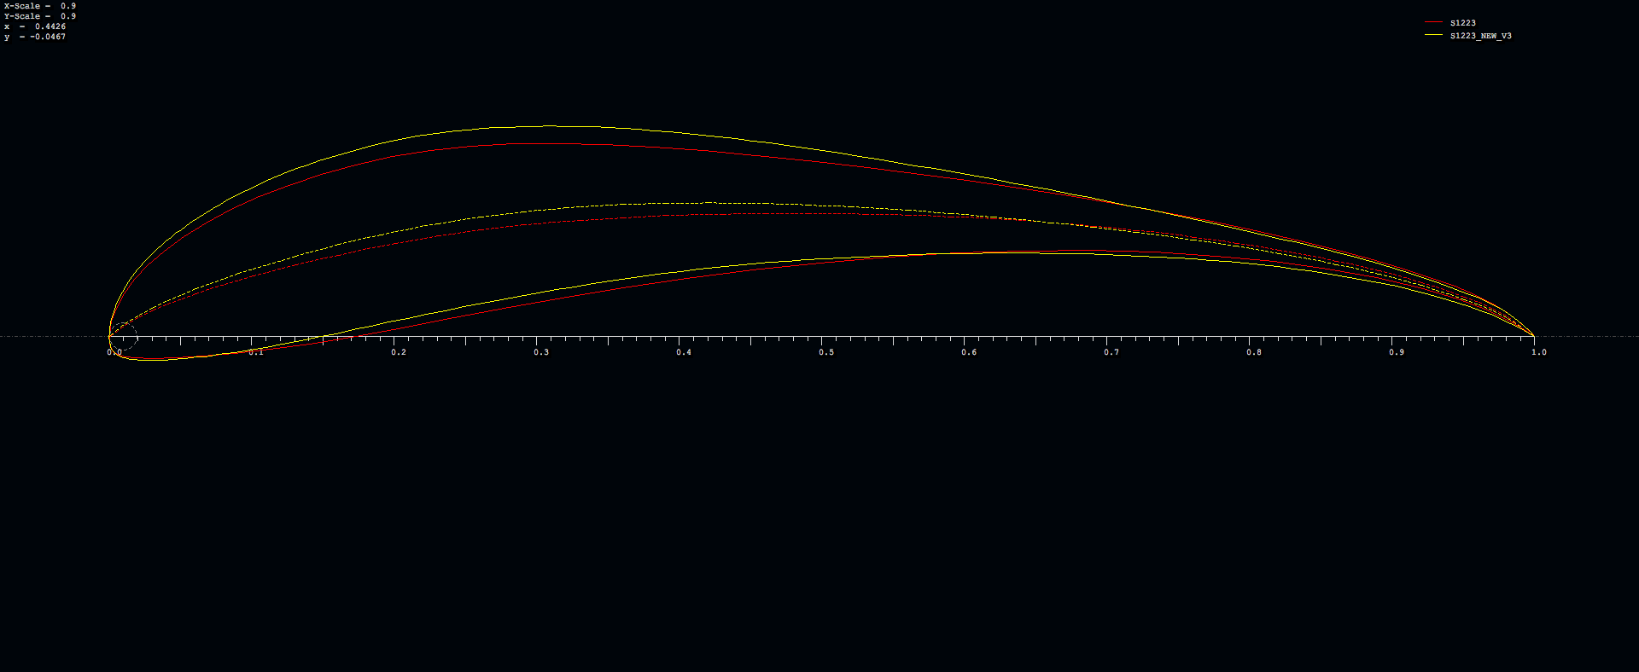
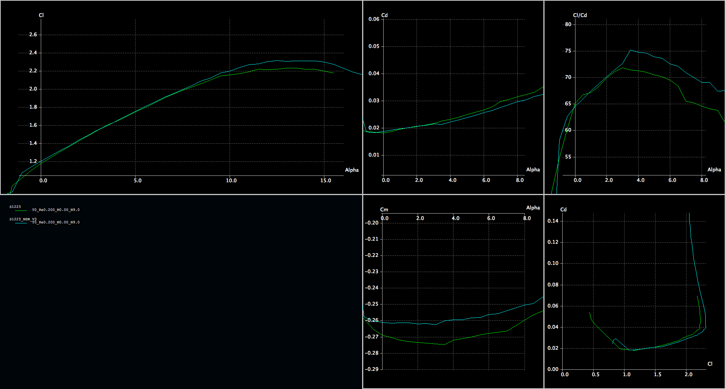

Planform

Half-Span:
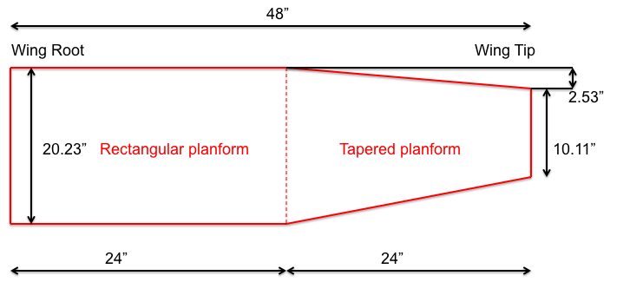
- Wingspan = 96”
- Root Chord Length (Cr) = 20.23”
- Taper Ratio (TR) = 0.50
  - Tapered about C/4

Sheeting

Rectangular Section- Sheeted with 1/32” balsa
- Bottom = 5%
- Top = 30%
- TOTAL LENGTH = 8.41”
Tapered Section- 1/32” balsa
- Bottom = 5%
- Top = 30%
REVISIT FOR COMPETITION PLANE

Front Spar
1.75”x1.6”
- 1/8” Basswood on top on bottom
- 1/8” Balsa stringers and shear webs
  - Lite ply in between center ribs

Rear Spar
- 1/8”x1/4” stringers on top and bottom (basswood)
- Balsa glued between
- Located at 70% chord

Trailing edge
- 1/32” sheet on top and bottom of TE
  - Sheeting begins at ~90% of chord
- 1/16” stringer in between sheets
- 3/16” x 1/16” stringers glued between front of TE sheets.

Half Ribs
NONE

Ailerons
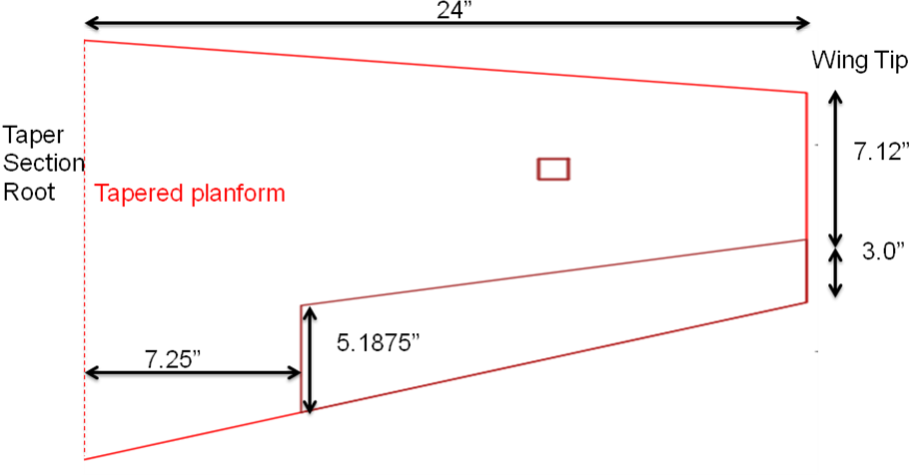
Ailerons = 30% of chord length

Half Ribs
In midpoint between tapered ribs
(34.375”, 40.25”, 45.5”)
Stringer bracings in between the ribs

Aileron Spar
At LE- 1/8” x 1/8” stringer (basswood)
1/8”h x 1/4"w stringer. basswood

Trailing Edge
Same as Main wing trailing edge

Control Arm
Nylon Control horns, 0.82” minimum length required.

Aileron Hinges
Nylon hinges at the top surface. Aileron beveled 45 degrees on the bottom.

Ribs
Rectangular Rib Placement
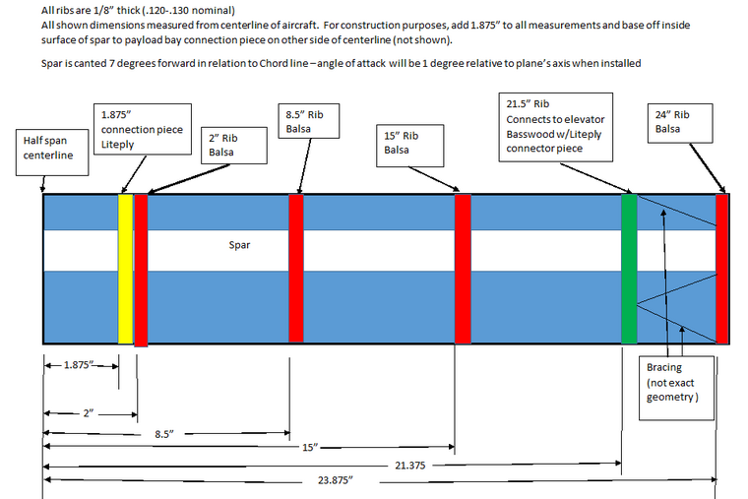

Rectangular Ribs with Materials:
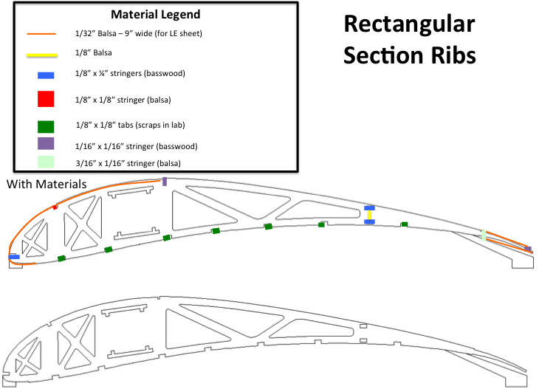

Tapered Section Ribs
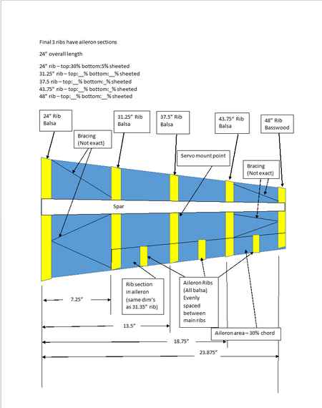

Winglets
No winglets

Fuselage

Loading Bay

Ballast Bay

      - Landing Gear
In progress

Propulsion

Electric Motor
Hyperion ZS 4020 12
- 304 grams
- 543 rpm/V
- 45 Amp ~ 75Amp operating current
- 90 Amp max current
- 1800 Watt max power
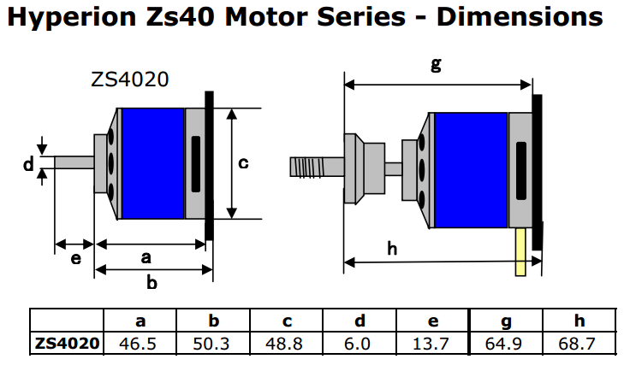

Propeller
APC 17 x 10
- 0.5” prop thickness
- 68 grams
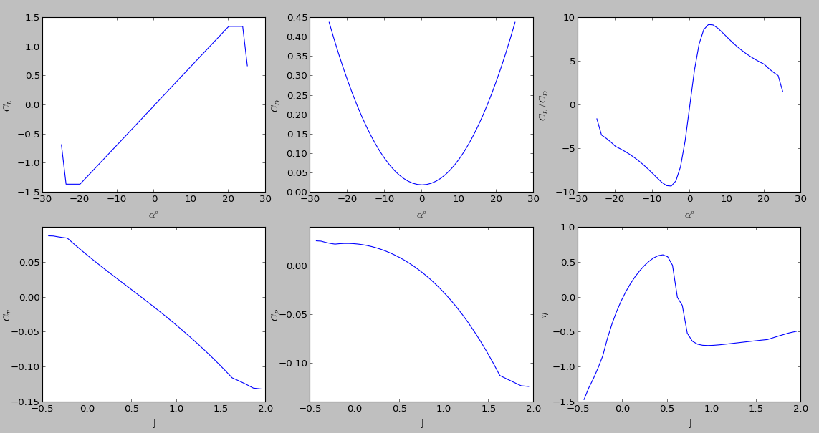
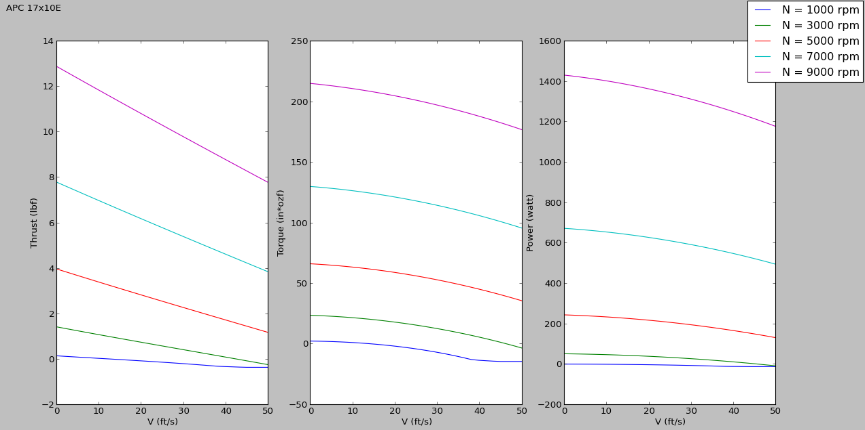
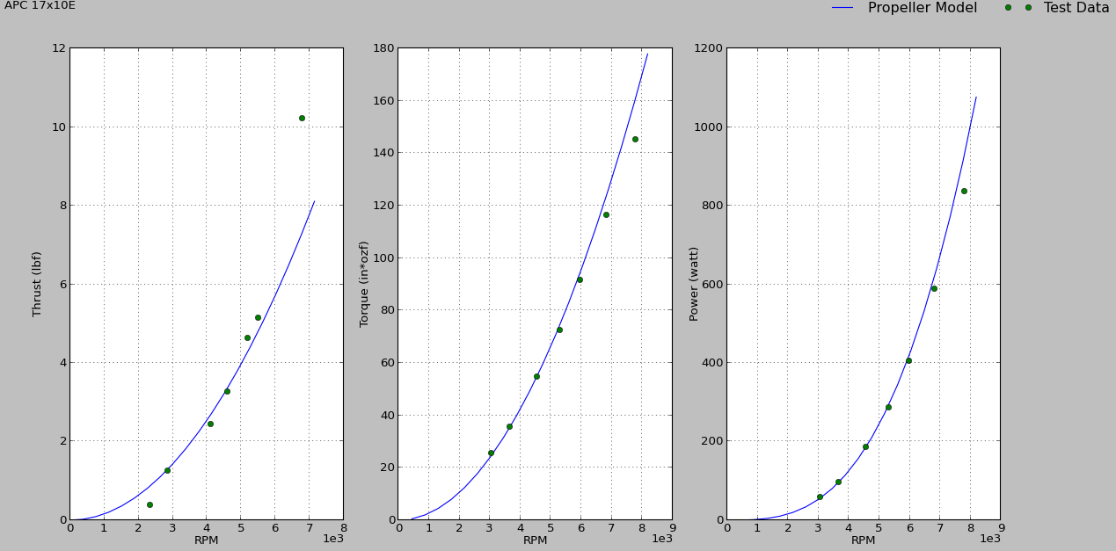

Safety Spinner
To be ordered

Batteries
ThunderPower 4400 mAh 25C 4S Lipo

Electric Control System, ECS
Castle Creation Phoenix Edge 100 Light
- 100 Amps max continuous current
- Dimensions: 1.2” X 2.6” X 0.8”
- 91.5 grams with wiring

Safety Shunt/Limiter
To be tested

Horizontal Tail

Airfoil
E221 inverted
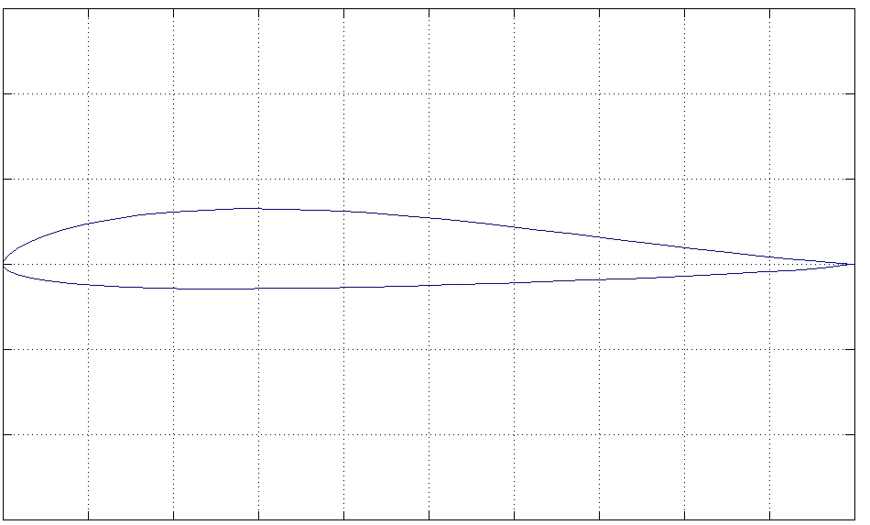

Planform
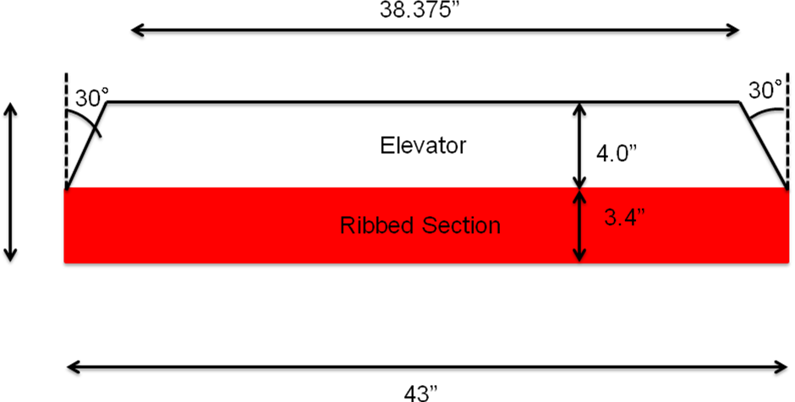

Half Rib Spacing
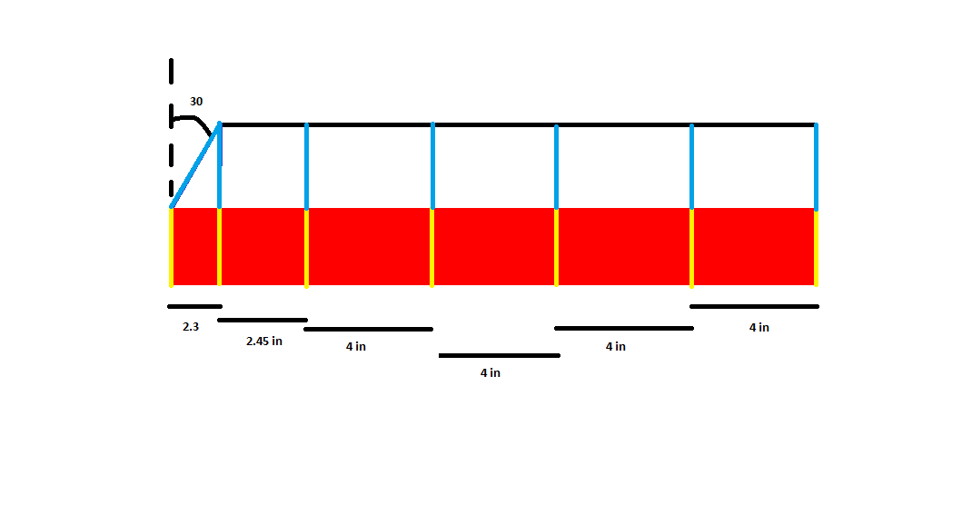

Leading Edge
No sheet

Spar
Basswood top and bottom
Balsa shear webs and stringers
Dimensions = ???

Ribs
TBD

4Hinges
Same as ailerons

Elevator

Spar

Ribs

Trailing Edge
Same as main wing and ailerons

Control Arm(s)

      - Placement
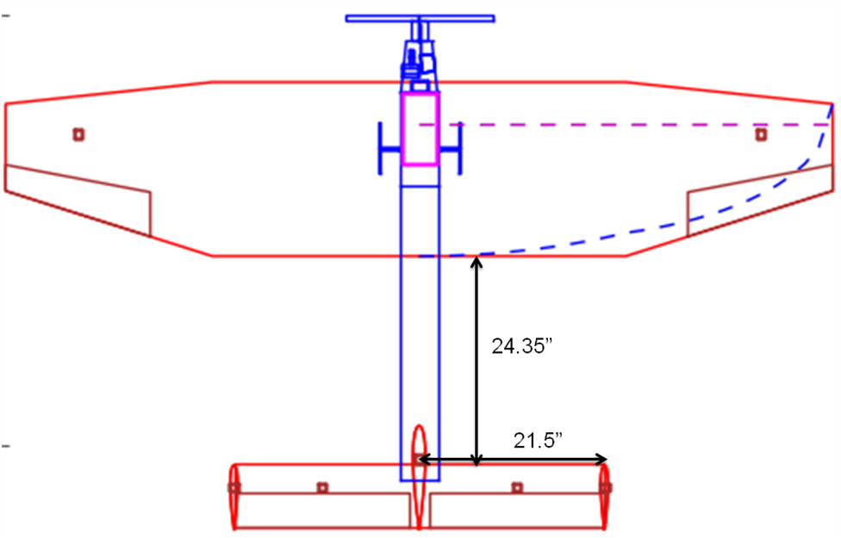
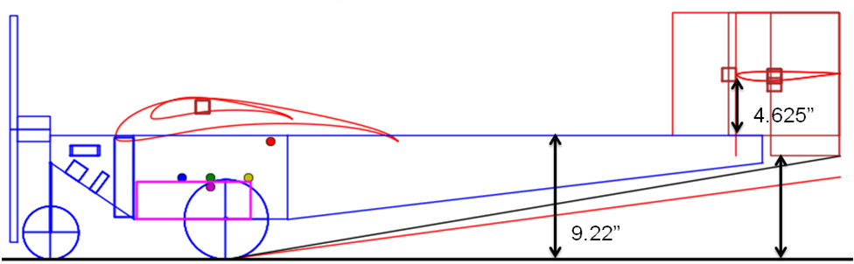

Vertical Tail
Center VTail- NACA 0012
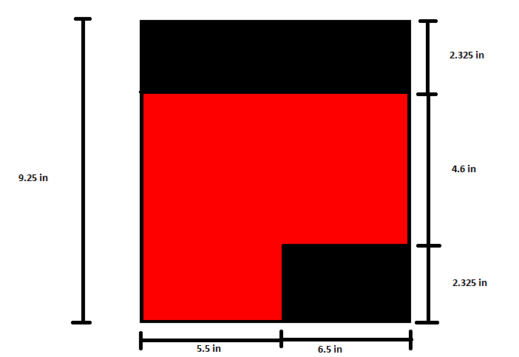

Side VTs
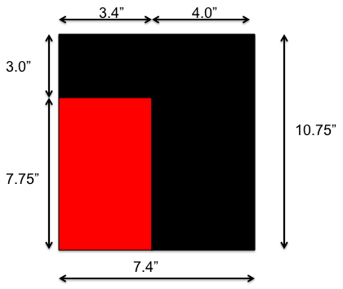

Side Vertical Tail Rib Spacing
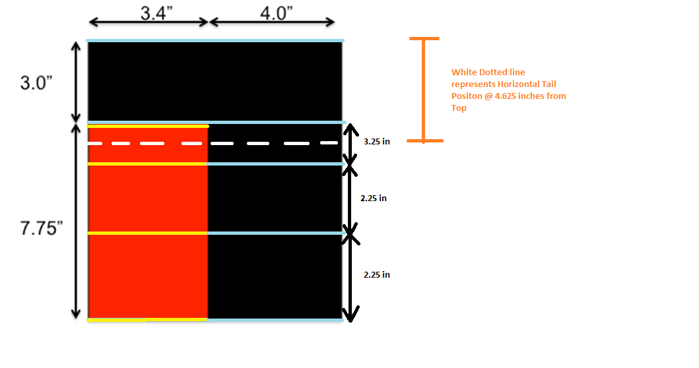

Center Vertical Tail Rib Spacing
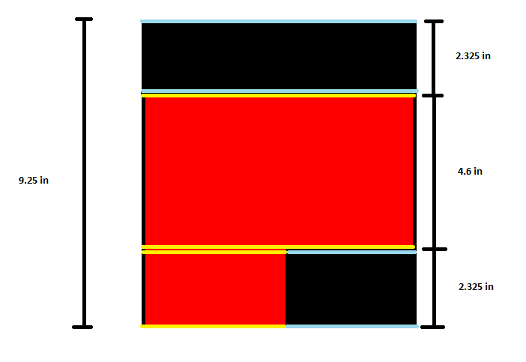

Spar

Leading Edge
No sheet

Ribs

Hinges
Same at as ailerons, taper about center

Rudder

Spar

Ribs

Trailing Edge
Same as aileron, wing, etc.

Control Arms

