**Team Count:** Aaron Prellegera

**Problem:**

1. People wants to find in the internet with a safe and affordable resort.
2. The target business needs to promote his business via publishing in the internet, also needs to establish his services to attract more customers even tourists.
3. The owner has competitive businesses around his area but the owner wants to attract more customers also tourists.

**Solution:**

1. Create own website with information of target business with services, accommodations and rates.
2. Have an own website with information and the services of business to attract customers.

**Project title**: Spring Ruin | Public Resort in Guinobatan

**Project Objectives:**

-Publish a new business and promote the newly resort in Guinobatan with low cost fee.

- Add the information and services of the business such accommodation, offers and rates.

**Target Users/ Audiences:**

1. Users or clients wants to find a better place to spend vocations or occasion.
2. A group who wants to find a place or resort to celebrate of his friend’s birthday, promoting etc.

**Introduction:**

This business launched this year, in order to attract more customers, the owner analyzed the thing that his business needs. A website that responses with future clients or customers who will book or view the resort which the offers, accommodations and services of the resort.

**Site Map:**

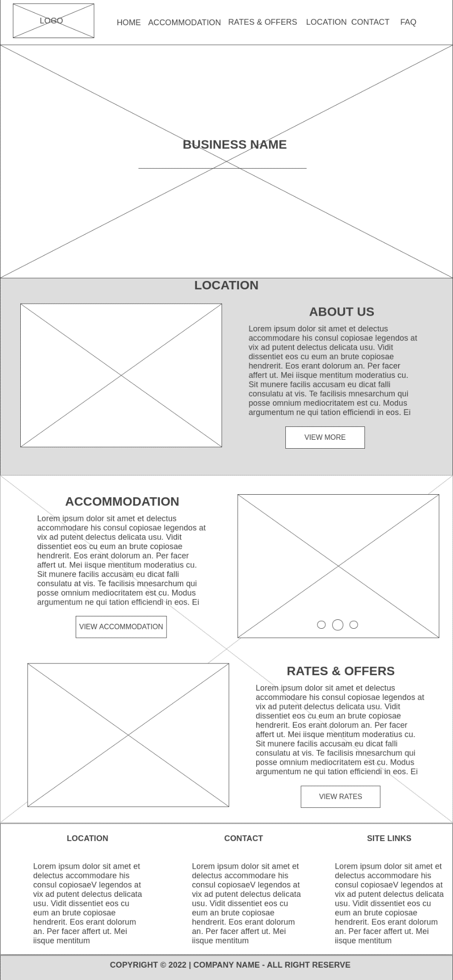**Wireframe:**

Home is for the Landing page, it contains the banner, about the business resort, accommodations, rates and offers and the footer with location, contact and site links of the business.

In navigation bar, it contains of accommodation which list of rooms and cottages that available in resort, rates and offers for the renting the rooms, amenities and cottages, location page contains of maps and direction, contacts are the list of information(phones, emails and social media) and message form and FAQ are the list questions, rules and answer by business owner.

**Features:**

* Accommodations
* Rates & Offers
* Location
* Contact
* FAQ
* About