# ETL Project Report with Power BI

## 1. Introduction

Objective: This report outlines the ETL process using Power BI for extracting, transforming, and loading data. The focus is on leveraging Power BI for insightful data analysis and visualization.  
Tools Used: Power BI, Microsoft Excel, and the provided CSV file.

## 2. Extract Process

Description:  
The data source is a CSV file uploaded into Power BI. The file contains the following columns:  
RowID, State_Name, District_Name, Crop_Year, Season, Crop, Area, Production, Unnamed: 8, Unnamed: 9, Unnamed: 10, Unnamed: 11  
Sample data from the file:  
 RowID State_Name District_Name Crop_Year Season Crop Area Production Unnamed: 8 Unnamed: 9 Unnamed: 10 Unnamed: 11  
 0 Bihar NALANDA 2005 Rabi Wheat 81934.0 160425.0 NaN NaN NaN NaN  
 1 Assam KARBI ANGLONG 2019 Whole Year Onion 257.0 514.0 NaN NaN NaN NaN  
 2 Gujarat ANAND 2020 Summer Maize 100.0 100.0 NaN Total production NaN Average

Screenshot: 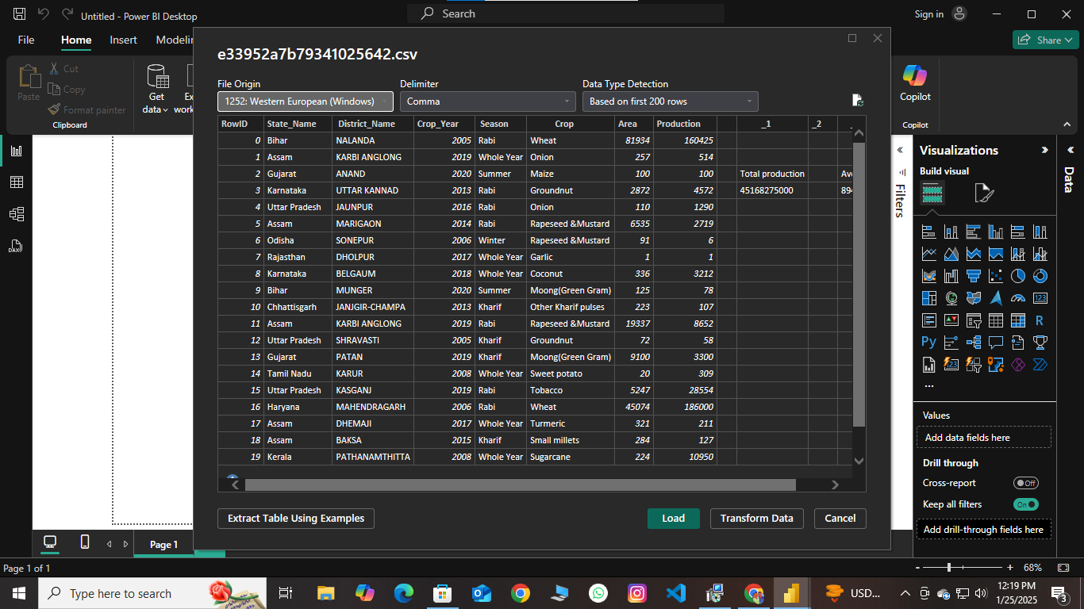

## 3. Transform Process

Description:  
The transformation process in Power BI includes data cleaning and formatting, such as:  
- Removing duplicates.  
- Handling missing values.  
- Changing data types where necessary.  
- Adding calculated columns or measures for analysis.

Screenshots: Include:  
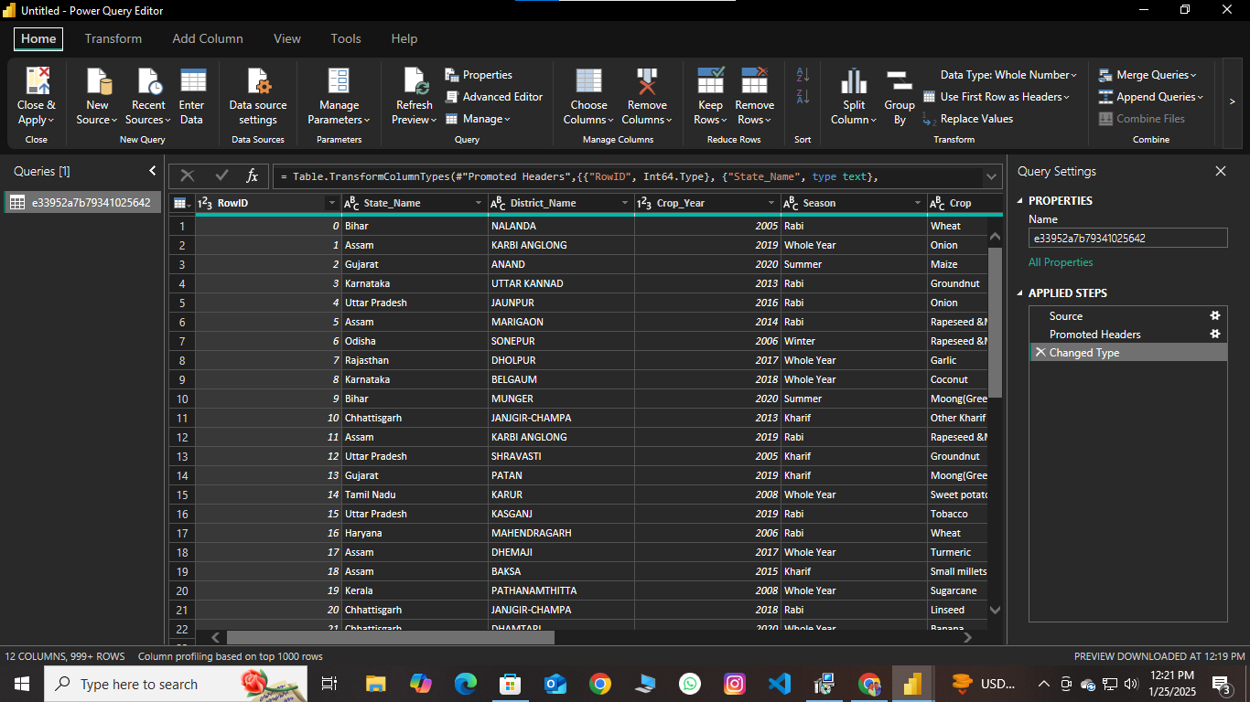  
- Screenshot of the transformed data preview in Power BI.

## 4. Load Process

Description:  
The cleaned and transformed data is loaded into Power BI's data model for analysis and visualization.

Screenshot: 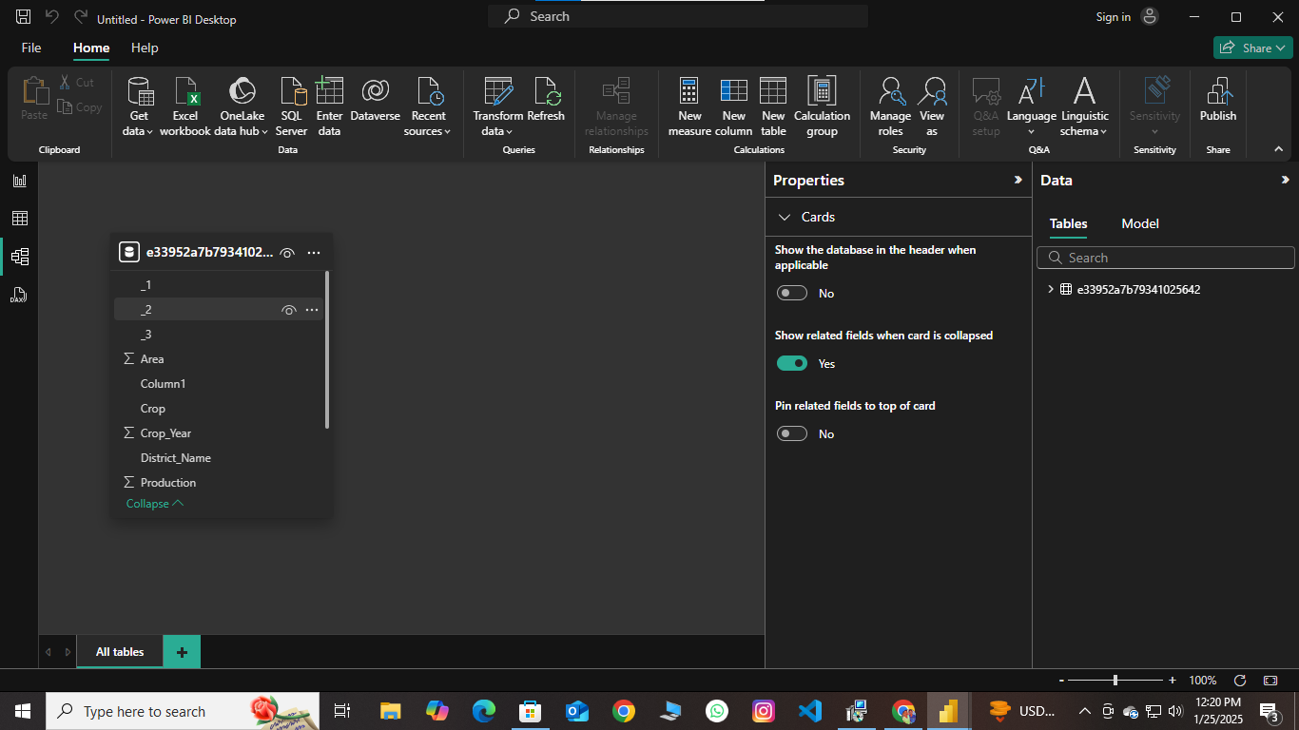

## 5. Report View

Description:  
The Report View in Power BI allows users to interact with visualizations and analyze data. The Table View provides detailed raw data, and the Model View shows relationships among datasets.

Screenshots: Include:

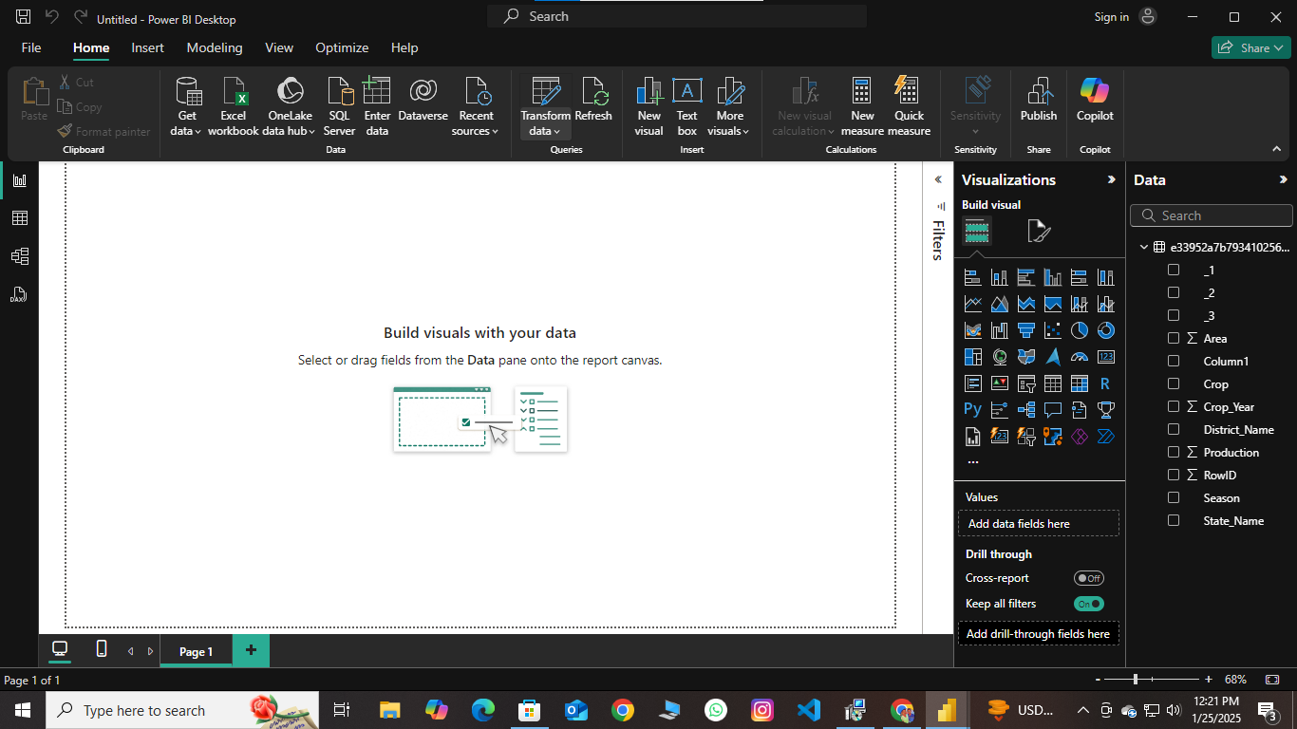  
- Screenshot of the Report View.

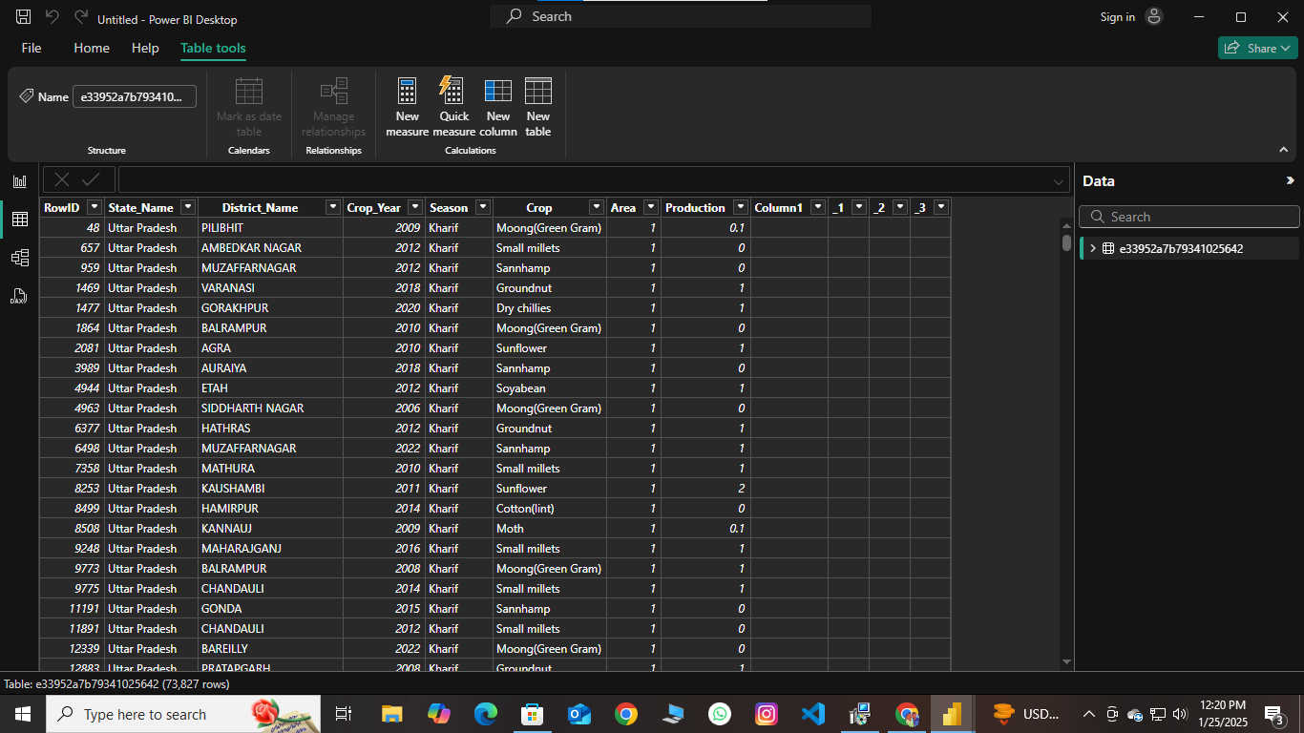  
- Screenshot of the Model View showing relationships.

## 6. Conclusion

The ETL process using Power BI demonstrates an efficient way to extract, transform, and load data for analysis. Key insights were visualized through dashboards, providing valuable information for decision-making.

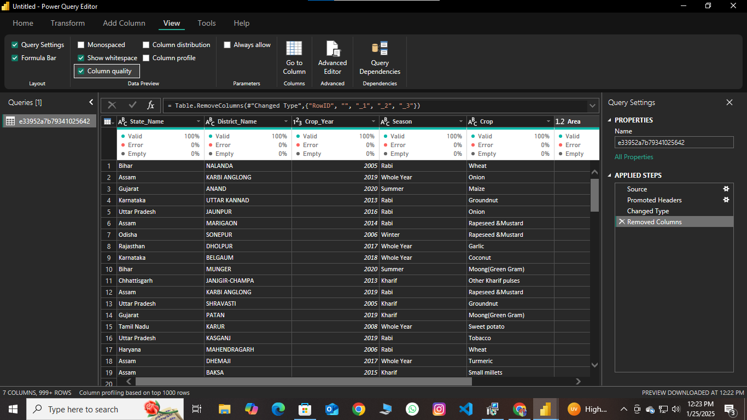

## Appendix

