

1 | Scope of the Project

The scope of the Vehicle Service Management System is to automate and manage the complete workflow of a vehicle service center. The system handles vehicle registration, customer details, job creation, technician assignment, service tracking, rework handling, manager approval, and final vehicle delivery. The application supports role-based access for receptionist, service advisor, technician, manager, and admin. It minimizes manual paperwork, improves service quality, and ensures transparency in the service process.
• Vehicle registration and check-in
• Customer detail management
• Job card creation and tracking
• Technician assignment and monitoring
• Rework and quality control process
• Manager approval system
• Vehicle delivery status tracking

2 | Goals of the Project

• To digitize the vehicle service management process
• To reduce manual records and human errors
• To improve coordination between service staff
• To track service progress in real time
• To ensure service quality through rework handling
• To enhance customer satisfaction

3 | Features of the System

The Vehicle Service Management System provides a set of features designed to automate and streamline the operations of a vehicle service center. The system ensures smooth coordination between staff, accurate job tracking, and improved service quality.

⭐ Vehicle Management
- Vehicle registration with customer details
- Storage of vehicle number, model, and owner information
- Real-time vehicle service status tracking
- Complete service history maintenance

⭐ Job Management
- Job card creation for vehicles
- Multiple jobs per vehicle
- Job status tracking (Assigned, In Progress, Completed, Rework)
- Service cost estimation

‍⭐ Technician Module
- View assigned jobs
- Update job status during service
- Add technician notes
- Handle rework jobs

⭐ Rework & Quality Control
- Rework requests by advisor or manager
- Rework notes visible to technicians
- Improves service quality

⭐Manager Approval System
- Review completed jobs
- Approve or reject services
- Rejected jobs sent for rework

⭐ Security & Access Control
- Secure login system
- Role-based access (Admin, Advisor, Technician, Manager)

⭐ Monitoring & Reporting
- Real-time service monitoring
- Centralized and accurate data management

⭐Vehicle Delivery
- Service completion tracking
- Vehicle delivery status update

4 | Roles in Vehicle Service Management System

1. Admin
The Admin has complete control over the system and is responsible for overall management and configuration.
Responsibilities:
- Manage users and assign roles (Receptionist, Advisor, Technician, Manager)
- Configure system settings and permissions
- Monitor overall system activity
- Access all modules without restrictions

2. Security Guard
The Security Guard manages vehicle entry and exit at the service center premises.
Responsibilities:
- Verify vehicle entry at the service gate
- Record vehicle arrival time
- Allow only registered vehicles inside the service area
- Ensure vehicle safety and prevent unauthorized access
- Assist in vehicle exit verification after service completion

3. Receptionist
The Receptionist acts as the first point of contact between the customer and the service center.
Responsibilities:
- Register vehicles and perform check-in
- Enter customer and vehicle details
- Create initial service requests
- Forward vehicles to service advisors

4. Service Advisor
The Service Advisor manages the service workflow between reception and technicians.
Responsibilities:
- Create job cards for registered vehicles
- Assign service jobs to technicians
- Track job progress and service status
- Send completed jobs to the manager for approval
- Initiate rework requests when required

5. Technician
The Technician performs the actual vehicle service tasks assigned by the advisor.
Responsibilities:
- View assigned jobs in the technician dashboard
- Update job status (In Progress / Completed)
- Add service and rework notes
- Rework rejected jobs as per instructions

6. Manager (Task / Service Manager)
The Manager ensures service quality and final approval before vehicle delivery.
Responsibilities:
- Review completed service jobs
- Approve or reject jobs based on quality
- Send rejected jobs back for rework
- Ensure service standards and customer satisfaction

5 | System workflow

“ The workflow defines the complete process from vehicle entry to final with proper verification, service execution, and quality approval.”

Vehicle Service Management System – Workflow

⬇
Vehicle Entry (Vehicle Entry)
⬇
⬇
Vehicle Registration (Registration)
(Receptionist)

⬇
Job Card Creation (Service Advisor)

⬇
Service Execution (Technician)
(Technician)

⬇
Manager Approval

Rework

Service Execution (Technician)
(Receptionist)
Approve

⬇
Delivered (Service Advisor)

6 | Diagram
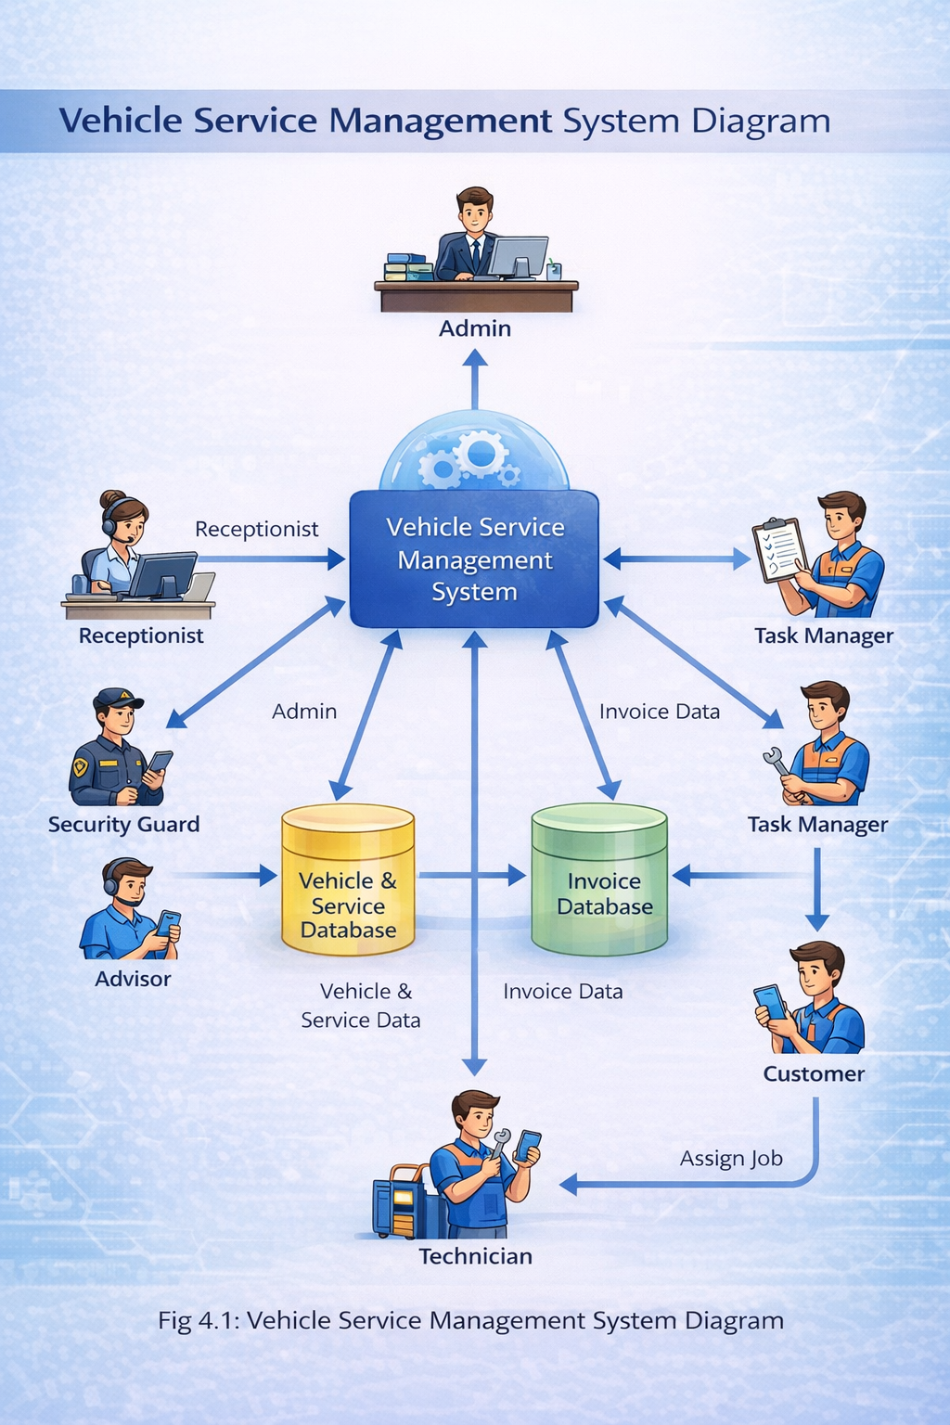

7 | Project Conclusion Summary

s

No. | Aspect | Conclusion Description
1 | Project Overview | The Vehicle Service Management System is a web-based application developed to manage vehicle service center operations digitally and efficiently.
2 | Problem Solved | CHECK IN - IN DATE ALWAYS SHOW CURRENT TIME ,remove acttinos from table , like complete and pending buttons from security , only service advisor can add job, emove not required content from all form
3 | System Functionality | It handles vehicle entry, service requests, job assignment, service tracking, and billing systematically.
4 | Role Coordination | Smooth coordination is maintained among Admin, Receptionist, Security Guard, Advisor, Task Manager, and Technician.
5 | Benefits | The system saves time, reduces errors, and improves productivity and customer satisfaction.
6 | Usability | The system is user-friendly and requires minimal training.
7 | Real-World Use | The system is suitable for real vehicle service center implementation.
8 | Final Outcome | Overall, the system is reliable, efficient, and modern.

8 | TEXT REPORT

1. Introduction
Vehicle Service Management System (VSMS) ek web-based application hai jo vehicle service center ke daily operations ko digital aur automated banata hai. Is system ka main goal manual paperwork ko kam karna aur service process ko fast, accurate aur transparent banana hai.

2. Purpose of the System
Is system ka purpose vehicle service center ke end-to-end operations ko manage karna hai jaise:
- Vehicle entry
- Service request
- Job assignment
- Service tracking
- Billing & reporting

3. System Overview
System me alag-alag user roles hote hain:
- Admin
- Receptionist
- Security Guard
- Service Advisor
- Task Manager
- Technician
- Customer
Sabhi roles apni-apni responsibility ke according system use karte hain.

4. Functional Description
- Customer service request raise karta hai
- Receptionist vehicle details entry karti hai
- Security guard vehicle entry verify karta hai
- Advisor service plan banata hai
- Task manager technician assign karta hai
- Technician service complete karta hai
- System automatically invoice generate karta hai

5. Advantages
- Paperless system
- Time saving
- Accurate data management
- Easy service tracking
- Better customer satisfaction

6. Conclusion
Vehicle Service Management System service centers ke liye ek reliable, efficient aur user-friendly solution hai jo business productivity aur service quality dono improve karta hai.

9 | QUALITY REPORT

1. Quality Objectives
- System accuracy ensure karna
- Data security maintain karna
- User-friendly interface provide karna
- Reliable performance ensure karna

2. Quality Attributes

🔹 Accuracy
- Vehicle aur service data correctly store hota hai
- Invoice calculation automatic aur error-free hoti hai

🔹 Reliability
- System continuously work karta hai
- Data loss ka risk minimum hota hai

🔹 Security
- Role-based access control
- Authorized users hi system access kar sakte hain

🔹 Usability
- Simple UI
- Easy navigation
- Minimal training required

🔹 Performance
- Fast response time
- Multiple users ek sath system use kar sakte hain

3. Testing Approach
- Unit Testing
- Integration Testing
- User Acceptance Testing (UAT)

4. Quality Control Measures
- Regular data backup
- Error handling & validation
- Access control checks
- Performance monitoring

5. Quality Assurance Conclusion
Vehicle Service Management System industry standards ke according develop kiya gaya hai. System reliable, secure aur scalable hai aur real-world vehicle service operations ke liye suitable hai.

