Papa John’s – Rota System

REQUIREMENTS SPECIFICATion

Web application development

Adam Speer, Petrut Vasile, Toby White | DMC Level 6 | 04/09/2019

Table of Contents

Brief 4

Goal 4

Stakeholders 4

Role 4

Responsibilities 4

Communication 4

Sitemap 4

Page Descriptions 5

User Personas 6

Manager 6

Employee (in Store) 7

Employee (Driver) 7

High Level Requirements 9

Process Flows 10

Page: Manager - Login 10

Page: Description 10

Page: Functions 10

Page: Manager - Main Menu 11

Page: Description 11

Page: Functions 11

Page: Manager - Rota 12

Page: Description 12

Page: Functions 12

Page: Manager - Copy Week 13

Page: Description 13

Page: Functions 13

Page: Manager - Copy To 14

Page: Description 14

Page: Functions 14

Page: Manager - Rota View Day 15

Page: Description 15

Page: Functions 16

Page: Manager - Pick Staff 16

Page: Description 16

Page: Functions 16

Page: Manager - Manage Staff 17

Page: Description 17

Page: Functions 17

Page: Manager - Remove Staff 18

Page: Description 18

Page: Functions 18

Page: Manager - Add / Edit Staff 19

Page: Description 19

Page: Functions 19

Page: Manager – Holiday Requests 20

Page: Description 20

Page: Functions 20

Page: Manager – Holiday Accept / Deny 21

Page: Description 21

Page: Functions 21

Page: Manager – Send Alert Message 22

Page: Description 22

Page: Functions 22

Page: Employee – Rota 23

Page: Description 23

Page: Functions 23

Page: Employee – Request Holiday 24

Page: Description 24

Page: Functions 24

Page: Employee – Cancel Holiday 25

Page: Description 25

Page: Functions 25

Page: All – Password Reset 1 26

Page: Description 26

Page: Functions 26

Page: All – Password Reset 2 26

Page: Description 26

Page: Functions 26

# Brief

Papa John’s have a requirement for staff to be able to access via the web a staff rota system so that they can check their allocated hours and shift patterns. The system should also provide functionality for them to be able to submit holiday requests.

The system should allow the Manager of the branch to be able to add new staff and remove leavers. Manage shifts allocated to staff and approve holiday requests.

The system should be accessible via the internet and designed first for Mobile devices, but accessible from any browser.

# Goal

Create a website for Papa John’s Staff so that they can see the shift rota and request holiday bookings.

# Stakeholders

The primary stakeholders for the project are

|  |  |
| --- | --- |
| Role | Responsibilities |
| Manager | Define requirements  Agree design and approach  Ongoing communication  Provide sign off |
| Employees (End users) | Support requirements gathering  Support user testing |
| Developers | Gather & document requirements  Evaluate development tools  Ongoing communication  Develop solution  Quality assurance testing |

# Communication

Communication regarding the project will be conducted through both email and documented, regular meetings in person.

# Sitemap

# Page Descriptions

|  |  |
| --- | --- |
| **Page** | **Description** |
| Login | This page is where all employees will enter their username and password to access the system. |
| Manager Main Menu | This is where the manager selects the task he wants to complete. |
| Manager Rota | Provides a managerial overview of shifts currently booked and available. |
| Manager Copy Week | Allows the manager to select a weeks’ worth of shifts in order to copy them to another. |
| Manager Copy To | Allows the manager to select the weeks in which he wants to mirror the prior copied shifts. |
| Manager Rota Day | Provides a detailed view of the staff working on a specific day and allows to add and remove staff to either shift. |
| Manager Pick Staff InStore | Allows the manager to select from all available In Store staff. |
| Manager Pick Staff Driver | Allows the manager to select from all available Drivers. |
| Manager Manage Staff | Provides the manager the ability to add new members of staff as well as remove staff whom have left. |
| Manager Staff Info | Records information about each member of staff i.e. their role in the store, their contact information, and their availability. Editable by manager. |
| Manager Remove Staff | Allows the manager to remove staff from availability after they have left employment. |
| Manager Holiday Requests | Displays all pending holiday requests sent by employees awaiting decision. |
| Manager Holiday Rota | Displays all current accepted holiday to the manager. |
| Manager Cancel Holiday | Allows the manager to cancel any currently booked holiday. |
| Manager Holiday Requests Accept/Deny | Allows the manager to accept or deny a pending holiday request. |
| Manager Send Alert | Allows the manager to send an alert message via email to either specific members, groups of, or all staff regarding sickness etc. |
| Employee Rota | Displays any currently booked shifts and holiday relevant to the specific employee. |
| Employee Request Holiday | Allows the employee to highlight desired date to date holiday and submit request. |
| Employee Cancel Holiday | Allows an employee to cancel any current holiday that they have booked. |
| Password Reset | Allows users to enter their registered email to receive a password reset link. |
| Password Reset Link | Allows a user to update their password. |

# User Personas

## Manager

|  |  |
| --- | --- |
| User Type | Website User (Internal) |
| Occupation | Manager |
| Name | John Smith |
| Gender | Male |
| Age | 40 |
| Location | Ipswich, Suffolk |
| Objective | John is the manager at the Ipswich Papa Johns, John needs to manage the staffs shift patterns and annual leave. He also wants to be able to issue staff alerts. For example, to request additional cover for a shift due to sickness. |

## Employee (in Store)

|  |  |
| --- | --- |
| User Type | Website User (Internal) |
| Occupation | Employee (In Store) |
| Name | Sam Smith |
| Gender | Female |
| Age | 22 |
| Location | Ipswich, Suffolk |
| Objective | Sam works at papa johns and wants to be able to quickly check to see what shifts she is working and how much holiday she has left for the year, and to be able to request annual leave. |

## Employee (Driver)

|  |  |
| --- | --- |
| User Type | Website User (Internal) |
| Occupation | Employee (Delivery Driver) |
| Name | Dan Smith |
| Gender | Male |
| Age | 22 |
| Location | Ipswich, Suffolk |
| Objective | Dan works at papa johns as a delivery driver, and wants to be able to quickly check to see what shifts he is working and how much holiday he has left for the year, and to be able to request annual leave. |

# High Level Requirements

Employee

* I want to be able to view the rota for the coming week / month / year?
* I want to be able to request holiday. From date to date
* I want to be able to cancel a future booked holiday.
* I want to be emailed a reminder when I’m due to work – 1 hour before?

Manager

* I want to be able to view the rota for the coming week / month / year?
* I want to be able to set who is working for the coming day / week / month
* I want to be able to copy a shift pattern
* I want to be able to add a new employee
* I want to be able to remove an employee
* I want to be notified when an employee submits a holiday request
* I want to be able to approve a holiday request
* I want to be able to deny a holiday request
* I want there to be a limit on how close to the current date employees can request holiday

General

* I want the website to have user access controls for the Manager
* I want the employees to have a unique user id / password
* I want the system to support password resets
* I want the website to work on multiple device types / Mobile / Tablet / Desktop. The primary optimisation should be for mobile layout.
* I want the website to be branded to look like Papa Johns

Non Functional

* Website will be built using Bubble.io
* The application must work in all modern browsers
* The application must be responsive (work well and look good on all screen sizes)
* The application must be able to support 50 simultaneous users

# Process Flows

## Page: Manager - Login

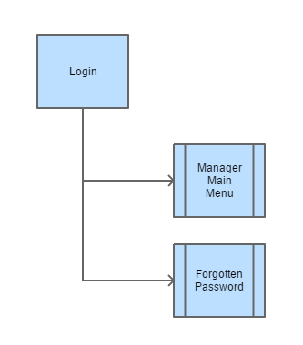

### Page: Description

This page is where all employees will enter their username and password to access the system.

### Page: Functions

The system will check the entered credentials against the system database and display and error message if the username / password combination does not match.

If a valid username password combination is entered the user will be logged in and taken to the appropriate page (Main Menu for Manager, Rota for employee)

If the user clicks the forgotten password link they should be taken to the password reset page.

## Page: Manager - Main Menu

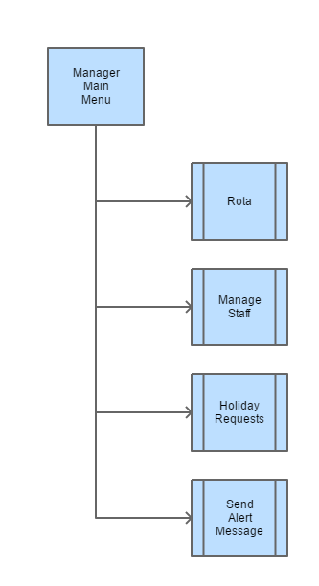

### Page: Description

This is where the manager selects the task(s) he wants to complete.

### Page: Functions

Rota – If the manager selects this option they will be taken to the Rota view screen

Manage Staff - If the manager selects this option they will be taken to the Manage Staff screen

Holiday Requests - If the manager selects this option they will be taken to the Holiday Requests screen

Send Alert Message - If the manager selects this option they will be taken to the Send Alert screen

## Page: Manager - Rota

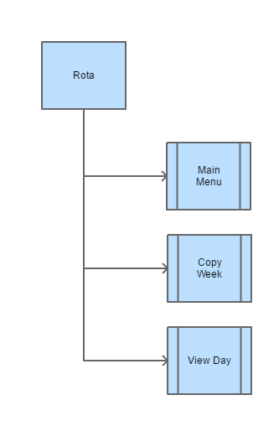

### Page: Description

Provides a managerial overview of shifts currently booked and available (Month View).

### Page: Functions

Main Menu – Navigates back to the Main Menu

Copy Week – If the manager selects this option they are taken to the Copy Week Screen

View Day – If the manager taps a specific day in the rota view they are taken to the rota day view for that date.

## Page: Manager - Copy Week

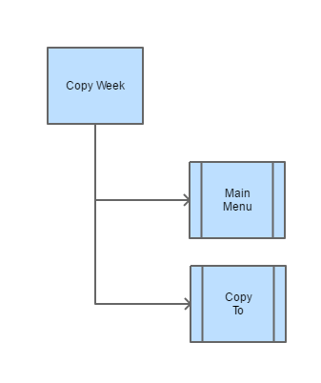

### Page: Description

This page displays the month calendar view and allows the manager to select a weeks’ worth of shifts in order to copy them to another.

### Page: Functions

Main Menu – Navigates back to the Main Menu

Copy to – If the manager selects this option they are taken to the Copy to Screen where they can select a week in the future to copy the selected shift pattern into.

## Page: Manager - Copy To

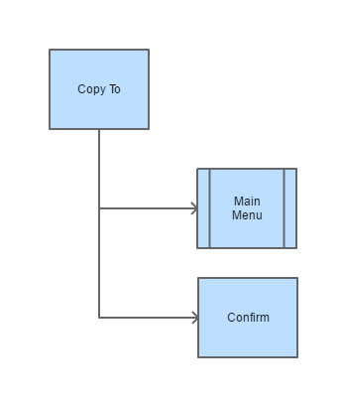

### Page: Description

Allows the manager to select the weeks in which he wants to mirror the prior copied shifts.

### Page: Functions

Main Menu – Navigates back to the Main Menu

Confirm – Commits the shift pattern selected into the Rota System

## Page: Manager - Rota View Day

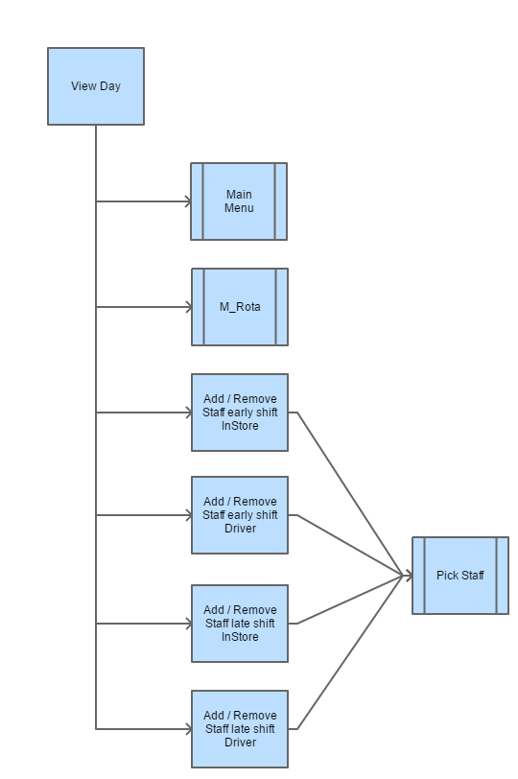

### Page: Description

Provides a detailed view of the staff working on a specific day and allows to add and remove staff to either shift.

### Page: Functions

Main Menu – Navigates back to the Main Menu

Rota – Navigates back to the Rota Month View

Add / Remove Staff early shift InStore – Navigate to the Pick Staff screen

Add / Remove Staff early shift Driver – Navigate to the Pick Staff screen

Add / Remove Staff late shift InStore – Navigate to the Pick Staff screen

Add / Remove Staff late shift Driver – Navigate to the Pick Staff screen

## Page: Manager - Pick Staff

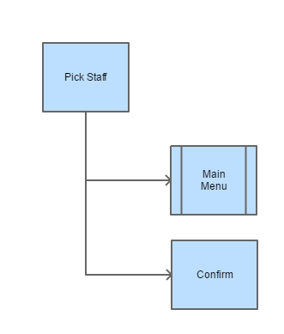

### Page: Description

Displays a list of staff for the manager to pick, the list shown will be context aware. If he has requested the list from an early shift for in store staff the system will automatically filter the list of staff displayed to only those people associated with the in store role and who are currently available to work.

### Page: Functions

Main Menu – Navigates back to the Main Menu

Confirm – Adds the staff selected to the appropriate shift in the Rota System

## Page: Manager - Manage Staff

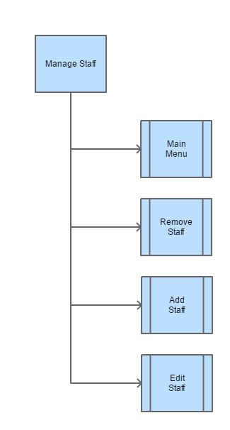

### Page: Description

This page provides the manager the ability to add new members of staff as well as remove staff whom have left, they can also edit details for existing staff members.

### Page: Functions

Main Menu – Navigates back to the Main Menu

Remove Staff – Navigate to the page where the manager can select staff who have left.

Add Staff – Navigate to the page where new staff member details can be recorded.

Edit Staff – Shows a list of names on the page of existing staff clicking one of these navigate to the page where new staff member details can be recorded, prepopulated with existing details that can be amended.

## Page: Manager - Remove Staff

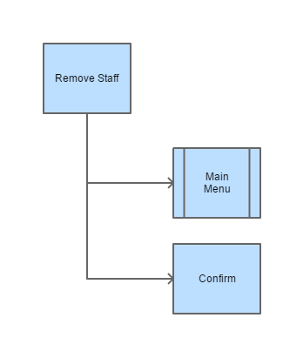

### Page: Description

Displays a list of staff for the manager to pick, the list shown will be context aware. If he has requested the list from an early shift for in store staff the system will automatically filter the list of staff displayed to only those people associated with the in store role and who are currently available to work.

### Page: Functions

Main Menu – Navigates back to the Main Menu

Confirm – Adds the staff selected to the appropriate shift in the Rota System

## Page: Manager - Add / Edit Staff

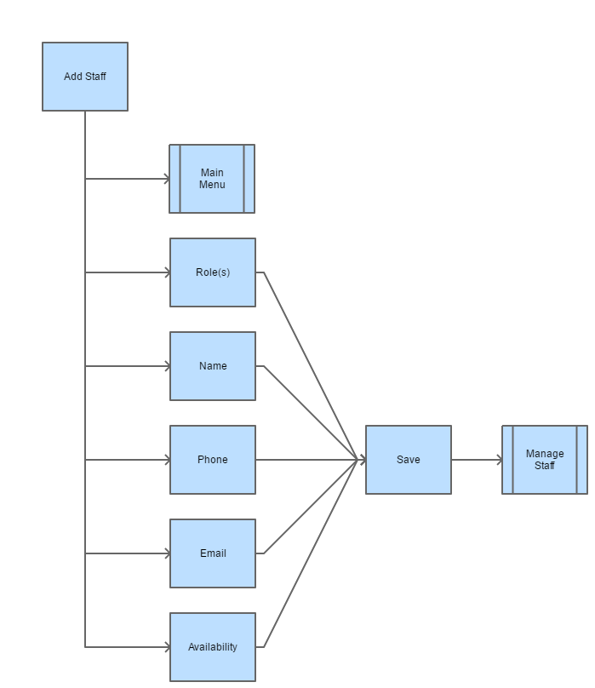

### Page: Description

Displays a page for the Manager to add a new member of Staff and capture the required information: Name, Phone No. Email address. The system also captures the staff members availability for shift selection so that the manager does not try to add them to a shift which they will not be able to cover. (Works another Job, College etc.)

### Page: Functions

Main Menu – Navigates back to the Main Menu

Role(s) – The manager selects the Role(s) the employee will be performing, either In Store, Driver or Both.

Name – The employees name

Phone – The employees mobile telephone number

Email – The employees email address, this will be the username they should use to access the system, it will also be the email address used to receive Alerts and Notifications from the system.

Availability – The manager can highlight which shifts the employee will be able to cover, these are split by day of the week and early / late shift.

## Page: Manager – Holiday Requests

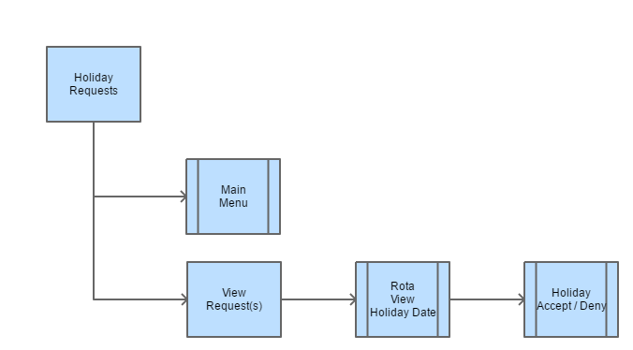

### Page: Description

Displays a list of Holiday requests that have been sent by staff.

### Page: Functions

Main Menu – Navigates back to the Main Menu

Request – Clicking on a request navigates to the Rota View with the requested holiday highlighted on the calendar.

## Page: Manager – Holiday Accept / Deny

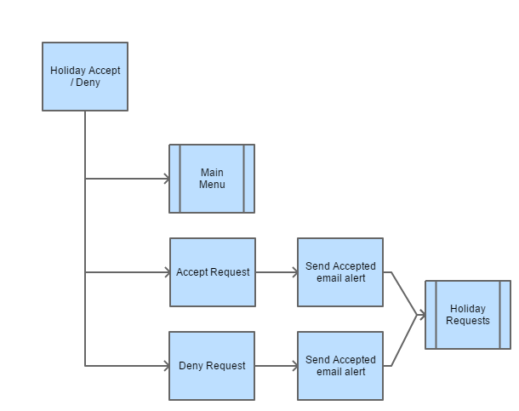

### Page: Description

The manager is shown the summary of the holiday request: Employees Name, Date Request Received, Holiday from Date, Holiday to Date. They can either Accept or Deny the request.

### Page: Functions

Main Menu – Navigates back to the Main Menu

Accept – Clicking on the request should add the holiday to the rota and mean that the employee is not selectable for allocation to a shift on those dates. It should also generate an email alert from the manage to the employee that the request has been approved.

Deny – The system will generate an email alert from the manage to the employee that the request has been denied.

## Page: Manager – Send Alert Message

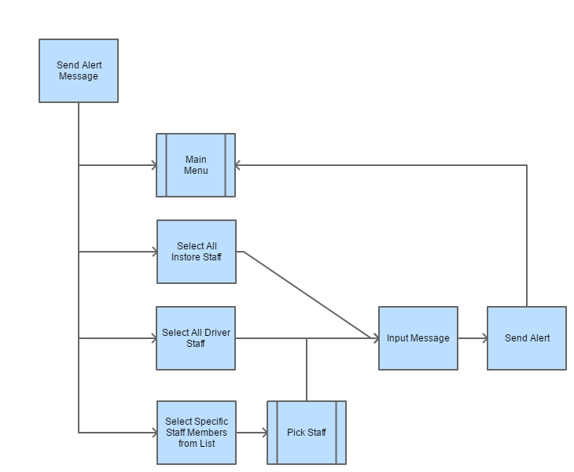

### Page: Description

The manager can choose to send an Alert message to staff, they can pick either All in store staff, all drivers, all staff (by picking in store and Drivers), or chose specific members of staff from a list. The manager then enters the text he wishes to email into the input text box.

### Page: Functions

Main Menu – Navigates back to the Main Menu

Select Staff – Navigates to the Pick Staff screen where the manager can select specific individuals.

Send Alert – The system sends the inputted text to the email addresses of the selected staff / staff group. It then navigates back to the Main Menu.

## Page: Employee – Rota

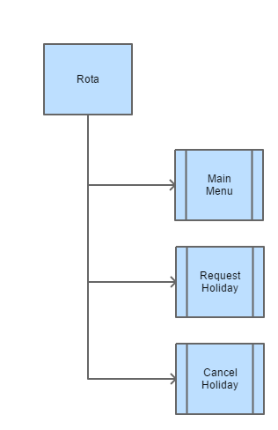

### Page: Description

The employee is shown a view of the Rota for the current Month view on which they can see the shifts and roles they have currently been allocated. They can also see any approved holiday requests that are in the future.

### Page: Functions

Main Menu – Navigates back to the Employee Rota View

Request Holiday – Navigates to Request Holiday Screen

View Holiday – If there is an approved future holiday for the employee showing on the rota they can tap this to be given the option to cancel the leave.

## Page: Employee – Request Holiday

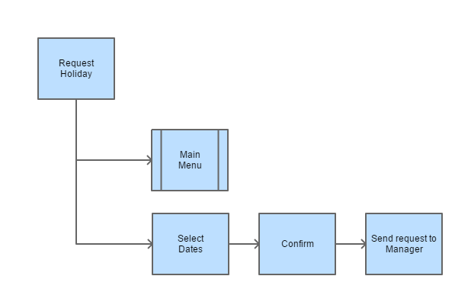

### Page: Description

The employee is shown a view of the Rota for the current Month, they can select date to request holiday be highlighting with a tap.

### Page: Functions

Main Menu – Navigates back to the Employee Rota View

Select Dates – Tap date to select it for inclusion in the holiday request.

Confirm – The system sends the holiday request to the Manager for approval.

## Page: Employee – Cancel Holiday

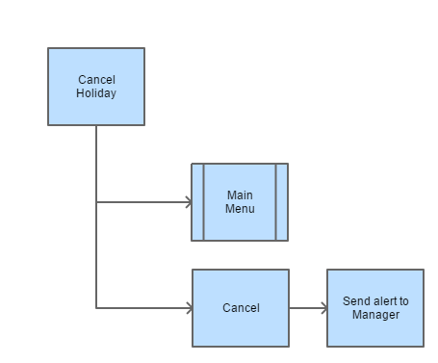

### Page: Description

The employee is shown a view of the Rota for the current Month with the selected holiday period highlighted, they can then choose to cancel the holiday. It will be removed from the Rota, the Manager will be notified and they will be added back into the pool of employees available to be selected for allocation to a shift.

### Page: Functions

Main Menu – Navigates back to the Employee Rota View

Cancel – The system cancels the booked holiday and sends a notification email to the Manager.

## Page: All – Password Reset 1

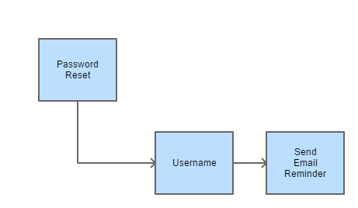

### Page: Description

When clicking the forgotten password link on the Login page the employees can enter their username here to request an email reminder of the password.

### Page: Functions

Username – Employee enters their username (Email address)

Send Reminder – The system will check to see if the email address supplied is a valid user. If it is, it will mark the user’s current password as expired and send an email message to the user with a link to the set new password page. If the system does not recognise the username it will do nothing.

## Page: All – Password Reset 2

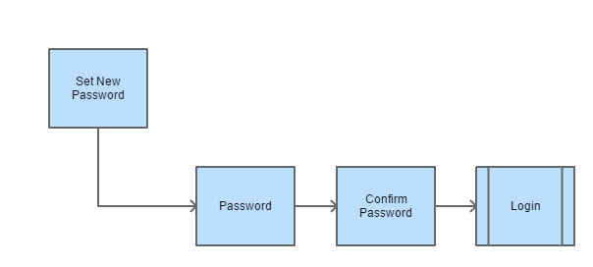

### Page: Description

When clicking the link in the password reminder email the user will be directed to this page where they can set a new password.

### Page: Functions

Password – Enter new password

Confirm Password – Enter new password again.

The system will check that the new passwords match and that the new password meets the security requirements of the system.

On clicking confirm the user will be returned to the login screen where they can login with the new credentials.